
CHATHAM COUNTY
DISASTER RECOVERY PLAN

CHATHAM COUNTY

DISASTER

RECOVERY PLAN

AUGUST 2013

MONTH YEAR

CHATHAM COUNTY
DISASTER RECOVERY PLAN

THIS PAGE INTENTIONALLY BLANK

MONTH YEAR

CHATHAM COUNTY
DISASTER RECOVERY PLAN

FOREWORD

This Chatham County Disaster Recovery Plan is developed for use by County and local governments and volunteer organizations to ensure a timely recovery from emergencies affecting Chatham County. This Plan was designed to identify potential actions required and the assistance necessary to support the citizens of Chatham County and to return the County to normal conditions.
This Plan is predicated upon the concept that response and recovery operations will begin at the local government level. County assistance shall be provided upon request when the need exceeds the capability of the jurisdiction. Federal assistance is supplemental to State and local governments and is made available upon approval of a Presidential Disaster Declaration.

This Plan is intended to be used by County agencies, local governments, and volunteer organizations to develop Standard Operating Procedures and recovery annexes to emergency operations plans in order to facilitate continuity and coordination of recovery activities.

The Chatham County Disaster Recovery Plan is a "living" document and the Chatham
Emergency Management Agency acknowledges additional recovery issues will be identified in the future and will be included in revised editions of this document.

Clayton S. Scott
Director

i AUGUST 2013

CHATHAM COUNTY
DISASTER RECOVERY PLAN

THIS PAGE INTENTIONALLY BLANK

ii AUGUST 2013

CHATHAM COUNTY
DISASTER RECOVERY PLAN

DISASTER RECOVERY PLAN

SIGNATURE OF ADOPTION

This document was adopted in accordance with National, State, and local guidelines regarding disaster recovery planning and coordination practices. The document was developed to ensure safe and methodical recovery from incidents affecting Chatham County. By signature, the entities below accept this document as a standard practice for disaster recovery coordination.
________________________________ | ________________________________
 | Date
________________________________ | ________________________________
 | Date
________________________________ | ________________________________
 | Date
________________________________ | ________________________________
 | Date
________________________________ | ________________________________
 | Date
________________________________ | ________________________________
 | Date
________________________________ | ________________________________
 | Date
________________________________ | ________________________________
 | Date
________________________________ | ________________________________
 | Date
________________________________ | ________________________________
 | Date
________________________________ | ________________________________
 | Date
________________________________ | ________________________________
 | Date
________________________________ | ________________________________
 | Date

iii AUGUST 2013

CHATHAM COUNTY
DISASTER RECOVERY PLAN

THIS PAGE INTENTIONALLY BLANK

iv AUGUST 2013

CHATHAM COUNTY
DISASTER RECOVERY PLAN

ACRONYMS

ARC American Red Cross

CEMA Chatham Emergency Management Agency

CFR Code of Federal Regulations

COG Continuity of Government

COOP Continuity of Operations
DRC Disaster Recovery Center

DRM Disaster Recovery Manager

DRP Disaster Recovery Plan

EMAC Emergency Management Assistance Compact

EOC Emergency Operations Center

EOP Emergency Operations Plan

ESF Emergency Support Function

FCO Federal Coordinating Officer

FDRC Federal Disaster Recovery Coordinator

FEMA Federal Emergency Management Agency

FOUO For Official Use Only

GEMA Georgia Emergency Management Agency

ICS Incident Command System

JFO Joint Field Office

LDRM Local Disaster Recovery Manager

NDRF National Disaster Recovery Framework

NIMS National Incident Management System

PDD Presidential Decision Directive

RAP Recovery Action Plan

RCC Recovery Coordination Center

RSF Recovery Support Function

SDRC State Disaster Recovery Coordinator

SOP Standard Operating Procedures

v AUGUST 2013

CHATHAM COUNTY
DISASTER RECOVERY PLAN

THIS PAGE INTENTIONALLY BLANK

vi AUGUST 2013

CHATHAM COUNTY
DISASTER RECOVERY PLAN

TABLE OF CONTENTS

Foreword i

Signature of Adoption iii

Acronyms v

Table of Contents vii
I. Introduction 1

II. Purpose 1

III. Scope 1

IV. Authorities 2

V. Plan Organization 2

VI. Assumptions 3

VII. Implementation 4

VII. Concept of Operations 4

A. Overview 4

B. Emergency Management Phases 4

C. Recovery Timeline 6

D. Incorporation of NIMS 8

E. Disaster Recovery Goals 8

F. Recovery Support Functions 16

G. Designated Recovery Positions 17

H. Activation/Demobilization 20

I. Recovery Sites and Facilities 21

J. Recovery Action Planning Cycle 22

VIII. Responsibilities 27

A. Overall 27

B. Specific Roles and Responsibilities 30

VIII. Plan Management and Maintenance 33

A. Executive Agent 33

B. Types of Changes 33

vii AUGUST 2013

CHATHAM COUNTY
DISASTER RECOVERY PLAN

C. Coordination and Approval 33

D. Notice of Change 33

E. Distribution 33

viii AUGUST 2013

CHATHAM COUNTY
DISASTER RECOVERY PLAN

- INTRODUCTION

  - This Disaster Recovery Plan (DRP) is designed in coordination with the Chatham County Emergency Operations Plan (EOP) and will serve to identify a range of required actions required by county agencies to support local governments and coordinate emergency recovery activities. The DRP provides County and local emergency management personnel with operational guidance necessary to effectively manage recovery activities in the aftermath of a major disaster or catastrophic emergency.

  - The DRP is a “living” document and the Chatham Emergency Management Agency (CEMA) acknowledges additional recovery issues will be identified in the future and will be included in revised editions of this document.
- PURPOSE

  - The purpose of the DRP is to provide a framework for the delivery of coordinated recovery assistance and to return the County to normal or new-normal conditions as quickly as possible.

  - This DRP provides emergency management personnel with operational guidance in order to successfully manage recovery activities in the event of a major emergency.

  - This plan should be used as a guiding document during the recovery phase of an event. Response phase activities are identified and outlined in the County’s EOP. Due to the cyclical nature of emergency management, there will be some overlap between the response and recovery phase.

- SCOPE

  - The mission of the County government during disaster recovery operations is to coordinate and direct operations when local resources are exhausted and to coordinate assistance from mutual aid resources, the State, and the Federal government as necessary and appropriate.

  - This DRP should be used by County agencies, local governments, and volunteer organizations to develop Standard Operating Procedures
(SOPs) and recovery annexes in order to facilitate continuity and coordination of recovery activities.

1 AUGUST 2013

CHATHAM COUNTY
DISASTER RECOVERY PLAN

IV. AUTHORITIES

  - Federal:

    - Robert T. Stafford Disaster Relief and Emergency Assistance Act,
Public Law 93-288, Title VI as amended

    - Code of Federal Regulations (CFR), Title 44, as amended

    - National Response Framework (NRF), October 2008, as amended

    - National Disaster Recovery Framework (NDRF), September 2011

    - Presidential Executive Order 12148- Federal Emergency Management

    - Presidential Decision Directive-63, Critical Infrastructure Directive, May 1998

  - State: Georgia Emergency Management Act of 1981. As Amended
December 1992

  - County: The Code of Chatham County, 2006. Chapter 4, Administration, Article III, Emergency Management.

- PLAN ORGANIZATION

  - This Disaster Recovery Plan (DRP) is designed so it can be either read through from beginning to end, or can be utilized such that the only sections relevant to particular users during a disaster are used.

  - Base DRP: The DRP base plan contains basic information about the functioning of Chatham County during disaster operations. Participants participating in activation will want to review this material, as it provides common general information, common operating concepts, and other over-arching information.

  - Recovery Support Function (RSF) Annexes: RSFs are six groupings of core recovery capabilities providing a structure to facilitate problem solving, improve access to resources, and coordination between partners. The RSFs operate similar to the ESFs do in the EOP. The RSF Annexes are intended to be used by each respective RSF and other key staff during activation. Each is designed and intended to provide a basis for establishing objectives and strategies in each recovery subject area. The
RSF annexes are intended only as a supplement to the DRP Base Plan.

2 AUGUST 2013

CHATHAM COUNTY
DISASTER RECOVERY PLAN

- Other Annexes: The DRP also includes other Annexes and Appendices supporting Disaster Recovery and cover such topics as re-entry, damage assessment, funding sources, etc. With respect to recovery activities and specific disaster-related programs, the Plan Annexes focus on three main areas: listing of recovery programs by functional area; general role and responsibilities of those involved entities; and descriptions of appropriate activating mechanism(s) for each specific recovery program.

VI. ASSUMPTIONS
- This plan is intended to be used in preparation for and after a disaster of such magnitude that long-term recovery efforts become necessary.

- Activation of this plan assumes a catastrophic incident has occurred; such an occurrence may be regional and/or multijurisdictional in nature.

- Damage will be catastrophic in nature and will cause the disruption of normal life support systems and the disruption of regional economic, physical, and social infrastructures.

- Prior to or concurrent with activation and implementation of this plan the
Chatham County EOP, County Departments and City Continuity of
Operations (COOP) plans, and Continuity of Government (COG) planning will be implemented. Emergency response and continuity of essential functions will be provided to the degree possible.

- The County Chairman will declare a local emergency and request the
Governor implement the Georgia EOP. The assumption will also be that the Governor will request disaster assistance from the President.

- Regional mutual aid, pre-positioned contracts, emergency procurements, and Emergency Management Assistance Compact (EMAC) resources will be requested.

- Volunteer organizations within and from well beyond the area will implement their disaster relief programs.

- Resources critical to the disaster recovery process will be scarce, at least initially, and competition to obtain such resources will be significant.

- Local governments will follow the process for requesting resources, supplies, and personnel. Local resources and capabilities must have been exhausted and then requested through the County.

3 AUGUST 2013

CHATHAM COUNTY
DISASTER RECOVERY PLAN

VII. IMPLEMENTATION

- Actual measures taken by the county and local governments will be tailored to the recovery of each disaster. As such, a great deal of flexibility is built into the implementation of this DRP. Some variation in the implementation of the operational concepts may be necessary to protect the health and safety of the public.

- The DRP, in part, or in whole, can be activated during disaster conditions, as determined by the Chairman of the Chatham County Commission and the Director of CEMA.

- In most situations, for the DRP to be implemented and activated, there will be a Declaration of Local Emergency.
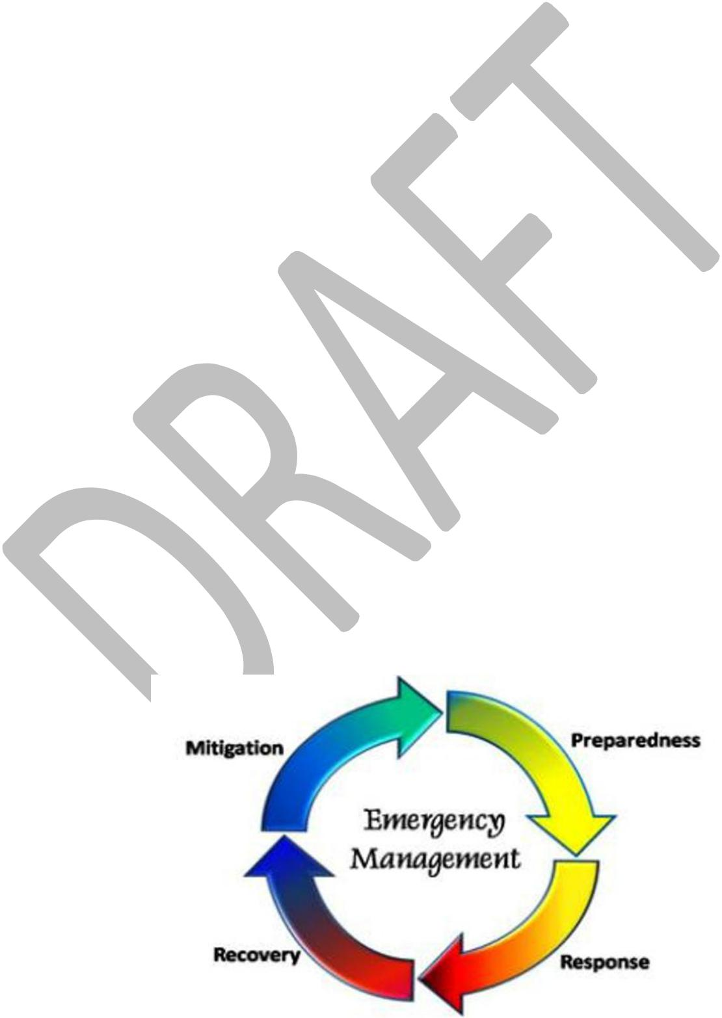
VIII. CONCEPT OF OPERATIONS

- Overview: This DRP provides a flexible and scalable framework for organization and decision making which may be effectively deployed against unknown and unpredictable threats. The DRP has a myriad of potential options, depending on the scope and scale of an incident. The
DRP is not a tactical or a field manual, nor does it provide standard operating procedures. It is a tool to use to help guide recovery, throughout the entire process.

- Emergency Management Phases: The DRP focuses primarily on two of the four phases of emergency management: preparedness and recovery.
It is useful, however, to understand the four phases and how they overlap and inter-relate. There is often no firm, fixed boundary between phases. For example: recovery activities often begin immediately after an incident occurs; recovery measures often involve implementation of mitigation measures; and response activities may persist well into recovery in limited arenas.

4 AUGUST 2013

CHATHAM COUNTY
DISASTER RECOVERY PLAN

- Mitigation: Mitigation takes place both in advance of and in response to disasters. Mitigation activities intend to reduce risk of casualties and property damage from natural and/or human-caused disasters by preventing disasters and/or reducing exposure or vulnerability to them. Such activities have a long-term sustained effect. They provide value to the public by creating safer and more resilient communities and breaking the cycle of disaster damage, reconstruction, and repeated damage. Activities taken and plans devised during recovery will have the same intent, meaning there will be significant overlap between this DRP and mitigation planning and actions, as described in Chatham County Mitigation Plan.

- Preparedness: Preparedness takes place prior to a disaster and it includes efforts to increase readiness and resiliency. Preparedness actions involve planning, training, exercising identifying resources, and organizing to build, sustain, and improve operational capabilities. This DRP in itself is a preparedness tool, specific to recovery.

- Response: Response describes activities undertaken during and in the aftermath of an incident to save lives, protect property and the environment, and to meet basic human needs. Response also includes the execution of emergency plans and actions which transition into short-term recovery. The DRP does not directly address response. The County EOP guides activities during response, while COG and COOP plans ensure governance and essential functions are able to be maintained.

- Recovery: Recovery is the phase between the end of response and the resumption of normal life or a “new normal.” Recovery may be expected to last for a very long time. Because recovery is such a lengthy process, it involves several different phases.

  - Stabilization: The process/phase in which the immediate impacts of an event on community systems are managed and contained, thereby creating an environment where recovery activities can begin. Stabilization includes such activities as:

    - Providing essential health and safety services

    - Providing congregate sheltering or other temporary sheltering solutions

    - Supporting return of medical patients to appropriate facilities in the area

5 AUGUST 2013

CHATHAM COUNTY
DISASTER RECOVERY PLAN

      - Supporting family reunification

    - Intermediate Recovery: Intermediate Disaster recovery involves returning individuals and families, critical infrastructure, and essential government or commercial services back to a functional state, not necessarily a pre-disaster state. Examples include:

      - Continuing to provide, individual, family centered and culturally appropriate case management. Providing accessible interim housing and planning on long-term housing solutions

      - Returning displaced populations and businesses

      - Complete assessments of natural and cultural resources and develop plans for long-term environmental and cultural resource recovery.

    - Long-Term Recovery: Long term recovery is the phase following intermediate recovery and may continue for months to years. The goal underlying long-term recovery is the impacted community moving toward self-sufficiency, sustainability, and resilience.

- Recovery Timeline

  - Response vs. Recovery Comparison
 |  |  |  | Response |  | Stabilization/ |  | Short- |  | Intermediate/Long-Term
 |  |  |  |  |  | Term Recovery |  |  |  | Recovery
 | Incident Contained? |  |  | No |  | Mostly or Completely |  |  |  | Yes
 | Life Safety Issues |  |  | Widespread |  | Remain | a | primary |  | No | longer a widespread
 |  |  |  | Concern |  | concern in some areas |  |  |  | concern
 | Overall Goals |  |  | Contain incident and |  | Provide interim support |  |  |  | Get | community to “new
 |  |  |  | protect life-safety |  | to | people | and |  | normal”
 |  |  |  |  |  | businesses
 | Duration after incident |  |  | A few days or at |  | Weeks to months |  |  |  | Months into years
 |  |  |  | most weeks

- Response to Recovery Transition:

  - The transition from response to recovery is a gradual process, the pace and timing of which will depend on circumstances. As response activities diminish, recovery activities will increase. If the scope of the disaster dictates, a

6 AUGUST 2013

CHATHAM COUNTY
DISASTER RECOVERY PLAN

separate recovery organizations will be established to manage recovery operations. This will start as ESF-14 of the Emergency Operations Center (EOC) and may grow to become the temporary recovery agency.

- Below is a diagram of the transition from response to recovery and the plans associated with each phase.
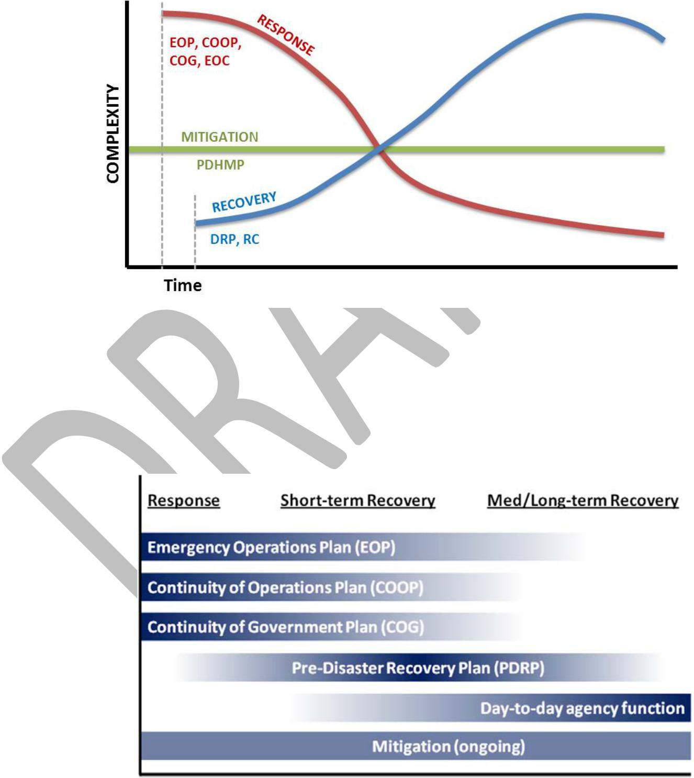

- Plan Synchronization: County uses various plans and programs to guide the activities of county functions, agencies, departments, and resources in response to the requirements necessitated by the particular situation. The plans will be implemented in concert with the DRP. Day to day agency functioning will also continue during disaster recovery.

7 AUGUST 2013

CHATHAM COUNTY
DISASTER RECOVERY PLAN

- Incorporation of NIMS: Chatham County has adopted the National Incident Management System (NIMS) approach and guidance to incorporate the elements of NIMS essential to efficient management of emergencies and disasters involving local, state, and federal response agencies. The federal government places criteria for emergency plans to comply with
Homeland Security Presidential Directive #5 (HSPD-5). For additional information on NIMS and the Incident Command System (ICS), refer to the Chatham County EOP.

- Disaster Recovery Goals

  - Pre Disaster Goals: The following are goals which will guide ongoing pre-disaster activities intended to result in the development of a full recovery readiness capability in Chatham County.

    - Be prepared and pro active

      - Recovery planning and preparedness efforts will include the following key elements:

      - Establish and maintain an inventory of critical capabilities, assets, and resources (within County government and municipalities, and its partners and stakeholders

      - Identify appropriate legal authorities, triggers, and safeguards, such that critical governmental and non-governmental functions and activities can be executed with maximum efficiency

      - Educate elected officials and policy makers on priorities and decision making processes which support transparent and credible allocation of resources

      - Establish relationships with public and private stakeholders key to the recovery process

      - Establish and maintain understanding of state and federal recovery funding resources

      - Pre-identify resources, providers, and restoration and reconstruction priorities

    - Establish and maintain the County’s leadership role Chatham County will be responsible for defining and executing its own recovery and will establish its leadership

8 AUGUST 2013

CHATHAM COUNTY
DISASTER RECOVERY PLAN

role in such a way that the County can integrate into federal, state, and regional recovery efforts, and thus access external funding streams.

- Leveraging the private and non-profit sectors, using existing relationships. The private and non-profit stakeholders are critical in acquiring, managing, and distributing resources, advancing economic recovery and development, and supporting other key disaster recovery functions. Some of these roles will be consistent with day to day activities and responsibilities and others may make contributions and out of the ordinary commitments.

- Pre-disaster recovery work will continue to leverage existing networks, such as COAD, organizational structures, and pre-established relationships to help clear the understanding of roles, responsibilities, and expectations. The County will provide leadership and participate to match needs to providers and to reduce resource overlaps and gaps.

- Promoting legitimacy and credibility: To be effective, post-disaster recovery implementation must be characterized by transparency, community participation and intense stakeholder outreach and involvement. Community partners are crucial to ensuring two-way information both prior to and after a disaster, and they are also in a position to “champion” elements of recovery. These community partners help to balance long-term community gains through economic development, mitigation, and social and cultural enhancements with the short-term well being of county residents.

- Focus on fairness: Individuals and organizations with the slimmest reserves prior to the disaster in terms of preparedness, income and/or capital reserves, and or social and organizational networks will be the most vulnerable afterwards. The County is committed to pre-and post disaster recovery work and intends to fairly and transparently resolve competing, legitimate interests among diverse community organizations and economic drivers.

- Build on existing deliberative plans and asset identification/prioritization: To ensure legitimacy of prioritization, resource allocation, and program management, the pre-and post disaster decision making will be based on existing deliberative plans and policies whenever possible.

9 AUGUST 2013

CHATHAM COUNTY
DISASTER RECOVERY PLAN

- Ensure sufficient financial reserves: Disasters often place immediate financial pressures on a local jurisdiction. Not all costs will be reimbursed and when they are, there is a very lengthy delay. For this reason, the availability of sufficient financial resources be it in the form of budgeted reserves or the pre-event establishment of emergency lines of credit will be extremely important.

  - Post-Disaster Goals: The following are post-disaster operational goals intended to guide the leadership, coordination, and implementation of recovery measures

    - Provide effective command and coordination:

      - The DRP will guide the establishment and continuity of coordinated, effective, flexible, scalable, and responsive command and coordination.. An organized transition of command structures from response to recovery will allow emergency management functions to evolve smoothly, and for recovery work to begin even while the basic life-safety, incident stabilization and immediate property protection issues are still being addressed.

      - During recovery, the expertise of planners, engineers, and financial professionals in fields such as land use, economic development, transportation, storm water management, capital projects, etc. will become increasingly important, and the roles of first responders reverts back to their day to day functions.

    - Maximize funding opportunities: Recovery leadership will work to leverage state and federal recovery technical and financial assistance, as well as identify and pursue additional sources of recovery funding and financing. The County will strive to ensure appropriate, fair, and accountable utilization

10 AUGUST 2013

CHATHAM COUNTY
DISASTER RECOVERY PLAN

and/or distribution of such funds, as well as safeguard its own fiscal condition.

- Communicate effectively: The recovery committee and county leadership will strive to communicate useful, practical, relevant, accurate, and timely information regarding services and resources to impacted members of the community, using communication capabilities to reach county residents in their homes or in temporary housing. It will also make accommodations for non-English speakers and others with access and functional special needs. This will include reasonable communications accommodations and alternate formats for people with disabilities, as appropriate.

- Promote mitigation and foster resilient redevelopment and construction: The County will use education, incentives, and regulation to reduce community vulnerability to various hazards by fostering more resilient land use patterns and building practices while deferring to existing deliberative plans such as the EOP and Hazard Mitigation Plan.

- Maintain and enhance the county’s economic base

  - Maintenance and/or restoration of the economic base is vital to the County’s economic health. The County will focus on business continuity, maintenance of business-critical infrastructure systems, supply chains, and social services, and proactive business, recruitment and retention strategies by recognizing new markets, new expertise, and new opportunities will be created by crises. Such efforts will extend beyond the economic sector, involving “catalyst” projects designed to simultaneously advance social, environmental, cultural, and economic recovery goals.

11 AUGUST 2013

CHATHAM COUNTY
DISASTER RECOVERY PLAN

  - Businesses and employers will have varying levels of operational capability after a catastrophe. Concerted efforts will be made by County leaders to retain core businesses and to support their recovery. After a disaster, the County will support area businesses by clearing obstacles to recovery, including assisting in facilitating staffing, supporting relocation if needed, and helping to resolve supply-chain issues.

  - The private sector will play a critical role in maintaining public confidence after a disaster. When the private sector is resilient in restoring employment, critical services, and normal day-to-day economic functioning, the community recovers more quickly. This translates into jobs retention and tax-base recovery. Communities where public private partnerships have been at the forefront of recovery planning, the public has been more optimistic about the community’s ability to recover.

- Sustain social and human services, public safety, and health services: The County, working with private and nonprofit partners, will work to provide and/or restore basic services needed to sustain the community. A Recovery Committee will coordinate unmet needs and other ongoing needs remaining from the response phase. These efforts include providing for continuity and/or restoration of basic services, providing physical safety and security, as well as a sense of stability necessary for recovery and resumption of normal or new normal levels of functioning.

- Provide and/or ensure quality housing

  - The County will strive to ensure residents are able to continue living in the county in settings which are:

12 AUGUST 2013

CHATHAM COUNTY
DISASTER RECOVERY PLAN

• Safe, sanitary, and secure

• Affordable at levels comparable to resident’ pre-disaster housing

• Integrated with the rest of the community

• Accessible to public services and transportation
• Compliant with applicable regulations and standards

  - Such quality housing will be a goal of both temporary medium-term housing and of permanent reconstruction and redevelopment of housing to contribute to basic economic and emotional stability, allowing residents to attain other elements of individual recovery. Individual recovery, in turn, will contribute to the maintenance of the county’s economic base and to its overall recovery.

- Sustain lifelines and restore infrastructure and public facilities

  - The County will work to ensure continuity of lifeline utilities and services and infrastructure restoration. According to the standard federal definition, critical infrastructure refers to “those physical and cyber-based systems essential to the minimal operations of the economy and government” (PDD-63). These include, but may not be limited to:

    - Food

    - Water

    - Power

    - Wastewater and sewage

    - Transportation

13 AUGUST 2013

CHATHAM COUNTY
DISASTER RECOVERY PLAN

• Fuel

• Communications systems (IT/telecom)

• Solid waste removal

    - Additionally, restoration and reconstruction of public facilities needed for maintenance of lifelines and basic public services will likely be required as well as maintaining operations related to debris clearance and disposal.

- Recovery Priorities: The following priorities are intended to provide overall guidance regarding prioritization of actions and investments undertaken by the County and the Recovery Committee during recovery operations. These priorities will be addressed in a Recovery Action Plan (RAP). The priorities are not specific to actual pieces of infrastructure, resource allocation, or policy development. They are intended to help guide such real-world decisions in the wake of a disaster.

  - Overall Disaster Recovery Priorities

    - Address life safety concerns

    - Provide for pubic safety/security

    - Provide basic health and essential social and human services needs

    - Protect property and maintain basic economic stability

    - Respect basic liberties, legal protections, and privacy safeguards

    - Maintain basic standards of fairness, and balance individual rights and community interests

    - Support general well-being and address intangible social and personal impacts

14 AUGUST 2013

CHATHAM COUNTY
DISASTER RECOVERY PLAN

  - Protect and restore natural and cultural resources

- Stabilization Priorities: To affect safe and efficient operations, Chatham County utilizes a threat-based approach reinforcing resource management, life safety, and the delivery of mission essential tasks for critical services restoration. Response and short-term activities will be conducted following applicable Department of Labor and regulations, and the laws and policies of Chatham County, and the State of Georgia. The agreed upon priorities for the Stabilization time period are:

  - Life Safety, to include Search and Rescue

  - Establish and Maintain County Security

  - Temporary health, welfare, and shelter

  - Activate, Mobilize, and Support Render Safe Teams

  - Initiation of damage assessment and debris removal affecting the ability to restore primary and secondary transportation routes, staging areas

  - Engage in public information and community relations activities

  - Reestablishment of local government operations

- Intermediate Recovery Priorities: Intermediate recover priorities are priorities intended to provide a bridge to permanent measures. The agreed upon priorities for Intermediate time period are:

  - Expanded social, health, and medical systems

  - Restoring essential public facilities, infrastructure, and services

15 AUGUST 2013

CHATHAM COUNTY
DISASTER RECOVERY PLAN

      - Coordinating with federal disaster assistance programs

      - Initiating a long-term housing plan for those displaced

      - Restoration of utility and transportation services

    - Long Term Recovery Priorities: Long term recovery priorities are priorities intended to get a community back completely operational and at a “new normal.” The agreed upon priorities for Long-Term Recovery are:

      - Redevelopment and revitalization of damaged area

      - Rebuilding social, economic, and educational systems

      - Implementing mitigation projects and strategies

      - Implementing permanent housing strategies

      - Addressing recovery needs across sectors of the economy and community

      - Recovery of disaster response costs

- Recovery Support Functions

  - Recovery Support Functions comprise the coordinating structure for the DRP. Their purpose is to facilitate problem solving, improving access to resources and by fostering coordination among Local, State, and Federal agencies, nongovernmental partners and stake holders.

  - The RSF structure coexists with and builds upon the ESF under the
National Response Framework and the Chatham County EOP. RSFs are different from ESFs in that they have different mission objectives, partnerships, approaches, time spans and organizational structure; additionally, the players and skill sets involved may be different.

16 AUGUST 2013

CHATHAM COUNTY
DISASTER RECOVERY PLAN

  - There is some overlap between ESF and RSF missions, but as the ESF requirements diminish and the recovery issues take center stage, the RSFs take over the residual ESF activities associated with recovery.

  - The objective of the RSFs is to facilitate the identification, coordination, and delivery of assistance needed to supplement recovery resources and efforts. An additional objective is to encourage and complement investments and contributions by the business community, individuals, and voluntary, faith-based and community organizations.

  - The RSF’s are:

    - RSF-01Disaster Recovery and Redevelopment
Assistance Coordination and Planning

    - RSF-02Economic Development

    - RSF-03Health and Social Services

    - RSF-04Community Development, Planning and
Housing

    - RSF-05Infrastructure Systems

    - RSF-06Natural and Cultural Resources

  - Detailed information and tasking for each RSF may be found in the RSF Annex to the DRP.

G. Designated Recovery Positions

  - Local

    - Disaster Recovery Manager (DRM)

      - Chatham County will designate a Disaster Recovery Manager (DRM) to oversee the overall disaster recovery process. The DRM is appointed by and reports to the County commission and serves as the lead for coordination and command of local recovery efforts. The DRM will have authority over the recovery operation; will determine the timeframe for operational periods and may activate other County resources as needed.

17 AUGUST 2013

CHATHAM COUNTY
DISASTER RECOVERY PLAN

  - This individual will be solely dedicated to the recovery effort, and will be unable to perform duties related to his/her permanent job or home agency until released from this role by the County Chairman. The DRM also serves as the Local Disaster Recovery Manager
(LDRM) as defined in the NDRF. The Recovery Manager is authorized to liaise directly with the State Disaster Recovery Coordinator (SDRC) and the
Federal Disaster Recovery Coordinator (FDRC).

  - The DRM shall have the authority to appoint a deputy and other staff positions consistent with the ICS organizational structure as necessary. As personnel transition from the response role, they can also be assigned to work for the DRM.

b.Recovery Committee

  - The Recovery Committee is charged with advising the
Recovery Manager regarding general direction, overarching policy guidance, and general prioritization for the County’s recovery activities. The committee has no authority to speak for the County, to encumber funds, or make commitments biding on the County. Its purpose will be to provide advice on policy related to the disaster recovery efforts.

  - The Recovery Committee should include a mix of public and private sector representation; personnel with relevant professional experience and expertise; and represent a geographical distribution adequately and equitably represents areas impacted by the disaster.

  - The major duties of the Recovery Committee include:

    - Establish uniform policies for effective coordination to accomplish recovery tasks

    - Recommend and coordinate efforts to return to normal operations

    - Assist in identifying mitigation opportunities and resources

    - Determine activation of recovery functions

18 AUGUST 2013

CHATHAM COUNTY
DISASTER RECOVERY PLAN

  - Recovery Agency

    - The County Executive may establish a temporary Recovery Agency within the executive branch of the
County Government. The Recovery Agency will comprise the leadership of the recovery effort, including the Recovery Manager who serves as the Director of the Recovery Agency.

    - The Recovery Manager will be a full-time appointment; Command and General Staff may be detailed to the Recovery Agency full or part time, depending on the situation. Recovery Agency staff will be full time to the Recovery Agency and will serve in such roles as planners, facility liaisons, facility managers, community outreach, and other positions as needed.

- State

  - State Disaster Recovery Coordinator: The State Recovery
Coordinator (SDRC) position is established to ensure those who have the capability to support community recoveries are actively engaged in a well coordinated way.

- Federal

  - Federal Disaster Recovery Coordinator: The Federal
Emergency Management Agency (FEMA) will appoint a Federal Recovery Coordinator (FDRC) as established by the NDRF. The FDRC is responsible for the actual field implementation of programs under the Stafford Act and handles the day to day operations of FEMA at the Joint Field Office (JFO).

  - Federal Coordinating Officer:

    - FEMA will appoint a Federal Coordinating Officer (FCO), who is responsible for coordinating supplemental federal disaster assistance available under the Presidential Disaster Declaration (PDD).

    - The responsibilities of the FCO include public information coordination, Congressional liaison, community liaison, outreach, and establishment of the
JFO.

19 AUGUST 2013

CHATHAM COUNTY
DISASTER RECOVERY PLAN

- Activation/Demobilization

  - Activation: The CEMA Director, under the direction of the County Chairman and county manager, will activate the DRP as appropriate. Because recovery and response operations often overlap, the director may activate any or all of the recovery support functions to return the county to its pre-disaster condition or to its “new normal.” The director will first ensure the immediate emergency situations are addressed as outlined in the EOP.

  - Maintenance of Local Control

    - After a disaster triggers the DRP, Chatham County will have the primary role of planning and managing aspects of the county’s recovery programs and initiatives, consistent with the State DRP and the NDRF. The Recovery Manager will exercise granted authority in his/her role as County officials. County officials operating from the EOC or the RCC will retain the authority to allocate local resources and deploy those resources as appropriate

    - The county will almost undoubtedly be overwhelmed and need staffing, recovery expertise, and other assistance. The county manager, in coordination with county government agency leaders, will determine the staff necessary to restore essential services and conduct recovery operations. They will staff these functions by temporarily reassigning staff members, hiring contractors, using mutual aid, volunteers, and EMAC. Some functions may be partially funded through federal and state disaster programs.

    - State and federal officials will work with the county in the development and implementation of incident specific long-term recovery plans when requested. In such cases, the
State of Georgia will act in support of the County, evaluate its capabilities, and provide support as needed

  - Demobilization

    - The county manager, in coordination with the emergency services director and the Recovery Committee, determines when to discontinue recovery operations and return to normal operations. This decision should be made considering the completion of intermediate and long term recovery operations.

20 AUGUST 2013

CHATHAM COUNTY
DISASTER RECOVERY PLAN

    - It is important to note some recovery functions may demobilize before others based on the extent of the damage and the complexity of recovery operations.

- Recovery Sites and Facilities

  - Emergency Operations Center (EOC): The EOC is the initial location activated to support field operations. The EOC is a central facility from which local governments can provide interagency coordination and decision making in support on incident response.
The EOC will operate until the incident is stabilized, life safety concerns are mitigated and the issues are more focused on long term strategies and issues as opposed to response.

  - Recovery Coordination Center (RCC)

    - Recovery Coordination Center (RCC) may be established during the response phase of operations to begin planning for the recovery process, support damage assessment, ensure documentation of disaster-related operations and expenditures, and provide for coordination with Georgia
Emergency Management Agency (GEMA) on recovery programs issues and implementation.

    - The response phase EOC Manager, in consultation with the ESF-14 Recovery Lead, will begin to establish the County
RCC as soon as it is determined significant interagency recovery resource coordination is necessary. Establishment and set up of the RCC will be at the direction of the CEMA Director and the responsibility of the Logistics Section Chief. Initial recovery activities may be coordinated from the EOC; however long term recovery must not interfere with stand-bye emergency response capabilities.

    - The RCC will be the physical location of the County’s
Recovery Committees offices. It will be a command, control, and coordination center for recovery activities and should have sufficient work space to accommodate government and nongovernmental stakeholder organizations, as well as facilitate coordination with the state and federal agencies.

    - The RCC should be co-located or nearby the facilities used by GEMA and FEMA.

  - Disaster Recovery Center: Disaster Recovery Centers (DRC) are the FEMA/State mechanism for delivering assistance to disaster

21 AUGUST 2013

CHATHAM COUNTY
DISASTER RECOVERY PLAN

victims. It is a facility where victims can meet face to face-to face with representatives of Federal, State, County, local, and volunteer agencies. The facility should always have a local manager staffing the facility, if activated.

- Insurance Assistance Center: The Georgia Insurance
Commissioner has agreed to provide leadership and assistance to assist in recovery operations. A Disaster Advance Team, from the Insurance Commissioner, may be deployed to assess the extent or need for insurance provide and client interaction. This facility will ensure a facilitated client and provider interaction. The facility should always have a local manager staffing the facility, if activated.

- Business Recovery Center: The County may open one or more
Business Recovery Centers to receive request for recovery assistance from businesses, organizations, or other entities such as public and private universities and healthcare facilities. This may be co-located with the Disaster Recovery Center. The facility should always have a local manager staffing the facility, if activated.

- Joint Field Office (JFO): The Federal Coordinating Officer (FCO) will establish a Joint Field Office (JFO) to coordinate the relief and recovery effort. The JFO will be staffed with representatives from Federal Agencies having emergency responsibilities as well as
State and Local officials. The JFO should be co-located or nearby the County RCC.

- Recovery Action Planning Cycle

  - The Recovery Action Planning (RAP) cycle provides a defined process, structure, and schedule for setting and prioritizing objectives, ensuring resource availability, monitoring progress, and generally executing the Recovery
Manager and Recovery Agency’s Mission. It specifies communications, meetings, assessments, and course-corrections which are fundamental components of the planning process. The RCC Planning Chief or the Recovery
Agency Planning Chief is charged with overall coordination and scheduling of this process.

  - During recovery, operational periods may last days, weeks, or even months, at the discretion of the Recovery Manager.

    - Recovery Action Plan

22 AUGUST 2013

CHATHAM COUNTY
DISASTER RECOVERY PLAN

  - The Recovery Manager is in charge of ensuring a RAP is developed based on the event and its impacts. The event-specific RAP, in part, will specify which recover functions are activated.

  - The RAP defines a phased recovery program with priorities and actions mirroring the goals and priorities as defined above.

- Planning Cycle: The Recovery Action Planning cycle is modeled on the Incident Command System (ICS)
Incident Action Planning Cycle, sometimes known as the “Planning P” for its diagrammatic shape. It will be generally consistent with the EOP Incident Action Planning Process used during the EOC Response operations (See EOP).
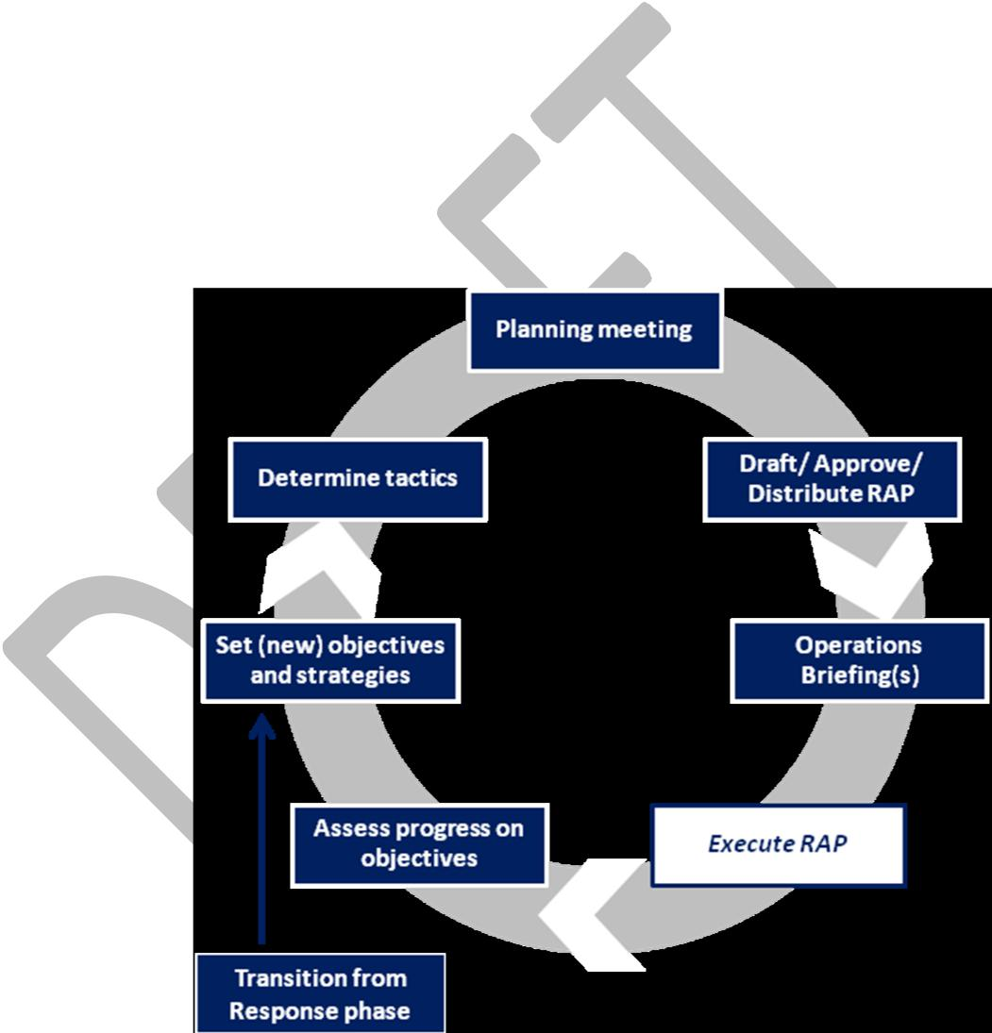

- The steps of the RAP cycle are outlined below.

  - Transition from response phase: As management of the overall incident

23 AUGUST 2013

CHATHAM COUNTY
DISASTER RECOVERY PLAN

transitions from Response to Recovery, non -life-safety objectives which were set but not fully accomplished during
Response will be transitioned from the responsibility of the Response-phase
Incident Command to the Recovery Agency. These unmet needs and other ongoing Response objectives will form the initial basis for setting Recovery objectives.
- Assess progress on objectives: Regardless of whether the Recovery Agency is in its initial operational cycle or conducting ongoing planning, the first step of a new RAP cycle is for the Operations Section to report on the status of its objectives, as well as identifying additional needs or new objectives. This will include input from the RSF. This is a very important step and will help to reinforce the development of measureable objectives by ensuring specific RSF input results in clearly scoped and defined objectives, particularly for objectives lasting over numerous operational periods.

- Set (new) objectives and strategies

  - The next step of the RAP cycle is for the Recovery Manager to work with his/her staff (and – at the Recovery Manager’s discretion only – the Recovery Committee) to identify and prioritize objectives and strategies for the next operational period. These may be ongoing or incomplete objectives from previous operational periods, or they may be new.

  - As each new RAP is developed, progress made against identified criteria for each objective will be assessed in coordination with the appropriate RSF and this information will be used to refine and focus objectives in future RAPs.

24 AUGUST 2013

CHATHAM COUNTY
DISASTER RECOVERY PLAN

- Determine tactics

  - Once the next operational period’s objectives and strategies have been set, the Operations Section identifies and prioritizes specific tactics which will be used to achieve the objectives and strategies, as well as identifying evaluation criteria and monitoring mechanisms for the tactics.

  - The DRM then works with the RCC Logistics Section Chief, RCC Planning Section Chief or designee, Legal Advisor, Safety Officer, and others as necessary to review and validate the tactics; they may add, remove, or re-prioritize tactics as necessary. The Recovery Manager and his/her staff also assigns available resources to the tactics and/or secure additional necessary resources.(ICS form 215 may provide a useful framework for this process.)

- Planning meeting: After tactics and resources have been set, this information is shared broadly with the
Recovery Agency and lead and supporting agencies at the Planning Meeting. Participants have the opportunity to review and vet the tactics and resource assignments. At this phase, the Community Recovery Planning RSF again reviews to ensure consistency of near-term tactics with long-term recovery goals.

- Draft/ approve/ distribute the Recovery
Action Plan: Following the Planning Meeting, the Planning Section drafts and finalizes the RAP for the next operational period. Once it has been approved by the Recovery Manager, the
Recovery Action Plan is distributed to the entire Recovery Agency and becomes the new controlling document; this marks the beginning of a new operational period.

25 AUGUST 2013

CHATHAM COUNTY
DISASTER RECOVERY PLAN

    - Operations briefing(s): After the Recovery Section Plan is approved and distributed, RSF mission assignments are officially handed down and started. At this point, Recovery Agency staff and lead and supporting agencies are briefed on the new RAP. Depending on the situation, this briefing may be for the entire Recovery Agency at once, or smaller briefings may take place at the
RSF or at other levels within the Operations Section.

    - Execute Recovery Action Plan: This step comprises the main work of the Recovery Agency, as its mission assignments are implemented from within the Operations Section.

- Management by Objective

  - Common Objectives: Lead and Supporting Agencies. Specific objectives are described for each Recovery Group in the RSF Annexes to this DRP. In addition to these, Lead and
Support Agencies for Recovery Groups will share common objectives as they execute the Recovery Agency’s mission objectives

      - Brief Supporting Agencies and organizations

      - Identify and address resource needs

      - Identify additional or extraordinary funding needs

      - Maintain documentation

      - Provide information and updates

      - Maintain compliance with applicable legal requirements

      - Ensure health and welfare of recovery staff

26 AUGUST 2013

CHATHAM COUNTY
DISASTER RECOVERY PLAN

IX. Responsibilities

- Overall

  - Individual and Families Responsibilities

    - Individuals and families need to plan and be prepared to sustain themselves in the immediate aftermath of a disaster. Those who prepare reduce personal stress, and they enhance their ability to undertake their own recovery.

    - The extent that individuals and families prepare has an impact on the success of the community’s recovery.
Resources to help individuals and families prepare are available through websites and publications, specifically to include the CEMA website and partners such as the
American Red Cross (ARC) and the Georgia Emergency Management Agency (GEMA) website.
 | Individuals and Families Pre-Disaster Checklist | Individuals and Families Post-Disaster Checklist
 | Develop a disaster preparedness and recovery | Implement individual and family recovery plans
 | plan seeking assistance as necessary (www.
 | Chathamemergency.org or www.ready.gov)
 | Purchase and maintain an adequate and | Reach out to others who may need assistance
 | appropriate level of hazard and flood insurance
 | Maintain supplies of food, water, and battery- | Follow advice and suggestions of local government
 | powered communication devices
 | Mitigate home vulnerabilities such as hurricane | Educate yourself on programs available to support
 | shelters, bracing cripple walls, anchoring | disaster victims
 | bookshelves among other strategies

- Private Sector Responsibilities

  - The private sector plays a critical role in establishing public confidence after a disaster. Businesses play a critical role in the stabilization and revitalization of the local economy as employer, service and good providers, investors, developers, planners and in other economic roles.

  - The private sector owns and operates the vast majority of the Nation’s critical infrastructure such as electric power, financial and telecommunication systems. These entities play a major role in the recovery of a community.

27 AUGUST 2013

CHATHAM COUNTY
DISASTER RECOVERY PLAN

 | Private Sector Pre-Disaster Checklist | Private Sector Post-Disaster Checklist
 | Develop, test, and implement business continuity | Implement business continuity plans
 | and recovery plans
 | Educate and train employees to implement | Support employees impacted by disaster by
 | mitigation and preparedness measures consistent | providing critical information on recovery process
 | with business continuity plans
 | Carry adequate insurance to rebuild damaged | Provide volunteers, leaders, commodities and
 | facilities and to survive disruption of work | facilities as willing and able
 |  | Research available funding sources and
 |  | understand the application process

- Non-Profit Sector Responsibilities

  - The nonprofit sector plays a vital role in the recovery of impacted communities. Non-profits include voluntary, faith-based and community organizations, charities, foundations and philanthropic groups as well as professional associations and academic institutions.

  - Non-profit sector support is provided by a range of organizations, from small locally based non-profits to organizations with national reach having extensive experience. Non-profits can directly supplement and fill the gaps where government authority and resources cannot be applied.

 | Nonprofit Pre-Disaster Checklist | Nonprofit Post-Disaster Checklist
 | Build relationships with emergency management | Deliver recovery resources and support services to
 | agency and other recovery officials. Participate in | vulnerable and underserved groups, individuals
 | CCOAD | and communities as necessary
 | Provide training related to post-disaster activities | Communicate and coordinates with the local
 | in which the agency participates | CCOAD
 | Educate clients on disaster preparedness and | Serve as subject matter experts based on agency
 | mitigation strategies | experience
 |  | Coordinate recovery programs with other entities
 |  | involved in recovery to ensure unified recovery
 |  | efforts

- Local Government Responsibilities: The local government has the primary role in planning for and managing aspects of its community’s recovery. Individuals, families, businesses as well as State and federal officials look to local government to clearly

28 AUGUST 2013

CHATHAM COUNTY
DISASTER RECOVERY PLAN

articulate their recovery priorities and develop plans in order to optimally support local communities.

 | Local Government Pre-Disaster Checklist | Local Government Post-Disaster Checklist
 | Lead local preparedness, pre-disaster and | Organize, develop, implement, and modify
 | mitigation planning | recovery, mitigation and land use plans as
 |  | necessary
 | Pre-identify a structure for managing recovery | Appoint a local disaster recovery manager (LDRM)
 | Establish agreements and mechanisms to address | Ensure integrated efforts across government
 | surge capabilities | offices, the private and non-profit sector during
 |  | the formulation and implementation phase of
 |  | recovery projects
 | Institute mechanisms for immediate post-disaster | Communicate and coordinate with other levels of
 | damage assessment | government involved in recovery
 | Ensure compliance with local, State, and Federal | Manage rebuilding so that risk reduction
 | civil right obligations | opportunities are optimized and comply with
 |  | standards for accessible design
- State Government Responsibilities: States manage and drive the overall recovery process and play a key role in coordinating recovery activities including providing financial and technical support. States oversee regional coordination of recovery and direct assistance where it is needed. States are a conduit to local governments for key federal recovery assistance programs.

 | State Government Pre-Disaster Checklist | State Government Post-Disaster Checklist
 | Develop the State recovery and mitigation plans | Implement State recovery and mitigation plan.
 | including COOP and COG plans | Activate the State Disaster Recovery Coordinator
 |  | (SDRC)
 | Create and manage requirements and incentives | Assess local government recovery needs and
 | for pre-incident disaster recovery preparedness | capacities for the specific incident and assist local
 | and planning | governments and communities with identifying
 |  | recovery resources
 | Identify recovery activities that are either | Receive, record, and manage Federal grant
 | primarily responsibilities of State government or | resources, setting appropriate State policies to
 | beyond the capabilities and/or authority of local | guide State Agency activities as well as inform the
 | governments | applicant of federal funding
 | Support local area efforts to conduct damage | Develop and implement strategies for raising and
 | assessments and share information regarding | leveraging recovery funds through private
 | damages | investments, charitable donations and State
 |  | sources.
 | Form a State-led disaster housing task force to | Oversee volunteer and donation management and
 | develop a housing strategy that outlines potential | coordinate with Voluntary Agency Liaison
 | approaches in response to specific disaster | Specialists
 | Develop a State Recovery Support Function- | Provide timely and accessible public information

29 AUGUST 2013

CHATHAM COUNTY
DISASTER RECOVERY PLAN

equivalent | recovery framework | that addresses | and manage expectations
housing, | economic, | environmental,
infrastructure, and health and social services needs at a minimum

- Federal Government Responsibilities: The primary role of the federal government is to support state and tribal governments with their responsibilities to manage and lead disaster recovery. When a disaster occurs which exceeds the capacity for local resources the federal government may use the NDRF to engage necessary and available department and agency capabilities to support local recovery efforts.
 |  | Federal Government Pre-Disaster Checklist |  |  | Federal Government Post-Disaster Checklist
 |  | Develop Federal Recovery Support Functions |  |  | Deploy a Federal Disaster Recover Coordinator
 |  |  |  |  | (FDRC) and activate and deploy RSF with necessary
 |  | Facilitate the sharing of planning best practices |  |  | Identify how Federal programs can effectively
 |  | and recovery plans adopted by various local and |  |  | address and support recovery needs
 |  | state jurisdictions
 |  |  |  |  | Ensure transparency and accountability of Federal
 |  |  |  |  | expenditures that aid disaster recovery

- Specific Roles and Responsibilities

  - Chairman of County Commission:

    - Implements policies and has the overall responsibility for ensuring disaster recovery operations take place

    - Ensures government departments are meeting with disaster recovery agency of the County

  - Municipality Elected Officials:

    - Coordinate with county officials on disaster-related issues concerning their municipalities.

    - Ensure municipalities provide documentation to county, when appropriate and needed, to ensure financial support from State and Federal agencies

30 AUGUST 2013

CHATHAM COUNTY
DISASTER RECOVERY PLAN

- CEMA Director: The CEMA Director shall have direct responsibility for the organization, administration, and operation of the local organization for emergency management, subject to the direction and control of the County Commission Chairman and County Manager or their designee

- Local Disaster Recovery Manager

  - Pre-Disaster

    - Serve as primary point of contact (POC) for disaster recovery preparedness with the state and local governments

    - Coordinate development, training, and exercise of jurisdiction disaster recovery plan

    - Establish and maintain contacts and networks for disaster recovery resources and support systems

  - Post-Disaster

    - Lead the creation and coordinate the activities of the local recovery-dedicated organizations and initiatives

    - Work with the SDRC to develop a unified strategy and accessible communication strategy

    - Participate in damage and impact assessments with other recovery partners

    - Organize disaster planning processes

    - Communicate recovery priorities to State and Federal governments and other recovery stakeholders and supporters

    - Work closely with the recovery leadership to ensure a well coordinated, timely and well-executed recovery

    - Develop and implement recovery progress measures and communicate adjustments and improvements to applicable stakeholders and authorities

    - Manage the Disaster Agency as established by
County management

31 AUGUST 2013

CHATHAM COUNTY
DISASTER RECOVERY PLAN

- RSF Coordinator: The RSF coordinator is the entity with management oversight for a particular RSF. The coordinator has ongoing responsibilities throughout the preparedness, response and recovery phases to ensure ongoing communication and coordination between primary and support agencies.

- RSF Primary Agencies: Each RSF has a designated primary agency. The RSF Primary Agency will serve as the primary agent to accomplish the assigned objectives within the Recovery Agency.
The Primary Agency will coordinate activities, resources, and identification of recovery needs. Lead agencies are not expected to have all the necessary assets, expertise, or capabilities internally; however they are responsible for requesting, tasking and coordinating the activities of supporting agencies to accomplish objectives.

- RSF Support Agencies: Each RSF has extensive rosters of potential supporting agencies. These agencies offer specific capabilities or resources available to support the Lead Agency in executing Recovery Agency objectives. Supporting agencies may provide information, advice, counsel, operational support, and coordination.

- State Disaster Recovery Coordinator (SDRC)

  - Pre-Disaster: Serve as primary POC for disaster recovery preparedness with local and federal governments

  - Post-Disaster

    - Provide support for local recovery dedicated organization initiatives

    - Communicate the roles and responsibilities of the State to the local governments

    - Work with Recovery Coordinators and Local Recovery Managers to facilitate the development of a unified and accessible communication strategy

    - Coordinate State, Federal, and other funding streams for recovery efforts and communicate issues and solutions to recovery assistance gaps and overlaps.
Work closely with recovery leadership to ensure a well-coordinated, timely, and well-executed recovery.

32 AUGUST 2013

CHATHAM COUNTY
DISASTER RECOVERY PLAN

- PLAN MANAGEMENT AND MAINTENANCE

  - Chatham Emergency Management Agency (CEMA) is the executive agent for Tab management and maintenance. The Tab and supporting documents will be updated periodically as required to incorporate new directives and changes based on lessons learned from exercises and actual events. This section establishes procedures for interim changes and full updates of the Exhibit.

  - Types and Changes: Changes include additions of new or supplementary material and deletions. No proposed change should contradict or override authorities or other plans contained in statute, order, or regulation.

  - Coordination and Approval: Any department or agency with assigned responsibilities within the Tab may propose a change to the plan. CEMA is responsible for coordinating proposed modifications to the Tab with primary agencies, support agencies and other stakeholders. CEMA will coordinate review and approval for proposed modifications as required.

  - Notice of Change: After coordination has been accomplished, including receipt of the necessary signed approval supporting the final change language, CEMA will issue an official Notice of Change. The notice will specify the date, number, subject, purpose, background, and action required, and provide the change language on one or more numbered and dated insert pages that will replace the modified pages in the Emergency
Operations Plan (EOP), Annex, or supporting documents. Once published, the modifications will be considered part of the EOP for operational purposes pending a formal revision and re-issuance of the entire document. Interim changes can be further modified or updated using the above process.

  - Distribution: CEMA will distribute the Notice of Change to participating agencies. Notice of Change to other organizations will be provided upon request. Re-issuance of the individual annexes or the entire EOP will take place as required. Working toward continuous improvement, CEMA is responsible for an annual review and update of the EOP to include related annexes, and a complete revision every four years (or more frequently if the County Commission or Georgia Emergency Management Agency deem necessary). The review and update will consider lessons learned and best practices identified during exercises and responses to actual events, and incorporate new information technologies. CEMA will distribute revised EOC Annex documents for the purpose of interagency review and concurrence.

33 AUGUST 2013

CHATHAM COUNTY
DISASTER RECOVERY PLAN

THIS PAGE INTENTIONALLY BLANK

34 AUGUST 2013

