

GREATER KNYSNA MUNICIPAL

DISASTER RISK MANAGEMENT
PLAN
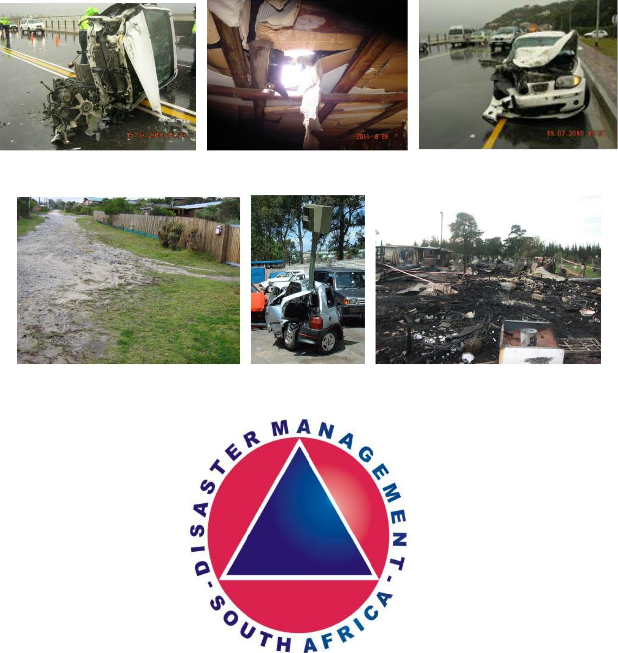

TABLE OF CONTENTS

No | Contents | Page
- Municipal Logo

- Table of contents

- Foreword

- Purpose of the Plan

- Background
  - Introduction
  - Objectives
  - Types of Disasters

  - Response to a major disaster
  - Communications
  - Counselling Services
  - Insurance Liability
  - Financial Implication
  - Debriefing
  - Closure of incident
  - Abbreviations
  - Definitions/Glossary of terms

- Constitutional Legislative mandates

- Institutional arrangement

- Hazard/Vulnerabilities Assessment (Risk Profile)

- New severe weather alert levels

- Primary & Secondary responsibilities

- ICT Disaster Recovery Action Plan

- Disaster Response Plan process flow and incident command structure

- Knysna Municipal Disaster Management Plan for Sedgefield

- Declaration

Authorization and approval of the Disaster Risk Management Plan

3. FOREWORD

“Disaster Management is everybody’s business”

We live in a fast changing global environment where peril and risk to human society abound. Disaster has the ability to maim and kill people. They destroy property and the environment. Yet, disasters occur and re-occur with lasting detrimental consequences.

The enormity of the disaster problem today and in the foreseeable future calls for a more proactive approach that ensure effective disaster reduction at all levels towards sustainable development.

Though one must always remember that it is not always possible to completely eliminate a risk, extensive experience and practise in the past have demonstrated that the damage caused by any disaster can be minimized largely by careful planning, mitigation and prompt action.

We would like to further invite relevant stakeholders to join in contributing to Disaster Risk reduction.

Disaster Risk Management is and will always be everybody’s business.

4. PURPOSE OF THE PLAN

The purpose of the disaster risk management plan is to enhance the capacity of the Municipality to prevent and to deal with disaster and to avoid developments which are subject to high risk of disaster.

The Disaster Management Plan is to be seen as an information guide to the relevant role players. It shall advise the role players how to lead in case of a disaster to prevent or at least mitigate negative effects on the Greater Knysna.

The plan will be the basis to establish procedures which will assure maximum and efficiently utilization of all resources in and around the Greater Knysna, minimize the loss of life and/or injury.

With a comprehensive DMP (Disaster Management Plan), Greater Knysna Municipality will be better prepared to support the local communities in dealing with disasters and to speed up the recovery process. It is crucial to have effective and efficient Disaster Risk Management in order to save lives, prevent escalation of emergencies and incidents and relieve suffering.

5. BACKGROUND

The Garden Route has a Mediterranean maritime climate with moderately hot summers, and mild to chilly winters

This plan serves to confirm the arrangements within the Greater Knysna Municipality to effectively prevent disaster from occurring and to lessen the impact of these hazards that cannot be avoided.

Disaster Management is a continuous and integrated multi-sectoral and multi-disciplinary process of planning and implementation of measures aimed at Disaster prevention – mitigation, preparedness, response, recovery and rehabilitation (Disaster Management Act 2007)

Province: | Western Cape
District: | Eden
Type: | Local Municipality
Municipal Code: | WC048
Main town: | Knysna
Languages: | Afrikaans, English & Xhosa
Area: | 1059km²
Population: | 65043

The population is diversified across race, groups and culture and are characterised by varying levels of socio-economic status and education.

INTRODUCTION

In accordance with the Act and with the desire to better provide for the wellbeing of its citizens, the Knysna Municipality is developing a Disaster Management Plan to ensure preparedness and effective response by the Municipality and its citizens in the event of a disaster.

What is a disaster?

A disaster is a progressive and sudden, widespread or localized, nature or man-made occurrence which causes:

- (i) death, inquiry or sickness
  - damage to property, infrastructure or the environment, or
  - disruption of a community, and

- if of a magnitude which exceeds the ability of those who are affected to defend the results by making use of only their own resources.

What is disaster management?

Disaster management is a continuous and integrated multi sector, multi disciplinary process of planning and implementation of measures aimed at-

- prevention or reduction of the risk of disaster;
- relieve of the severity of results of disasters;
- emergency preparedness;
- swift and effective reaction on disasters; and
- after-disaster repair and rehabilitation.

OBJECTIVES

The objectives of the plan are as follows:

- To regulate the disaster response to the benefit of the community and visitors.

- To respond effectively to the requirements of individuals towards the protection of life and property.

- To establish those most vulnerable and at risk.

- To provide temporary sheltered accommodation, clothing and feeding arrangements for persons evacuated, or made temporarily homeless.

- To restore normality o the affected community within a reasonable timescale, dependent on the seriousness of the incident.

TYPES OF DISASTERS

It often happens that disasters do not occur in isolation and that one disaster occurs as a result of another. Therefore it is important to be aware of all possible disasters that may affect your region.

DISASTER CATEGORIES
Broad Hazard Category |  | Specific Disaster Risk Category
 |  | Extreme weather
 | Climate-Related | Meteorological drought
 |  | Riverine flooding
Hydrometeorological |  | Estuarine flooding
 |  | Coastal flooding/storm surges
 | Hydrological | Urban flooding
 |  | Hydrological drought
 |  | Agricultural drought
 |  | Seismic risks and earthquakes
Geological |  | Rock falls and landslides
 | Fires | Urban fringe fires, Veld fires
Biological | Epidemics | Humans, Livestock
 |  | Air pollution
Environmental |  | Water pollution
 |  | Soil erosion/land degradation

 |  | Power plants
 | Risks associated | Bridges, Dams
 | with installations | Petrochemical installations
 |  | Roads
 | Risks associated | Air, Sea
 | with transport | Rail
Technological |  | Marine oil spills
 | Hazmat | Toxic cargo spills
 |  | Radioactivity emissions
 | Risks associated
 | with flammable | Urban format fire
 | surfaces | Urban informal fire

RESPONSE TO A MAJOR DISASTER

  - Activating Procedure

    - The Disaster Control Official, after having received an early warning from the Eden Disaster Risk management of a possible incident, will contact the Municipal Manager / Disaster Management by telephone, and if he is not available, the Acting Municipal Manager.

    - Disaster Control Official will in turn contact the Duty Officer at the Control Room and advise them of the danger.

    - The Control Room Official will be instructed to contact all the relevant role players requesting them to place their personnel on stand by.

    - Emergency Services will receive instruction from the Control Room to undertake evacuation in the event of a flood where residents will be endangered, as well as in other cases.

      - The Disaster Control Official will advise the Disaster Management Department of PAWC in the event of a large incident.

- Establishment of a Joint Operations Centre

It will be the responsibility of the Municipal Manager for the Greater Knysna Municipality, to invoke a local emergency response, after consultation with the Knysna Disaster Management Team plus all Directors. At the onset of the event the Municipal Manager, Directors and the Disaster Management Team will congregate at the Disaster Management Centre and determine whether a Joint Operations Centre is required. This decision must be communicated to the Eden JOC.

The Municipal Manager as Head of the JOC will have the responsibility, depending on circumstances to invoking all or part of the plan. The JOC will determine what internal and external resources are required. A representative to the Eden JOC must be identified.

- Composition of Joint Operation Committee

The JOC will comprise of the following:

  - Municipal Manager: Head of the JOC / Disaster Management

  - JOC spokesperson: Head of Communication and Secretariat co-ordinator.
  - Disaster Management Team: Chief: Law Enforcement, Chief: Fire, Chief: Traffic.

  - Directors: It is advisable that all Directors attend the establishment meeting. Thereafter the Directors are involved in terms of line function.

  - S.A. Police Services: An officer, not below the rank of Inspector, with knowledge of the Greater Knysna Area, as well as knowledge of the specific area affected if appropriate.

  - Medical Services: Medical Practitioner from the Knysna Provincial Hospital.
  - Secretariat: A team responsible for the data collection, communication and Call Centre.

  - Delegated Councillors: Two councillors are to be nominated to sit on the JOC. Ideally these should not be Ward Councillors as the Ward Councillors will be required within their ward.

Other possible members will include Knysna Tourism, the Department of
Labour, the Department of Social Development and the Department of
Transport / SANRAL.

- Functions of the Joint Operation Centre

  - To act as a node for the required joint response according to the disaster itself and developing situation.

  - To act as an emergency communication centre, for all responding services including public enquiries.

  - To ensure continuity of locally motivated response.
  - To record and process and act upon information received from whatever source.
  - To act as a media centre, preparing media releases for residents and visitors.

COMMUNICATIONS

The JOC Media spokesperson shall be responsible for all communication and thus act as the Secretariat Co-ordinator.

The Secretariat shall comprise of at least four Municipal officials, depending on the extent and nature of the event.

All incoming calls shall be logged and channelled to the relevant office for prioritisation and action. As far as possible all logging and response should be captured electronically. Every role player will make use of his own communication equipment.

The line function must in turn provide the Head of Communication with regular updates on progress and this information will then be fed to the JOC and the Call Centre.

The JOC will require a minimum of two incoming lines and one outgoing unpublished number, as well as a further dedicated channel. A JOC will be established where organization with regard to incidents will be handled. Ideally e-mail and fax facilities should be available and the support of

Telkom, in the provision of additional communication, should be sought at the earliest opportunity.

Regular line function briefings should be held to ensure continuity of effort, together with an overall assessment of progress.

The Media Officer will send out information to the media and community, thus avoiding unnecessary pressures on those co-ordinating the emergency response, and also in an attempt to reduce the spread of rumours which otherwise could cause harm and unnecessary alarm. The use of the local media should be sought to achieve this.

Community-based Disaster Nodes will be established in each Ward, which will provide information to the JOC and feed information to the community. These will be situated at the Housing Offices, or in the relevant Community Hall. Limited supplies will also be placed in these centres. The CBDN will be staffed by the Housing/Customer Care Offices, the relevant NRP and the Ward Councillor.

COUNSELLING SERVICES

Where appropriate the counselling services of psychologist and local faith practitioners will be sought. These services will be available to all persons, directly or indirectly involved in the disaster itself.

INSURANCE LIABILITY

The Municipality shall agree to indemnify all volunteer staff acting in good faith and with the knowledge of this Municipality, against personal injury and/or loss or damage to personal property, whilst carrying out duties directly to the disaster.

FINANCIAL IMPLICATION

An audit trail to be maintained by the Municipal Treasurer, throughout the incident, so that accounts may be sent to the appropriate votes against invoices raised.

DEBRIEFING

As soon as possible after the JOC has been established, Council needs to be briefed on the matter. The purpose of the briefing is to formally inform Council of the extent of the event, and to decide whether to declare the event a disaster. The outcomes of this meeting need to be communicated to Eden District Municipality and the Provincial Administration.

CLOSURE OF INCIDENT

Once all of the emergency services have withdrawn from the scene with their onsite investigation completed, the JOC will close, and it will be the responsibility of the JOC to initiate whatever recovery programme is identified as necessary to re-establish the status quo.

ABBREVIATIONS

ACSA – Airports Company of South Africa DRM – Disaster Risk Management

DRMC - Disaster Risk Management Centre (Eden) DRMP - Disaster Risk Management Plan

DVI – Disaster Victim Identification

EMS – Emergency Medical Services (PG:WC) – also known as METRO-EMS F & RS – Fire and Rescue Service

FCP – Forward Command Post (at Incident Site) GIS – Geographical Information System

GPS – Global Positioning System

HRAVA – Hazard, Risk and Vulnerability Assessment IMT – Incident Management Team (On-site)
JMC – Joint Media Centre

JOC – Joint Operation Centre (usually located off-site) LOC – Local Organising Committee

MLE – Municipal Law Enforcement NGO – Non- Governmental Organisation NIA – National Intelligence Agency NSRI – National Sea Rescue Institute

PDMC – Provincial Disaster Management Centre (PG:WC) PG:WC – Provincial Government of the Western Cape

ProvJOC – Safety & Security Joint Operations Committee at Provincial level SANDF – South African National Defence Force

SAPS – South African Police Service

SOP – Standard Operating Procedure VIP – Very Important Person
VOC – Venue Operations Centre (located at a particular venue site)

DEFINITIONS / GLOSSARY OF TERMS

ALERT – An “Alert” is an incident that currently does not affect the local or general population but has the potential to a more serious emergency. The situation is unresolved and should be monitored closely. Some limited protective actions may be implemented and additional assistance requested from the relevant specialist Agencies.

CAPACITY – The ability or the resource availability of one or more services / organisations to respond to any given incident, emergency or disaster situation.

CONTROL AREA – The bringing together of organisations and elements to ensure effective emergency/disaster management response and is primarily concerned with the systematic acquisition and application of resources (organisation, manpower and equipment) in accordance with the requirements imposed by the threat or impact of an emergency or disaster. Co-ordination relates primarily to resources, and operates vertically, within an organisation as a function of the authority to command, and horizontally, across organisations, as a function of the authority to control – refer also to the UNIFIED COMMAND definition.

CROWD BARRIER – Temporary or permanent structure/s that prevents access to demarcated areas as identified by the risk assessment.

DANGER ZONE (HOT ZONE) – The cordoned off area immediately around the crash site where emergency operations take place.

DISASTER – A progressive or sudden, widespread or localised, natural phenomena or human-caused occurrence which-

- causes or threatens to cause:
  - death, injury or disease;
  - damage to property, infrastructure or the environment; or
    - disruption of a community; and

- is of a magnitude that exceeds the ability of those affected by the disaster to cope with its effects using only their own resources.

DISASTER MITIGATION-

Disaster mitigation refers to structural and non-structural measures that are undertaken to limit the adverse impact of natural hazards, environmental degradation and technological hazards on vulnerable areas, communities and households. These efforts can target the hazard or threat itself) for example, the positioning of firebreaks on the urban/wildland interface). This is often referred to as “structural mitigation”, since it requires infrastructure or engineering measures to keep the hazard away from those at risk. Disaster mitigation efforts can also target people who are at risk, by reducing their vulnerability to a specific threat (for instance, promoting community responsibility for controlling fire risk in an informal settlement). This is often called “non-structural mitigation”, as it promotes risk-avoidance behaviours and attitudes.

DISASTER OPERATIONS CENTRE (EDEN DMC)

Is a fully equipped dedicated facility within the Municipal, Provincial or national Disaster (Risk) Management Centre. Such a facility must be capable of accommodating any combination of emergency and essential services representatives, including all relevant role players and stakeholders identified in response and recovery plans for the purpose of multi disciplinary strategic management of response and recovery operations, when a local, provincial or national disaster occurs or is threatening to occur. This facility will also be linked to all other established safety & security centres.

DISASTER RECOVERY

Disaster Recovery (including rehabilitation and reconstruction) focuses on the decisions and actions taken after a disaster to restore lives and livelihoods, services, infrastructure and the natural environment. In addition, by developing and applying risk reduction measures at the same time, the likelihood of a repeated disaster event is reduced. Disaster recovery includes:

- rehabilitation of the affected areas, communities and households
- reconstruction of damaged and destroyed infrastructure

- recovery of losses sustained during the disaster event, combined with the development of increased resistance to future similar occurrences.

DISASTER RISK (or RISK)

The measure of potential harm from a hazard or threat. Risk is usually associated with the human inability to cope with a particular situation. In terms of disaster management it can be defined as the probability of harmful consequences, or expected losses death, injury, damage to property and the environment, jobs, disruption of economic activity or social systems. Hazards will affect communities differently in terms of ability and resources with which to cope. Poorer communities will be more at risk than others.

DISASTER RISK ASSESSMENT

Assessment of the threat posed by any identified hazard with a disaster potential.

DISASTER (RISK) MANAGEMENT

Means a continuous and integrated multi-sectoral, multi-disciplinary process of planning and implementation of measures aimed at:

- preventing or reducing the risk of disaster
- mitigating the severity or consequences of disasters
- emergency preparedness
- a rapid and effective response to disasters, and
- post-disaster recovery and rehabilitation.

DISASTER RISK MANAGEMENT CENTRE

A centre specializing in Disaster (Risk) Management established in a Municipality, Province or at National level in terms of the Disaster Management Act, no. 57 of 2002.

DISASTER (RISK) MANAGEMENT PLAN

A document describing the organisational structure, its roles and responsibilities and concept of operation covering all aspects of the Disaster Risk Management Continuum and placing en emphasis on measures that reduce vulnerability, viz. hazard identification, risk and vulnerability assessment, risk reduction and mitigation, planning and preparedness, emergency response, relief and recovery efforts.

DISASTER RISK REDUCTION

Disaster risk reduction can be seen as the systematic development and application of policies strategies and practices to minimize vulnerabilities and disaster risks throughout a society to prevent and limit negative impacts of hazards, within the broad context of sustainable development. In South Africa, disaster risk reduction is an integral and important part of disaster management.

EMERGENCY

A local event, actual or imminent, which endangers or threatens to endanger life, property or the environment, and which is beyond the resources of a single organization or community or which requires the co-ordination of a number of significant emergency management activities.

EMERGENCY EXIT

Structural means whereby a safe route is provided for people to travel from any point in a building or structure to a place of safety without assistance.

EMERGENCY RESPONSE PLAN

The section of a Disaster Risk Management Plan developed to deal specifically with the organisational structure, its roles and responsibilities, concept of operation, means and principles for intervention during an incident or emergency occurring at a specific venue or event.

EMERGENCY PROCEDURES

A set of documents describing the detailed actions to be taken by response personnel during an emergency.

EVACUATION

The controlled, rapid and directed withdrawal of a population, during an emergency, from a place of danger to a place of safety in order to avoid acute exposure to any incident.

EVACUATION CONTROL PROCEDURES

The Plans made by the various Services to outline their duties and to ensure the orderly movement of people during the evacuation period.

EVACUEES, SPONTANEOUS

Persons who might leave an area in periods of intense crisis in response to a real or feared threat, whether or not they are advised to do so.

EVENT

Entertainment (including live acts), recreational, educational, cultural, religious, business (including marketing, public relations and promotional), charitable, exhibitional, conferential, organisational and similar activities hosted at a stadium or a venue or along a route or its precinct. NOTE: the staging of the 2010 FIFA World Cup Event may also be referred to in this DRM Plan as the
“EVENT”.

TECHNICAL EVENTS COMMITTEE

Committee established for each designation of an event as contemplated in section 8 of the safety at Sports and Recreational Events Act and any other relevant legislation, including in cases where the provisional risk categorization of an event or type of event requires the establishment of such a committee.

EXERCISE

An evaluation of major portions of emergency response capabilities. An exercise tests the integrated capability of the emergency response organisation, to identify weaknesses that could affect the response to an actual emergency.

FINAL EXIT

Termination of an escape route from a venue or structure giving access to a place of safety such as a street, passageway, walkway or open space and positioned to ensure that people can disperse safely from the vicinity of the building or structure and from the effects of a hazard.

FORWARD COMMAND POST (FCP) or INCIDENT COMMAND POST (ICP)

This is the single point of joint command for all on-site operations during the response phase of an emergency incident and it will be located at an appropriate location at or nears the scene of the emergency, normally within the INNER PERIMETER/RESTRICTED ZONE. Incident Commanders/Managers from key response agencies as the Incident Management Team, will jointly operate under UNIFIED COMMAND to co-ordinate incident operations. The FCP may also be referred to as the ON-SITE JOINT OPERATIONS CENTRE (ON-SITE JOC)

HAZARD

A potentially damaging physical event including human injury or death, social and economic disruption or environmental degradation or some combination of these.

HAZARD AREA

Area(s) designated by the Disaster Risk Management Services, or locally through a hazard risk and vulnerability analysis, which are relatively more likely to experience the direct effects of natural or man-made disasters.

HAZARD MITIGATION

All methods and measures employed during the response phase to eliminate or make less severe/reduce the effects of a major disaster or emergency, or pro-active risk reduction initiatives – refer also to the DISASTER MITIGATION and MITIGATION definition.

HAZARDOUS MATERIAL

Any substance or material in a quantity or form which may be harmful or injurious to humans, animals, economical crops, or property when released into the environment. There are 4 traditional classes: chemical, biological, radiological and explosive (CBRE)

HELIPORT

A defined area on land or water (including any buildings, installations and equipment) intended to be used either wholly or in part for the arrival, departure and surface movement of helicopters.

HOT ZONE

Refer to DANGER ZONE.

INCIDENT

An emergency which impacts upon a localized community or geographical area, but not requiring the co-ordination and significant multi-agency emergency management activities at a District or State level.

INCIDENT COMMAND POST (ICP )

refer to the forward command post (FCP) or ON-SITE JOC definitions.

ON-SITE JOINT OPERATIONS CENTRE (ON-SITE JOC)

This is the single point of joint command for all on-site operations during the response phase of an emergency incident and it will be located at an appropriate location at or near the scene of the emergency, normally within the INNER PERIMETER/RESTRICTED ZONE. Incident Commanders/Managers from key response agencies will jointly operate under UNIFIED COMMAND to co-ordinate incident operations – this function was previously referred to as the

FORWARD COMMAND POST (FCP) or the INCIDENT COMMAND POST (ICP )

OUTER PERIMETER (SAFE ZONE)

The area outside of the Restricted Zone/Inner Perimeter, still with limited public access, to act as a safety (buffer) zone from the public.

PLACE OF SAFETY

Place away/outside of danger

PREPAREDNESS

The range of deliberate, critical tasks and activities necessary to build, sustain, and improve the operational capability to prevent, protect against, respond to, and recover from incidents. Preparedness contributes to disaster risk reduction through measures taken in advance to ensure effective response to the impact of hazards, including timely and effective early warnings and the temporary evacuation of people and property from threatened locations. Preparedness enables organs of state and other institutions involved in disaster risk management, the private sector, communities and individuals to mobilise, organise, and provide relief measures to deal with an impending or current disaster, or the effects of a disaster. Preparedness differs from prevention and mitigation, as it focuses on activities and measures taken in advance of a specific threat or disaster.

PREVENTION

Actions taken to avoid an incident or intervene to stop an incident from occurring.

PROTECTION

Actions to mitigate the overall risk to critical infrastructure people, assets, systems, networks and functions and their interconnecting links, from exposure, injury, destruction, incapacitation or exploitation.

RESILIENCY

The capability of people, assets and systems to maintain functions during a disaster and to expeditiously recover and reconstitute essential services after the event.

RESPONSE (DISASTER RESPONSE)

The implementation of measures that is necessary to protect against a hazard. Disaster response refers to the provision of assistance or intervention during or immediately after a disaster to meet the life preservation and basic subsistence needs of those people affected. It can be of an immediate, short-term or protracted duration.

RISK or (DISASTER RISK)

The measure of potential harm from a hazard or threat. Risk is usually associated with the human inability to cope with a particular situation. In terms of disaster management it can be defined as the probability of harmful consequences, or expected losses death, injury, damage to property and the environment, jobs, disruption of economic activity or social systems. Hazards will affect communities differently in terms of ability and resources with which to cope. Poorer communities will be more at risk than others.

RISK ANALYSIS

The systematic use of information to identify risk sources and to estimate risk.

RISK ASSESSMENT

Assessment of the threat posed by any identified hazard.

SAFETY

The state of being safe, free from danger or risks and the prevention of physical harm.

SAFE ZONE

Refer to OUTER PERIMETER

SERVICE COMMAND POST (SCP)

A special facility established on site to exercise operational command of a specific Emergency or other Service responding to an Incident Situation. It will liaise with its own Service’s Tactical

Management Centre, as well as the FCP/On-site JOC to ensure service integration, co-ordination and communication for response and relief activities (also refer to UNIFIED COMMAND)

STANDARD OPERATING PROCEDURES (SOP’s)

A set of instructions having the force of a directive, covering those features of operations which lend themselves to a definite or standard procedure without loss of effectiveness.

TEMPORARY STRUCTURE

Structures usually found at events includes but is not limited to stages, sets, barriers, fencing, tents and marquees, seating, lighting and special effect towers, platforms and masts, video screens, TV platforms and crane jibs, dance platforms, loudspeaker stacks, signage and advertising hoardings which are erected for the event and do not form part of the permanent structure of the venue.

THREAT

The intention and capability of an adversary (i.e. people and nature) to undertake actions that would be detrimental to critical infrastructures – refer also to the HAZARD definition.

TRAFFIC CONTROL POINTS

Places along access or egress routes to/from the incident site and primarily used by emergency vehicles and/or places along evacuation routes that are manned by law enforcement officials to direct and control to and from the area being evacuated.

TRIAGE

Means the medical sorting of casualties into treatment priority.

VEHICLE STAGING AREA(S)

An area demarcated for all primary emergency vehicles of the responding Services to assemble and deploy their vehicles on an organised basis.

VENUE

An area or place where an event is to be hosted, which may consist of seating for spectators, attendees and/or audience and a field of play and/or a permanent or temporary podium or other recreational area, which has a safe seated and/or standing spectator, audience or event attendee capacity of at least 2000 persons at any one time, as certified by a local authority.

VENUE OPERATIONS CENTRE (VOC)

The designated structure equipped with the necessary facilities, located in a suitable position at a particular Venue and established pro-actively to enable all relevant role-players/disciplines to jointly manage all safety & security related aspects of any event, using the UNIFIED COMMAND system. During the Response Phase of any major incident at an event, the VOC may be supplemented by an FCP (or On-Site JOC/ICP) if the situation so warrants.

VULNERABILITY

The degree to which people, property, the environment or social and economic activity – in short, all elements-at-risk-are susceptible to injury, loss of life, damage, disruption, exploitation or incapacitation by all hazards.

6. CONSTITUTIONAL LEGISLATIVE MANDATES

In terms of Section 41(1)(b) of the Constitution of the republic of South Africa, all spheres of government, local government are required to secure the well being of the people of the Republic. Local Government is also empowered to deal with a number of functions, which are closely related to Disaster Management under part B of schedule 4 and 5 of the Constitution. In addition Section 152 (1)(d) of the Constitution requires local government to provide a safe and healthy environment.

Specific statutory requirement/Legal Framework

The following legislation impacts on the integrated Disaster Risk Management Planning effort and will provide the basis for operation by the relevant role players, whether they are lead or supporting disciplines:

- Municipal By-Laws

- National Road Traffic Act, Act 93 of 1996
- Act on Animal Sicknesses
- Criminal Process Act
- Act on Disaster Management
- Act on the transport of dangerous substances

- National Building Regulations
- Defense Act
- Act on the Convening of gatherings
- Act on Fire-Brigade Services, Act 99 of 1987
- National Act on Field and Forest Fires

- Act on Occupational Safety and Health, Act 85 of 1993

- Animal Protection Act
- Act on announcement of information
- Police Act
- Water Act
- Safety at Sport and Recreational events, Act 2 of 2010

The Act on Civil Aviation

7. INSTITUTIONAL ARRANGEMENTS

MANAGEMENT STRUCTURE

Disaster Management

Disaster Management role in terms of the Disaster Management Act (Act 57 of 2002) Section 48(1) and (2), is to act as an advisory and consultative body during any event, so as to ensure that the appropriate prevention, mitigation and disaster response initiatives have been implemented.

As a major incident or a disaster occur, Disaster Management can perform a response coordinating role, ensuring that multi-disciplinary coordination is in place and communication between responding agencies is efficient.

8. RISK PROFILE: VUNERABILITIES ASSESSMENTS

Risk and vulnerabilities will determine the priorities for Disaster Management programmes and projects.

The following hazards were found as the most significant threats of disaster to the communities.

Natural Hazard

- Fire (Forest & Bush)

The risk of fire, particularly in the dry season is prevalent throughout the Municipal area.

- Fire (Informal settlements)

Communities in informal settlements are the most vulnerable.

c) Extreme weather events (Climatic) i) Floods

During periods of heavy rainfall in the catchments areas, a number of low lying areas become flooded. Cut off low pressure system contributes to the floods in and around the Greater Knysna area, including Sedgefield.

ii) Gail force winds

Gail force winds have increased over the years. Winds normally with a speed of from 34 to 40 knots (63 to 74 kilometres per hour)

Draught and water supplies

Drought risk is a risk, and is prevalent throughout the Municipal area.

It is important to note that drought management is a shared responsibility between all spheres of Government, the farming communities, the private sector and civil society.

Technological Hazard

a) Transportable and Hazardous Materials

The N2 Lagoon Road and the current unmonitored transportation of Hazardous material create risk if accidents occurred. The National Road (N2) passing through the area is a conduit from the transportation of a large variety of goods including Hazardous Material. These include, but are not limited, to petroleum products and chemicals.

b) Power outages

The problem experienced by Escom and the projected inability to meet future demands indicates that power outages are likely to occur on or more frequent basis. It is therefore imperative that emergency power facilities are put in place to maintain essential services.

Administrative Hazard

In any Municipal Administration the loss of or damage to Municipal records and IT Systems will result in major difficulties.

Human Hazards

- Arson / Bomb Explosion

Fires in the informal settlements mentioned above are sometimes attributed to arson.

- Crime

Crime is an ongoing social hazard particularly prevalent in areas of high unemployment.

Summary of the new severe weather alert levels that will be used in the Severe Weather Warning System in future.

 | Alert Level |  |  | No Alert |  |  | Advisory |  |  | Watch |  |  | Warning
 | Threat |  |  | No hazardous |  |  | Early warning of |  |  | Weather |  |  | Hazard is
 |  |  |  | weather |  |  | o\potential |  |  | conditions are |  |  | already
 |  |  |  | expected in next |  |  | hazardous |  |  | likely to |  |  | occurring
 |  |  |  | few days |  |  | weather |  |  | deteriorate to |  |  | somewhere or is
 |  |  |  |  |  |  |  |  |  | hazardous levels |  |  | about to occur
 |  |  |  |  |  |  |  |  |  |  |  |  | with a very high
 |  |  |  |  |  |  |  |  |  |  |  |  | confidence
 | Risk |  |  | No adverse |  |  | A risk that |  |  | Moderate risk |  |  | Very high risk,
 |  |  |  | weather is |  |  | adverse weather |  |  | that adverse |  |  | about to happen,
 |  |  |  | expected |  |  | conditions may |  |  | weather |  |  | or already
 |  |  |  |  |  |  | occur |  |  | conditions will |  |  | happening
 |  |  |  |  |  |  |  |  |  | occur
 | Impact |  |  |  |  |  | A risk of damage |  |  | Moderate risk of |  |  | High risk of
 |  |  |  |  |  |  | to infrastructure |  |  | damage to |  |  | damage to
 |  |  |  |  |  |  | and disruption, |  |  | infrastructure |  |  | infrastructure
 |  |  |  |  |  |  | dangerous to |  |  | and disruption, |  |  | and
 |  |  |  |  |  |  | people and |  |  | dangerous to |  |  | disruption,
 |  |  |  |  |  |  | communities |  |  | people and |  |  | dangerous to
 |  |  |  |  |  |  |  |  |  | communities |  |  | people and
 |  |  |  |  |  |  |  |  |  |  |  |  | communities
 | Advice |  |  |  |  |  | Be alert and |  |  | Be vigilant and |  |  | Be extra vigilant
 |  |  |  |  |  |  | follow the latest |  |  | follow the latest |  |  | of dangerous
 |  |  |  |  |  |  | weather |  |  | weather |  |  | conditions and
 |  |  |  |  |  |  | forecasts |  |  | forecasts |  |  | follow the advice
 |  |  |  |  |  |  |  |  |  |  |  |  | given by
 |  |  |  |  |  |  |  |  |  |  |  |  | authorities.
 | Timescale |  |  |  |  |  | 2 to 6 days |  |  | 1 to 3 day period |  |  | Within next 24
 |  |  |  |  |  |  | period |  |  |  |  |  | hours

Environmental Hazard

  - Maritime (Chemical/Oil spillage)

This would result in severe impact on the Knysna estuary.

- NEW SEVERE WEATHER ALERT LEVELS

Floods

Although most floods occur in rural areas, urban areas are also at risk of flooding as build-up areas make it difficult for the soil to absorb rainwater. During periods of urban flooding, streets cab become swift-moving rivers, which can cause extensive damage to buildings and infrastructure.

What you can do to reduce the risk of flooding in your community:

- Be aware of where you build your home – avoid high-risk areas such as riverbeds and floodplains.

- Speak out if you think that local developments are increasing your risk of flooding

- Consult with your local councilor and disaster management centre about flood risks and the development of a community flood risk management plan

What to do if flooding is imminent:

- Listen out for warnings on radio and TV

- Alert your neighbours, especially the elderly and people with special needs

- Id advised to evacuate, do so immediately. Save yourself and your loved ones, NOT your belongings.


Protect your Home
- Raise your floors above ground level

- Move to higher ground if you are staying in a flood-prone area
- Warn others not to build in areas that are prone to flooding

- Ensure that water can drain away from your house. Make furrows to channel water around your site and keep storm-water drains clear – especially during heavy rains.

- Report or blocked or damaged storm water systems to your municipality
- Waterproof your roof
- Keep sandbags ready to divert water from your home


What to do during a flood

- No matter how the flood occurs, the rule for being safe is simple: head for higher ground and stay away from flood waters.

- If you come upon flood waters, stop, turn around and go another way. Whether by car or on foot, never try to cross flood waters.

- Watch out for animals, especially snakes – remember that they were also driven from their homes and are most probably scared, which makes them more dangerous.

- Stay away from streams and river banks in flooded and recently-flooded areas

- Stay away from damaged power lines and electrical wires. Electrocution is another major source of deaths in floods as electric current passes easily through water.

- If possible, listen continuously to the radio for safety updates and instructions from the authorities.

- Do not become part of the “spectator factor” during flooding – it can cause traffic congestion and could place you at risk.


Protect Your Health
Flood water is dirty and it can make your family sick.
- Tell children not to play in flood water

- Beware of sharp objects in the water
- Wash your hands with soap and clean water before working with food.


Veld Fires

A veld-fire is any fire that occurs outside the boundaries of urban built areas and poses the potential of running out of control. About 90% of veld fires are started by humans; the other 10% are started by natural occurrences.

Warning: Cigarette Butts are the most common cause of veld fires.
3 Components are needed for a veld fire to start: oxygen, fuel and heat.

- At least 16% oxygen must be in the air for a fire to start (our atmosphere contains 21%)

- Fuel is any living or dead material that will burn. Fuels such as dead plants, dry leaves and grass burn easier than green plants because the dead material contains less moisture.

- Heat is usually supplied by a lighting strike or cigarette butts.


Protect your Home

During fire-season it is important to be vigilant and make sure your home is not susceptible to fire damage.

- Form a safety zone around your house, using paving, gravel or green lawn that is kept short and well watered. Keep the area free of dead leaves and twigs. Avoid having trees and bushes adjacent to the house, or creepers on the walls.

- Keep roof surfaces and gutters free from flammable debris

- Choose fire-resistant, water-wise plants for your garden – especially those near your house.

- Install screens or shutters. During a fire, wind can blow embers on your property, sometimes with enough force to break windows.

- Keep useful tools readily available to deal with small fires before the fire professionals arrive e.g. a rake, axe, saw, spade, fire beaters

- Store any combustible substances e.g. firewood, gas, petrol, paint and solvents as far away from the living area as possible.

- Make sure your water hoses are in good working order, and can reach all parts of the property.

If a fire approaches:

- Hose down the garden and house, especially on the side of the approaching fire
- Fill baths and other containers with water for use in case the water pressure drops
- Block gaps under doors with wet towels
- Close doors, windows and window screens

- If you have decided to stay on your property, go indoors before the fire front arrives and stay there until it has passed

- Remain vigilant even after the fire front has passed: watch for flare-ups and listen to radio broadcasts for advice from the authorities

Informal Settlement fires

Informal settlement fires are fires that occur randomly within informal settlements, and run the risk of becoming out of control. These fires start for various reason like human negligence and natural occurrences.

The Main Contributor to Informal Settlement Fires is Human Negligence.


Protect yourself from fire:

- Build homes at least 3 meters apart to prevent fires from spreading.
- Every home needs more than one way out in case of fire
- Keep matches, lighters and paraffin out of reach from young children
- Use a child safety cap on paraffin bottles
- Keep stoves on a flat surface – away from things that cab burn
- Fires and cooking stoves should never be left unattended

- Pit out candles and lamps before you go to sleep or leave home
- Smoking in bed is dangerous
- Keep candles away from open windows & curtains

Plan ahead:

- Keep a bucket of water/sand ready to stop small fires before spreading

- Use water to extinguish wood, paper and material fires
- Use sand to extinguish paraffin fires

Electrical fires:

- Turn off the electricity before putting out an electric fire

Gas fires:

- First turn off the gas. Then use a lid or damp cloth to put out the flames.
- If you can’t turn off the gas, get out and stay out

Calling for help:

- Know and show the emergency number and teach children how to dial the number in emergencies.

- When you phone, give the full address and a landmark or beacon such as a shop or school close to find you quickly.

If a fire breaks out:

  - Warn people inside the building to get out
  - Crawl low under smoke to escape the fire
  - Help people to get out, and then stay out
  - Call the emergency services and get help fast!
  - Keep roads clear for easy access of the fire engines
  - Keep fire hydrants clear for fire-fighters to get water to put out the fire

- PRIMARY AND SECONDARY RESPONSIBILITIES:

Internal to the Municipality:

Department Financial:

Duties and responsibilities:

The Department of Finance must budget for a disaster situation.

Procedure during a disaster:

- The Department of Finances must assign an official to manage funding during a disaster situation regarding the availability of funds.

- The person assigned must work closely with the disaster control official and non-governmental organizations.

Fire-Brigade:

Duties and responsibilities:

- The primary task of this discipline is to extinguish fires as early and effectively as possible in order to protect human and animal life and property.

- The Fire-Brigade is primarily responsible for fire fighting, rescue and evacuation.
- The Fire-Brigade will be involved in all the risks as identified.

- The Fire-Brigade must ensure that fire dangers are excluded or minimalised.
- The Fire-Brigade must make a survey of all fire hydrants marking them clearly visible and

also ensure that they are in working condition.
- Fire-Brigade volunteers must be trained in the combating of fires, rescue and evacuation.

- Lectures and demonstrations must be provided to the public in order that they may be informed regarding the preventative measures to be taken and the purchase of fire fighting apparatus must be encouraged.

- Existing fire fighting equipment must be inspected regularly

- Where external resources are identified, it must be resolved with the institution(s) in question.

- Surveys must be made of the different dangerous materials transported by the Greater Knysna in order that the required garments can be obtained in order to handle a situation effectively.

Procedure during a disaster

- On receipt of an emergency call, the Fire-Brigade Chief will activate his disciplines and they will visit the site immediately.

- The Head of the Fire-Brigade reports to the Disaster Control Official.
- Fire-Brigade staff will undertake fire combating, rescue and evacuation.
- The Head Fire-Brigade will report fully to the Disaster Control Official.
- Nobody leaves the disaster site without the permission of the Disaster Control Official.

Streets and Storm-water:

Duties and responsibility:

- The primary task of this discipline is to provide alternative routes and to repair roads as early as possible.

- Streets must also be maintained properly on a continuous basis and where problems are identified, such problems must be addressed.

- The storm-water system must be maintained on a continuous basis.

- Provision must be made for emergency stock such as storm-water pipes, the necessary requirements and road signs.

- To maintain a record of external supplies with a view of assistance during a disaster.

Procedure during a disaster:

- The Head of the discipline must summon the available personnel to the disaster site when an emergency call is received.

- The disciplinary Head must report to the Disaster Control Official.

- The discipline, in co-operation with the Traffic Department, is responsible for the closing of streets and the indication of alternative routes.

- The disciplinary Head must report to the Disaster Control Official.
- Nobody leaves the disaster site without the permission of the Disaster Control Official.

Sewer purification and Sewer Network:

Duties and responsibilities:

- It is the primary task of this discipline to repair the sewer network and everything associated therewith as early as possible.

- To plan timeously how the sewerage can be discharged/removed in the case of the break of

pipelines.

- To make surveys of the availability of equipment in the area which is uses in a disaster situation.

- To make surveys of qualified specialists who could be involved in the functions of the discipline.

- To maintain a record of external resources with a view of assistance during a disaster.

Procedure during a disaster:

- The Head of the discipline must summon the available personnel to the disaster site when an emergency call is received.

- The disciplinary Head must report at the Disaster Control Official.

- The discipline, in co-operation with the Traffic Department, is responsible for the closing of streets and the indication of alternative routes.

- The Disciplinary Head must report fully to the Disaster Control Official.

Nobody leaves the disaster site without the permission of the Disaster Control Official.

Storage dams, Water Works and Distribution:

Duties and responsibilities:

- The primary task of these disciplines is to repair water supply networks as early as possible.

- To determine and to record on charts the position of water pipes, storage dams and their capacities.

- To take surveys of other water storage places, such as boreholes, farm dams, etc. in the area and to maintain a proper record thereof.

- To determine how drinking water could be provided along other methods for consumers cut off from existing water resources.

- To make surveys of qualified experts who could be involved in the activities of this discipline.

- To plan expedicously how water, in the case of a break of pipelines, storage dams, or purification works can be provided to consumers.

- To encourage the public to provide rainwater tanks at their homes as a possible water source in the case of emergency.

- To maintain a record of external resources with the view to assistance during a disaster.

Procedure during a disaster:

- The Head of the discipline must summon the available personnel to the disaster site when an emergency call is received.
- The disciplinary Head must report at the Disaster Control Official.
- The discipline, in co-operation with the Traffic Department, is
responsible for the closing of streets and the indication of alternative routes.
- The disciplinary head must report fully to the Disaster Control Official.

- Nobody leaves the disaster site without the permission of the Disaster Control Official.

Traffic Department:

Duties and responsibilities:

- The primary task of this discipline is to arrange traffic and to lead vehicles along alternative routes, as well as to limit collisions and traffic congestions to an absolute minimum.

- The discipline must be maintained continuously be prepared to handle any emergency or disaster situation which may occur in the area.

- Traffic reservists must be trained to handle traffic flow.
- External resources must be identified with a view to assistance during a disaster.

Procedure during a disaster:

- The Head of the discipline must summon the available personnel to the disaster site when an emergency call is received.

- The Head must report at the Disaster Control Official.

- The discipline, in co-operation with the Traffic Department, is responsible for the closing of streets and the indication of alternative routes.

- The disciplinary head must report to the Disaster Control Official.
- Nobody leaves the disaster site without the permission of the Disaster Control Official.

Electricity Department:

Duties and responsibilities

- The task of this department is to repair power disruptions as early as possible.

- The discipline must be kept continuously prepared to handle any emergency or disaster situation which may occur in the area.

- The establishing of all cables, wires, substations, etc. and the indication on a diagram.

- To undertake investigation regarding the best method upon which electricity could be connected during power disruptions along other methods and other routes in order to provide electricity to consumers.

- To ensure that there is an adequate supply of electricity.
- To test equipment on a regular basis to ensure that it is in a good working condition.

- To make a survey of all power generations in the area with a view to use thereof during a disaster.

Procedure during a disaster:

- The Head of the discipline must summon the available personnel to the disaster site when an emergency call is received.

- The disciplinary Head must report at the Disaster Control Official.

- The discipline, in co-operation with the Traffic Department, is responsible for the closing of streets and the indication of alternative routes.

- The disciplinary head must report to the Disaster Control Official.
- Nobody leaves the disaster site without the permission of the Disaster Control Official.

Fire Safety of Escom Sub-Station – Knysna

Duties and responsibilities

Fire Safety of Sub-stations

Area of Sub-stations

In Knysna area – 3 sub-stations, namely:

Knysna Sub-station | – | Industrial Area
Rheenendal Sub-station | - | Rheenendal Rd ± 12km from N2
Karatara Sub-station | - | Karatara Rd ± 10km from N2

Excess control

The Fire Department will be on standby until Escom personnel have safeguard the area for the Fire Department to put out the fire.

All equipment must be regarded as live and officers should only react on instructions from Escom personnel.

Sub-station – Quality of oil
1. | Knysna Sub-station | - | ±4000litres oil
2. | Rheenendal Sub-station | - | ± 1500 litre oil
3. | Karatara Sub-station | - | ±1500 litre oil
Telephone and contact numbers
1. | Dispatch |  | 021 9152525
2. | Escom George Office |  | 044 8012730 (Only office hrs)
3. | Charles Daniels (TSO) |  | 0829616457
4. | Kobus Louw (Work co-ordinator) |  | 044 8841664

Parks & Gardens:

Duties and responsibilities

- The primary task of this discipline is to undertake clearing work as early and effectively as possible.

- To plant ground covers as far as possible in order to limit soil erosion to a minimum.
- To remove tree branches, trees and shrubs presenting a danger.
- To examine the working of all equipment to establish that it is in a good working condition.
- To clean the rivers flowing through the Greater Knysna area on a regular basis.
  - The removal of trees, shrubs and driftwood.

Procedure during a disaster:

- The Head of the discipline must summon the available personnel to the disaster site when an emergency call is received.

- The disciplinary Head must report at the Disaster Control Official.

- The discipline, in co-operation with the Traffic Department, is responsible for the closing of streets and the indication of alternative routes.

- The disciplinary head must report to the Disaster Control Official.
- Nobody leaves the disaster site without the permission of the Disaster Control Official.

Technical Services Directorate

Water and Sanitation

Duties and responsibilities

Scope of Plan

The water and sanitation Disaster Management Plan for the greater Knysna is a generic plan for the following infrastructure.

(WTW = water treatment works; WWTW = waste water treatment works; DMPlan = Disaster Management Plan)

- Knysna, WTW, WWTW and water and sewer reticulation.

- Sedgefield WTW, WWTW and water and sewer reticulation.
- Brenton on Sea, borehole and WWTW and water and sewer reticulation.
- Brenton on Lake, borehole and water and sewer reticulation.
- Belvidere, boreholes and WWTW and water and sewer reticulation.
- Rheenendal, WTW and WWTW and water and sewer reticulation.
- Karatara, WTW and WWTW and water and sewer reticulation.

- Buffalo Bay, WTW and water reticulation.
- Various private WWTW at estates and private boreholes.

The above are recorded on the Knysna Municipality GIS, Water Services Development Plan and Asset register.

Identifiable hazards

The following are the identifiable hazards:
- Water supply interruptions of 12 hours or more.
- Failure of purification process for potable water.
- Contamination of reservoirs and reticulation of potable water.
- Contamination of raw water supplies, commonly salt water intrusion.
- Extensive electrical interruptions, all pumping activities.
- Hazardous materials – chlorine at WTW and WWTW.
- Sewerage or effluent spill into recreation waters or sensitive areas.
- Contaminants entering waste water, commonly oil contamination.
- Extensive damage to sewer reticulation with threat to environment.

Early warning system

The following early warning systems are in place in the event of an incident:
- Bacteriological warning from auditing consultants.
- Process problems from operation staff.
- Customer care reports.
- Monitoring by Eden District Municipality

Communication to public by SMS, flyers (knock and drop), radio, loud hailers and notice boards.

Incident reporting
LEVEL 1. NATURE RESPONSIBLE ACTION

 |  | PERSON
 | Operational adjustment | Process Controller | Advise superintendent
 | within normal range |  | before end of shift
LEVEL 2. | Adjustments to A.L. | Foreman/ | Advise superintendent
 | Abbotts adjustments to | Superintendent | before end of shift
 | operations.
 | Continuous adjustments | Process Controller | Advise superintendent
 | to operations |  | before end of shift
LEVEL 3. | Abnormal operational | Process Controller | Advise superintendent
 | adjustment required |  | immediately who alerts,
 |  |  | Manager
 | Health and Safety issue | Process Controller | Advise superintendent
 | arises |  | immediately who alerts,
 |  |  | Manager
 | Operational | Process Controller | Advise superintendent
 | Malfunction |  | immediately who alerts,
 |  |  | Manager
 | Significant water quality | Process Controller | Advise superintendent
 | detoriation |  | immediately who alerts,
 |  |  | Manager
LEVEL 4. | Sustained level 3 incident | Foreman/ | Advise Manager who
 |  | Superintendent | takes up Communication
 |  |  | protocol to Director,
 |  |  | Municipal Manager
 |  |  | and DWAF
 | Immediate Health risk | Process Controller/ | Advise Manager who
 |  | Foreman/ | takes up Communication
 |  | Superintendent | protocol to Director,
 |  |  | Municipal Manager
 |  |  | and DWAF
Resources

Equipment and consultants and contracts – see main DMPlan
Water Tankers - x 3 Knysna Municipality
 | - | SA Defense Force
 | - | Eden District Municipality
Generator | - | x 3 Knysna Municipality
 |  | -
Oil spills | - | SANPARKS and Fire Department
Chlorine handling | - | Fire Department see DMPlan
Laboratories - | A.L. Abbott & Associates
 | Mr Davis
 | Tel.: 021-448 6340
 | Cell:083 325 8117
 | E-mail: info@alabbott.co.za
- | National Health Laboratory Services (NHLS)
 | Tel.:021-4179321

Cell:084-812-4225
E-mail: howard.jannicke@nhls.ac.za

- Knysna Basin Project Prof. Allanson Tel.:044-384 0658 Cell:082-551-9738
E-mail: estuary@mweb.co.za

- Pathcare - George Dr Laing Tel.:044-803 8200

E-mail: laing@pathcare.co.za

Additional assistance

Additional assistance can be obtained from the following organisations.

George Municipality | - | Tel.: 044-801 9127
Mossel Bay Municipality | - Tel.: 044- 606 5000
Bitou Municipality | - | Tel.: 044-501 3000

WATER

Water Shortage

Aim

The aim of the plan is to act as a barometer to manage the availability of water in the area, for the community.

Risk factors

- Dry seasons

- Unlimited usage of water by inhabitants of a town during a period of drought.

- The increase of visitors during festive season.

- The empting of existing bore holes that supply water to the town by private bore holes-borehole management.

- The filling of swimming pools and storage dams.

- Exhausting of existing water sources. ( water table)

- The existing channeling of water from the mountains. (evaporation)

- Pollution of existing sources.

- Ineffective demand management. (poor penalizing of misuse)

- Leakages from existing channeling of water.

Barometer with regard to different Water Sources

This plan serves as a barometer for the exhaustion of existing sources and sabotage, in order to provide a sustainable source for the future.

Infrastructure

- Primary Role Players

  - Greater Knysna Municipality

  - Municipal technical services

  - Disaster risk management

  - Municipal finance services

  - Community services

- Secondary Roleplayers

  - Department of water affairs and forestry. (DWAF)

  - Department of environmental affairs

  - Gorra water

  - Nature conservation

  - Eden Disaster Risk Management

  - Irrigation Committees

  - Department of Local Government and Housing

  - Environmental Health, Eden District Municipality

  - Agriculture. Local

  - Non Governmental organization

  - Rate Payers associations

PHASE APPROACH TO HANDLE WATERCRISIS

PHASE 1 | GREEN | PRECAUTIONS | The current situation with
 |  |  | regard to the provision of
 |  |  | water is normal. The
 |  |  | provision of water is
 |  |  | sufficient in that there is
 |  |  | adequate water available on
 |  |  | a daily basis.
PHASE 2 | ORANGE | WARNING | Availability of water is a
 |  |  | concern as water levels are
 |  |  | dropping below normal
 |  |  | levels.
PHASE 3 | RED | OPERATIONAL | Water for domestic use only.

CO ORDINATING MACHENISM

The water works foremen shall report to the Municipal manager, Director Technical services, Director Community services and Disaster Risk Manager. The situation with regard to the water sources and the sustainability must be reported on a weekly, monthly or as deem fit to the Municipal Manager.

Council will be informed about the situation so that the necessary measures can be implemented timeously. Secondary role players must be informed and activated when the situation worsens.

Members of the public must be kept informed by means of “SMS”.

EQUIPMENT

- As required by the different role players.

ACTIVATING PROCEDURE

Diagram in case of emergency, to activate plan when needed.

CONTINGENCY PLAN

PHASE 1

Prevention (Sufficient water)

- All existing monitoring mechanism with regard to the provision of water and water sources must be in place.

- Monitoring of boreholes must be done regularly and samples taken to determine water quality.

- Telemetric system must be installed to improve the monitoring process.
- Lines of communication as recommended must be followed.
- Consumer sliding scale on normal tariffs must be used.
- Members of the public and the media must be kept informed of water situation.

- Monitorium must be placed on the sinking of boreholes and building of swimming pools until such time as the accessibility of water improves.

- Pollution of water channel must be reduced.
- Agreements for the buying of water must be in place.

- Sub dividing of erven must be handled with care (Water Management Plan)

PHASE 2

Warning (Availability of water declining)

- All monitoring mechanisms with regard to the provision of water must be monitored.

- Water working group must meet on a regular basis.
- Secondary role players must be involved.
- Town Council must be informed
- Sliding scale tariffs must be implemented when water usage is high
- Notices must be sent to all users informing them of restriction measures that are in place.

PHASE 3

Disaster Conditions (Operational)

- Only water for domestic usage

- Sliding scale tariffs must be at its maximum
- Public must regularly be informed
- Restriction measures must be maintained at all times
- Additional help from secondary role players as well as specialist must be obtained
- Transporting of water from other sources must be arranged.

HUMAN RESOURCES

- Co-ordinating mechanisms

The Works Foreman shall report to the Director: Community Services and to the Risk Manager Disaster Management. The situation with regard to the water sources

and the sustainability must be reported on a monthly basis to the Municipal Manager so that the Municipal Manager can report to Council so that the necessary measures can be implemented timeously. Secondary role players must be activated when

the water situation increase. Members of the Knysna Public must be kept informed by means of SMS and circulars.

- Equipment

Equipment of Works Foreman to determine condition of boreholes. Water meter at every borehole.

Telemetric equipment for electronic measuring of water sources in the future. Every Consultant/Consultants to have there own measuring equipment.
Purification Services (Water & Sanitation:

Duties and responsibilities

- The primary task of this discipline is to undertake clearing work

- The discipline head must ensure that all equipment is inspected regularly to ensure that it is in a good working condition.

Droughts:

Whilst it is outside of the Municipality’s control to reduce the risk of drought occurring the protection of critical resources and systems upon which communities depend is imperative. Developing and maintaining a drought management capability will contribute to avoiding the following.
A number of steps can be taken to reduce the effects of drought:

- Awareness

- Alien species
- Water storage
- Water wastage
- Early warning

Corporate Services:

Duties and responsibilities

- The discipline is primarily responsible for the maintenance of Municipal property.

- The discipline head must therefore ensure that Municipal Buildings are maintained in an excellent condition and not present a danger for the general public.

- The discipline head must make a survey of all Municipal Halls as well as particulars
of the people in charge of such halls.

ICT Disaster Recovery Action Plan


DOCUMENT: NO 1 VERSION: 1.0 DATE: 11/01/2012

CONTACT: Knysna Municipality – IT Department

1. DISASTER RECOVERY PLAN OVERVIEW

1.1. Introduction

This document acts as an ICT disaster action plan that will guide the DMT (Disaster Management Team) and the Systems Recovery Team to ultimately recover the critical systems, applications and data in the event of a major interruption to or destruction of the IT infrastructure (e.g. server room, systems computer room or networks) at the Finance Treasury Building - Knysna Municipality. The ICT DRP also refers to the technical recovery procedure documentation to support this entire process.

The plan focuses primarily on a “worst case scenario” that can be defined as follows:
- Loss of the environment housing the IT systems.

- Denial of access to the site housing critical systems.

- Internal hardware problems (hard disk, controller card, CPU) causing the system/s to be unavailable for longer than 24 hours.

- Database failure and/or corruption causing system/s to be unavailable for an extended period.

- Application failure causing the system/s to be unavailable for an extended period.

- Network failure causing the system/s to be unavailable or inaccessible for an extended period.

- Building destruction or damage causing municipal buildings to be inaccessible. Declaring a disaster, resulting in off-site recovery, can be costly, time-consuming and very disruptive. Because of the potential variables of an interruption, including the time to repair/replace, the Disaster Recovery Coordinator must be prepared to make a "GO" or "NO GO" disaster decision within the critical timeframe.

HOW TO USE THIS PLAN
In the event of a disaster declaration, immediately “INVOKE”
If the1. 2document.Scopeis to be used either for reference or training, then it should be
the DRP using:
read initially in page order, then as if responding to an emergency, as per the
This ICT Disaster Recovery Plan, in the event of a disaster, will instruction above.

ANNEX A – ACTIONS TO BE FOLLOWED IN DISASTER MODE

2. DISASTER ALERT RESPONSE FLOW DIAGRAM

The diagram below illustrates the high-level disaster incident response activities for the Knysna Municipality.

 |  |  | DISASTER RECOVERY
ALERT from |  |  |  |  |  |  | ALERT from IT/
ALERT from |  |  | CO-ORDINATOR |  |  |  | ALERT from IT/
Security |  |  |  |  |  |  | Networks
Security |  |  | RESPONDS |  |  |  | Networks
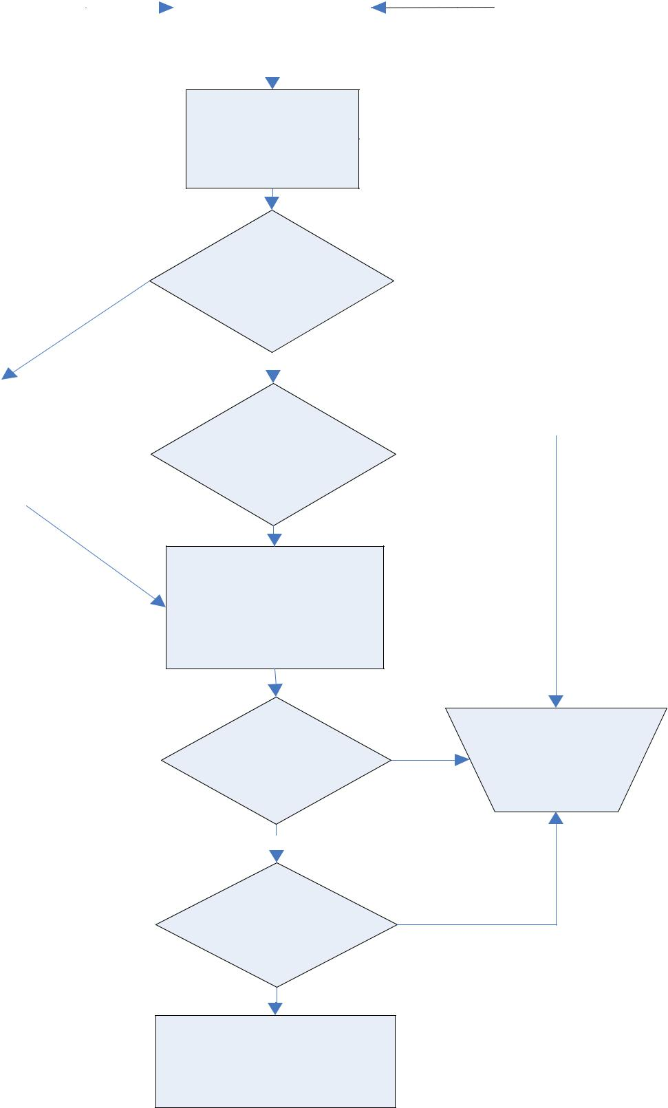
DRC INVESTIGATES
AND EVALUATESNO

SITUATION

SITUATION SERIOUS,
NEED ASSISTANCE?
YES
YES
INFORM RECOVERY
NO
SITE CO-ORDINATOR &
SUMMONS DISASTER
DR SECTION TEAM –
MANAGEMENT TEAM
GET DR ACTION PLAN

ASSIST DRC WITH

DECISION MAKING

 |  | COMPLETE
POTENTIAL | NO | Disaster
DISASTER? | NO | Record
 |  | Form
YES
INVOKE
DISASTER

MOBILISE RECOVERY

TEAMS AND START

RECOVERY AT DR SITE

Figure 1: Disaster alert response flowchart

3. TEAMS AND RESPONSIBILITIES

3.1. DMT Overview

The Disaster Recovery committee is made up of two main functional areas, which are the Disaster Management Team (DMT) and the Systems Technical Recovery Team. They are responsible for the coordination and management of the entire disaster recovery process in the event that a disaster is declared.

This team consists of the following members:
- Disaster Recovery Coordinator

- Process Coordinator

- Systems Recovery Coordinator

- Operations Recovery Coordinator

- Recovery Site Coordinator

The Systems Technical Recovery Team and their responsibilities include the following aspects:
- respond immediately to a summons from the Disaster Recovery Co-ordinator (DRC)

- assist the Disaster Recovery Coordinator in assessing the impact of the potential disaster

- deciding whether or not to declare a disaster

- channelling communication between senior management and the recovery teams

- ensuring that obstacles impeding on the recovery process are dealt with swiftly

- obtain a copy of the DR Plan from the Recovery Site Coordinator

The leaders of the Systems Technical Recovery Teams must continually report the status of the IT systems to the Systems Recovery Coordinator who in turn will report to the rest of the DMT.

4. DISASTER MANAGEMENT TEAM

The diagram below indicates the high-level structure applicable to the Disaster Management Team.

DISASTER MANAGEMENT TEAM
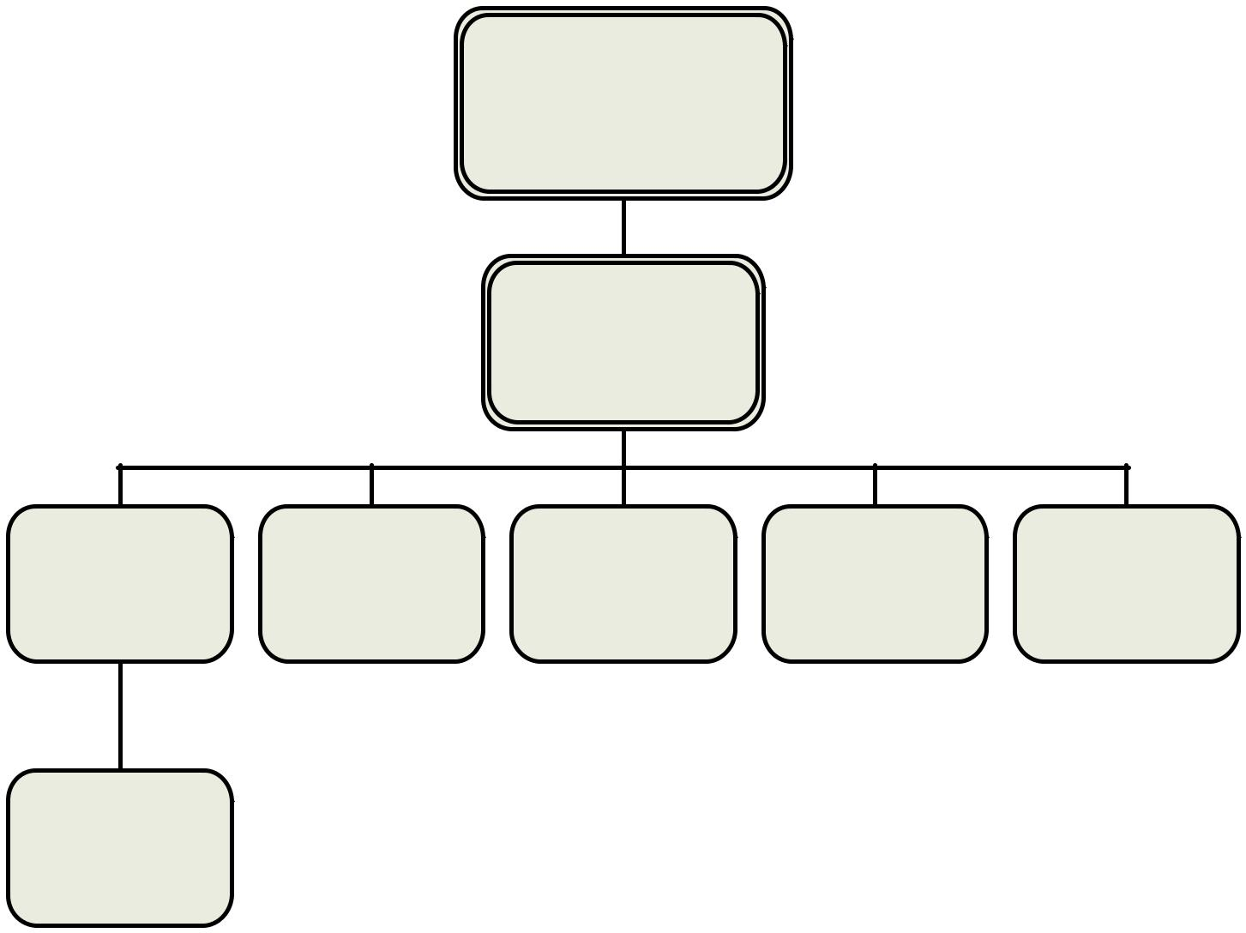
DISASTER RECOVERY

CO-ORDINATOR (DRC)

PROCESS

CO-ORDINATOR

SYSTEMS | OPERATIONS | RECOVERY SITE | NETWORK | APPLICATIONS
RECOVERY | RECOVERY | CO-ORDINATOR | RECOVERY | OWNER
CO-ORDINATOR | CO-ORDINATOR |  | CO-ORDINATOR | CO-ORDINATOR

SYSTEMS

TECHNICAL

RECOVERY TEAM

NOTE: Members of the DMT might also be members and/or leaders of the Systems Technical Recovery team

ACTIONS TO BE TAKEN IN DISASTER MODE

This section identifies the activities to be followed once a disaster has been declared.

A.1 Disaster Recovery Coordinator

NB!!
• This table needs to be used as a worksheet during testing or during disaster mode.
 | NO | ACTION | START | END | COMMENTS
 | 1 | Order mobilisation of recovery
 | 1 | team and inform Security staff.
 | 2 | Oversee recovery effort once in
 | 2 | disaster mode.
 | 3 | Notify users of incident and
 | 3 | handle queries.
 | 4 | Communicate with external
 | 4 | vendors if necessary.
 |  | Channel communication
 | 5 | between management and
 |  | recovery team.
 | 6 | Provide constant support
 | 6 | during recovery process.
 |  | Control any necessary
 | 7 | expenditure during recovery
 |  | process.

A.2 Process Coordinator

NB!!
- This table needs to be used as a worksheet during testing or during disaster mode.
NO ACTION | STARTEND | COMMENTS

- Respond do disaster declaration from DRC.

- Inform Systems Recovery Coordinator to mobilise recovery team.

- Notify users of incident and handle queries.

- Contact external vendors if required.

- Channel communication between recovery team and management.

- Provide constant support during recovery process.

A.3 Systems Recovery Coordinator

NB!!
• This table needs to be used as a worksheet during testing or during disaster mode.
 | NO | ACTION | START | END | COMMENTS
 | 1 | Respond to disaster declaration.
 | 2 | Liaise with Recovery Site Co-
 | 2 | ordinator to standby.
 |  | Mobilise Systems Technical
 | 3 | Recovery Team and contact alternate
 |  | members if necessary.
 |  | Assemble at Recovery Site and
 | 4 | explain disaster situation to recovery
 |  | team members.
 |  | Assign skilled systems recovery
 | 5 | members to perform recovery and
 |  | complete Table in Annex D5.
 | 6 | Collect all “Recovery documentation”
 | 6 | from the Recovery Site Coordinator.
 |  | Collect any confidential / password
 | 7 | documentation from Recovery Site
 |  | Coordinator.
 |  | Provide confidential passwords and
 | 8 | DR documents to relevant recovery
 |  | team members as assigned.

Work with Networks and verify

- network connectivity at the recovery site.

Work with Systems Technical

- Recovery Team to verify system recovery priority.

Ensure systems are recovered
11
according to priority.

Provide ongoing system support and

- communicate status to Process Co-ordinator.

Inform Process Coordinator of
13
successful recovery.

A.4 Operations Recovery Coordinator
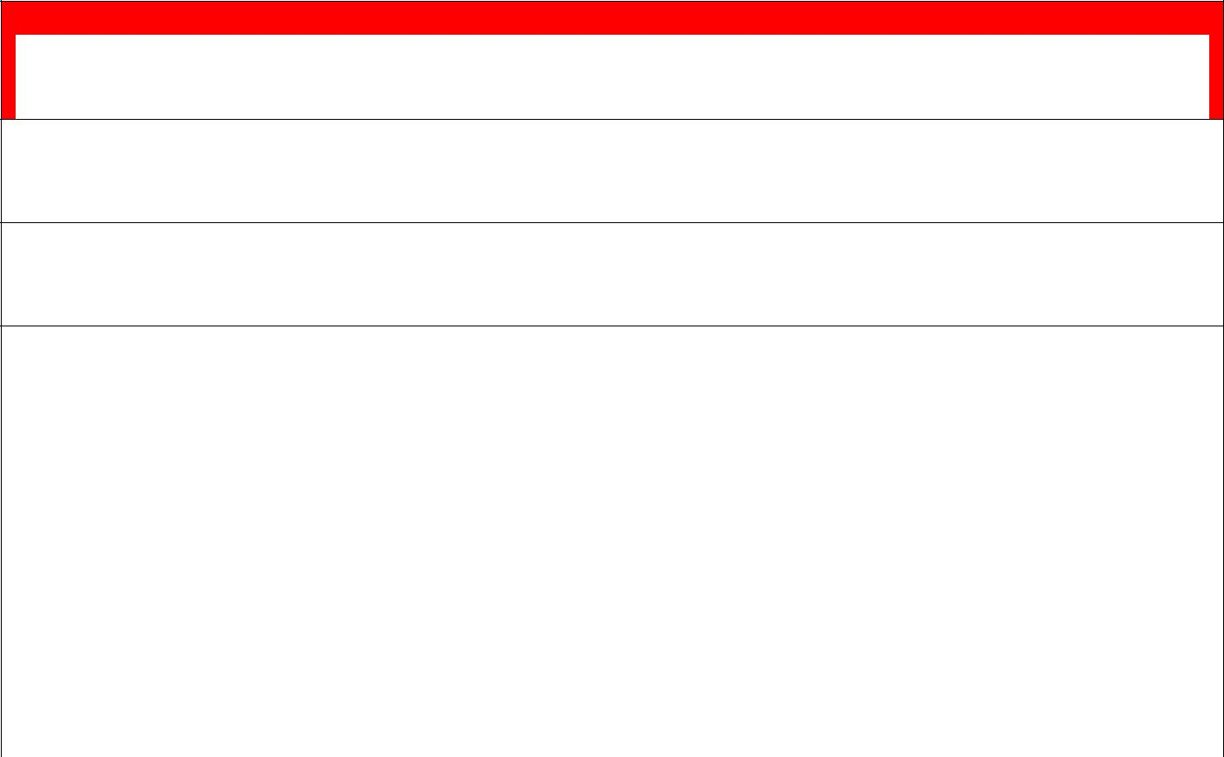
NB!!
- This table needs to be used as a worksheet during testing or during disaster mode.
NO ACTION | STARTEND | COMMENTS

- Respond to disaster declaration.

- Arrange shifts if necessary.

Assist technical recovery team in any
3
way possible.

Provide ongoing system support and

- communicate status to Process Co-ordinator.

A.5 Recovery Site Coordinator

NB!!
• This table needs to be used as a worksheet during testing or during disaster mode.
 |  | NO | ACTION | START | END | COMMENTS
 |  | 1 | Respond to disaster declaration.
 |  |  | Inform all Security personnel on duty
 |  | 2 | of situation and to be helpful and
 |  |  | responsible at all times.
 |  | 3 | Prepare recovery facility for use by
 |  | 3 | clients.
 |  | 4 | Arrange parking and access to
 |  | 4 | secure facility.
 |  | 5 | Collect all client DR documentation
 |  | 5 | and make copies of file content.
 |  |  | Assemble with DMT and Recovery
 |  | 6 | Team Members and hand-over all
 |  | 6 | documentation to Systems Recovery
 |  |  | Coordinator.
 |  | 7 | Accompany members to the recovery
 |  | 7 | facility.
 |  |  | Arrange for any consumables,
 |  | 8 | telephones, faxes and printers etc. to
 |  |  | be available.
 |  |  | Assist members in any way possible
 |  | 9 | and maintain effective communicate
 |  | 9 | & support throughout the recovery
 |  |  | process.

A.6 Systems Technical Recovery Team

NB!!
• This table needs to be used as a worksheet during testing or during disaster mode.
 | NO | ACTION | START | END | COMMENTS
 |  | Respond to disaster declaration and
 | 1 | relocate to the recovery site (Name of
 |  | DR site).
 |  | Assemble at venue at Knysna
 | 2 | Municipality and wait for instructions
 |  | from Systems Recovery Coordinator.
 |  | Obtain copies of all “Recovery
 | 3 | documentation” from the Systems
 | 3 | Recovery Coordinator once at DR
 |  | Site.
 |  | Obtain any confidential / password
 | 4 | documentation from Systems
 |  | Recovery Coordinator.
 | 5 | Begin restoration of systems
 | 5 | according to the recovery priority.
 | 6 | Inform Systems Recovery Co-
 | 6 | ordinator of successful recovery.
 | 7 | Provide ongoing system support.

DISASTER RESPONSE PLAN PROCESS FLOW AND THE

INCIDENT COMMAND STRUCTURE (ICS)
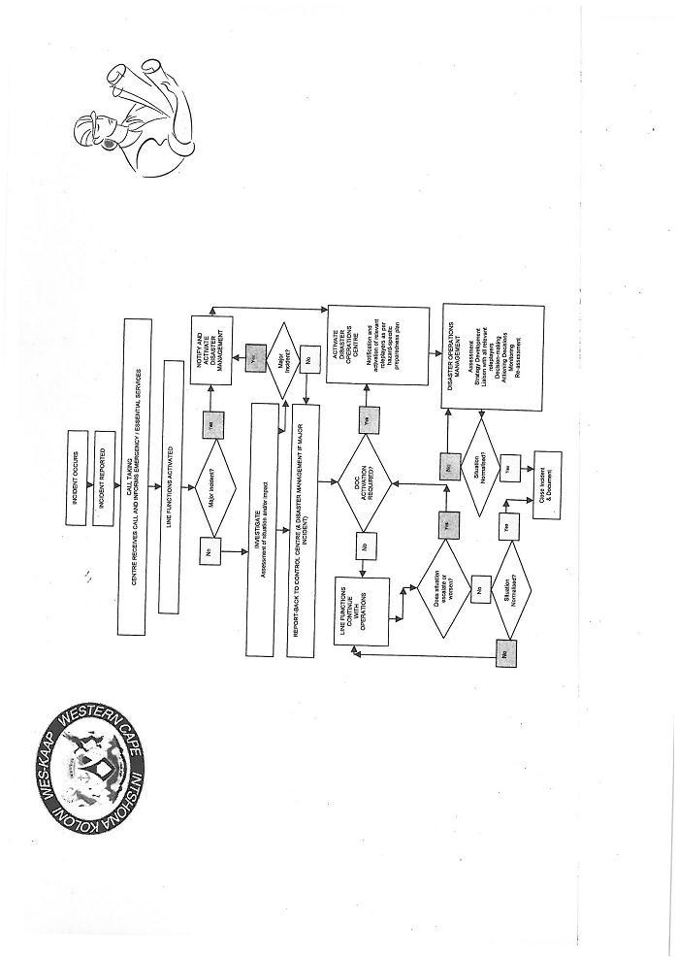
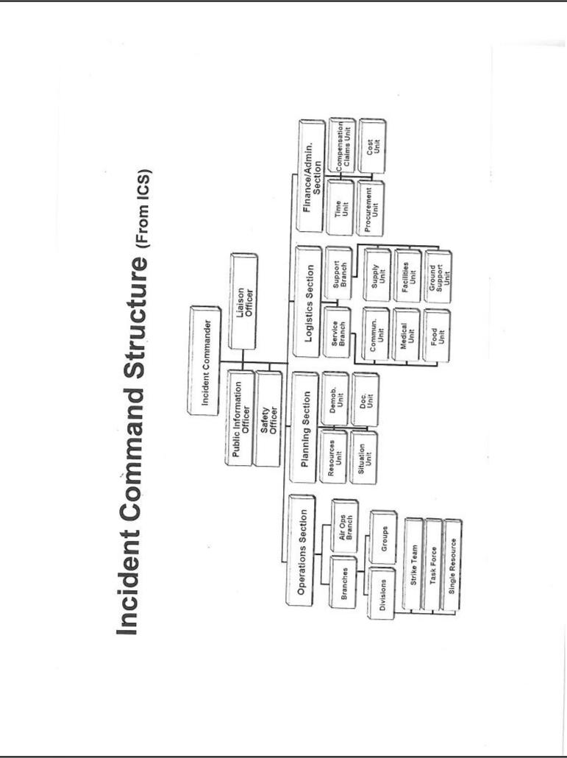


Disaster Management
Plan

for

SEDGEFIELD

 | INDEX
Section 1 | Introduction | Page
Section 2 | Aim of plan | Page
Section 3 | Objectives | Page
Section 4 | Declared Response | Page
Section 5 | Emergency Committee | Page
Section 6 | Emergency Committee Functions | Page
Section 7 | Communications | Page
Section 8 | Operational Control Functions | Page
Section 9 | Information to Community | Page
Section 10 | Inter Service briefings | Page
Section 11 | Counselling Services | Page
Section 12 | Insurance Liability | Page
Section 13 | Financial Implications | Page
Section 14 | Closure of Incident | Page
Section 15 | Maintaining DMP validity | Page
Section 16 | Emergency Appendices | Page
 | Appendices Details

Sedgefield Disaster Emergency Response Plan

- Introduction

  - This plan must be read in conjunction with the Greater Knysna Disaster Emergency Response Plan and all other services, public utilities and voluntary organisations disaster and emergency response preparations.

  - This plan is not a standalone document, but is complimentary to all other emergency arrangements to ensure an effective response in the event of such an incident occurring within the Sedgefield area, neither does it interfere with any existing adhoc voluntary efforts.

  - This document is an appendix to the main Knysna Plan.

  - Remember that “Failing to plan is planning to fail”.

- Purpose of plan

  - To assist all emergency service responding on a local basis to an incident of major proportion affecting, or likely to affect the residents and visitors to Sedgefield, in liaison with all other services locally based, both professionally and voluntary.

  - To keep the local community informed and provide them with a channel through which they can contact the local communications centre.

- Background Objectives
  - To assist in co-ordination of efforts to the benefit of the community and visitors.

  - To respond effectively to the requirements of individuals towards the protection of life and property.

  - To identify those most vulnerable and at risk (The aged, infirm, animals, etc)

  - To provide temporary sheltered accommodation, clothing and feeding arrangements for persons evacuated, or made temporarily homeless.

  - To restore normality to the affected community within a reasonable timescale, dependent on the seriousness of the incident.

- Declared Response to a major Disaster

  - It is the responsibility of the Sedgefield Depot Manager, Knysna Municipality, to initiate such a local emergency response. The depot Manager must consult with the Knysna Disaster Management Team for authorisation where necessary.

  - The Depot Manager has the responsibility, dependant on circumstances, for invoking all or part of this plan.

  - The local “Operational Control” must be based at the Municipal Offices, unless the incident precludes this use. Alternative sites are the Town Hall, Sports club hall, School hall, church hall and Smutsville Community Hall.

    - In the event of such an emergency response, and cording to appropriate circumstances, notification of an immanent or a major disaster event must be forwarded by SMS to all listed Municipal Officials and all listed external contacts. (Refer to attached Appendices).

- Composition of Emergency Committee

      - Comprising the following services, both professional and voluntary:

          - Disaster Management

          - Municipal Officer – Sedgefield Depot Manager

          - S.A. Police Service – An officer, not below the rank of Inspector, with knowledge of the Sedgefield area. (The officer should be a Sedgefield resident or alternatively an officer who resides close to Sedgefield)

          - Fire Service – Locally based Senior Fire Officer (The officer should be a Sedgefield resident or alternatively an officer who resides close to Sedgefield)

          - Traffic Service – Locally based Senior Traffic Officer. The officer should be a Sedgefield resident or alternatively an officer who resides close to Sedgefield

          - Medical Services – Doctor JC Venter, Flamingo Surgery and Dr Bennie Stander

          - Designated Councillors – Two elected Councillors representing the Sedgefield community.

          - Incident Liaison Representatives – Two appointed members of the local Municipal Staff.

          - Message Recording Team – Two local Municipality employees having the required language proficiency (English, Afrikaans, Xhosa) and telephone call handling skills.

          - Local Voluntary Organization Representation - One member from each organization (e.g. SFAC, Island Village, Island Neighbourhood Watch, Montage Village, SRVA). In the event of a flood situation being anticipated, members of the Sedgefield Flood Action Committee and associated organizations (e.g. Island Village, Island Neighbourhood Watch, Montage Village, Sedgefield Ratepayers and Voters Association) will assist the local Municipality by procedure in conjunction with the local Disaster Management Committee. A copy of the plan is contained in the Sedgefield DMP. (Refer to attached Annexure A)

  - Functions of the Emergency Committee during a Disaster Event

        - The services reflected at 5.1 will have the following functions:

            - Disaster Manager

Co-ordinating the various role-players.

- Sedgefield Depot Manager

  - Co-ordinate the response requirement of locally based Municipality staff.

Contact and set up a communications channel with the local voluntary organizations.

  - Hold regular briefings with the Emergency Committee ensuring continuity of effort.

  - Regularly update the Knysna Disaster Management

Team as to the known current scenario and likely progression.

      - Ensure continuity of locally motivated response by liaising daily with the local voluntary organisations.

      - Closes the Emergency Control Centre once emergency services have withdrawn and all residents/visitors immediate needs have been met.

      - Ensure that the repair of damaged essential services and infrastructure is undertaken as soon as possible after the incident.

    - SA Police

      - Maintain liaison with Sedgefield Depot Manager and Disaster Management providing locally based updates and identifying immediate and urgent requirements.

      - Liaise with all other agencies, both professional and voluntary, ensuring continuity of effort to alleviate identified risks and hardships.

  - Local Fire Station

      - Maintain liaison with Sedgefield Depot Manager, Disaster Manager, providing locally based updates and identifying immediate and urgent requirements.

      - Liaise with all other agencies, both professional and voluntary, ensuring continuity of effort to alleviate identified risks and hardship.

- Medial Services

      - Doctor Venter will establish rhesus posts at Flamingo Surgery and site of disaster; he will work in co-operation with Doctor B Stander and make use of the services from Hospice and volunteer nurses if required.

  - Designated Councillors

      - Liaise with Knysna Council on all matters pertinent to

the disaster, with the objectives of identifying where help to the community is most required, and achieving support relief to those residents and visitors directly

affected.

6.1.7 Incident liaison representatives

Will have responsibilities including:

      - Initiating and maintaining a detailed incident log control i.e. Date, Time, Caller identity, Specific details of call.

      - Maintaining an information flow through to the Sedgefield Depot Manager.

      - In the event of evacuation and setting up of rest centres, determining numbers and location of centres.

      - Liaison with voluntary organizations assisting in the relief of hardships and suffering of those directly affected.

      - Where appropriate arrange joint media briefings with all services involved. Media briefings will be managed by either the Knysna Municipal Manager or the Disaster Manager.

      - The collation and safekeeping of all log recordings at the closure of the incident.

    - Message Recording Team

      - The recording team members must have the required language proficiency in English, Afrikaans and Xhosa, and must record all incoming telephone messages on the appropriate message pads.

      - The time and date signature will identify the sequence in which messages are received. Messages must be explicate and contain as much relevant detail as possible.

      - Messages will then be passed on to the addressee and Depot Manager.

      - The team will also be responsible for electronic mail and faxes.

- Communications (Forward Control Point)

  - The Operational Control, wherever sited, must have a minimum of two incoming lines and one outgoing unpublished number.

  - E-mail and fax facilities must also be available.

  - Support of Telkom for the provision of additional communication facilities must be provided to the Depot Manager this is done by providing him with details of a senior Telkom official who can authorise the required additional facilities.

- Functions of the Operational Control

    - To act as a focal point for the required joint response according to the disaster itself and developing scenario.

    - To act as an emergency communications centre, for all responding services including public enquiries.

    - To record and process and act upon information received from whatever source

    - To act as an information centre, preparing news releases for those residents and visitors affected.

- Information to the Community

  - Regular bulletins must be issued to the local community, thus avoiding unnecessary pressures on those co-ordinating the emergency response, and also in an attempt to reduce the spread of rumours which otherwise could cause harm and unnecessary alarm.

  - All information to the general public must be authorised by the Knysna Municipality.

  - Where possible use of the local media must be sought to achieve this. However it must be remembered that the local paper “The Edge” is a bi weekly publication.

  - Information must be disseminated via one or a combination of the following methods using whichever is appropriate: Mobile Tannoy, SMS, Pamphlet drops, door to door, bulletin boards, volunteer network, Information Centre.

- Inter-Service Briefings

      - During an incident the Depot Manager / Disaster Manager must hold regular briefings to ensure continuity of effort, together with an overall assessment of progress.

      - In the event of a protracted incident, where shift patterns have become necessary, full briefings and debriefings must be held at changeover times by either the Depot Manager or Disaster Manager.

- Counselling Services

        - Where appropriate the counselling services of psychologists and local Faith Practitioners must be sought.

        - These services mustl be available to all persons, directly or indirectly involved in the disaster itself.

- Insurance Liability

- The Municipality must agree to indemnify all volunteer staff acting in good faith and with the knowledge of the Municipality, against personal injury and/or loss or damage to personal property, whilst carrying out duties directly related to the disaster

- Financial Implications

  - An audit trail must be maintained by the Municipality Finance Department throughout the incident, so that accounts may be sent to the appropriate disciplines against invoices raised.

- Closure of Incident

    - Once all of the emergency services have withdrawn from the scene with their onsite investigation completed, it is the responsibility of the Municipality to initiate whatever recovery programme is identified as necessary to re-establish the status quo. A thorough review of the whole response operation must be undertaken within two weeks of closure, with the aim of identifying any shortfalls or problems experienced, so that these can be corrected to improve the overall effectiveness of any future responses.

    - Maintaining the effectiveness of the Sedgefield DMP

To ensure the Disaster Management Plan for Sedgefield remains effective. The entire plan must be reviewed by the Sedgefield Depot Manager/Disaster Management Forum and the relevant departmental heads every 6 months from date of issue. Especially the contact list.

- Emergency Callout & Contact Appendices

  - The appendices aim to provide emergency contact detail
information in the initial response stages to disaster scenario.

- Reference must also be made to the appendices listed within the Greater Knysna Disaster Plan.

Appendix

FLOOD WARNING - AREA CONTACT & COORDINATORS CONTACT DETAILS
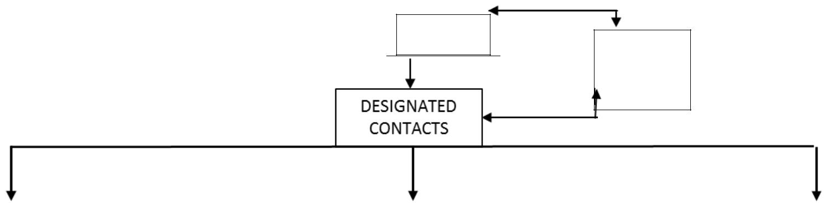
EDEN DMC

KNYSNA
JOC

Designated Contact 1 |  |  |  |  | Designated Contact 2 |  |  |  |  | Designated Contact 3
Name | Contact #s |  |  |  | Name | Contact #s |  |  |  | Name | Contact #s
John |  | 082 732 |  |  |  |  | 082 469 |  |  |  | 044 343 | 083 529
McGregor | 044 343 1084 | 6121 |  |  | Gert van Zyl | 044 343 2122 | 2989 |  |  | Alex Walters | 2171 | 4523
Area Co-ordinators |  |  |  |  | Area Co-ordinators |  |  |  |  | Area Co-ordinators
Name | Area | Contact #s |  |  | Name | Area | Contact #s |  |  | Name | Area | Contact #s
Terry |  | 044 343 | 082 829 |  |  |  | 044 434 | 073 345 |  |  | Montage | 044 343 | 083 529
Savage | Island 1* | 1787 | 3446 |  | Klaus Schluz | Island 6* | 2114 | 6110 |  | Alex Walters | Village | 2171 | 4523
Peter |  |  | 083 324 |  |  |  | 044 343 | 082 469 |  |  |  | 044 343 | 073 241
Hanrahan | Island 2* | - | 7519 |  | Gert van Zyl | Island 7* | 2122 | 2989 |  | Dave Miles | Lark Ave. | 2922 | 6057
Peter |  | 044 343 | 083 460 |  |  |  | 044 343 | 084 618 |  | Steve | Kingfisher | 044 343 | 072 690
Dawson | Island 3* | 2271 | 6457 |  | Martin Louw | Island 8* | 1832 | 1180 |  | Hartslief | Dr. | 2925 | 7954
Graham |  |  | 084 258 |  | Andre |  | 044 343 | 082 653 |  | Carel |  | 044 343 | 084 480
Bailey | Island 4* |  | 2654 |  | Knoetze | Scarab Market | 2455 | 5696 |  | Doubell | Eden Lawns | 2883 | 6133
 |  | 044 343 | 073 345 |  |  |  | 044 883 | 082 376 |  | Anton | Sedgemeer | 044 343 | 044 343
Anne Munro | Island 5* | 2989 | 8200 |  | Sue & Rose | Wild Oats Market | 1177 | 5020 |  | Kruger | Park | 1683 | 2117
 |  |  |  |  | Marius |  | 044 343 | 071 626
 |  |  |  |  | Schamerel | G/Route Villas | 2000 | 2001

* As per Neighbourhood Watch area co-ordination Updated: June 2014

Procedure for receiving and distributing “Severe Weather Warning Information” undertaken by members of the Sedgefield Flood Action Committee and

Island Neighbourhood Watch and other groups.
N.B. This applies to Sedgefield only.

Introduction

This procedure has been prepared using the output of 3 SFAC working group meetings, and input from reviews involving members of the SFAC, Island Neighborhood Watch, Montage Homeowners Assn, the Head of Disaster Management, Eden District Municipality and the Head of Disaster Management, Knysna Municipality.

The procedure was completed and approved in November 2008. The latest update was undertaken in 2011.

Purpose of Procedure

The purpose of this procedure, is to detail a process which will ensure that in the event of a “Severe Weather “Warning” Alert being received from Eden Disaster Management Centre, the information will be forwarded to residents living in the flood affected areas of Sedgefield as quickly and effectively as possible, thus ensuring that residents are informed and have time to make preparations to at least minimize the effect of any possible flooding. (Area covered, refer to Appendix 1.)

The new weather warning system operated by Eden Disaster Management Centre uses three levels of warning to advise their contacts in the affected area’s, These are:

“Advisory”, which provides an early warning of potentially hazardous weather is activated when 50mm or more of rain is expected within a 2 to 6

day period.

“Watch”, which is activated when weather conditions are likely to deteriorate to hazardous levels, within a 1 to 3 day period.

“Warning”, which advises, with very high confidence, that a hazard is about to occur within the next 24 hours. is activated 24hours before a possible flooding event.

Procedure

1. “Advisory” Warning received from Eden Disaster Management Centre by SMS to three designated contacts of the Sedgefield Flood Action Committee.

Currently the three contacts are: John McGregor, Alex Walters, and Gert van Zyl.

The “Advisory” warning is sent out by Eden Disaster Management Centre 2 to 6 days before heavy rainfall is expected in the Sedgefield area.

The “Watch” warning is activated when more than 50 mm of rain is expected to fall within a 1 to 3 day period in the Sedgefield catchment area.

At this stage, the area coordinators are not advised. This is because the anticipated rainfall would not constitute a flood threat at this stage.

- “Warning” advice received from Eden Disaster Management Centre by SMS to three SFAC designated contacts.

If the rainfall threat continues to grow, a “Warning” advice will be sent out by Eden
Disaster Management Centre to the 3 designated contacts.

The “Warning” advice is sent out 24 hours before a possible flooding event.

On receipt of this information, the 3 designated contacts will then advise the area coordinators.

Each designated contact will be responsible for informing a number of the area coordinators. (refer Appendix 1.)

This will be done either by telephone, cell phone, word of mouth or house calls

N.B. The Eden Disaster Management Centre will be continually monitoring the bad weather threat and will be sending out updates to Knysna Joint Operations Centre

which will be forwarded to the designated contacts.

The designated contacts will in turn update the area coordinators of any changes to the threat as and when the information is received.

- On receipt of the “warning” advise from the designated contacts.

As soon as the area coordinators receive the warning advice from the designated contact persons, they advise residents in their individual areas of responsibility, that there is
a possibility of their being flooded. This will be done either by telephone, cell phone,

word of mouth or house calls.

N.B. The coordinators are only responsible for advising residents of the possibility of flooding, based on information received from an authorized source i.e. Eden DMC or Knysna JOC. Any additional information from these sources will be advised via the designated contact persons.

- Advising Knysna Joint Operations Centre

The area coordinators should, at any stage during the flood warning period, pass on

any pertinent information they may have obtained e.g. elderly /sick person requiring assistance, empty house, damaged / closed road etc, to the Knysna Joint Operations Centre (Tel 044 302 8911) or the local Sedgefield. Joint Operations Centre (Tel
044343 1640).

(During the warning period the Knysna Disaster Management Plan will be activated, and the local Sedgefield Disaster Management Team will be operational)

- General

5.1 If a flood has occurred, residents requiring assistance should inform their area coordinators, who either gives the resident the appropriate number to contact for assistance, or passes on the information to the Knysna or Sedgefield JOC.

5.2 On receipt of an improving weather advice from Eden Disaster Management Centre or Knysna JOC, area coordinators will be informed, and they in turn advise the

residents in their areas of responsibility.

5.3 After every flood warning / flood, all persons involved in the SFAC and Island Neighbourhood Watch flood warning network, should partake in a de-briefing

exercise to review current procedures in order to highlight what went right, what went
wrong and what needs to be introduced to improve the procedures for the future.

If required a formal report should also be prepared for forwarding to Eden Disaster Management Centre and Knysna municipality.

This exercise should be undertaken within 2 weeks of the event finishing.

5.4 The above procedure should be reviewed / updated by members of the SFAC/ Island Neighbourhood Watch annually to ensure it remains relevant. The proposed review

period being July and January (before anticipated flood seasons)

5.5 Wording for flood warning message.

FLOOD WARNING MESSAGE

NB. This is the standard massage that should be communicated to all residents.

Sedgefield Flood Action Committee / Island Neighbourhood Watch.

Please be advised that we have received a Bad Weather Warning Advice. from Eden Disaster Management Centre today

This means that there is a possibility of flooding in our area within the next 24 hours.

Should you require any further information please contact either the Knysna or Sedgefield Joint Operations Centre on Tel 044 302 8911 or

044 343 1640.

5.6 Wording for All Clear message.

NB. This is the standard message that should be communicated to all residents.

FLOOD THREAT OVER MESSAGE

Sedgefield Flood Action Committee / Island Neighbourhood Watch.

Please be advised that we have received an advice from Knysna Joint Operations Centre stating that the flood threat is over.

Should you require any further information please contact the Knysna JOC on 44 302 8911.

5.7 Date of Implementation

All area coordinators will be advised.

- Procedure Review

This procedure will be reviewed annually.

Persons responsible for this being representatives of the SFAC, Island Neighbourhood Watch, Eden Municipality and Eden Disaster Management Centre.

Date Reviewed:

Please note, for the proposed system to work effectively, each area coordinator is responsible for obtaining and maintaining an up to date list of telephone and cell phone numbers for all the people living in their area of responsibility.

Each coordinator should have a back-up member in case of absence, and should arrange their own unique (warning) handover procedure.

DECLARATION OF EMERGENCIES

Whether or not an emergency situation is determined to exist, Municipal and other Agencies may take such actions under this plan as may be deem necessary to protect the lives and property of the inhabitants of the Greater Knysna Municipality.

Based on the information available, the Municipal Manager in consultation with the Management Teams (Disaster Management, Directors and relevant Managers) shall determine whether or not an emergency exist in the Municipal area.

If an emergency is determined to exist, the Municipal Manager shall immediately advise the Mayor (Mayco).

The Centre may request assistance and resources from another level of agreement and that request shall not be deemed to be a request for implementation of the Plan of the jurisdiction.

DECLARATION OF A LOCAL STATE OF DISASTER

In the event of a local Disaster, the Council may by notice in the Provincial Gazette declare a local state of disaster if existing legislation and contingency arrangements do not adequating provide for the Municipality to deal effectively with the Disaster or other special circumstances warrant the declaration of a local state of disaster (Section 55)

If a local state of Disaster has been declared, the Council may make by-laws or issue directions or authorize the issue of directions to:

  - assist and protect the public
  - provide relief to the public
  - prevent or combat disruption; or
  - deal with the destructive and other effects of the disaster

- AUTHORIZATION AND APPROVAL OF THE DISASTER RISK MANAGEMENT
PLAN

The Knysna Municipality Disaster Risk Management Plan has been prepared in accordance with the provision of the Disaster Management Act, 2002 (Act no 57 of 2002) section 52 & 53. The national Disaster Management Framework published 29 April 2005, The Disaster Management Regulations Chapter 5 Disaster Management Act, 2002 (Act 57 of 2002)

The Knysna Municipality Disaster Risk Management and Emergency Plan is signed into an Ordinance of Council as recommended by:

Municipal Manager: _______________________ Date: ________________
Knysna Municipality

and approved by Council

Mayor _____________________________ Date: _____________________
Knysna Municipality

