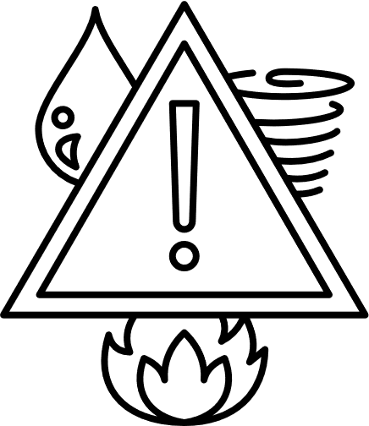

+00-123-456-789
Water
+00-123-456-789
Gas
+00-123-456-789
Electricity
Utilities
+00-123-456-789
Doctor Name
+00-123-456-789
Doctor Name
+00-123-456-789
Hospital Name
Hospitals
+00-123-456-789
Company Name
+00-123-456-789
Company Name
+00-123-456-789
Company Name
Insurance
+00-123-456-789
Name
+00-123-456-789
Name
+00-123-456-789
Name
Family and Friends
Government
911
Emergency Services
+00-123-456-789
National Weather Service
+00-123-456-789
Federal Emergency Management Agency
DISASTER PHONE TREE

