Sample Childminding Policies, Procedures and Statements

Table of Contents
Introduction 2
Master Template 3
Sample 1: Statement of Purpose and Function 4
Sample 2: Complaints Policy 6
Sample 3: Policy on Administration of Medication 8
Sample 4: Policy on Infection Control 11
Sample 5: Policy on Managing Behaviour 15
Sample 6: Policy on Safe Sleep 17
Sample 7: Fire Safety Policy 20
Sample 8: Inclusion Policy 22
Sample 9: Outings Policy 24
Sample 10: Policy on Accidents and Incidents 26
Sample 11: Policy on Authorisation to Collect Children 28
Sample 13: Policy on Outdoor Play 32
Sample 14: Policy on the Use of the Internet and Photographic and Recording Devices 34
Sample 15: Risk Management Policy 36
Sample 16: Settling-In Policy 38
Sample 17: Safety Statement 39
Appendix 40

Introduction
The following template and samples may assist childminders in developing or revising their own set of required policies, procedures and statements.

The suggested samples used here in this booklet, are just that – samples. You will need to adapt them to reflect your own Childminding Service. Your policies, procedures and statements are active documents, which reflect what you do and how you do it, within your Childminding Service every day. Your policies, procedures and statements standardise your approach to implementing best practice and ensuring compliance with the regulations.

Please note: The samples throughout this document are based on the master template on page 3. Some of the samples contain a web address underlined and in blue text, which will bring you to further information required. Also, you will notice wording in red text and italics, which is suggesting you include the specific information relevant to your service.

This booklet provides additional support for you as a childminder to help meet the core regulatory requirements, as set out in the Childminding Quality and Regulatory Framework (QRF). It is important that you refer to the Childminding QRF when you are writing and implementing your own policies, procedures and statements. For further support, you can also refer to Developing Policies, Procedures and Statements in Early Childhood Education and Care Services: A Practical Guide. This Practical Guide gives you further advice and direction in creating new or revising existing policies, procedures and statements for your service. These are both available at: www.tusla.ie/services/preschool-services/early-years-quality-and-regulatory-framework/

Policies, procedures and statements reflect your Childminding Service, as a ‘home from home’ to the children in your care and their families. Policies, procedures and statements, including any updates, must be communicated and available to parents and guardians. Parents and guardians confirm and sign that they have read and accept your policies, procedures and statements, for example by signing the childminding contract. (See Sample Appendix A).

Master Template

This template is a suggested standard layout for your policies, procedures and statements. The samples in this booklet are modelled on this template.

1. Rationale and Purpose
- Outlines the main reasons for the policy. For example – the reason for the policy as detailed in the 2016 Regulations.

- Describes the purpose of the policy and what you want the policy to achieve. For example – a safe sleep policy may seek to ensure that children will be safe in the service while sleeping.

2. Procedures and Practices
- Gives clear information and describes the specific steps and/or guidance to be followed to put the policy into practice.

- It outlines the way things are done in your childminding service.

3. Communication of Policy
- Outlines how parents and guardians are informed about the policy. For example – make parents aware of policies through a handbook.

4. Date of Policy and Childminder’s Signature
- Shows when the policy was written and when it will be reviewed (at least once a year). This is signed by the childminder.

  - Date policy was written:
  - Date policy is to be reviewed:
  - Childminder’s signature:

Sample 1: Statement of Purpose and Function

This sample statement needs to be modified to reflect your own childminding service.

1. Rationale and Purpose
- The statement of purpose and function is a description of my childminding service, reflecting the day-to-day operation.

2. Procedures and Practices
About my childminding service
- This is a home based childminding service, offering early years care for children aged 0-6 years who are not attending primary school.
- I care for a maximum of 5 pre-school children at any one time.
- I also offer out of school care for children up to the age of 12 years.
- I have a second person to care for the school aged children.
- The operating hours are from 8am until 6pm in general. I do not offer overnight care.
- My childminding service is registered with Tusla’s Early Years Inspectorate. You can find my most recent inspection reports at: www.tusla.ie/services/preschool-services/creche-inspection-reports/
- The cost of my childminding may vary, is agreed before enrolment and is subject to review.
- My childminding service is a home from home environment. My service mirrors the atmosphere and flexibility of home life, and allows children to grow and develop in this homely setting.
- I have an open door policy to all the parents/guardians of children attending. A parent or guardian can drop in at any time.
- I have a back-up person in the event of an emergency. They are Garda vetted and attend the service regularly so the children are familiar with her. They are aware of all policies, procedures and statements.
- Only visitors whom I know personally will be allowed into my home. If an unknown visitor is due, I will inform parents/guardians ahead of time, as far as practicable. Children are never left alone with any visitors.
- I have pets in my home; a dog and a cat.
- I work in partnership with parents and guardians, and I encourage and value on-going communication with you.
- If I am absent (planned or unplanned), the arrangements are {describe here your arrangements}.
- All adults in my home are Garda vetted.
- I take children under 15 months old.
About me
- I am a member of Childminding Ireland.
- I offer two references regarding my suitability to care for children.
- I am Garda vetted.
- My qualifications include {list your qualifications here}.
- I engage in on-going professional development and training, as required.
- I keep an up-to-date Curriculum Vitae, to show relevant training and experience.
- I have childminding insurance.
- I have completed Tusla’s online Child Protection Training programme.
- I am available to contact via:
- email {insert email here}
- phone {insert phone number here}.
Policies, procedures and statements
The following are a list of the policies, procedures and statements of my service:
Statement of Purpose and Function | Complaints Policy
Policy on Administration of Medication | Policy on Infection Control
Policy on Managing Behaviour | Policy on Safe Sleep
Fire Safety Policy | Inclusion Policy
Outings Policy | Policy on Accidents and Incidents
Policy on Authorisation to Collect Children | Policy on Healthy Eating
Policy on Outdoor Play | Policy on the Use of the Internet and Photographic and Recording Devices
Risk Management Policy | Settling-In Policy
Safety Statement.

Before enrolment
- Before enrolling a child, I meet with parents/guardians in my home to discuss my childminding service.
- Once terms and conditions, including fees and payment terms have been agreed, a contract between the parents/guardians of the child and myself will be signed.

3. Communication of Policy
- Parents/guardians are informed about the Statement of Purpose and Function at enrolment.
- Parents/guardians confirm that they have read and accept this statement.
- I will make a copy of this Statement of Purpose and Function, including any significant changes/updates, available to all parents and guardians.
- I welcome discussion, questions or comments on this statement.

4. Date of Policy and Childminder’s Signature
Date Statement of Purpose and Function was written:
Date Statement of Purpose and Function is to be reviewed:
Childminder’s signature:

Sample 2: Complaints Policy

This sample statement needs to be modified to suit your own childminding service.

1. Rationale and Purpose
- To set out a clear and specific procedure for making and dealing with complaints about any aspect of my service.
- To assure anyone who comes in contact with my childminding service that if they ever have a comment, concern or complaint, it will be welcomed and responded to appropriately.
To ensure complaints are taken seriously, treated sensitively, resolved efficiently, recorded appropriately and dealt with in a confidential manner.

2. Procedures and Practices
Concerns, comments or complaints
- I am committed to providing parents/guardians and children with a happy, high-quality childminding service.
- I welcome all comments on my service, whether they are positive or negative.
- I will respond to all complaints, irrespective of the nature of the complaint, or who the person making the complaint is.
- All complaints are handled sensitively without fear, favour or prejudice.
- I have a complaints management process that is fair, transparent, impartial and confidential.
- All details of the complaint are managed and recorded in a consistent and unbiased way
Complaint management: Informal
- If you consider that any aspect of my service was less than expected, please tell me.
- I can be contacted in person, by phone, letter, email or text. {Insert your contact details.}
- The complaint may be made by the parent/guardian or a person mandated by them.
- I would hope that we could resolve the matter informally, through discussion and agreeing a resolution, if possible.
- I will record all details of the complaint, including my response and any resolution.
Complaint management: Formal
- If a satisfactory resolution cannot be found, then a formal procedure will come into operation.
- I will encourage you to put your complaint in writing to me. Relevant names, dates and any other important information on the nature of the complaint should be included.
- I will acknowledge receipt of your complaint in writing as soon as possible.
- I will keep you informed of the process. If there is any delay, I will advise you and explain the reason why.
- I will consider and respond to your concern in writing within a specified timeframe and in as objective a manner as possible.
- Confidentiality will be maintained appropriately.
- If you are dissatisfied with my response or feel for any reason that you cannot bring a concern directly to me, you may contact (insert here the name of the person whom the complainant can contact).
- Alternatively you may contact Tusla’s Early Years Inspectorate at: www.tusla.ie/services/preschool-services/concerned-about-the-operation-of-a-eys/

Complaints not within the scope of the childminding service
- If I have good reason to believe that the situation has Child Protection implications, I will ensure that the local Tusla Duty Social Worker is contacted, according to the procedure set out in the Child Protection Policy.
Confidentiality and the recording and storage of complaints
- I will keep a record of complaints in a Complaints Record File, separate from the children’s files.
- I will only share information relating to complaints on a need-to-know basis.
- I am the only person to have access to the Complaints Records File for my childminding service.
- I will keep a record of the complaint for 2 years, from the date on which the complaint has been dealt with. (This period may vary depending on other legal requirements.)
- The record will include:
  - The name of the complainant
  - The nature and details of the complaint
  - The date and time the complaint was received
  - The manner in which the complaint was received
  - The name of the person who received the complaint
  - The level of risk to the child or children arising from the subject of the complaint
  - The manner in which the complaint was dealt with, including:
  - any local resolution implemented;
  - any specific meetings held with the person making the complaint and minutes of any such meetings; and
  - Timelines for investigation of the complaint and notification of the outcome to the person making the complaint.
  - Details of the investigation carried out
  - The outcome of the investigation
  - Details of any corrective or preventive actions to resolve the complaint
  - Information given to the person making the complaint about the progress and the outcome of the complaint
  - Details of the investigation and whether the action taken to resolve the complaint was accepted
  - Details of any plan implemented for the child’s care as a result of the complaint, as agreed with the child’s parents or guardians
  - Details of any review to the risk management process in light of the complaint
  - Details of any changes to practice or policy.

3. Communication of Policy
- Parents/guardians are informed about the Complaints Policy at enrolment.
- Parents/guardians confirm that they have read and accepted this policy.
- I will make a copy of this Complaints Policy, including any significant changes/updates, available to all parents and guardians.
- I welcome discussion, questions or comments on this policy.

4. Date of Policy and Childminder’s Signature

Date policy was written:
Date policy is to be reviewed:
Childminder’s signature:

Sample 3: Policy on Administration of Medication

This sample statement needs to be modified to suit your own childminding service.

1. Rationale and Purpose
- To ensure the safety, health and welfare of the children in my care, in relation to the administration and safe storage of medication.
- To describe the procedures to be followed to ensure the safe storage and administration of medication to children, including in an emergency situation.

2. Procedures and Practices
Consent
- Medications are only administered to a child where a child’s parents/guardians have given written consent.
- Written consent is also required to allow your child to have appropriate medical treatment, if required.
- This policy includes a medication consent form. (See Appendix B.)
- This written consent is given on enrolment, on your child’s registration form.
Storage of medication
- Medications are:
  - labelled with the child’s name and the expiry date;
  - stored in line with the manufacturer’s instructions;
  - kept in their original containers; and
  - stored out of sight and reach of children, but quickly accessible to me.
- Medications, creams and ointments are not stored in my first aid box.
Administering medication
- I have the relevant knowledge, skills and training to administer medication.
- If additional skills, training, information or instruction is required to administer a particular medication for your child, I will obtain this.
- If a child develops a fever and is distressed I may administer an anti-febrile medication with your written consent.
- If your child has an individual care plan, I will ensure the specific information about medication requirements are adhered to.
- I undertake the following safety procedures before, during and after administering medication:
Before administration I check:
- The appropriate consent has been given.
- The medication is given to the child for whom it is intended.
- The date and time the medication was last given.
- The dosage (prescribed/unprescribed.
- The expiry date.
- Any written instructions provided.
- Any possible side effects.
- With parents/guardians or a health professional, before taking further action if I am in any doubt.

On administration I ensure:
- The medication is given at the correct time and date.
- The correct dose is given.
- The correct route of administration.
- Appropriate equipment is used to administer the medication dose. For example – for liquids, the correct measuring tool is provided with the medication.
- The dignity and privacy of the child is ensured, as appropriate. For example – when medication is required to be administered by a route other than the oral route.
After administration:
- I observe the child for any possible side effects.
- Where appropriate, I observe the child’s response to medication. For example – where an anti-febrile agent is administered.
- I return medication to appropriate storage.
- I manage or dispose of any equipment used during administration.
Accidents and incidents involving medications
- In the event of a medication emergency, such as an allergic reaction, I will notify the child’s parents/guardians and also the emergency services.
- There is a suitably equipped first aid box in my home.
- Where a child refuses to take the medication prescribed for them, I will not force them to do so, but will inform the parents/guardians as a matter of urgency. If the child not taking the medication leads to an emergency situation, I will call the emergency services and the parents/guardians.
- If the medication cannot be given at the required time, I will record this on the administration of medication form (see Appendix B), with an explanation.
- If a child is mistakenly given another child’s medication, I will call a doctor immediately and follow their advice. I will contact and inform the parents/guardians of the child who mistakenly received the medication, as soon as possible.
- The poisons information line number, GP, pharmacist and other emergency numbers are readily available at all times.
- Where a child is taken to hospital by ambulance I will accompany them and remain with them until a parent/guardian arrives. The emergency person will take my place with the other children, in my absence. (See Accidents and Incidents Policy.)
- All required information is shared with the emergency services and the parents/guardians.
Sunscreen
- Parents/guardians should supply high factor sun protection cream (above 30 SPH) in sunny weather. Only the sunscreen supplied by the parent/guardian will be applied to their child. Written consent is not required to apply sun protection creams supplied by the parent/guardian for their own child, as the supplying of the sunscreen gives implied consent for that specific cream.
- When a parent/guardian has not supplied sunscreen, I will apply the following sunscreen {insert name of sunscreen and SPH factor here}. I will require written consent for the application of this cream, so that you can advise if a previous adverse reaction may have occurred with the type cream supplied by me.
- Sunscreen will be applied when required in accordance with the manufactures instructions.
- If a parent does not wish their child to have sunscreen applied I will discuss with the parent as to the best possible ways to protect the child in such an eventuality, for example use of clothing including sun hat and long sleeved top and long trousers, offering play in a shaded area etc.
Disposal of medications
- Medications with the expiry date exceeded or the period of use is complete, are returned to the parents/guardians of the child.
  - If not collected by the parents/guardians, I will return to the pharmacy for safe disposal.
Disposal of medications
- Medications with the expiry date exceeded or the period of use is complete, are returned to the parents/guardians of the child.
- If not collected by the parents/guardians, I will return to the pharmacy for safe disposal.
Records
- Children’s medication records are kept for 2 years from the date a child stops attending the service. This includes the medication consent form, administration medication form, and all related information.

3. Communication of Policy
- Parents/guardians are informed about the Administration of Medication Policy at enrolment.
- Parents/guardians confirm that they have read and accepted this policy.
- I will make a copy of this Administration of Medication Policy, including any significant changes/updates, available to all parents and guardians.
- I welcome discussion, questions or comments on this policy.

4. Date of Policy and Childminder’s Signature
Date policy was written:
Date policy is to be reviewed:
Childminder’s signature:

Sample 4: Policy on Infection Control

This sample statement needs to be modified to suit your own childminding service.

1. Rationale and Purpose
- The policy describes the procedures to be followed to protect the children and myself from the transmission of infections.
- My policy is reflective of the Management of Infectious Disease in Childcare Facilities and Other Childcare Settings, available at: www.hpsc.ie/a-z/lifestages/childcare/

2. Procedures and Practices
Hand-washing
- I wash and dry my hands correctly, using a cleaning agent. (See Appendix F.)
- Children are supported and supervised in correct hand-washing with a cleaning agent such as liquid soap, and hand-drying techniques,
- Children wash their hands when dirty, after nappy changing/toileting, after handling animals/pets, after outdoor activities, before eating, after touching a cut or sore, after sneezing, blowing their nose and coughing.
- Liquid hand soap dispenser is available and all areas are free of bar soap.
- Hygienic means of hand drying is available (state here what is in use for example, disposable paper towels, individual cloth towel, hand towel which is changed daily, etc ) with a foot operated bin for disposal.
- Hot and cold running water is available at sinks, via mixer taps. The hot water from sinks used by children is thermostatically controlled to a maximum of 43°C.
Respiratory hygiene (coughing and sneezing)
- I support children with good respiratory hygiene practices, by encouraging them to cover their mouth and nose when coughing, sneezing or nose blowing, with a tissue and then dispose of the tissue appropriately. (See Appendix G.)
- Tissues are always available for children.
Preventing cross-contamination
- 3 basic principles underlie how I aim to prevent the spread of infection in my childminding service. These are:
  - Handwashing is used at every opportunity.
  - I encourage all children to be appropriately immunised and I am up-to-date on my own immunisations.
  - In some instances, an unwell child will be excluded from the service to minimise the risk of infection to other children.
General infection controls
- I take all reasonable steps to prevent the spread of infection:
- I have a regular cleaning programme in place.
- All childminding areas in my home are clean.
- I use disinfectants and detergents correctly in accordance with the manufacturer’s instructions. These are stored in a locked cupboard in the kitchen.
- Any blood and body fluid spillages are cleaned immediately.
- Individual hairbrushes, toothbrushes and personal clothing are labelled and not shared.
- Infants feeding equipment and soothers are sterilised appropriately.
- Cots, sleeping mats and beds are at least 50cm apart.
- Soiled linen is washed separately in a hot wash.

- Children’s soiled clothing is placed in a sealed plastic bag and sent home with parents or guardians.
- Waste is managed safely. For example – recycled where possible, use a foot operated pedal bins, external bins are inaccessible to children.
Perishable food
- Perishable food is kept in my fridge, at a temperature between 0-5°C.
- Perishable food is not left at room temperature for more than 2 hours.
- Any perishable food left at room temperature for longer than 2 hours is discarded.
Immunisation
- On enrolment, parents/guardians are asked for their child’s immunisation details. I ask parents/guardians to keep me updated on these details. For further information see: http://www.hse.ie/eng/health/immunisation/pubinfo/pcischedule/immschedule/
- I inform parents/guardians of children who are not immunised of the risk to their child in the event of an infectious disease in my childminding service.
- If a child is not immunised, I will request that your child not attend my childminding service during an outbreak of a vaccine preventable disease (whooping cough, measles, etc.), even if your child is well. This is to protect any child who is not immunised.
Managing an outbreak
- When there is an outbreak, I will follow the guidance of the Department of Public Health Medicine to minimise the spread of infection, including paying close attention to:
  - Regular handwashing.
  - Use of gloves and aprons.
  - Hygienic nappy changing.
  - Hygienic management of toys.
  - Suspending certain group activities, if necessary. For example – sand play).
  - Washing soiled clothing and bed linen, using detergent and hot water (at least 60°C).
  - Disposal of contaminated waste, etc. into a plastic bag which is tied securely and placed in the external refuse bin.
  - Deep cleaning of the premises.
- All ill children and adults will be excluded as set out in Management of Infectious Disease in Childcare Facilities and Other Childcare Settings.
- I will close my service for a period of time if requested by the Department of Public Health Medicine, to prevent any other children becoming ill.
Illness
- If a child is unwell, parents/guardians are asked to keep them at home if they are unable to participate in the activities of the day, or if there is a risk of passing on the illness.
- If a child becomes ill in my care, I will contact the parents, guardians or nominated carer.
- I will keep your child as comfortable as possible, until they are collected.
- If there is any significant delay in contacting the parents/guardians of a child with fever, headaches and vomiting, and I am concerned for their wellbeing, I will call an ambulance while continuing to make contact with parents, guardians and carers.
- I am observant for any signs of meningococcal infection (see Appendix H). If this occurs, I will immediately call an ambulance and medical attention and contact the parents/guardians.
Exclusion in the event of illness
- In some instances, it may be necessary for a child not to attend the service for a period of time, to minimise the risk of infection to the other children. This period of time is known as an exclusion period and can vary depending on the type of illness.
- I follow the guidelines for exclusion periods as set out in the Management of Infectious Disease in Childcare Facilities and Other Childcare Settings.
Management of poultry, animals, fish, etc.
- Handwashing and drying procedures are adhered to before and after handling animals, pets, poultry and fish.
- All animals, pets, poultry and fish are managed according to the required and appropriate instructions for their care. For example – vaccinations, healthcare.
- Children are supervised at all times in the presence of animals, poultry and fish.
- {Detail here any specific pets/animals in your home and any other relevant information.}
Zoo and farm outings
- Prior to an outing to a zoo, farm or similar establishment, I will contact them to discuss visit arrangements and to ensure adequate infection control measures are in place.
- Children’s hand-washing is supervised during and on return from an outing.
Nappy changing and toileting
- Children’s hands are washed and dried after nappy changing/toileting.
- I wash and dry my hands before and after nappy changing/toileting.
- I provide a safe and clean environment to facilitate nappy changing.
- Parents/guardians supply all nappies, cotton wool, wipes, barrier creams, etc. for their own child and these supplies are clearly labelled.
- I use disposable gloves when changing nappies.
- I carry out nappy changing in a calm and unhurried way, and use this time for positive interactions with the child.
- The changing mats are waterproof, have an easily cleanable cover and are in a good state of repair with no breaks or tears.
- Changing mats are on a flat surface for baby changing.
- Nappy changing mats are cleaned before and after each nappy change.
- Soiled nappies and wipes are placed in a nappy sack and put in a sealed bin. This bin is inaccessible to children and is emptied regularly.
- My nappy changing procedure is in accordance with Appendix E.
- Toilet areas, including the toilet, sink and potties are kept clean.
- I work in partnership with parents to agree a toilet training routine, when their child is developmentally ready.
- I check that your child’s clothing is dry, and any wet or soiled clothing is changed promptly.
- A step-up is available for children in relation to the sink and toilet.
- Potties are stored appropriately.
- Toilet rolls are kept in holders.
- Toys and other play materials are not allowed into the toilet area.
Notifying infectious diseases to Tusla
- I will report any notifiable infectious diseases to Tusla’s Early Years Inspectorate. For example – Mumps, Measles, Tuberculosis and Rotavirus infection.
- The diseases I am required to notify to Tusla are set out in the List of Notifiable Diseases: www.hpsc.ie/notifiablediseases/listofnotifiablediseases/File,678,en.pdf
- The Department of Public Health will confirm if there is such a diagnosis of a child or other person in my service.
- I will follow the advice of the Department of Public Health in any such cases.
Risk management
- I risk assess each of the areas detailed in this policy, to ensure the children are not put at any unnecessary risk of infection.
- Any risks identified will be either eliminated or minimised, so they no longer pose a risk of infection to a child.

3. Communication of Policy
- Parents/guardians are informed about the Policy on Infection Control at enrolment.
- Parents/guardians confirm that they have read and accepted this policy.
- I will make a copy of this Policy on Infection Control, including any significant changes/updates, available to all parents and guardians.
- I welcome discussion, questions or comments on this policy.

4. Date of Policy and Childminder’s Signature
Date policy was written:
Date policy is to be reviewed:
Childminder’s signature:

Sample 5: Policy on Managing Behaviour

This sample statement needs to be modified to suit your own childminding service.

1. Rationale and Purpose
- The policy supports the children’s positive behaviour.
- It details the approaches for dealing with challenging behaviour, which helps a child to manage their behaviour appropriate to their age and stage of development.

2. Procedures and Practices
Supporting and promoting children’s positive social, emotional and behavioural wellbeing
- I provide a happy and secure environment, where children are encouraged to form and sustain relationships.
- I treat all the children in my service with empathy and respect, equally and fairly.
- I develop positive, secure and respectful relationships with the children in my care.
- I ensure I am a positive role model. Children learn values and behaviours from adults.
- I understand if children are bored, over excited or anxious their behaviour will change. Therefore my home environment is stimulating and challenging, and is focused on their active engagement and involvement. For example – opportunities to make choices, take the lead, play outdoors, and have space to relax.
- I have a good range of easily accessible and developmentally appropriate open-ended activities and materials for children to use, whenever they choose. These have enough complexity to keep children engaged for long enough, without having to share too much or wait too long.
- I nurture and comfort children, where appropriate. For example – I respond to infants in a timely and appropriate way when they cry or are upset.
- I ensure no child is bullied, mocked or excluded. For example – I intervene in play if it is racist, sexist, offensive or unsafe.
- I support children to recognise, express and cope positively with emotions. I encourage them to communicate their needs and wants and to discuss their wide range of feelings.
- I support children to demonstrate self-confidence. For example – playing, listening and talking to your child to foster their feelings of competence and self-esteem.
- I provide extra support to children who show signs of social and emotional difficulties.
- I assist the children in developing techniques that help them manage their positive and negative feelings. For example – OWL: Observe, Wait, Listen.
- In my home there are clear, reasonable and consistent boundaries, rules and routines set, explained and maintained.
- I encourage and praise children for specific, positive and appropriate behaviours.
- I share strategies with parents and guardians to ensure a consistent approach, which benefits the child.
- I attend behaviour support training when available as far as is possible, to ensure I am aware of any updates and new positive strategies.
Supporting children in preventing, managing and resolving conflict
- I support children to recognise and understand co-operation, and respect the rules for being together with others based on the capacity, age and stage of development. For example – waiting their turn, sharing.
- I encourage children to notice and understand how others are feeling, and how to comfort and help them.
- I respond promptly to children’s signals or cues expressing or indicating needs.
- I approach the situation calmly. I encourage children to negotiate and resolve conflicts peacefully, with my intervention and guidance when necessary.
- I encourage children to remove themselves from situations where they are experiencing frustration, anger or fear.
Responding to ongoing challenging behaviour
- I reflect on up-to-date professional practice in the area of behaviour management.
- I use appropriate strategies depending on the age, developmental stage and individual needs of the child.
- I focus on the behaviour and not the child.
- I support and help a child with on-going challenging behaviour to control their emotions and distress.
- I review my approaches taken to address a child’s challenging behaviour, so that every opportunity is taken to promote positive behaviour.
- I review the child’s programme of care, to ensure it is meeting the child’s needs.
- I engage with the child’s parents or guardians to work with them on addressing behavioural issues.
- I develop a risk assessment to manage the risks associated with the behaviours to the child and to other children.
Prohibited practices
- In my childminding service, the following are prohibited practices:
- The use of corporal punishment
- The use of or threat of any practices that are disrespectful, degrading, exploitative, intimidating, isolating, emotionally or physically harmful or neglectful to the child.
- I do not use any form of physical intervention. Unless it is necessary to prevent injury to the child, to another child or to an adult, or to prevent serious damage to property. I record any such incident and I inform the parents or guardians of the incident on the same day or as soon as reasonably practicable.
- Withholding food is not used as a form of behaviour management.
- I do not use a ‘naughty step’ or similar strategies.
Suspected abuse or neglect
- If I suspect any signs of child abuse or neglect, I will refer to my child protection and welfare policy (See Child Protection and Welfare Policy).

3. Communication of Policy
- Parents/guardians are informed about the Policy on Managing Behaviour at enrolment.
- Parents/guardians confirm that they have read and accepted this policy.
- I will make a copy of this Policy on Managing Behaviour, including any significant changes/updates, available to all parents and guardians.
- I welcome discussion, questions or comments on this policy.

4. Date of Policy and Childminder’s Signature
Date policy was written:
Date policy is to be reviewed:
Childminder’s signature:

Sample 6: Policy on Safe Sleep

This sample statement needs to be modified to suit your own childminding service.

1. Rationale and Purpose
- The policy specifies the way safe and suitable sleeping arrangements are provided for children in my home.
- This policy is developed in line with best practice guidelines from:
- First Light firstlight.ie/
- Safe Sleep for your Baby – Reduce the Risk of Cot Death https://www.healthpromotion.ie/hp-files/docs/HPM00078.pdf

2. Procedures and Practices
Sleep, rest and quiet time
- I provide for each child’s comfort and need for sleep, rest and relaxation.
- I communicate with parents and guardians in relation to each child’s sleep patterns and needs.
- Each child can rest or sleep in my home when they are tired, and not just at a designated time.
General sleep environment
- The children’s sleep environment is comfortable.
- The lighting in the sleep environment is controlled conducive to sleep, but allows for adequate visibility for my supervision. For example – blinds, curtains, dimmer switches.
- I ensure the children are not overheating. For example – light-weight blankets (cellular), the room is well ventilated, children’s clothes are loose and light.
- No child’s cot or bed is adjacent to a heat source, window, curtains, blind cords, door, or anything that would place a child at risk of injury or strangulation.
- Sufficient space is allocated for each cot and bed to allow ease of access and reduce the risk of infection.
- Soothers are used appropriately (no strings, clips, or cords attached to soothers).
- Bottle-propping is prohibited.
- I have an adequate supply of bed linen, so that each child has their own linen.
- (State here the sleep facilities/where children sleep) for example:
- Beds, cots and mattresses meet the required safety standards.
Sleep environment for children under 2 years of age
- The sleep room temperature is 16-20°C.
- All children up to the age of 2 years have access to and sleep in a standard cot, unless they have a history of climbing out over the cot (1 baby at a time per cot).
- There are no objects including toys, stuffed animals, bibs, bottles, quilts, pillows, cot bumpers and hanging items in any cot (clear cot).
Sleep environment for children over 2 years of age
- Children over the age of 2 years needing sleep or rest have access to a low-level bed or mat, and are offered a pillow.
Children’s sleep position
- Children under 12 months are put to sleep on their back, head uncovered, feet to the foot of the cot, with the covers below their shoulders. (Where a registered medical practitioner has recommended a different sleep position, a written note from the doctor must be provided.)
- Babies less than 6 months old, who roll onto their tummy, will be gently returned onto their back.
- Babies who are able to roll from back to front and back again, are allowed to find their own position, but will still be placed to sleep on their back at the beginning of sleep time.
Prohibited sleeping equipment
- The following are items prohibited for sleeping children in my service:
  - Car seats, buggies, strollers and infant carriers
  - Waterbeds, inflatable beds and inflatable mattresses
  - Beanbags
  - Couches, sofas, settees and chairs
  - Travel cots and portable cribs
  - Bunk cots and stackable cots
  - Pillows and cushions as a base to sleep on.
Supervision
- Sleeping children are within my sight or hearing at all times.
- I go into the sleep room at least every 10 minutes and observe each sleeping child.
- I complete these physical checks every 10 minutes, and this includes completing a sleep record for each child detailing:
  - the time of the check;
  - the sleep position of each child;
  - any change in the child’s normal skin colour;
  - any change in the child’s normal breathing pattern; and
  - the room temperature.
Use of slings
- I can use a sling for a baby, if requested.
- Where a sling is used, the baby will be positioned solidly against my upper body, in an upright position, with the baby’s chin off their chest to ensure their airway is free for ease of breathing.
Swaddling
- I will only swaddle a baby, if a baby is used to being swaddled at home and parents/guardians request it to be done for consistency of care. I am aware that current research suggests it is safest to swaddle infants from birth and not to change practices when the risk of sudden unexplained death in children is greatest:
  - I will be conscious of not overheating baby by swaddling
  - Baby’s head will never be covered
  - Thin materials such as cotton or muslin will be used
  - Baby will never be placed on their stomach when swaddled.
Sleep emergency
- In the event of a baby or child appearing to be unresponsive, I will respond immediately and appropriately in line with my First Aid Response training as follows:
- {Set out here the emergency procedure you have been taught in your most recent First Aid training.}

3. Communication of Policy
- Parents/guardians are informed about the Policy on Safe Sleep at enrolment.
- Parents/guardians confirm that they have read and accepted this policy.
- I will make a copy of this Policy on Safe Sleep, including any significant changes/updates, available to all parents and guardians.
- I welcome discussion, questions or comments on this policy.

4. Date of Policy and Childminder’s Signature
Date policy was written:
Date policy is to be reviewed:
Childminder’s signature:

Sample 7: Fire Safety Policy

This sample statement needs to be modified to suit your own childminding service.

1. Rationale and Purpose
- The policy specifies how often and at what times fire drills are carried out and the way the written record is kept.
- This policy also details my awareness and training of the procedures to be followed in the event of a fire, including the location and use of fire-fighting equipment.
- My policy is developed with reference to Fire Safety in Preschools 1999, available at: www.housing.gov.ie/sites/default/files/migrated-files/en/Publications/Community/FireandEmergencyServices/FileDownLoad,1027,en.pdf

2. Procedures and Practices
My fire safety training
- I know the procedures to be followed in the case of fire.
- I have particular awareness of the layout of my home and the location of my fire-fighting equipment.
- I am trained at least every 2 years by a qualified person in the use of this fire-fighting equipment.
Fire drills
- Fire drills are carried out with the children monthly and more frequently if necessary, to ensure children are familiar with the procedure.
- Fire drills are practiced by me setting off the fire alarm in my house.
Fire safety equipment
- I have the following fire safety equipment in my kitchen and they are checked regularly:
  - smoke alarm;
  - fire blanket; and
  - fire extinguisher.
Records
- I keep a record in writing of each fire drill that takes place.
- I keep a record in writing of the number, type and maintenance records of fire-fighting equipment and smoke alarms.
- Fire safety records are stored securely.
- I am the only person with access to these records.
- I keep fire safety records for 5 years after their creation.

3. Communication of Policy
- Parents/guardians are informed about the Fire Safety Policy at enrolment.
- Parents/guardians confirm that they have read and accepted this policy.
- I will make a copy of this Fire Safety Policy, including any significant changes/updates, available to all parents and guardians.
- I welcome discussion, questions or comments on this policy.

4. Date of Policy and Childminder’s Signature
Date policy was written:
Date policy is to be reviewed:
Childminder’s signature:

Sample 8: Inclusion Policy

This sample statement needs to be modified to suit your own childminding service.

1. Rationale and Purpose
- The policy sets out how the needs (including the physical, emotional, intellectual) and religious beliefs (if any) of each child are addressed in my childminding service.
- This policy is developed in line with the Diversity, Equality and Inclusion Charter and Guidelines for Early Childhood Care and Education: aim.gov.ie/wp-content/uploads/2016/06/Diversity-Equality-and-Inclusion-Charter-and-Guidelines-for-Early-Childhood-Care-Education.pdf

2. Procedures and Practices
Equality of access
- I ensure equality of access for all children into my childminding service.
  - I accept all children regardless of gender, family status, sexual orientation, religion, age, disability, race and membership of the Traveller community – where I have the necessary supports and resources to ensure the best outcome for your child in my home.
- If I do not have the necessary resources to meet the needs of your child, I will discuss this with you and see if appropriate accommodations can be made make every effort to secure these resources. For example – equipment, specialised training.
A culture of inclusion and acceptance
- I value and respect children, parents, guardians and families of all diversities and consult with them so that my service can incorporate cultural diversity. For example – home languages, traditions. (I also respect their wishes not to have their culture/background represented.)
- I acknowledge that every child is unique, with their own personalities, strengths, needs and approaches to learning.
- I ensure each child feels a sense of belonging, connectedness and wellbeing in my home. For example – developing friendships with other children.
- I support children to be confident about their individual and group identity.
- All children have equitable access to resources and participation.
- I look to give appropriate encouragement and always accept children’s best efforts.
- I support children to value and be comfortable with difference, and to think critically about diversity and bias.
- I empower children to stand up for themselves and others in difficult situations.
- I accommodate any reasonable request for cultural, religious or dietary requirements.
The home environment
- Children see themselves reflected in the environment. The broader community is also represented.
- Routines, experiences, toys and equipment reflect diverse backgrounds, identities, abilities, religions, skin colours, family structures, languages, cultures and additional needs in a positive way. For example – children’s books provide everyday images of diverse people and lives, music, songs, rhymes from different cultures.
Recognising and responding to bias or discrimination
- I do not tolerate any remark or action by an adult or child which denigrates a person on any of the nine grounds specified in equality legislation.
- I always recognise and acknowledge any incidents of bias or discrimination in my home.
- I discuss discrimination and bias with children and the reason for such behaviour. For example – how such actions are unfair, hurtful and unacceptable.
- I intervene in play if it racist, sexist, or in any way offensive or bullying.
- When an incident occurs, I consider the incident from all perspectives.
- I deal with discriminatory incidents by ensuring any children involved and any children who witnessed it have a positive learning experience from the incident.
Recording of discriminatory incidents
- I record any discriminatory incidents and any actions taken.
Reflective practice and training
- I critically reflect on my own attitudes and values, and how they influence children.
- I am always creatively thinking of new ways to address children in a democratic and sensitive manner about discriminatory issues.
- I review my practice regularly, to ensure it is inclusive and not promoting stereotyping, so that children feel as comfortable as possible in my home.
- I engage in training opportunities to gain up-to-date professional practice in the areas of inclusion, diversity and equality.

3. Communication of Policy
- Parents/guardians are informed about the Inclusion Policy at enrolment.
- Parents/guardians confirm that they have read and accepted this policy.
- I will make a copy of this Inclusion Policy, including any significant changes/updates, available to all parents and guardians.
- I welcome discussion, questions or comments on this policy.

4. Date of Policy and Childminder’s Signature
Date policy was written:
Date policy is to be reviewed:
Childminder’s signature:

Sample 9: Outings Policy

This sample statement needs to be modified to suit your own childminding service.

1. Rationale and Purpose
- The policy specifies the measures taken to ensure the safety and welfare of early years children, who are in my care while not on my premises.

2. Procedures and Practices
Before an outing
- I organise outings to promote children’s needs, wellbeing and interests.
- These outings offer children valuable opportunities for new experiences in the wider community.
- I obtain and keep records of written parental/guardian permission for children to take part in regular and local outings whilst in my care. These outings include trips to the playground, park, library and shop.
- I require specific written parental/guardian permission for a longer and more involved outings. Parents or guardians are informed prior of the details and proposed activities of these outings.
- I carry out a risk assessment before a once off outing, to identify any hazards.
- If needed, I will have another adult with me to increase supervision.
- Parents/guardians are asked to supply the appropriate clothes for the outings.
- My service is adequately insured for each outing.
How outings are managed
- Children are well supervised at all times during outings. I aim to keep all children within sight or hearing at all times.
- I ensure children hold my hand or the buggy whilst we are out, as necessary.
- Children wear appropriate clothing and footwear suitable for the type of outing.
- Food and drink requirements are in line with my Healthy Eating Policy. For example – any perishable food is kept in a cool box.
First aid
- I am trained in first aid for children.
- There is a well-stocked first aid kit available on an outing.
Communication systems
- On each outing, I have a charged and working mobile phone with network access.
- The phone holds relevant emergency contact details and parents’/guardians’ contact numbers.
Records
- I bring any specific relevant medical records required for a child.
- I bring parents/guardians contact details for example electronically on my phone
- I bring my emergency contact persons details.
Transportation
- I have a car which takes a maximum of 5 children in the backseats. The number of passengers for the car is never exceeded.
- I have the appropriate car safety seat for each child. These meet the European standards and are correctly fitted and regularly checked. Seat belts are used.
- If the weather is nice, we will walk to the post office or local shop. I have the appropriate buggies for this.
- I hold a clean full driving license.
- My car is kept in roadworthy condition, with NCT and breakdown cover.
- My car is taxed and insured.
- Children will never be left unattended in the car at any time.
Infection control measures
- Prior to an outing to a zoo, farm, or similar establishment, I will contact them to discuss visit arrangements and to ensure adequate infection control measures are in place.
- Children’s hand-washing is supervised during and on return from an outing.
Accidents or incidents
- In the event of an accident or incident while on an outing, I follow my Accidents and Incidents Policy.

3. Communication of Policy
- Parents or guardians are informed about the Outings Policy at enrolment.
- Parents or guardians confirm that they have read and accepted this policy.
- I will make a copy of this Outings Policy, including any significant changes/updates, available to all parents and guardians.
- I welcome discussion, questions or comments on this policy.

4. Date of Policy and Childminder’s Signature
Date policy was written:
Date policy is to be reviewed:
Childminder’s signature:

Sample 10: Policy on Accidents and Incidents

This sample statement needs to be modified to suit your own childminding service.

1. Rationale and Purpose
The policy specifies the:
- Measures taken to prevent accidents and incidents.
- Procedures to be followed when a child has an accident or incident, including the steps I take to contact a parent/guardian.
- Way I keep a record of each accident and incident.
- Way a record is shared with the parents or guardian of the child involved.

2. Procedures and Practices
Preventing accidents and incidents
- I take all possible precautions to prevent and avoid any accidents or incidents that could cause harm to anyone. Even with the best care and supervision, children are active and energetic and as a result are at greater risk of injury.
- I supervise children appropriately at all times. There is constant and careful supervision, by both sight and sound where risks are higher. For example – swimming, climbing trees.
- I have a clear understanding of each child, their stage of development, abilities and capacity for challenging experiences.
- I identify any hazards and risks in the indoor and outdoor environment and take the necessary steps to reduce or eliminate them (risk assessments – See Risk Management Policy).
- I ensure all equipment, furniture and materials are appropriate. For example – ride-on toys, water play tables, finger pinch protectors, high chairs.
- Safety equipment is used correctly and consistently. For example – car seats, stair gates, fire guards.
- My safety statement is documented and implemented (See Safety Statement).
How accidents or incidents are managed
- I am aware of my roles and responsibilities if there is an accident or incident.
Should an accident or incident occur:
- I will ensure the child is attended, reassured and comforted.
- I am a trained first aider, and will carry out an assessment and administer immediate first aid, if required.
- I will contact my emergency person for assistance if necessary (a second person within close distance, familiar with the operation of my service and in a position to provide assistance to me in the event of an emergency).
- I will also contact the relevant parents or guardians.
- The child will remain under my continuous supervision until the child recovers, or until the child’s parents/guardians/nominated carer takes charge of the child.
- If your child has to go to hospital before you can arrive, I will accompany the child and stay until you arrive.
- In the event of a critical incident, (for example – a child in my care goes missing), I follow the guidelines set out in page 16 of the Critical Incident Plan: Toolkit for Childcare Providers, available at: www.tusla.ie/uploads/content/Critical_Incident_Plan_English_Feb2012.pdf
- I complete an Accident or Incident Form, including documenting the first aid care and response provided. A parent/guardian is asked to sign the form – to confirm that they have been informed of the accident/incident. (See Appendix C.)
- Following an accident or incident, parents/guardians are given feedback. Information is shared with parents/guardians in respect of their own child.
- If required, I notify Tusla’s Early Years Inspectorate within 3 working days of the notifiable event: www.tusla.ie/services/preschool-services/notification-of-incidents-form/
- I am aware of accidents and incidents that need to be reported to parties other than Tusla, and I ensure that all such reports are made.
- Out of my concern, I keep in contact with the child’s parents/guardians following the accident/incident, to know how the child is recovering.
Record retention timeframe
- I keep accident, incident and injury records involving a child in my service for 2 years from the date the child stops attending.
Review
- I investigate the reason for the accident/incident as soon as possible.
- I take the necessary actions to prevent any reoccurrence of accidents, incidents or injuries.
- I review all accidents and incidents to see if a change is needed in any of my practices, policies or procedures.

3. Communication of Policy
- Parents/guardians are informed about the Policy on Accidents and Incidents at enrolment.
- Parents/guardians confirm that they have read and accepted this policy.
- I will make a copy of this Policy on Accidents and Incidents, including any significant changes/updates, available to all parents and guardians.
- I welcome discussion, questions or comments on this policy.

4. Date of Policy and Childminder’s Signature
Date policy was written:
Date policy is to be reviewed:
Childminder’s signature:

Sample 11: Policy on Authorisation to Collect Children

This sample statement needs to be modified to suit your own childminding service.

1. Rationale and Purpose
- The policy specifies my rules in relation to collecting children attending my childminding service.

2. Procedures and Practices
Routine for pick-up and drop-off
- I have clear arrangements in place to ensure children are safe and secure when coming into my home and also when leaving.
- Parents/guardians/carers must make direct contact with me on arrival and share any information relevant to the child for the day.
- Any person taking a child out of my service, who is authorised to do so, must make contact directly with me at the time of collection. I give information to the parents/guardians/carers on how the child has got on during the day and any significant events.
Supervision
- I provide adequate supervision to ensure no one can remove a child from my service without my knowledge.
- During drop-off, a child comes under my supervision when handed over by a parent/guardian/carer.
- During collection, each child is under my direct supervision until collected by a parent/guardian/carer.
- I authorise the entry of any person to the premises, while the children are in my service.
Who is authorised to collect a child
- Parents/guardians must provide information on who is authorised to collect their child, in their absence. This authorisation includes:
  - The name(s), address(es) and contact number(s) of the person(s) who is authorised to collect the child.
  - Written authorisation from the parent or guardian allowing the child to be release by the childminder into the care of the authorised person.
  - Proof that the authorised person is aged 16 years or over.
- Parents/guardians must notify me if any person, other than those already authorised, is to collect their child on any given day. This person must be aged 16 years or over. They must provide photo identification on arrival or give a password/code which I have agreed with the parent/guardian previously. I will record the name of any such person in my daily records.
Non-authorised person collecting a child
- If an unauthorised or unknown person tried to collect a child, I will:
  - Request their identification (with a photograph).
  - Explain the rules and procedures I am obliged to follow and offer them a copy of this policy.
  - Make contact with the child’s parent/guardian to seek clarification.
  - If the situation is getting out of control, or if the person threatens me or the children in my care, I may have to call An Garda Síochána.
Unusual circumstances
- Late collections:
  - Parents/guardians/person authorised to collect must inform me as soon as they become aware that they will be late collecting and for how long they will be detained until collection.
  - Depending on my circumstances that day, the child might be able to remain in my care or I may have to request their collection at the normal time.
  - Habitual late collection (on more than 3 occasions) will incur a charge of €xx per hour.

- When a child is not collected and no contact from parent/guardian:
  - I will try to make contact with parents, guardians and all authorised persons.
  - If unable to make contact, I will implement my Child Safeguarding Policy.

- When a parent/guardian or authorised person arrives in an unfit state to collect a child:
  - I will try to make contact with the child’s other parent/guardian/authorised person and explain the situation.
  - I will attempt to talk to the person and offer them any assistance. For example – inviting them to sit down for a cup of coffee, offering to call them a taxi.
  - I will always act in the child’s best interests. Where a parent/guardian appears in an unfit state and insists on taking their child, I will follow my Child Safeguarding procedures.
Records
- I hold records for 2 years from the date a child stops attending my childminding service.

3. Communication of Policy
- Parents/guardians are informed about the Policy on Authorisation to Collect Children at enrolment.
- Parents/guardians confirm that they have read and accepted this policy.
- I will make a copy of this Policy on Authorisation to Collect Children, including any significant changes/updates, available to all parents and guardians.
- I welcome discussion, questions or comments on this policy.

4. Date of Policy and Childminder’s Signature
Date policy was written:
Date policy is to be reviewed:
Childminder’s signature:

Sample 12: Policy on Healthy Eating

This sample statement needs to be modified to suit your own childminding service.

1. Rationale and Purpose
- The policy specifies the way I ensure food and drinks provided to the children are nutritious and meet the dietary and religious requirements of each child.
- This policy also takes the preferences and any other individual needs of each child into consideration.
- My policy is developed in accordance with:
- Food and Nutrition Guidelines for Pre-School Services: health.gov.ie/wp-content/uploads/2014/03/Food-and-Nutrition-Guidelines-for-Pre-School-Services.pdf
- What is a Serving Size? A Guide for Pre-schools: www.safefood.eu/SafeFood/media/SafeFoodLibrary/Documents/Publications_1/G6101-Safefood-App-Port-Control-Guide_single-pages.pdf

2. Procedures and Practices
Food and drink
- I promote healthy eating in my home, based on the Department of Health’s Healthy Eating Guidelines.
- The atmosphere during snack and meal times is relaxed, and each child is given enough time to eat/enjoy their bottle, snack or meal without being rushed.
- Snacks, water and milk are available to children when needed.
- I can provide a menu for your child (A copy of my weekly menu planner is included at Appendix J), or alternatively parents and guardians can provide nutritious food and drinks. Where a child’s food and drinks are brought into my home, they are clearly identifiable to me. For example – labelled with the child’s name.
- Appetising meals and snacks are served at regular times, but there is flexibility. For example – if a child is deeply engaged in play, I don’t disrupt them.
- Food portions are suitable for each child’s age and stage of development. For example – food has the appropriate texture.
- I only offer tooth-friendly drinks, such as milk and water.
- I co-operate with parents and guardians with regard to any specific dietary requirements. For example – hypersensitivities, religious requirements and any other needs.
- I encourage and support the children to feed themselves independently, by ensuring the crockery, cutlery and drinking utensils are suitable for the children’s age and stage of development. For example – spill proof cups.
- Bibs are available for babies and toddlers at meal times.
- Children sit at a comfortable height in relation to my kitchen table and an infant is not placed in a highchair until they are developmentally ready. Infants younger than 12 months are held during bottle-feeding.
- I use mealtimes and snacks to give children the opportunity to explore new foods through different colours, tastes and textures.
- I use learning materials and offer experiences to develop children’s knowledge and skills to reinforce nutritious food choices. For example – cooking experiences.
- A child who has not eaten, or who is hungry is offered:
- An alternative food option
- Food at times outside routine meal and snack times.
Menu
- I have a weekly menu plan describing a wide variety of healthy meals, snacks and drinks. Any changes in my menu are substituted with food of equal nutrient value.
- The main meal includes appropriate servings of protein, starch, dairy, vegetables and iron.
Partnership with parents and guardians
- I provide breastfeeding supports where required. For example – storage for breast milk, a quiet comfortable area for a mother to feed her baby. Individual requirements for additional supports can be discussed and supported where possible.
- Parents’ and guardians’ choices are supported. For example – bottle feeding.
- I inform parents/guardians if their child has not eaten well.
- I support the parents/guardians to encourage good eating habits. For example – I can provide nutritional guidance regarding healthy lunches and snacks, where parents wish to provide these.
Powdered infant formula
- Powdered infant formula is managed in accordance with the Food Safety Authority’s Guidance Note No. 22, available at: www.lenus.ie/hse/bitstream/10147/227213/1/GN+22+REV+2+FINAL.pdf
Food safety
- I pay due attention to hygiene and safety in the purchase, storage, preparation, cooking and serving of all food. For example:
  - I shop regularly to ensure a supply of nutritionally balanced meals and snacks.
  - All food is stored appropriately, including perishable food which is stored in my fridge at or below 5°C.
  - I adhere to careful hand washing before, during and after handling food.
Supervision
- I supervise children while they are eating and drinking.
Special occasions
- Birthday parties and any other special occasions are usually celebrated special with non-food treats such as party games, face painting and decorations.
- Sometimes, cakes, sweets and crisps are included in the celebrations. Parents and guardians will be informed of these celebrations.

3. Communication of Policy
- Parents/guardians are informed about the Policy on Healthy Eating at enrolment.
- Parents/guardians confirm that they have read and accepted this policy.
- I will make a copy of this Policy on Healthy Eating, including any significant changes/updates, available to all parents and guardians.
- I welcome discussion, questions or comments on this policy.

4. Date of Policy and Childminder’s Signature
Date policy was written:
Date policy is to be reviewed:
Childminder’s signature:

Sample 13: Policy on Outdoor Play

This sample statement needs to be modified to suit your own childminding service.

1. Rationale and Purpose
- To specify the way the children have access to outdoor play on my premises.
- To outline the way the health and safety of children is ensured during outdoor play.

2. Procedures and Practices
Access to outdoor play
- Children have access to outdoor play in my back garden on a daily basis, in all weather conditions, except where a risk assessment does not allow.
- I believe that there is little that happens indoors, that cannot happen outdoors.
- Appropriate clothing, footwear and other measures when dealing with diverse weather conditions. For example:
  - If it is sunny, application of sunscreen, hats, shaded play areas.
  - If it is wet, wellies, rain jacket, covered play areas.
Play opportunities
- Children are given the opportunity to relax, enjoy and have fun outdoors.
- While outdoors, children have opportunities to engage in:
  - running;
  - climbing;
  - gardening;
  - challenging play;
  - risky play;
  - problem solving;
  - spontaneous free play;
  - investigating; and
  - using their imagination.
- I balance the children’s need for safety with the need to provide physical and challenging experiences.
- The equipment and materials available in my garden provide children with play, movement and exploration opportunities that are unique to the outdoors.
- Outdoor play in my service is a central means to support young children’s learning, development and creativity.
Supervision and safety requirements
- I am vigilant in my supervision of the children outdoors, as the risks may be higher. The layout of my garden allows for the children to be supervised by both sight and sound at all times.
- My garden is safe, suitable and secure.
- My garden can be accessed directly from the playroom, allowing for free flow between indoors and outdoors.
- The area is enclosed with a fence and two gates, to prevent unauthorised access to the street and other dangers.
- I am diligent in the inspection of the outdoor play area on a daily basis, to ensure it is made safe from hazards.
- My back garden, including all the equipment is well maintained.
- Safe and comfortable outdoor spaces are for children who are not yet walking.
- There is shaded area for sunny days.
- There is a covered area to protect from rain.
- I have two swings that are secured to the ground including restraints and placed on a shock-absorbing surface.
- Outdoor play equipment is stored in a locked shed when not in use.
- I ensure children have sunscreen protection when needed outdoors.
- All safety precautions are maintained with regard to my house pets (cat and dog) and children are always under my direct supervision outdoors.

3. Communication of Policy
- Parents or guardians are informed about the Policy on Outdoor Play at enrolment.
- Parents or guardians confirm that they have read and accepted this policy.
- I will make a copy of this Policy on Outdoor Play, including any significant changes/updates, available to all parents and guardians.
- I welcome discussion, questions or comments on this policy.

4. Date of Policy and Childminder’s Signature
Date policy was written:
Date policy is to be reviewed:
Childminder’s signature:

Sample 14: Policy on the Use of the Internet and Photographic and Recording Devices

This sample statement needs to be modified to suit your own childminding service.

1. Rationale and Purpose
- The policy specifies :
- When, in what circumstances and for what purpose children have access to the internet.
- When, in what circumstances and for what purpose the use of photographic or recording devices are allowed in my childminding service. It also outlines in what circumstances and who can view, listen to, or retain a photograph or recording of a child.
- It describes the way parents or guardians give consent before their child is given access to the internet, photographed or recorded.

2. Procedures and Practices
Internet access
- The internet is only used in my service to enhance and support children’s learning and development, and for limited, intermittent periods of time.
- I accept parents’ right not to consent to their children having access to the internet.
- I ensure that software is suitable for use for the child’s age and stage of development.
- I supervise children during technology use, including internet access.
- I have a filter on my computer and internet that blocks out inappropriate material.
- I discuss with children the importance of keeping safe online and balancing their time engaged in ICT with other activities.
- Internet is used only for brief periods and to support children’s learning.
Photographing and recording children
- I am the only person who photographs and records your child in my service.
- I only take photographs or recordings with the consent of parents/guardians.
- I only take photographs and recordings with the permission of the child/children.
- I only share photographs or recordings with parents and guardians in the service.
- I never post photographs or recordings of the children on social media.
- Photography and recording is not undertaken in areas where children change their clothes, use the toilets or in nappy changing areas.
- Photographs and recordings are taken for the purpose of enhancing children’s learning and development, to communicate a child’s progress to their parents, in learning stories and individual portfolios, for safety purposes. For example – group photographs on outings.
- I am the only person who has access to recordings and photographs in my service.
- I do not use CCTV in my home.
Viewing of, listening to and retention of photographs and recordings
- Recordings and photographs of children are permitted to:
  - The children within the service;
  - A parent or guardian, in respect of their own child; and
  - An Early Years Inspector.
- For the purpose of:
  - Viewing activities and progress, either currently or retrospectively;
  - Enhancing the health, welfare and development of your child;
  - Supporting the annual review of the service;
  - Identifying potential risks;
  - Inspection.
Consent
- I require written consent from a parent or guardian before your child is allowed access to the internet.
- Written consent is also needed from a parent or guardian in order for me to photograph and record your child.
- Both of these consents are included in the enrolment form.
Storage and retention of images and recordings
- All images and recordings are retained in accordance with Data Protection requirements.
- Images and recordings are kept securely in an electronic file on my password protected computer. Printed photographs are retained in each child’s portfolio.
- Images and recordings are kept in my home until your child leaves my service.
- Images and recordings are given to parents/guardians on a regular basis, on request and when your child leaves my service.
- Any remaining images and recording are deleted or destroyed. For example – computer file deleted, USB stick erased.

3. Communication of Policy
- Parents/guardians are informed about the Policy on the Use of the Internet and Photographic and Recording Devices at enrolment.
- Parents/guardians confirm that they have read and accepted this policy.
- I will make a copy of this Policy on the Use of the Internet and Photographic and Recording Devices, including any significant changes/updates, available to all parents and guardians.
- I welcome discussion, questions or comments on this policy.

4. Date of Policy and Childminder’s Signature
Date policy was written:
Date policy is to be reviewed:
Childminder’s signature:

Sample 15: Risk Management Policy

This sample statement needs to be modified to suit your own childminding service.

1. Rationale and Purpose
- The policy specifies how I assess any potential risks to the safety of the children.
- It describes the steps I take to either eliminate those risks or reduce them.

2. Procedures and Practices
Details of each risk assessments
- I carry out regular risk assessments (see Appendix D) of all aspects of my service and take remedial action as required.
- Each risk assessment details:
  - The potential hazard being assessed
  - The current controls in place to address the risk
  - An assessment of the risk
  - Additional controls needed to eliminate or reduce the risk
  - Those responsible for implementing the additional controls, where appropriate.
Identifying hazards and completing the risk assessment
I complete risk assessments to identify any potential hazards which may pose a risk to:
- My childminding service being well governed. For example, the risks associated with -
  - Vetting, qualifications and training.
  - The number and age of children in my care at any one time.
  - My planned and unplanned absences.
  - The emergency person.
  - The review of quality and safety in my childminding service.
  - Record management.
  - Notification of incidents.
  - Complaints.
- The health, welfare and development of each child. For example, the risks associated with –
  - My care practices and programme.
  - Children’s rest and sleep.
  - Children’s play experiences.
  - Food and drink.
- The safety of each child. For example, the risks associated with –
  - Safeguarding children.
  - Children’s records of attendance and checking in and out. (Appendix I)
  - My first aid training and equipment.
  - Fire safety measures.
  - Supervision of children.
- My home being safe, suitable and appropriate for the care and education of children. For example, the risks associated with –
  - Equipment and materials.
  - My premises.

- I use the Health and Safety Authority’s A Guide to Risk Assessments and Safety Statements www.hsa.ie/eng/Publications_and_Forms/Publications/Safety_and_Health_Management/Guide_to_Risk_Assessments_and_Safety_Statements.pdf
- I also use their online tool www.besmart.ie/ to assist me in the risk assessment process. These risk assessments form part of my Safety Statement.
Individual risk assessment
- An individual risk assessment is an assessment of the potential risks that might occur in relation to a child and their individual needs.
- I will develop an individual risk assessment, where warranted. For example – a child with allergies, medication requirements, difficulties relating their behaviour.
- These individual risk assessments provide an input to the child’s care plan.
Involving relevant parties in risk assessment
- I involve children and their parents and guardians in the risk assessments, where relevant.
- The risk assessment records any person involved in the process.
Risk management records
- My completed risk assessments are documented.
- A child’s risk assessment is retained with their personal file.
- The risk management strategy is included in my safety statement.
- I keep risk management records for {state how long}.
- Each risk assessment is reviewed annually or more frequently if needed.

3. Communication of Policy
- Parents/guardians are informed about the Risk Management Policy at enrolment.
- Parents/guardians confirm that they have read and accepted this policy.
- I will make a copy of this Risk Management Policy, including any significant changes/updates, available to all parents and guardians.
- I welcome discussion, questions or comments on this policy.

4. Date of Policy and Childminder’s Signature
Date policy was written:
Date policy is to be reviewed:
Childminder’s signature:

Sample 16: Settling-In Policy

This sample statement needs to be modified to suit your own childminding service.

1. Rationale and Purpose
- The policy describes the procedures in place to facilitate your child’s integration into my childminding service and their transition to primary school.
- To ensure your child’s transitions are made as easy and comfortable as possible.
- It details how we work together, through your child’s transitions to make them positive experiences and how you can be involved.

2. Procedures and Practices
Settling-in procedure
- I will support and help you and your child to settle in and make this transition as easy and comfortable as possible.
- I will arrange for your child to visit my home and spend some time with the other children in the service.
- I will encourage you to provide me with lots of information about your child. For example – their likes, dislikes, routines, favourite activities, how to comfort them.
- You are encouraged to stay until your child is settled, relaxed and happy in my home.
- I will arrange some short stays for the child on his/her own.
- I will ensure the settling period is not hurried, to give support and reassurance to your child for as long as required.
- I always encourage parents or guardians to collect their child on time.
- I will establish a routine that the child can relate to and take comfort in.
Transitioning to primary school
- I will make this transition as seamless and positive as possible for your child
- If requested and with your permission, I will provide information about your child to the primary school. For example – their interests, strengths.
- To make the transition to primary school as easy and comfortable as possible, I will talk to your child about your chosen primary school and what it will be like.
- We may also visit the school if the opportunity arises.

3. Communication of Policy
- Parents/guardians are informed about the Settling-In Policy at enrolment.
- Parents/guardians confirm that they have read and accepted this policy.
- I will make a copy of this Settling-In Policy, including any significant changes/updates, available to all parents and guardians.
- I welcome discussion, questions or comments on this policy.

4. Date of Policy and Childminder’s Signature
Date policy was written:
Date policy is to be reviewed:
Childminder’s signature:

Sample 17: Safety Statement

This sample statement needs to be modified to suit your own childminding service.

1. Rationale and Purpose
- The safety statement is a written commitment to managing safety and health in my service.
- I am committed to safeguarding the children in my care and to providing a safe environment where children can play, learn and develop.
- It is a safety statement within the meaning of the Safety, Health and Welfare at Work Act 2005.
- My statement is developed in accordance with the Health and Safety Authority: A Guide to Risk Assessments and Safety Statements www.hsa.ie/eng/Publications_and_Forms/Publications/Safety_and_Health_Management/Guide_to_Risk_Assessments_and_Safety_Statements.pdf

2. Procedures and Practices
- I have developed my safety statement using the www.besmart.ie/ online tool that has guided me through the risk assessment process.
- My safety statement is specific to my childminding service.
- See my attached safety statement.
{BeSMART.ie is a free online tool that will guide you through the entire risk assessment process using simple language and easy-to-follow instructions. On completion you will have a workplace-specific safety statement that can be downloaded, edited, printed and implemented in your workplace.
Register, select your business type and then work your way through a series of questions about the hazards in your workplace, answering ‘yes’, ‘no’ or ‘not applicable’.
You then need to walk around your workplace, consult with your employees and make sure that no hazards have been missed (a blank template will allow you to risk assess any hazards specific to your workplace that have not been covered and you can search for additional hazards at the end of the process). When you have finished you can download, edit and print your safety statement.}

3. Communication of Policy
- I will make a copy of this Safety Statement available to all parents and guardians.
- The Safety Statement will be brought to the attention of visitors that may be exposed to any risks.
- I welcome discussion, questions or comments on this policy.

4. Date of Policy and Childminder’s Signature
Date safety statement was written:
Date safety statement is to be reviewed:
Childminder’s signature:

Appendix

Appendix A
Sample Contract between Childminder & Parent
Childminder Contact Details

Name of Childminder:
Address:
….
Phone Number: …………………………………………Mobile no:………………………………………

Parent/Guardian Contact Details

Name of Parent/Guardian: ………………………………………………………………………………

Address: .
….

Phone no: ……………………………Work no:……………………. Mobile no:……………………

Name of Child:

Address (if different from above): ………
Collection:
Child/ren will be collected by (include names and relationship to the Child.)

__________________________________________________
The Child/ren will not be handed to any other person, unless prior instruction has been given personally to the Childminder.

Childminding start date / /
Mornings Afternoons Evening/Overnight

Monday Start____ Finish____ Start____ Finish____ Start____ Finish____
Tuesday Start____ Finish____ Start____ Finish____ Start____ Finish____
Wednesday Start____ Finish____ Start____ Finish____ Start____ Finish____
Thursday Start____ Finish____ Start____ Finish____ Start____ Finish____
Friday Start____ Finish____ Start____ Finish____ Start____ Finish____
Saturday Start____ Finish____ Start____ Finish____ Start____ Finish____

Childminding Details

Childminder to provide:
Breakfast □ Lunch □ Snacks □ Dinner □
Other □ Specify _________________________________________________________

The cost of providing food is / is not included in the fees

Parent to provide:
Nappies □ Food □
Change of clothes □ Baby toiletries □
Sun screen □
___________________________________________________________________________

Cost of transport, outings to be covered by __________________

Payment
Electronic payment is preferred. My bank details are:

IBAN…………………………………..

BIC…………………………………….

Bank Name……………………………

Bank Address……………………………………………………………………..

Rate of pay is € _______ per hour per child

Payment to be paid weekly in advance every Thursday

Fee for late pick-up: € _______

Non-refundable deposit of €_______ required.

Holidays

Childminder Annual holidays:

Number of days paid holiday per year: _________________
Including public holidays

Notice of annual leave given * _________________

Parent Annual Holidays

Number of days paid holiday per year: _________________

Notice required of annual leave: _________________

Other Holidays:

Bank Holidays Occasional day/s off (Parent) Occasional day/s off (Childminder)

Fee Y/N Fee Y/N Fee Y/N
_____________________________________________________________________________

Sickness:

Children should not attend if they have an infectious illness.

Fees to be paid in the event of Childminder sickness Y/N
Parent sickness Y/N
Child sickness Y/N

Contract review

This contract will be reviewed every___________

Next review date: ___________

Notice to end the Childminding Arrangement.

The required notice period from either party is _________. Payment in lieu of notice is payable to the Childminder where the notice period agreed is not complied with.

Childminder’s Signature:_____________________________Date:_________________________

Parent or Guardian Signature: _________________________
Date: ________________________

Appendix B

SAMPLE MEDICATION CONSENT FORM
Child’s full name:
Child’s address:
Date of birth:
Details of medical condition (what medicine is for):
Name of medicine:
Name and contact details of prescriber:
Dosage of medicine:
Route for administration of medicine (circle correct one): | Oral (by mouth) Topical (rub in) Inhale  Injection Rectal
Frequency of dosage/ times to be given:
Effective from:  Effective to: | Date:  Date:
Any other information (side effects, potential adverse reaction, special precautions):
How the medication is to be stored (as on directions given on medication label):
Printed name of parent:
Signature of parent or guardian authorising medicine:
Date:

Appendix B
SAMPLE MEDICATION ADMINISTRATION RECORD

Each time medication is to be administered, I first:
- Confirm the child’s identity.
- Check that parent’s/guardian’s written consent has been given.
- Check when medicine was last given.
- Check the administration instructions, including the name of the medication,
the method and times for administration and the required dose.
- Check whether medication is within date.

Child’s name:

Date | Time | Name of Medication  (state whether prescribed or non-prescribed) | Dose  Given | Route of administration  (by mouth, injection, inhale, rectal, topical – rub in) | Signature of person administering | Signature  of witness | Comments

Appendix C

SAMPLE ACCIDENT AND INCIDENT FORM

Name of child/adult affected: |  |  | Date of birth of child/adult:  Age of child/adult:
Name of person dealing with the accident/incident: |  |  | Date and time of accident/incident:
Place of the accident/incident: |  |  | Detailed description of the accident/incident:
Circumstances surrounding the accident/incident, including any apparent illness or symptoms:
Name of parents/guardians contacted and time they were contacted:
Nature of the injury:
Treatment provided (medication or first aid administered)
Medical personnel or emergency services contacted and time of contact:
Details of any person(s) present:
Details and signatures of any witness(es):
Name of those to whom the accident was notified and date and time:
When the child was collected/removed to hospital and by whom:
Details of the accident area/layout, including the number of adults and children present:
Details of all communications with parents/guardians in relation to the accident/incident:
Details of any investigation completed in relation to the accident/incident:
Details of all required corrective and preventative actions taken:
Details of any changes made to policy and/or practice, following review of accident/incident:
Details of whether the incident/accident has been notified to Tusla:

Notification details to other external parties
Notified to | Yes | No | Date | Details
Tusla Social Work Services (if there is a child protection concern)
An Garda Síochána (where this is a danger to staff or children, or a criminal offence)
Health and Safety Authority (where the incident is dangerous or staff member has been injured as a result)
The service’s insurance (where appropriate)

To be completed by parent(s)/guardian(s)
Print Name(s):
Signature(s):
Time & Date:

To be completed by the person writing the report
Print Name:
Signature:
Time & Date:

Review and close off - To be completed by the Registered Provider
Print Name:
Signature:
Date:

Appendix D

SAMPLE RISK ASSESSMENT FORM
Identify potential hazard/risk | Current controls in place | Assess the risk | Additional controls to eliminate/reduce the risk | Person responsible for implementing the controls

Appendix E

SAMPLE NAPPY CHNAGING PROCEDURE
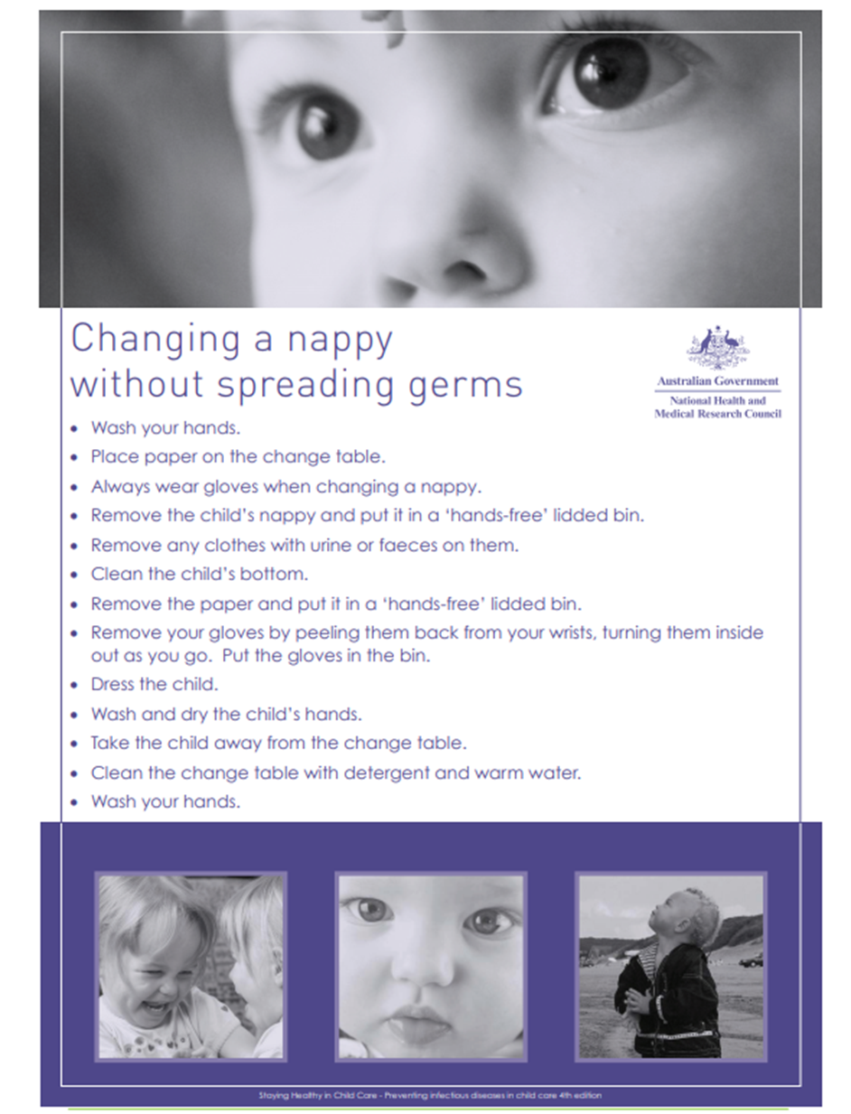

Appendix F

SAMPLE HAND WASHING PROCEDURE
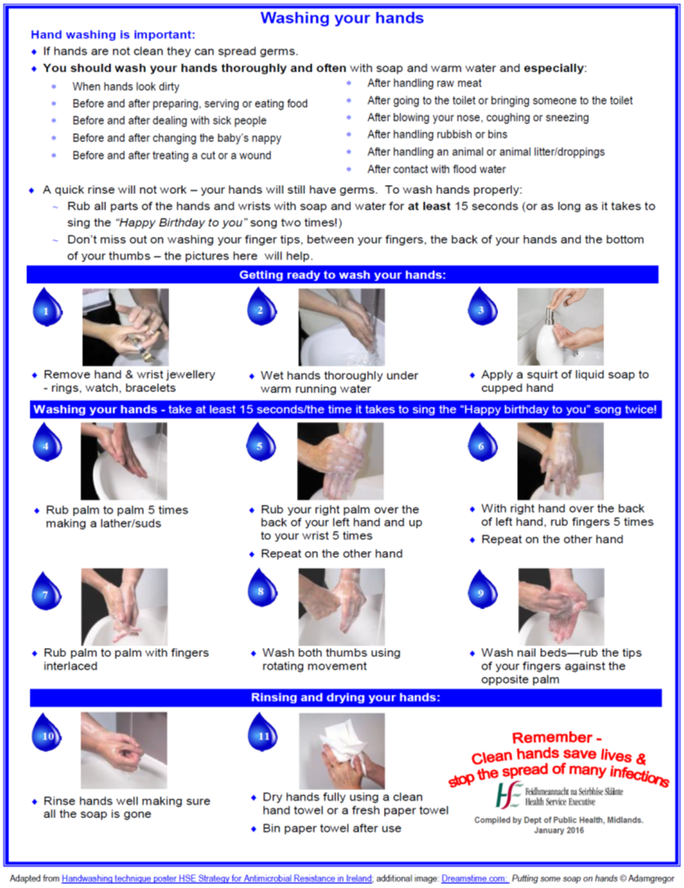

Appendix G

RESPIRATORY HYGIENE
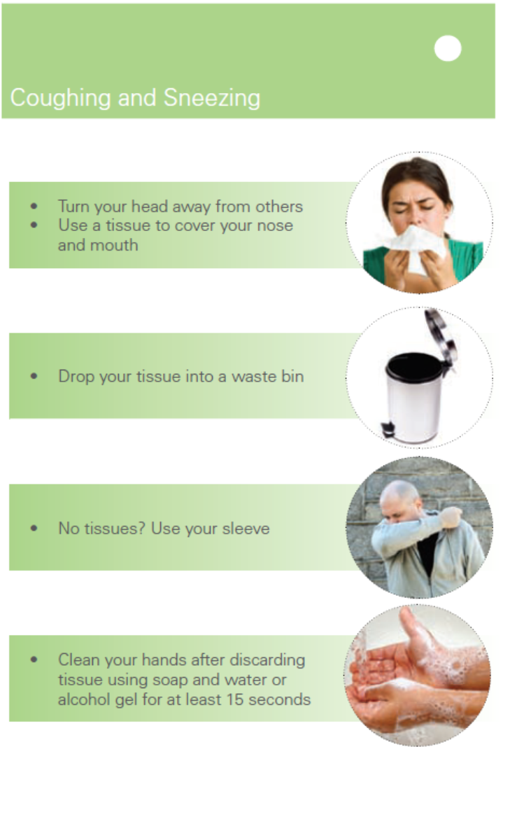

Appendix H

SYMPTOMS: MENINGITIS & SEPTICAEMIA

Appendix I

Sample Attendance and Fees Sheet.

Record arrival and departure time.
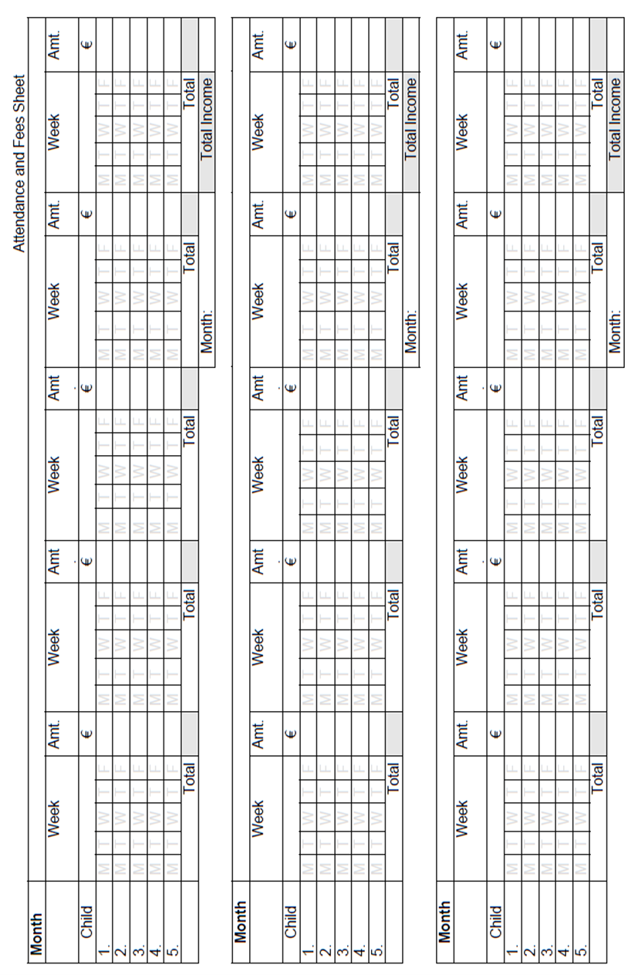
Adopted from Child Minding Ireland (2018)

Appendix K

Menu Planner
Week Number:
Day | Breakfast | Snacks | Lunch | Dinner
Monday
Tuesday
Wednesday
Thursday
Friday

Adopted from Childminding Ireland (2018)

Appendix K
Child’s Record
Name of Childminder or Service: ___________________________________________________
Child’s Full Name: ______________________________________________________________
Date of birth: ___/___/___ Sex: Female: ( ) Male: ( )
Date child commenced with Childminder: ___/___/___
Date child ceased to attend Childminder: ___/___/___
Home Address: ________________________________________________________________________________________________________________________________________________________________________________________________________________________
Change of address: ________________________________________________________________________________________________________________________________________________________________________________________________________________________
Details of Parents/Guardians
Name: (1) _______________________ (2)___________________________
Relationship to Child: (1) _______________________(2)___________________________
Home Tel no: (1) _______________________ (2)___________________________
Mobile number:(1) _______________________ (2)__________________________
Contact email:(1) _______________________(2)___________________________
Home Address:(1) _______________________(2)__________________________
Home address of parent if different from above: ______________________________________________________________________________________________________________
Who does the child live with?____________________________________________________
Do both parents have custody of the child, if not please give details:
___________________________________________________________________________
Child’s country of origin ____________________________________________________________
Parent’s country of origin: ____________________________________________________________
Child’s first language: ____________________________________________________________
Parent/Guardian’s first language: ____________________________________________________________
Work Details
Place of Work: (1) ________________________ (2) _____________________
Work contact no: (1) ________________________ (2) _____________________
Work email: (1) ________________________ (2) _____________________

Person(s) authorised to collect my child (other than the parents)
Name:(1) ________________________ (2) ________________________
Address: (1) ________________________ (2) ________________________
Relationship to child:(1) ________________________ (2)________________________
Contact no: (1)________________________ (2) ________________________
Mobile: (1) ________________________ (2) ________________________

Nominated Emergency Contacts
Name: (1)________________________ (2) ______________________
Address: (1)________________________ (2) ______________________
Relationship to child : (1)_______________(2) ______________________
Contact No: (1) ________________________ (2) ______________
Landline: (1) ________________________ (2) ______________________
Mobile: (1) ________________________ (2) ______________________
Date form filled in: ___/___/___ Information updated: 1) ___/___/___ (2) ___/___/___

Medical History
Does your child suffer from any medical conditions, illness, and/or allergies? ________________________________________________________________________
Is your child on any medication? ________________________________________________________________________
Has your child been hospitalised for any major illness or injury, if so please give details: ________________________________________________________________________
Family Doctor: ______________________________________________________________
Address: ___________________________________________________________________
________________________________________________________________________
Tel no: _______________________________________________________________________
Web Address: _________________________________________________________________

Immunisation Record (Please enter date received)

Age | Where | Vaccine | Date Received
Birth | Hospital/Clinic | BCG (TB)
2 Months | GP | 6 in 1 + PCV
4 Months | GP | 6 in 1 + Men C
6 Months | GP | 6 in 1 + Men C + PCV
12 Months | GP | MMR + PCV
13 Months | GP | Men C + Hib
4-5 Years | GP/School | 4 in 1 + MMR
In Ireland it is not a statutory requirement that children must be immunised (vaccinated) in line with the National immunisation schedule. This is a parent’s choice. It is highly desirable that children are vaccinated in accordance with the schedule unless contraindicated for medical reasons as children who are not vaccinated are dependent on “herd immunity “to protect against disease.

Vaccination protects the individual immunised who is less likely to be a source of infection to others. This reduces the risk to unimmunised individuals being exposed to infection. Thus, individuals who have not been immunised, or those who cannot be immunised, get some benefit from the immmunisation programme. This concept can also be called population immunity.
The registered provider must keep a record of immunisations, if any, received by the child; so they must be aware of children attending the service who are vaccinated and those who are not vaccinated so that those children who are not vaccinated can be best protected in the event of such an infectious disease occurring within service.
Additional Needs
Does your child suffer from any additional needs, physical/intellectual disability or allergies?
_______________________________________________________________________
___________________________________________________________________________
Please outline details and special requirements if any: _____________________________________________________________________________________________________________________________________________________________________________________
Does your child suffer from any hearing and/or speech difficulties? ________________________________________________________________________________________________________________________________________________________________________
Please outline details and special requirements if any: ________________________________________________________________________________________________________________________________________________________________________
Does your child have any specific dietary/cultural requirements? _________________________________________________________________________
Please outline details: _________________________________________________________
________________________________________________________________________________________________________________________________________________
Does your child have any fears or phobias and if so please describe?
________________________________________________________________________________________________________________________________________________
______________________________________________________________________
Additional Information
Name of siblings and/or close personal relationships in your child’s life: _____________________________________________________________________________________________
Does your child have any special talents/areas of interest? ________________________________________________________________________
Does your child use ‘pet’ language for special comfort toys? ______________________________________________________________________________________________________
Notes provided by parents concerning the above are attached to file:
Yes ____ No___

Parental Consent Form
- Emergency Medical Care
I understand that every effort will be made to contact the named guardian or next of kin in the event of an emergency, requiring medical attention. However, if none of these can be contacted I hereby authorise the Childminder to transport my child to the doctor’s surgery or to the appropriate hospital A/E department by ambulance or as is necessary and to secure the necessary medical treatment for my child. I give my permission for my child to be given appropriate emergency medical treatment.
Patient Number if the child attends any clinics/specialists in the hospital: _________________
Parent/Guardian’s signature: ________________________________ Date: ___/___/____
2. First Aid
I authorise that the Childminder trained in First Aid may administer First Aid to my child as appropriate.
Parent/Guardian’s signature: ________________________________
Date: ___/___/___
3. Antipyretic
I consent to teething gels and temperature control medication in accordance with the policy and procedures of the Childminder.
NB: Parents will always be informed when medication has been administered to their child.
Parent/Guardian’s signature: ________________________________Date: ___/___/___
4. Permission for Outings
I authorise that my child may be taken on outings/walks that may be planned outside the Childminders home. The adult/child ratio for these outings will be based on a risk assessment carried out prior to the outing taking place. I understand that all necessary precautions will be taken to ensure my child’s safety.
Parent/Guardian’s signature: ________________________________ Date: ___/___/___

5. Internet , Photo and Recording Permission
I give permission for _____________________________________________ (child’s name) to access the internet. The Internet is used only for brief periods and to support children’s learning in accordance with the childminding service policy.
I give permission for _____________________________________________ (child’s name) to be photographed or recorded. Photographs/recordings may be used for:
  - Giving feedback to parents
  - Viewing activities and progress, either currently or retrospectively;
  - Enhancing the health, welfare and development of your child;
  - Supporting the annual review of the service;
  - Identifying potential risks;
  - Inspection.
Parent/Guardian’s signature: _____________________________ Date: ___/___/___
6. Access to Pets
I give permission for my child to be in contact with or have supervised access to pets. Care will be taken to ensure that the health, safety and welfare of the children is not put at risk.
Parent/Guardian’s signature: __________________________________ Date: ___/___/___
7. Sun Cream Permission
I give permission for the application of sun cream to my child as outlined in the Childminders sun protection policy.
Parent/Guardian’s signature: __________________________________ Date: ___/___/___
8. Parent/Childminder Declaration
I have read and understand the policies referred to above. I will notify the Childminder of changes to any of the details in this form.
Parent/Guardian’s signature: __________________________________ Date: ___/___/___

Childminders signature: ______________________________________ Date: ___/___/___

Adapted from Childminding Ireland (2018)

See also Management of Infectious Disease in Childcare Facilities and Other Childcare Settings, page 72 and 74, for other examples.
Management of Infectious Disease in Childcare Facilities and Other Childcare Settings, page 75.

