Test Case Name
- Conversion of Commonplace name to actual Geofile name
- Customized parameters for the City of Richmond appear correctly

Test Case ID | 3.20, 3.20.3.11.1 | Created By | Heather Smith
Component | I/Calltaker & I/Dispatcher | Creation Date | 7/25/07 12:30 PM
Modified By |  | Modified By
Modified Date |  | Modified Date
Requirements Covered
1.3.2.4.31, 1.3.2.3.80 from original RFP

Purpose of test
- Conversion of Commonplace name to actual Geofile name
- Entries in dropdown for the field ‘Remarks’ match City of Richmond parameters
- Entries in dropdown for the field ‘Disposition Code’ match City of Richmond parameters

Input Test Data
- Valid Commonplace Name Location [@BOTTOM]
- Event Type/Subtype [ACC-INJURY - ACCIDENT WITH INJURY/ S - SEE COMPLAINANT]

- Remarks Information
- Selected Remark from dropdown [STATE POLICE NOTIFIED]
- Spreadsheet stating all items to be within the ‘Remarks’ dropdown
- Disposition Code Information
- Unit number for entering in a disposition code - 1234
- 1st code = 11/ 1st Time = 1640
- Spreadsheet stating all Disposition Codes to be within the dropdown for field ‘Disposition Code’
Test Steps
Step # | Description | Expected Outcome | PASS | FAIL
1 | Enter in valid commonplace location address [@BOTTOM] into the “Loc” field and hit <enter> or <tab> | [@BOTTOM] will be validated against database and bring up the ‘Verify Commonplace Location’ window:  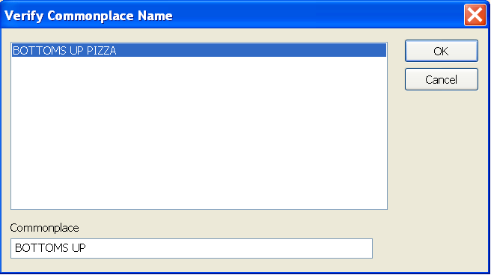
2 | Highlight on the ‘BOTTOMS UP PIZZA’ location and click on the ‘OK’ button | Commonplace name location will appear within the “Loc” field in the following format – [geofile name: @commonplace name] as shown below:
Cross streets will appear within the “Cross St.” field [S 17TH ST and S 18TH ST] showing that the address has been verified against the central database
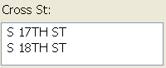

Step # | Description | Expected Outcome | PASS | FAIL
Parcel ADDRID will be displayed within the ‘Remarks’ textbox area:
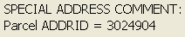
 |  | Map display will zoom in to where 1700 DOCK ST is located
3 | Select the [ACC-INJURY - ACCIDENT WITH INJURY] event type from “Type” field dropdown | Event type [ACC-INJURY - ACCIDENT WITH INJURY] will appear within the “Type” field
4 | Select the [S - SEE COMPLAINANT] subtype from the “Subtype” dropdown | Event subtype [S - SEE COMPLAINANT] will appear within the “Subtype” field
Appropriate agencies will be shown as assigned within the “Agency Response” window including which fire district, dispatch zone, police precinct, police sector – agencies will be assigned corresponding to the event type/subtype selected from the dropdowns [screen shot shown is for example purposes only]:
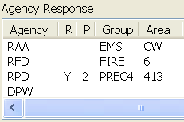
5 | Click on the arrow beside of the ‘Remarks’ field | Listing of all available remarks will appear:  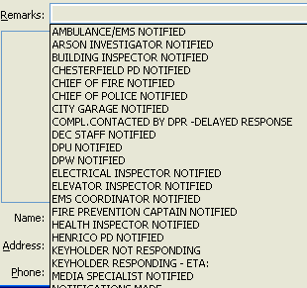
Step # | Description | Expected Outcome | PASS | FAIL
6 | Validate that all required remarks (based on City of Richmond parameters) are available and selectable within the dropdown list | All preset remarks which were set up in the CAD DBM will be available as selectable options within the list:
7 | Select the [STATE POLICE NOTIFIED] remark from “Remarks” dropdown and hit <tab> or <enter> | Remark selected [STATE POLICE NOTIFIED] will appear within the textbox directly below the “Remarks” field:

Step # | Description | Expected Outcome | PASS | FAIL
8 | Hit the <Enter> key | The selected remark of “STATE POLICE NOTIFIED” will appear within the text area for remarks:  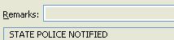
9 | Within the ‘Remarks’ field, enter the following text:  “FREE FORM TEXT AS WELL” | “FREE FORM TEXT AS WELL” will appear within the ‘Remarks’ field:
10 | Hit the <Enter> key | The previously entered text [“FREE FORM TEXT AS WELL”] will now appear within the text area for remarks under the previously entered remark of “STATE POLICE NOTIFIED”:  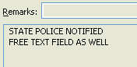
11 | Click on the “Supp Info” button: | “Supplemental Information” window will come up separately:  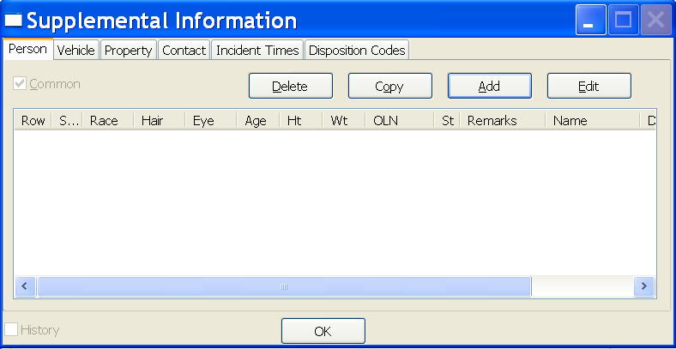

Step # | Description | Expected Outcome | PASS | FAIL
12 | Select the “Disposition Codes” tab | The “Disposition Codes” tab will appear within the “Supplemental Information” window:  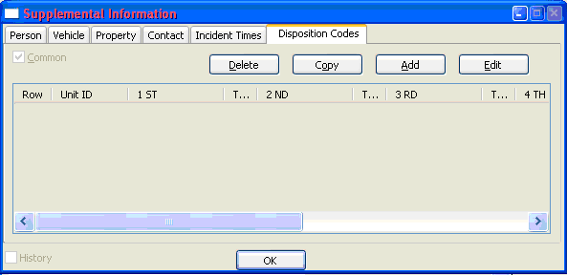
13 | Click on the “Add” button | The separate window for entering “Supplemental Information” dealing with disposition codes will come up:  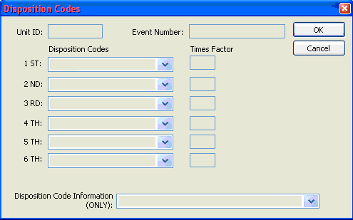

Step # | Description | Expected Outcome | PASS | FAIL
14 | Enter ‘1234’ as the unit information within the “Unit” field | ‘1234’ will appear within the “Unit” field:
** | Event Number is not pre-filling with event number created | Event number should be pre-filled with event number that was created when event was accepted??
15 | Click on the arrow beside of the ‘1^{ST’} field | A list of available disposition codes will display:  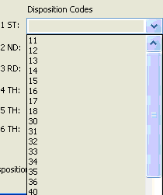
16 | Validate that the disposition codes listed within the dropdown match those setup with the CAD DMB for the City of Richmond | All disposition codes listed will match those setup in the CAD DMB per the City of Richmond parameters:
17 | Select ‘11’ as the 1st disposition code from the dropdown in the “1st” field | ‘11’ will appear within the “1st” field:  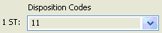
Step # | Description | Expected Outcome | PASS | FAIL
18 | Enter ‘1640’ as the 1st desired disposition code time into the “Times Factor” field to the right of the “1st” field | ‘1640’ will appear in the first “Times Factor” field:  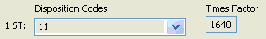
19 | Click the arrow beside of the field ‘Disposition Code Information’ located at the bottom of the window | A listing of all available disposition codes will appear within a dropdown:  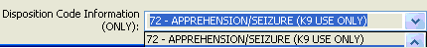
20 | Validate that all listed disposition codes match those defined as City of Richmond parameters | All disposition codes will match those defined specifically for the City of Richmond and will be available as valid selections:
21 | Select ‘72 - APPREHENSION/SEIZURE (K9 USE ONLY)’ as the desired disposition code information from the dropdown | ‘72 - APPREHENSION/SEIZURE (K9 USE ONLY)’ will appear within the “Disposition Code Information” field:
 |  | An asterisk ‘*’ will appear beside of the “Disposition Codes” tab title indicating that there is information there:
22 | Click on the “Cancel” button to close the window: | Window for adding information regarding disposition codes will close
23 | Click on “OK” at the bottom of the main “Supplemental Information” window | Main “Supplemental Information” window will close

Overall Outcome
Requirements 1.3.2.3.25, 1.3.2.3.36, 1.3.2.3.54, 1.3.2.3.67, 1.3.2.3.69, 1.3.2.3.80, 1.3.2.4.31 needs should be met.

Results
# | Date Run | Test Performed By | Results
1
2
3
4
5
6
7
8
9
10

Customer Sign-Off_________________________________________________ Date____________________________

