Business Requirement Gathering Template

Claromentis Generic Business Requirement template for Web application development or business tool



1. Objectives & Purpose

1.1 Describe objectives and main purpose of this application/tool

1.2 Describe how this application can help your business

1.3 Who are the stakeholders, and what are their roles and responsibility within this application

e.g: Administrator, Students, Clients, Partner.....

Stakeholders Name | Roles & Responsibilty
Administrator | Oversee overall system...
Product manager | Managing product catalog...
Student | main customer

1.4 List the stakeholders “pain-points” and specify problem you are trying to solve.

Stakeholder | Pain-Points

1.5 Describe your current solution if exist? and why it is not adequate

1.6 Are there similar application available?, state reasons you feel these are not viable solution.

Application name | Company | Pros | Cons
MS Excel | Microsoft | Flexible | Not easily accessible and no audit trails

1.7 Create list of Functional requirement and indicate the priority (Must Have, Should Have, Could Have, Nice to have)

e.g:

Stakeholder | Function | Priority
Customer | Place an order and pay for the order | Must Have
Customer | Check order status and amend order | Should Have
Product Manager | Upload and create new product | Must Have
Product Manager | Export customer list into Excel | Nice to have

1.8 Terminology, describe any specific terminology used in this application.

Terminology | Description

2. Technology

2.1. How do you envisage this application will be delivered to your audience?

e.g: via Web, Mobile/ Tablet apps ?

2.2. Is there any particular technology platform you are currently using and if it has impact to this deployment of application ?

e.g: Exclusive to Apple devices...

2.4. Hardware: is it going to be hosted in the server locally or in the cloud

3. Budget and Timescale

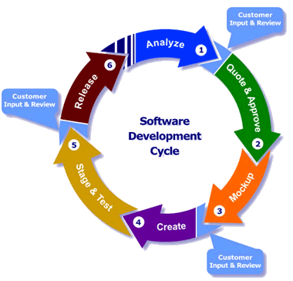

Typical Software Development Process

3.1. What is your rough budget for this application

3.2. Timescale

4. Miscellaneous

2.3. Is there any IP, Patents in which we'll need to be aware of

2.4 Who is the subject matter expert for this project

2.5 List project team contact and what are their roles and responsibility to this project

Name | Company | Email | Roles & Responsibility
Claire Matthew | Claromentis | name@email.com | Project Owner
 |  |  | Client
 |  |  | Business Analyst
 |  |  | Information Architect
 |  |  | Subject Matter Expert

4. Wireframe

Sketch the wireframe here if you have any visual idea.

