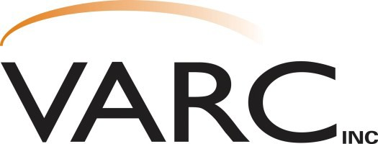
Capability Statement

Contact: Eric Filter
District Manager
608-637-3934 Ext. 335
Fax: 608-637-7016
efilter@varcinc.com

Corporate Office
1133 Nelson Parkway
Viroqua, WI 54665
608-637-3934

Sauk Division
220 Wengel Drive
Reedsburg, WI 53959
608-524-3716

Richland Division
111 W. Robb Road Richland Center, WI 53581
608-647-3850

Juneau Division
925 W. State St. Mauston, WI 53948
608-847-4675

History and Growth

VARC, Inc. is a value-added service provider to major corporations throughout the Midwest. Over the past 38 years, through very strong and steady growth, we have expanded from one small op- eration to a world class assembly and packaging fulfillment company with four locations in West Central Wisconsin. VARC, Inc. has over 125,000 square feet of production space and 60,000 square feet of warehousing, giving us the ability to perform a wide range of services. Examples of our diverse range of capabilities include, but are not limited to:
Packaging Assembly Additional
- Blister Sealing • Cable and Wire Harness • Inspection/Sorting/Rework
- Strapping Assembly • Inventory Control
- Heat Sealing • Collating • Label Printing
- Shrink Wrapping • Sanding/Buffing • Second Shift Capacity
- Autobagging • Hand Soldering • 400 Production Employees
- Stapling • Drilling/Deburring • ISO 9001 Process Ready
- Polybagging • Ultrasonic Welding • P.O.P. Displays
- Custom Packing Programs • Manual Printing/Binding • Sewing
  - Electronic Board Assembly • Weigh Counting and Testing

Why VARC?
When you work with VARC, Inc., you gain a partner who:
- Consistently meets or exceeds customer deadlines, production goals and delivery dates.
- Is a solution to help customers deal with spikes in demand.
- Assists in setting priorities to better serve long term and strategic goals
- Currently incorporates Management Resource Systems such as SAP and Navision.
- Has a proven reputation for high quality, efficiency, innovation, creativity and excellence.
People

Enough cannot be said about our employees at VARC, Inc. The staff is knowledgeable, committed, and proud of the work we do. Our management team and production workers all strive to main-
tain the success for our customers.

Quality Assurance

VARC takes pride in our very thorough and extensive Quality Assurance Program. This has been the cornerstone of our success and has separated us from our competitors. This system enables us to meet customer specifications and maintain being “Committed to Quality and Excellence”.

References and Quality Assurance System Available Upon Request

“Where Quality and Innovation Meet”

