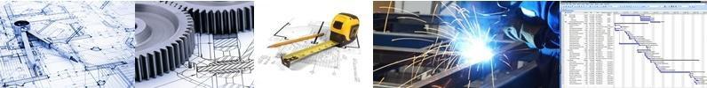
CAPABILITY STATEMENT
Innovative Engineering and Project Management Solutions
Any industry! No job is too small!
Downstream Consulting is a group of multidisciplinary, consulting engineers providing engineering and technical services with a strong focus on safety, sustainability and innovation.
Our Principals and Associates have extensive experience across all engineering disciplines with combined experience of over hundred years.
We bring in combined local and global knowledge for the benefit of Australian industries as per the local conditions and Australian industry regulations. We put clients first.
Services
We provide engineering consultancy and execute project and engineering management for small to medium projects. Downstream Consulting will build an appropriate engineering capability for your technical requirements.
We provide following services:
Engineering, Design and Analysis
Civil and Structural
Design of foundations and buildings (industrial and residential) Earthworks and structural design
Analysis of existing structures 3D model development
Peer review (all disciplines)
Mechanical and Piping
Mechanical, piping and pump calculations Plant design 2D and 3D Analysis Pressure vessels
Materials handling Rotating equipment
Electrical, Instruments and Control
Electrical equipment design and selection Power reticulation and distribution
Substation, switchboards and switch-rooms design
Process and Metallurgical
Process flow sheet development
Metallurgical test work development and supervision

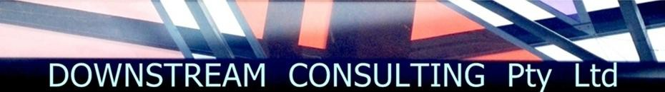
Process design
Management
Project Management
Study and Project management
Project cost estimate development and review Project reviews and due diligence
Risk and quality management Contract management
PMC or Owner’s engineering Commissioning management Operational readiness Construction management Project economic evaluation
Project Controls
Cost management Planning and scheduling Change management Project reporting
Quality management and control
Improvement services
Business process improvements
Develop and implement business management processes Database development and management
Benefits
•
•
•
Maximise value for your money through efficient engineering and project delivery Quick response time
Optimally engineered and clearly defined options, costing and suggestions making investment decisions on new engineering projects, expansions modifications of existing installations
No surprises – predictable project outcomes
Smooth interface and minimum disruption with your existing operations
for or
•
•
We will hand-pick multi-tasking individuals or develop small engineering and project teams to produce innovative, cost effective solutions for your technical requirements.
Contact us to develop your scope of services and estimate to execute the work at:
John Ganser:
+61 (0) 417 971 681
Email: contact@downstreamconsulting.com.au
Jigar Sheth:
+61 (0) 403 413 889
Web:
www.downstreamconsulting.com.au

