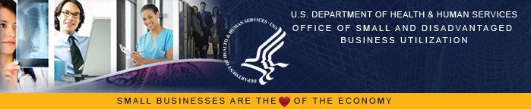
Consulting • Technology • Managed Services
Business Consulting, Inc. provides strategic consulting technology
services and managed services to commercial, not for profit and government organizations. Our Consulting can mobilize the right people, skills and technologies to help organizations improve their performance.
Managed Services
Many companies these days choose to focus on their core strengths and outsource certain business processes. If you choose to go that route, BCI can help you in the following areas;
•
•
•
•
•
Business Process Outsourcing
Application Outsourcing Resource Management Help Desk Services Infrastructure Outsourcing
As a Minority Owned Small Business with SBA 8(a) & HUBZone
certification, BCI is committed to excellence and creating innovative and flexible solutions for our State and Federal clients.
Federal Certification
What sets BCI apart from the competition?
➢
➢
➢
➢
➢
Our People
Performance-Based Processes Integrated Solutions Teams Client Relationship Management
Strategic Mix of Technology and Business
•
•
•
SBA – 8(a)
SBA – HUBZone SBA – SDB
Contract Vehicles GSA IT Sched-70 GS-35F-1234
District of Columbia MOBIS Supply Schedule-(DCSS)
State of Maryland-(CATS#)
CORE CAPABILITIES
Our technology experts and business professionals analyze research, design and implement solutions in the areas of:
➢
➢
➢
Consulting
Technology Managed Services
State Certifications
District of Columbia
•
•
WMATA-(DBE)
District of Columbia-(CBE)
Consulting
Our Consulting Services focus on integrated solutions designed to enhance the performance of your business. By incorporation industry best practices into your business processes and management strategies, we can help you stay ahead of the competition and better serve your customers. Our services include;
Maryland
•
•
MDOT-(MBE/DBE)
Small Business Reserve (SBR)
Virginia
•
•
•
•
•
•
Business Strategy & Planning Support
Change Management & Facilitation Support
CMMI Process Development and Assessment Services Security Assessment
Financial/Statistical Analysis Training
•
•
MWAA-DBE & LDBE
VA-SWaM
Local Government
•
•
Prince George’s County, MD-(MBE)
Howard County, MD-(MBE)
Technology
Our Technology Services focus on developing robust, secure and stable technology solutions for your business. By incorporating common sense solutions into seemingly daunting deliverables, we can ensure at the start of the project that we will safely deliver the product to completion. Our services include;
Quasi Government
•
Washington Suburban Sanitary Commission-(WSSC)
Non-Government
•
•
•
•
•
•
Application & Web, Design & Development
Commercial Off the Shelf (COTS) Integration Data Cleansing & Conversion
Database Design, Development, & Maintenance Architecture Solutions
Verification & Validation Service
•
NMSDC-The Minority Supplier Development Council-
MD/DC MSDC (MBE)
US Pan Asian American Chamber of Commerce (USPAACC-MBE)
•

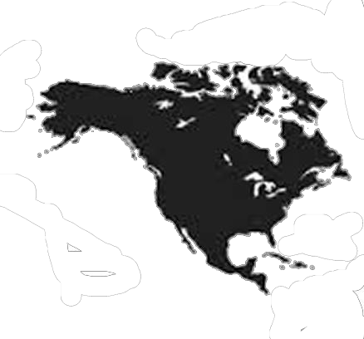
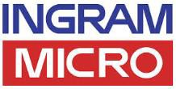
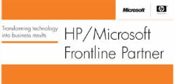
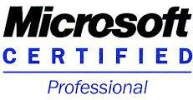

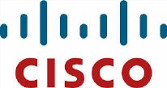


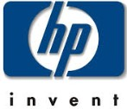

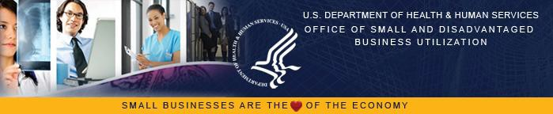
Consulting • Technology • Managed Services
SAMPLE – MAJOR CLIENTS
SAMPLE – Partners / Authorized Reseller
❖
❖
❖
❖
Top Secret SCI SSBI Cleared staff
Certified SAP software staff Certified Expert Level ITIL V3 staff Certified ISO 2000 and 9001 firm
NORTH AMERICAN INDUSTRY CLASSIFICATION SYSTEM (NAICS)
519130 – Internet Publishing and Broadcasting and Web
Search Portals
541320 – Landscape Architectural Services 541330 – Engineering Services
541430 – Graphic Design Services
541511 – Custom Computer Programming Services
GENERAL INFORMATION
Registered Company Name:
DBA:
Year Incorporated: State of Incorporation: Corporation Type:
D-U-N-S Number: CAGE Code:
Business Consulting, Inc.
BCI
January 15, 2008 Delaware Subchapter S 123456789
541512 – Computer Systems Design Services
541513 – Computer Facilities Management Services 541519 – Other Computer Related Services
541611 – Administrative Management and General Management Consulting Services
541612 – Human Resources Consulting Services 541618 – Other Management Consulting Services 561311 – Employment Placement Agencies
561312 – Executive Search Services
CONTACT INFORMATION
Voice:
Fax: Email: Web:
(202) 555-1234
(202) 555-4321
info@bci.com www.bci.com
Commercial
Government
- Accenture

- Department of Consumer & Regulatory Affairs, DC
- RricewaterhouseCoopers
- Choice Hotels International
- Department of Employment Services, DC (DOES)
- BearingPoint
- Baltimore Gas & Electric
- AstraZeneca
- Virginia Power
- Midwest Consulting
- iRise
- Maryland Department of Transportation (MDOT)
- International Air Trans- portation Authority (IATA)

- Office of Chief Technology Officer, DC (OCTO)
- WMATA
- V-Empower
- Optimal Solutions & Technology

- Office of Chief Financial Officer, DC (OCFO)
- DC Public Schools (DCPS)

