
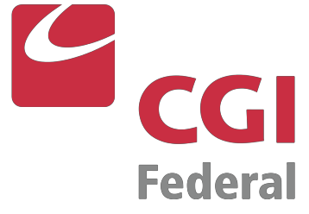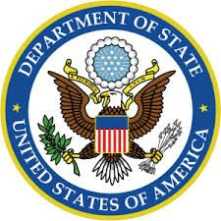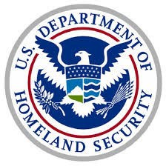
Woman-Owned Small Business
CAGE Code: 69LT4 DUNS: 967015855
NAICS Codes:
541611
Administrative Management & General Management Consulting Services
541219
Other Accounting Services
541519
Other Computer Related Services
541612
Human Resources Consulting Services
541618
Other Management Consulting Services
541990
All Other Professional, Scientific & Technical Services
561312
Executive Search Services
561320
Temporary Help Services
561499
All Other Business Support Services
561611
Investigation Services
CAPABILITY STATEMENT
Allied Government Solutions, Inc. (AGS) is an SBA HUBZone-Certified, Woman-Owned Small Business that provides comprehensive solutions and support services to federal
government agencies (classified/non-classified contracts), prime contractors, state
governments and local municipalities. AGS is a highly respected, service-oriented business
built on strong client relationships, tailoring its services to meet its customers’ specific needs.
Core Competencies
•
•
•
•
•
•
•
•
Administrative Support Services
Staff Augmentation & Surge Recruitment HR Consulting & Personnel Management
Security Clearance Processing Key Personnel Recruitment
Professional & Accounting Services Records Management
Mailroom Operations
SCA Contract Management & Compliance •
•
Operations & Management Consulting
Past Performance/Differentiators
•
•
Hired over 2,000 employees at 20+ locations nationwide in 12 different states since 2000
Performance on DoS Passport Support Services contract since 2000, and DoS Book Personalization Facility contract since 2011
Successfully onboarded 90 FTE’s within a 30-day transition period in 2016 on DHS/USCIS National Benefits Center Records Operations contract
Timely delivery of 120 cleared employees within a 3-month period for annual H1B Visa Cap on DHS/USCIS Service Center Operations Support Services contract since 2015
Experience with establishment and adherence to Collective Bargaining Agreement (CBA) under DoS Visa Support Services contract
20 years’ experience managing employees in Service Contract Act (SCA) positions
Received SBA Administrator’s Award for Excellence
•
•
•
•
•
CONTACT INFORMATION
Allison Aboody
President (800) 559-2611
aaboody@alliedgov.com
Roy S. Aboody
Chief Executive Officer (603) 234-6070
raboody@alliedgov.com
Tricia-Marie Closs Director of Operations (800) 559-2611
tcloss@alliedgov.com
90 Washington Street, Suite 211 • PO Box 1275 • Dover, NH 03821 • Phone: 800-559-2611 • Fax: 603-772-1930 • www.alliedgov.com
Clients

