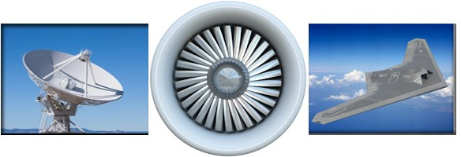
CAPABILITY STATEMENT
OVERVIEW
Established in 1992, WestWind Engineering, Inc. provides full service staffing and payroll solutions for Government, Commercial and Private Sectors.
“Our strength is our people and the experience they bring to your projects with their extensive background in information technology, aerospace and defense engineering and management.”
CAPABILITIES
COMPANY DATA
WestWind Engineering has the very best professional staff of engineers, scientists and managers available to you for:
WestWind Engineering has earned a reputation built upon producing results that not only meet, but surpass expectations.
➢
➢
➢
System Engineering and Integration Project Management, Planning and control Electronic, Optical and Mechanical Design, Development and Test
Software and Information Systems
Quality, Reliability and Safety Planning and Implementation
Contract and Subcontract Management Capture, Proposal, Red/Blue Team Support
➢
➢
➢
➢
➢
➢
➢
➢
SBA Certified SDB
SBA Certified 8(a) Business SBA Certified EDWOSB Supplier Clearinghouse WBE
GSA Schedule – 736-5 - GS-02F-100AA
Incorporated in California in 1992 DUNS – 007911907
Cage Code – 0VSK6
➢
➢
➢
➢
NAICS
PROGRAMS
WestWind Engineering primary NAICS:
WestWind has contributed subject matter expertise towards many successful aerospace and defense programs including:
➢
➢
➢
➢
➢
➢
561311 – Employment Placement Agencies 541214 – Payroll Services
541330 – Engineering Services
541511 - Computer Programming Services 541611 – Admin/Gen Management Consulting 541614 – Professional, Scientific & Technical Services
541712 – R&D in the Physical, Engineering, and Life Sciences (except biotech)
➢
➢
➢
➢
➢
➢
➢
ABL AEHF AMP AP-910
Argon B-2 CEV
➢
➢
➢
➢
➢
➢
➢
COIL F-35
GOES-R HESSLT ISAT JIMO JWST
➢
➢
➢
➢
➢
➢
➢
NPOESS SBIRS SBR STSS TDRSS UCAS-D UCLASS
➢
CUSTOMERS
WestWind’s past and present customers include:
➢
➢
➢
➢
➢
BAE Systems Eastman Kodak Good Engineering Hughes
JPL
➢
➢
➢
➢
➢
Maxima Systems NASA MFFC
Northrop Grumman Optimal Energy Raytheon
CONTACT
Address - 461 W. 6th St., Suite 226, San Pedro, CA 90731 – Tel (310) 831-3454 / Fax (310) 540-7172 Mary Anne Graves – ma.graves@westwind111.com

