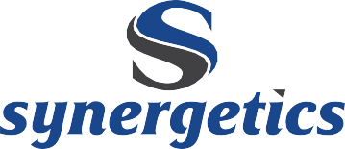
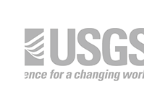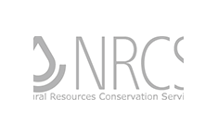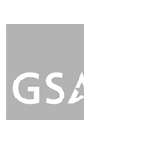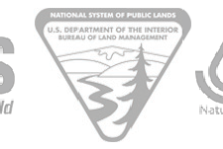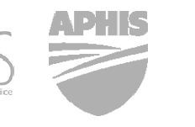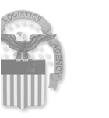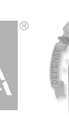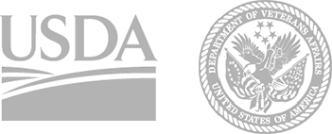
CAPABILITY STATEMENT
Synergetics is a professional services company that provides strategy, custom information technology, information security, consulting, digital, technology, operations and R&D services. Synergetics builds government and enterprise data solutions, ranging from business process optimization to mission-critical software systems. Our cutting-edge solutions are used to detect earthquakes worldwide, track food supply chain information and manage defense logistics data processing across the globe.
DUNS: 966870115
CAGE: 1FBW9
GSA Schedule 70
Number: GS-35F-0389K
GSA 8(a) STARS II GWAC
Constellations I & II, Functional Areas 1 & 2
Number: GS-06F-0780Z
COMMITTED EXPERTS Synergetics principals are involved in each engagement to add oversight and commitment to every project’s success. We enable our clients’ transformation into customer-centric digital organizations. Our work extends beyond ideas into tangible outcome-driven results.
INDUSTRY VETTED Synergetics is authorized to provide managed cloud services on leading FedRAMP CSPs, including Microsoft Azure Government and Amazon AWS
GovCloud. We currently provide FedRAMP management services to DoD and have been approved to operate on DLA’s exclusive Azure Government region.
With Contract Vehicle GSA 8(a) STARS II, the U.S. Federal Government may award Synergetics task orders under the
$4 million competitive threshold on a sole-source basis.
No protests on orders under $10 million.
per Section 8(a) of the Small Business Act (15 U.S.C. 637 and FAR 19.8).
“Costs were always below or within
budget at all times, contractor even suggested ways to streamline and cut costs, amazing!”
“Contractor was consistently
ahead of milestone completion times. [Synergetics] production and processes never missed a deadline.”
– J. ROGERS, FED LOG PM, DLA INFORMATION OPERATIONS
LOCAL ACCOUNTABILITY With oﬃces in Colorado, Illinois, Michigan
and Washington DC, Synergetics is prepared to respond quickly and in person.
COMPREHENSIVE QUALITY Synergetics’s quality is supported by industry- leading frameworks, such as the CMMI Level 3 appraisal and ISO 9001:2015 quality management system, along with rigorous client feedback assessments.
FLEXIBLE ARCHITECTURE Synergetics builds cross-platform,
cross-device and automated deployment systems. We oﬀer COTS solutions for input interaction testing (i.e. keyboard, mouse) to non-technical user operated database solutions. Our software can run anywhere, on any device type.
SET-ASIDE PROGRAMS
» SBA 8(a) Program Certified
» Minority-Owned Business
» Small Business
» Small Disadvantaged Business
CERTIFICATIONS
» CMMI Level 3 Appraisal
» ISO 9001:2015 QMS
» ISO 8000-110:2009 Data Quality
INDUSTRY CONNECTIONS
» Microsoft Certified Partner
» Apple Developer
» Oracle Partner
» Microsoft .NET
» Microsoft SQL Server
» Microsoft Azure Government
» Amazon AWS GovCloud
NAICS CODES
Software Publishers
Data Processing, Hosting, and Related Services
All Other Information Services Custom Computer
Programming Services
Computer Systems Design Services
Computer Facilities Management Services
Other Computer Related Services Administrative Management
and General Management Consulting Services
Process, Physical Distribution, and Logistics Consulting Services
511210
518210
519190
541511
“[Synergetics team] are always cooperative, and often go above and beyond what is required.
Where many contractors will only follow the exact word of the contract, [Synergetics team] applies logic and common sense to work to the intent of the contract.
They are very concerned about making sure customers are taken care of, and happy with the results.”
– J. MICHAEL, DOD, DLA, LEAD CONTRACT SPECIALIST
541512
541513
541519
541611
541614
© Synergetics, Inc. www.synergetics.com 970-498-9723 contact @ synergetics.com
1520 South College Avenue, Fort Collins, CO 80524

MISSION SUPPORT SERVICES
PROGRAM, PLANNING
& MANAGEMENT SERVICES
INFORMATION MANAGEMENT
»
»
»
»
»
»
»
»
»
»
»
Field Support Services
Systems Engineering Lifecycle Support Managed Cloud Services (FedRAMP) Research and Development (R&D) Modeling and Simulation
Logistics Data Syndication and Dissemination Engineering
Operations Support Staﬃng
Virtualization Support
IT Infrastructure Support
»
»
»
»
»
»
»
»
»
»
Enterprise Architecture & Technology Support COTS Enterprise Database Solutions Responsive Web/Mobile Solutions
DevOps, Release Management & Monitoring Business Application Services Support Systems Integration and Exercise Support Database Design, Development, DaaS System and Database Administration
LAN/WAN Management Disaster Planning & Operational Continuity Support
Software Technology Demonstration/Transition Conﬁguration Management & Standards Support Health IT Support Services
Social Networking & Collaboration Services Knowledge and Content Management Services
Quality Assurance Services, Automated Testing, User Acceptance Testing, TDD
»
»
»
»
»
»
»
»
»
»
»
Administrative and Operations Support Business Process Reengineering Program, Fiscal & Acquisition
Planning and Support
Program and Budget Documentation Budget/Management Analysis Change Management
Cost Estimating and Analysis Data Analytics
Earned Value Management Enterprise Resource Planning
Federal Sustainability Compliance Planning and Management
»
»
»
»
»
»
CYBERSECURITY SERVICES & SUPPORT
ENTERPRISE CUSTOMER SERVICE
»
»
»
»
»
»
»
»
»
»
»
»
»
Cybersecurity Compliance Information Assurance
NOC/SOC Cybersecurity Services Risk Assessment and Mitigation Penetration Testing
Intrusion Detection, Analytics, Monitoring Incident Handling and Mitigation
Digital Forensics SIEM Monitoring
DIACAP to RMF Transition and ATO FISMA Assessment Services
IV&V and Software Testing
24/7 Network and Security Operations and Data Center Support
»
»
»
»
»
»
»
»
»
»
»
Help Desk Services
Service Desk Management (ITIL v.3)
IT Service Management (ITSM) Development and Deployment Services
Desktop Support and Application Support Request, Incident & Problem Management Services
Telecommunications Support Services SharePoint Administration Support Services Business Intelligence/Report Writing
Metric & Service Delivery Analysis and Development
Conﬁguration Management & Inventory Database Management
On-Boarding Support Services
TRAINING SERVICES
»
»
Computer-Based Training (CBT) Development Development of Project-Speciﬁc Training Policies, Procedures, and Standards
Instructional System Design Course Design, including Virtual Classroom Delivery
Curriculum Development
Training Assessment Development and Delivery Services Competency Modeling
»
»
»
»
»
CLIENT TESTIMONIALS
Exceptional CPARS rating for over 20 years
“Quality was always stressed by both my staff and the [Synergetics team]. There is no margin for error in some of the projects we have. Contractors take quality seriously and pride themselves in their work and their zero quality errors.”
“Contract team has always immediately notified me of issues/potential problems. Upon discovery of the issue they worked relentlessly, no matter the day of week or hour of the day to ensure problem was resolved.
All the key management staff were responsive and available 24/7, exceeding our qualifications and requirements. Their team shared diverse and rich knowledge, enabling support on all echelons. All my staff would attest to the enthusiastic support they provided for both the team and customers alike.”
“[Synergetics team] were clear in identifying the company size, assets and advantages. Their business arrangement and ability to subcontract additional personnel to their team gave them all the great personnel aspects of working with a small company yet asset availability of a large company. I feel they are truly prepared to execute and deliver, regardless of the project scope.”
-J. Rogers, FED LOG PM, DLA Information Operations
“[Synergetics team] consistently produces a quality product that exceeds expectations. Any problem or program bug/error is addressed expeditiously to ensure that the product exceeds the warfighter’s needs. They are innovative in overcoming any obstacles that arise, and are flexible as government processes and procedures present ever changing challenges. Additionally they eagerly make suggestions for changes that will benefit the product, process, and warfighter.”
“Given what I know today about the contractor’s ability to perform in accordance with this contract or order’s most significant requirements, I would recommend [Synergetics’s team] for similar requirements in the future.”
– J. Michael, DoD, DLA, Lead Contract Specialist
© Synergetics, Inc. www.synergetics.com 970-498-9723 contact @ synergetics.com 1520 South College Avenue, Fort Collins, CO 80524

