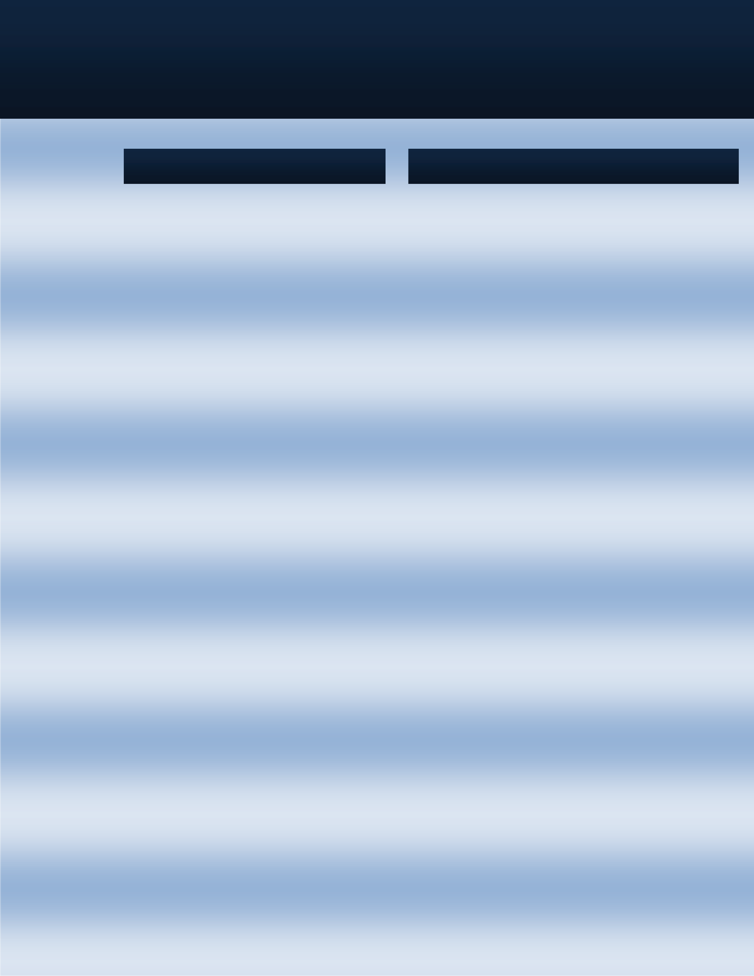
An 8(a) Janitorial and related building service company
Capability Statement
http://www.eagleproclean.com
Eagle Pro Clean
I am very pleased to send you the latest copy of The Harkins Header, which features your company inside the front cover as having excelled on one or more of our projects.

We are proud of our commitment to quality and excellence, and commend you and your management team for your dedication to those principles.

Please pass on our congratulations for a job well done to your project team. All of us at Harkins Builders look forward to many more successful projects with your firm in the future.

HARKINS BUILDERS, INC.
Richard M. Lombardo President/CEO
Socio-Economic Certifications:
We are Socio -Economic 8(a) Certified as, Hispanic American Owned, Minority-Owned business, SWaM, and Small Business. We are active members of the BSCAI (Building Services Contractors Association International) IWCA, (International Window Cleaning Association), CABSC (Capitol Association of Building Service Contractors) and following their ethical and safety guideline in our performances.

Work Area
DC - DISTRICT OF COLUMBIA MD - MARYLAND VA – VIRGINIA

FDA
MD Bldg 61 New Hampshire Ave.
Final Clean 1,100 SqFt Finished Office bldg Int/Ext Wind & Atrium
QUANTICO BASE
The Basic School P370 - P-546 - P-555-619- P547-565
OCS Headquarter - Mess Hall P-625

GSA
Tenant at Founders Square: Janitorial/Final Cleaning tenant build out Offices- Int Windows

FDA
MD Bldg 32
Janitorial/Final Cleaning 1,400 Finished Office bldg Int/Ext Wind & Atrium

GSA FDA CBER
Labs at White Oak Janitorial/Final Cleaning Offices + Int/ext Windows 1,100.000 SqFt office Bldng

Commercial
700 sixth street Washington DC- Janitorial/Final Cleaning 12 Floors Core Building- Interior Ext Windows

Mason Inn Hotel Janitorial/Final Cleaning. George Mason Hotel @ Conference center

700 Second Street NE Wah DC Janitorial/Final Clean Station Place Buildings 3 and 2 - SEC

Eagle Pro Clean is an 8(a) certified company and a U.S Green Building Council Member. Established in 2006 by Oleg Otero. Close customer relations and adjusting to customer's
needs has made Eagle Pro Clean a fast growing company. We provide janitorial and related building maintenance services. We are a solution oriented company dedicated to ensuring that our clients receive only the highest degree of service while getting the best value for their money.

Our promise to you is 100% Satisfaction Guarantee. we offer, Commercial, Retail, general building maintenance, Final Construction Cleaning, Facilities management services, Warehousing, Garage and side walk pressure wash, Landscaping and grounds maintenance, Floor maintenance, plus any janitorial and related building maintenance services. Our specialist technicians use the most- advanced equipment and environmental friendly "Green" products.

PAST GOVERNMENT PERFORMANCE

PROFILE AND CORE COMPETENCIES

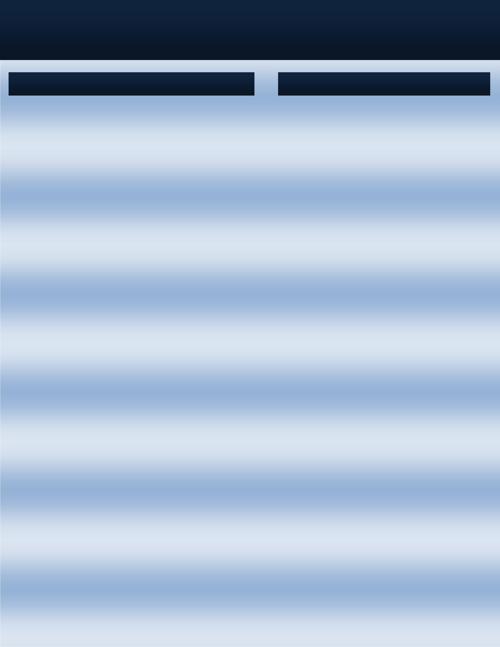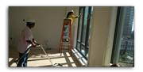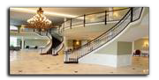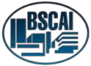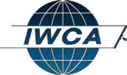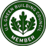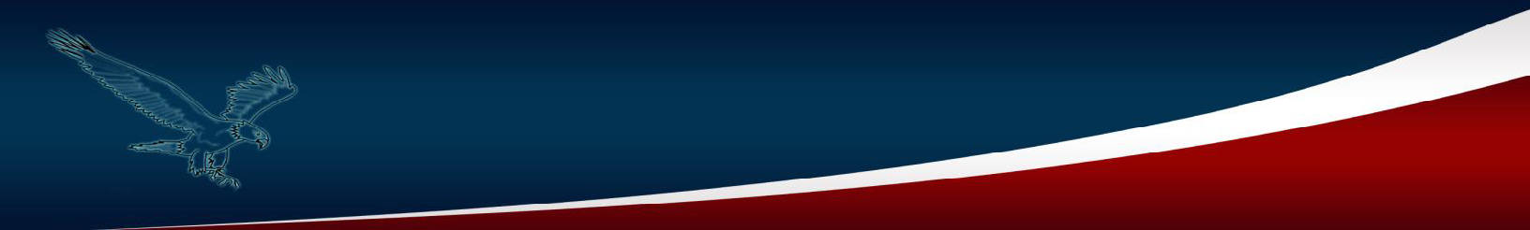
Eagle Pro Clean Is Located in Stafford VA, with Services
in Virginia, Washington DC and Maryland. We are Socio-
The difference comes with our attitude towards the customer and our
standard of performance. Having been in this business for more than 7 years we apply our experience so that the customer feels a lot less hassle. There will always be issues but our Account Managers take immediate control of the situation thus resolving the matter in a professional manner
Economic
Certified
as: Hispanic American Owned,
Minority-Owned business, Small Business
We offer Commercial, Retail, Janitorial services, Final
Construction Cleaning, Garage /side walk pressure wash
cleaning, Carpet and Upholstery Cleaning,
Building services/maintenance
and
Other
Eagle Pro Clean is an Eco Friendly Building service company. We strive
to perform Green Cleaning. (Cleaning to protect health without harming the environment). The goal is to reduce pollutants spread throughout your facility and to promote indoor air quality.
Our Mission
To be the leading provider of the highest quality Building services solutions by achieving satisfaction delivered through competency and professional integrity.
Our Vision
Become the benchmark in the integrated building services service by sample
CAGE: 6D2L2
DUNS: 785120622
NAICS CODES:
Primary NAICS Code
561720
561730
561740
238330
Work Area
DC - DISTRICT OF COLUMBIA MD - MARYLAND VA – VIRGINIA
Secondary NAIC Codes
236210
238310
236220
Contacts
Oleg Otero
611420
491110
493110
Ph:
Fax:
e-mail: Web:
703-499-2064
1-866 225 2443
olegotero@eagleproclean.com www.eagleproclean.com
541513
238390
493190
561110
493110
561990
561210
561499
484220

COMPANY DATA

DIFFERENTIATOR

