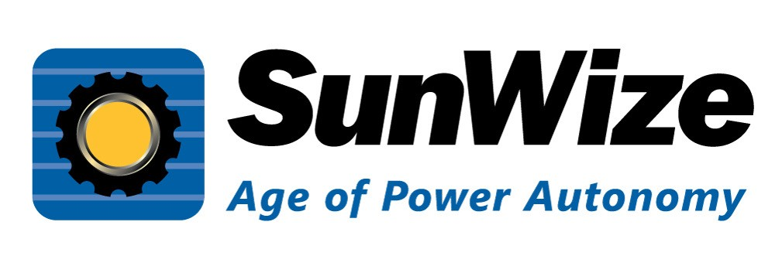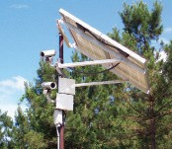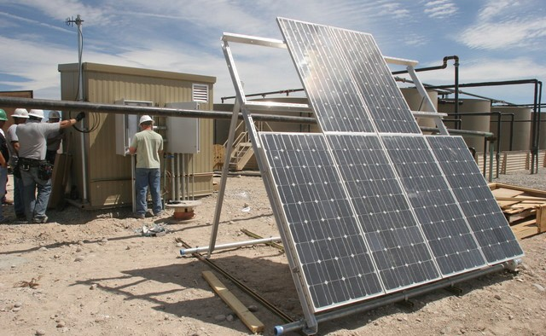
Capability Statement
Core Competencies
SunWize Power & Battery is a small business enterprise that designs and builds reliable, stand-alone industrial power solutions and electronic assemblies for integration into OEM products and off-grid field applications. With over 20 years of proven reliability
in extreme environments, our solar, battery backup, and hybrid power systems are pre-engineered, assembled and tested for easy installation and minimal maintenance.
We also offer a broad spectrum of remote industrial power system components, such as electrical components, batteries, solar modules, enclosures, and solar module mounts.
CAGE code:
77K75
Products
Services
•
•
•
•
•
•
Solar electric power systems Uninteruptible power sources Battery back-up systems Wholesale system components
DC and AC power conditioning systems Solar/Generator/Hybrid systems
•
•
•
•
•
Contract manufacturing
Power system specification & design Engineering & consultation
Solar module manufacturing Sheet metal manufacturing
DUNS #:
079520886
NAICS Code:
221114
221118
334413
335122
335129
335312
335911
423690
541330
Past Performance
Our business focuses on working closely with our customers to understand power system requirements and provide high quality, comprehensive, reliable, and cost- effective power systems to meet customer needs. We are constantly evaluating our approach to ensure we are using industry-leading products and the highest standards when building our systems. We are committed to excellence in everything we do, which is why our customers continually come to us with their power needs.
Government
Commercial
International
•
•
•
•
•
National Park Service Department of Transportation Department of Defense Bureau of Land Management
Navajo Tribal Utility Authority
•
•
•
•
•
Chevron Honeywell Verizon Emerson
Lockheed Martin
•
•
•
•
•
ADCO
Bearcom Unavco
Burhani Engineers
SAIC
Differentiators
Our real point of difference is the ability to collaborate with customers and partners to provide custom battery-based power solutions for remote locations, suited to meet very different application needs.
•
•
•
Close relationships with top-tier vendors for reliable components Experienced Project Managers & Engineering team
Documented quality control manufacturing program with pre-shipment quality control testing of all manufactured power systems
Fast design and manufacturing of high quality custom aluminum and steel battery and electronics enclosures
•
Headquarters:
1337 Main Street
Philomath, OR 97370
Contact:
(866) 827-6527
power@sunwize.com
Website:
www.sunwizepower.com
Contact Us:

