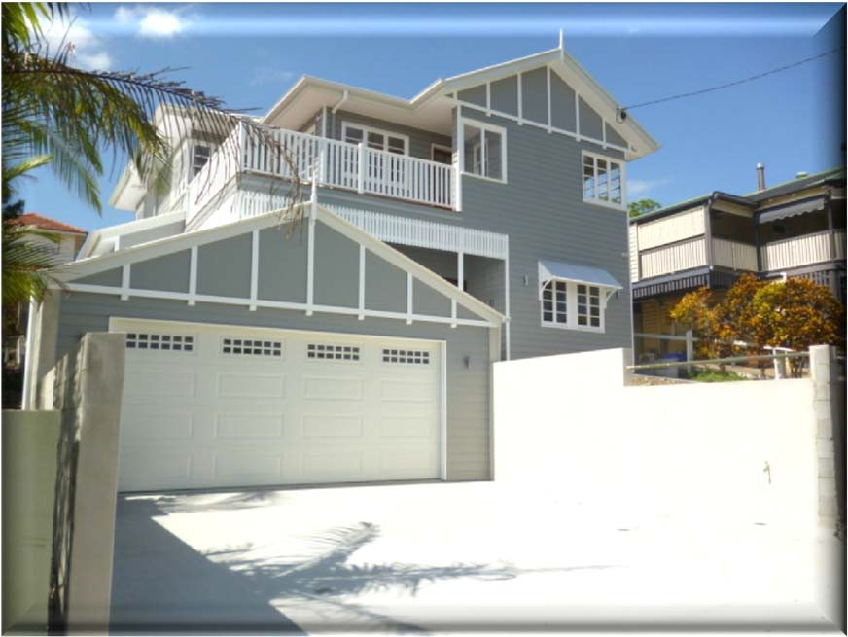
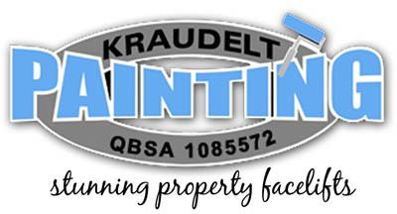
BUSINESS CAPABILITY STATEMENT
March 2014
Kraudelt Painting Pty Ltd
17, Explorers Way Mount Cotton, QLD, 4165
Tel: 07 3829 5735 Fax: 07 3829 5735
Website: www.kraudeltpainting.com.au Email: louise@kraudeltpainting.com.au


Business Capability Statement
CONTENTS:
Introduction
Page 3
Credentials / Workcover / Insurance Details
Page 3
Occupational Health & Safety
Page 3,4
Environmental Management Systems
Page 4
Quality Assurance
Page 4,5
Key Personnel
Page 5
Core Services & Expertise
Page 5
Capabilities / Competitive Skills
Page 6
Track Record
Page 6,7
Summary
Page 7
2
January 2014 review

Business Capability Statement
Introduction
Kraudelt Painting is a family owned business specialising in all forms of painting projects both residential and commercial throughout South East Queensland.
The company began operation in 2005, but began its life as a "sole trading entity" in 2001, expanding to where we find ourselves today, a highly successful business employing a total of 15 staff and an apprentice. All staff are professional painters, fully qualified holding or working towards the highest qualification attainable in the form of a Certificate 3 in Painting and decorating.
Our strategy of providing Concept to Completion service has enabled us to build relationships with our clients that have ensured our growth and capabilities.
Our mission is to minimize downtime and maximise comfort and peace of mind. Our painting is guaranteed to provide long term value and we guarantee the quality of our workmanship or it is fixed for free. We operate to very high standards and use inspections and checklists as part of our process to maintain quality control and offer a superior service through consistent quality work. Our attention to detail and perfection along with highly competitive pricing, innovation, colour consulting and green technology sets Kraudelt Painting apart from many other paint contractors.
Credentials
A.B.N:
A.C.N: BSA: CM3:
80 744 583 607
116208256
1085572
002389 - OHS capability Category 1 - WH&S portal www.cm3.com.au
Work Cover registration numbers:
▪
QLD WNA051128567 exp 30th June 2014
Insurance Details
▪
▪
▪
Public Liability Insurance BRBP-0002-2202 exp 24.03.15 Personal Accident & Sickness Insurance CommInsure 011645116
$20 Million
QLD construction cards for all staff - register of copies kept on file.
Occupational Health & Safety
▪
We have in place strictly compliant Occupational Health and Safety Policies and Procedures that are implemented at all times at every site
▪
The safety of our workers is imperative as well as these procedures represent a significant investment by the company for our goal of lost time injuries, we manage to achieve this successfully and consistently.
3
January 2014 review

Business Capability Statement
▪
Kraudelt Painting has in place policies and procedures POL-001-013, consultation, training and inductions, risk identification, assessment and control. We promote, maintain and improve WHS programmes by regularly reviewing our policies and procedures with the aim of continual improvement.
Environment Management System POL-007
Kraudelt Painting Pty Ltd is committed to:
▪
Maintaining or enhancing the services or product provided to customers while simultaneously minimizing our resource use and operating costs
▪
Achieving compatibility between economic development and the maintenance of the environment ensuring that proper consideration is given to the care of the flora, fauna, air, land, water and the community, which may be affected by our activities.
▪
Ensuring that we comply with local and state government legislation pertaining to the operation of the business, in addition to Government legislation and guidelines relating to the impact of the business on the surrounding environment
▪
Providing a safe and clean environment
▪
Limiting the impact that the business has on the surrounding environment through the sound and careful management of its activities
Kraudelt
Painting Pty Ltd acknowledges the benefits of environmental management and
undertakes to fulfil its legal and community duty, by taking all reasonable and practical measures to prevent or minimise harm to the environment.
All employees, contractors and visitors are directed to act likewise by exercising due diligence toward the environment in all their activities.
To fulfil this commitment Kraudelt Painting Pty Ltd will observe all environmental laws and promote environmental awareness among all staff to increase an understanding of environmental matters.
Kraudelt Painting Pty Ltd also undertakes to notify the relevant authority in the event of a major environmental impact that causes harm, or has the potential to cause harm to the environment.
Quality Assurance
▪
Kraudelt Painting ensures we meet and maintain ISO 9001 quality management systems, AS/NZ 4801 OH & S management standards and ISO 14001 environmental management. Our flexibility allows us to accommodate any of our Client's specific formats and requirements in reporting.
▪
4
January 2014 review

Business Capability Statement
▪
We adhere to our own Business Management System which covers all aspects of Workplace Health and Safety Policy and Procedures, Safe Work Method Statements and Safety Plans, this documentation is available upon request.
We only ever use premium, highest quality paints and paint products that are APAS approved, low VOC and meet environmental requirements and international certification standards AS/NZ 4801, ISO 14001 and ISO 9001.
Performance Evaluation can be unique for each customer or project. To ensure the delivery of outstanding performance as our customer sees it, we adapt our operations to meet each customer's specific needs and expectations while ensuring adherence to our own internal performance standards.
▪
▪
Key Personnel
▪
▪
▪
Owner / Director: Business Manager: Staff Credentials:
Craig Kraudelt Louise Kraudelt
craig@kraudeltpainting.com.au louise@kraudeltpainting.com.au
Please refer to Appendix A - Staff Credentials
Our Core Services and Expertise:
•
•
•
•
•
•
•
•
•
•
•
•
•
•
•
•
Internal and External painting Repaints - residential and commercial.
New Builds - residential and commercial. Office Buildings - new, repaints or maintenance
Patching, sanding, gapping, bogging, puttying all imperfections Grinding and removing paint.
Removal of graffiti
Schools and childcare centres. Commercial buildings - maintenance
Colour matching from photos and swatches Minor plaster repairs including expansion joints Mould and water damage repair work
Textured finishes and Airless Spraying Faux finishes and wallpapering Painted or stained timber
Concrete, bagging and metal finishes
5
January 2014 review

Business Capability Statement
Capabilities
Kraudelt Painting provides services structured to the individual needs of each client. We have extensive experience in the following forms of project delivery:
▪
▪
▪
▪
▪
▪
▪
▪
▪
Itemised quotation for complete or breakdown needs. Fixed lump sum contracts as well as hourly rate.
Residential and Commercial contracts. Ongoing contracts with Builders.
Ongoing contracts with Real Estate Tenancy needs and maintenance. Ability to undertake multiple projects at any one time.
We service all of South East Queensland.
We are able to reschedule jobs to start to suit every client's needs.
We have 17 employees and 1 subcontractor (colour consultant) as well as an extensive list of back up staff painters that can be called on as and when is necessary.
Competitive Skills:
▪
▪
▪
▪
▪
▪
We are local and provide jobs to local people and services to local people and companies. We deliver the highest quality level attainable on every project we undertake.
We are on-schedule, responsive and prompt with every request and contract requirement. We will provide fully qualified and technically capable staff.
We will communicate frequently, professionally and effectively.
We will be fair and competitive in pricing and strive to provide customers with the best value on every project.
We have been purchasing large volumes of paint over many years with Taubmans and Dulux which has put us in the enviable position of being on the lowest pricing tier available. This means we can pass on these great reductions to all of our clients, both commercial and residential.
In our 13 years of operation we have met every contract cost, schedule and performance requirement for every contract we have been awarded.
▪
▪
Track Record
Leading Projects - Complete / Ongoing Major Clients
▪
Coles Distribution Centre Warehouse - regular maintenance and repainting - Internal and External
Plantation Homes - new residential builds
Colliers International - regular maintenance and repainting corporate offices - Internal and External.
St Matthew's Catholic Primary School, Cornubia - Repainted full internal and external. Wise Realty - regular maintenance and repaints internal and external to 800 properties. Raine & Horne, Beenleigh- regular maintenance and repaints internal and external to 700 properties.
▪
▪
▪
▪
▪
6
January 2014 review


Business Capability Statement
▪
▪
Your Choice Realty - regular maintenance and repaints to keep properties tenanted. Over 200 residential private repaints within past 12 months.
Please refer to Appendix B - Testimonials
Summary
Kraudelt Painting has extensive industry knowledge backed up by our extensive practical painter experience totalling a combined 290 years which we believe makes us a capable service provider regardless of how big or small your project is.
We follow a best practice philosophy to always deliver an innovative solution to our customer
requirements.
We strive to meet or exceed our customers' expectations, always and on time.
Please visit our website: www.kraudeltpainting.com.au
YOUR PEACE OF MIND GUARANTEE
"We guarantee the quality of our workmanship - or it's fixed for FREE"
7
January 2014 review

Business Capability Statement
Appendix A - Staff Credentials
8
January 2014 review
Trade
Tradespersons Name
Trade Qualification
Licence / Certificate Details
Painting & Decorating

Craig Kraudelt
[Director/Owner] 18 years experience

- Cert III in Painting and Decorating

- BSA Licence Kraudelt Painting Pty Ltd

- BSA Supervisor Licence

- High Risk Licence

- Construction Card

- Trade Papers ‐
Painter

- 1085572

- 895072

- 0003071270

- 143939

Painting & Decorating

Louise Kraudelt
[Business Manager] 4 years painting
14 years administration

- Cert III in Painting and Decorating

- Cert III in IT

- Certificate in Business Administration

- Trade Papers‐ Painter

Painting & Decorating

Michelle Simpson
[Admin Assistant] 20 years

- International Business Diploma

- Business Admin

Painting & Decorating

Jason Hinks
[Painter]

22 years experience

- Construction Card

- Cert III in Painting and Decorating

- 024728

- Trade Papers

Painting & Decorating

Tui Pakau
[Brush hand ‐ no certificate required]
- Construction Card

- 0357754
- In process of recognition of prior

Business Capability Statement
9
January 2014 review

34 years experience

learning.

Painting & Decorating

Jai Coffison
[Painter]

8 years experience

- Construction Card

- Cert III in Painting and Decorating

- 006368

- Trade Papers

Painting & Decorating

Gary Maclot
[2nd in charge]

36 years experience

- Construction Card

- Cert III in Painting and Decorating

- Blue Card ‐ White Master Builders Card
- Trade Papers Painter

Painting & Decorating

Gavin Coulson
[Painter]

7 years experience

- Construction Card

- Cert III in Painting and Decorating

- 134905
- Trade Papers Painter

Painting & Decorating

James Russell
[Supervisor]

22 years experience

- Construction Card

- Cert III in Painting and Decorating

- 1018116
- Trade Papers Painter

Painting & Decorating

Jeffrey Morton
[1st yr Apprentice]

6 months experience

- Construction Card

- Waiting on Card Number. Please refer to Certificate of Attainment in Appendix 28.
Painting & Decorating

Joshua Cowell
[Painter]

8 years experience

- Construction Card
- Cert III in Painting and Decorating

- 581160
- Trade Papers Painter

Painting & Decorating

Juso Jakupovic
[Painter]

20 years experience

- Construction Card
- Cert III in Painting and Decorating

- 0459508
- Trade Papers Painter

Painting & Decorating

Aaron Simmons
[Painter]

14 years experience

- Construction Card
- Cert III in Painting and Decorating

- 0459508
- Trade Papers Painter

Painting & Decorating

Chris Kraudelt
[Painter]

10 years experience
- Construction Card
- Cert III in Painting and Decorating

- 143938
- Trade Papers Painter

Business Capability Statement
10
January 2014 review

Painting & Decorating

Wayne Johnstone [Brush Hand ‐ no certificates required]

10 years experience
- Construction Card

- 362283

Painting & Decorating

Mirza Sahovic
[Painter]

12 years experience

- Construction Card
- Cert III in Painting and Decorating

- 170191
- Trade Papers Painter

Painting & Decorating

Zoren Trbovic
[Supervisor]

20 years experience

- Construction Card
- Cert III in Painting and Decorating

- 0438874
- Trade Papers Painter

Colour Consultant

Melissa Royal

10 years experience
- Cert III in Commercial Arts Interior Design

No blue card required.

