
CRITICAL-PATH ANALYSIS FOR NETWORK SCHEDULING
From studying this section, you will be able to:
-
-
-
-
-
-
Perform CPM and PDM analyses for AOA and AON networks; Calculate the early / late times that an activity can start / finish;
Determine the total project duration, activity floats, and the path of critical activities; Represent the schedule using Bar charts (Gantt charts);
Use Microsoft Project Software to schedule projects; and Experiment with a spreadsheet model for network analysis.
Scheduling = Planning + Time.
The schedule is very important for the contractor to know when and how much labor is needed; vendors to know when to deliver materials; and subcontractors to know when they can do their work.
Critical-Path Method (CPM) for AOA Networks
The CPM is a systematic scheduling method for AOA network. The CPM involves 4 main steps:
A forward pass to determine activities early-start times; A backward pass to determine activities late-finish times; Float calculations; and
Identifying critical activities.
-
-
-
-
Forward Pass & Backward Pass
The forward pass determines the early-start times of activities, while the backward pass determines the late-finish (LF) times.
5
B (3)
d1
A (3)
C (4)
E (5)
1
3
9
11
D (6)
d2
7
Float Calculations
47

Activity

Duration (d)
Results of Forward & Backward Pass
Calculations of Other Activity Times
Total Float & Criticality Calculations
(ES)
(LF)
LS = LF - d
EF = ES + d
TF = LF- ES - d
Critical (Y/N)
A B C D E
3
3
4
6
5


d
d
Name duration = d
i
i
a) Activity is early
b) Activity is late
LF
Total Float (TF) = Total Slack = LF – EF = LS – ES = LF – ES – d
Another type of float often used in network analysis is the Free Float, which can be calculated as:
Free Float = Es (of succeeding activity) – EF (of activity in question)
The free float defines the amount of time that an activity can be delayed without taking float away from any other activity. With free float available for an activity, a project manager knows that the float can be used without changes the status of any non-critical activity to become critical.
Identifying Critical Activities
Critical activities are the ones having TF = 0. They form a continuous path of the critical activities that is the longest in the network (Critical Path).
Precedence Diagram Method (PDM) for AON Networks
Sequence
Step
1
2
3
48

D (6)

C (4)

A (3)

E (5)

B (3)

ES EF=ES+d
TF

LS=LF-d
TF

Total time available for the activity = LF - ES

LF
ES

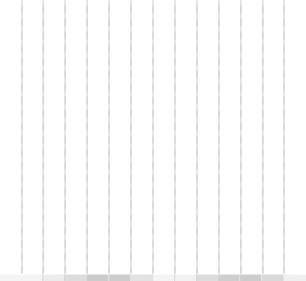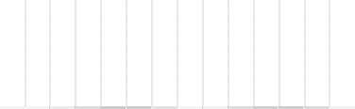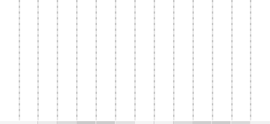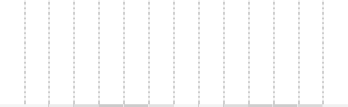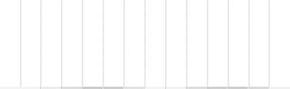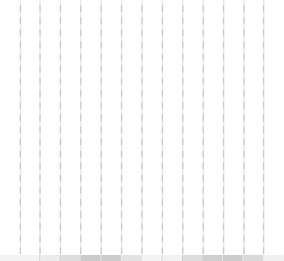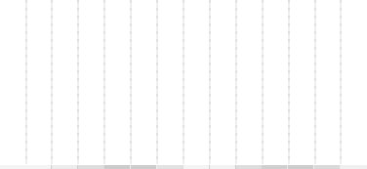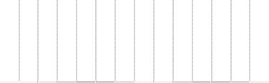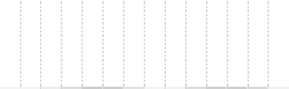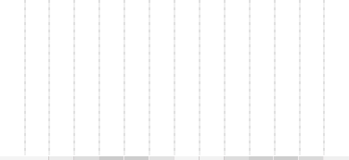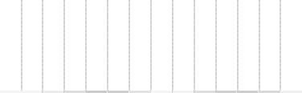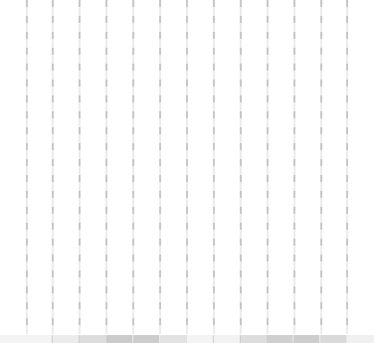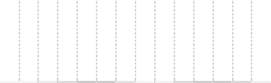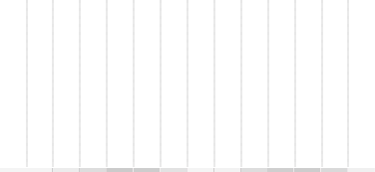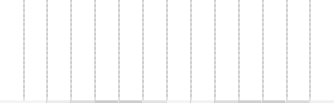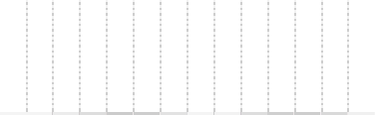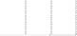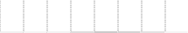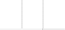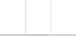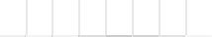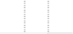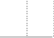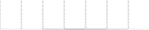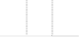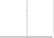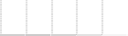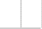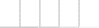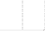
Schedule Presentation
Activity
Early Bar Chart
0
Activity
1
2
3
4 5
6
7
8
9
10
11
12
13
14
Time
d=3
A B C
D
E
LF=3
Late Bar Chart
TF=3
d=3
LF=9
TF=2
d=4
LF=9
d=6
LF=9
d=5
LF=14
0
1
2
3
4
5
6
7
8
9 10
11
12
13
14
Time
Activity
2
2
2
Labor amount / day
A B C
D
E
Using Bar Chart to Accumulate Resources
2
2
2
1
1
1
1
3
3
3
3
3
3
1
1
1
1 1
0
1
2
3
4
5
6
7
8
9
10
11
12
13 14
Time
2
2
2
6
6
6
4
3
3
1
1
1
1
1
Total labors
6
6
5
4
3
2
1
Profile of the labor resource demand
4
3
2
1
49

A
ES
B C D E

d=3
= 0 d=3 TF=3 ES=3
d=4 TF=2
ES=3
d=6
ES=3
d=5
ES=9

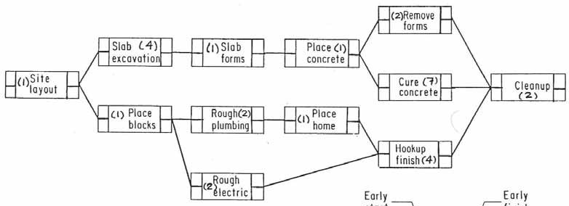
Example
Solved Example
Perform PDM calculations
for the small AON network shown
here.
Pay
special
attention
to
the
different
relationships and the lag times shown on them.
0+2=2
12-2=10
Criticisms to Network Techniques
-
-
-
-
-
-
Assume all required resources are available Can result in large resource fluctuations Ignore project deadline
Ignore project costs
Use deterministic durations
Do not consider realistic productivity factors
50

SS=2
2
5

B (3)
4
7
5, 7 or
(9+2-5)
0
3

3
7

7
12
A (3)
C (4)
E (5)

0
3
3
7
7
12
4 or
3 or
(4-2+3)

3
9

FF=2
D (6)

4
10

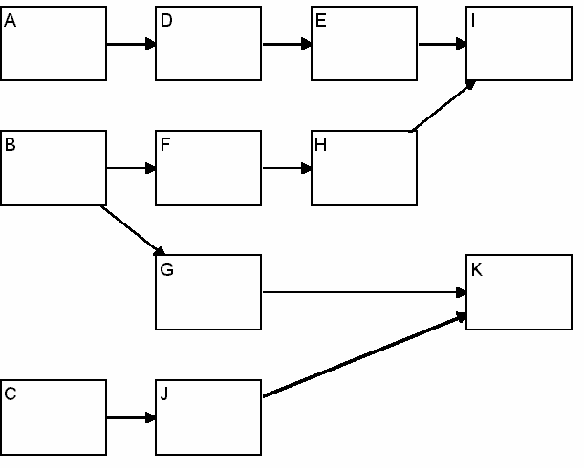
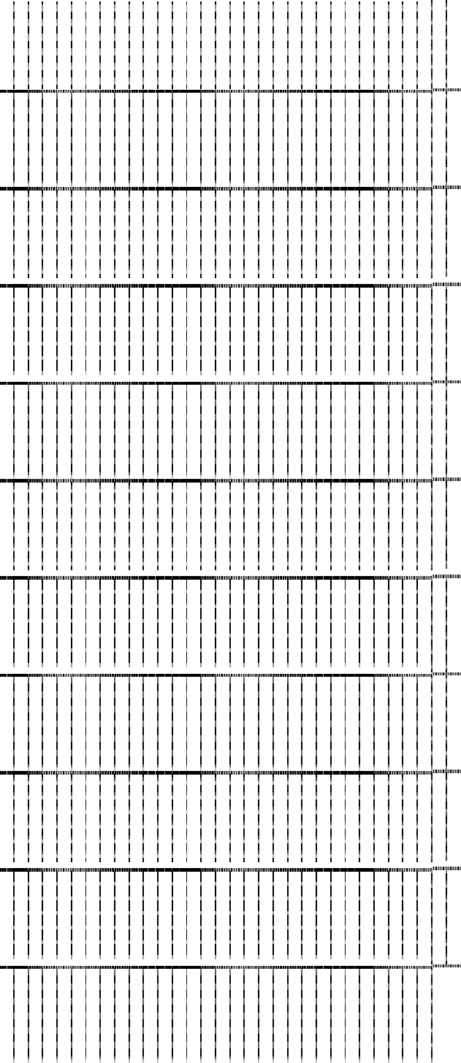
Back to Our Case Study Project
We need to do the following:
-
-
Calculate ES, LF, & TF for all activities. Identify critical ones. Draw a Late Bar Chart for the project.
What is the effect of delaying activity H by two days on project duration?
Solution:
51
ACTIVITY
1
2
3
4
5
6
7
8
9
10
11
12
13
14
15
16
17
18
19
20
21
22
23
24
25
26
27
28
29
30
31
32
A B C D E F G H I J K

Activity
Duration
ES
LF
TF=LF-ES-d
Critical
A
4

B
6

C
2

D
8

E
4

F
10

G
16

H
8

I
6

J
6

K
10

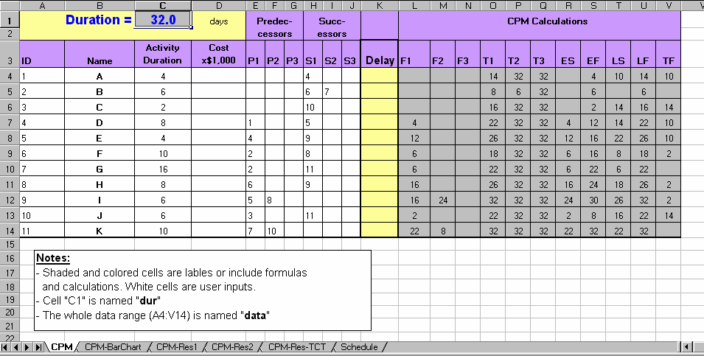
LS 3
Critical Path Model on a Spreadsheet
Delay_{B}
Delay_{E}
Del
Delay_{A}
Del
The spreadsheet file (“CPM.xls”) represents a template for CPM analysis with one row for each activity. The data for an activity are represented in columns. The shaded cells include formulas while the white cells are user inputs pertaining to the activity ID, Name, Duration, Cost, IDs of 3 predecessors, IDs of 3 successors, and a Delay value. The total project duration (32 days) is also included in a separate cell at the top of the spreadsheet.
Any change in the duration of any activity or the logical relationships automatically changes the project duration along with all the CPM data regarding the activities’ early and late times as well as the total floats, which identify critical and non-critical activities. Experiment with different option and see their impact on the schedule.
52

ES
A

3
EF

LS
LF_{A}

ES_{E}

E

5
EF

LS

LF

ES
B

3
EF_{B}

LS
LF

ay_{C}

ay_{D}

ES
D

6
EF_{D}

LS
LF

ES
C

4
EF_{C}

LS
LF

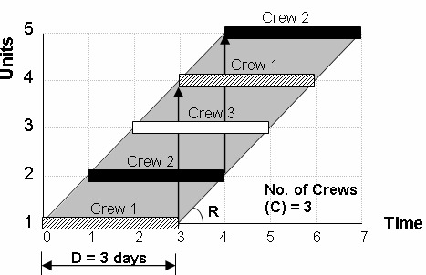
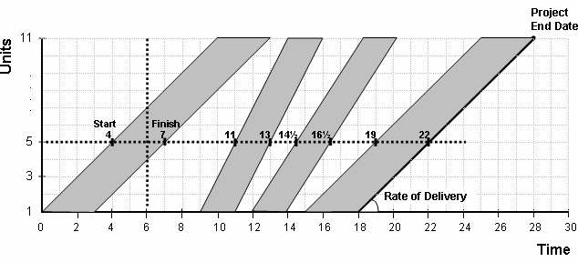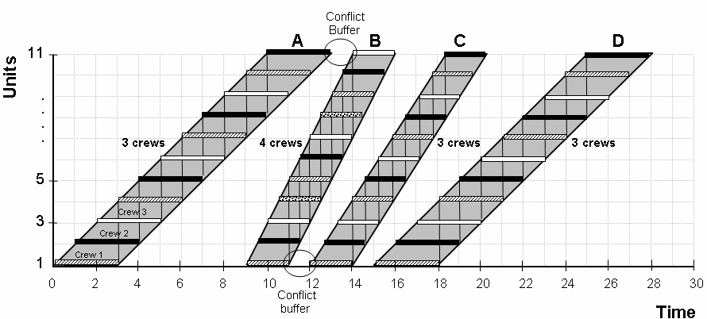
SCHEDULING REPETITIVE & LINEAR PROJECTS
Repetitive Projects:
Highways, Multiple Houses, Multiple Bridge Maintenance, etc.
Characteristics:
Multiple locations, complex, many resources
Challenges:
-
-
-
Crew Work Continuity Learning Phenomenon
Representing the large amount of data
New Representation:
How to Design the Schedule:
-
-
How many crews needed to meet deadline?
How to arrange the crew assignment to maintain work continuity?
Crew Synchronization Calculations:
Crews (C) = (D) x (R)
53

n
Calculating a Desired Progress Rate (R):
.
.
.
2
R
1
Time
Unit
Advanced Scheduling Options
1.
2.
Use of interruption to save project time
Each activity has up to 3 methods of construction (e.g., normal work, overtime, or subcontractor) with associated time, cost, and crew constraints. The model can then be used to select the proper combination of methods that meet the deadline, cost, and crew constraints;
Activities can have non-standard durations and costs at selected units; and
Conditional methods of construction can be specified by
the user.
3.
Saved Time
4.
Activity A
Activity B
Activity
C
Activity
D
9
8
7
6
5
4
3
2
1
Work proceeds forward from station 3 to 8 only.
No work at
station 8.
Crew 2
Crew 3
Top crew works from station 9 to 5, while bottom crew works from station 1 to 4.
Crew 1
Crew 1
Small quantity
at Station 4.
Crew 3
Crew 2
Work proceeds
from station 3 to 8 only, with
Low productivity at
Station 2 (Large duration).
Crew 1
interruption at
Time
station 5.
54
Unit No.
Units

Time

Time

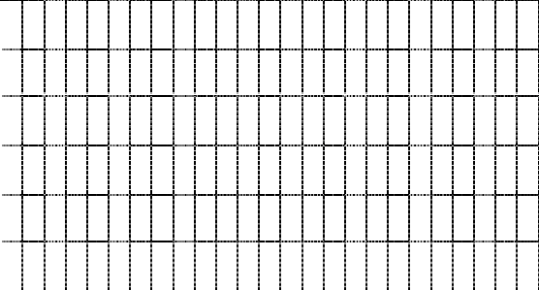
Example:
For this small project, the work hours and the number of workers for each activity are shown. if you are to construct these tasks for 5 houses in 21 days, calculate the number of crews that need in each activity. Draw the schedule and show when each crew enters and leaves the site. Use EasyPlan & compare your solution.
Step 1: CPM Calculation
D. Footing 2
B. Sanit. Main
64 hrs, 2 W
48 hrs, 3 W
Deadline T_{L} = 21;
T₁ = ;
n = 5
Step 2: LOB Calculations
Step 3: Draw the Schedule
Draw the critical path
1
2 3 4 5 6
7 8
9 10 11 12 13 14 15
55
16 17 18 19
20 21 22
23 24 25

Activity

Duration (D)

Total Float (TF)

Desired Rate (R) (n-1) / (TL-T1+TF)

Min. Crews
(C) = D x R

Actual Crews (Ca)
Actual Rate (Ra) = Ca / D
A

B

C

D

E

F

A. Excavation

C. Footing 1

E. Wall 1

F. Wall 2
48 hrs, 3 W
64 hrs, 2 W
72 hrs, 3 W
72 hrs, 3 W

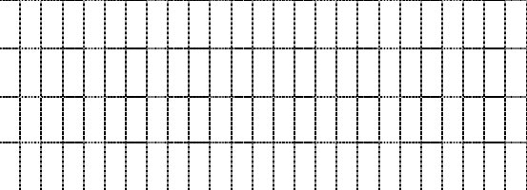
Assume:
- Same no. of Crews
- Activity A in unit 2 has double the duration
- Unit 4 does not need excavation
1
2 3 4 5 6
7 8 9 10 11 12 13 14 15 16 17 18 19 20 21 22 23 24 25
Back to the Case Study Project
onsider that the project involves 5 typical units. The owner wants the contractor to finish all the work in 50 days. Compare manual solution to that of EasyPlan.
A(4)
B(6)
C(2)
D(8)
E(4)
F(10)
G(16)
H(8)
I(6)
J(6)
K(10)
Step 1:
CPM Calculations
Step 2:
LOB Calculations
T_{L} = deadline duration = 50 days; T₁ = CPM duration of a single unit; * = Critical activity
56

Activity
Activity Duration (D)
Total Float (TF)
Desired Rate
(R) =
(n-1) / (T_{L}-T₁+TF)
Required Crews
(C) = D x R
Actual Crews (C_{a})
Actual Rate
(R_{a}) = C_{a} / D
A
4
10
0.143
0.572
1
0.25
*B
6
0
0.222
1.332
2
0.333
C
2
14
0.125
0.250
1
0.5
D
8
10
0.143
1.144
2
0.25
E
4
10
0.143
0.572
1
0.25
F
10
2
0.200
2
2
0.2
*G
16
0
0.222
3.552
4
0.25
H
8
2
0.200
1.6
2
0.25
I
6
2
0.200
1.2
2
0.333
J
6
14
0.125
0.75
1
0.167
*K
10
0
0.222
2.22
3
0.3

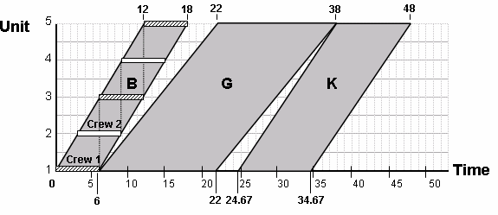
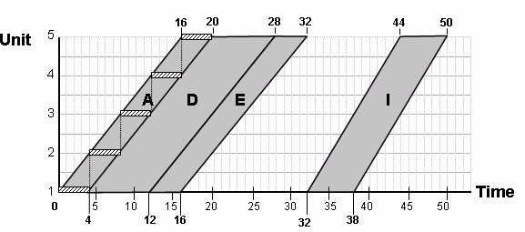
Step 3:
Draw the Schedule
The Critical Path B-G-K
32 38
C
J
K
0
2
8
24.67
Path C-J-K
Path A-D-E-I
36 44
B
F
H
I
0
6
16
28
32
38
Path B-F-H-I
57

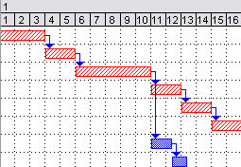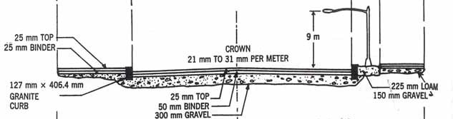
Highway Example
A three-kilometer highway stretch is divided to ten sections for planning purposes. Each section is 300 meters. The cross section is shown below along with activities’ details.
1.8 m
10 m
0.9 m
1.5 m
Total excavation thickness: Middle = 500mm; and Shoulders = 200 mm.
Activities’ estimates are as follows:
The logical relationships are
shown. Also, for all activities,
seasonal productivity factors are: Winter = 0.65; Spring = 1.0; and Fall = 0.85.
Requirements:
Use the Repetitive Schedule feature of EasyPlan to develop an optimum schedule.
-
-
Deadline = 30 days and the project starts June 1, 2006.
-
How will your plan differ if you start the whole project on Feb. 1, 2006?
-
How will your plan differ if you have a maximum of 3 crews for each activity?
-
How will your plan differ if you start the whole project from one side as opposed to employing half the crews from each side?
58

Estimate 1
Estimate 2
Estimate 3

Activity

Cost ($)
Time (days)
Cost ($)
Time (days)
Cost ($)
Time (days)
- Excavation
- Sub-base
- Base
- Binder
- Asphalt
- Curbs
- Lighting
- Sidewalks

21,000
7,800
72,000
30,000
14,400
31,200
19,245
10,950
3
2
10
1.2
1
2
2
2
30,000
---- 80,000
----
---- 38,000
25,000
----
2
---- 8
----
---- 1
1
----
----
---- 100,000
----
----
----
----
----
----
---- 5
----
----
----
----
----

