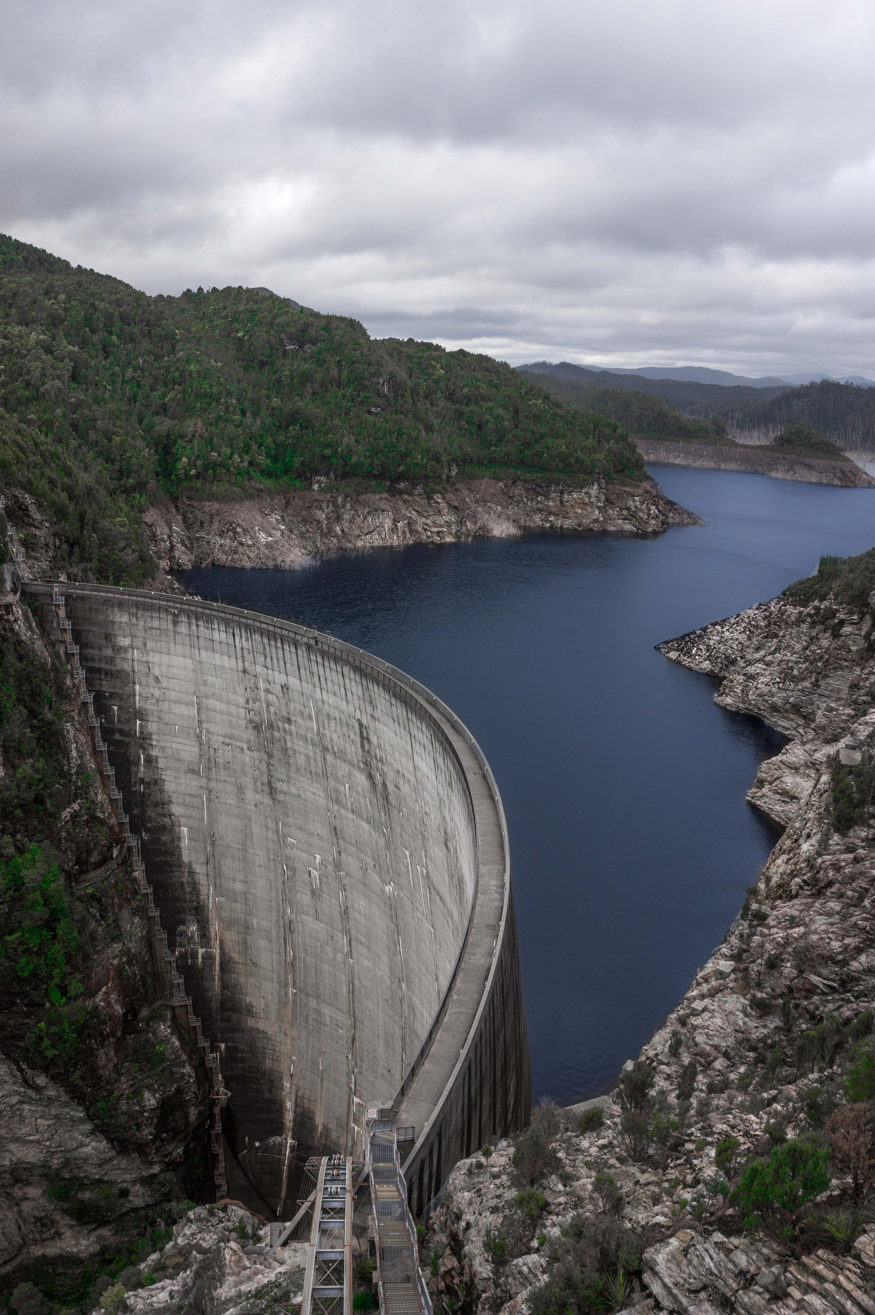
Feasibility of a second
Tasmanian interconnector
Final Study
Dr John Tamblyn
April 2017

© Copyright Commonwealth of Australia, 2017, except where otherwise identified.
This report, with the exception of the Coat of Arms of the Commonwealth of Australia and third party material (which includes signatures and logos, and photographs, images and other content marked as supplied by third parties), is licensed by the Commonwealth of Australia for use under a Creative Commons Attribution 4.0 International licence. For licence conditions see: https://creativecommons.org/licenses/by/4.0/.
Material subject to the above licence should be attributed as ‘Feasibility of a Second Tasmanian interconnector, Commonwealth of Australia and Tasmanian Government—Final Study, 2017’.
No licence is given in relation to third party material.
Disclaimer:
This report has been prepared for the purposes of providing advice to the Commonwealth and Tasmanian Governments. The views and opinions expressed in the report do not necessarily reflect those of the Commonwealth or Tasmanian Governments. This publication does not indicate commitment by Commonwealth or Tasmanian governments to a particular course of action.
The content of this report does not constitute advice to any third party. Although due care and skill has been applied in the preparation and compilation of the information and data in this publication, no reliance may be placed on it by any other party. No representation expressed or implied is made as to the currency, accuracy, reliability, completeness or fitness for purpose of the information contained in this publication. The reader should rely on its own inquiries to independently confirm any information and comment on which they may intend to act.
The Commonwealth of Australia, its officers, employees, agents and the other parties involved in creating this report disclaim, to the maximum extent permitted by law, responsibility to any other party for any liability, including liability for negligence, loss howsoever caused, damage, injury, expense or cost incurred by any person as a result of accessing, using or relying upon any of the information or data in the report.
Cover image (front): Gordon Dam, Tasmania. Photo: Department of the Environment and Energy

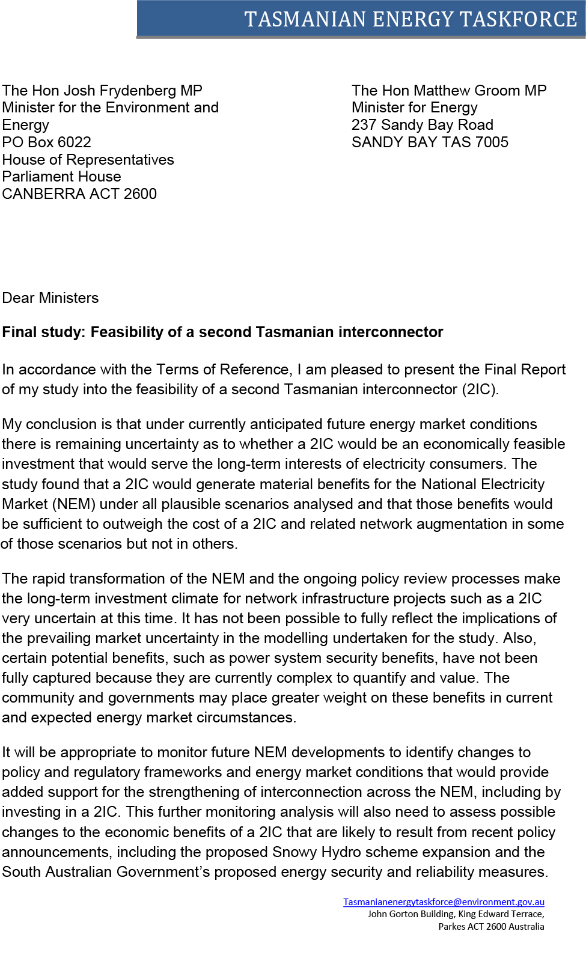

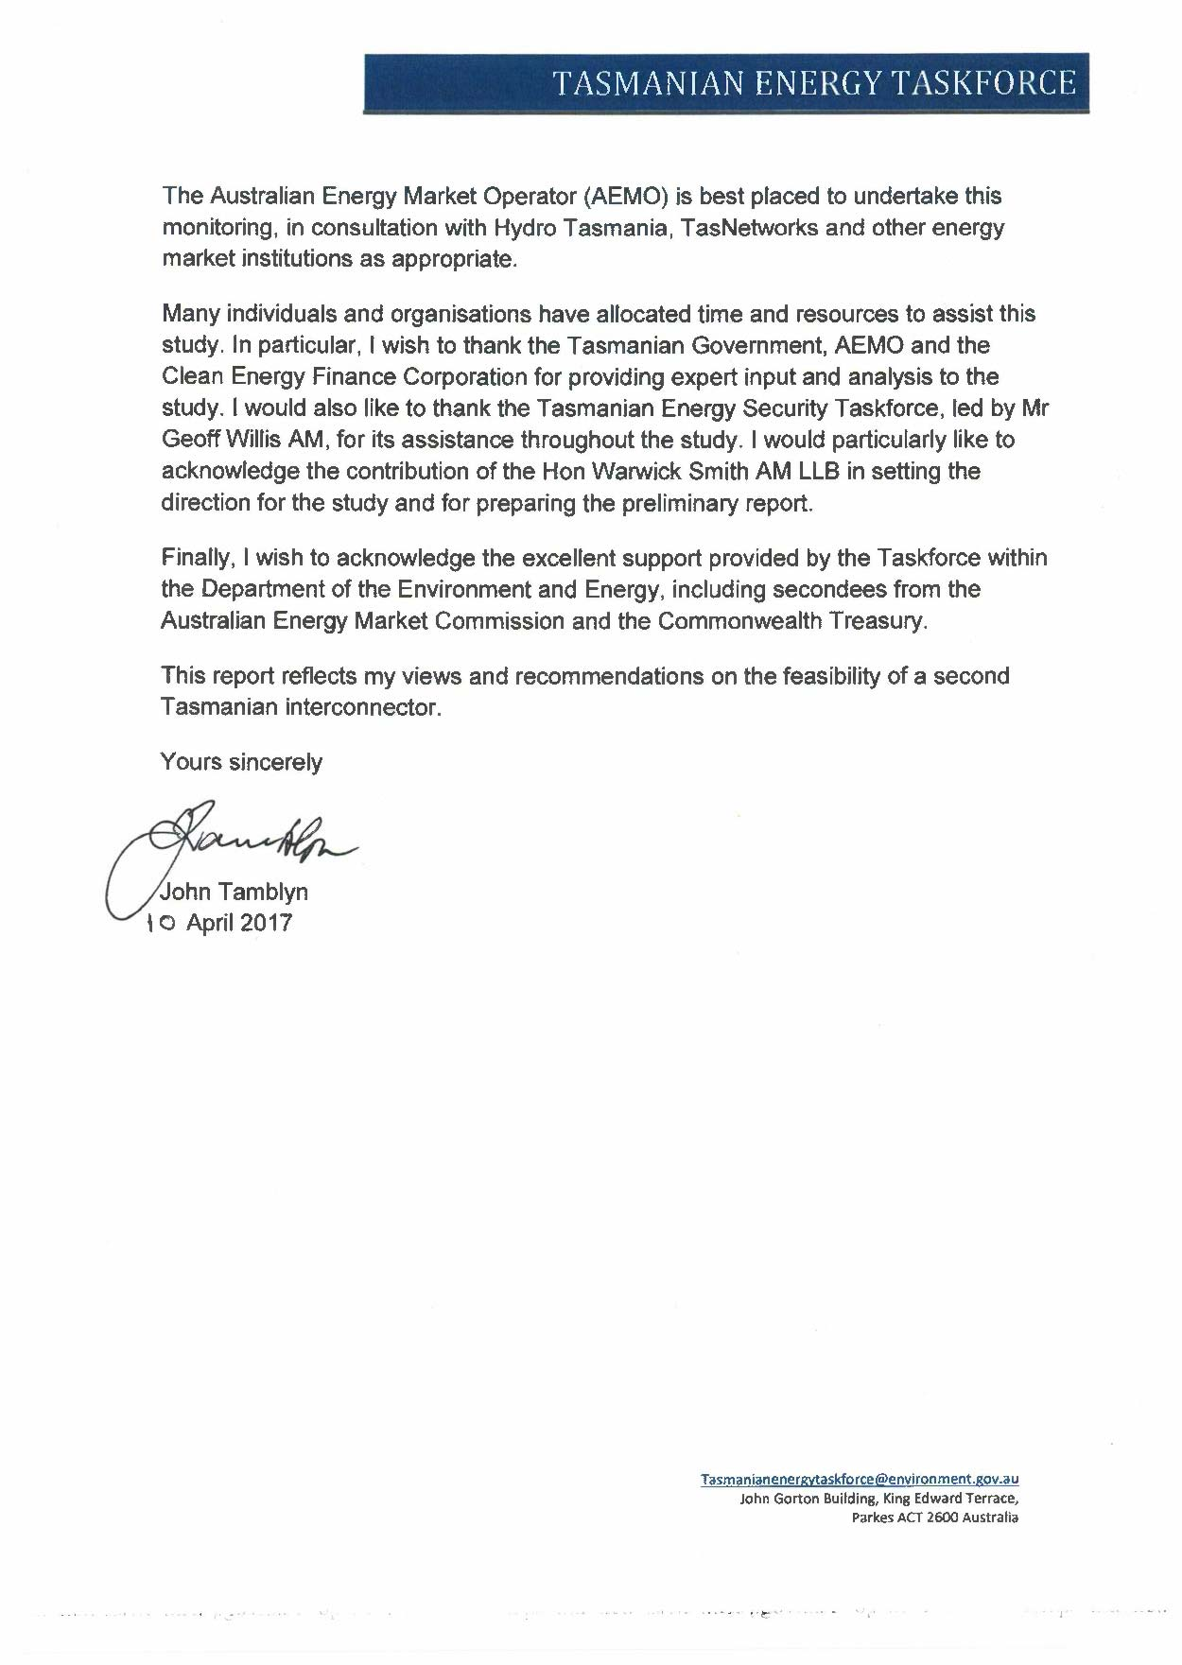

Contents

Executive summary viii
1 Introduction 1
2 Context for the study 2
2.1 Transformation of the national electricity market 2
2.2 Renewable energy development 3
2.3 Energy security and reliability 4
2.4 Complementary work to the study 5
3 Study approach, assumptions and methodology 7
3.1 Economic efficiency assessment framework 7
3.2 Study methodology 8
3.3 Tasmanian Government 2IC specification work 10
3.4 Interconnector cost assumptions 12
3.5 Modelling and technical analyses 13
3.6 Commercial and financial advice 18
3.7 Differences between AEMO and EY’s modelling approaches 18
4 Results of modelling and analysis 20
Key findings 20
4.1 AEMO modelling findings 21
4.2 AEMO’s analysis of market benefits resulting from a 2IC 22
4.3 EY market dispatch modelling results 23
5 Economic efficiency assessment 33
5.1 Regulated 2IC market outcomes assessment 33
5.2 Other potential market costs and benefits from a regulated 2IC 34
5.3 Merchant interconnector market outcomes assessment 37
6 Commercial and financial arrangements 38
6.1 Business models 38
6.2 EY modelling methodology 40
6.2.1 Qualitative analysis methodology 41
6.3 Outcomes of financial and commercial analysis 42
6.4 Market sounding 45
6.5 EY findings 45
6.6 Other considerations 46
7 Renewable energy and energy security implications 47
7.1 Role of interconnectors 48
7.2 Renewable energy development 48
7.3 Energy security 55
8 Implications for consumers 58
8.1 Allocation of costs 59

9 Planning and approval requirements 66
9.1 Basslink approval process 66
9.2 Considerations for a 2IC 69
10 Conclusions and recommendations 71
Recommendation 73
Appendix A: Terms of Reference 74
Appendix B: Stakeholder consultations 75
Appendix C: Australian Energy Market Operator Report: Second Tasmanian Interconnector 77
Appendix D: Ernst & Young Report: Market dispatch cost benefit modelling 78
Appendix E: Ernst & Young Report: Financial and Commercial Analysis—Second Tasmanian Interconnector 79

Acronyms
Acronym | Term
2IC | A second interconnector between Tasmania and Victoria
AC | Alternating current
AEMC | Australian Energy Market Commission
AEMO | Australian Energy Market Operator
AER | Australian Energy Regulator
BDB | Basslink Development Board
BDSC | Basslink Development Steering Committee
BSA | Basslink Services Agreement
CCGT | Combined cycle gas turbine
COAG | Council of Australian Governments
DC | Direct current
DOEE | Department of the Environment and Energy
EY | Ernst & Young
FCAS | Frequency control ancillary services
FCSPS | Frequency control special protection scheme
GW / GWh | Gigawatts / Gigawatt hours
HVDC | High voltage direct current
IRR | Internal rate of return
JAP | Joint Advisory Panel
KV | Kilovolt
LCC | Line commuted converter
LRMC | Long-run marginal costs
MLEC | Modified load export charges
MPAA | Major Projects Approval Agency
MW / MWh | Megawatts / Megawatt hours
NCSPS | Network control special protection scheme
NEFR | National Electricity Forecasting Report
NEL | National Electricity Law
NEM | National Electricity Market
NEO | National Electricity Objective
NER | National Electricity Rules
NPV | Net present value
NSCAS | Network support and control ancillary services
NTNDP | National Transmission Network Development Plan
OCGT | Open cycle gas turbine
OTTER | Office of the Tasmanian Economic Regulator
PPA | Power purchase agreement
POSS | Project of State Significance
PV | Photovoltaic
QNI | Queensland–New South Wales Interconnector
RET | Renewable Energy Target
RIT-T | Regulatory Investment Test for Transmission
SCER | Standing Council on Energy and Resources
SPS | System Protection Scheme
SRAS | System restart ancillary services
SRMC | Short-run marginal costs
TEST | Tasmanian Energy Security Taskforce
TNSP | Transmission network service provider
TVPS | Tamar Valley Power Station
VRET | Victorian Renewable Energy Target
VNI | Victoria–New South Wales Interconnector


Dr John Tamblyn
Dr John Tamblyn has an extensive background in the regulation of public utilities and in energy policy. He is currently the Chair of the COAG Energy Council Appointments Selection Panel and was the inaugural Chair of the Australian Energy Market Commission (AEMC).
Dr Tamblyn was one of two expert advisors appointed by the then Standing Council on Energy and Resources (SCER) to provide advice on the establishment of the National Energy Consumer Advocacy Body (now Energy Consumers Australia). He was a member of the expert panel that conducted the 2012 review of the energy market Limited Merits Review regime for SCER. Dr Tamblyn is also a former member of the Solar Flagships Council.
Before chairing the AEMC, he gained significant experience in regulation of public utility services, including the positions of Chairman of the Essential Services Commission (Victoria) and Regulator-General (Victoria). He has also held senior positions in the Australian Competition and Consumer Commission.
Dr Tamblyn served on Tasmania’s Electricity Supply Industry Expert Panel, which advised the Tasmanian Government on options for improving the performance of the Tasmanian electricity supply industry.

Executive summary
In April 2016, the Australian and Tasmanian governments established this study of the feasibility of a second electricity interconnector (2IC) between Tasmania and Victoria. The study was initiated in response to energy supply challenges in Tasmania during 2015–16 caused by an extended outage of Basslink combined with low hydro water storage levels resulting from low rainfall.
The Terms of Reference for this study call for a feasibility assessment of a 2IC and advice on whether it would; address energy security issues, facilitate development of Tasmania’s large scale renewable energy resources and integrate with the Victorian electricity market and the wider National Electricity Market (NEM). The study was also to advise on implications for electricity consumers and related regulatory and financing issues.
Studies of a 2IC and the possible role it could play in developing Tasmania’s renewable energy resources are not new. For example, the Tasmanian Government commissioned an earlier study in 2010–11.
This study is being undertaken at a time when the NEM as a whole is undergoing substantial transformation. Rapid technological changes, increasing penetration of renewable energy, more decentralised generation, reduced synchronous generation and shifting patterns of consumer demand are reshaping the NEM.
Energy market events in Tasmania in 2015–16 and South Australia in 2016 have led to a greater focus by governments on ensuring that all Australians can access a reliable and secure supply of energy. Energy reliability and security is a particular priority for Tasmania as a relatively energy intensive state where energy is vital for home heating and to support its major industrial businesses.
Interconnectors have a role to play in managing energy market changes by enabling the transfer of energy and power system security services between regions. Interconnectors can also facilitate the more efficient development and distribution of intermittent renewable energy across the interconnected NEM.
A number of related policy and regulatory reviews have been initiated in response to these changing market dynamics. They include:
- the Independent Review into the Future Security of the National Electricity Market
- the Tasmanian Energy Security Taskforce (TEST) work on energy security risk mitigation measures for Tasmania
- ElectraNet’s South Australian Energy Transformation Regulatory Investment Test for Transmission (RIT-T) process
- the Australian Energy Market Operator (AEMO) and the Australian Energy Market Commission (AEMC) power system security reviews.
This shifting policy and regulatory environment has been an important consideration throughout the study.

This study builds on the preliminary report, which governments released in June 2016. It provides an assessment of whether a 2IC is likely to be an economically feasible investment which could support energy security and reliability in the NEM and the efficient transition of the NEM to a lower emission generation mix.
The National Electricity Objective (NEO) and the RIT-T provided the analytical framework for assessing whether, and in what circumstances, a 2IC would be an economically efficient investment. This approach ensured that, when conducting this study, a whole of NEM perspective was taken, with the long-term interests of consumers in mind.
To understand the drivers and circumstances that might support investment in a 2IC, power system and market dispatch modelling was obtained, together with financial and commercial advice. Input was also obtained from the Tasmanian Government, AEMO and the Clean Energy Finance Corporation as well as through targeted stakeholder consultations.

Economic feasibility assessment
Assessment of the economic feasibility of a 2IC has proven to be a difficult and uncertain task. It is challenging to forecast, with the requisite degree of confidence, future energy market conditions that will apply over a 2IC’s 40 year or more economic life. That uncertainty is exacerbated by the ongoing transformation of the NEM and the long lead time required for planning and construction of a 2IC. As the study considers the period to 2066, that uncertainty has a significant impact on the ability to make a confident assessment of the viability of a 2IC.
Market modelling by AEMO and Ernst & Young (EY) sought to address this uncertainty by analysing the projected NEM-wide costs and benefits that would be generated by a 2IC under plausible future energy market conditions. They also analysed case studies that set out different possible future investment environments.

Market benefits of a 2IC
The modelling identified two key sources of benefits from a 2IC:
1. A 2IC would indefinitely defer between 450 and 600 megawatts (MW) of thermal generation investment in the NEM which would otherwise be required to maintain reliability in Victoria as its brown coal generation is retired. However, this capacity deferral would not occur until the early 2030s, meaning that the benefits of reduced capital investment would be discounted significantly.
2. A 2IC would also generate variable cost savings in the NEM. These savings are primarily attributable to more efficient use of Tasmanian hydro storage and generation facilities. The additional capacity of a 2IC would allow increased exports of dispatchable renewable energy to Victoria during periods of high demand and value when higher-cost generation would otherwise have been required. It would also allow more imports of energy at low value times, maintaining dam levels for later high value use. Together a 2IC and Basslink would enhance the capability for Tasmania’s water storages and hydro facilities to be used much like a large battery, by flexibly sending out or absorbing power to and from Tasmania, to maximise its value to Tasmania and the rest of the NEM.
Additional benefit was also identified from improved utilisation of other lower-cost Tasmanian generation assets, including the Tamar Valley Power Station’s combined cycle gas turbines.

Other significant market benefits
A 2IC would also deliver reliability benefits to Victoria and Tasmania by providing reliability support to Victoria at times of peak demand and to Tasmania during periods of drought and low water storage levels. Tasmania would also benefit from increased ‘resilience’ to potential failures of Basslink by retaining connection to the NEM in that event, avoiding the need for voluntary and involuntary load shedding. A 2IC, incorporating advances in interconnector technology, could also transfer power system security services between Tasmania and the rest of the NEM. While power system security benefits were not fully considered in the AEMO and EY modelling, they are likely to be in greater demand and accorded a higher value in future as the penetration of intermittent renewable generation continues to increase. AEMO has noted, however, that as the mainland NEM has significant synchronous generation and is interconnected by an alternating current network, it has access to sufficient frequency control ancillary services to meet requirements for the foreseeable future.
A 2IC would facilitate development of Tasmania’s rich wind resources. The modelling indicated that a 2IC would increase the financial viability of renewable generation in Tasmania and reduce the risk of it being constrained by transmission limitations. The modelling showed that without a 2IC in operation Tasmanian wind generation could increase by up to 730 MW by 2036 and with a 2IC an additional 365 MW could be developed over the same period. Much of this wind development is expected to occur in the late 2020s and 2030s due to the earlier build of wind generation in Victoria (incentivised by the Victorian Renewable Energy Target) and South Australia (assuming additional interconnection is built).
While the market benefit assessments varied markedly according to the different scenarios and case studies being modelled, two case studies resulted in significant improvements in the market benefits from a 2IC. The development of an additional interconnector between South Australia and the eastern states before a 2IC is developed would result in larger market benefits than those achieved when each interconnector was assessed separately. Stronger interconnection between NEM regions was found to facilitate more efficient transfer of un-correlated renewable energy flows between NEM regions. The market benefits of a 2IC would also increase markedly if there was a significant reduction in Tasmanian electricity demand because the resulting surplus generation could be exported rather than being wasted because of constrained interconnection capacity.

Capital and operating costs of a 2IC
The capital and operating costs involved in constructing and operating an undersea interconnector are substantial compared to the cost of overhead interconnectors. The total capital cost of a 2IC (including network augmentation costs) has been estimated at up to $1.1 billion, with estimated ongoing operational and maintenance costs of $16.7 million per annum. These cost estimates are preliminary and may change during the more detailed planning, construction and regulatory approval processes. Thus, while a 2IC would be capable of delivering material benefits to the NEM and Tasmania, those benefits would need to outweigh the substantial capital and operating costs of a 2IC by a significant margin in most modelled scenarios to establish a persuasive case in support of a 2IC investment.
Net benefit assessment
The modelling identified two future NEM development scenarios in which a 2IC would produce market benefits sufficient to outweigh the capital and operating costs by a significant margin in net present value terms. They were where:
- an additional South Australian interconnector was built before a 2IC came into operation
- there is a significant reduction in future Tasmanian electricity demand.
Under a further scenario (AEMO’s neutral demand scenario) modelled net benefits were only marginally positive, with projected net market benefits of just $20 million. In the remaining scenarios and case studies modelled the net benefit assessments were negative to varying degrees. Overall, these results indicate that the economic feasibility of a 2IC remains uncertain and is likely to be economically justified in some plausible future market circumstances and not in others.
Based on the modelling results and analysis of other relevant considerations, the overall conclusion is that, while a 2IC would deliver significant net economic benefits to the NEM under certain plausible scenarios, under other modelled scenarios the potential benefits from a 2IC would be unlikely to exceed the significant capital and operating costs of a 2IC and related network augmentation.
As noted above, the modelling did not include and evaluate certain potential benefits from a 2IC which are allowable in a RIT-T assessment including, for example, competition benefits, some aspects of power system security and reliability benefits, and options value benefits. These benefits were omitted from the analysis because they are currently complex to quantify and value. Power system security benefits in particular, are likely to be in greater demand and valued more highly in future than they have been historically. Where only marginal differences are identified between costs and benefits, more detailed analysis of these potential benefits may be warranted to assign an imputed value to them.
While the modelling forms an important basis for developing conclusions about the feasibility of a 2IC, it also has limitations due to the necessity for simplifying assumptions about future policy frameworks, market conditions and responses of market participants in making projections of future market outcomes from investment initiatives. There is also scope for different weightings to be placed on the categories of benefit generated by investment in a 2IC compared to those reflected in the modelling. For example, at a time of heightened pressure on the security and reliability of the NEM, the community and governments may place greater value on the energy security and reliability benefits of a 2IC than has been captured in the modelling results. Similarly, the value of investing in a 2IC may be enhanced if there is reason to regard it as a replacement asset for Basslink at some point in its economic life.
As already noted, the study is being conducted at a time of heightened uncertainty regarding the energy market conditions that are likely to apply during the economic life of a 2IC. The outcomes of ongoing policy reviews, ElectraNet’s RIT-T process and future AEMO National Transmission Network Development Plan (NTNDP) reports will all contribute to clarifying the future NEM investment environment. Ongoing monitoring of these and related NEM developments would be appropriate to identify changes to energy market frameworks and conditions that would give added support to the case for strengthening interconnection across the NEM, including by investing in a 2IC.

Other considerations
The study also examined the implications of a 2IC for the broader issues identified in the Terms of Reference. This examination was conducted on the assumption that a 2IC would be economically efficient and financially viable. In particular, the study considered optimal commercial arrangements for a 2IC’s financing and operations and cost recovery from consumers.

Commercial and financial arrangements
Interconnectors can either be regulated or merchant. They recover revenue from consumers in different ways. If a 2IC meets the RIT-T, it could be a regulated interconnector and earn regulated revenue set by the Australian Energy Regulator (AER). A regulated 2IC was found to be the more attractive option from an investment and financing perspective due to its predictable revenue stream and lower risk. However the market modelling suggests that satisfying the RIT-T would be a challenge.
Alternatively, if a 2IC were operated as a merchant interconnector its costs would be recovered through arbitrage revenues earned from wholesale market trading on the difference between Tasmanian and Victorian regional spot market prices. Modelling indicated the potential for higher revenues from a merchant model rather than from a regulated model, but the merchant revenues would be volatile and risky.
Investors have indicated that a 2IC will need to either be a regulated interconnector or if operated as a merchant asset, be supported by a facility or availability charge similar to the Basslink arrangement, in order to provide a viable and fundable commercial model.

Implications for consumers
The development of a 2IC would have implications for consumers. While a 2IC would impose costs on consumers, it would also provide them with market benefits. The market benefits would not necessarily be as significant as the costs, but over the longer-term a 2IC would facilitate market efficiency benefits and contribute to reliability and security of supply.
A regulated 2IC would recover its costs through regulated revenues determined by the AER, regardless of the 2IC’s utilisation. These costs would be allocated to Victorian and Tasmanian consumers according to the proportionate direction of flows across the 2IC and would be recovered primarily through the network component of consumers’ bills. By facilitating greater flows between Victoria and Tasmania, a regulated 2IC would also reduce inter-regional constraints, resulting in convergence of wholesale energy prices.
A merchant 2IC’s costs would be recovered through wholesale market trading revenues. The impact on consumers would depend on the owner’s strategy in bidding the 2IC. Cost impacts would also depend on spot price differences between the regions, the volume of the flows between them and competitive conditions in wholesale and retail markets.
While a 2IC would deliver benefits as well as costs to consumers, the critical issue for the study is whether the NEM-wide benefits would exceed the NEM-wide costs. In the case of a regulated 2IC, that question would be addressed by a formal RIT-T assessment. The issue does not arise formally in the case of a merchant 2IC. However, the study’s market modelling indicated that NEM-wide benefits would be lower for a merchant 2IC than for a regulated 2IC, due in part to the bidding strategies that may be used to maximise arbitrage trading revenues.

Conclusion
The NEM is undergoing rapid transformation. The increasing penetration of non-synchronous forms of renewable generation is driving the need for responses that will maintain power system security. This presents opportunities for Tasmania to export balanced and dispatchable renewable energy, based on its hydro resources, to other NEM regions.
Interconnectors can play an important role in facilitating this energy market transition. Governments are examining, through policy review and network planning, whether further strengthening of interconnection across the NEM would be justified when viewed as a system wide strategy. As one example, in its 2016 NTNDP report, AEMO found that positive net benefits could be achieved from the development of a 2IC following construction of an additional interconnector from South Australia to the eastern states. Modelling for this study confirmed that outcome. However, these potential benefits would come at a significant cost and decisions on interconnection investment must be made on the basis of well-informed assessments of their potential costs and benefits.
The current energy market environment is subject to uncertainty. The uncertainty of the future investment environment for a 2IC is further exacerbated by the length of its economic life of 40 years or more and the long lead times for planning and construction. While the modelling results suggest that under current anticipated market conditions a 2IC may not be economically feasible, it has not been possible to fully reflect the implications of prevailing market uncertainty in those projections. Also, other relevant market benefits, such as power system security and reliability benefits, have not been fully captured by the modelling and may be given greater weight by electricity consumers and governments in current market conditions.
In view of this prevailing market uncertainty, it would be appropriate to monitor future NEM developments to identify changes to policy and regulatory frameworks and energy market conditions that would provide added support for the strengthening of interconnection across the NEM, including by investing in a 2IC. AEMO is best placed to undertake this monitoring through its NTNDP reports and related network planning work, in consultation with Hydro Tasmania and TasNetworks as appropriate.
As the current suite of reviews is completed, providing greater certainty about future energy market frameworks, AEMO’s future NTNDPs will be in a better position to evaluate the feasibility of additional interconnection across the NEM. Future NTNDP assessments will also provide a comprehensive NEM-wide basis for forming a view on the prospective economic feasibility of a 2IC as a precondition for initiating more detailed work on the proposal. Other preconditions, being a reduction of Tasmanian electricity demand or approval of additional interconnection between South Australia and the eastern states, would also provide a credible basis for initiating further detailed work.
Should monitoring establish one or more of the relevant preconditions, a detailed business case should be developed by the Tasmanian Government, taking into account developments in the NEM investment environment since this study was undertaken.

Recommendation
I therefore recommend that the Tasmanian Government develop a detailed business case for a second Tasmanian interconnector when ongoing monitoring establishes that one or more of the following preconditions has been met:
1. The Australian Energy Market Operator, in consultation with Hydro Tasmania and TasNetworks, concludes in a future National Transmission Network Development Plan that a second interconnector would produce significant positive net market benefits under most plausible scenarios.
2. Additional interconnection is approved for construction between South Australia and the eastern states.
3. A material reduction occurs in Tasmanian electricity demand.

1 Introduction
In April 2016 the Australian and Tasmanian governments established this feasibility study on whether a second electricity interconnector (2IC) between Tasmania and Victoria could improve Tasmania’s energy security and facilitate the development of Tasmania’s large scale renewable energy resources.
The Terms of Reference for the study, at Appendix A, call for an examination of the extent to which a 2IC would address energy security issues; facilitate development of Tasmania’s large scale renewable energy resources; and integrate with Victoria and the wider National Electricity Market (NEM). The study was also to advise on implications for electricity consumers and related regulatory and financing issues.
The study was undertaken by Dr John Tamblyn, with support from a taskforce led by the Department of the Environment and Energy, including secondees from the Commonwealth Treasury and the Australian Energy Market Commission (AEMC). Dr Tamblyn replaced the previous head of the study, the Hon Warwick Smith AM LLB, in September 2016 and the reporting date for the study was extended to the end of January 2017. Mr Smith’s preliminary report was publicly released by the Hon Greg Hunt, the then Minister for the Environment, on 21 June 2016.
Studies on a 2IC and the role it could play in supporting development of Tasmanian renewable energy resources are not new. In 2010−11 the Tasmanian Renewable Energy Industry Development Board commissioned a preliminary proof of concept study on a 2IC. It found that a 2IC would have only a modest impact on the development of additional renewable energy generation and recommended that more detailed modelling not proceed at that time.
The Tasmanian Government, with the assistance of Hydro Tasmania and TasNetworks, has also completed its own preconditions assessment for a 2IC between Tasmania and Victoria.
Building on this previous work, this study examined the costs and benefits of a 2IC for the NEM, having regard to the Terms of Reference. The purpose of the study is to assess whether the construction and operation of a 2IC is likely to be an economically efficient investment which would serve the long-term interests of electricity consumers, including by promoting energy security and reliability and supporting the transition to a lower emission energy mix in the NEM.
With this purpose, the study examined whether there are potential future development paths for the NEM which would make investment in a 2IC viable as either a regulated or a merchant interconnector.

2 Context for the study

2.1 Transformation of the national electricity market
The NEM is undergoing substantial change as the result of an increase in renewable energy generation and related reduction of synchronous generation capacity, together with the adoption of rapidly changing energy technologies, development of more decentralised power generation and shifting patterns of consumer demand.
These changes are testing the capacity of existing energy market arrangements, including Australia’s ageing generation fleet and energy network infrastructure, to maintain the security and reliability of power supply in the NEM.
The main catalyst for the study was the combined impact of:
- historically low Hydro Tasmania water storage levels resulting from the record low rainfall over the 2015 spring−summer period
- the Basslink cable outage from 20 December 2015 to 13 June 2016.
These events highlighted Tasmania’s unique energy constrained system and its dependence on a single connection to the rest of the NEM. This was the first extended outage of Basslink since it was commissioned in April 2006. Before the 2015−16 outage, in its nearly 10 years of operation Basslink had experienced 65 outages lasting from less than hours to just over nine days. The majority of the outages had a duration of less than a day. The exact cause of the subsea cable fault that led to the 2015−16 Basslink outage has been described as ‘cause unknown’.
During the outage, reliability and security of supply was maintained at considerable cost by returning the Tamar Valley Power Station (TVPS) to service, installing temporary diesel generation and requiring major industrial consumers to reduce their demands on the system.
At a time when Tasmania was unable to import electricity from the rest of the NEM, its ability to generate its own electricity to meet demand was also greatly reduced because of record low rainfall and the resulting historically low water storage levels. The net cost of responding to the energy supply challenge was estimated by Hydro Tasmania to be between $140 million and $180 million. This highlighted the importance of effective management of Hydro Tasmania’s water storages. This is one of the issues being reviewed by the Tasmanian Energy Security Taskforce (TEST) process.
These events, and the black system event in South Australia on 28 September 2016, have prompted governments to consider a range of initiatives to improve the security and reliability of the NEM. One measure that is under active consideration is the role that strengthened interconnection can play in supporting energy security and in renewable energy development. The preliminary report of the Independent Review into the Future Security of the National Electricity Market highlighted the need for power system integration. It noted that power system security and reliability can be improved by investing in new network assets to allow connected regions to access a diversity of generation supply across the NEM.
The transformation that is occurring in the NEM is not unique to Australia. Globally, a number of governments are evaluating their electricity systems and facilitating the construction of additional interconnectors between electricity grids to boost security of supply and integrate more renewable energy into their power systems.
The Australian Energy Market Operator (AEMO) has stated that a more interconnected NEM could improve system resilience. Improving resilience would better enable the NEM to withstand major high-impact, low-probability disturbances such as interconnector failures.
AEMO also notes that increased interconnection across the NEM has the potential to provide a range of other benefits, including increased efficiency in generation production costs, greater reliability and security outcomes and reduction in capacity investment related to new generation.

2.2 Renewable energy development
The shift towards a lower emissions generation mix in the NEM is being driven by the following Australian Government targets:
- the Australian Government’s commitment, through the Paris Agreement, to reduce Australia’s carbon emissions by 26 to 28 per cent below 2005 levels by 2030
- the Renewable Energy Target (RET), which requires at least 33 000 gigawatt hours (GWh) of Australia’s electricity generation to come from renewable sources by 2020. This requires an estimated 6000 megawatts (MW) of new renewable energy to be built by 2020.

This shift in generation mix towards renewable energy generation, as detailed in Figure 1, is changing the operation of the NEM.
Figure 1: Projected changes in installed generation capacity in the NEM, 2016−17 to 2035−36
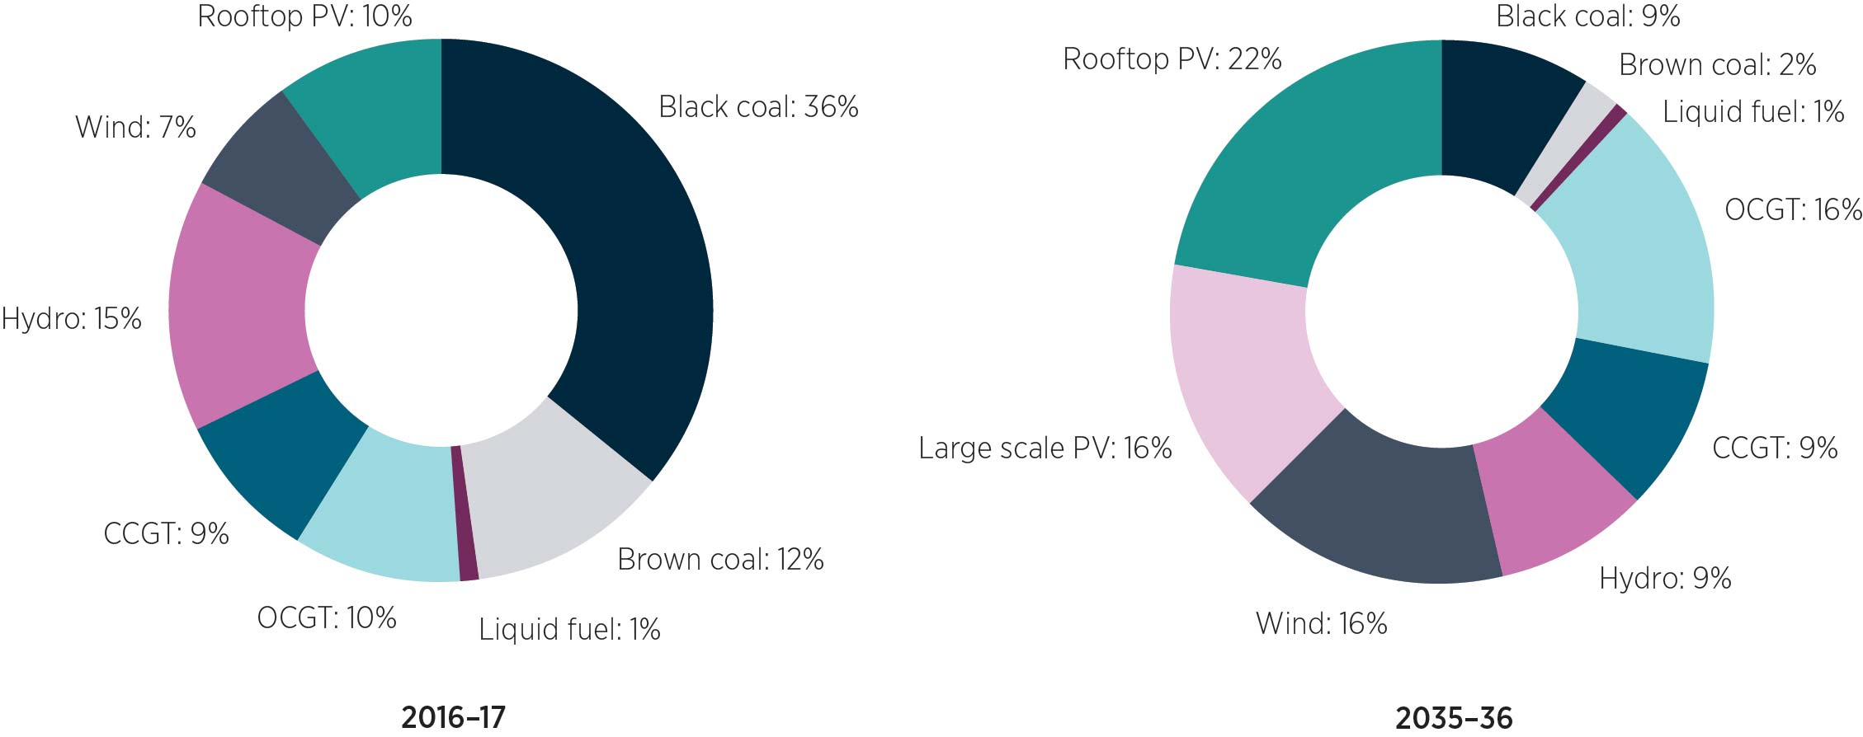
Interconnectors can play a role in supporting renewable energy integration by enabling more efficient transfer of renewable generation. Interconnectors can also more efficiently facilitate supplementation of generation from dispatchable sources (such as coal, gas and hydro) at times when renewable generation is not available. Ultimately, interconnectors diversify and expand the range of energy sources available to meet demand across the NEM. This is likely to be of greater importance in the future, when there will be a higher proportion of renewable energy.
Tasmania has abundant and high-quality renewable energy resources. In 2014−15, over 99 per cent of generation in Tasmania was from renewable energy. There is an opportunity for Tasmania to make a greater contribution to the NEM’s transition towards a lower emission generation mix through exporting more renewable energy (primarily wind, supported by hydro) to the rest of the NEM. The combination of Tasmania’s hydro and wind resources provides unique advantages, as the hydro reservoirs can be operated much like a large scale energy storage facility. When the wind is blowing, wind turbines can generate directly into the electricity grid, allowing water storages to be maintained for hydro generation when there is little wind available.

2.3 Energy security and reliability
Energy security has varying meanings and can be used interchangeably depending on the context and contemporary concerns. Consistent with the approach taken by AEMO and the AEMC, this study has interpreted energy security in terms of power system security—that is, the ability to maintain the operation of the power system within relevant technical parameters encompassing frequency, voltage and fault levels.

Reliability of energy supply is related to, but distinct from, power system security and refers to the likelihood of being able to supply all consumer energy requirements in the NEM or a NEM region with the generation and network capacity that is currently available. This includes an adequate availability of dispatchable generation; and transmission and distribution network capacity to deliver required electricity to demand centres as needed.
The increasing penetration of renewable energy generation creates technical challenges for the maintenance and restoration of the required power security settings in the NEM. Renewable energy technologies do not currently provide the same power system security services that synchronous generation, such as coal, gas and hydro, can provide. Effective alternative sources of power system security services will therefore be needed in the future as the proportion of synchronised generation declines in the NEM.
The value of power system security services in the NEM has been low historically. The revenue generators earned for providing ancillary services has been small compared to revenue from electricity sales. In 2015, the total value of ancillary services purchased in the NEM was $112 million, or 1.4 per cent of the $8.3 billion traded on the NEM.
The value of security services may increase as the share of renewable energy in the NEM increases. The AEMC is considering changes to market and regulatory frameworks to support the provision of additional system security services, including market or contractual mechanisms for the purchase of system security services, such as inertia, on a competitive basis.
The preliminary report of the Independent Review into the Future Security of the National Electricity Market highlighted the need for careful integration of renewable energy generation into the NEM, noting that intermittent generators typically lack the capability of synchronous generators to provide spinning inertia and deliver instantaneous or medium-term security and frequency control services.
The declining role of synchronous generation in the NEM is reducing the ability to correct frequency disturbances in some circumstances, and frequency control ancillary services (FCAS) will need to be obtained from other sources to compensate. Interconnectors can supply FCAS across regional boundaries, but individual regions still need to source an adequate indigenous supply of FCAS if they are separated from the rest of the NEM.

2.4 Complementary work to the study
The Basslink outage and the tripping of the South Australia to Victoria (Heywood) Interconnector on 28 September 2016 have demonstrated that there can be significant consequences for reliability when interconnectors fail. For this reason, increasing consideration is being given to the potential for augmenting existing interconnection across the NEM. This could strengthen the stability and resilience of the NEM by enabling the efficient transfer of energy and security services between NEM regions.

This study is part of that wider assessment of the future role of interconnectors as the transformation of the NEM continues. The following work could also have direct or indirect implications for that role:
- ElectraNet is conducting the South Australian Energy Transformation Regulatory Investment Test for Transmission (RIT-T) process, which is due in late 2017.
- TEST is currently assessing energy security risk mitigation measures for Tasmania. It released an interim report in December 2016, and its final report to the Tasmanian Government is due by mid-2017.
- The Australian Government is undertaking a review of its climate change policies during 2017.
- Various related work is being conducted by the Council of Australian Governments (COAG) Energy Council, AEMO and the AEMC. This includes:
- the work of the independent panel charged with conducting an Independent Review into the Future Security of the National Electricity Market
- the COAG Energy Council’s agreed improvements to the RIT-T
- review of the technical and regulatory aspects of the NEM energy security mechanisms being conducted by AEMO and AEMC.
The outcomes of these intersecting energy market policy reviews and regulatory initiatives is uncertain. They may have a substantial bearing on the NEM’s investment environment, particularly over the long-term, and therefore on the economic efficiency of a 2IC.

3 Study approach, assumptions and methodology
This chapter outlines the general methodology used to assess the economic feasibility of a 2IC. It describes the approach taken and the modelling and analysis commissioned to support the study. In this study, economic feasibility is assessed by considering whether a 2IC would be an economically efficient investment.

3.1 Economic efficiency assessment framework
To understand whether a 2IC would be an economically efficient investment, the study has considered whether, and in what circumstances, a 2IC is likely to be in the long-term interests of electricity consumers. The study has therefore assessed the economic efficiency and financeability of a 2IC under a range of plausible scenarios for the future development of the NEM.
In this study, the term ‘economically efficient’ refers to an investment which, if made, would be efficient in the long-term interests of electricity consumers in the NEM, meaning that its expected benefits to consumers would outweigh its expected costs. ‘Economically efficient’ as it relates to an investment is different from the notion of financeability. The former relates to whether the investment would be in the long-term interests of consumers; the latter relates to whether investors would be willing to fund the investment.
The National Electricity Objective (NEO) provides an appropriate framework for these considerations, as its core focus is on achieving efficient investment that is in the long-term interests of electricity consumers with respect to price, reliability and security of energy supply across the NEM.
The NEO reflects the overall objective of the Australian Energy Market Agreement. Using it as guidance requires the analytical framework for the study to:
- take a NEM-wide perspective
- consider economically efficient long-term outcomes
- focus on outcomes that promote the long-term interests of consumers.

The RIT-T is the test used to determine whether a transmission investment is economically efficient. It is set out in the National Electricity Rules (NER), and it tests for economic efficiency by determining whether major network investments would provide net positive benefits for electricity consumers in discounted net present value (NPV) terms.
The RIT-T identifies the transmission investment option (or alternative non-network option) that meets an identified need and maximises net economic benefits. It therefore serves to protect consumers from the cost and other consequences of inefficient investments where costs outweigh benefits. It requires consideration of a range of alternative credible options that could meet an identified need. This identified need is the objective a transmission network service provider (TNSP) is seeking to achieve in proposing that a particular investment be made in its transmission network.
In practice, the RIT-T has to be satisfied before the Australian Energy Regulator (AER) can approve a major network investment such as an interconnector as a regulated asset to be funded from regulated revenues. For regulated interconnectors, the AER periodically sets the amount of revenue that can be recovered each year. The revenues are then recovered directly from consumers through the network tariff component of their bills.
For the study, a discounted cash flow analysis of the projected costs and benefits of a 2IC was conducted under different assumptions about future demand and supply conditions in the NEM. The test was adopted for the purpose of assessing whether an investment in a 2IC would be economically efficient and whether or not a 2IC could be shown to deliver market benefits in excess of its costs. While this approach is consistent with the RIT-T, the NPV analysis was confined to the market costs and benefits of the 2IC itself, and other credible options were not analysed. Thus, even if the market benefits of a 2IC exceeded its costs, it may still not pass the RIT-T if other options having higher net benefits were available.
An interconnector that has not passed the RIT-T may still be constructed if it was financially viable as a merchant asset. Merchant interconnectors earn revenue by trading in the spot markets of the NEM regions they connect. The objective is to maximise profits from arbitrage trading—that is, by buying energy in one region when prices are lower and selling it to the other region at a higher price.,

3.2 Study methodology
As discussed above, to assess whether a 2IC would be feasible, it is necessary to understand the likely costs and benefits it would generate in the NEM under plausible assumptions about the future development of the NEM. It also requires an understanding of whether, and under what circumstances, investors would be prepared to invest in a 2IC. To gain an understanding of these issues, power system and market dispatch modelling and analysis was commissioned from AEMO and Ernst & Young (EY). The modelling reports are at Appendices C, D and E.

The modelling approaches used were based on a comparison of power system responses and market cost and benefit outcomes with and without a 2IC in operation. The sensitivity of modelling outcomes was assessed under different scenarios about future energy market conditions. Modelling scenarios were also developed to assess changes in power system and energy market responses to different combinations of Basslink and a 2IC operating as regulated or merchant assets.
To understand arrangements that might support the financing of a 2IC, expert analysis of possible commercial, financial and procurement approaches was also sought. The interconnector costs, revenues and benefits from the power system and market modelling formed a significant input into this analysis of the possible commercial operating models for the interconnector. The views of potential investors were also sought to inform the various potential commercial and financial models.
A flowchart summarising the approach of the study, including key inputs and modelling conducted, is at Figure 2.
Figure 2: Flowchart of study approach
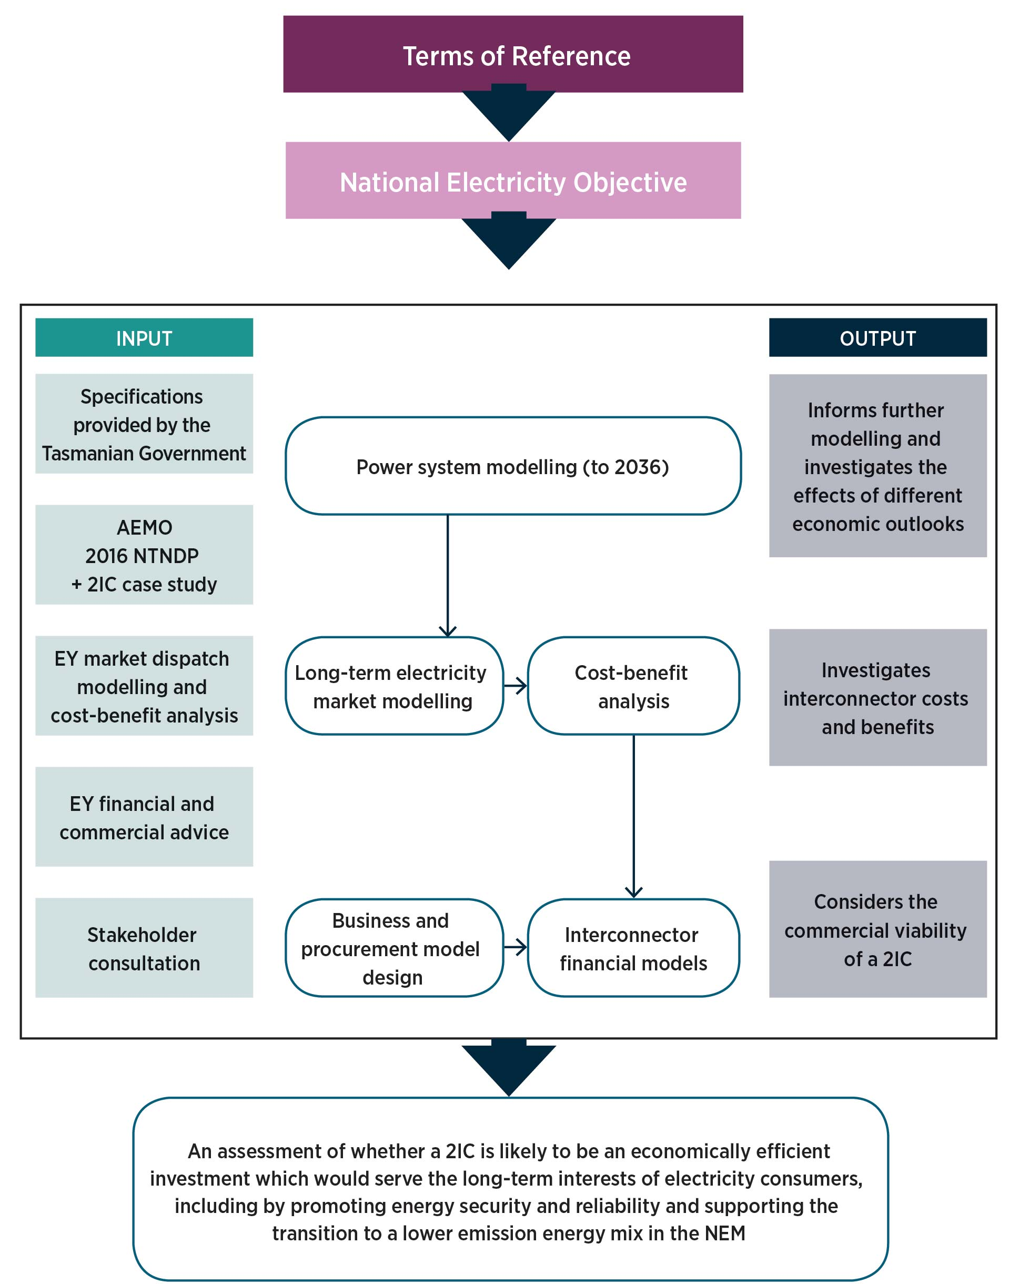
The study’s preliminary report set out a number of questions on energy security, renewable development, and costs and benefits for consumers. These questions formed the basis of targeted consultation sessions with energy market bodies, consumer groups, industry representatives and government stakeholders between October and December 2016. The insights from stakeholders have been integral in the development of the study. A summary of these consultations is at Appendix B.

3.3 Tasmanian Government 2IC specification work
The Tasmanian Government, supported by Hydro Tasmania and TasNetworks, has developed specifications for a potential 2IC, and these have been incorporated into the study’s analytical framework. This included a preliminary specification of the preferred 2IC route, technical specifications and capital cost estimates.
A high-level assessment of NEM market benefits from a 2IC was conducted as part of the Tasmanian Government’s preliminary work. This analysis found that a scenario with significant excess Tasmanian generation capacity would be needed before net positive economic benefits would be generated in the NEM. Modelling for the study explored this scenario further.
The interconnector specifications developed for the Tasmanian Government are outlined in Table 1.
Table 1: Tasmanian Government specifications
Details | Parameters
Interconnector Tasmania location | Smithton
Interconnector Victoria location | Tyabb
Interconnector technology | High-voltage direct current (HVDC) based on new voltage source converter technology, able to provide voltage control and continuous frequency control ancillary services.
Interconnector size (MW) | 600 MW
Time to develop interconnector | 8 years
Interconnector economic lifespan | 40 years (noting that AEMO has used 50 years in its modelling).
Interconnector voltage | +/− 320 kilovolt (KV)
Length of cable | 293 km
HVDC costs | $560 m
Associated Tasmanian and Victorian network augmentation costs | $237 m
Expected total project cost | $888 m (this includes connection costs in both regions).
Min. capital cost | $799 m
Max. capital cost | $1110 m
Operational & maintenance costs | $16.7 m per year
FOREX basis for costs | €0.65
Associated network augmentations | Would include augmentation to the 220 kV network in north-west Tasmania and some connection works in Victoria. Further augmentation costs might be incurred depending on the location of the additional generation and agreed connection points—these are likely to be separate from interconnector costs.
Figure 3 shows the route of a 2IC as proposed by the Tasmanian Government, as well as the Victorian and Tasmanian transmission networks at the landing points. Figure 4 shows the technical network configuration for the connection of a 2IC to the Victorian and Tasmanian transmission networks. More detailed technical studies would be needed following confirmation of the route and connection corridor if a 2IC were approved.
Figure 3: Proposed route of a 2IC, with Tasmanian and Victorian transmission networks
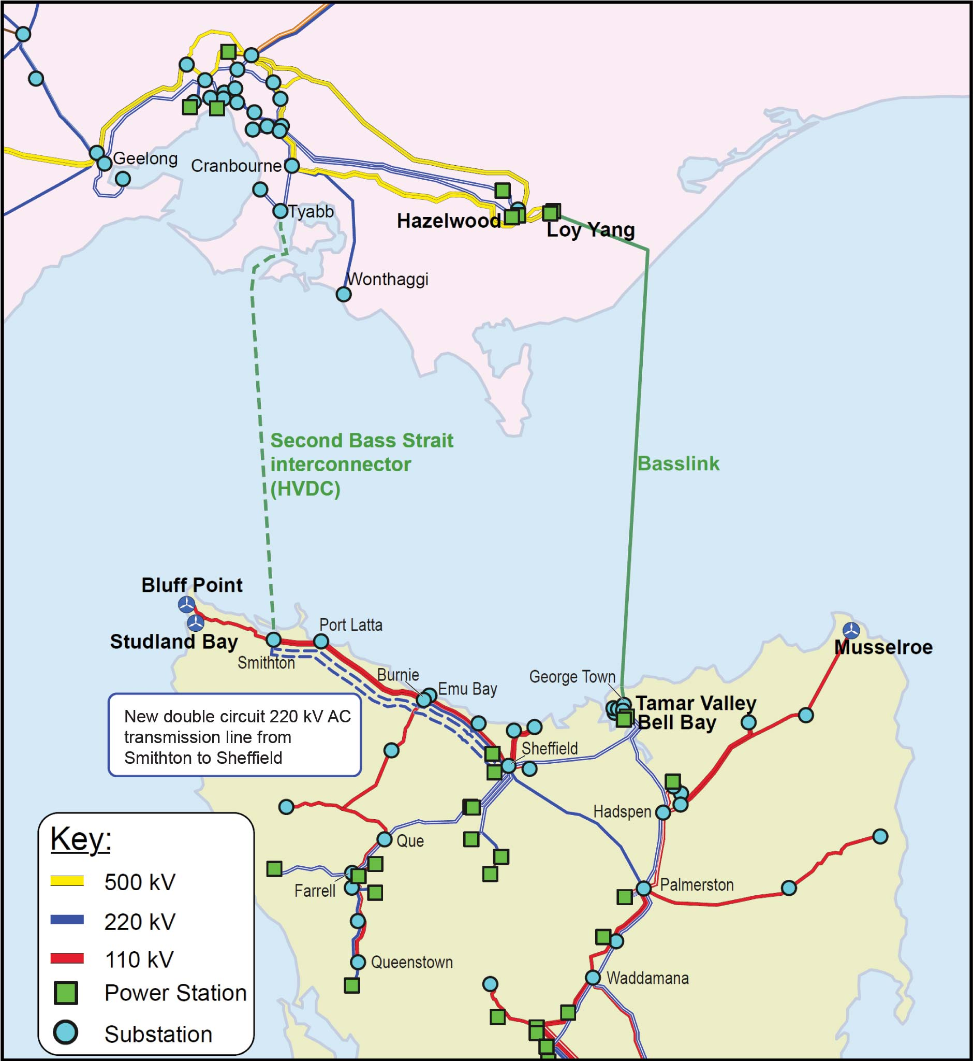
Figure 4: Proposed 2IC electrical connection and network configuration
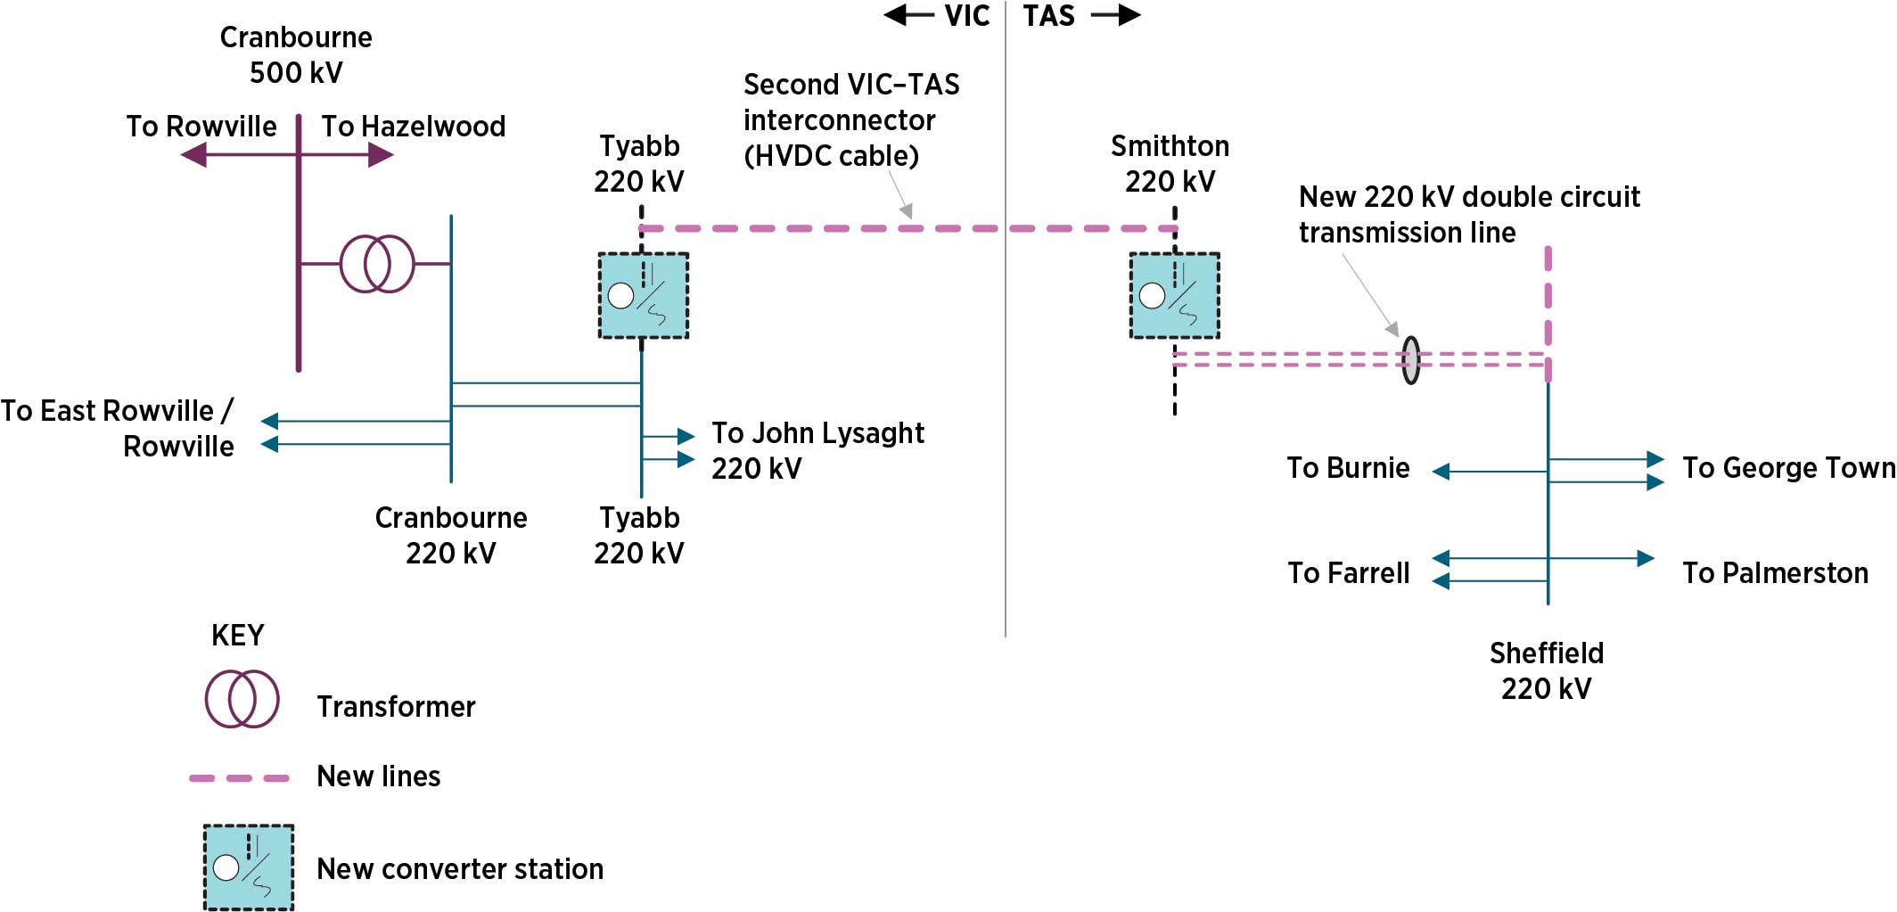

3.4 Interconnector cost assumptions
As the basis of its cost assumptions in its modelling, EY adopted the interconnector capital expenditure figures that AEMO used in its 2016 National Transmission Network Development Plan (NTNDP) and the operating expenditure figures provided by the Tasmanian Government. These figures, adjusted to 2016 dollars, are shown
in Table 2.
Table 2: Interconnector cost assumptions
Capital expenditure | Operating expenditure | NPV with 7% discount rate | NPV with 10% discount rate
$930 m in real  June 2015 dollars  (adjusted to $940 m  in real June 2016 dollars) | $16.7 m/year in real  June 2015 dollars  (adjusted to $16.87 m/year in real June 2016 dollars) | $940 m + $224 m = $1164 m in real  June 2016 dollars | $940 m + $164 m = $1104 m in real  June 2016 dollars
These cost figures have been consistently applied across the modelling. They do not reflect the total costs of developing an interconnector, in that they do not include financing and project development costs. These costs are discussed in Chapter 6.
With regard to the discounting methodology applied to AEMO and EY’s modelling results, including interconnector costings, both sets of results are presented in 2016 dollars throughout the report. However, it should be noted that these numbers are discounted differently to reflect the different modelling time periods. AEMO discounted NPVs to 2016 in 2016 dollars, as this best suited the general purposes of the NTNDP. In contrast, EY discounted NPVs to 2026 valued in 2016 dollars because 2026 is the projected start date for a 2IC.
This difference in discounting approaches changed the total NPV values of the results. For example, a value discounted to 2016 is approximately 50 per cent of the value of the same figure discounted to 2026, where a 7 per cent discount rate (real, pre-tax) is applied. Similarly, if a 10 per cent discount rate is applied then a value discounted to 2016 is approximately 38 per cent of the value of the same figure discounted to 2026. The impact this had on EY’s modelling results is discussed in further detail in Section 3.7.

3.5 Modelling and technical analyses

3.5.1 AEMO modelling and associated technical analyses
AEMO publishes NTNDPs which provide an independent, strategic view of how the power system is projected to evolve over a 20 year horizon. AEMO makes these projections by modelling in detail how the power system might change in response to changes in supply and demand.
In its 2016 NTNDP, AEMO developed three possible future scenarios. These scenarios, at Table 3, were based on assumptions about potential changes in future economic conditions and patterns of energy supply and demand. They involve scenarios of neutral and weak economic growth, as well as different emission reduction targets to 2030.
Table 3: AEMO modelling scenarios
Modelling scenario | Description
NTNDP neutral scenario | Assumes operational consumption changes in line with the 2016 National Electricity Forecasting Report (NEFR) neutral demand sensitivity.
NTNDP low grid demand scenario | Assumes technology cost reductions leading to greater growth of small distributed generation sources and energy efficiency uptake and corresponding low operational consumption growth, consistent with the weak demand sensitivity of the 2016 NEFR.
NTNDP 45 per cent emissions reduction scenario | Assesses the changes in the development of the electricity market should higher carbon abatement be targeted from the stationary energy sector (to reduce carbon emissions by 45 per cent below 2005 levels by 2030). Otherwise, consistent with the NTNDP neutral scenario.
In the 2016 NTNDP, AEMO developed a series of case studies to investigate the effects of upgrading or developing additional interconnector capacity across the NEM, including a 2IC between Tasmania and Victoria. AEMO’s case studies assessed the NEM-wide costs and benefits that would be generated with and without various interconnectors in operation under different scenarios for economic and market conditions and policy settings, consistent with the methodology required by the RIT-T.
The case studies are described in Table 4. For each, AEMO conducted:
- long-term least-cost expansion modelling showing the expected supply changes in response to each modelling scenario
- short-term time-sequential modelling to provide gross market benefits from the case studies associated with each modelling scenario (excluding competition benefits) as well as additional insights into changes to system operation with the 2IC and additional wind energy generation in place
- supporting technical analyses to determine any technical factors which might constrain or otherwise affect the modelling or subsequent cost and benefit assessment outcomes.
Table 4: AEMO case studies
Case study | Description
Upgrade QNI and VNI interconnectors (‘Base Case’) | Incremental augmentation to the existing QNI and VNI interconnectors.
2IC | Introduction of a second TAS-VIC interconnector as well as the augmentations identified in the Base Case.
Additional South Australian interconnector | Introduction of an additional South Australian interconnector as well as the augmentations identified in the Base Case.
Both 2IC and additional interconnection with South Australia | Introduction of both of the above proposed interconnectors as well as the augmentations identified in the Base Case.
2IC with 1200 MW additional Tasmanian wind generation | Introduction of a 2IC and concurrent build of 1200 MW of wind generation in Tasmania as well as the augmentations identified in the Base Case.
At the request of the taskforce, AEMO modelled an additional case study involving the concurrent development of a 2IC and 1200 MW of additional wind generation in Tasmania. This was to specifically assess the Tasmanian Government’s preliminary assessment that the case for a 2IC would be strengthened by the development of excess Tasmanian generation.

3.5.2 EY market dispatch modelling and cost−benefit analysis
EY was engaged to conduct market dispatch modelling and associated cost−benefit analysis to assess likely changes in the operation of the NEM due to the development of a 2IC. For various combinations of a 2IC and Basslink operating as regulated or merchant interconnectors, the modelling and analysis assessed:
- the likely market dispatch and bidding outcomes, including interconnector and generator revenues
- the total costs and benefits to the NEM and financial revenues and costs for potential project financiers (depending on whether 2IC and Basslink are operating as regulated or merchant interconnectors)
- the sensitivity of costs and benefits to changes in market conditions and emission reduction targets.
EY’s modelling covered the period from 2026 (the assumed commencement date for a 2IC) to 2065−66. Up to 2035−36, EY utilised in part AEMO’s modelling inputs for consistency with the NTNDP. EY’s modelling built upon AEMO’s modelling and extended the time horizon out to 2065−66 using half-hourly market simulations.

Scenario selection
The scenarios that EY modelled are summarised in Table 5. These scenarios involved comparing a base case with no 2IC in operation with scenarios that involved Basslink and a 2IC operating as either both regulated or both merchant assets.
EY did not model other potential operating combinations, such as Basslink operating as a regulated interconnector while the 2IC operates as a merchant interconnector. This is because the modelling outcomes would be heavily influenced by the assumed operating relationship between Basslink and a 2IC, and there could be a number of variations on that relationship.
To understand how potential future market conditions could influence the NEM-wide costs and benefits from a 2IC, EY modelled the following scenarios:
- a 40 per cent reduction in Tasmanian electricity demand
- low Tasmanian rainfall
- an emission reduction target that is higher than the current target.
EY’s modelling of a merchant 2IC’s financial viability assessed the arbitrage revenues the 2IC could earn from spot market trading. EY also modelled the impact that a 2IC’s trading activities would have on the costs and revenues of other stakeholders, including Basslink, Hydro Tasmania and Tasmanian electricity consumers. Those outcomes from merchant 2IC trading were then compared to the distribution of revenues and costs that would be expected if a 2IC were operated as a regulated asset.
In modelling the potential arbitrage trading revenues of a merchant 2IC, EY made a number of simplifying assumptions, including that a 2IC and Basslink would adopt a cooperative revenue-maximising bidding strategy which would be accommodated by Hydro Tasmania and other market participants. It also assumed that bidding by a 2IC and Basslink would be restricted to $0/MWh on interconnector imports.
The analysis of the viability of a merchant 2IC was concerned with the private revenues that an investor in the asset could earn from arbitrage trading and the resulting cash flows between it and other stakeholders. It is not directly comparable with the modelling of NEM-wide costs and benefits in order to test the economic viability of a regulated 2IC. Although NEM-wide market benefits may result from a merchant 2IC, those benefits would not be captured in arbitrage trading revenues and would not be relevant to an investor’s assessment of financial viability.
For its merchant interconnector analysis, EY added an alternative scenario assuming that the market in regions of the NEM other than Tasmania is consistently oversupplied with generation over the modelling period. It adopted this approach to test how robust merchant interconnector revenues are to wholesale market conditions in the rest of the NEM, noting historical trends which show that wholesale market prices have been consistently below the long-run marginal cost of new entrant generation in recent times.

EY’s scenarios are based on AEMO’s neutral scenario, extrapolated to 2065−66, except for the higher emission reduction scenarios, which are based on AEMO’s 45 per cent emissions reductions by 2030 scenario. For the alternative scenario, where the market is constantly oversupplied, EY added a consistent amount of open cycle gas turbine (OCGT) and combined cycle gas turbine (CCGT) generation to the base case scenario. EY assessed NPVs of market benefits and costs using both 7 and 10 per cent discount rates, in line with RIT-T cost and benefit analysis guidance published by Grid Australia and to match a 7 per cent discount rate used by AEMO in its 2016 NTNDP.
Table 5: EY modelling scenarios
EY Scenario name | Scenario description | Modelling assumptions
Base case
Base case  Basslink only | 2IC is not developed. | Uses thermal retirements and renewables generation planting from AEMO, based on 28 per cent emissions reduction by 2030 on 2005 levels.  No 2IC, Basslink operating under current protocols (effectively as a regulated interconnector).
Regulated Basslink and 2IC operation | Basslink and 2IC operate as regulated interconnectors. | Uses renewables generation planting from Base Case Basslink Only scenario.  Uses thermal retirements from AEMO, 28 per cent emissions reduction by 2030.  2IC operational from 1 July 2026 as regulated 2IC.  Basslink and 2IC bid at $0 (regulated behaviour).
Merchant Basslink and 2IC operation | Basslink and 2IC operate as merchant interconnectors. | Uses same renewables and thermal generation planting as Regulated Basslink and 2IC operation scenario.  2IC operational from 1 July 2026 as a merchant 2IC. Basslink and 2IC bid at or above $0 to maximise combined profit in each period.
TasWind
TasWind Basslink only | 1200 MW of wind is developed in Tasmania by 2026, 2IC is not developed. | Uses thermal retirements and renewables generation planting from AEMO, 28 per cent emissions reduction by 2030, 1200 MW of wind built in Tasmania in 2026.  No 2IC, Basslink operating under current protocols (effectively as a regulated interconnector).
TasWind regulated Basslink and 2IC operation | 1200 MW of wind is developed in Tasmania by 2026, Basslink and 2IC operate as regulated interconnectors. | Uses thermal retirements and renewables generation planting from AEMO, 28 per cent emissions reduction by 2030, 1200 MW of wind built in Tasmania in 2026.  2IC operational from 1 July 2026 as regulated 2IC. Basslink and 2IC bid at $0 (regulated behaviour).
TasWind merchant 2IC and Basslink operation | 1200 MW of wind is developed in Tasmania by 2026, Basslink and 2IC operate as merchant interconnectors. | Uses same generation planting as TasWind Regulated Basslink and 2IC Operation, with 2IC operational from 1 July 2026 as merchant 2IC.  Basslink and 2IC bid at or above $0 to maximise combined profit in each period.
TasDemand
TasDemand Basslink only | Loss of 40 per cent of Tasmanian electricity demand, 2IC is not developed. | Uses generation planting from Base Case Basslink Only—except no new Tasmanian wind after 2020.  Retires 40 per cent of Tasmanian demand uniformly throughout each study year.  No 2IC, Basslink operating under current protocols (effectively as a regulated interconnector).
TasDemand regulated Basslink and 2IC operation | Loss of 40 per cent of Tasmanian electricity demand, Basslink and 2IC operate as regulated interconnectors. | Uses generation planting from Basslink Only—except no new Tasmanian wind after 2020.  Retires 40 per cent of Tasmanian demand uniformly throughout each study year.  2IC operational from 1 July 2026 as a regulated 2IC. Basslink and 2IC bid at $0 (regulated behaviour).
Reduction in Tasmanian demand—merchant Basslink and 2IC operation | Loss of 40 per cent of Tasmanian electricity demand, Basslink and 2IC operate as merchant interconnectors. | Uses same generation planting as the TasDemand Regulated Basslink and 2IC Operation.  Retires 40 per cent of Tasmanian demand uniformly throughout each study year.  2IC operational from 1 July 2026 as merchant 2IC. Basslink and 2IC bid above $0 to maximise combined profit in each period.
LowRain
LowRain—  Base case | Long-term decline in rainfall in Tasmania, 2IC is not developed. | Uses renewable and thermal development plan from Base Case  Basslink Only.  High probability of dry years, lower probability of wet years.  No 2IC, Basslink operating under current protocols (effectively as a regulated interconnector).
LowRain Regulated Basslink and 2IC operation | Long-term decline in rainfall in Tasmania, Basslink and 2IC operate as regulated interconnectors. | Uses renewable and thermal development plan from Base Case  Basslink Only.  High probability of dry years, lower probability of wet years.  2IC operational from 1 July 2026 as regulated 2IC. Basslink and 2IC bid at $0 (regulated behaviour).
LowRain—merchant Basslink and 2IC operation | Long-term decline in rainfall in Tasmania, Basslink and 2IC operate as merchant interconnectors. | Uses same generation planting as Low Rain Regulated Basslink and 2IC Operation.  High probability of dry years, lower probability of wet years.  2IC operational from 1 July 2026 as merchant 2IC. Basslink and 2IC bid above $0 to maximise combined profit in each period.
StrongAction
StrongAction—Base case | 45 per cent by 2030 national emissions reduction target, 2IC is not developed. | Uses thermal retirements and renewables planting from AEMO, 45 per cent emissions reduction by 2030.  No 2IC, Basslink operating under current protocols (effectively as a regulated interconnector).
StrongAction— regulated Basslink and 2IC operation | 45 per cent by 2030 national emissions reduction target, Basslink and 2IC operate as regulated interconnectors. | Uses thermal retirements and renewables planting from AEMO, 45 per cent emissions reduction by 2030  2IC operational from 1 July 2026. Basslink and 2IC bid at $0 (regulated behaviour).

3.6 Commercial and financial advice
Separate from the market modelling, EY also provided analysis and advice on the financial and business models that could support a 2IC’s operation. The financial assessment is not aimed at determining whether a 2IC is economically efficient; instead, it tests whether, and under what market conditions and business models, a regulated 2IC or merchant 2IC would be financeable.
EY also completed market soundings with potential investors of varying sizes and with different interests in funding a 2IC.
EY’s approach and advice on commercial and financial structures is examined in Chapter 6.

3.7 Differences between AEMO and EY’s modelling approaches
AEMO’s modelling provides general information that NEM participants use for a variety of purposes. It has a broad focus—it identifies likely power system changes and emerging network constraints; and highlights options that might address these constraints over a 20 year forward outlook. EY’s modelling was commissioned specifically for the study and has considered more detailed scenarios and regulatory arrangements than those modelled by AEMO.
EY’s modelling built on AEMO’s work and its technical specifications of the power system and the interconnected network of the NEM. However, there are some differences between the two modelling approaches which mean that they are often not readily comparable. The main differences are outlined in Table 6.
Table 6: Key differences between AEMO and EY modelling
AEMO | EY
AEMO’s modelling period is from 2016−17 to 2035−36. | EY’s modelling period is from 2026−27 to 2065−66 in order to consider the costs and benefits of the 2IC over a modelled 40 year economic life.
AEMO’s modelling assumed that generators are dispatched according to their short-run marginal costs. | EY assumed that generators will make strategic spot market bids which seek to maximise their revenues while having regard to the market positions and bidding strategies of other generators.
AEMO incorporated detailed assessment of the capabilities of the transmission network throughout the planning horizon, including the impacts of an evolving NEM supply and demand. | EY’s market modelling simplifies these complex network capabilities to a subset of transmission limitations impacting on interconnector flows. Therefore, it may provide material differences in the benefits (or lack of benefits) of interconnectors.
AEMO modelled a low grid demand scenario in which demand gradually declines across the entire NEM (including Tasmania). | EY modelled the impact of an immediate and significant reduction in Tasmanian demand.
AEMO identified and valued potential ‘resilience benefits’ from interconnector investments in the NEM (which give a value to the capacity to respond to low-probability, high-impact events such as the recent Basslink outage). | EY did not consider resilience benefits as they have not traditionally been included in RIT-T analysis.
AEMO has modelled the Tasmanian hydro generation as a 6-pond model with individual hydro generators linked to one of the six geographically grouped storages. The storage energy available to the units are updated with publicly available data at the time of commencing NTNDP modelling. Energy inflow data for each Tasmanian hydro water storage is determined from long-term historical yield information. | In consultation with Hydro Tasmania, EY developed detailed modelling of the operation of its hydro generation assets, recognising that the flexibility of these assets has a large bearing on the operation of a 2IC and Basslink.
 | EY’s modelling assessed the sensitivity of a 2IC’s viability to different regulatory arrangements, including operation of a 2IC and Basslink as either regulated or merchant assets.
AEMO and EY modelled, in a time sequential manner, the dispatch of the NEM, including the inherent volatility of intermittent renewable generators. However, the timing of the renewable resources across the NEM may differ between models, particularly with regard to the contribution of renewable generators to meeting peak demand conditions. This potential difference may impact on the value that wind generation in particular provides in deferring capital investment in peaking thermal generation.

A key reason that EY’s 2IC results differ from AEMO’s is that they have been discounted to 2026, rather than to 2016, as discussed in Section 3.4. Also, AEMO discounted only 11 years of annualised cost because of its shorter analysis period, whereas EY discounted the costs over its 40 year analysis period. EY noted that discounting to 2016, while changing the magnitude of the benefits to costs, maintains the same ratio between benefits and costs. An example is shown in Table 7.
Table 7: Base case regulated interconnector outcomes (NPV)—impact of discounting
 | 7% discount rate—discounted to 2026 | 7% discount rate—discounted to 2016 | 10% discount rate—discounted to 2026 | 10% discount rate—discounted to 2016
Market benefits | $809 m | $411 m | $634 m | $245 m
Interconnector costs | −$1164 m | −$592 m | −$1104 m | −$426 m
Net benefit | −$356 m | −$181 m | −$470 m | −$181 m
Ratio of benefit to cost | 69% | 69% | 57% | 57%

4 Results of modelling and analysis
This chapter presents the results and key findings of the modelling that AEMO and EY developed to support the study, other than EY’s financial and commercial analysis, which is discussed in Chapter 6. AEMO’s modelling report is at Appendix C. EY’s market dispatch modelling report is at Appendix D.

Key findings
- Modelling and analysis by AEMO and EY identified two future NEM development scenarios where a 2IC would produce significantly positive net market benefits. They were where:
- an additional South Australian interconnector is built before a 2IC comes into operation
- there is a significant reduction in future Tasmanian electricity demand.
- AEMO’s results indicated that a 2IC could produce marginally positive net benefits under its neutral economic growth scenario, but it would produce negative net benefits under its other scenarios.
- EY’s modelling indicated that a regulated 2IC would not generate positive net market benefits in the scenarios it modelled other than under an assumption of significant reduction in Tasmanian electricity demand.
- Both modelling results identified that the principal source of NEM-wide benefit from a 2IC would be the deferral of higher-cost generation investment and variable cost savings from more flexible and efficient use of Tasmania’s hydro generation.
- AEMO’s results also showed that market benefits from a 2IC would improve and result in positive net market benefits under most scenarios if other interconnections were implemented across the NEM
as well as a 2IC.
- EY’s scenario modelling demonstrated that the market benefits generated by a 2IC were sensitive to modelling assumptions about future supply and demand conditions. For example, lower than expected Tasmanian rainfall or a higher emissions reduction target would reduce the modelled benefits.
- EY’s modelling indicated potential for higher revenues from a merchant rather than a regulated 2IC, but the merchant revenues would also be highly volatile and risky. A regulated 2IC’s revenues would be more predictable and lower risk, which would be attractive for financiers. However, satisfying the RIT-T would be difficult on the basis of the market modelling projections.

4.1 AEMO modelling findings
AEMO assessed the costs and market benefits of a 2IC through to 2036 as described in Chapter 3. AEMO’s key insights from its modelling and analysis are presented in Box 1.

Box 1: AEMO’s key modelling findings
Assuming neutral economic growth, a 2IC is projected to deliver gross market benefits of $361 million over the next 20 years to 2035−36 by:
- delivering $85 million savings in fuel and variable operating and maintenance costs due to hydro and wind generation in Tasmania primarily displacing higher-cost gas generation in the rest of the NEM
- facilitating the gradual development of additional renewable generation in Tasmania (mainly wind) to support supply changes in the NEM, resulting in $6 million in market benefits due to reduced environmental scheme costs
- deferring the need for gas generation investments in the NEM, producing $134 million in market benefits
- reducing reliance on voluntary demand curtailment and involuntary load shedding, producing $87 million
in market benefits
- delivering $48 million in market benefits (including reliability benefits) if Basslink was out of service for an entire year, discounted for the low probability of this high-impact event.
Over the same period, the annualised cost of the 2IC is estimated to be around $341 million. As the resulting net market benefits under the neutral demand scenario were just $20 million, further analysis would be required to justify investment in the long-term interests of electricity consumers.
Greater interconnection would deliver significant synergies. Net market benefits of a 2IC would increase if an additional South Australian interconnector were built first. This would mainly be because the development of more interconnection would more effectively utilise the diversity of renewable generation across the regions. The need for higher-cost gas generation would be reduced by allowing renewable generation in one region to complement the intermittency of renewable generation in another.
The net market benefits of a 2IC would be negative under the low grid demand and higher emissions reductions scenarios. The 2IC would only be economically justified in scenarios where it would deliver capital deferral benefits in addition to fuel cost savings. If future operational demand were low, or emerging technologies such as utility-scale batteries became widespread, the ability for the 2IC to defer new generation build would diminish.
Building additional renewable generation in Tasmania may lead to oversupply. Building new renewable generation in Tasmania (1200 MW of wind), timed to coincide with commissioning of the 2IC, would not increase projected market benefits. New renewable generation is projected to be developed in Victoria to meet the proposed Victorian Renewable Energy Target (VRET). In that case any additional generation from Tasmania would lead to oversupply in the southern regions (Victoria, Tasmania and South Australia). This would either drive further generation withdrawals or require stronger interconnection between Victoria and New South Wales.
While a 2IC may provide additional power system security services such as FCAS, AEMO noted that these support services are adequately provided by existing generators in Tasmania and Victoria.

4.2 AEMO’s analysis of market benefits resulting from a 2IC
As noted in Chapter 3, AEMO has modelled the market benefits and costs of a 2IC under its Base Case scenario for its 2016 NTNDP, which included anticipated upgrades of interconnection between Queensland and New South Wales (QNI) and between Victoria and New South Wales (VNI).
These projections indicate that a 2IC would deliver incremental net market benefits beyond those benefits delivered in AEMO’s Base Case of $20 million per year under a neutral economic growth scenario. There was an incremental net benefit of negative $147 million for the low grid demand scenario and negative $57 million for the 45 per cent emissions reduction scenario. This suggests the net market benefits from a 2IC would be marginal under the neutral economic outlook scenario and negative under other plausible scenarios of future NEM development modelled by AEMO.
AEMO’s modelling found that a significant portion of the projected benefits of a 2IC would be from the more efficient use of existing generation assets in Tasmania, because the additional transfer capacity that a 2IC would provide would allow Hydro Tasmania’s facilities to generate more during periods of highest value and to import energy during periods of lowest value. This would result in both dispatch efficiency benefits when hydro generation replaces dispatch of more costly OCGT generation in Victoria; and capital cost reductions in the NEM due to deferral of investment in costly peaking gas generation. A 2IC would provide marginally positive net market benefits only in scenarios where these significant capital deferral and fuel cost savings are both realised. A 2IC’s ability to defer new generation build in the NEM would be diminished in scenarios where operational demand growth is low (as in the low grid demand scenario) or where emerging technologies such as utility-scale battery storage reduce the requirement for new gas generation (as in the 45 per cent emission reduction by 2030 scenario).

4.2.1 Synergies of a more interconnected NEM
AEMO modelled the market benefits resulting from new interconnection across the NEM, including between South Australia and Victoria or New South Wales, and assessed the impact this could have on net benefits generated by a 2IC.
The net benefits from interconnector investment across the NEM compound when other interconnection investment occurs. This is mainly because renewable generation would be able to flow across regions more effectively, smoothing patterns of intermittency and reducing the need for higher marginal cost generation such as gas generation. This is illustrated in Table 8, which highlights the net benefits of different interconnection scenarios under the neutral economic growth, low grid demand and 45 per cent emissions reduction scenarios.
Under AEMO’s neutral economic growth scenario, a new interconnector between South Australia and Victoria would produce incremental net market benefits of $136 million, compared to net benefits of $20 million for the 2IC between Tasmania and Victoria. However, the combined net benefits increase to $179 million if both interconnectors are modelled together.
In practice, however, each incremental interconnection investment would need to undergo a full RIT-T assessment before those investments could proceed. Recognising that these are long-term investments with asset lives stretching to the 2050s and 2060s and beyond, AEMO emphasised that its post-2030 benefits assessments are subject to high levels of uncertainty. If the NEM evolves in a way that reduces the role of the inter-regional trade facilitated by interconnectors, these projected incremental benefits could be reduced or eliminated.
Table 8: Net benefits of various interconnection options under different AEMO case studies
Case study | NPV of gross market benefits to 2035−36 | NPV of annualised cost to 2035−36 | Overall net benefit of the case study | Incremental net benefit above  base case
Neutral economic growth scenario
2IC + QNI + VNI | $531 m | $387 m | $143 m | $20 m
New SA Link + QNI + VNI | $595 m | $335 m | $260 m | $136 m
New SA Link + 2IC+ QNI + VNI | $978 m | $676 m | $302 m | $179 m
Low grid demand scenario
2IC + QNI + VNI | $357 m | $418 m | −$61 m | −$147 m
New SA Link + QNI + VNI | $630 m | $366 m | $264 m | $178 m
New SA Link + 2IC+ QNI + VNI | $758 m | $707 m | $51 m | −$35 m
45 per cent carbon target scenario
2IC + QNI + VNI | $611 m | $387 m | $224 m | −$57 m
New SA Link + QNI + VNI | $888 m | $335 m | $553 m | $272 m
New SA Link + 2IC+ QNI + VNI | $1354 m | $676 m | $678 m | $397 m

4.3 EY market dispatch modelling results
As noted in Chapter 3, EY modelled changes to NEM-wide costs and benefits resulting from the operation of a 2IC under both regulated and merchant scenarios. It also modelled the private costs and revenues associated with operating a merchant 2IC to test its financial viability as an unregulated asset.

4.3.1 EY regulated 2IC modelling findings
Key insights from EY’s modelling of a 2IC as a regulated interconnector are stated in Box 2.

Box 2: EY’s key modelling findings—regulated 2IC
- A 2IC is unlikely to generate market benefits that exceed its cost, except in a scenario with reduced Tasmanian electricity demand.
- There are two key sources of market benefits from a 2IC (in scenarios other than the Tasmanian demand reduction scenario) where the primary source of benefits is from the improved utilisation of surplus Tasmanian generation:
  - A 2IC would defer between 450 MW and 600 MW of thermal generation in the NEM which would otherwise be required to maintain reliability in Victoria once brown coal generation is retired. This capacity deferral does not occur until the early 2030s, meaning that the benefits of reduced capital investment would be discounted significantly.
  - A 2IC would also facilitate variable cost savings primarily due to more efficient use of water storages and generation facilities to increase export to Victoria during periods where higher-cost generation would otherwise be required. There would also be some benefit from improved utilisation of other lower-cost Tasmanian generation assets, including the TVPS.
- Although a 2IC would facilitate additional wind generation investment in Tasmania, the market benefits from this investment would be relatively minor.
- Higher rainfall in Tasmania would increase the volume of Tasmanian surplus energy available for export. This would increase the potential for variable cost savings in the NEM. The opposite outcome would be expected in periods of low rainfall and water storage levels.
- The modelling of a higher emissions reduction target scenario showed a reduction in benefit from a 2IC because earlier brown coal retirements are replaced by earlier battery storage development, reducing the benefit from more flexible use of Tasmanian water storage and generation facilities.
The results of EY’s modelling are shown in the tables below. Table 9 shows the gross market benefits from a 2IC for 7 and 10 per cent discount rates. Table 10 presents the interconnector cost assumptions. Table 11 shows the overall net market benefits once costs have been considered.
Table 9: Gross market benefits from a 2IC for EY modelling scenarios
Scenario description | 7% discount rate | 10% discount rate
Regulated 2IC development | $809 m | $634 m
Fixed 1200 MW of new wind capacity in Tasmania by 2026 | $522 m | $257 m
40% reduction in Tasmanian demand | $2017 m | $1528 m
Lower average rainfall in Tasmania | $647 m | $379 m
45% emissions reduction by 2030 | $833 m | $592 m
Table 10: Interconnector cost assumptions
 | 7% discount rate | 10% discount rate
Capital cost | $940 m | $940 m
Operating and maintenance | $224 m | $164 m
Total cost | $1164 m | $1104 m
Table 11: Net market benefits from a 2IC for EY modelling scenarios
Scenario description | 7% discount rate | 10% discount rate
Regulated 2IC development | −$356 m | −$470 m
Fixed 1200 MW of new wind capacity in Tasmania by 2026 | −$642 m | −$848 m
40% reduction in Tasmanian demand | $853 m | $424 m
Lower average rainfall in Tasmania | −$518 m | −$725 m
45% emissions reduction by 2030 | −$331 m | −$512 m

Table 11 indicates that the market benefits of a 2IC would be outweighed by its costs for all scenarios other than the scenario with reduction of Tasmanian demand. That scenario would produce positive net market benefits because a 2IC would enable the resulting surplus energy to be exported. This would avoid spillage of water from Hydro Tasmania’s storages that could otherwise occur without a 2IC, particularly in high rainfall years.
Table 11 also shows that the net market benefits that a 2IC provides are sensitive to plausible market and environmental assumptions. For example, the scenarios that assume lower than expected Tasmanian rainfall or a higher emission reduction target would both reduce the benefits from a 2IC.
Consistent with AEMO’s analysis, EY ‘s modelling found that the primary source of market benefits from a 2IC would be from more efficient use of existing generation assets in Tasmania, which would lead to both variable cost reductions and benefits from capital cost deferrals.
This is illustrated in Figure 5, which presents a comparison of flows between Tasmania and Victoria with and without a 2IC in an example year (2027−28), assuming higher Tasmanian wind generation. Combined Basslink and 2IC flows are shown in blue, while operation of Basslink alone is shown in purple. The shaded area between the two lines represents additional value that would be gained from the extra transfer capacity a 2IC would offer, beyond that of Basslink.

Figure 5: Comparison of VIC–TAS electricity flows with and without a (regulated) 2IC
for 2027–28
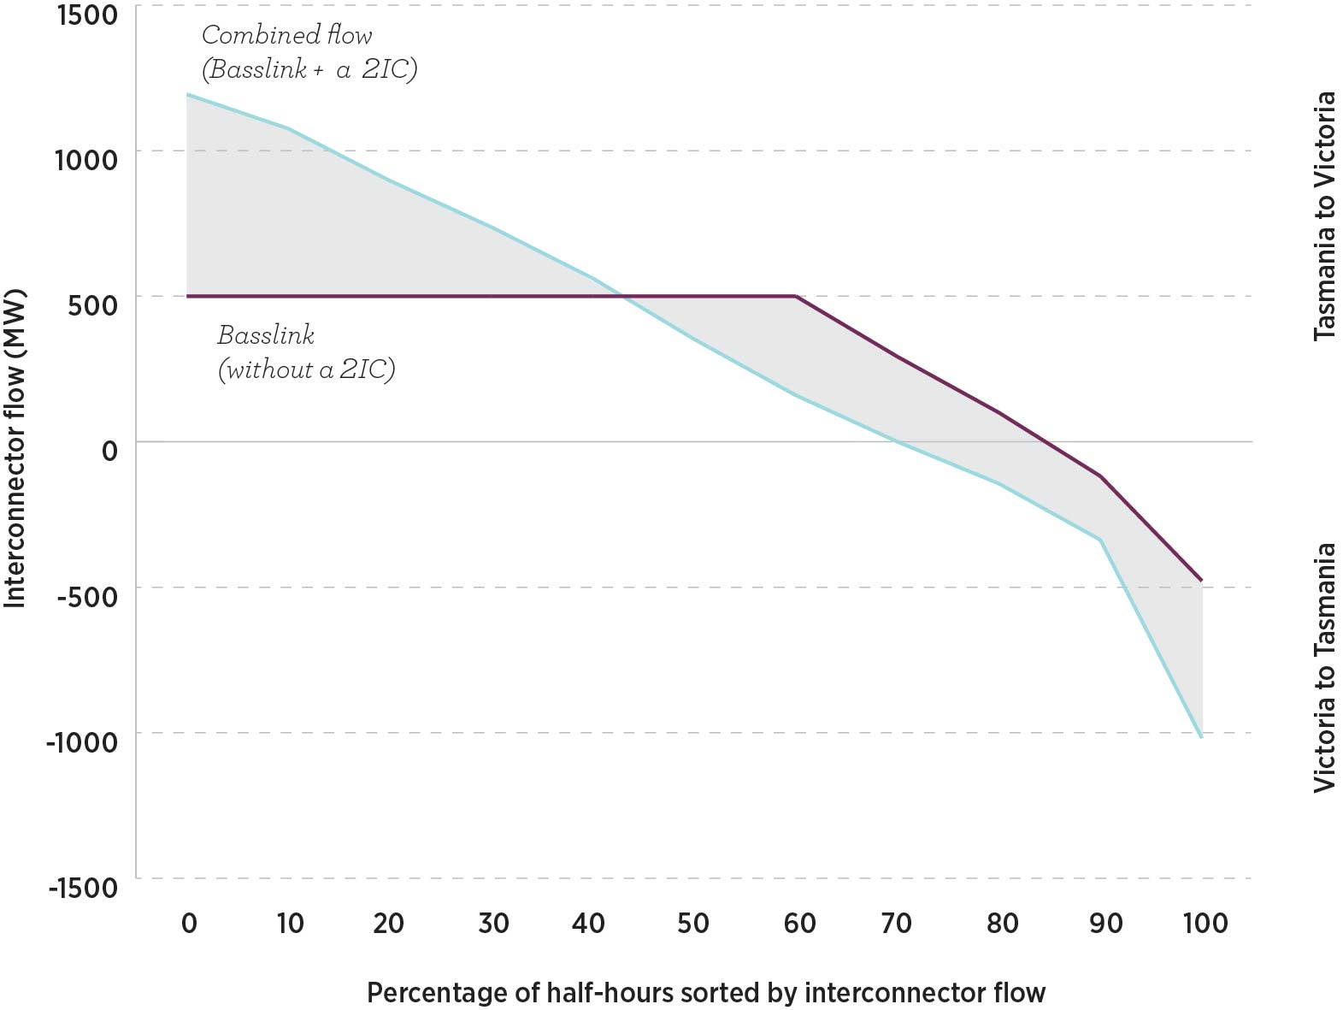
The additional export energy that the development of a 2IC could facilitate in 2027–28 is 1400 GWh. The difference of flow from +500 MW to +1200 MW shows that there are likely to be periods where the 2IC is capable of extracting additional value through increased Tasmanian hydro generation exports. EY estimated that the improved use of Tasmanian generation exports, facilitated by a 2IC, could lead to capital cost savings of
$286 million because of the deferral of 450 MW of additional investment in new OCGT capacity in Victoria.

Sensitivity of market benefits to the operation of the Tamar Valley Power Station
EY’s modelling also showed that market benefits from a 2IC would be enhanced by continued operation of the TVPS. That was because TVPS is a lower-cost CCGT than the OCGT peaking plants that would otherwise be required, and its availability could reduce the variable costs of dispatch and so increase market benefits. EY’s modelling found that TVPS could operate to increase exports to the rest of the NEM, offering an additional
200 MW of Tasmanian generation capacity for export. EY found that, as a CCGT, TVPS would be more efficient and therefore less costly to operate than much of the gas generation in the rest of the NEM. Running TVPS could therefore reduce variable costs, which would increase market benefits.
EY’s modelling shows that the market benefits of a 2IC would improve by around $200 million if TVPS were operational in Tasmania. Of these benefits, around $100 million would be from variable cost savings and around $100 million would be from capital cost deferrals from the construction of OCGT generation in Victoria.

Tasmanian wind resources
EY’s modelling indicated that 1100 MW of additional wind generation (above the existing level) could be accommodated in Tasmania. However, although a 2IC would facilitate additional wind generation investment in Tasmania, the market benefits from this investment would be relatively minor. Wind resources in Tasmania are abundant and of high quality. However, the benefits of developing these resources would be limited because of:
- transmission losses in exporting wind generation from Tasmania at exports above the current export capacity of Basslink
- high levels of wind generation in Tasmania, which would interact with the ability of the hydro generators to manage run-of-river water inflows and storage levels and may limit their ability to cost-effectively use hydro resources
- export of Tasmanian wind to Victoria, which would already have significant wind generation due to the impact of the VRET.

Other market benefits and costs not captured in EY’s modelling
EY noted that there are several sources of additional benefits and costs that may result from a 2IC that have not been captured in the market benefits presented in its report. These additional sources of benefits would be assessed and valued (at least qualitatively) in a full RIT-T analysis and could improve a 2IC feasibility assessment under different future states of NEM development.
These potential benefits and costs include:
- the value of a 2IC as part of a more interconnected transmission network across the NEM—EY’s modelling included the capital and operating costs of a 2IC and the direct costs of connecting a 2IC to the existing transmission network. EY modelling of market benefits did not extend to possible compounding benefits from a 2IC investment arising from prior sequential investments in other interconnection assets, although its analysis assumes augmentation of QNI and VNI. EY did not consider the impact of additional renewable generation development on transmission development and connection costs.
- avoidance of the need for more conservative operation of Tasmania’s hydro generation facilities—in the absence of a 2IC, it may be necessary to operate Hydro Tasmania’s water storages and generation facilities more conservatively to mitigate the reliability risk from periods of low rainfall, insufficient wind or gas generation availability and failure of Basslink. While this would help to insure against reliability shortfalls, there would be a cost in terms of reduced trading revenue and less efficient utilisation of the Tasmania’s dispatchable renewable energy resources. That cost could be avoided with a 2IC in operation and could be viewed as a market benefit arising from a 2IC.
- any escalation in costs would reduce the net market benefit case—EY used the cost estimate for a 2IC provided by the Tasmanian Government for its net benefit modelling. However, there is a material risk that the capital and environmental approval-related costs would escalate during the development process. This is demonstrated by the experience of Basslink, where costs increased by almost $375 million by commencement of operations (this is discussed further in Chapter 9).
- energy reliability and ancillary services—a 2IC would provide benefits due to increased energy reliability (in case of future Basslink outages) and through provision of another source of ancillary services to the market. Energy reliability and ancillary services are discussed in greater detail, alongside discussion of other costs and benefits that have not been quantitatively modelled by EY and AEMO, at Section 5.2.

4.3.2 EY merchant 2IC modelling findings
The key findings of EY’s modelling of a 2IC and Basslink operating as merchant interconnectors are stated in Box 3.

Box 3: EY’s key modelling findings—merchant 2IC
- EY’s modelling showed the potential for a merchant 2IC to earn high arbitrage trading revenues, which were projected to exceed its capital and operating costs. However, these revenues would also be volatile and risky. This would have adverse implications for financeability. EY’s modelling results were heavily dependent on the assumptions chosen, including the assumed bidding behaviour of the interconnectors and Hydro Tasmania.
- A merchant 2IC model would generate lower NEM-wide market benefits than the regulated 2IC. This is due in large part to a capacity-withholding strategy assumed to be used to maximise arbitrage trading revenues.
- The modelling showed that a regulated 2IC would have lower revenues than a merchant 2IC, but they would be more predictable and lower risk.
- If a 2IC was a merchant asset, Tasmanian spot prices would tend to remain below Victorian spot prices, with much of the difference being captured in arbitrage trading revenues. For a regulated 2IC, spot prices in the two regions would tend to converge.
- In the merchant asset case Tasmanian wholesale energy costs would tend to be lower than in the regulated 2IC case, and Hydro Tasmania’s revenues would tend to be lower.
- However, the allocation of revenues and costs between these stakeholders in the merchant 2IC case is heavily dependent on the assumed bidding behaviour of the interconnectors and Hydro Tasmania. Different allocations of revenues would result from different behavioural assumptions.
As described previously, a merchant 2IC would earn revenues from the arbitrage opportunities between the spot prices in Victoria and Tasmania. That means, the greater this spot price differential, the greater the revenues. EY found that a merchant 2IC would act to preserve this spot price differential to the extent possible, even if it meant withholding flow on the interconnector.
Victorian spot prices are generally higher than those in Tasmania. Therefore, a merchant 2IC would mostly cause power to flow north, buying power in Tasmania and selling it in Victoria. This was the driver for many of EY’s findings. A merchant 2IC would earn greater revenues whenever the Victorian spot prices were higher and the Tasmanian spot prices were lower; and it would earn lower revenues where spot prices in the two regions converge.

As the revenues of a merchant 2IC would depend on the spot price outcomes in Tasmania and Victoria, these projected revenues are highly dependent on the assumptions EY made about market conditions and the behaviour of the interconnectors and Hydro Tasmania. EY’s analysis is based on the following assumptions:
- Hydro Tasmania would bid its generation into the spot market at the water value in Tasmania. On this assumption, Hydro Tasmania would be restricted from using any market power. If Hydro Tasmania were to bid strategically by reference to the spot price differential to Victoria, it could appropriate the spot price differential for itself and significantly reduce 2IC’s revenues. While this assumption was necessary to simplify the modelling, it is not clear that it would be accurate in practice.
- A 2IC would be operated independently of Hydro Tasmania. This impacts on a 2IC’s modelled bidding behaviour. An independent 2IC would operate to preserve the spot price differential between Victoria and Tasmania. If a 2IC were instead to be operated by Hydro Tasmania, in most cases it would earn higher revenues across its whole portfolio by bidding the 2IC at or close to $0/MWh, increasing the flow on the interconnector and bringing the Tasmanian spot price closer to the (higher) Victorian price. Hydro Tasmania could then bid its generation in Tasmania at higher prices. However, there would be limited periods in which a combined Hydro Tasmania, Basslink and 2IC portfolio would benefit from bidding both interconnectors at higher prices to achieve higher revenues at reduced export volumes to the rest of the NEM.
- A 2IC and Basslink would not compete with each other. If they did compete, the revenues of each could be reduced.
- A 2IC would be restricted to bidding its capacity at $0/MWh when power is flowing south, meaning it would be prevented from earning revenue when Tasmania is importing. EY noted that a 2IC could make large profits at times of shortages of supply in Tasmania (by restricting southward power flows). To simplify the modelling, it assumed a 2IC would be prevented from bidding strategically on import flows.

Modelling outcomes
Tables 12 and 13 show revenues that a 2IC and Basslink would earn for the merchant interconnector scenarios modelled by EY, assuming 7 and 10 per cent discount rates. To test how robust merchant interconnector revenues would be to oversupplied wholesale market conditions in non-Tasmanian NEM regions, EY also completed an additional sensitivity scenario (shown as ‘Non-Tasmanian generation oversupply’).
Table 12: Merchant interconnector revenue—7% discount rate
 | 2IC | Basslink | Total
Merchant 2IC development | $2110 m | $772 m | $2881 m
1200 MW of new wind capacity in Tasmania by 2026 | $2244 m | $848 m | $3092 m
40% reduction in Tasmanian demand | $4869 m | $2579 m | $7448 m
Lower average rainfall in Tasmania | $2014 m | $705 m | $2720 m
Non-Tasmanian generation oversupply | $1357 m | $420 m | $1776 m
Table 13: Merchant interconnector revenue—10% discount rate
 | 2IC | Basslink | Total
Merchant 2IC development | $1481 m | $549 m | $2030 m
1200 MW of new wind capacity in Tasmania by 2026 | $1591 m | $609 m | $2200 m
40% reduction in Tasmanian demand | $3453 m | $1844 m | $5297 m
Lower average rainfall in Tasmania | $1409 m | $502 m | $1911 m
Non-Tasmanian generation oversupply | $966 m | $304 m | $1270 m

Analysis of merchant 2IC modelling outcomes
The results of Tables 12 and 13 show that, under the simplifying assumptions made by EY, the total revenue of the two merchant interconnectors would be considerable, and would exceed the cost of a 2IC in most scenarios.
EY found that the merchant interconnectors would achieve these revenues by withholding capacity on the interconnectors during periods of export from Tasmania when Victorian demand and prices were high. By limiting the quantity of Tasmanian generation flowing to Victoria, upward pressure would be placed on the Victorian spot price as the ‘missing’ power in Victoria is replaced by higher-cost (usually gas) generation from the rest of the NEM. At the same time, reducing hydro exports would build water storage levels in Tasmania, and this would lower the value of its stored water over time. The net result would be to lower Tasmanian wholesale electricity market prices and to raise Victorian wholesale prices—the difference would be captured in arbitrage trading revenues that the interconnectors earned. This would not be the case if Hydro Tasmania was the operator of the 2IC and bid its capacity on the basis of the assumptions outlined previously.

EY did not consider arbitrage trading revenues from bidding by the interconnectors during periods of imports from Victoria to Tasmania in its findings because of its simplifying modelling assumptions. If the interconnectors were to bid on imports into Tasmania during low Victorian pool price periods, this would in practice raise the regional spot price differential and result in additional revenues to a 2IC and to Basslink, particularly during periods where Tasmanian hydro resources are low.
EY found that high levels of wind in Tasmania would act to increase merchant 2IC revenue, as wind would be expected to bid at low prices. If Tasmanian wind generation were added, it would further reduce wholesale prices in Tasmania and increase the price differential between Tasmania and Victoria, particularly in trading intervals of high Tasmanian wind production. However, this finding did not take into account whether the Tasmanian wind generation would be profitable in this scenario.
Similarly, loss of demand in Tasmania would result in an oversupply of generation. This would have a large impact in that it would reduce the spot price in Tasmania and increase the spot price differential with Victoria. This is the scenario in which a merchant 2IC’s revenues would be highest. Alternatively, an oversupply of generation in Victoria would lower spot prices in Victoria and bring them closer to those in Tasmania. This would reduce the differential and therefore reduce the 2IC’s revenues.
Lower rainfall in Tasmania would also reduce the amount of water in hydro storages and increase water values. Under EY’s assumption that Hydro Tasmania continued bidding at its opportunity cost of water, its bids would increase and the spot price in Tasmania would rise, converging towards the Victoria spot price and lowering the 2IC’s revenues.
The overall purpose of this analysis was not to predict the price and revenue outcomes for a merchant 2IC that are likely under different scenarios. Rather, it was to illustrate how sensitive those price and revenue outcomes are to changing wholesale market conditions, especially in Victoria, and to the bidding strategies of other market participants, particularly Hydro Tasmania. The scenario where there is an oversupply of generation in Victoria and the 2IC’s revenues are much lower highlights this point.
EY commented that, while market modelling appeared to forecast scenario outcomes with perfect foresight, recent history has shown that the drivers of wholesale market outcomes can be hard to predict. The modelling results emphasised that, while the revenues of a merchant 2IC are potentially higher than the 2IC’s costs, those revenues are also inherently volatile and risky. This uncertainty has a large impact on the financeability of a merchant 2IC, as discussed in Chapter 6.

Impact on market benefits of a merchant 2IC
EY modelled the NEM-wide market benefits that would be provided by a merchant 2IC compared to a regulated 2IC. EY found that a merchant 2IC would generate much lower market benefits than a regulated 2IC. For example, for a 7 per cent discount rate, a regulated 2IC would have market benefits of $809 million. This would be reduced to $183 million if the 2IC was operated on a merchant basis. This is due to the expected bidding strategy of a merchant 2IC. EY found that a merchant 2IC would withhold flows from Tasmania to Victoria on numerous trading intervals, increasing revenue through widening the spot price differential. This would reduce NEM-wide market benefits below their potential due to the impact of the merchant bidding behaviour on the ability of Tasmania’s hydro generation and storage facilities to be utilised to displace higher cost generation in the rest of the NEM.

4.3.4 Financial impacts of a 2IC on Tasmanian energy market participants
EY also modelled revenue outcomes for participants in the Tasmanian electricity market for different
commercial models.
EY found that when both interconnectors were operated as merchant interconnectors, they could earn substantial revenues from spot market trading, with relatively minor impacts on the cash flows of Hydro Tasmania and Tasmanian consumers. In contrast, if both interconnectors were regulated, Hydro Tasmania would earn large net wholesale market revenues. However, this would partly be offset by the increase in costs to Tasmanian consumers.
These results reflect the different bidding strategies that would be likely in each case. In the case of merchant interconnectors, EY assumed they would bid cooperatively to maintain spot price differences between Tasmania and Victoria with limited consequences for the level of Tasmanian wholesale prices. Maintaining the spot price differential results in large interconnector revenues, with the modelled revenues exceeding the costs of a 2IC.
If both interconnectors were regulated Hydro Tasmania was assumed to bid the interconnectors at $0/MWh, which would act to increase Tasmanian wholesale prices towards Victorian wholesale prices. The modelled revenues of Hydro Tasmania exceeded the combined cost of a 2IC and the additional costs of supplying Tasmanian demand for most of the scenarios modelled by EY.
The cash flow modelling was based on EY’s simplifying assumptions which are supportive of the commercial viability of a 2IC, though in practice may not be reflective of market behaviour and outcomes. The actual revenue and wholesale price outcomes will depend on future wholesale market conditions and participant bidding behaviour, particularly in Victoria. EY found that in an oversupplied generation market in the NEM, merchant interconnector revenues would fall by approximately 40 per cent. As merchant interconnectors would be subject to substantial market volatility and risk compared to regulated interconnectors, this will be a relevant consideration for financing decisions of private investors. For these reasons, EY’s revenue modelling results can only be interpreted as the likely direction of revenue flows, rather than the magnitudes of actual revenue. Commercial structure and financing considerations are examined further in Chapter 6.

5 Economic efficiency assessment
This chapter presents the study’s economic efficiency assessment of the market outcomes of a 2IC.

Key findings
- A 2IC could deliver significant net economic benefits to the NEM, but its economic feasibility remains uncertain when its significant capital costs are weighted against the potential benefits. A 2IC is likely to be economically justified in limited future market circumstances when assessed in terms of AEMO and EY’s modelling results, the potential risks of 2IC cost escalation and the high level of investment uncertainty arising from the substantial change and review that is currently occurring in the NEM.
- The modelling did not include and evaluate all potential benefits from a 2IC which are allowable in a RIT-T assessment. These included competition benefits, some aspects of power system security and reliability benefits and options value benefits. More detailed analysis of these potential benefits would be appropriate where the net market benefits from a 2IC are assessed as marginal.
- There would be merit in closely monitoring market conditions and undertaking further detailed work on a 2IC should more favourable market conditions emerge—for example, if additional interconnection from South Australia is approved.

5.1 Regulated 2IC market outcomes assessment
The evidence and analysis that is available, including AEMO and EY modelling of plausible scenarios for future NEM development paths and consideration of other potential costs and benefits, shows that while a 2IC could deliver significant positive net economic benefits to the NEM under certain scenarios, under others net benefits would be negative, indicating that the economic viability of a 2IC remains uncertain at this time.
This conclusion is based on:
- the substantial capital cost, operating cost and related network augmentation costs of a 2IC, which exceeds its market benefits for many of the modelled future NEM scenarios
- the potential for increased capital and construction costs
- the investment risks associated with uncertain NEM settings and conditions over a 2IC’s lifespan.

5.1.1 Modelling projections
AEMO found that a 2IC would generate market benefits in the 2030s and beyond that would exceed its costs under some plausible scenarios of the future development of the NEM. It found marginally positive or otherwise negative net market benefits under other modelled scenarios of the incremental benefits of a 2IC. Positive net market benefits were found by EY under one scenario (a 40 per cent reduction in Tasmanian demand). However, for most scenarios it modelled, there were negative net market benefits. Findings also highlighted the investment risks involved in that market benefits may not eventuate if adverse market conditions arise.
While the modelling provides an important basis for assessing the economic efficiency of a 2IC, it has its limitations and there are other factors that need to be considered. To complete the modelling it has been necessary to make simplifying assumptions about future policy frameworks, market conditions and market participant behavior which may not be realistic in practice. There is considerable uncertainty as to how the NEM might evolve and it has not been possible to fully capture the implications of this uncertainty in the modelling scenarios. There is also scope to place different weighting on the market benefits and costs of a 2IC than those captured in the modelling. For example, following recent events in the NEM, electricity consumers and governments may place greater weight on the power system security and reliability benefits that a 2IC might provide. Also, some potentially relevant market benefits and costs were not considered in the modelling and are instead addressed qualitatively in this chapter.

5.1.2 Capital and operating costs of a 2IC
At this early stage of consideration, there are still some capital and construction cost uncertainties. The cost estimates that the Tasmanian Government provided are preliminary, and should be taken to have a potential margin of error. The capital and operating costs involved in constructing and operating an undersea interconnector are substantial compared to the cost of overhead interconnectors and may change during the more detailed planning, construction and regulatory approval processes for a 2IC. Costs may also change as a result of market and regulatory factors—for example, adverse foreign currency and materials cost fluctuations.
During consultation, several stakeholders warned of these risks and suggested that cost estimates may increase.
They recommended that, in recognition of these risks, a conservative approach be adopted to estimating interconnector costs and the conditions under which a 2IC may be economically efficient.

5.1.3 NEM development uncertainty
As noted in Chapter 2, the NEM is undergoing rapid transition towards a lower emission generation mix, raising challenges for integrating the rapid growth of renewable generation while maintaining reliability of energy supply and security of power system operations. This is creating uncertainty about the future investment climate for a 2IC. This uncertainty is exacerbated by the long lead times involved in constructing a 2IC and operating it over an economic life of 40 years or more.
Over the next few years, much more detailed and relevant information about the longer-term NEM investment climate will become available, including from; the outcome of ongoing reviews, the result of ElectraNet’s South Australian Energy Transformation RIT-T and AEMO’s future NTNDP reports.
Ongoing monitoring will be appropriate to identify future changes that would establish the preconditions for an informed decision on the future viability of a 2IC investment. For example, AEMO’s modelling suggested that there would be merit in reconsidering the case for a 2IC if other interconnection improvements occurred across the NEM. The modelling results also indicated that a reduction in demand in Tasmania would improve the case for a regulated 2IC. There may also be additional market benefits if long-term forward gas prices are higher than expected because this may further reduce the competitiveness of gas generation relative to the more efficient Tasmanian hydro generation that a 2IC would facilitate. This proposition would need to be tested by further modelling and analysis.

5.2 Other potential market costs and benefits from a regulated 2IC
This section considers certain benefits and costs that are allowable under the RIT-T process that were not modelled by EY or AEMO and that could have a material impact on the feasibility of a 2IC if they were able to be valued and included in the cost−benefit assessment. Where modelling finds only a marginal difference between market costs and benefits, more detailed analysis could be warranted to impute a value to these costs and benefits.

Ancillary services
Ancillary services are used to manage the power system by maintaining or restoring key technical and operational features of the system, including standards for frequency, voltage, network loading and system restart processes.
A 2IC may provide benefits in delivering FCAS between Victoria and Tasmania. However, these were not valued and assessed in the modelling for the study. This is because FCAS and related ancillary services markets are complex and are currently not priced in a manner which reflects their likely future value in the NEM. The emergence of new ancillary service technologies and any necessary redesigned ancillary services markets are under consideration in the Independent Review into the Future Security of the National Electricity Market and reviews of energy security mechanisms that AEMO and AEMC are conducting.
In any future analysis of a 2IC’s viability, consideration of ancillary services costs and benefits should also include any consequences and costs a 2IC would have for the System Protection Schemes (SPS) in Tasmania. For example, there may be additional complexities and costs involved in extending the current contractual arrangements that underpin the existing SPS so that they also cover contingencies resulting from a 2IC outage. More information regarding SPS can be found in Box 4.

Box 4: System Protection Schemes
SPS were introduced when Basslink was established. The schemes include a frequency control SPS (FCSPS) and a network control SPS (NCSPS) to manage very large contingencies such as the credible contingency of the Basslink interconnector tripping on import or export. The FCSPS monitors interconnector flow and calculates the required load or generation tripping that is necessary to mitigate the loss of the interconnector. The NCSPS prevents the thermal overloading of transmission network elements following a specified contingency.

Reliability benefits
The components of reliability of supply include an adequate supply of dispatchable generation to meet demand and adequate capacity of reliable transmission and distribution networks. Insufficient reliability of supply can impact on consumers through greater involuntary load shedding or voluntary load curtailment. It also creates possible generation dispatch inefficiencies if backup generation needs to be mobilised. An investment that strengthens reliability by reducing the risk of load shedding would provide market benefits relevant to a RIT-T assessment.
AEMO found that a 2IC would provide $87 million in reliability benefits and $48 million in net market benefits associated with increased resilience of the Tasmanian network to potential interconnector failures. Here, resilience refers to the power system’s ability to respond to low-probability, high-impact events such as interconnector outages. Response to these events can be costly. This is demonstrated by the outage of Basslink, when approximately
$47 million was spent on additional gas generation and $64 million was spent on additional diesel generation.
While EY modelled some reliability benefits that would be provided by a 2IC, it did not put a value on the role of a 2IC in reducing the probability of Tasmania being islanded from the rest of the NEM due to a future Basslink outage.

Competition benefits
Competition benefits refer to the net changes in market benefits arising from the impact of a 2IC on the competitive behaviour of participants and resulting market outcomes in the NEM. There are challenges in quantifying competition benefits because it requires assumptions about changing NEM supply and demand conditions, the structure of generation fleets, generation entry and exit decisions and the competitive bidding behaviour of market participants.
Hydro Tasmania has considerable latent market power in Tasmania, as it produces the dominant share of all generation output within the region. A 2IC would limit this market power and improve competition because an increase in the capacity for power flows between the Tasmanian and Victorian regions would result in the Victorian price setting an upper limit on Tasmanian spot market prices at times when this interconnection capacity was unconstrained.
A 2IC may also have secondary competition effects on the financial market in the NEM that would need to be considered under a RIT-T. For example, greater quantities of cheaper electricity imports from Tasmania may mean that thermal generators in Victoria could be retired earlier.
During consultations a number of stakeholders commented that investment in a 2IC would create a market structure more suited to merging of the Tasmanian and Victorian regions into a single NEM region. Under this view, a combined Victorian and Tasmanian region would subject Hydro Tasmania to greater competition for dispatch with other generators. This would reduce Hydro Tasmania’s latent market power in Tasmania and facilitate more competitive hedge contracting between generators and retailers in Victoria and Tasmania. It was also suggested that Tasmanian wind farms would have the opportunity to negotiate power purchase agreements (PPAs) with Victorian retailers in a combined Victorian and Tasmanian region. Further discussion of a single NEM region is included in Box 5.

Option values
Option value refers to a market benefit that results from retaining flexibility in the market where changed circumstances or new information may arise which would undermine or increase the expected benefits and economic viability of a project.
There could be positive market benefits from the development of a 2IC in the future—for example, in scenarios where there is significant interconnection across other regions or a future reduction in Tasmanian electricity demand. Other credible options may emerge in the future which are able to deliver comparable NEM outcomes to a 2IC in less time and at lower cost. A decision to build a 2IC involves a substantial capital cost and is irreversible. If it is built and operated as a regulated interconnector, the costs would be recovered from consumers over the life of the asset, regardless of its future utilisation and economic viability.
Therefore, it may be prudent to retain decision-making flexibility by evaluating and adopting smaller, more incremental investments that achieve comparable NEM benefits in the short to medium-term while delaying further evaluation and commitment to a 2IC investment until the long-term NEM investment environment becomes clearer. That approach would be regarded as offering an option value benefit under the RIT-T.

The cost of network losses
Network losses refer to the electricity which is lost in transport from sources of supply to demand centres. The market benefits capture some of the impact on transmission losses to the extent that losses across interconnectors affect the generation that is needed to be dispatched in each trading interval. A more complete analysis of the impact of a 2IC on transmission losses would require detailed load flow modelling to be completed.

Box 5: Potential competition benefits from a single Tasmanian−Victorian NEM region
The construction of a 2IC would create an opportunity to re-examine the merits of establishing a combined Victorian and Tasmanian region in the NEM.
The issue was examined in 2012 by the Electricity Supply Industry Expert Panel. The panel concluded that Hydro Tasmania possessed significant latent market power in the Tasmanian region. That latent market power could be deterring retailers from entering into Tasmania because of concern that Hydro Tasmania may exercise its market power in the future to their detriment. The panel noted that the creation of a combined Victorian and Tasmanian region would expose Hydro Tasmania to competition from Victorian generators for dispatch on the basis of a new (combined) regional reference node in Victoria. This should reduce Hydro Tasmania’s latent market power while promoting more competitive spot and contract market outcomes in the combined region. If this promoted retailer entry and investment in Tasmania, competition and dynamic efficiency would be enhanced in the Tasmanian energy market.
The panel also noted that Basslink would become a significant network constraint within the combined region. This would create opportunities for disorderly bidding by Hydro Tasmania whenever Basslink was constrained. That could involve submission of bids below SRMC so that dispatch would occur during high-demand/high-price periods; and above SRMC to avoid dispatch during excess-supply/low-price periods. This could have potentially adverse consequences for productive and allocative efficiency.
However, if a 2IC were in operation that would effectively double the interconnector capacity between Tasmania and Victoria. The much larger unconstrained power flow capacity would presumably strengthen the competition benefits from establishing a combined region while at the same time reducing the opportunities for disorderly bidding and the associated risk of resulting productive and allocative inefficiencies.
However, the panel also noted that a rule change would be required to combine the regions and that conversion of Basslink to regulated status would also be necessary (or a rule change would be needed to allow a merchant interconnector to operate within a region).

5.3 Merchant interconnector market outcomes assessment
EY found that a merchant 2IC would generate enough revenue to recover its financing and operating costs (including a risk adjusted return) under a commercial model which assumes a 2IC and Basslink would act cooperatively to maximise profits and there is no competition from Hydro Tasmania on interconnector revenues.
A superficial view of those results may suggest that a merchant 2IC is a financially viable investment proposition. However, EY’s assessment is based on a very specific set of assumptions and commercial arrangements which favour the development of a 2IC.
The financial and commercial arrangements that underpin the operation of a merchant 2IC are key to determining whether a 2IC may be built. Potential investors would need to consider these models carefully.
Merchant 2IC investors would also need to consider the risks of capital and construction cost escalations and investment risks associated with uncertain NEM settings, as highlighted for a regulated 2IC earlier in this chapter. These risks would equally apply for consideration of the market outcomes for a merchant 2IC.
Further discussion of commercial and financial models for a merchant 2IC is included in Chapter 6.

6 Commercial and financial arrangements
This chapter describes the potential commercial models under which a 2IC could operate in order to assess whether a regulated or merchant 2IC would be financeable. The commercial model chosen would have a significant impact on revenues that a 2IC would earn. This chapter draws conclusions about the financeability of different models.
Where this chapter has discussed the financeability of a regulated 2IC, it has assumed that the RIT-T has been passed.

Key findings
- The feasibility of a 2IC would depend on which commercial model was chosen for its operations, including whether it was operated as a regulated or merchant interconnector, because its revenues and returns would depend on those arrangements. Also, a 2IC’s viability and revenue earning potential cannot be viewed in isolation from the operations and commercial arrangements of Basslink.
- While a merchant 2IC offers higher revenues and returns than a regulated 2IC, it would also involve a much higher level of risk for investors. This is because it would derive its revenues from the difference in spot prices between Tasmania and Victoria, which are volatile and hard to predict. This risk would make a merchant 2IC less attractive to investors.
- A regulated 2IC would provide lower overall returns, but it also has a lower risk level because it would earn relatively certain regulated revenues for the life of the asset. This lower level of risk would make a regulated 2IC more attractive to investors.
- The introduction of a 2IC would affect the commercial viability of Basslink. This may require its owners to consider other commercial and ownership options or to seek to renegotiate the existing Basslink Services Agreement (BSA).
- Ultimately, to be commercially viable in the current environment a 2IC will need to be developed as a regulated interconnector or as a merchant interconnector supported by a facility fee component similar to Basslink.

6.1 Business models
The feasibility and financeability of a 2IC would depend on whether it was a regulated or merchant interconnector and on the commercial model chosen for its management and operation. The choice of model affects both the scale of potential revenues and their riskiness and volatility. This in turn will affect the financeability of the investment.
The risk of a 2IC for investors refers to the certainty of revenues. It is a key element in financeability. A regulated 2IC would be expected to carry less risk for an investor than a merchant 2IC.
The choice of commercial model for a 2IC would also depend on the commercial and market relationship it would have with Basslink. The revenue and returns for each interconnector would be highly dependent on the model and operational arrangements for the other interconnector. This would include their respective ownership and regulatory arrangements and whether they had a cooperative or competitive relationship in their energy market activities. These considerations would include whether both interconnectors were regulated or merchant assets, whether they would be separately or jointly owned, and the relationships they had with Hydro Tasmania.
The choice of commercial model would also be affected by the energy market structure in Tasmania. Hydro Tasmania, as the dominant generator, has substantial market power in the Tasmanian spot and contract markets. That could raise concerns for an independently owned and operated merchant 2IC given Hydro Tasmania’s ability to influence the price at which a merchant 2IC could purchase electricity. For that reason, consideration may be needed as to whether the operations of a merchant 2IC would need to be underwritten by a facility fee arrangement with Hydro Tasmania similar to the current BSA. A description of the BSA is given in Box 6.

Box 6: Basslink Services Agreement
The BSA is an agreement between Basslink Pty Ltd and Hydro Tasmania which establishes the rights and obligations of both parties with respect to the operation of Basslink. The BSA provides for Basslink Pty Ltd to swap its market-based revenue for an agreed fixed facility fee plus performance-related payments. It also gives Hydro Tasmania the rights to control the way in which Basslink Pty Ltd bids its interconnector capacity, although this has been partially curtailed by Tasmanian legislation. The initial term of the BSA was set at 25 years, with an option to extend a further 15 years.

6.1.1 Identified commercial models
EY identified seven possible commercial models (five of which are referenced at Table 14) for the operation of a 2IC.
EY also provided advice on different procurement models that could be adopted to manage the tendering, construction, ownership and operation stages of the implementation process for a 2IC. Those issues are included in EY’s report, at Appendix E, but are not addressed in this chapter.
Base case 2 referred to conditions being imposed on those who operate a 2IC so that Basslink would be the primary source of flow and the 2IC would only be used as an overflow cable. This would help to preserve Basslink’s business case.
In addition to the commercial models in Table 14, EY identified two hybrid models, where a 2IC could be partially regulated or partially merchant. These models attempted to improve the viability of a 2IC by allocating risk differently among different stakeholders:
- Partially regulated—a partially regulated 2IC would require changes to the NER to be implemented and has therefore not been a focus of the study.
- Partially merchant—a partially merchant 2IC model would not need to pass the RIT-T because it would generate its own revenue stream through wholesale market trading. However, it would require some financial contribution from a third party in order to be financially viable. This could include a facility fee or availability payment (similar to the payments from Hydro Tasmania to Basslink under the BSA).

Table 14: EY identified commercial models
Commercial model | Key features
Base case 1  Basslink—merchant  2IC—merchant. | 1. Basslink operates as a pure merchant interconnector (no availability charge is earnt).  2. 2IC enters the market as a merchant interconnector.  3. Unless there is a single owner, both interconnectors would compete for flow to ensure efficient use of the assets.
Base case 2  Basslink—merchant  2IC—merchant. | 1. Basslink remains a merchant interconnector while earning an availability charge (mimics current operations).  2. 2IC enters the market as a merchant interconnector.  3. Commercial restrictions on 2IC require it to operate as an overflow cable only (only utilised when Basslink is at capacity).
Alternative case 1  Basslink—merchant  2IC—regulated. | 1. Basslink remains a merchant interconnector (with availability charge).  2. 2IC meets RIT-T to become a regulated interconnector.  3. 2IC’s regulated revenue determined by the AER.
Alternative case 2  Basslink—regulated  2IC—merchant. | 1. Basslink becomes a regulated interconnector with regulated revenues.  2. 2IC to operate as a merchant interconnector.
Alternative case 3  Basslink—regulated  2IC—regulated. | 1. Basslink becomes a regulated interconnector with regulated revenues.  2. 2IC regulated, revenue determined by the AER.

6.2 EY modelling methodology
EY conducted qualitative and quantitative analysis using the models described above. This analysis identified what the revenues and costs would be for private investors in a 2IC and Basslink under different scenarios:
- being both operated as regulated or merchant interconnectors
- with and without availability payments similar to those provided under the BSA to Basslink.
This financial analysis drew on market outcomes identified in EY’s market modelling work, but the analysis differed from the modelling work in some important respects—for example, it focused on the risks and returns to investors from the interconnectors rather than on revenues and market outcomes when it was modelling merchant interconnector impacts.
A consequence of these different purposes was that the NPV assessments were also very different. The market modelling considered market outcomes resulting from dispatch, fuel savings, the generation mix, future investment and other market benefits across the NEM. The financial analysis considered the NPV of cash flows available to investors in the interconnectors. For a merchant interconnector this would depend on market trading outcomes, and the analysis did not address the economic efficiency of those outcomes in a RIT-T sense. The outcomes of the NPV assessment would therefore be quite different.

Regulated versus merchant
The approach to EY’s financial analysis was different for regulated and merchant interconnectors.
For a regulated interconnector, the interconnector would earn a regulated return that is set by the AER, regardless of utilisation. The interconnector would be effectively passive in terms of how it was operated, and the power flows would be determined by the dispatch outcomes and spot price difference between the two regions. The revenue return set by the AER would allow recovery of capital financing costs and operating costs, including a risk-reflective rate of return. Market modelling was therefore not needed to determine these regulated revenues.
However, assessing the revenue a merchant interconnector would earn is more complex because whether the interconnector was dispatched (and therefore received revenue) would depend on its bids in comparison to the bids of other market participants, including Hydro Tasmania. For this reason the merchant revenue outcomes must be modelled.

Key assumptions
EY made a number of assumptions which underpin its financial analysis. They were:
- For the regulated interconnector models, it assumed that a 2IC had passed the RIT-T. It did not imply that a 2IC would meet that test in practice.
- For the models that involve merchant interconnectors, EY assumed that the interconnectors acted cooperatively and that Hydro Tasmania would bid at its opportunity value of water.
- Costings for interconnector build and operation were provided by the Tasmanian Government.

6.2.1 Qualitative analysis methodology
For the qualitative assessment, EY identified key criteria to use as the basis for its evaluation (Table 15).
An importance rating was used to more accurately represent the value of each criterion.
Table 15: EY financial and commercial analysis—key evaluation criteria
Criteria | Exploration | Importance
Risk transfer | Which business model provides the greatest level of effective risk transfer to operators/owners of a 2IC? | High
Operational utilisation/incentives | Which business model(s) encourage the greatest level of interconnector utilisation/operational efficiency? | Medium
Energy security | Do any of the potential business models improve or hinder the energy security benefits that an additional interconnector could provide? | Medium
Financing costs | Which business model offers the lowest financing costs? | Low
Suitability for funding | Which business model is bankable? | Medium
Market appetite | Is there market appetite for the business model? | High

In conducting the qualitative analysis, EY tested each of the commercial models in Table 14 against the criteria in Table 15 to produce an overall score for each one. This score was then weighted based on the relative importance rating of the different criteria as determined by EY.

6.2.2 Quantitative analysis methodology
EY tested each of the operating models in a bespoke financial model to determine:
- ability to support a capital structure
- project and equity internal rates of return (IRR)
- cost impact of each operating model.
The revenue input for each model was derived from the market modelling undertaken by EY. Other key assumptions are shown in Table 16.
Table 16: EY financial and commercial analysis—key assumptions
Assumptions | Input
2IC capital costs | A$930 million (June 2015$)
2IC operating costs | A$16.7 million annually (June 2015$)
2IC construction period | 6 years beginning 2020
2IC operational start date | 2026
Inflation rate (CPI) | 2.0% p.a
Costs of equity funding | 15.0% p.a (post tax nominal)
Costs of debt funding | 5.03% p.a (post tax nominal)
Weighted average cost of capital | 8.78% p.a (post tax nominal)
Capital structure (gearing) | 75% debt; 25% equity
Loan term | 20 years
Debt service coverage ratio (DSCR target) | >1.50x

6.3 Outcomes of financial and commercial analysis

6.3.1 Qualitative outcomes
EY found that, of all the models tested, regulated interconnector models had the lowest degree of risk transfer to investors and more stable, regulated revenues. Revenues set by the AER are more predictable and easier to raise debt against and would more readily support financing and investment. There was some remaining risk that the AER could adjust the framework for regulated revenues and returns, but that risk did not appear significant.
In contrast, EY found that merchant interconnectors had less stable revenues and higher levels of risk. In part, this was because it was challenging to forecast the price differential between Victoria and Tasmania over the longer-term, making future revenue forecasting complex and uncertain. This would in turn make it more difficult for investors to finance the investment. Financiers would seek a risk premium as compensation for this higher level of risk and would be likely to require a larger equity contribution. This would mean that the proportion of debt to debt plus equity (the level of gearing) would also be lower and financing costs higher compared to a regulated model with more stable cash flows. The risks and costs involved in a merchant 2IC would therefore be significantly higher than for a regulated 2IC.
Although not quantitatively modelled, EY commented that where the two interconnectors were competing on a merchant basis under separate ownership, the levels of risk would be particularly significant. Being in competition, they would be likely to drive down their aggregate revenues, exposing the investors to significant revenue and asset stranding risk. In a competitive situation a 2IC, with a higher marginal loss factor, could be expected to be dominant over Basslink because it would be able to bid more competitively. Basslink could therefore be expected to suffer revenue losses if it were in head-to-head competition with a 2IC.
The potential bidding behaviour and strong market position of Hydro Tasmania could also be a cause of concern for investors in merchant interconnectors. Without the involvement of Hydro Tasmania in the operation of the two interconnectors or some obligation to bid at its opportunity cost of water, Hydro Tasmania could bid its generation into the Tasmanian spot market at prices marginally below the Victorian spot price and thus appropriate most of the revenue potential of both merchant interconnectors (an example of this is provided in Box 7 below). Since the revenues of a regulated interconnector would be independent of utilisation, this would not be a concern in that case.

Box 7: An example of Hydro Tasmania’s ability to affect merchant interconnector revenues
Consider an example where interconnector losses were ignored, the wholesale price in Victoria is
$100/MWh and water values in Tasmania are $20/MWh. Assume there was 1200 MW of interconnector capacity available and a surplus of supply in Tasmania of 1000 MW.
If the interconnector were merchant, it could bid a price differential of $79. This would still be dispatched in Victoria, as the cost of this export is effectively the $20 spot price in Tasmania plus the $79 merchant interconnector bid. In this scenario, the wholesale price in Tasmania would move to $21 and the merchant interconnector would earn revenue on the $79 wholesale price differential.
However, if Hydro Tasmania bid its generation into the spot market in Tasmania at $98, the differential between the Tasmanian and Victorian spot prices would be $2. If the interconnector were to bid at $1,
it would still be dispatched as the total of the Tasmanian spot price and the interconnector bid would be less than the price in Victoria. However, the interconnector’s revenue would be minimal compared to the example in the previous paragraph.
EY found that the hybrid cases could offer benefits to investors. A partially merchant model would involve some form of third-party assistance, which would lower the level of return required to remain viable as a merchant interconnector.
Other key observations on EY’s qualitative analysis include:
- Models involving two merchant interconnectors would only be viable if either Hydro Tasmania operated both interconnectors in some capacity or Hydro Tasmania was able to guarantee electricity flows at a discount to market prices for the interconnector that is not operated by Hydro Tasmania.
- If a 2IC was merchant and subject to commercial restrictions to preserve Basslink’s business case, it would be even more limited in its ability to generate revenue and attract finance.
- A model where both Basslink and a 2IC were regulated would support a level of funding and IRRs that would attract investors. However, because line losses would be lower for a 2IC than for Basslink, this could result in Basslink being used as an overflow cable only.

6.3.2 Quantitative outcomes
EY’s quantitative results based on the methodology and assumptions in the financial analysis described above are set out in Table 17. Note, however, that the results depend on restrictive assumptions about cooperative behaviour by the two interconnectors and accommodating responses by Hydro Tasmania. Also, the analysis of a 2IC and Basslink as regulated interconnectors assumed that both would satisfy the RIT-T and be able to recover their capital financing and operating costs from revenues regulated by the AER. In practice, that may be difficult for both interconnectors given the market modelling projections described in Chapter 4.
The columns in Table 17 reflect the commercial models described in Table 14. The rows show the overall NPVs of revenues for a 2IC and Basslink based on a 40 year economic life. These results are presented based on both a cost of capital of 7 per cent and a cost of capital of 10 per cent.
Below these rows are the overall Project IRR and the Equity IRR, leading to a conclusion as to whether the project would be debt fundable and then financeable overall.
Table 17: Investor suitability summary
Scenario | Base  case 1 | Base  case 2 | Alternative case 1 | Alternative case 2 | Alternative case 3 | Hybrid case 1 | Hybrid case 2
Description | Both merchant | Both merchant, commercial restrictions on 2IC | Basslink merchant, 2IC regulated | Basslink regulated, 2IC merchant | Both regulated | Partially merchant | Partially regulated
NPV (2016) of Interconnector Revenues @ 7% ($m)—2IC | $1662 m | $598 m | $1152 m | $1662 m | $1152 m | $662 m | $1314 m
NPV (2016) of Interconnector Revenues @ 7% ($m)—Basslink | $598 m | $1013 m | $1013 m | $791 m | $791 m | − | −
NPV (2016) of Interconnector Revenues @ 10% ($m)—2IC | $827 m | $304 m | $619 m | $827 m | $619 m | $353 m | $695 m
NPV (2016) of Interconnector Revenues @ 10% ($m)—Basslink | $304 m | $515 m | $515 m | $407 m | $407 m | − | −
Project IRR | 12.7% | 3.9% | 9.9% | 12.7% | 9.9% | 9.9% | 11.2%
Equity IRR | 18.2% | 1.7% | 15.0% | 18.2% | 15.0% | 15.0% | 18.1%
Debt fundable? | Yes | No | Yes | Yes | Yes | Yes | Yes
2IC financeable? | No | No | Yes | No | Yes | No | Yes
These results suggest that most options, whether they involved regulated or merchant interconnectors, would deliver significantly positive NPVs given the cash flows projected for private operators of a 2IC. EY acknowledged the supportive influence of the underlying assumptions but noted that, if these NPVs could be achieved in practice, they would support high levels of gearing and deliver equity returns of 10 per cent or more.
Options that involved the development of a merchant interconnector were found to offer the highest levels of return to investors, although the levels of risk may be prohibitive. The modelling indicated that regulated interconnectors would make lower overall returns but still remain highly financeable due to their more certain, lower risk returns. EY found that only one option—the dual-merchant option with commercial restrictions on 2IC—would not be debt fundable. This is because it would preserve the business case for Basslink at the expense of a 2IC.
These quantitative results provide important insights. However, they need to be interpreted with caution because, to an extent, they reflect the supportive modelling assumptions that have been adopted.

6.4 Market sounding
In order to validate the findings of the qualitative assessment process, EY conducted a series of market soundings to discuss with market participants the market conditions, regulatory arrangements and business models under which they would be willing to finance a 2IC. In line with the qualitative assessment, market participants generally indicated that merchant models were unlikely to be commercially viable or financeable. Market participants strongly preferred the regulated income model to a merchant option and believed that regulated revenues would provide superior outcomes.
However, market participants noted that the RIT-T is a challenging test to meet and that a 2IC might not pass it under current settings. If this were the case, market participants indicated that a structure that allowed for ongoing regular payments, such as the partially merchant model, could also be viable.

6.5 EY findings

6.5.1 General findings on models
EY observed that a simplistic view of the qualitative and quantitative results presented in its report would suggest that, as merchant interconnectors appear to be the most profitable, they would encourage the highest level of investor interest.
However, EY concluded that the level of market-exposed risk for a merchant investor is considerable and may well be prohibitive from the perspective of investors and financiers. This market risk has a number of dimensions:
- A merchant interconnector would make its revenue from the spot price differentials between Victorian and Tasmanian regions, which are very difficult to forecast and highly volatile.
- The price differential risk would be exacerbated to the extent that Hydro Tasmania bids its generation at prices marginally below the Victorian spot price rather than in order to facilitate the revenue-maximising strategies of the interconnectors.
- If a 2IC and Basslink were in competition for the arbitrage trading revenues, this would drive their combined revenues down.
The challenges of operating and financing merchant interconnectors are demonstrated by the fact that no merchant interconnectors are currently operating in Australia without some form of revenue guarantee (for Basslink, the BSA provides this guarantee).
Regulated interconnector models, on the other hand, avoid many of these risks through having a revenue profile that is predetermined through regulation. As a result, regulated interconnectors are considerably more financeable than merchant interconnectors, assuming they are able to satisfy the RIT-T requirements.
Hybrid models offer some of the benefits of regulation for investors, such as the lower risk profile, but at the same time offer some of the advantages of merchant interconnectors.
Overall, in the current environment, for an interconnector to be viable it would need to be supported by some form of regulated return or availability charge (similar to the BSA) to avoid the riskiness that would otherwise be inherent in returns.

6.5.2 Other findings
Other key findings of EY include:
- The potential inter-relationships between a 2IC and Basslink are such that it is not possible to consider a commercial model for 2IC without considering how it would affect Basslink and how Basslink would affect it. A 2IC would inevitably impact Basslink in some way.
- The preferable model appears to be one in which there is a single owner for a 2IC and Basslink. Separate ownership would only be likely if both assets were regulated.

6.6 Other considerations
There are several other considerations in relation to the financing of a 2IC that go beyond the EY report.
EY identified the strong interdependence of outcomes between a 2IC and Basslink. Where a 2IC was regulated, Basslink would be unlikely to continue to be viable as a merchant interconnector, so consideration should be given to converting it to regulated status. However, there are a number of steps before Basslink could become a regulated asset—for example, it would need to satisfy the RIT-T.
If Basslink were to remain a merchant interconnector and an arrangement similar to the current Basslink BSA were to be put in place for a 2IC, this could trigger or require a renegotiation of Basslink’s BSA, particularly if Hydro Tasmania were to be given control of both interconnectors. That, and related commercial matters, would require discussion with Basslink’s owners.

7 Renewable energy and
energy security implications
This chapter examines the implications of a 2IC for the development of large scale renewable generation in Tasmania and for the management of power system security in Tasmania and the wider NEM.

Key findings on renewable energy
- Modelling showed that a 2IC would increase the financial viability of renewable generation in Tasmania and reduce the risk of it being constrained by transmission limitations.
- If a 2IC were in operation, Tasmania’s relatively rich wind resources could be more readily exported to the broader NEM. Also a 2IC would increase Tasmania’s ability to import electricity during lower price periods. This would mean that Hydro Tasmania would have greater flexibility within its generation portfolio to maximise the value of its stored water, while also reducing NEM-wide costs.
- AEMO’s modelling showed that, even if a 2IC is not developed, Tasmanian wind generation capacity could increase by up to 730 MW between now and 2036.
- However, it also indicated that a 2IC would enable an additional 365 MW of generation capacity to be developed over the same period.

Key findings on energy security
- Greater interconnection can facilitate inter-regional transfer of some services that support energy security. However, sufficient underlying power system security and strength has to be maintained to support interconnectors.
- A 2IC could transfer additional ancillary services, such as FCAS, from Tasmania to the rest of the NEM. However, adequate supplies of these services are already available. A 2IC could also reduce the need to rely on Tasmanian generators to provide ancillary services, allowing the generators to operate more flexibly to provide efficiency benefits.
- A 2IC could increase power system security risks in Tasmania. The Tasmanian transmission network
has a number of system strength, inertia and voltage control challenges which may increase with a 2IC in operation.
The Terms of Reference call for an assessment of whether a 2IC would:
- address energy security issues
- facilitate development of Tasmania’s prospective large scale renewable energy resources
- allow delivery of balanced, dispatchable renewable energy into the NEM
- integrate with the Victorian electricity market and the wider NEM.
A relevant consideration for the study is the extent to which strengthened interconnection in the NEM, particularly between Tasmania and Victoria, would contribute to efficient renewable energy development and provision of power system security services in Tasmania and the NEM. These issues are examined in this chapter on the assumption that a 2IC would be economically efficient and would be built and in operation from 2026.
This assumption has been adopted for the purposes of this chapter and should be distinguished from the analysis and findings in Chapters 4 and 5, which are concerned with whether a 2IC would be economically efficient to construct and operate.

7.1 Role of interconnectors
Interconnectors are an increasingly prominent feature of global energy systems. They can be used to maintain energy security and reliability of supply while integrating increasing flows of intermittent renewable energy into the generation mix. According to the International Energy Agency (IEA), interconnectors can be a cost-effective option when seeking to combine an increasing share of variable renewable energy with the need to maintain a highly secure electricity supply.
As noted earlier, the NEM is undergoing a period of rapid transformation and is moving into a new era for transmission planning. That is, transmission networks that were originally designed for transporting energy one way from remote coal generators to demand centres are now evolving to support large scale renewable generation development in new areas and two-way power flows emanating from distributed generation installations. Transmission networks will also increasingly be needed for power system support services, such as frequency and voltage support, to maintain a reliable and secure electricity supply.
Interconnectors can play a role in the transition of power system security by facilitating the growth and transportation of intermittent renewable energy across NEM regions while promoting power system security by enabling interregional transfers of security services from available synchronised generators and other emerging equipment and installations.

7.2 Renewable energy development
The transformation of the NEM towards a lower generation mix is already underway—renewable energy is making up an increasing proportion of the national generation capacity. The RET and state and territory government renewable energy targets are driving changes in the NEM.
Under the Paris Agreement, there is to be a reduction in carbon emissions by 26 to 28 per cent below 2005 levels by 2030. AEMO has projected that Australia’s 2030 emissions reductions targets will be met mostly by replacing coal generation with large scale renewable energy generation as coal generation withdraws from service. AEMO states that, by 2036, 63 per cent (15.5 GW) of the existing coal generation fleet may retire. This would result in 49.5 GW of new generation, which may include wind (19 per cent), large scale photovoltaic (PV) (27 per cent), gas (24 per cent) and rooftop PV (30 per cent).
Hydro has an important role to play in supporting the changing generation mix because it has the advantage of being a renewable energy source that is also fully dispatchable—that is, Tasmania’s hydro power can be controlled and dispatched in response to AEMO’s instructions in order to maintain the balance between supply and demand within and between NEM regions. This is in contrast to wind and rooftop solar PV generation, which is non-dispatchable and whose output varies depending on the availability of wind and sunshine at different times of the day.,

7.2.1 Facilitating large scale renewable energy development in Tasmania
Tasmania has abundant high-quality, large scale renewable resources with the potential to contribute to a lower emission generation mix in the NEM. In particular, Tasmania has substantial hydro generation capacity—it has
30 power stations generating an average of 9000 GWh of renewable energy per year.
Beyond hydro, wind farms provide the most significant Tasmanian large scale renewable energy generation source. Tasmania has an abundance of locations with high-quality wind resources that also coincide with areas of relatively low population density. In contrast, many other Australian wind development opportunities are located closer to established communities with greater potential for community opposition. Tasmania currently has 308 MW of installed capacity from three wind farms.
The combination of Tasmania’s wind and hydro resources is also advantageous because Tasmania’s hydro storages can provide large scale energy storage capability. When the wind is blowing, wind farms can generate into the electricity grid, allowing water storage levels to be maintained for later use when it is more valuable or when less wind energy is available.
A question for the study is how best to develop and use Tasmania’s current and prospective large scale renewable resources. Although there is potential in Tasmania for development of a range of renewable sources, such as large scale solar farms, biomass, wave and geothermal energy, wind power is the most likely resource for development in the short to medium term. Wind is expected to remain one of the most cost-efficient forms of renewable energy, and Tasmania has highly productive wind resources and prospective areas for future development.
Under its neutral economic growth scenario, AEMO projected the development of up to 730 MW of new wind capacity in Tasmania by 2036 even without a 2IC., Without further interconnection, AEMO projected that Tasmania can accommodate no more than 1100 MW of existing and new wind farms before becoming constrained by transmission limitations.
AEMO’s modelling did not expect installation of any large scale solar PV capacity in Tasmania, but it projected that up to 330 MW of additional rooftop PV would be connected over the next 20 years, independent of a 2IC. Figure 6 shows the installed capacity for Tasmania projected by AEMO under its neutral scenario base case over the next 20 years.

Figure 6: Projected total installed capacity in Tasmania by fuel type to 2035–36
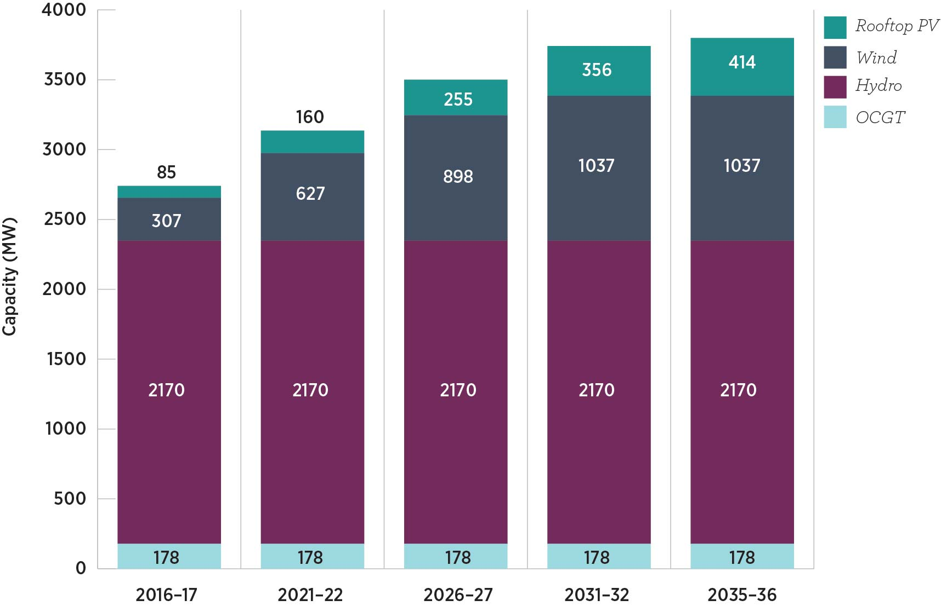
Over 300 MW of wind farm developments have been proposed in Tasmania (Granville Harbour (100 MW), Cattle Hill (200 MW) and Low Head (30 MW)). There is also the potential for wind farms at Robbins Island and elsewhere in north-west Tasmania. Existing (blue) and possible (green) wind farms and possible pumped hydro (purple) in Tasmania are identified in Figure 7.

Figure 7: Existing and possible wind farms and pumped hydro in Tasmania
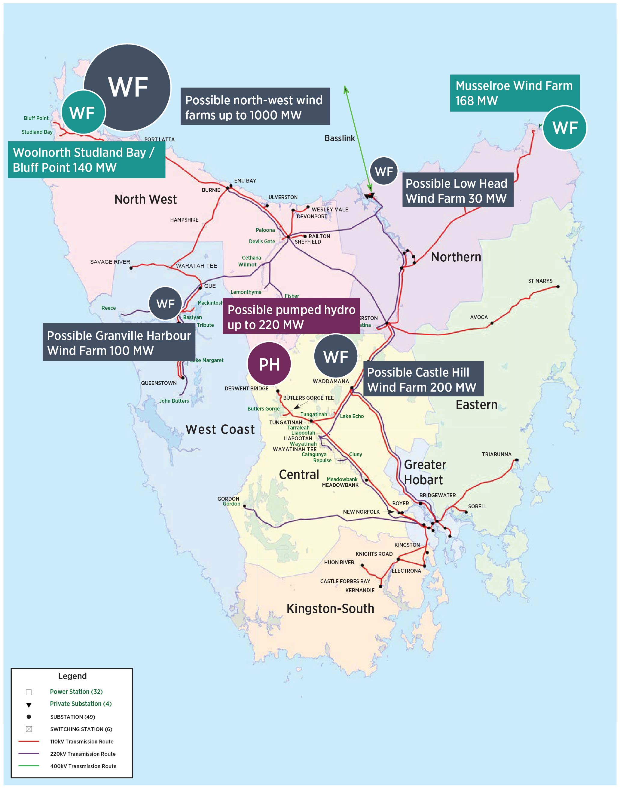

7.2.2 Challenges of market structure in Tasmania
While Tasmania has significant wind resources, there are complex issues that need to be considered in its development. In particular, the market structure in Tasmania creates some challenges for wind farm development. Wind farms rely on being able to secure long-term PPAs to underpin their investment and must be able to find a PPA counterparty.
There are three broad options for a counterparty for a wind farm development in Tasmania:
1. Hydro Tasmania
2. a counterparty in Tasmania, such as Aurora or a major industrial load
3. a counterparty from elsewhere in the NEM.
Hydro Tasmania is the dominant counterparty for PPAs in Tasmania. This is the case for three reasons. First, its market power in the wholesale market in Tasmania allows it to mitigate price impacts when wind farms are not producing electricity and to deploy other sources of generation to offset the intermittency of wind. Secondly—and this point is related to the first—these other sources of generation are principally hydro, which are flexible and able to ramp up quickly. For these reasons, Hydro Tasmania is better placed than other purchasers of PPAs to take ‘volume risk’ (the risk of low output from the wind farm) under a PPA. Thirdly, Hydro Tasmania has less risk in using power purchased under a PPA in Tasmania to offset demand it has in the rest of the NEM through its retailer, Momentum, because it is able to bid Basslink under the BSA.
The fact that the other counterparties listed above do not have these characteristics means that they cannot offer PPAs on terms as competitive as Hydro Tasmania can. For example, Aurora has load in Tasmania, but it does not have a natural hedge against the intermittency of wind. Also, potential counterparties in the rest of the NEM would be exposed to basis risk in purchasing electricity under a PPA in Tasmania because the spot price in Tasmania can diverge from the spot price in Victoria.
Hydro Tasmania’s market dominance gives it a commercial advantage in negotiations with wind farm investors because it effectively removes the ability of wind farm developers to find other offtakers for their electricity. This makes wind investment within Tasmania more challenging for developers.
It should be noted that the discussion above relates to the sale of energy, not renewable energy certificates (RECs) under the RET. Since there is only one price for RECs, they can be more readily traded across borders and therefore there is more competition.

7.2.3 The 2IC’s role in developing Tasmania’s dispatchable renewable energy resources
AEMO has noted that a 2IC would increase the financial viability of renewable generation in Tasmania, reducing the risk of it being constrained because of transmission limitations and increasing access to the broader NEM. AEMO’s modelling showed that a 2IC could facilitate approximately 365 MW of additional Tasmanian wind generation capacity by 2036 relative to the base case of up to 730 MW new wind. Tasmania’s relatively rich wind resources are more capable of export with a 2IC, while Tasmania’s ability to import electricity during off-peak periods increases the flexibility of the Hydro Tasmania generation portfolio to maximise the value of stored water while reducing NEM dispatch and investment costs.
AEMO has suggested that the reliance on wind generation from Tasmania will increase over time as coal generation progressively retires. As wind penetration increases in a particular region in the NEM, there will be a diminishing return on further developments because the correlation of wind generation in locations that are geographically close together is relatively high. Conversely, increasing the geographical diversity of intermittent generation developments is expected to smooth the variability of renewable energy flows. In that respect, investment in a 2IC could make an efficient contribution by allowing a higher volume of Tasmania’s dispatchable renewable energy to be exported into the interconnected NEM.
A key benefit of a 2IC is that Tasmania’s wind and hydro resources could be used more effectively. Modelling by EY and AEMO indicated that a 2IC would enable Tasmania’s hydro generation to be more easily exported to the rest of the NEM at times of greater value—during high-demand periods or when renewable generation was low. This would lead to conservation of water during low-value periods for subsequent export during high-demand, high-value periods. A 2IC would therefore allow Tasmanian water storage facilities to be operated in a manner similar to a large generator or storage for other NEM regions by flexibly providing or absorbing power to and from Tasmania as needed.
More efficient use of Tasmania’s hydro resources, facilitated by a 2IC, could provide market benefits in terms of both variable cost reductions, where lower cost dispatchable renewable energy could be substituted for more expensive gas generation; and capital cost deferrals, where better use of Tasmania’s hydro facilities defers the need for investment in high-cost gas generation in the rest of the NEM.
AEMO has commented that, with 600 MW of increased interconnection capability to export available hydro generation, up to 600 MW of gas generation could be deferred in the rest of the NEM. With increased interconnection, the export of additional wind generation can be expected to supply energy to the NEM that CCGT otherwise would be needed to provide.
However, it is important to note that the hydro generation in Tasmania does not have unlimited flexibility. In particular, the Mersey Forth, Derwent and Anthony Pieman schemes have a number of generators with very limited storage. This means that, at times, non-discretionary hydro output can be significant, particularly during high seasonal inflows. If this occurs at times of high wind output, this may constrain export flows and cause either water to be spilled or wind generation to be curtailed. Either possibility effectively reduces the benefits of Tasmania’s hydro flexibility and superior wind resource.

7.2.4 Impacts on timing and magnitude of expansion of Tasmania’s renewable energy
Tasmania has good wind resources and a 2IC could unlock some development. However, there are factors that may impact the timing and magnitude of wind development.
Tasmania’s location presents some challenges. If Tasmania’s wind capacity was expanded in conjunction with a 2IC, much of the generation that results will be exported across both the existing Basslink and a 2IC. Line losses would occur in transporting power to the interconnectors across the regional boundaries and from the connection points in Victoria to demand centres. This would reduce some of the advantage of Tasmania’s high wind capacity factors.
In addition, AEMO’s modelling found that building new renewable generation in Tasmania (1200 MW of wind) timed to coincide with commissioning of a 2IC (around 2025–26) would not increase its projected market benefits. Although this case delivers benefits, the additional capital investment costs outweigh the benefits gained. This is largely due to the oversupply of renewable generation in the southern regions (South Australia, Victoria and Tasmania). Prior to the 2IC, renewable generation is already built in South Australia (facilitated by the RET) and Victoria (facilitated by the VRET and RET).
Without further interconnection between Victoria and New South Wales, or further brown coal retirements, the additional Tasmanian wind generation will compete, at times, with other renewable generation in the rest of the NEM and is therefore not as beneficial as it would otherwise have been in the absence of these other renewable energy policies.
The VRET establishes targets for renewable energy to represent 25 per cent of total Victorian generation by 2020, rising to 40 per cent by 2025. AEMO’s modelling projected that the VRET will deliver about 4800 MW of additional renewable generation in Victoria and is expected to encourage renewable generation proponents to locate within Victoria in preference to other regions.
Modelling by AEMO suggested that, for Tasmania, the VRET may lower the value of the 2IC and defer substantial renewable generation build in the region until later in the period. Exporting local renewable generation from Tasmania to the rest of the NEM is more valuable if it displaces coal and gas generation rather than other renewable generation sources.
The timing of wind build in Tasmania would also be influenced by the earlier development of an additional South Australian interconnector. Given the timing differences of the two interconnectors (a South Australian link by 2021−22 and a Tasmanian link by 2025−26), AEMO’s modelling shows that Tasmanian wind generation developments are likely to be delayed by South Australia’s first-mover advantage. However, while early development of the South Australian link is forecast to lead to delayed development for Tasmanian wind farms, the long-term development is likely to be enhanced by the prospect that developers will seek increased diversity in their wind generation portfolios.
As the typical daily pattern for wind in Tasmania complements the profiles in regions such as South Australia, the operation of the two interconnectors would help to capture those efficiencies. For example, while Tasmanian wind capacity has greater daytime production, South Australia’s wind capacity has greater production near peak load times in the evening and overnight. These differences can help to smooth intermittency of wind generation in aggregate across the NEM if there is strengthened interconnection.
In summary, while a 2IC offers the potential to further develop Tasmania’s renewable energy resources to supply more efficient dispatchable renewable energy to the NEM, there are factors that are likely to delay the timing of these developments. While the expansion of Tasmania’s renewable energy capacity has not been shown to be a major outcome or benefit that would result from a 2IC, AEMO and EY modelling showed that the more efficient operation of Tasmania’s existing dispatchable and renewable resources is the principal market benefit to the NEM that is likely to result from a 2IC.

7.3 Energy security
The move towards a lower emissions generation mix with a higher proportion of renewable energy generation is making it more difficult to maintain the operation of the power system within the relevant technical parameters of power system security encompassing frequency, voltage and fault levels. Currently, renewable energy technologies do not contribute in the same way as synchronous generation such as coal, gas and hydro to maintaining these technical parameters.
AEMO manages power system security through a number of measures, including ancillary services markets and contracts (where power system security refers to the operation of the power system within the technical parameters referred to above). This can be distinguished from reliability, which refers to the probability of supplying all consumer energy needs with the existing generation capacity and network capability. The components of power system security are presented in Box 8.

Box 8: Components of power system security
Frequency: Frequency is a measure of the instantaneous balance of supply and demand. Changes in electricity supply and demand can increase or decrease the frequency. AEMO manages frequency in a number of ways, including by procuring FCAS. FCAS is typically provided by synchronous generation such as coal, hydro or gas.
Inertia: The power system has a level of inertia, which helps resist changes of frequency and mitigate the effects of a disturbance of the power system. Inertia is naturally provided by large spinning conventional generators such as hydro, coal and gas generators that are synchronised to the frequency of the system.
System strength: System strength is a broad measure of the maximum current that is expected to flow in response to a short-circuit at a given point in the power system. A reduction in system strength may occur as the generation mix changes.

7.3.1 Benefits of a 2IC for energy security in the broader NEM
Interconnectors can contribute to energy security in the regions they connect. For example, an alternating current (AC) interconnector, such as Heywood between South Australia and Victoria, allows two regions to be synchronously connected and allows inertia and power system security services to be shared between the two regions.
A 2IC would reasonably be expected to incorporate advances in interconnector technology since Basslink’s construction. In particular, new voltage sourced converter (VSC) technology is now commercially available.

VSC technology has advantages over the line commuted converter (LCC) technology used by Basslink. It offers instantaneous changes in the direction of power flows and capacity to provide continuous FCAS and voltage support through injecting or absorbing reactive power. It could also provide Network Support and Control Ancillary Services and system restart capabilities. In contrast, Basslink does not operate at a power flow of below 50 MW and requires a period with no power transfer before it can change the direction of its power flow.
During this no power transfer period the Tasmanian network must source all of its FCAS locally. Basslink also requires higher system strength to operate than a VSC would need.
AEMO’s modelling considered the NEM-wide benefits of a 2IC using VSC technology. As noted in Chapter 4, AEMO concluded in its 2016 NTNDP that additional power system security support is not needed in the rest of the NEM because these support services are adequately provided by existing hydro generators in Tasmania
and Victoria.

7.3.2 Impacts of a 2IC on energy security in Tasmania

Potential contribution of a 2IC to energy security in Tasmania
In Tasmania, key sources of FCAS are Basslink, Hydro Tasmania’s hydro generating units (which can also be run as synchronous condensers) and the TVPS. To manage larger contingencies there are other options, including the SPS (described in Chapter 5) which would trip load or generation to meet system requirements.
AEMO’s 2016 NTNDP indicates that the current levels of regulation FCAS in Tasmania exceed the projected need. The exception to this is if there was a significant reduction in Tasmanian demand, which would affect the viability of the SPS. In these circumstances, a 2IC could improve frequency control in Tasmania and allow for increased imports from Victoria to Tasmania.
Despite this, there may be power system security benefits in having a 2IC. While power system requirements are currently able to be met by Hydro Tasmania, this does come at a cost. Foremost among these is that, when hydro units are run to support the system, they do not operate optimally in terms of energy production. Not only is the amount of energy produced reduced but also the units would run inefficiently and the amount of wear and tear would increase. Further, operating a hydro unit as a synchronous condenser consumes energy. Activating the SPS would come at the cost of lost production. A 2IC could operate to provide additional FCAS in Tasmania and avoid these impacts.

Energy security challenges of a 2IC in Tasmania
A 2IC could increase the power system security challenges in Tasmania. Tasmanian regions, such as George Town, can experience voltage control difficulties. At times of low spot prices in Victoria or low water storage levels in Tasmania, a 2IC would enable higher imports from Victoria, leaving fewer hydro generators in service in Tasmania. AEMO found that this could result in reduced system inertia, lower availability of FCAS and weaker system strength in Tasmania. If a 2IC were to be developed, these power system security challenges would have to be overcome through measures such as construction of new transmission lines, use of synchronous condensers or the installation of dynamic reactive support at the George Town substation.

7.3.3 Alternative options
A 2IC is one potential option that would address Tasmania’s energy security and reliability concerns. TEST is considering other energy risk management measures for Tasmania, including:
- new prudent water storage thresholds
- the opportunity for further renewable energy development in Tasmania
- the future role of gas generation
- consumer participation opportunities, including emerging technologies.
Tasmania will need to implement short-term and medium-term measures in light of the TEST final report. Therefore, it is likely that many of the TEST recommendations will be implemented well before a 2IC could be completed. The incremental Tasmanian energy security benefits that might result from a 2IC in the longer-term may be reduced significantly when the benefits of these short-term and medium-term initiatives are taken into account.
It would probably be necessary to maintain and continue to operate the CCGT unit of the TVPS to maintain energy security and reliability without the redundancy of a 2IC. Modelling for the study indicates that there are significant market benefits which could be obtained from a 2IC if the TVPS were to be kept operational, particularly in an environment where generation such as brown coal leaves the market.
Further, governments will need to consider the consequences of Basslink reaching the end of its (estimated) 40 year economic life. Total loss of Basslink could involve risk to reliability and security of supply, loss of generation and revenue opportunities for Hydro Tasmania and other associated consequences (such as higher electricity supply costs). The benefits of investing in a 2IC may increase if there is a reason for regarding it as a replacement asset for Basslink at some point during its economic life.
While a 2IC could provide some power system security and reliability benefits (as discussed in Chapter 5) and a redundancy option for Basslink, these benefits would be incremental to those likely to be provided much earlier by options implemented as a result of recommendations of TEST. These alternatives for enhancing Tasmanian power system security and reliability of supply are likely to be more efficient, lower cost and be implemented before the 2IC is commissioned.

8 Implications for consumers
This chapter considers the implications a 2IC would have for electricity consumers, including how the total costs involved are likely to be recovered and allocated between consumers in Tasmania and Victoria. It examines the different cost implications for consumers depending on whether the 2IC operates as a regulated or a merchant interconnector.

Key findings
- The costs of a 2IC would be recovered from consumers through either the wholesale or the network component of consumer bills.
- The allocation of the costs would differ depending on whether a 2IC was a regulated or a merchant asset. A merchant 2IC would recover its costs through spot market trading. A regulated 2IC’s costs would be recovered through regulated revenues approved by the AER.
- For a regulated 2IC, the revenues would be recovered from Victorian and Tasmanian consumers according to the proportionate direction of flows across the interconnector.
- A regulated 2IC would also have the effect of reducing constraints between Victoria and Tasmania, resulting in convergence of wholesale prices between the two regions.
- The impacts on consumers of a merchant 2IC would depend on the owner’s strategy in bidding the interconnector.
- If the bidding strategy was to maximise the differential between Tasmanian and Victorian spot prices, Tasmanian spot prices would be kept relatively low when the 2IC was exporting and relatively high when it was importing.
- If the bidding strategy was more passive (as it may be with a BSA type of arrangement in operation) the wholesale price outcomes would be similar to those for a regulated 2IC.
- A 2IC would also offer benefits to consumers, including in respect of reliability of supply and market competition, as discussed in Chapter 4.
As in Chapters 6 and 7, this chapter assumes a 2IC would be economically efficient for the purpose of considering the likely costs and benefits for electricity consumers of a regulated or a merchant 2IC.
Importantly, while a 2IC would impose costs on consumers, it would also provide them with market benefits. While these would not necessarily be as tangible as the costs, over the longer-term a 2IC would facilitate efficiency benefits and contribute to reliability and security of supply. By reducing constraints between Tasmania and Victoria, it would also provide market competition benefits. The potential market benefits of a 2IC are discussed in greater detail elsewhere in the study, where the conclusion is that, based on the modelling projections that are currently available, those benefits are unlikely to outweigh the costs in many of the scenarios analysed.

8.1 Allocation of costs
The costs of a 2IC would be significant. They would involve:
- interconnector construction and operation
- related network augmentations.
It is estimated that up to $1.1 billion would be required for the construction of the 2IC itself and associated network augmentation.
In considering the likely cost implications for consumers, it is relevant to note there are different cost components to consumer bills. These can broadly be grouped into three categories:
- competitive market costs (including retailer costs such as hedging)
- regulated network costs
- environmental policy costs.
Figure 8 represents a generalised breakdown of the cost components in the electricity supply chain, including their relative proportion.
Figure 8: Generalised components of electricity supply chain costs
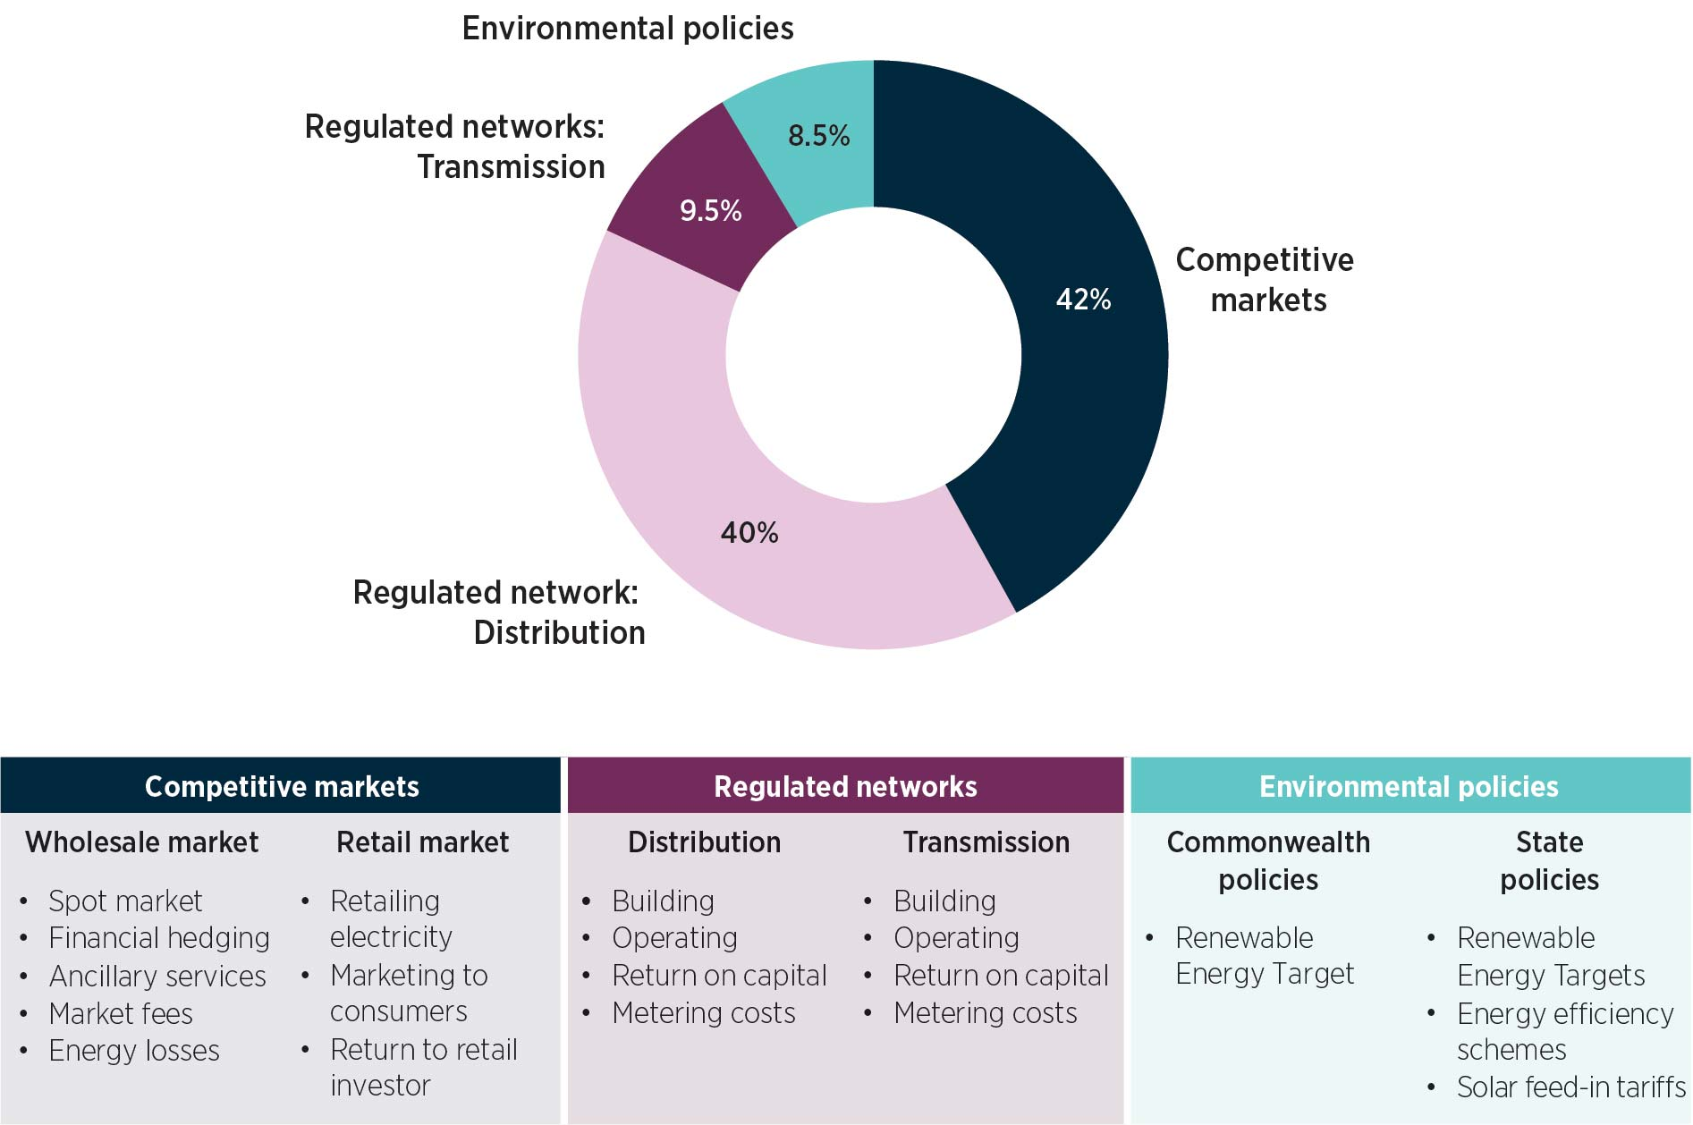
This breakdown of the electricity supply chain costs demonstrates how the costs associated with a 2IC are likely to impact on retail prices and consumer bills. In general, regulated network costs are recovered in revenues set by the AER and passed through to consumers in retail prices. However, if a 2IC’s costs are recovered through the wholesale market (if a 2IC is a merchant asset), the extent to which those costs will be borne by consumers depends on competition at both the generation and retail levels. For example, the impact on consumers will depend on how the 2IC and other generators bid, price outcomes in the market and retailers’ hedging strategies and costs.
A 2IC could indirectly affect the costs relating to environmental policies that are included in Figure 8. The RET, for example, is a subsidy for renewable energy paid for by consumers. Its costs are recovered from consumers through retail bills. What these costs will be depends on the rate of renewable energy development and the future price for RECs. If the 2IC facilitates the development of wind energy, it may affect the costs passed through to consumers under these policies.

8.1.1 Interconnector construction and operation costs
Whether the 2IC is regulated or merchant will determine which element of the electricity supply chain its costs would be recovered through, and therefore how these costs impact on consumer bills.

Regulated interconnector

Regulated revenues
A regulated 2IC would be able to recover its costs through regulated revenues determined by the AER, regardless of the interconnector’s utilisation. It would only be approved as a regulated asset if it had satisfied the RIT-T by demonstrating that the costs to electricity consumers as a whole were outweighed by the expected benefits it would provide.
In most cases, regulated revenue is calculated every five years for TNSPs. The AER sets these revenues to enable the recovery of capital expenditure and financing costs (assessed on the regulated asset base and projected investments) and operating costs. The regulated revenues are then converted into transmission charges. These are passed through to retailers, which recover them from consumers as part of the network component of consumer bills.
Transmission charges
The NER provides the mechanism by which transmission charges (including for the recovery of regulated interconnector costs) are determined. The AER determines the revenues to be earned by a regulated interconnector over five years. Those revenues would be converted into costs to be recovered annually from consumers at each end of the interconnector. A portion of these costs (usually 50 per cent) would be recovered equally from Victorian and Tasmanian consumers. The remainder would be recovered on a locational basis, with reference to the proportionate use of the 2IC in serving the connected regions. For example, if the 2IC flowed towards Victoria 80 per cent of the time then 80 per cent of this locational component would be recovered from the Victorian region (subject to any further inter-regional charging, as described in Box 9).
The costs allocated to each region in respect of the 2IC would then be recovered by the TNSP in that region from consumers at its transmission connection points. These costs would be added to the costs that the TNSP recovers from consumers in respect of its own network. These additional charges would be allocated to connection points on the same basis. Most of these connection points are points of intersection with distribution networks. The distribution networks would pass the cost through to retailers, who in turn pass the costs on to consumers.
There is a mechanism by which a portion of transmission costs within one region of the NEM can be allocated to another region. This would include costs allocated from one region to another where the network assets in one region support power flows to other regions. This is described further in Box 9.

Box 9: Inter-regional transmission charging
Inter-regional charging was introduced into the NER in 2013 in the form of a modified load export charge (MLEC). This mechanism gives TNSPs a way to recover from neighbouring regions the costs associated with the use of assets that support inter-regional flows. The mechanism aims to better reflect the benefits that transmission provides in supporting energy flows between regions in the NEM.
Inter-regional charging applies to all transmission costs within a region. This makes it relevant to costs associated with both the construction and operation of a regulated 2IC as well as any associated network augmentation.
The proportion of costs allocated from one region to another is determined by analysing electricity flows and the assets which support flows into other regions. The allocation of costs between regions is determined on a net basis, reflecting that all regions both import and export electricity.
Inter-regional charges form a relatively small proportion of overall transmission costs. During the 2016−17 financial year, the net amount that Tasmania will recover from the Victorian region is approximately
3.79 per cent of the total Tasmanian transmission costs. These costs do not include the recovery of costs for Basslink as it is not a regulated asset.

Effect on spot prices
A regulated 2IC is also likely to have an impact on the wholesale market, including price outcomes, which will in turn affect Victorian and Tasmania electricity consumers. As demonstrated by Figure 9, Victorian and Tasmanian spot prices, while linked, are not identical.

Figure 9: Quarterly volume weighted average spot prices in Tasmania and Victoria
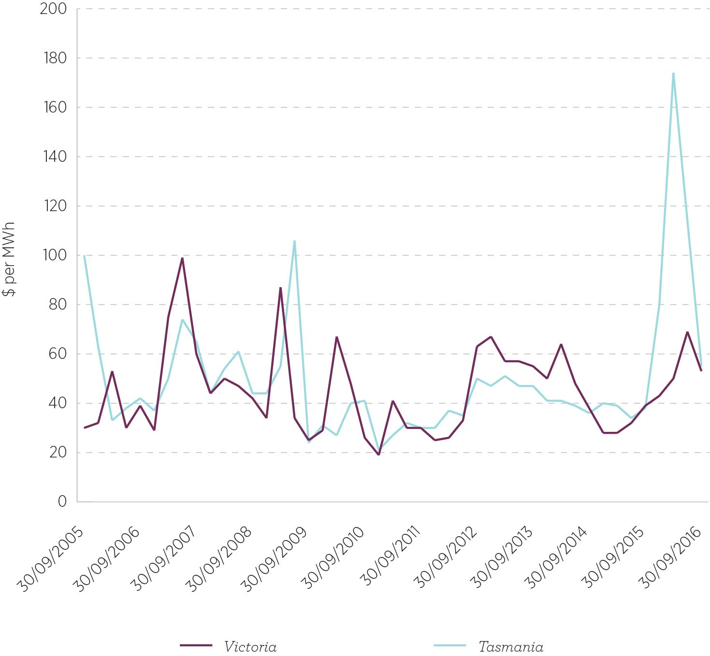
A regulated 2IC earns revenue regardless of utilisation, so it has no incentive to operate strategically. Its presence will therefore serve to reduce the constraints between Victoria and Tasmania and increase the unconstrained power flows between Victoria and Tasmania. This will bring the spot prices in these regions closer together, as demonstrated in Figure 10.

Figure 10: Effect of interconnectors on electricity spot prices
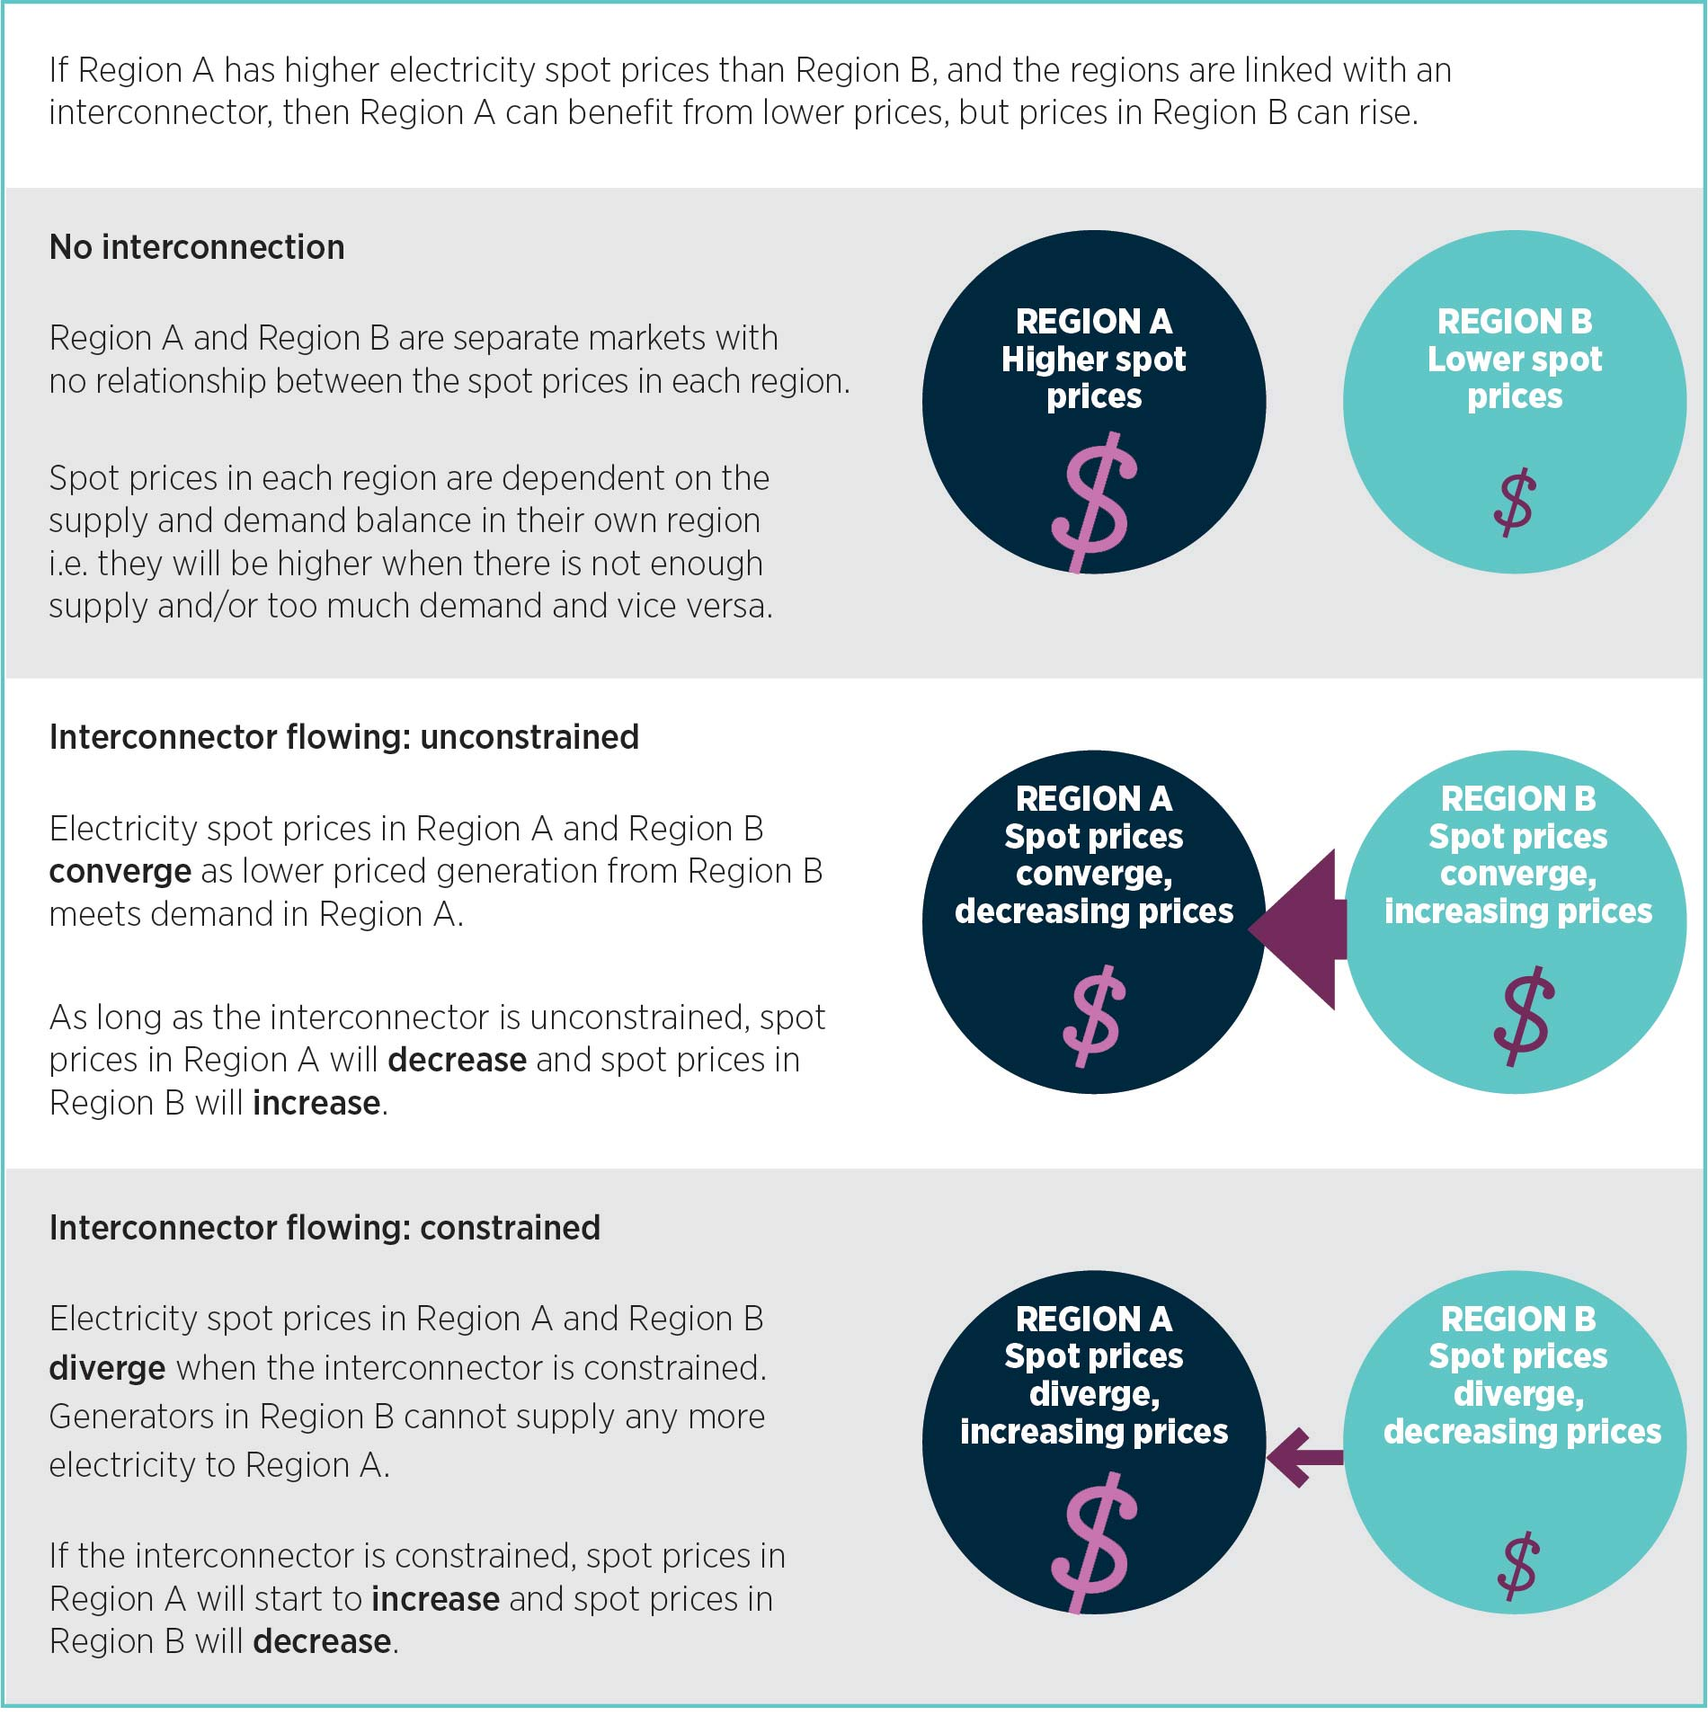
There would be a number of consequences of the convergence of the Victorian and Tasmanian spot prices. EY indicates that greater unconstrained access to the Victorian market would increase the value of water in Tasmania and would be likely to result in Hydro Tasmania selling energy at higher wholesale prices.
Further, with a 2IC in operation, long-term trends in Victorian spot prices would be expected to be reflected in Tasmanian spot prices in the future. For example, retirements of coal generation in Victoria are expected to increase spot prices in Victoria. The AEMC’s 2016 price trends report forecasts that the retirement of Hazelwood
would lead to a 36 per cent increase in Victorian wholesale electricity purchase costs from 2016−17 to 2017−18. Any further generation retirements in Victoria would affect the spot prices in Tasmania if there was stronger interconnection between Victoria and Tasmania.
The potential for retirement of generation in Victoria should be considered in the context of the VRET, which may initially suppress prices as new renewable generation enters, but could result in subsequent price rises as this development hastens the retirement of Victorian thermal generators.
Stronger interconnection with a regulated 2IC could be expected to have a dampening effect on the anticipated Victorian spot price increases for the reasons illustrated in Figure 10. However, as a 2IC would be a relatively small proportion of Victoria’s electricity supply, this dampening effect is not expected to be large. In contrast, a 2IC would represent a relatively larger proportion of Tasmania’s overall electricity supply, so it may have a stronger effect on Tasmanian spot prices.

Merchant interconnector
The revenue earnings and subsequent costs to consumers of a merchant 2IC would be subject to its utilisation and to competition at the wholesale and retailer levels. The recovery of a 2IC’s costs in arbitrage trading revenues would depend on the direction and volume of electricity flows across the interconnector and the extent of spot price differences between the regions over time. These revenues would be more volatile and higher risk in contrast to a regulated 2IC.
Ultimately, the impacts on spot prices, and therefore the costs for consumers, would depend on the strategy the owner or operator adopts for how it bids a 2IC. In general, as a merchant 2IC would rely on the spot price differential between Tasmania and Victoria to earn its revenues, it would be incentivised to bid in a way that would maintain or even widen the differential. For example, this would mean that, if a 2IC was flowing north, it would increase revenues by keeping Tasmanian prices low and Victorian prices higher. At a time of supply shortage in Victoria, it could withdraw capacity, exacerbating the supply shortage and putting upward pressure on Victorian prices. This should mean wholesale prices flowing through to Tasmanian consumers would remain low. EY modelling on the basis of this bidding strategy supports this conclusion.
On the other hand, there may be circumstances in which the owner of a 2IC would adopt a bidding strategy of bringing the spot prices in Tasmania and Victoria closer together. For example, if Hydro Tasmania were to control the bidding of a 2IC in the way it does for Basslink, EY modelling indicated that Hydro Tasmania would benefit more by bidding the 2IC at or close to zero to ensure the Tasmanian and Victorian spot prices would converge. This means Tasmanian wholesale prices would rise and Hydro Tasmania would earn more from the rest of its generation portfolio in Tasmania. In this case, spot prices in Tasmania would rise in a similar way to when the 2IC was regulated, and higher costs would flow through to Tasmanian consumers.
As discussed in Chapter 6, the financeability of a 2IC would be improved from an investor perspective if a third party such as Hydro Tasmania were contracted to pay a facility fee or availability charge to the owner of a merchant 2IC. This could extend to Hydro Tasmania receiving the rights to trade a 2IC, in which case the more likely strategy would be for it to bid the 2IC at $0/MW to bring the Tasmanian and Victorian spot prices together. This convergence in spot prices may impact costs for Tasmanian consumers.

8.1.2 Network augmentation costs
A 2IC is likely to require substantial network augmentation in Tasmania to accommodate additional power flows, including from new generators.
In general, the costs relating to network augmentations would be recovered from consumers within the region where those augmentations take place and would be subject to AER revenue and tariff regulation decisions. Where approved by the AER, these augmentation costs would be recovered in network tariffs based on AER approved revenues and the tariff-setting methodology described above.
Inter-regional transmission charging could result in a portion of the augmentation costs being allocated to consumers in other regions.

9 Planning and approval requirements
This chapter explores the potential governance arrangements which could assist with the business case, technical specifications and regulatory approval stages if the market circumstances emerge in the future that support making a commitment to develop a 2IC. It draws on work by the Electricity Supply Industry Expert Panel in 2012 to highlight the issues and learning from the development of Basslink. The Australian Government’s Major Projects Approval Agency has also identified potential cross-jurisdictional processes that a 2IC proponent may need to navigate.

Key findings
- The development of a 2IC would be a major project development in Australia which would need to comply with relevant regulatory approvals across multiple levels of government.
- It would probably be declared a Project of State Significance in Tasmania because it would be a major development with statewide implications.
- If future market conditions indicate that a 2IC would be viable, the Tasmanian Government could consider establishing governance arrangements similar to those adopted for Basslink. The process undertaken for Basslink provides useful insight, especially regarding the management of potential delays in the regulatory approval processes.
- The initial groundwork on environmental and regulatory approvals, including a RIT-T if a 2IC was to be regulated, could be facilitated by establishing a development board.
- The Major Projects Approval Agency could play a role in assisting a 2IC proponent to navigate the relevant regulatory requirements and could facilitate engagement with communities, government and business.
- A coordinated approach could potentially streamline the development and approval process for a 2IC, saving time and money.

9.1 Basslink approval process
Basslink is the only major subsea electricity cable to have been constructed in Australia. The development and approval stage took five years (1997–2002) and the construction of the interconnector took an additional three years (2002−2005). Figure 11 illustrates the approval and construction process for Basslink.

Figure 11: Basslink approval and construction process
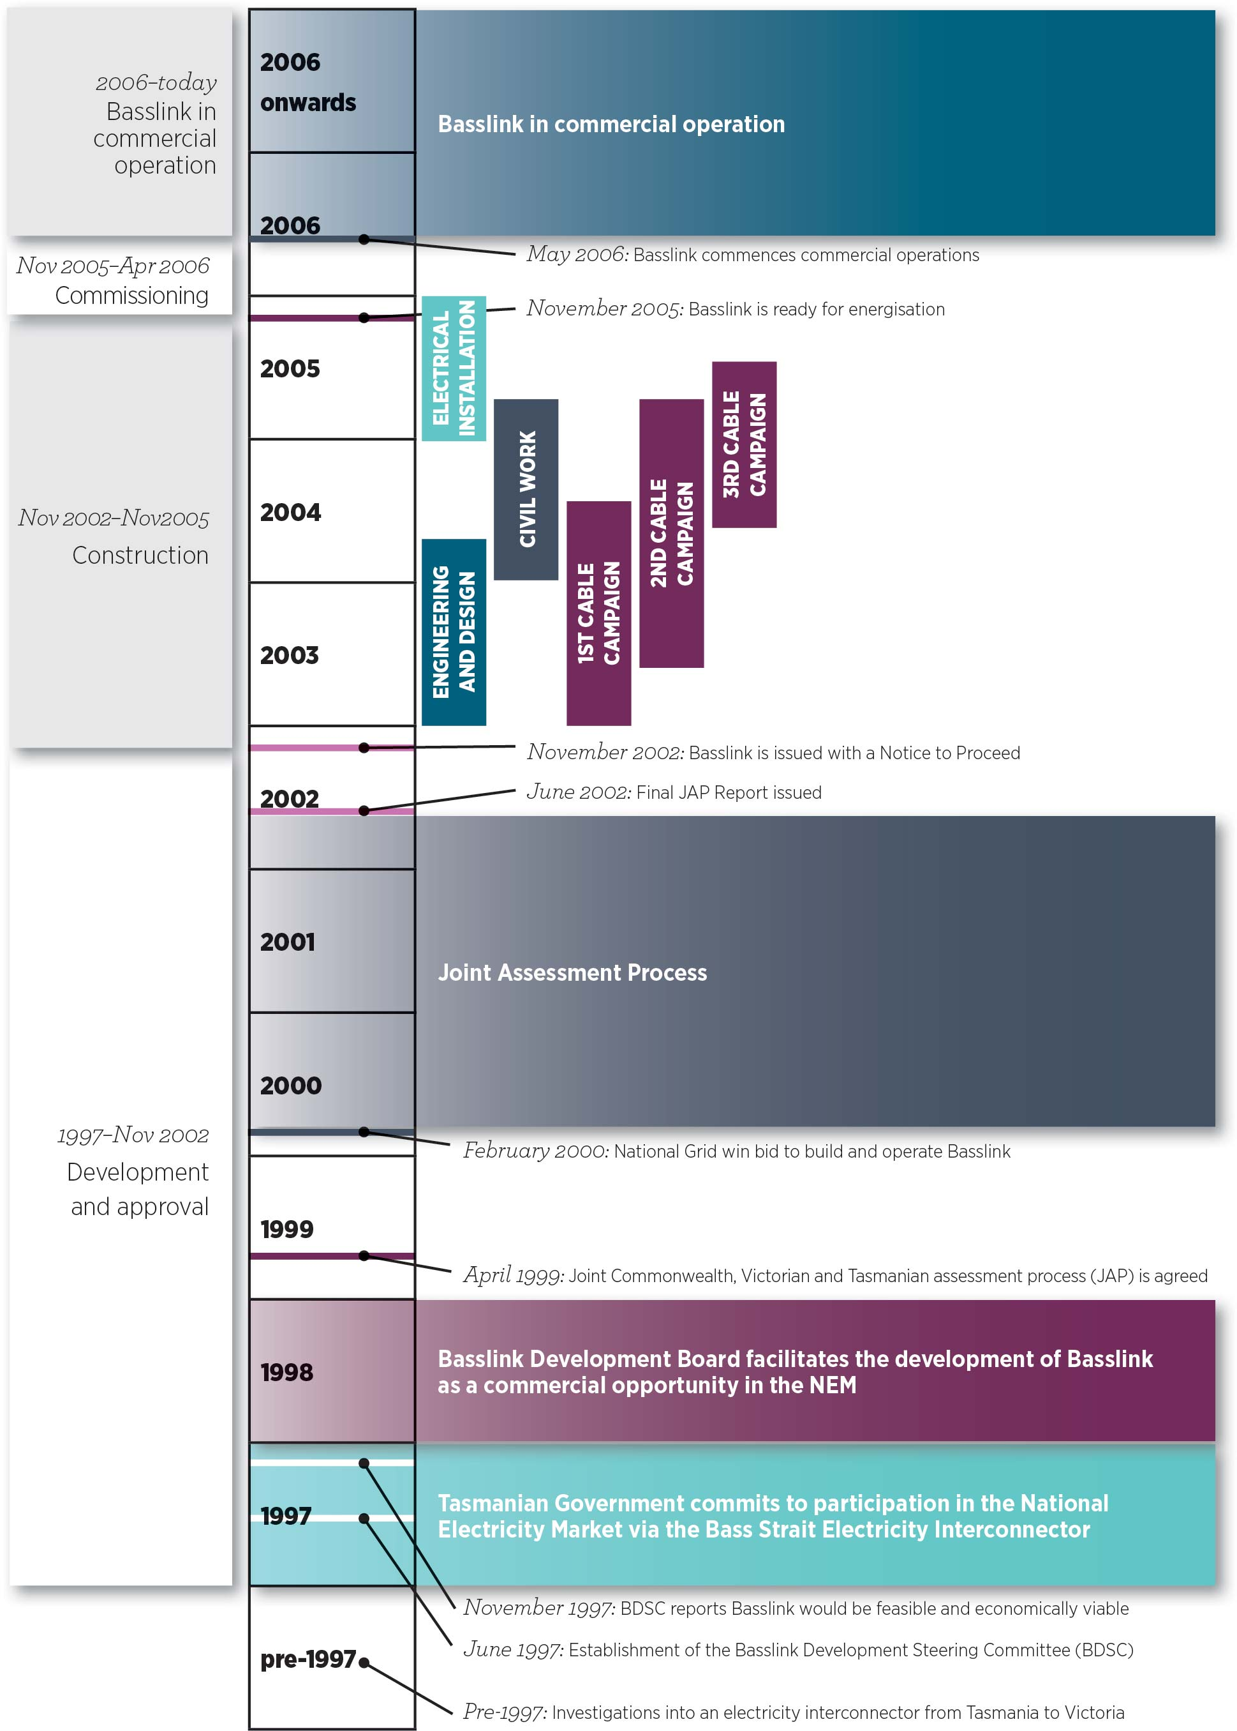
Key bodies which facilitated the development and approval processes for Basslink are discussed below.

Basslink Development Steering Committee
The Tasmanian Government established the Basslink Development Steering Committee (BDSC) in June 1997. The BDSC provided the state with advice on the economic, technical and environmental feasibility of Basslink with a view to having a merchant interconnector built and operating within four years. The BDSC found that interconnection with Victoria would be technically feasible and economically viable for proponents.
The BDSC also recommended that the Tasmanian Government call for expressions of interest from proponents interested in developing an interconnector.

Basslink Development Board
In response to the BDSC findings, the Tasmanian Government established the Basslink Development Board (BDB) in 1998. The BDB was responsible for taking the lead in developing Basslink as a commercial opportunity in the NEM as well as conducting the selection process to identify the project proponent. The BDB shortlisted expressions of interest, allowing potential proponents to propose development of either a merchant or a regulated interconnector.
The two final proponents that the BDB identified expressed doubts regarding the development of Basslink as a regulated interconnector. Their concerns related, in part, to the uncertainty and lack of clarity associated with the market benefits test which Basslink would be required to satisfy in order to receive regulated revenue, as well as the lengthy approval process. This reduced the attractiveness of developing Basslink as a regulated interconnector, and the Basslink process proceeded on the basis that it would be a merchant interconnector. The BDB also worked with project proponents to resolve issues regarding the commercial model to be adopted and the management of sovereign and counterparty risk.
Once the BDB transferred development of the project to the proponent, its role changed to ensuring that the obligations of each party were met and that the project reached financial close as soon as possible. It also continued to manage stakeholder relations.

Nominal company
A company, Basslink Pty Ltd, was established in 1998 to initiate work on matters such as preliminary environmental planning and impact assessment studies. This meant that an existing company which was already on the path to attaining regulatory approvals could be transferred to the eventual proponent when all contractual arrangements were finalised.

Joint Advisory Panel and other regulatory assessment processes
The construction of Basslink impacted on three jurisdictions: Tasmania, Victoria and the Commonwealth
(as the cable went through Commonwealth waters in the Bass Strait). An independent Joint Advisory Panel (JAP) was set up to facilitate a single combined assessment process for the interconnector. The panel was
made up of representatives from each jurisdiction. Its aim was to expedite the necessary environmental and regulatory approvals.
The combined approval and assessment was originally estimated to take around 10 months, but eventually it took 30 months from the time the project proponent was selected to get the final approval from the JAP. This resulted in a significant increase in Basslink’s project development costs and a significant extension of the project completion timeline. Basslink was eventually commissioned some three years later than originally proposed.
The Electricity Supply Industry Expert Panel found that the total cost of Basslink increased from approximately $500 million to almost $875 million by commencement of operations in 2006. The majority of these increased costs were incurred during the approval process from 2000 to 2002 as a result of various design changes required to meet environmental and development approvals. Major changes included the provision of a metallic return in the interconnector’s design, changes to route and subsea cable burial, and various additional development and construction costs.

9.2 Considerations for a 2IC
The development of a 2IC would be a major project development in Australia, and it would need to comply with all relevant regulatory approvals across multiple levels of government.
A 2IC proponent would need to factor in construction time as well as the time and cost of attaining regulatory approvals, such as planning and environmental approvals.
Although regulatory and approval requirements and processes will have changed since the development of Basslink, the governance arrangements used for the Basslink process may be a useful starting point in planning implementation processes for a 2IC if market conditions emerge that would make it viable. A coordinated approach would allow the requirements of all governments to be met in an efficient and timely manner. An illustrative action plan is provided at Box 10. The action plan shows the range of actions that could be taken to develop appropriate management arrangements and governance structures to oversee planning, decision-making and implementation for the investment in a 2IC.

Project of State Significance
If a 2IC was feasible and was to be built, it would probably be deemed a Project of State Significance in Tasmania (POSS). A POSS is declared when Tasmanian projects are recognised as major developments with statewide implications. A POSS would be assessed under the Tasmanian State Policies and Projects Act 1993.
If the Minister for State Growth in Tasmania considers that a 2IC is a POSS, the Minister may recommend that the Governor of Tasmania declares the proposal to be a ‘project of State significance’. The project must then be approved by the Tasmanian Parliament before an assessment can begin. If the 2IC were to be approved, the Minister would direct the Tasmanian Planning Commission to undertake an integrated assessment of the proposal.

Major Projects Approval Agency
The Major Projects Approval Agency (MPAA) is an Australian Government initiative which provides a single point of entry for businesses that are considering major investments in Tasmania and the Northern Territory. The MPAA could assist the developer of a 2IC by providing information on all government regulatory approval requirements and on the approval obligations for a 2IC. It could also work with regulators to facilitate effective and efficient approvals. The involvement of the MPAA would assist the developers of a 2IC to navigate the approvals process.

Box 10: Illustrative action plan
If future changes in market conditions and frameworks improved the viability of a 2IC investment, the Tasmanian Government could proceed with the following actions.
Organisation | Action
1. Tasmanian Government | Establish a steering committee.
2. The steering committee | Develop a business case to provide recommendations on how the government should proceed (with Victorian Government agreement).
If a 2IC is found to have net market benefits through that business case, the following actions could be taken.
Organisation | Action
1. Tasmanian Government | Set up an entity (2IC development board) to progress the approvals processes for a 2IC.
2. Development board | Develop a 2IC on behalf of the state and identify a proponent to take the project forward.  Establish a nominal company to progress project.
3. Nominal company | Undertake the RIT-T if the 2IC is to be regulated.  Establish a joint advisory panel (Victoria, Tasmanian and Commonwealth governments) to progress approvals.  Continue to refine interconnector preparatory work, including associated network technical specifications and route selection.  Initiate preliminary environmental planning and impact assessment studies such as visual assessment, flora and fauna, cultural heritage, geology and hydrology, marine and coastal, social impacts and electro-magnetic fields.

10 Conclusions and recommendations
The NEM is undergoing a rapid transition towards a lower emissions generation mix, making it difficult to predict, with the requisite degree of confidence, the energy market supply and demand conditions and regulatory settings that will apply during the economic life of a 2IC. While AEMO’s annual NTNDP remains the best source of information on likely future energy market conditions, it covers only a 20 year period. Currently anticipated changes in energy market conditions suggest that a wide range of potential development paths could emerge for the NEM over the next 20 years and more. Therefore, a business as usual projection of the future energy market conditions would not be appropriate. The heightened uncertainty regarding the future investment environment for a 2IC has been acknowledged as a reality in the study.
The analysis undertaken sought to address this uncertainty by projecting the NEM-wide costs and benefits that could be generated by a 2IC under a range of plausible assumptions about future energy market conditions. This analysis established that a 2IC would deliver significant economic benefits to the NEM, and to Tasmania, by facilitating more efficient use of Tasmania’s existing hydro and gas generation facilities. However, while under some modelled scenarios, the potential benefits exceeded the capital and operating costs of a 2IC and related network augmentation, under others the modelled benefits were exceeded by the costs.
The modelling analysis identified two future NEM development scenarios in which a 2IC would achieve a significantly positive net benefit feasibility assessment. The modelling found that a 2IC would deliver positive net benefits if there was a significant future reduction in Tasmanian electricity demand because the resulting surplus generation could be exported rather than being wasted due to constrained interconnection. The development of an additional interconnector linking South Australia with the eastern states before a 2IC is constructed was also found to result in larger net economic benefits than those resulting from each of the interconnectors when assessed separately. This effect was further amplified when these investments were combined with additional interconnector upgrades from New South Wales to Victoria and New South Wales to Queensland, resulting in larger positive net market benefits from a 2IC under most of the scenarios modelled. AEMO concluded in its 2016 NTNDP that integrated strengthening of the interconnected power grid in this way would deliver synergies by facilitating complementary utilisation of the diversity of renewable generation among the NEM regions.
While the modelling analysis has been informative in understanding the market dynamics and forming views about the economic feasibility of a 2IC, the modelling did not evaluate a number of potential benefits from a 2IC that would be allowable under a RIT-T analysis, including competition benefits, some power system security and reliability benefits and option value benefits. Power system security benefits in particular are likely to be in greater demand and valued more highly in the future than they have been historically. There is also potential for different weightings to be placed on the various categories of benefit generated by a 2IC compared to those assigned in the modelling. For example in current market circumstances, electricity consumers and governments may place a higher value on the energy security and reliability benefits from a 2IC than is captured in the modelling results.
A 2IC would also facilitate development of Tasmania’s productive wind energy resources by increasing the capacity for export of balanced and dispatchable renewable energy to the rest of the NEM. However, most of that wind development was forecast to occur in the late 2020s and 2030s due to earlier build of renewable generation in Victoria and South Australia. A 2IC would provide reliability benefits to Tasmania and Victoria, supporting reliability in Tasmanian at times of drought and low water storage levels and in Victoria during peak demand periods. A 2IC could also transfer power system security services between Tasmanian and Victoria, although those benefits would be incremental to their current availability through Basslink and other sources in the NEM. They would also be incremental to power system security benefits provided by initiatives likely to result from the TEST review, which may be implemented earlier and at lower cost.
The feasibility of a 2IC would also depend on whether a regulated or merchant commercial model is chosen for its operation. The choice of model would affect the scale of the revenues earned and their volatility and riskiness which would in turn affect the financeability of the project. While modelling indicated that a merchant 2IC could potentially earn higher revenues and profits than a regulated 2IC, the merchant revenues would be highly volatile and risky. For that reason, financing advice indicated that a regulated 2IC would be more attractive and financeable from an investor perspective due to its predictable regulated revenue stream and lower risk. However, a 2IC would need to satisfy the RIT-T to achieve regulated status, which would be a challenge under current market projections.
Regardless of how the NEM develops, a 2IC would have cost implications for electricity consumers. If a 2IC were regulated, the costs would be recovered from consumers through the regulated network component of their bills. These costs would be allocated to Tasmanian and Victorian consumers according to the proportionate direction of flows across the 2IC, with the region receiving more of the flows paying more of the costs. A merchant 2IC’s costs would be recovered through wholesale market trading revenues. Cost impacts on consumers would depend on the spot price differences between the regions, the volume of flows between them and competitive conditions in the wholesale and retail markets.
While a 2IC would result in benefits as well as costs for consumers, the critical issue for consumers is whether the NEM-wide benefits would exceed the NEM-wide costs. In the case of a regulated 2IC, this question would be addressed by a formal RIT-T assessment. The issue does not arise formally in the case of a merchant 2IC, but modelling indicated that NEM-wide benefits would be lower for a merchant 2IC than for a regulated 2IC, due in part to an assumed capacity withholding strategy used to maximise arbitrage trading revenues.
Decisions that arise from the various energy market policy and regulatory reviews will have an important bearing on the development of the NEM and the future role of interconnectors. Policy consideration is currently being given to whether further strengthening of interconnection across the NEM can be justified when viewed as a system-wide strategy. The outcomes from these reviews will assist in clarifying the future NEM investment environment for long-term interconnection assets such as a 2IC.
Ongoing monitoring of these and related NEM developments would be appropriate to identify changes to energy market frameworks and conditions that would give added support to the case for strengthening interconnection across the NEM, including by investment in a 2IC.
AEMO is best placed to undertake this monitoring through its annual NTNDP reports and related network planning work, drawing on Hydro Tasmania and TasNetwork’s knowledge of the Tasmanian energy market environment, as necessary, to inform its consideration of the future role a 2IC could play. The future NTNDP planning framework will provide a NEM-wide context within which to form a considered view on the prospective economic feasibility of a 2IC as a precondition for initiating more detailed analytical work on the proposal.
Other preconditions for initiating further detailed work would include a significant reduction in Tasmanian electricity demand and approval of the construction of additional interconnection between South Australia and the eastern states.
Should monitoring establish one or more relevant preconditions, a detailed business case should then be prepared by the Tasmanian Government, taking into account developments in the NEM since this study was undertaken.

Recommendation
I therefore recommend that the Tasmanian Government develop a detailed business case for a second Tasmanian interconnector when ongoing monitoring establishes that one or more of the following preconditions has been met:
1. The Australian Energy Market Operator, in consultation with Hydro Tasmania and TasNetworks, concludes in a future National Transmission Network Development Plan that a second interconnector would produce significant positive net market benefits under most plausible scenarios.
2. Additional interconnection is approved for construction between South Australia and the eastern states.
3. A material reduction occurs in Tasmanian electricity demand.

Appendix A:
Terms of Reference
The Australian and Tasmanian governments will conduct a feasibility study into whether a second Tasmanian interconnector could improve Tasmania’s energy security and facilitate renewable energy investment.
The study will:
1. Analyse the extent to which a second Tasmanian interconnector would:
- address energy security issues;
- facilitate the development of Tasmania’s prospective large scale renewable energy resources;
- allow the development of dispatchable and balanced renewable energy into the National Electricity Market (NEM); and
- integrate with the Victorian electricity market and wider NEM.
2. Investigate how best to use and develop Tasmania’s current and prospective large scale renewable energy resources, noting the system security benefits provided by Tasmania’s hydroelectricity generation.
3. Advise on regulatory and financing issues and potential cost impacts on electricity consumers.

Appendix B:
Stakeholder consultations
In completing the study, targeted stakeholder consultations were undertaken with a range of energy market bodies, consumer groups, industry representatives and government stakeholders in Canberra, Sydney, Melbourne, Adelaide and Hobart. A public call was also made for submissions. The purpose of the consultations was to understand the diverse views, interests, opportunities and concerns about a 2IC. A general summary of stakeholder opinions is below.

Defining the problem
One of the consistent themes in the stakeholder consultations was that there was a lack of clarity concerning the problem at hand. Many stakeholders asked the question: ‘What problem is a 2IC trying to solve?’ Stakeholders highlighted that it is difficult to assess the feasibility of a 2IC without first understanding the purpose of a 2IC and the problem it will address—that is, whether a 2IC would address energy security in the NEM or encourage the development of renewable energy generation or a combination of both.

Renewable energy considerations
A consistent message from stakeholders was that renewable energy is becoming an increasingly significant part of the NEM. However, there are challenges in managing this transition, and the future direction of change in the NEM is uncertain. This is predominately due to the uncertainty about future emission reduction policies in Australia as well as uncertainty around the time frames for retirement of coal generators.
Stakeholders acknowledged that Tasmania has some of the country’s best wind resources and that there was generally minimal resistance to local wind farm developments from communities. Stakeholders were also of the view that growth and development of large scale wind generation in Tasmania was contingent on the construction of a 2IC and associated network augmentations. Some stakeholders supported the notion that building a 2IC would stimulate wind investment in Tasmania and, in turn, allow the export of balanced and dispatchable renewable generation to Victoria.
Other stakeholders noted it might be more efficient to invest in wind generation in Victoria. They pointed out that the overall cost of this would be lower than the cost of building a 2IC and more wind generation in Tasmania. Stakeholders noted that further integration of wind in Tasmania would be likely to mean that additional network augmentation was needed, which would further increase the overall NEM-wide costs of a 2IC.
Many stakeholders highlighted the lack of competition in Tasmania’s energy market due to Hydro Tasmania’s market power. This creates challenges for wind farm developers in Tasmania in securing long-term power purchase agreements (PPAs).

Costs and benefits to consumers
Some stakeholders raised concerns about how the costs of a 2IC would be allocated, in terms of geographical location, and whether the benefits for consumers would outweigh the costs. Many stakeholders expressed an opinion that a 2IC would not be feasible based on the benefits to Tasmanians alone and that benefits would have to flow to several regions of the NEM for the project to be feasible. Stakeholders in Tasmania noted it could be difficult to communicate the costs to Tasmanian consumers in particular, since individual consumers were quite unaffected by the Basslink outage.

Stakeholders also noted that estimated costs for a large scale project such as an interconnector were likely to escalate during planning, approvals and construction, which would reduce initial estimates of net market benefits.

Energy security and reliability
One of the main concerns that stakeholders had about energy security and reliability was the costs associated with the project. Several stakeholders acknowledged that a 2IC could contribute to power system security and reliability. However, the majority of views suggested that stakeholders believed that improving the energy security of both Tasmania and the greater NEM can be achieved without a 2IC and that the predicted cost of a 2IC could instead be invested in other smaller projects with similar benefits. Stakeholders indicated that gas would potentially be a better option for improving energy security in Tasmania. Stakeholders also discussed the extent to which a 2IC would enhance the energy security of Victoria and the wider NEM, particularly in reference to the transfer of balanced and dispatchable renewable energy from Tasmania.
Some stakeholders noted that the security benefits that a 2IC could provide would only be the marginal benefits it could provide if Basslink was at capacity.

Time uncertainties
Stakeholders raised concerns that the lengthy planning, approvals and construction period required to commission an interconnector would lead to a risk that technology changes and natural evolution of the NEM may mean that a 2IC would be made redundant before it is completed. Stakeholders noted the time factor also meant that the interconnector would not be able to contribute to the Renewable Energy Target. Stakeholders considered that there is significant uncertainty surrounding policy settings, technology changes and the pace of energy market transformation, which may significantly alter the prospects of a 2IC.

Financing and commercial arrangements
There was a general agreement among stakeholders that the appetite for investment in a 2IC would be greater if the asset was regulated, as opposed to merchant, due to the lower risks associated with a regulated asset.
Feedback from stakeholders suggested that there may be interest among investors in financing both a 2IC and associated wind projects. This would be contingent on whether there were appropriate policy incentives to stimulate demand and whether there was a market for wind farm developers to sign PPAs.
Noting that the existing Basslink is a merchant interconnector, a question arose as to the interaction that Basslink would have with a 2IC. Stakeholders commented this would be highly dependent on whether the 2IC is regulated or merchant, because each outcome would result in a different relationship.

Appendix C:
Australian Energy Market Operator Report: Second Tasmanian Interconnector
AEMO’s report: Second Tasmanian Interconnector, Report for the Tasmanian Energy Taskforce, January 2017.
See separate report.

Appendix D:
Ernst & Young Report: Market dispatch cost benefit modelling
EY report: Market dispatch cost benefit modelling of a second Bass Strait interconnector, 13 January 2017.
See separate report.

Appendix E:
Ernst & Young Report: Financial and Commercial Analysis—Second Tasmanian Interconnector
EY report: Financial and Commercial Analysis—Second Tasmanian Interconnector, 22 December 2016.
See separate report.

Marchment Hill 2011, RELink preliminary proof of concept final report, p. 4.
Tasmanian Energy Security Taskforce 2016, Interim Report, p. 8
The RIT-T is a cost–benefit analysis which identifies the transmission investment option that meets an identified need, which maximises net economic benefits. It therefore serves to protect consumers from inefficient investments where costs outweigh benefits. It requires consideration of a range of credible options that meet the identified need.
In this study economic feasibility is assessed by considering whether a 2IC is an economically efficient investment. While the accepted dimensions of economic efficiency (allocative, productive and dynamic) were in mind when analysing the net benefits from a 2IC, a more comprehensive assessment in those terms was not feasible because the study was unable to assess the net benefits of other credible options that may have generated greater benefits for the same or lower costs.
Basslink commenced operation in 2006. Basslink was established by two main contracts. The Basslink Operations Agreement, between the Tasmanian Government and Basslink Pty Ltd, is designed to ensure that Basslink is available to Tasmania for a period of 40 years. The Basslink Services Agreement, between Hydro Tasmania and Basslink Pty Ltd, establishes the rights and obligations of both parties in respect to the operation of Basslink. The initial term of the BSA was set at 25 years, with an option to extend the term for a further 15 years.
The Hon Josh Frydenberg MP 2016, New head of Tasmanian interconnector feasibility study, http://www.joshfrydenberg.com.au/guest/mediaReleasesDetails.aspx?id=255 (accessed 13 December 2016).
Marchment Hill 2011, RELink preliminary proof of concept final report, p. 4.
Marchment Hill 2011, RELink preliminary proof of concept final report, p. 8.
In the NEM, merchant interconnectors earn revenue by arbitrage trading in the spot markets of two NEM regions, whereas a regulated interconnector earns a regulated revenue stream determined by the Australian Energy Regulator (AER), having first satisfied the Regulatory Investment Test for Transmission (RIT-T).
Basslink Pty Ltd 2016, Basslink has returned to service, http://www.basslink.com.au/wp-content/uploads/2016/06/Media-statement-13-June-final1.pdf (accessed 18 January 2017).
Tasmania’s energy system is considered unique in the NEM because it is energy constrained rather than capacity constrained. This means Tasmania’s energy system has more than enough installed generation capacity to meet peak demand, but fuel sources (principally water) to supply this generation can sometimes be in short supply. See Office of the Tasmanian Economic Regulator (OTTER) 2015, Energy in Tasmania—Performance report 2014−15, pp. 53−54.
Tasmanian Energy Security Taskforce 2016, Consultation paper, p. 9.
Basslink Pty Ltd 2016, Basslink fault cause investigation completed, http://www.basslink.com.au/wp-content/uploads/2016/12/161205-Media-statement.pdf (accessed 15 December 2016).
Hydro Tasmania reports that the cost of running gas generation was approximately $47 million. It was approximately $64 million for diesel generation. Hydro Tasmania 2016, Annual report 2016, p. 15.
Hydro Tasmania 2016, Annual report 2016, p. 12.
Tasmanian Energy Security Taskforce 2016, Consultation paper, p. 8.
On 28 September, the electricity supply in South Australia was lost when a black system event occurred due to severe weather. A black system event is defined in the National Electricity Rules as ‘The absence of voltage on all or a significant part of the transmission system or within a region during a major supply disruption affecting a significant number of customers’. See Expert Panel 2016, Independent Review into the Future Security of the National Electricity Market Preliminary Report, pp. 31−33.
Expert Panel 2016, Independent Review into the Future Security of the National Electricity Market preliminary report, p. 27.
For example, the European Union has set a target of 10 per cent electricity interconnection by 2020. This means that all European Union countries should have electricity interconnectors in place that allow at least 10 per cent of the electricity generated by their power plants to be exported to neighbouring countries. See EurActive 2015, Energy union aims for elusive 10% power grid interlinkage, http://www.euractiv.com/section/energy/news/energy-union-aims-for-elusive-10-power-grid-interlinkage/ (accessed 16 January 2017).
AEMO 2016, NTNDP, p. 3.
AEMO 2016, NTNDP, p. 27.
The Paris Agreement was agreed under the United Nations Framework Convention on Climate Change (UNFCCC) at the 21st Conference of the Parties in Paris (30 November to 12 December 2015). The Paris Agreement sets in place a durable and dynamic framework for all countries to take climate action from 2020, building on existing international efforts in the period up to 2020. See United Nations Framework Convention on Climate Change, The Paris Agreement, http://unfccc.int/paris_agreement/items/9485.php (accessed 17 January 2017).
Department of the Environment and Energy (DOEE) 2016, Australia’s 2030 Emission Reduction Target, https://www.environment.gov.au/climate-change/australias-emissions-reduction-target (accessed 15 December 2016).
Clean Energy Council 2016, Renewable Energy Target, https://www.cleanenergycouncil.org.au/policy-advocacy/renewable-energy-target.html (accessed 13 January 2017).
Based on data provided by AEMO from its neutral economic growth scenario. See AEMO 2016, NTNDP, p. 25.
OTTER 2016, Energy in Tasmania report 2015−16, p. 6.
Hydro Tasmania 2014, The power of nature—Tasmania’s renewable energy from water and wind, p. 7.
AEMC 2016, Consultation paper—System Security Market Frameworks Review, p. 2.
AEMC 2016, Consultation paper—System Security Market Frameworks Review, p. 5.
Expert Panel 2016, Independent Review into the Future Security of the National Electricity Market preliminary report, p. 38.
Expert Panel 2016, Independent Review into the Future Security of the National Electricity Market preliminary report, p. 38.
Expert Panel 2016, Independent Review into the Future Security of the National Electricity Market preliminary report, p. 25.
Expert Panel 2016, Independent Review into the Future Security of the National Electricity Market preliminary report, p. 26.
AEMO 2016, CEDA—AEMO Chairman—Dr Tony Marxsen speech, p.21, https://www.aemo.com.au/-/media/Files/Media_Centre/2016/CEDA_Chairman-speech_12-Dec-2016.pdf (accessed 15 December 2016).
Tasmanian Government Department of State Growth, Tasmanian Energy Security Taskforce, http://www.stategrowth.tas.gov.au/tasmanian_energy_security_taskforce (accessed 19 December 2016).
DOEE 2016, Review of Australia’s climate change polices, http://www.environment.gov.au/climate-change/review-climate-change-policies (accessed 13 December 2016).
COAG Energy Council 2016, Meeting communique, p. 2, http://www.scer.gov.au/sites/prod.energycouncil/files/publications/documents/Energy%20Council%20Communique%20-%2014%20December%202016%20Version%201.0.pdf (accessed 14 December 2016).
Economists interpret economic efficiency in terms of the following dimensions: allocative efficiency, where resources are allocated to their highest value uses; productive efficiency, where outputs are maximised for given inputs; and dynamic efficiency, where ongoing innovation and investment maximises efficient resource allocation over time. While these dimensions of efficiency were in mind when analysing the net benefits from a 2IC, a more comprehensive assessment in terms of all three dimensions of efficiency was not feasible because the study was unable to assess the net benefits of other credible options that may have generated greater net benefits at the same or lower cost.
AEMC 2016, National electricity market, http://www.aemc.gov.au/Australias-Energy-Market/Markets-Overview/National-electricity-market (accessed 15 January 2017). The NEO, as stated in the Australian Energy Market Agreement, is ‘to promote efficient investment in, and efficient operation and use of, electricity services for the long-term interests of consumers of electricity with respect to—price, quality, safety, reliability, and security of supply of electricity; and the reliability, safety and security of the national electricity system’.
The Australian Energy Market Agreement sets out the legislative and regulatory framework for Australia’s energy markets. It provides for national legislation that is implemented in each participating state and territory.
On 14 December 2016, the COAG Energy Council agreed to a number of improvements to the RIT-T, which remain to be adopted in the rules. See COAG Energy Council 2016, Meeting communique, p. 2, http://www.scer.gov.au/sites/prod.energycouncil/files/publications/documents/Energy%20Council%20Communique%20-%2014%20December%202016%20Version%201.0.pdf (accessed 14 December 2016).
The study has based its analysis on the RIT-T and application guidelines (version 1), June 2010. See AER 2010, RIT-T and application guidelines 2010, https://www.aer.gov.au/networks-pipelines/guidelines-schemes-models-reviews/regulatory-investment-test-for-transmission-rit-t-and-application-guidelines-2010 (accessed 15 January 2017).
Credible options are defined in clause 5.6.5D of the NER as an option or group of options that address the identified need; is (or are) commercially and technically feasible; and can be implemented in sufficient time to meet the identified need.
AEMC 2014, Decision report: Last resort planning power—2014 review, p. 20.
For example, if a merchant interconnector was to buy one MWh for $50 in Tasmania and sell it for $80 in Victoria, the interconnector would receive a return of $30.
Prime Minister’s Office 2016, Feasibility study of second interconnector to focus on improving energy security and maximising Tasmania’s renewable energy resources, https://www.pm.gov.au/media/2016-04-28/feasibility-study-second-interconnector-focus-improving-energy-security-and (accessed 15 January 2017).
Excess generation equates to around 500 MW of continuously operating generation, which equates to 1200 MW of wind generation, assuming a 40 per cent capacity factor.
Information provided by the Tasmanian Government. Figure based on AEMO 2017, Second Tasmanian interconnector, p. 13.
AEMO 2017, Second Tasmanian interconnector, p. 14.
EY 2017, Market dispatch cost benefit modelling of a second Bass Strait interconnector, p. 14, and EY 2016, Financial and commercial analysis— Second Tasmanian interconnector, p. 14.
AEMO 2016, NTNDP, pp. 5−6.
Operational consumption refers to electricity used over a period of time that is supplied by the transmission grid. See AEMC 2015, Annual market performance review final report 2015, p. iii.
AEMO 2016, National electricity forecasting report, http://www.aemo.com.au/-/media/Files/Electricity/NEM/Planning_and_Forecasting/NEFR/2016/2016-National-Electricity-Forecasting-Report-NEFR.pdf (accessed 15 January 2017).
The Queensland to New South Wales interconnector (QNI) is a 330 kV alternating current (AC) interconnection between Dumaresq in New South Wales and Bulli Creek in Queensland. There is also a smaller regulated AC interconnector link between Terranora and Mudgeeraba, partly controlled by a direct current (DC) link, called Directlink in New South Wales. The VIC–NSW interconnector (VNI) consists of the 330 kv lines between Murray and Upper Tumut, Murray and Lower Tumut, Jindera and Wodonga, the 220 KV line between Buronga and Red Cliffs, and the 132 kV bus tie at Guthega.
South Australia has an AC interconnector between Victoria and South Australian (Heywood) and a direct current (DC) link between Red Cliffs in Victoria and Monash in South Australia.
EY’s market dispatch modelling scenarios are based on and extrapolate AEMO’s modelling scenarios for the NTNDP. They include AEMO’s base case assumptions of QNI and VNI upgrades.
Scenarios which assume the operation of Basslink as a regulated interconnector are purely hypothetical. Basslink is operated as a merchant interconnector under a facility fee arrangement which allows Hydro Tasmania to bid the interconnector’s capacity into the NEM. There is no suggestion that Basslink’s owner is contemplating its conversion to regulated status.
EY notes that modelling imports for a merchant 2IC is more problematic given the interaction with water plans and hydro limitations. EY found that large profits could be earned by a merchant 2IC by withdrawing import flow at times where resources in Tasmania were limited due to low storage levels and low wind generation. EY found that this was costly from the perspective of very high wholesale prices in Tasmania and difficulties in managing Hydro Tasmania’s water storages. Because of this, EY restricted the bidding of a 2IC on imports to $0/MWh.
Grid Australia 2011, RIT-T cost benefit analysis Grid Australia handbook, http://www.gridaustralia.com.au/index.php/docman-items/rit-t-cost-benefit-analysis-handbook/129-grid-australia-rit-t-cost-benefit-analysis-handbook-draft/file, (accessed 20 December 2016).
EY 2017, Market dispatch cost benefit modelling of a second Bass Strait interconnector, p. 22 (Table 11).
AEMO 2017, Second Tasmanian interconnector, pp. 1−2.
Total cost is estimated to be about $940 million, with an economic life of 50 years and weighted average cost of capital of 8.76 per cent. Assuming a 7 per cent social discount rate, the $341 million cost represents the net present value (NPV) of annualised costs for the period to 2035−36, with the interconnector operational from July 2025.
Capital deferral benefits are the benefits to the NEM from delaying or avoiding the costs of building additional infrastructure (either network or non-network infrastructure) to ensure supply efficiently meets demand.
Incremental benefits are those benefits which a 2IC would provide above or below the benefits modelled by AEMO in its base case scenario, which includes developing other interconnector upgrades between Queensland, News South Wales and Victoria.
AEMO 2017, Second Tasmanian interconnector, pp. 37, 42, 44.
AEMO 2017, Second Tasmanian interconnector, pp. 36, 40−41.
AEMO 2016, NTNDP, p. 33.
Adapted from AEMO 2017, Second Tasmanian interconnector, p. 37 (Table 8).
Adapted from AEMO 2017, Second Tasmanian interconnector, p. 44 (Table 12).
Adapted from AEMO 2017, Second Tasmanian interconnector, p. 42 (Table 10).
This finding assumes that the VRET is implemented in full. Different market outcomes could arise under different assumptions of Victorian renewable energy growth.
EY 2017, Market dispatch cost benefit modelling of a second Bass Strait interconnector, pp. 2−3.
The results for the Fixed 1200 MW of new wind capacity in Tasmania by 2026 scenario presented in Tables 9 and 11 compare the market benefits of developing a 2IC and 1200 MW of wind against a counterfactual of no wind and no 2IC development (rather than a counterfactual of 1200 MW wind and no 2IC development). This is based on EY’s view that it is unrealistic to assume that 1200 MW of wind would be built in Tasmania without a 2IC. In practice, the market benefits from a 2IC would be higher if there is additional wind development in Tasmania. AEMO modelling projects that up to 730 MW of wind could be built without a 2IC.
Derived from EY 2017, Market dispatch cost benefit modelling of a second Bass Strait interconnector, pp. 29 and 40 (Tables 20 and 35, NPV in June 2016 dollars).
EY 2017, Market dispatch cost benefit modelling of a second Bass Strait interconnector, p. 2 (Table 2, NPV). As explained in Section 3.4, EY’s 2IC cost assumptions differ from those used by AEMO, as they have been discounted on a different basis.
EY 2017, Market dispatch cost benefit modelling of a second Bass Strait interconnector, p. 2 (Table 1, NPV in June 2016 dollars).
EY 2017, Market dispatch cost benefit modelling of a second Bass Strait interconnector, p. 20 (Figure 3).
EY 2017, Market dispatch cost benefit modelling of a second Bass Strait interconnector, p. 20.
EY 2017, Market dispatch cost benefit modelling of a second Bass Strait interconnector, p. 19.
EY 2017, Market dispatch cost benefit modelling of a second Bass Strait interconnector, p. 21.
EY 2017, Market dispatch cost benefit modelling of a second Bass Strait interconnector, p. 21.
EY 2017, Market dispatch cost benefit modelling of a second Bass Strait interconnector, p. 21.
EY 2017, Market dispatch cost benefit modelling of a second Bass Strait interconnector, p. 3.
EY 2017, Market dispatch cost benefit modelling of a second Bass Strait interconnector, p. 3.
EY 2017, Market dispatch cost benefit modelling of a second Bass Strait interconnector, pp. 30−32.
Electricity Supply Industry Expert Panel 2011, Basslink: Decision making, expectations and outcomes, p. 5.
EY 2017, Market dispatch cost benefit modelling of a second Bass Strait interconnector, pp. 33−42.
EY 2017, Market dispatch cost benefit modelling of a second Bass Strait interconnector, p. 11.
A numerical example of how this could occur is given in Box 7 in Chapter 6.
EY 2017, Market dispatch cost benefit modelling of a second Bass Strait interconnector, p.4.
EY 2017, Market dispatch cost benefit modelling of a second Bass Strait interconnector, p. 36.
EY 2017, Market dispatch cost benefit modelling of a second Bass Strait interconnector, p. 33.
EY 2017, Market dispatch cost benefit modelling of a second Bass Strait interconnector, p. 34 (Table 23).
EY 2017, Market dispatch cost benefit modelling of a second Bass Strait interconnector, p. 34 (Table 24).
EY 2017, Market dispatch cost benefit modelling of a second Bass Strait interconnector, p. 4.
EY 2017, Market dispatch cost benefit modelling of a second Bass Strait interconnector, p. 12.
EY 2017, Market dispatch cost benefit modelling of a second Bass Strait interconnector, p. 3.
EY 2017, Market dispatch cost benefit modelling of a second Bass Strait interconnector, p. 34.
EY 2017, Market dispatch cost benefit modelling of a second Bass Strait interconnector, p. 38.
EY 2017, Market dispatch cost benefit modelling of a second Bass Strait interconnector, p. 39.
EY 2017, Market dispatch cost benefit modelling of a second Bass Strait interconnector, p. 36.
EY 2017, Market dispatch cost benefit modelling of a second Bass Strait interconnector, p. 40, Table 35.
EY 2017, Market dispatch cost benefit modelling of a second Bass Strait interconnector, p. 40.
These participants included Hydro Tasmania, Tasmanian consumers, Basslink and a 2IC.
EY 2017, Market dispatch cost benefit modelling of a second Bass Strait interconnector, p. 36.
EY 2017, Market dispatch cost benefit modelling of a second Bass Strait interconnector, p. 36.
Based on analysis of EY 2017, Market dispatch cost benefit modelling of a second Bass Strait interconnector, pp. 2 and 34 (Tables 2, 23 and 24).
EY 2017, Market dispatch cost benefit modelling of a second Bass Strait interconnector, p. 36.
Based on analysis of EY 2017, Market dispatch cost benefit modelling of a second Bass Strait interconnector, pp. 2 and 43 (Tables 2, 36 and 37).
EY 2017, Market dispatch cost benefit modelling of a second Bass Strait interconnector, p. 36.
EY 2017, Market dispatch cost benefit modelling of a second Bass Strait interconnector, p. 36.
Hydro Tasmania advised that the interconnector construction and operating cost figures provided by the Tasmanian Government have an error margin of plus or minus 30 per cent. This error margin includes currency exchange, regulatory change and labour cost risk.
Whether or not the competitiveness of gas generation will improve or decline over time will depend on cyclical and structural changes in the gas market. The COAG Energy Council is currently reviewing gas markets in order to improve supply, market operations, transportation and market transparency.
OTTER 2015, Energy in Tasmania—Performance report 2014−15, p. 20.
AEMC 2016, Consultation paper—System Security Market Frameworks Review, p. 8.
AEMO 2017, Second Tasmanian interconnector, p. 37.
AEMO 2016, NTNDP, p. 31.
Hydro Tasmania 2016, Annual report 2016, p. 15.
Electricity Supply Industry Expert Panel 2012, Final report volume I, p. 146.
Electricity Supply Industry Expert Panel 2011, Draft report, p. 247.
Any changes to the ownership or regulatory arrangements for Basslink would depend on commercial decisions of Basslink’s owner.
Electricity Supply Industry Expert Panel 2012, Final Report Volume II, p. 18.
It was suggested during stakeholder consultations that a capital contribution or commitment to pay a facility fee from government could enhance a 2IC’s feasibility for investors. However, such a direct or indirect contribution or commitment from government would likely distort network and generation investment decision-making and could raise perceptions of sovereign risk for current and future private investors in the NEM. Therefore, government contributions or facility fee commitments would need careful consideration, being mindful of these risks.
EY 2016, Financial and commercial analysis—Second Tasmanian interconnector, p. 3.
EY 2016, Financial and commercial analysis—Second Tasmanian interconnector, p. 12.
EY 2016, Financial and commercial analysis—Second Tasmanian interconnector, p. 13.
EY 2016, Financial and commercial analysis—Second Tasmanian interconnector, p. 15.
EY 2016, Financial and commercial analysis—Second Tasmanian interconnector, p. 17.
As noted in Chapter 4, a merchant interconnector could increase revenues by bidding to maintain or increase spot price differentials, but the result would be less flexible and efficient use of Tasmania’s hydro facilities and foregone NEM-wide benefits in terms of lower variable dispatch costs.
IEA 2016, Re-powering markets: Market design and regulation during the transition to low-carbon, pp. 173, 177.
AEMO 2016, NTNDP, p. 3.
AEMO 2016, NTNDP, p. 4.
AEMO 2016, NTNDP, p. 24.
Some large scale renewable generators are semi-dispatchable in that their generation can be curtailed by AEMO but they cannot be relied upon to start or increase generation when needed.
AEMO 2016, NTNDP, p. 72.
Hydro Tasmania 2016, Submission to the Tasmanian Energy Security Taskforce consultation paper, p. 9.
Information supplied by Hydro Tasmania.
Tasmanian Energy Security Taskforce, Consultation paper, p. 11.
Hydro Tasmania 2011, The Power of Nature—Tasmania’s renewable energy from water and wind, p. 10
CO2CRC 2015, Australian power generation technology report, p. V.
AEMO 2017, Second Tasmanian interconnector, p. 21.
AEMO’s modelling projections do not consider in detail the costs and practicalities of wind generation development, financing and construction and connection to the Tasmanian network. The installed capacity of wind generation in Tasmania may vary once these and other market factors are considered.
AEMO 2017, Second Tasmanian interconnector, p. 23.
AEMO 2017, Second Tasmanian interconnector, p. 21.
AEMO 2017, Second Tasmanian interconnector, p. 22.
AEMO 2017, Second Tasmanian interconnector, p. 15. This map shows only potential new renewable energy generation modelled by AEMO for this study.
AEMO 2017, Second Tasmanian interconnector, p. 22.
AEMO 2017, Second Tasmanian interconnector, pp. 21, 23.
AEMO 2017, Second Tasmanian interconnector, p. 22.
AEMO 2017, Second Tasmanian interconnector, p. 22.
AEMO 2017, Second Tasmanian interconnector, p. 23.
AEMO 2017, Second Tasmanian interconnector, p. 25.
EY 2017, Market dispatch cost benefit modelling of a second Bass Strait interconnector, p. 25.
EY 2017, Market dispatch cost benefit modelling of a second Bass Strait interconnector, p. 25.
AEMO 2017, Second Tasmanian interconnector, p. 38.
AEMO 2017, Second Tasmanian interconnector, p. 38.
AEMO 2017, Second Tasmanian interconnector, p. 20.
AEMO 2017, Second Tasmanian interconnector, p.20.
AEMO 2017, Second Tasmanian interconnector, p. 20.
AEMO 2017, Second Tasmanian interconnector, p. 22.
AEMO 2016, NTNDP, p. 33.
AEMC 2016, Consultation paper—System Security Market Frameworks Review, p. 2.
All NEM ancillary services can be grouped under one of the following three major categories: frequency control ancillary services (FCAS)—to maintain the frequency on the electricity system close to 50 cycles per second (50 hertz); network support and control ancillary services (NSCAS)—to control the voltage and power flow through the network; and system restart ancillary services (SRAS)—reserved for situations which there has been a complete or partial system blackout and the electricity system must be restarted.
Information provided by Hydro Tasmania.
EY 2017, Market dispatch cost benefit modelling of a second Bass Strait interconnector, p. 32
Information provided by Hydro Tasmania.
OTTER 2016, Energy in Tasmania report 2015−16, p. 11.
Hydro Tasmania 2016, Managing a high penetration of renewables—A Tasmanian case study, p. 8—provided as part of a submission dated 13 October 2016 to the AEMC System Security Market Frameworks Review.
AEMO 2016, NTNDP, p. 65.
AEMO 2017, Second Tasmanian interconnector, p. 48.
Hydro Tasmania 2016, Managing a high penetration of renewables—A Tasmanian case study, p. 4—provided as part of a submission dated 13 October 2016 to the AEMC System Security Market Frameworks Review.
AEMO 2016, NTNDP, p. 99.
AEMO 2017, Second Tasmanian interconnector, p. 47.
TEST 2016, Interim Report, pp. 58, 93, 136, 143
EY 2017, Market dispatch cost benefit modelling of a second Bass Strait interconnector, p. 21.
EY 2017, Market dispatch cost benefit modelling of a second Bass Strait interconnector, p. 30.
This assumption is in contrast to the approach and analysis undertaken in Chapters 4 and 5, which addressed the question of whether or not a regulated 2IC investment would be economically efficient.
Information provided by the Tasmanian Government, as discussed in Section 3.3. As noted in Chapter 5, cost estimates are preliminary in nature and have the potential to vary considerably.
Based on AEMC 2016, Residential electricity price trends report, p. 76.
AEMC 2016, Residential electricity price trends report, p. 191 (adapted from Figure I.1).
AEMC 2014, Decision report—Last resort planning power—2014 review, p. 20.
AER, Our role in networks, https://www.aer.gov.au/networks-pipelines/our-role-in-networks (accessed 13 December 2016).
AEMC 2016, National Electricity Rules, Chapter 6A: Economic Regulation of Transmission Services Rules, clause 6A.23.3, pp. 864−867.
Murraylink Transmission Company Pty Ltd 2012, Pricing methodology 2013 to 2023, requirement (d), p. 3.
Analysis derived from the following sources: AEMC 2016, National Electricity Rules, Chapter 6A: Economic Regulation of Transmission Services Rules, clause 6A.23.3, pp. 864−867; AEMO 2015, Approved amended pricing methodology for prescribed shared transmission services from 1 July 2014 to 30 June 2019, pp. 17−24; TasNetworks 2015, Approved pricing methodology 1 July 2015 to 30 June 2019, pp. 6−17.
AEMC 2013, Inter-regional transmission charging, http://www.aemc.gov.au/News-Center/What-s-New/Announcements/Inter-regional-Transmission-charging (accessed 13 December 2016).
AEMC 2013, Rule determination: National Electricity Amendment (Inter-regional transmission charging) rule 2013, p. i.
The MLEC payable to Tasmania from the Victorian region is $7 056 107 (net MLEC is $6 573 970). Net MLEC has been calculated using the following sources: TasNetworks 2016, Modified load export charge from 1 July 2016 to 30 June 2017, p. 1; AEMO 2016, Modified load export charge for Victoria from 1 July 2016 to 30 June 2017, p. 1.
TasNetworks’ 2016−17 annual expected Maximum Allowed Revenue (smoothed) is $173.2. See AER 2015, Final decision: TasNetworks transmission determination 2015−2019, p. 10.
AER 2016, Quarterly volume weighted average spot prices, https://www.aer.gov.au/wholesale-markets/wholesale-statistics/quarterly-volume-weighted-average-spot-prices (accessed 13 December 2016). Figure 9 also demonstrates the price spike which occurred due to the outage of Basslink.
AEMC 2016, Residential electricity price trends report, p. 25 (Box 2.2).
EY 2017, Market dispatch cost benefit modelling of a second Bass Strait interconnector, p. 43.
Wholesale electricity purchase costs include spot prices and contract prices.
AEMC 2016, Residential electricity price trends report, p. 29.
EY assumed that a 2IC would be prevented from withholding capacity to raise Tasmanian prices and energy costs when a 2IC was importing. See EY 2017, Market dispatch cost benefit modelling of a second Bass Strait interconnector, p. 33.
AEMO found that a 2IC did not materially change projected transmission network augmentation in the rest of the NEM. See AEMO 2017, Second Tasmanian interconnector, p. 13.
Adapted from Basslink Pty Ltd 2016, The Basslink Interconnector—History, http://www.basslink.com.au/basslink-interconnector/history/ (accessed 9 January2017) and Electricity Supply Industry Expert Panel 2012, Basslink: Decision making, expectations and outcomes, Chapters 1 and 2.
Electricity Supply Industry Expert Panel 2011, Basslink: Decision making, expectations and outcomes, p. 11.
The Expression of Interest document refers to ‘a commercially viable business, developed in the NEM within a Build, Own, Operate framework’ without ‘any financial contribution by the Government, either direct or contingent’.
This test was similar in concept to the current RIT-T and was applied by the Australian Competition and Consumer Commission as the transmission network regulator at that time.
Electricity Supply Industry Expert Panel 2011, Basslink: Decision making, expectations and outcomes, p. 34.
Electricity Supply Industry Expert Panel 2011, Basslink: Decision making, expectations and outcomes, pp. 20−22.
Tasmanian Department of State Growth 2015, Projects of state significance, http://www.stategrowth.tas.gov.au/ti/home/major_projects/projects_of_state_significance (accessed 13 December 2016).
Tasmanian Department of State Growth 2015, Projects of state significance, http://www.stategrowth.tas.gov.au/ti/home/major_projects/projects_of_state_significance (accessed 13 December 2016).

