Feasibility Study of Green Walls
At the University of Illinois

CEE 398: Project Based Learning
Final Project Report

Written By: Jaime Mathew, Aromi Salot
EXECUTIVE SUMMARY

Our group developed a feasibility study on the implementation of a Green Wall at the University of Illinois. Green walls have the potential to be a new sustainable resource for our campus to provide many environmental and economic benefits. After conducting research on the different types of green walls and their characteristics, our group decided to focus our study on the construction of an Intensive Green Wall at the Krannert Center for the Performing Arts.

Our objective was to determine the environmental impact and economic benefits a green wall could have for our campus while also determining whether it is a financially feasible project. Over the course of the semester, we researched different design factors that determine the proper type of green wall that should be implemented. The main design factors that we addressed were the climate of Champaign, IL, and the building characteristics of the Krannert Center. We determined that a Panel system green wall designed with plants that can withstand the colder climates is the best alternative for an intensive green wall on campus. Along with improving the aesthetics of the building, we evaluated the main environmental benefits such as improving air quality by reducing CO2 and other pollutants, and the reduction of the urban heat island effect. Our group further researched how a green wall could reduce the energy consumption in heating and cooling the Krannert Center. This was done by analyzing simulations done of green walls on buildings for characteristics similar to the Krannert Center at a temperate climate. To analyze the financial feasibility of the project, we consulted green wall construction companies to determine the total installation, materials and maintenance fees and whether the potential energy savings would make the project self-sufficient.

Our group concluded that a 10m by 9m green wall located on the South Wall near the Goodwin Ave would have a total installation and materials cost of $70,250-$120,920 with a yearly maintenance fee of $5800-$9680. We predicted that the annual energy savings due to cooling would be around 2.0% and 1.0% for heating. These savings could increase with the implementation of all four walls of one of the theatres being covered with all four sides of a green wall. Due to the lack of factual evidence from past green wall projects of similar size and climate, and relying on simulations, we made a sensible estimate of the heating and cooling costs savings. This would be about $9360 of savings per year. With our initial construction costs, we determined the green wall was not self-sufficient on a financial standpoint. However, we concluded that with proper plant selection, an intensive green wall has the ability to significantly reduce greenhouse gases such as carbon dioxide and formaldehyde by 40-50% of the initial concentrations. The green wall can also increase the visual appeal of the building while improving the mental health of the students and faculty due to the added greenery. While the indoor temperature of the Krannert Center might remain the same, the exterior walls were estimated to reduce in temperature by 3-7 degrees Celsius. The added shading during the summer time reduces solar reflection on the walls and the absorption of the solar radiation can improve the urban heat island effect.
Table of Contents

Introduction …………………………………………………………………...............................3
Background……………………………………………………………………………….3
Benefits……………………………………………………………………………………4
On Campus……………………………………………………………………………….5
Project Objective…………………………………………………………………………………6
Methodology……………………………………………………………………………………....6
Alternative Solutions……………………………………………………………………..7
Results and Discussion………………………………………………………………………….10
Design Factors…………………………………………………………………………...10
Benefits……………………………………………………………………………..........13
Conclusion……………………………………………………………………………………….18
Reflections……………………………………………………………………………………….19Acknowledgements……………………………………………………………………………...20
References……………………………………………………………………………………….21
Appendix………………………………………………………………………………………...23
ECE Green Wall..……………………………………………………………………….23
Budget……………………………………………………………………………………24

INTRODUCTION

In today’s world, many businesses and institutions are making sustainability their main priority. This is because of the adverse effects of environmental degradation, resource depletion, and climate change on our society. Our society is providing new environmentally friendly technologies to reduce carbon emissions, improve air quality, and provide health benefits. Even with the resources and technologies available, many businesses make sustainable efforts only if the project is economically feasible, with a proper payback period. Hence, a proper analysis of the feasibility of a sustainable project is done with the help of life-cycle assessment (LCA). As opposed to an economical study, a LCA addresses potential environmental impacts, availability of resources, construction costs and limitations, and other aspects of a sustainable project. A LCA of green walls analyzes the mentioned criteria to determine whether it is a feasible solution in aiding the environment.

Background- Types of Green Walls
Green walls, also known as living walls or vertical gardens, are man-made stable ecosystems attached to the walls of buildings. As seen in Figures 1 and 2, a green wall can be located on either the interior or exterior of a building. Exterior green walls generally reduce energy consumption and help with the urban heat island effect, while interior green walls are used for a healthier and stress free environment.

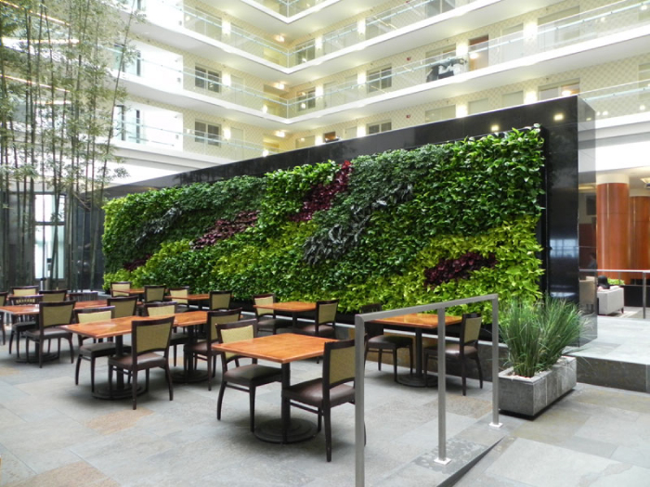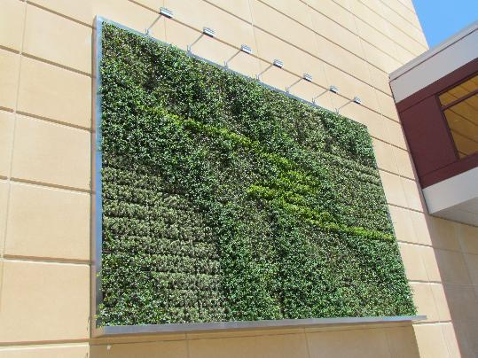
Figure 1-Interior wall (Source: G-Sky Inc. (2014). Figure 2- Exterior wall (Source: Hefferman, Sean (2013).)

According to the company, Green Roof Technologies (2014), there are four general kinds of green walls - Extensive, Free Standing, Semi-intensive and Intensive. Figure 3 shows the different characteristics and appearance of these green walls. Extensive walls are the most commonly found walls, comprising of vines growing on the sides of buildings. They have little to no maintenance as well as a very low installation cost. Freestanding walls do not need a building’s support to grow, like trimmed bushes in a garden. Semi-Intensive walls are made with a wire mesh to support the vines and creepers for growth (“Green Walls,” 2014). However, Intensive Walls have a more intricate framework for plants to grow on. For example, an Intensive panel system wall have the plants’ roots embedded in soil panels that are pre-cultivated off site. Intensive walls tend to be around 3-6 inches (7-15 cm) deep, which allows for the growth of larger plants (“Green Walls,” 2014). An intensive green wall, the main focus of our study, is the costliest green wall, but provides the most environmental benefits due to its size and design.
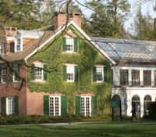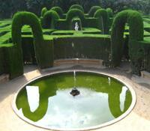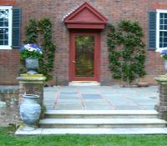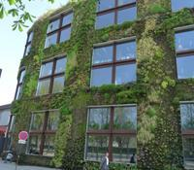
Figure 3- from left to right– An extensive, freestanding, semi intensive, and intensive green wall. (Source: “Green Walls,” 2014).

Green walls are recently becoming more and more popular across the globe. They are widespread in Europe and other areas of warmer temperatures, although with the proper plant variety, they can be made to survive in the colder climates. A well-known exterior green wall is the Il Fiordaliso Shopping Center in Milan, Italy (Figure 4), which is 13,594 feet wide and covered with over 44,000 plants (Zimmer, 2012). Green walls are also popular in Singapore and Germany, where many buildings are being designed to integrate green walls panels into their structure.

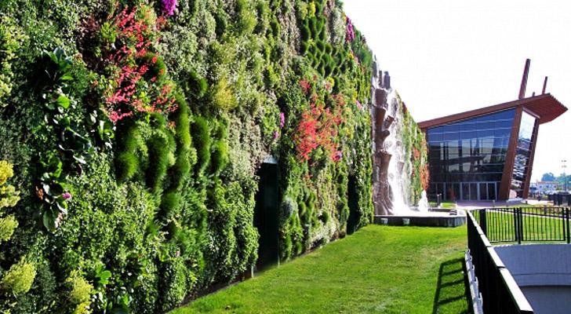
Figure 4: The Il Fiordaliso Shopping Center (Source: Zimmer, Lori. 2012)

Benefits
Along with being aesthetically appealing, green walls can provide many environmental and financial benefits. There can be a reduction in cooling costs inside a building due to the additional layer of protection that limits UV radiation in the summer. A reduction of heating costs can occur in the winter as the green wall acts as insulation and prevents heat transfer through the walls (Dinsdale, et al. 2006). This not only reduces the total energy costs in heating and cooling, but also helps counteract the urban heat island effect. An urban heat island is a phenomenon observed in densely populated regions surrounded by rural area, in which the urban area has higher temperature fluctuations than the surrounding area (“heat Island Effect.” 2014). This is because of the larger population producing higher carbon emissions and the buildings trapping in solar radiation.

On Campus
At the University of Illinois, trying to balance efforts to improve the environment while being cost efficient is a large issue faced in implementing sustainable projects on campus. The implementation of a green wall at the Krannert Center for the Performing Arts can have numerous benefits for our campus. The Krannert Center is an ideal location for green wall due to the design of the building. As seen in Figure 5, Krannert is mainly comprised of three large theatres, which have no windows and high walls. Green walls are ideally built where there are few windows and obstructions to ease construction and installation. Also, the spacious and high walls allow a larger green wall to be built, which can beautify the building. Krannert does not have any neighboring buildings that provide proper ventilation for the wall and sunlight for the plants to grow. Also thousands people come to watch concerts here, which makes the place a hotspot to look more aesthetically appealing.
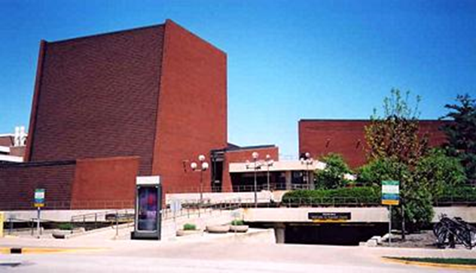
Figure 5: Bare Walls of the Krannert Center for the Performing Arts. (Source: Miller, Malcolm. 2013).

PROJECT OBJECTIVES

The objective of our project was to determine the financial feasibility, the environmental impact, and economical benefits of implementing an intensive green wall at the Krannert Center for Performing Arts on the U of I campus. After reviewing green walls in terms of heating and cooling costs, health benefits, and other potential advantages, our aim is to make an assessment of the initial costs, maintenance, and overall net savings of a potential green wall on Krannert Centre for the Performing Arts. The final deliverable solution will provide the University with estimated initial construction costs, predicted energy savings, calculated reduced CO2 emissions, and other potential benefits for the Krannert Center area.

METHODOLOGY

Tasks
In order to accomplish our objective of this project by the end of the semester, we have created three main goals to address the feasibility of a green wall. These goals were further divided into tasks to be completed over the semester, as seen in the Gantt chart in Figure 6.

- Our first goal was to address the proper type of green wall that should be built and its cost and design. Factors we addressed were the location and climate of our campus year round and how a green wall can survive in winter. In order to determine the proper plant selection, we got in contact with two green wall companies located in the Midwest to provide information on local green walls. With this information and other research, we can calculate the total installation and materials cost, along with determining annual maintenance fees for a green wall suited for Champaign’s climate and the green wall size.

- The next goal was had was to determine the expected energy savings a green wall could provide in heating and cooling costs at the Krannert Center. In order to reach this goal, we created multiple tasks such as research and reviewing energy cost documents, and researching other alternative locations for a green wall. We had a meeting with Rebecca McBride, the Senior Director of Krannert Center to provide information on the Krannert building. We have used data from local green walls and estimated possible cooling and heating savings relative to the age and size of the building, to the size of the green wall, and to climatic patterns.

- The last goal we had was addressing the other benefits a green wall can provide aside from energy savings in order to address multiple factors of a life cycle assessment. These benefits included reducing air pollution and the urban heat island effect, improving human health, LEED points for Krannert Center, and the aesthetic appeal and marketing/advertising ideas. The majority of these tasks were accomplished by researching case studies done on previous green walls, and by contacting various green wall companies.

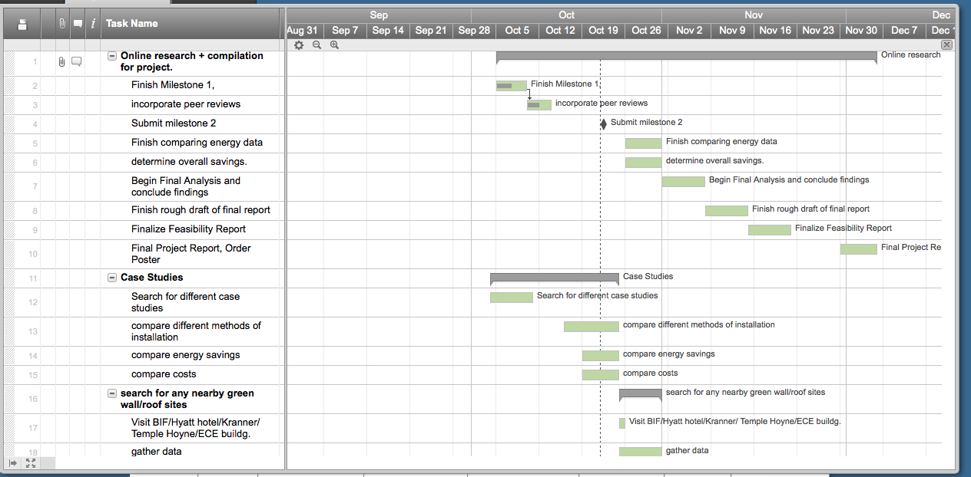
Figure 6: Gantt chart of project schedule to accomplish tasks over the course of the Semester

Meeting with Rebecca McBride
In order to assess any limitations that Krannert Center building may possess in building a green wall, we set up a meeting with Rebecca McBride, the Senior Director of Krannert Center. During this meeting, we discussed the past design idea of building a green roof on Krannert Center. That project was halted due to technical difficulties. However, there have been no known issues that came up for the addition of green walls. A concern we had was if resonance due to vibrations could potentially damage the wall or if the wall would affect the acoustics of the theatre. What we concluded at the meeting was that the noise would not affect the plants, as they have damped the vibrations down to not affect the exterior of the building. The meeting with Rebecca strengthened our proposal that the Krannert Center would be a good location for the installation of a green roof. The added design would work well with Krannert’s message of being a center for performing arts, a place for exemplifying creativity. A green wall would aid Krannert’s goal of becoming more sustainable and taking measures to become green. This can be seen in their switch to LED lighting systems in the lobby and cutting their wattage use by 62% since 2004 (“We’re Green” 2014). This could also give the Krannert Center a few LEED points to distinguish them as a green building. We also discussed the possibility of using the Green Wall as a student led activity as well as a marketing strategy. There could be contests to determine the design of the green wall’s plants while also allowing the students to finance their own plant on each panel.

Alternate Solutions (Similar Projects)
- Temple Hoyne Buell Hall Green Wall
If the directors of Krannert Center are not too keen on the idea of installing a Green Wall, there is an alternative to installing a Green Wall at the Temple Hoyne Buell Hall. This building is located on the south side of campus, and is the head office for the college of Landscape Architecture. What makes this building a great alternative to Krannert Center is its location and design. Noted in Figure 8, the Temple Hoyne Buell Hall has a 3 story metal screen jutting out on one of its windowless walls, where we could place an intensive green wall (University of Illinois Dept. of Urban and Regional Planning, 2014). This structure was initially used for movie screenings, however this use has now been discontinued. The wall could have green wall panels installed, which can be accessible from every floor, for easier installation and maintenance. The green wall would be aesthetically pleasing to the offices that overlook the wall, and a good site for urban architecture, which will attract the interest of students and faculty in and around the building. The wall could reduce the urban heat island effect, and improve ventilation since the green wall would have more open air around it. The downside of an addition of a wall in the building would be that it faces a partially deserted parking lot, and can be overlooked by many people.
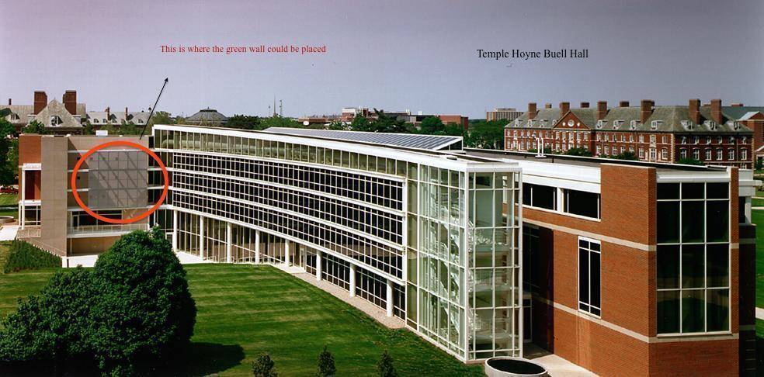
Figure 7: Temple Hoyne Buell Hall (Source: “University of Illinois, Temple Hoyne Buell Hall.” 2014).

- Extensive Green Walls
There are different kinds of green walls that could pose as a substitute to intensive green walls. Extensive green walls could be used if the maintenance and installation costs become an issue. We can see these kinds of walls on fraternity and sorority buildings around campus. Because this kind of green wall is easy to install, we could add it to most buildings around campus. As seen in Figure 8, Hendrick House, on the corner of Lincoln and Green Street, also has an extensive green wall.
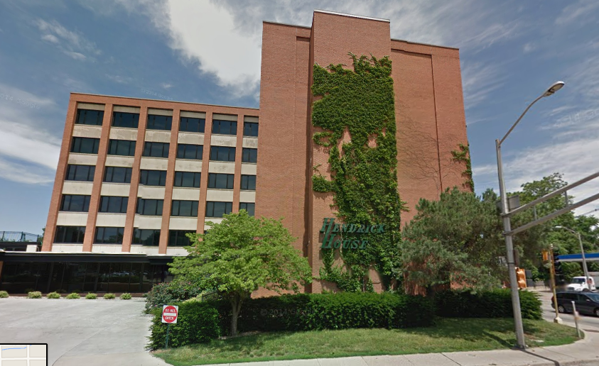
Figure 8: Hendrick House (Source: Google Earth)

- Vertical Farms
Another alternative solution for a green wall on our campus is vertical farms. This can alter the farming industry by cultivating different kinds of fruits and vegetables on vertical walls for commercial or private utilization. Dickson Despommier, author of the “The Vertical Farm: Feeding the world in the 21st Century” advocates green wall to counteract the decline in crop production due to urbanization and shortage of land (‘The Vertical Farm.” 2014). By creating vertical farms, there would be less allocation of land dedicated to farming, and it would be utilizing the barren walls of urban cities, as seen in Figure 9. The profits from growing and selling these crops could help with the cost of maintenance, making the wall self-sustainable. The biggest problems faced with building vertical gardens are the high installation rates, along with the expenditure to keep the gardens well-maintained (“The Vertical Farm.” 2014). A schedule of planting and harvesting seasons would also need to be taken into consideration in order for the farms to be kept healthy throughout the year. Also, proper water allocation would need to be maintained depending on the type of plants being cropped.
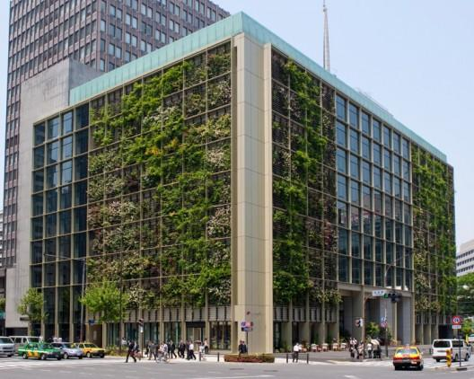
Figure 9: Vertical Farm located in Tokyo (Source: Allen, Katherine. 2013).

RESULTS AND DISCUSSION

Design Factors:
There are numerous design factors that should be taken into consideration to determine the proper type of green wall to be built. We have addressed the main factors that are relative to our campus and helped narrow down the green wall projects we were interested in comparing.

- Climatic Conditions and Plant Selection
The majority of green walls are usually located in warmer climate locations to avoid the harsh weather conditions during the winter such as snow, strong winds, and the dry air. However, depending on the plant selection and with proper maintenance and watering, green walls can be made to survive the colder climate, and still provide a visually pleasing wall. For example, as seen in Figure 10, a green wall located in Philadelphia was created with plants that can survive in the winter. These plants include, the Mondo Grass and Sedum, which retains its green color year round; the Blue Star Juniper has a dullish blue color; and the Huechera Purple Palace, which turns from green to purple during the winter (Irwin 2011). These plants are able to withstand the harsher temperatures while still giving an appealing look to the wall. Along with these plants, G-Space Design, a Philadelphia based green wall company, has over 20 plants that are eye appealing and can survive year-round (Irwin 2011).
In order for these plants to survive the cold, the green wall needs more care and maintenance because unlike ground plants, they do not have any protection from the wind. With poor selection of plants based solely for decoration and warmer climates, the green wall can become too delicate in the winter and fall apart. G-Space Design places high importance in retaining the moisture of both the plants and the growing medium (Irwin 2011). According to G-Space Design, in order to prevent the moisture loss, the irrigation system should be turned on when the temperature becomes 35 degrees or higher, which is when the plants are more susceptible to take in and retain the water (Irwin 2011).

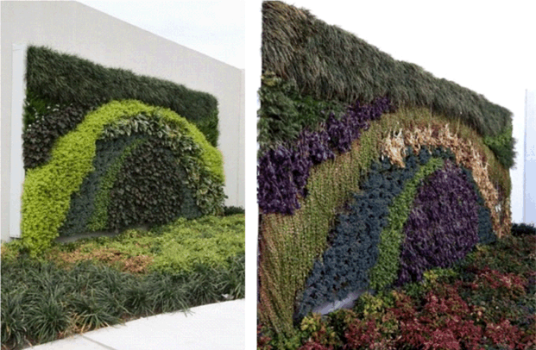
Figure 10: Green Wall located in Philadelphia, PA. Image on left shoes green wall in October 2012 and the right in January 2011. (Source: Irwin, George 2011).

- The Building Structure-Krannert Center
There are many factors of the construction of the building itself that plays a role in determining what type of green wall to build. After reviewing data on the Krannert Center, we were able to determine how effective a green wall would be and what benefits we could expect.
The age of the building can predict how efficiently a green wall can insulate and cool a building. Typically, for buildings built before 1980, we can expect more energy savings since the material and age of the buildings have weaker insulation properties. Krannert Center was built in 1969 and the exterior is built from bricks (“Krannert Center for the Performing Arts #52” 2012). This fits the criteria of being built before 1980 and we can expect there to be more noticeable heating and cooling savings. The construction of the building also determines the maximum weight of a green wall that the walls can withstand. While a thicker green wall provides more insulation, it also increases the weight of the green wall. Therefore, a building that has a heavy load bearing capacity will be able to hold a more intensive green wall. For an intensive wall ranging from 3-6 inches deep, a green wall can weigh around 10-15 lbs. per square foot (“Live Wall Structural Considerations.”). According to Rebecca McBride, the Krannert Center’s walls had already been tested to withstand large weights during the green roof analysis. As the size of the building increases, there is a larger surface area of the walls exposed to the sunlight, which increases the temperature in the summer. And in the winter, there is more area for the heat to escape, decreasing the temperature. The Krannert Center has three large indoor theatres, which range from a height of 76 to 96 ft. (“Krannert Center for the Performing Arts.”).

Intensive Green Walls and Installation:
The decision to recommend an intensive green wall was made after analyzing the major design factors of a green wall. An intensive green wall can be built in two ways: one way is building it into the building’s infrastructure and the other is as an addition to the exterior. Other than the framework, the installation and parts of the green wall remain the same. There are many layers to a complete intensive green wall along with optional components, as seen in Figure 7. The first layer is the frame that is mounted on to the building with no damage to the original walls. The next layer is a waterproof panel to protect the building when the plants are being watered. If the green wall is larger and has more than an aesthetic purpose, an irrigation system can be installed. This reduces weekly maintenance and makes the wall more self-sustaining. Most intensive living walls have a panel installation system as opposed to one large complete wall. These individual panels contain the medium and soil where the plants root and are attached to the frame. The panels can be removed separately after the green wall is installed for easier maintenance (“Introduction to Green Walls Technology” 2008).
Once the main framework of the green wall is constructed, the remaining layers are the medium and the plants. For a panel system, the medium is relatively thicker than semi-intensive green walls. The medium layer contains soil, pumice, and fiber, to keep the project lightweight as opposed to just traditional soil (Dame, et al. 2000). The medium sticks to the surface before being lifted vertically with the aid of pinching metal brads and root barriers that keep the soil from falling out (Dame, et al. 2000). As the thickness of the soil increases, there is greater insulation for the walls and more variety of larger plants can be planted. Water retention also increases as the medium becomes thicker, which is necessary to keep the plants healthy.
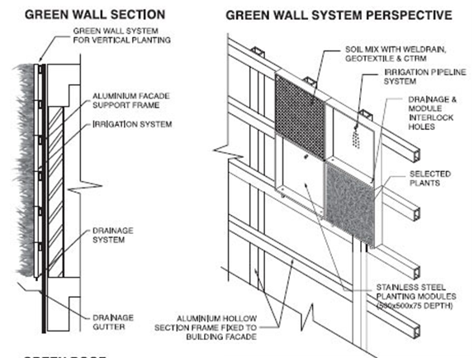
Figure 7: Cross-Sectional View of an Intensive Green Wall- Panel System

In comparison to an intensive wall, the free standing and extensive walls have fewer components and less variety. They typically contain smaller sized plants and are self-sustaining; requiring maintenance as little as twice a year. They also have a lower construction costs since most extensive and free-standing plants are planted in the ground near the building. These plants are usually creepers or vines that can either grow on the building itself or onto a built in netted frame.
Costs and Installation-Predicted for Krannert Center
The location of the green wall for this feasibility study is on the Wall located near the South entrance facing Goodwin Ave, as Figure 8 shows. This green wall would be about 10m X 9m for one wall (32.8ft X 29.5ft). The size of this green wall would cover about half of the surface area of one wall, 90m^2 (967.6 ft^2).
An intensive green wall is more expensive than other green walls because it requires more materials such as the metal frame, the growing medium and the plants. On average, an intensive green wall comprised of panels can cost between $75-$125 per square foot for installation, plants, soil, and irrigation. This was the average cost of a green wall after requesting quoted from two different companies that have panel systems, Ambius and Green Living Technologies. After contacting Sam Negotia, a representative of Ambius, we determined that we could expect the average cost per square foot to decrease, as the size of the green wall gets larger. In a sustainable progress report done by Eric Liang, the maintenance costs of an intensive green wall is expected to cost about 8 to 10 percent of the installation cost (CITE). This is around $12-$18 per square foot of a green wall for total maintenance over a year. With a single green wall at Krannert, the cost would be $72,570-$120,940, with a yearly maintenance costs of $5800-$9680. There is also the cost of water and electricity used to run the irrigation system.
The larger the surface area that the green wall covers, we can predict there to be more energy savings in heating and cooling. The best way to make the green wall more sustainable is placing a green wall on all four walls of any of the protruding theatres to increases total benefits. The total surface area covered by a green wall on all four sides of one of the theatres would be around 360m^2(3870.4ft^2). The total installation and costs would be about $290,280-$483,800 and there would be an annual maintenance fees would be around $46,450-$69,700.

Benefits

Aesthetics:
A green wall is an innovative idea of incorporating greenery in an urban environment. This additional greenery is eye catching and improves the look of once bare walls. The addition of a green wall can create a more aesthetically pleasing environment for the students at the University of Illinois. As opposed to green roofs that aren’t visible from the streets and usually visually unappealing, green walls can be considered as a new form of portraying art. Many green walls have very unique designs using a variety of colorful plants that beautify the neighboring are.
The work of Patrick Blanc, a botanist and researcher, can be seen in Figure 8, of the L’Oasis D’Aboukir. The original design of the 25m high wall, as seen in Figure 8, is constructed of over 237 plants and covers the original graffiti covered concrete wall (Andrews 2013). This addition instantly beautifies the walls of the street making it and enjoyable sight to see.

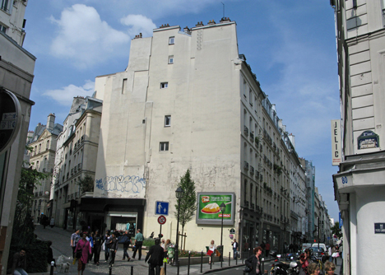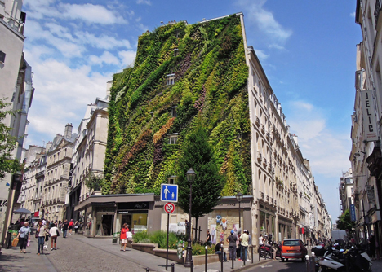
Figure 8: L’Oasis D’Aboukir green wall located in Paris, France. Source (Andrews, Kate 2013).

Reducing Urban Heat Island Effect:
An "urban heat island" is an area, generally a major city that is hotter than its nearby rural areas. According to the Environmental Protection Agency (EPA), if the city has 1 million or more people, its annual mean air temperature is generally 1–3°C warmer than its surroundings. The difference with the temperature can go as high as 12°C in the evening. Communities are affected by heat island because of increase in summertime peak energy demand, thereby increasing air conditioning costs, air pollution and greenhouse gas emissions, various heat-related illness, and water quality. Adding plants to the environment reduces the urban heat island effect by promoting natural cooling processes, like photosynthesis. Green Walls are strategically placed to create turbulence to break vertical airflow, which in turn cools down the air.
Most of the research done on green walls has shown that most of the energy savings in green walls comes from the result of reducing cooling costs in the summer over reduced heating costs during winter. Due to this, we will see most of the savings during the summer. According to a study done by the National Research Council Canada, green walls are able to reduce heating temperature costs due to shading, insulation, and decreases radiation heat losses (Dame, et al. 2000). If the plants chosen are able to withstand winter conditions, then they are able to provide both heating and cooling costs. This however would result in deeper soil panels, larger winter plants to increase insulation, and an overall higher installation and maintenance costs.

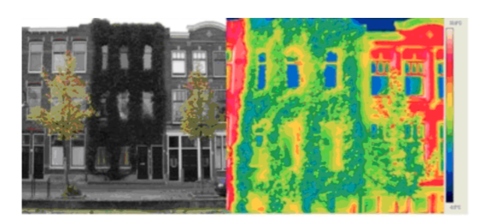 Figure 9: Urban Heat Island Effect shown using infrared rays (source: Vertical Gardens (2013))

Air Purification

Planting trees/plant is a general solution to improve air quality. During photosynthesis, carbon dioxide is removed from the air, and produce fresh oxygen as a byproduct. According to the company, Green Plants for Green Buildings, it has been estimated that a minimum of 300g (10 oz.) of carbon dioxide is removed for every squared meter of greenery. This can remove up to 6 cubic feet of CO2 gas in a year. The reduction of CO2 can be expected to be smaller since Krannert Center is not located near any large factories or in the center of an urban city, so it can be expected to not have high concentrations of CO2 around. In one year, a 50 square ft. green wall can consume as much carbon dioxide as a 14 foot tree (“The Benefits of Living Green Walls” 2014).
Ambius, a landscaping company located in Des Plaines, IL recommends an intensive green wall, the Sage Vertical Gardens System, for reducing greenhouse gases and protecting the environment. Plants used for their green walls are be chosen to improve air quality and target pollutants such as carbon monoxide, formaldehyde, and other common VOC’s. As seen from Figure 10, plants such as Dracaena, Chlorophytum, and Epipremnum can reduce almost 50% of the initial concentrations of these pollutants (“The Benefits of Living Green Walls” 2014). These are the top air purifying plants Ambius incorporates in their green walls.
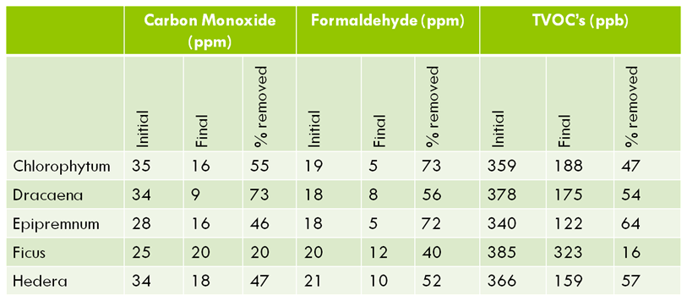Figure 10: Ambius’ Top Green Wall Plants for Air Purification
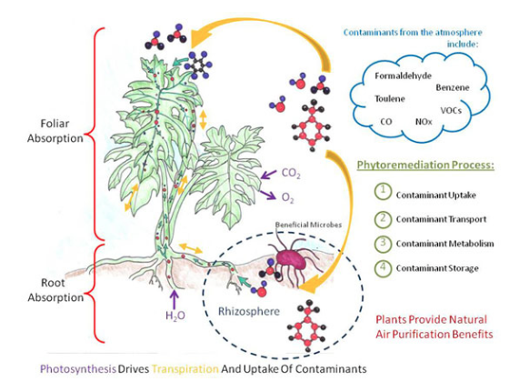 Figure 11: Photosynthesis in plants

Energy Savings (Heating and Cooling):
Green walls are a new modern technology, and as a result, definite energy savings of actual green walls located in temperate climates are still being determined. In a Lifecycle Assessment of Living Walls done by Haibo Feng in 2008, multiple simulations of a 200 m­­² living wall were made in a temperate location, Albany New York. This simulation was done through EnergyPlus and calculated total energy consumption of a 40m x 10m x 5m building with and without green walls. Parameters for this simulation included building activity such as people density and electrical plug density, along with the HVAC system and building fenestration (Feng 2008). These parameters make the simulation more reliable as it imitates an average building in use. The total heating energy consumed was 70.77 GJ/year and 17.59 GJ/year the total cooling energy (Feng 2008). For an intensive living wall, the energy savings for heating was 6.3% and a negligible savings for cooling. This is a savings of about 4.46 GJ/year, which gives a 7 year breaking point of the green wall (Feng 2008).
Haibo Feng’s Assessment also included an alternative study of having all four walls of a building be covered by a green wall. The evaluation included three types of buildings, a large office building, a strip mall, and a warehouse. It also simulated buildings built from three different time periods, before 1980, between 1980 and 2004, and after 2004 (Feng 2008). Due to Krannert Centre’s large building size, approx. 298,293 ft2 of total floor area, and being built in 1969, the simulation data that best fits the Krannert Center is for the office building (46320 m² total floor area) that was built before 1980 (“Krannert Center for the Performing Arts #52” 2012). One of the 7 different climate zones that the simulation was done for was a cold and humid climate, with the representative city being Chicago, IL. From this simulation, it was found that 1139.6MWh of energy was used in July for cooling without a green wall (Feng 2008). After adding a green wall to all four sides of the building, there was 19.9MWh of energy saved in cooling. A 23.4% savings of the yearly heating consumption of 530.2MWh energy was found due to the green wall (Feng 2008).
The simulation also showed that July had the highest energy savings, and from May to October, the energy savings were slightly lower. In the cooler months, from November to April, there was negligible energy savings as there was less cooling energy required. This supports the idea that the majority of the energy savings will be seen in reducing the cooling costs during the summer as opposed to the heating costs in the winter. This also shows that green walls are better at reducing heat absorption by the building than being used as insulation.
General trends from the simulation showed that for newer buildings, those built after 2004, the energy savings decreased as the buildings are better insulated. There was also more energy savings for the office built before 1980 than the strip mall and warehouse. This shows that a green wall is more effective than a green roof, due to the larger surface area that the building has on all four sides of the exterior in comparison to just the roof.

Expected Energy Savings for the Krannert Center
Using the data provided by the Life Cycle Assessment done by Haibo Feng, there is potential for a green wall to offer energy savings, although the construction costs do not seem to pay for itself over time. We predict that the annual energy savings due to cooling would be around 2.0% and 1.0% for heating for one 90m^2 wall. Because green walls are a modern technology, energy savings data on past green wall projects of similar size and climate are not qualitative yet. As a result, the simulations presented provide data under ideal circumstances. This led us to make a sensible estimate of a smaller heating and cooling costs savings. For the alternative that all four walls are covered, we expect these savings to increase to around 5-6%. This agrees with the general trend of expected savings for a green wall.
To determine how much money this could potentially save us, we calculated the total energy costs that Krannert Center consumes. According to Facilities and Services, in 2012, the post retro-commissioning (RCx) the energy cost index (ECI) was $3.14/ft2. Using this, we calculated that the total energy consumption by the Krannert Center is approximately $936,640 per year. With an annual energy savings of 5.0% due to all four green walls could save around $46,832. If the lifespan of a green wall is 25 years, the total costs and maintenance becomes $2,226,300. The total expected a savings cost of energy is about $1,170,800. This shows that green wall is not self-sufficient and will not pay for itself over time

Marketing Potential:
Green walls can also be used for advertising purposes. Each wall can be structured in a different way, according to what the client needs. For example, if the directors for Krannert Centre wanted their company logo on the wall, it could be done with a plantation of different types of shrubs. As seen in Figure 12, they could also put up different patterns on the wall. With removable panels in intensive green walls, the installation process for different plants is easier to accomplish and multiple patterns may be achieved.
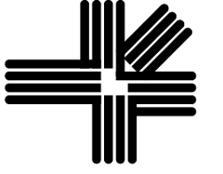
Figure 12: Logo of Krannert Centre (left) and Masks (right)

Improve Health and Well-Being

Dr. Ed Wilson, a Harvard biologist, has found that people have an affinity towards nature. This affinity is called biophilia (“Benefits of Green Plants”). By promoting sustainable efforts such as a green wall on campus, the health of the students and faculty could be improved. According to the EPA, “Sick Building Syndrome” is when people have clinical health complaints that are correlated to amount of time that they spend in a building (“Sick Building Syndrome” 1991). There have been studies showing a direct relationship between plants and people, proving that plants have can positively someone’s mental health.
Many studies on the effects of plants and their reduction of the Sick building Syndrome have been carried out. Professor Tove Feld of the Agricultural University in Oslo, Norway conducted a study of including plants in offices. When plants were included in the work environment, 12 of the common symptoms due to sick building syndrome had a 23% lower complaint rate. This shows that green walls have the potential to improve the mental health of the students and faculty on campus.

Inspires creativity

The Krannert Center attracts a large variety of people, ranging from artists and musicians to engineers and businessmen all visiting Krannert to fulfill their passion for performing arts. This makes Krannert Center a beacon of old fashioned entertainment in the city of Urbana. The addition of green walls could be aesthetically pleasing to anyone passing by. Bill Sullivan, in his case study presented to CEE 398 PBL students, showed that any greenery helps calm the minds of people and acts as a stress reliever. People that work in offices near plants are more focused, take fewer sick days, and become more creative (“The Benefits of Living Green Walls” 2014). Green spaces also help people pay more attention, especially for people with high anxiety levels because of work or study. Green Walls have also been known to improve social ties among neighbors (Sullivan). People are known to have been in a more jovial mood due to more “greenery” around them. Therefore, they seem friendlier to a random stranger, and entice a feeling of happiness from strangers. This is how green walls could add more value to the peace loving place the Krannert Center is.

CONCLUSION

Our group has determined that the most beneficial green wall to be implemented at the University of Illinois would be a panel system intensive green wall. We concluded that a 10m by 9m green wall located at the Krannert Center would have a total installation and materials cost of $70,250-$120,920 and a yearly maintenance fee of $5800-$9680. We predicted that the annual energy savings due to cooling would be around 2.0% and 1.0% for heating, and that would be about $9360 in savings per year. For the case where the green wall was on all four sides of the building, we calculated a total construction and maintenance cost of and a yearly maintenance fee of. We predicted that this design would have a total 5-6% annual energy savings, which would save approx. $ every year. Comparing the initial costs with the overall savings over a lifespan of 25 years, we concluded that a green wall would not be self-sufficient. However, our group decided that with proper plant selection, an intensive green wall can reduce greenhouse gases such as carbon dioxide and formaldehyde by 40-50% of the initial concentrations. Another environmental benefit was the reduction of the urban heat island effect due to the shading of the walls. This can reduce the temperature of the exterior wall by 3-7 degrees, which proves that there is a reduction in solar absorption of and solar radiation off of the exterior walls. Along with the visual appeal improving the mental health of the students and faculty due to the added greenery, a green wall can deliver the University with many environmental and economic benefits, for an extra cost. We believe that the green wall can be worth the investment once taking into consideration of the sustainable efforts it is providing. The next step in the project would be to continue the green wall analysis with a more descriptive Lifecycle Assessment to quantify the benefits of a green wall
REFLECTIONS

Over the course of the semester and upon completion of this project, our group has gained a lot of experience from working on this study. We have been exposed to a professional environment where we were able to discuss our ideas and receive feedback. We were also able to implement our studies and research into a project that could aid our University towards being more sustainable. We were able to see different work environments through in class presentations made by different professors, and field trips to different facilities. One of the most important things we learnt in this class is, when given so much data; how we can narrow it down to add to the material at hand.
Our group has faced a few shortcomings that we have learned to be able to avoid for future projects. One of the biggest drawbacks included emailing professors about questions pertaining to green walls. The professors either did not reply to our emails, or asked us to email another professor for the same. We were going around in circles, searching for professors to help us. This is what happened with collection of data for the ECE Green Wall. We had access to a large number of documents of the ECE Building, but no one to explain what document meant. Another shortcoming we faced is that we did not have exact cost values; it is just estimation, using different green wall company's quoting on their costs. What we could not add is labor costs, which fluctuate in every state, and with every contractor used on projects.
We have achieved many things with this project. Our project till now has been received with positive reviews, where people were willing to listen and suggest their ideas to make our project better. Our biggest triumph was getting the approval of Rebecca McBride, senior Director of Krannert Centre, to go ahead with the feasibility study. Another triumph of ours would be contacting different companies to give us their quoting on the prices of green walls. These are the first few steps taken to make corporate connections. In doing this, we learned how to talk to people professionally, as well as how to interview someone.
We have learned a great many things with this project, pertaining to our career choices. We hope that the skills we have gained help us in our future endeavors.

ACKNOWLEDGEMENTS

We would like to thank Morgan Johnston from Facilities and Services for providing us with data on the Krannert Center to aid our research. We would also like to thank Rebecca McBride, the Senior Director of the Krannert Center for meeting with us and providing us information to analyze our data. We would also like to thank Professor Arthur Schmidt of the CEE Department for providing us information on green walls, We would also like to thank Professor Jeffery Roesler of the CEE Department and Professor Lance Schideman of the ABE Department and for offering feedback on how to revise our objective and scope of the project. We would also like to thank Paul Littleton of the CEE Department for reviewing our proposals and drafts. We would also like to thank Alec Heilstedt for providing feedback on our proposal and Milestones. We would also like to thank Professor Mary Hays of the English Department for improving our technical writing skills. We would further like to thank to thank all the professors and instructors of CEE 398 for providing feedback and helping us revise our paper.

REFERENCES

Allen, Katherine. (Sep. 29 2013). “In Tokyo, A Vertical Farm Inside Out.”
<http://www.archdaily.com/428868/in-tokyo-a-vertical-farm-inside-and-out/>. (Dec.
8, 2014).

Andrews, Kate. (Sep. 8, 2013). “The Oasis of Aboukir Green Wall by Patrick Blanc.”
< http://www.dezeen.com/2013/09/08/the-oasis-of-aboukir-green-wall-by-patrick-blanc/>. (Dec. 8, 2014).

“Benefits of Green Plants.” < http://greenplantsforgreenbuildings.org/resources/benefits-of-green-plants/>. (Dec. 10, 2014).

Dame, A., Walke, C., & Wilson, C. (2000, July 20). The Future of Rooftop Gardens on the
University Of Waterloo Campus. (Nov. 1, 2014).

Dinsdale, S., Pearen, B., & Wilson, C. (2006). Feasibility Study for Green Roof Application on
Queen’s University Campus. (Nov. 1, 2014).

Embassy Suites Chicago. (2011). “Gallery.”
<http://gsky.com/projects/embassy-suites-chicago-downtown/>. (Dec. 10, 2014).

Feng, Haibo. (2008). Lifecycle Based Energy Assessment of Green Roofs and Walls. (Nov. 1,
2014).

“Green Walls.” (2014). <http://www.greenrooftechnology.com/green_walls>. Green Roof
Technology. (Dec. 10, 2014).

“Heat Island Effect.” (Aug. 31, 2014). <http://www.epa.gov/heatisland/>. US EPA. (Oct. 15,
2014).

Heffernan, Sean. (March 26, 2013). “Living Green Walls: The Wallpaper of the Future is Alive!”
<http://www.ambius.com/blog/living-walls-the-wallpaper-of-the-future-is-alive/>. (Dec. 10, 2014).

Introduction to Green Walls Technology, Benefits and Design. (2006, September 1). (Nov. 1,
2014.)

Irwin, George. (March 18, 2011). “Green Walls and Winter Interest.”
<http://www.greenroofs.com/archives/green_walls.htm>. (Nov. 22, 2014).

“Krannert Center for the Performing Arts.” LocalWiki.
<https://localwiki.org/cu/Krannert_Center_for_the_Performing_Arts>. (Dec. 11, 2014).

“Krannert Center for the Performing Arts #52.” Facilities and Services.
<http://www.fs.illinois.edu/docs/default-source/retro/buildingsummary-kcpa.pdf?sfvrsn=2>. (Dec. 11, 2014).

“Live Wall Structural Considerations.” Live Wall.
<"http://livewall.com/pro/technical/engineering/>. (Nov. 1, 2014).

Miller, Malcolm. (Aug. 7, 2013). “Creative Reinterpretation.”
<http://www.mvdaily.com/articles/2003/08/solemnis3.htm>. (Dec. 1, 2014).

Özgür Burhan Timur and Elif Karaca (2013). Vertical Gardens, Advances in Landscape
Architecture, Dr. Murat Ozyavuz (Ed.), ISBN: 978-953-51-1167-2, InTech, DOI:
10.5772/55763.
<http://www.intechopen.com/books/advances-in-landscapearchitecture/vertical-gardens>

“Sick Building Syndrome.” (Feb. 1991). EPA.
< http://www.epa.gov/iaq/pdfs/sick_building_factsheet.pdf>.
(Dec. 10, 2014).

“The Vertical Farm.” (2014). <http://www.verticalfarm.com/>. (Dec. 8, 2014).

University of Illinois Department of Urban and Regional Planning. (2014).
<http://www.urban.uiuc.edu/about-durp/our-mission/facilities>. (Nov. 1, 2014).

“University of Illinois, Temple Hoyne Buell Hall.” (2014). Perkins Will.
<http://perkinswill.com/work/university-of-illinois-temple-hoyne-buell-hall.html>. (Dec.
12, 2014).

“We’re Green.” (2014). Krannert Center for the Performing Arts.
<http://www.krannertcenter.com/meetus/missionandvision/weregreen.aspx>. (Dec. 5,
2014).

Zimmer, Lori. (Sept. 30, 2012). The World's Largest Living Wall Flourishes With 44,000 Plants
at Milan's IL Fiordaliso Shopping Center.
<http://inhabitat.com/a-milan-shopping-center-is-now-home-to-the-worlds-largest-living-wall/>. Inhabitat. (October 29, 2014).

APPENDIX:
ECE Green Wall
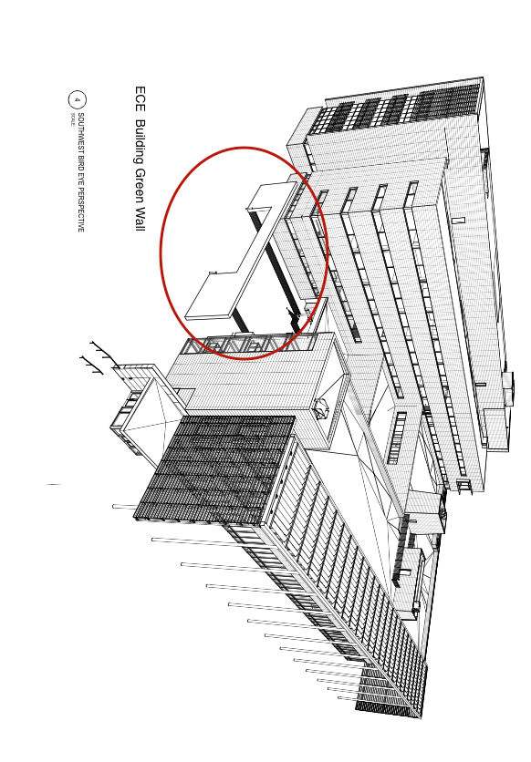
At the newly constructed Electrical and Computer Engineering (ECE) Building, the plan to build a green wall near the west entrance is underway. This project includes an extensive green wall that is expected to survive the winter temperatures. As of now, there is a frame built on to the wall where the vines will be able to grow. Because the project is relatively new, and the construction has not begun, there is no available data breaking down the green wall according to costs and installation.

However, we were able to receive data about the site plans of the future project. However, since the green wall will be an extensive wall, it is out of the scope our project and was not relative to an intensive green wall.

BUDGET

All of our research and data collected to complete this project did not require any funds. We did not have a budget.

