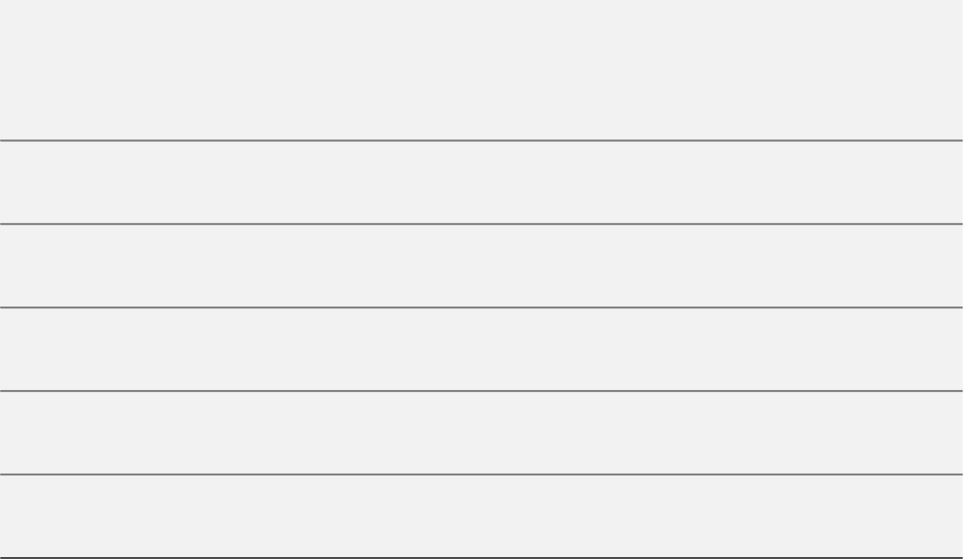
1
15
30
1
15
31
1
15
30
September
October
November
John Doe
Identify consumer buying habits in the industry, market size, growth or decline, and any current trends.
Lorem Ipsum.
Marketing Research
Ellie Morgan
To identify our most likely buyers. In addition, discuss at least two or three levels of segmentation.
Target Market
Sandra Goodwill
Look at the entire marketplace and then break down specific tactics including such as events, direct mail, email, social media - that will help us gain access to customers.
Market Strategy
Flavia Gomes
Develop a month-by-month schedule of what we plan to spend on marketing. Also include a “red light” decision point.
Budget
Alexandra Hollins
Track our marketing success with Google Analytics for website conversions and a simple Excel sheet to compare our budget against the actual ROI.
Metrics
YEAR 2022

MARKETING GANTT CHART
PROJECT NAME GOES HERE
September 01 – November 30, 2022
Prepared By: John Doe

