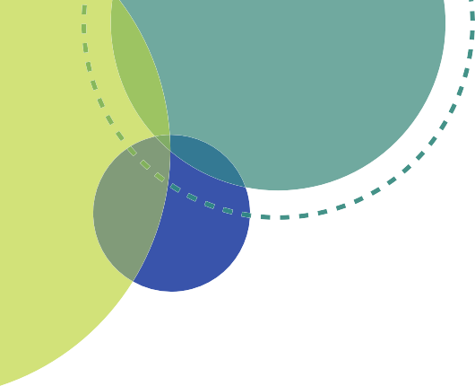

P
&
N
Work Together
Assess Needs & Resources
Evaluate Actions
Public Health
Healthcare
Business
Community Members
Education
Government
hilanthropy Investors
Community Development
Act on What’s Important
Focus on What’s Importan
onprofits
Communicate
Choose Effective Policies & Programs
© 2014 County Health Rankings and Roadmaps
TEMPLATE IMPLEMENTATION PLAN
A tool to help your community’s efforts to be focused and effective
Template Implementation Plan v2.0: February 2015 www.wicommunityhealth.org
Wisconsin Community Health Improvement Plans and Processes (CHIPP) Infrastructure Improvement Project
1

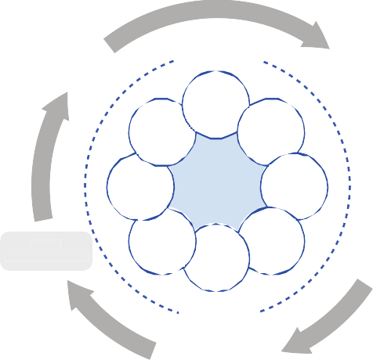
What’s Important
Work Together
Assess Needs & Resources
Evaluate Actions
TEMPLATE IMPLEMENTATION PLAN
A tool to help your community’s efforts to be focused and effective
Public Health
Healthcare
Business
Community Members
Government
Education
Philanthropy & Investors
Community Development
Act on What’s Important
Focus on What’s Important
Nonprofits
Communicate
Choose Effective Policies & Programs
© 2014 County Health Rankings and Roadmaps
Introduction
When it comes time to take action on a community’s chosen health priorities, sometimes it is a challenge to move from a broad goal to effective and strategic action. In the “Act on What’s Important” checklist of the Wisconsin Guidebook on Improving the Health of Local Communities there are several steps outlined to help ensure effective implementation – be sure to review those steps when using this tool.
This document addresses one specific part of action planning for impact: a well thought-out implementation plan. An implementation plan can help assure the work gets done. You may have already created some of the critical parts of this plan: priority areas and broad goals. This template moves into more specificity, including:
•
•
•
•
Specific and measurable objectives
Strategies that are known to be or have a high likelihood of being effective (i.e., evidence-based) Specific action steps with accountabilities, deadlines and resources needed
Links to national goals and strategies
This template will help your community to create a plan that is focused and evidence-based and that will help you stay on track. In addition, the tool will help hospitals and health departments to achieve some of their specific requirements related to community health improvement. Some of the sections of the template are there to assure those key requirements are included. (See the Attachment 1 for a more detailed description of the specific requirements.)
To enhance the effectiveness of your efforts, be sure you are fully engaging the community leaders and community members concerned with each issue at every stage, including this planning phase. Their involvement at this stage will help to assure chosen strategies fit the community and will leverage ongoing support of this work during implementation. (See the “Work Together” checklist in the Wisconsin Guidebook on Improving the Health of Local Communities for more guidance on engaging partners.)
Template Implementation Plan v2.0: February 2015 www.wicommunityhealth.org
Wisconsin Community Health Improvement Plans and Processes (CHIPP) Infrastructure Improvement Project
2


How to Use this Tool
Your community will have already selected top priority areas to address and may have selected broad goals and some strategies for addressing those priority areas. Many times those elements are included in a final report to the community on the results of the community health assessment process. Now it is time to get more specific.
A few things to keep in mind:
•
Consider forming small, focused teams to do this work. Many communities use “implementation teams” with expertise and interest in the particular priority topics. Engaging those key partners in this planning process will help in maintaining commitment and involvement over the long haul.
An implementation plan should describe the logical sequence of events that will result in the change you desire. It works like a logic model or strategy map, helping you to drill down from a broad goal to intermediate accomplishments or outcomes and then to very concrete strategies and action steps. (See Attachment 2 for a description of the link between the Template Implementation Plan and a logic model. For more information on logic models, see the University of Wisconsin Extension resources.)
The most detailed level of your Implementation Plan – the Action Plan – often becomes your implementations team’s annual work plan. You may wish to cut and paste it into an annual work plan document and have your teams use that to guide their work.
- When put into use, a work plan should be a dynamic tool. Target dates may need to be adapted. Actual results may be different than anticipated.
- Use this tool to document your progress. (Note: Some organizations are required to track and report on their progress in their community health improvement plan. Using this tool can achieve that end. See Attachment 1 for more information on those requirements.)
Partner organizations can extract the appropriate sections of this Implementation Plan to insert into their organization’s reports, strategic plan and/or performance management plan. Doing that will help to document their commitment to the collaboration and to track their efforts internally.
While this tool is primarily designed for writing an entire implementation plan for a community health improvement initiative, it can also be used on a smaller, more specific scale. For example, a team or volunteer working on strategies to improve healthy nutrition within one particular school might use just the “Action Plan” portion to organize and guide their work.
•
•
•
•
Once your plan is complete, your community will move into actual implementation, when you will use this document as a foundation for monitoring, evaluating, and communicating progress to community leaders and community members. For more information on these steps, review the “Act on What’s Important” and “Evaluate Efforts” checklists in the Wisconsin Guidebook on Improving the Health of Local Communities.
Template Implementation Plan v2.0: February 2015 www.wicommunityhealth.org
Wisconsin Community Health Improvement Plans and Processes (CHIPP) Infrastructure Improvement Project
3

Helpful Resources
As you complete this tool for your community, there are several resources that will be very helpful.
Instructions
Below are both a blank template for you to complete and a sample to help illustrate how it can be used. Editable versions of the blank template and the sample are available at http://www.walhdab.org/?page=customsitetable.
Complete one template for each priority area; add sections for additional goals or objectives as needed. Adapt this tool as you see fit for your community.
The following brief description of each section will help to guide your work. (Note: Planning terms are used in many different ways. You may find other definitions of terms such as “objective” or “goal.” The list below is intended to explain how those
terms are used in this document.
Adapt the terms as needed to fit your community.)
Template Implementation Plan v2.0: February 2015 www.wicommunityhealth.org
Wisconsin Community Health Improvement Plans and Processes (CHIPP) Infrastructure Improvement Project
4
Priority Area:
Enter here one of the top issues your community selected as a priority to address at this time.
Goal:
Write a broad statement of what you hope to accomplish related to this priority area.
Performance Measures:

Demonstrate in this section how you will know you are making progress. State specifically what you will measure to determine whether changes have occurred. Select indicators of progress for both the short term (1-2 years) and long term (3-5 years). Specify the data source you will use for those indicators (or your plan to develop a measurement system if necessary).
Objectives:

Describe the specific measurable end-products of your intervention. Objectives should be SMART: specific, measurable, appropriate, realistic, and time-framed.
(Note: When writing your objectives, consider using the “Objectives with Focus” tool.)
Background:

Document the type of strategy you are using. Cite any evidence-base for the strategy. (See Helpful Resources above.) Cite if the strategy is a policy change (required for public health accreditation). You may also choose to provide a link to any program sites as applicable.
State and National Community Health Improvement Plans:

- Healthiest Wisconsin 2020
- Healthy People 2020
- National Prevention Strategy

Sources for Evidence-Based Strategies:

- The Community Guide
- What Works for Health

Additional Wisconsin Resources:

- Objectives with Focus: A Pick List of Sample Objectives for Effective Implementation
- Recommended Core Data Set for Community Health Improvement
- Compendium of Data Sources for Community Health Improvement Processes

This resource was developed with funding from the University of Wisconsin School of Medicine and Public Health from the Wisconsin Partnership Program. The resource is a result of a collaboration between the Wisconsin Association of Local Health Departments and Boards, the University of Wisconsin Population Health Institute, and numerous additional partners. For more information, please go to www.wicommunityhealth.org or www.walhdab.org.
Template Implementation Plan v2.0: February 2015 www.wicommunityhealth.org
Wisconsin Community Health Improvement Plans and Processes (CHIPP) Infrastructure Improvement Project
5
Activity:

Outline the steps you will take to achieve each objective. The activities are the “how” portion of the action plan. It is best to arrange activities chronologically by start dates. Place each activity in a separate row and add as many rows as you need to the template.
Timeline:
State the projected start and end date for each activity.
Resources Required:
Include all resources needed for this action step. (Examples: funding, staff time, space needs, supplies, technology, equipment, and key partners.)
Lead Person/ Organization:
Identify by name the key person who will initiate the activity, provide direction for the work, and monitor progress.
Anticipated Result:
Describe the direct, tangible and measurable results of the activity. (Examples: a product or document, an agreement or policy, number of participants.)
Progress Notes:

Track progress of completion of activities. Also note any unexpected outcomes, both positive and negative.
Alignment:

Show the alignment between your community’s priority area and both state and national priorities. Also show the alignment to tribal priorities when applicable. You can cite the specific objectives listed by state and national health plans (listed above under Helpful Resources).

Example Template
Editable versions of the blank template and the example are available at http://www.walhdab.org/?page=customsitetable
ABC Community Health Improvement Process Implementation Plan
Date Created:
Date Reviewed/Updated:
Template Implementation Plan v2.0: February 2015
www.wicommunityhealth.org
6
Wisconsin Community Health Improvement Plans and Processes (CHIPP) Infrastructure Improvement Project
PERFORMANCE MEASURES
How We Will Know We are Making a Difference
Short Term Indicators

Source

Frequency

By DATE, decrease the percentage of adults engaging in no physical activity from x% to y%.

WI-Behavioral Risk Factor Surveillance System (BRFSS)
Annual

By DATE, decrease the percentage of adults eating less than five servings of fruits and vegetables daily from x% to y%.
WI-BRFSS

Annual

By DATE, increase the percentage of WIC infants ever breastfed from x% to y%.

WI-Dept. of Health Services, Pediatric Nutrition Surveillance System (PedNSS)
Annual

Long Term Indicators

Source

Frequency

By DATE, decrease the percentage of overweight adults from x% to y%.

WI-BRFSS

Annual

By DATE, decrease the percentage of obese adults from x% to y%.

County Health Rankings
Annual

PRIORITY AREA: Nutrition & Physical Activity
GOAL:
ABC County will implement policies that support residents in achieving a healthy diet and increased physical activity.

Template Implementation Plan v2.0: February 2015 www.wicommunityhealth.org
Wisconsin Community Health Improvement Plans and Processes (CHIPP) Infrastructure Improvement Project
7
OBJECTIVE #1:
By DATE, increase the number of ABC County municipalities that are working towards adopting local complete street policies from # to #.
BACKGROUND ON STRATEGY
Source: Complete Streets Program http://www.completestreets.org/
Evidence Base: “Urban design and land use policies” recommended by The Guide to Community Preventive Services Policy Change (Y/N): Yes
ACTION PLAN

Activity

Target Date

Resources Required

Lead Person/ Organization

Anticipated Product or Result

Progress Notes

Attend training on WI’s complete street legislation and assess expected impact on ABC County by discussing with Highway Dept.

12/31/15

Staff time Travel

Amy Adams, ABC Health Department

Increased knowledge Written resources Assessment of impact

Finish photovoice project, targeting the communities of X, Y, and Z.

4/30/16

Staff time Volunteer time Travel Cameras
Amy Adams and Physical Activity Team Volunteers

Photo display/ presentation for each community

Find at least 1 street/road in each community and graphically design a complete street.

4/30/16

Staff time

Amy Adams

Graphic presentation of desired design for each community’s selected street

Conduct walkability/ bikeability checklists in those communities.

5/31/16

Staff time Volunteer time Travel
Amy Adams and Physical Activity Team Volunteers
Completed assessment for each community

Create a presentation for city councils about the new state law, using photovoice and complete street pictures.
8/30/16

Staff time

Susie Smith, ABC Health Officer Terri Thomas, ABC Hospital
PowerPoint presentation and packet of materials

Present to city councils and invite to go on a walk audit.

10/31/16

Staff time

Susie Smith Terri Thomas

Presentation and walk audit completed

Follow up with city council chair after meeting
11/30/16

Staff time

Susie Smith

Discussed next steps

Announce approved policy to the community collaboratively with the city council (if approved)
12/31/16

Staff time

Terri Thomas

Press release Press coverage

Template Implementation Plan v2.0: February 2015 www.wicommunityhealth.org
Wisconsin Community Health Improvement Plans and Processes (CHIPP) Infrastructure Improvement Project
8
OBJECTIVE #3:
By DATE, increase the number of early care and education providers who have adopted the Ten Steps to Breastfeeding- Friendly Child Care Centers from # to #.
BACKGROUND ON STRATEGY
Source: 10 Steps Resource Kit
Evidence Base: Breastfeeding promotion programs indicated to be “scientifically supported” in “What Works for Health’” Policy Change (Y/N): Yes
ACTION PLAN

Activity

Target Date

Resources Required

Lead Person/ Organization

Anticipated Product or Result

Progress Notes

OBJECTIVE #2:
By DATE, increase the number of schools participating in a comprehensive Farm to School Program from # to #.
BACKGROUND ON STRATEGY
Source: http://www.healthinpractice.org/a-healthy-community/farm-to-school
Evidence Base: Farm to School programs indicated to be effective based on “expert opinion” in “What Works for Health” Policy Change (Y/N): Yes

ACTION PLAN

Activity

Target Date

Resources Required

Lead Person/ Organization

Anticipated Product or Result

Progress Notes

Template Implementation Plan v2.0: February 2015 www.wicommunityhealth.org
Wisconsin Community Health Improvement Plans and Processes (CHIPP) Infrastructure Improvement Project
9
ALIGNMENT WITH STATE/NATIONAL PRIORITIES

Obj #
Healthiest Wisconsin 2020
Healthy People 2020
National Prevention Strategy
1

Design communities to encourage activity

Increase legislative policies for the built environment that enhance access to and availability of physical activity opportunities (Physical Activity-15)
Encourage community design and development that support physical activity

2

Make healthy foods available for all
Increase access to healthy foods and support breastfeeding

Increase access to healthy and affordable foods in communities

3

Increase access to healthy foods and support breastfeeding

Increase the proportion of infants who are breastfed (Maternal, Infant and Child Health-21)
Support policies and programs that promote breastfeeding

Blank Template
Editable versions of the blank template and the example are available at http://www.walhdab.org/?page=customsitetable..
[Name of Community] Health Improvement Process Implementation Plan
Date Created:
Date Reviewed/Updated:
Template Implementation Plan v2.0: February 2015
www.wicommunityhealth.org
10
Wisconsin Community Health Improvement Plans and Processes (CHIPP) Infrastructure Improvement Project
PERFORMANCE MEASURES
How We Will Know We are Making a Difference

Short Term Indicators

Source

Frequency

Long Term Indicators

Source

Frequency

PRIORITY AREA:

GOAL:

Template Implementation Plan v2.0: February 2015 www.wicommunityhealth.org
Wisconsin Community Health Improvement Plans and Processes (CHIPP) Infrastructure Improvement Project
11
OBJECTIVE #1:
BACKGROUND ON STRATEGY
Source: Evidence Base:
Policy Change (Y/N):

ACTION PLAN

Activity

Target Date

Resources Required

Lead Person/ Organization

Anticipated Product or Result

Progress Notes

Template Implementation Plan v2.0: February 2015 www.wicommunityhealth.org
Wisconsin Community Health Improvement Plans and Processes (CHIPP) Infrastructure Improvement Project
12
OBJECTIVE #3:
BACKGROUND ON STRATEGY
Source: Evidence Base:
Policy Change (Y/N):

ACTION PLAN

Activity

Target Date

Resources Required

Lead Person/ Organization

Anticipated Product or Result

Progress Notes

OBJECTIVE #2:
BACKGROUND ON STRATEGY
Source: Evidence Base:
Policy Change (Y/N):

ACTION PLAN

Activity

Target Date

Resources Required

Lead Person/ Organization

Anticipated Product or Result

Progress Notes

Template Implementation Plan v2.0: February 2015 www.wicommunityhealth.org
Wisconsin Community Health Improvement Plans and Processes (CHIPP) Infrastructure Improvement Project
13
ALIGNMENT WITH STATE/NATIONAL PRIORITIES

Obj #
Healthiest Wisconsin 2020
Healthy People 2020
National Prevention Strategy

1

2

3

Attachment 1:
Hospital and Public Health Department Requirements Related to Implementation Planning
Not-for-profit hospitals have particular requirements related to community health improvement. In terms of an Implementation Strategy, those requirements include:
•
•
Adopt a written Implementation Strategy to address the community health needs identified during the assessment.
Describe how the hospital will address the needs including:
•
The actions the hospital intends to take to address the needs (or indicates if the hospital does not intend to address the need and explains why they will not be addressing the health need).
The anticipated impact of these actions.
The programs and resources the hospital plans to commit to address the health needs.
Any planned collaboration between the hospital and other facilities or organizations in addressing the health needs.
•
•
•
•
•
If the hospital does not intend to address the need, describe why they will not be addressing the health need.
Execute the implementation strategy.
Additionally, the hospital’s CHNA must include an evaluation of the impact of any actions that were taken to address the significant health needs since the previous assessment.
[Note: While the IRS requirements for non-profit hospitals were reviewed and expertise was consulted, using this template does not guarantee compliance with IRS requirements. Hospitals should consult with their community benefit (or other appropriate) staff in order to determine whether or not a local plan meets the IRS requirements.]
Public health departments seeking national accreditation need to meet the specific requirements for an implementation plan outlined in Public Health Accreditation Board (PHAB) Standard 5.2.2L and 5.2.3L. Those requirements include:
•
Community health priorities, measurable objectives, improvement strategies and performance measures with measurable and time-framed targets.
- Strategies should be evidence-based or promising practices (using sources such as the National Prevention Strategy, Guide to Community Preventive Services, and Healthy People 2020).
- Strategies should consider the social determinants of health, causes of higher risks and worse health outcomes in special populations, and health inequities.
Policy changes needed to accomplish health objectives.
- Policy changes should address the causes of health inequities, including social and economic factors. Individuals and organizations who have accepted responsibility for implementing strategies.
Measurable health outcomes or indicators to monitor progress.
Alignment between the community health plan and the state and national priorities (and tribal where appropriate). Provide a report documenting the process of and progress toward implementing the community health improvement plan. (See 5.2.3A)
•
•
•
•
•
[Note: While state and national experts familiar with the PHAB Standards reviewed and gave input on this tool, using this template does not guarantee PHAB compliance. Only PHAB site reviewers during the accreditation review process can determine whether or not a local plan meets the PHAB requirements.]
Template Implementation Plan v2.0: February 2015 www.wicommunityhealth.org
Wisconsin Community Health Improvement Plans and Processes (CHIPP) Infrastructure Improvement Project
14

All public health departments in Wisconsin are required under state statute and administrative rule to:
•
Involve key policymakers and the general public in determining and developing a community health improvement plan that includes actions to implement the services and functions specified under s. 250.03(1)(L). [251.05 (3)(c)]
Develop and deliver services to reduce the incidence or prevalence of the chronic diseases or injuries that are the leading causes of disability and premature death in the jurisdiction of the local health department, the chronic diseases or injuries for which resources are available to the local health department from the department or the chronic diseases or injuries identified through a community needs assessment under s. 251.04(6)(a), Stats., as priority public health problems, or by the regular and systematic collection of information on the health of the community as required under
s. 251.05(3)(a), Stats. [DHS 140.04(1)(c)]
Provide an annual report on the activities of the local health department for the preceding calendar year, including a narrative which describes the progress and performance toward achieving the objectives that the local health department has identified as part of its community health assessment process. [DHS 140.04(3)(c)]
•
•
Sources
1.
Affordable Care Act (ACA) – Title IX/Section 9007 http://www.gpo.gov/fdsys/pkg/PLAW-111publ148/pdf/PLAW- 111publ148.pdf
IRS Notice 2011-52 (7/25/11) http://www.irs.gov/pub/irs-drop/n-11-52.pdf
IRS Proposed Rule April 2013 http://www.irs.gov/PUP/newsroom/REG-106499-12.pdf
IRS Final Rule December 2014 http://www.gpo.gov/fdsys/pkg/FR-2014-12-31/pdf/2014-30525.pdf Public Health Accreditation Board (PHAB) http://www.phaboard.org/
Wisconsin State Statutes & Administrative Rules http://legis.wisconsin.gov/rsb/Statutes.html http://legis.wisconsin.gov/rsb/code.htm
2.
3.
4.
5.
6.
7.
Template Implementation Plan v2.0: February 2015 www.wicommunityhealth.org
Wisconsin Community Health Improvement Plans and Processes (CHIPP) Infrastructure Improvement Project
15

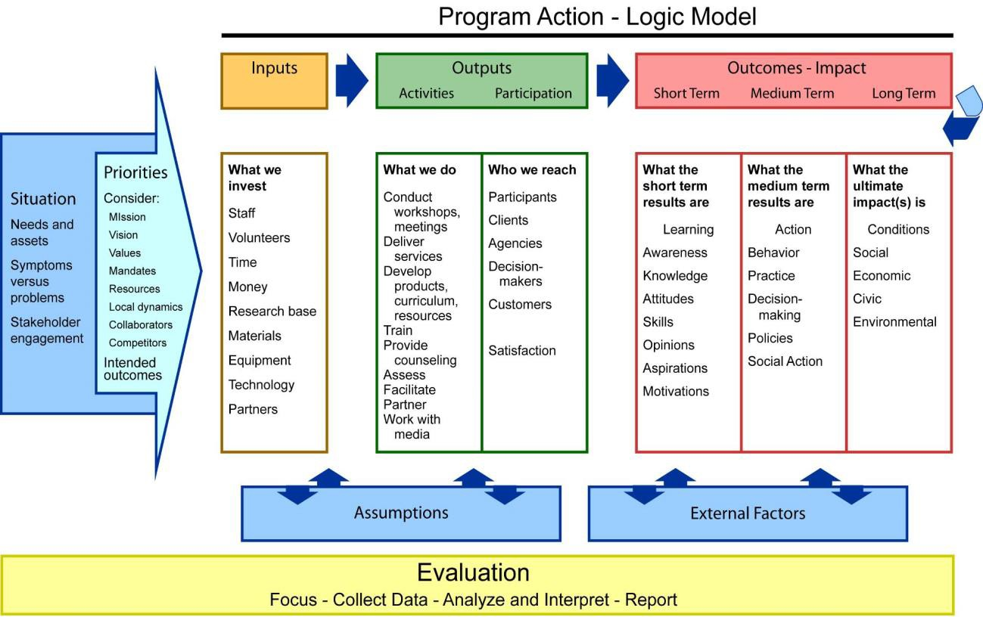
Attachment 2:
Link Between Template Implementation Plan and Logic Model
The template implementation plan provided here is intended to follow a typical logic model by providing a structure to move from a broad goal to intermediate accomplishments or outcomes and then to very concrete strategies and action steps.
Because different models/tools use different language, this crosswalk is provided to illustrate the link between the language used in this template implementation plan and that used in a logic model.
Template Implementation Plan Category
Goal …………………………………………………………………..
Long Term Indicators ………………………………………..
Short Term Indicators……………………………………….
Objectives ………………………………………………………..
Anticipated Product/Results …………………………….
Resources Needed …………………………………………..
Logic Model Category Long Term Outcome Medium-Term Outcomes Medium-Term Outcomes Short-Term Outcomes Outputs
Inputs
Source: http://www.uwex.edu/ces/pdande/evaluation/evallogicmodel.html
Template Implementation Plan v2.0: February 2015 www.wicommunityhealth.org
Wisconsin Community Health Improvement Plans and Processes (CHIPP) Infrastructure Improvement Project
16

Acknowledgements
This template draws heavily on the work of the Healthy Wisconsin Leadership Institute’s Action Plan Template. The Healthy Wisconsin Leadership Institute is a continuing education and training resource supported jointly by the University of Wisconsin School of Medicine and Public Health and the Medical College of Wisconsin.
The sample implementation plan borrows from actual examples created by Polk County Health Department (WI) and Oneida County Health Department (WI).
Consultation on this tool was provided by members of the CHIPP Infrastructure Improvement Project Operations Group and Lauren Shirey, Senior Program Manager, Assessment and Planning for Accreditation Preparation, National Association of County and City Health Officials (NACCHO).
This resource was developed with funding from the University of Wisconsin School of Medicine and Public Health from the Wisconsin Partnership Program. The resource is a result of a collaboration between the Wisconsin Association of Local Health Departments and Boards, the University of Wisconsin Population Health Institute, and numerous additional partners. For more information, please go to www.wicommunityhealth.org or www.walhdab.org.
Template Implementation Plan v2.0: February 2015 www.wicommunityhealth.org
Wisconsin Community Health Improvement Plans and Processes (CHIPP) Infrastructure Improvement Project
17

