 | PROJECT MANAGEMENT
 | Work Breakdown Structure
 | 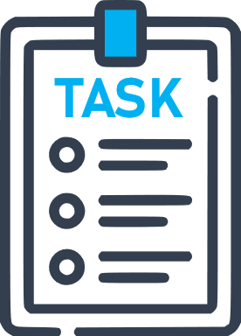 |  |  |  |  | 05/06/2023 | 12/06/2023 | 19/06/2023 | 26/06/2023 | 03/07/2023 | 10/07/2023 | 17/07/2023 | 24/07/2023 | 31/07/2023 | 07/08/2023 | 14/08/2023 | 21/08/2023 | 28/08/2023 | 04/09/2023 | 11/09/2023 | 18/09/2023
 |  |  |  |  |  | WEEK 1 | WEEK 2 | WEEK 3 | WEEK 4 | WEEK 5 | WEEK 6 | WEEK 7 | WEEK 8 | WEEK 9 | WEEK 10 | WEEK 11 | WEEK 12 | WEEK 13 | WEEK 14 | WEEK 15 | WEEK 16
 | TASK 1 |  | 05/06/2023 | 16/06/2023
 | Activity 1.1 |  | 05/06/2023 | 11/06/2023
 | Activity 1.2 |  | 05/06/2023 | 16/06/2023
 | Activity 1.3 |  | 12/06/2023 | 16/06/2023
 | TASK 2 |  | 19/06/2023 | 25/08/2023
 | Activity 2.1 |  | 19/06/2023 | 07/08/2023
 | Activity 2.2 |  | 26/06/2023 | 18/07/2023
 | Activity 2.3 |  | 08/07/2023 | 14/08/2023
 | Activity 2.4 |  | 01/08/2023 | 25/08/2023
 | TASK 3 |  | 20/07/2023 | 12/09/2023
 | Activity 3.1 |  | 20/07/2023 | 25/08/2023
 | Activity 3.2 |  | 11/08/2023 | 12/09/2023
 | TASK 4 |  | 10/08/2023 | 22/09/2023
 | Activity 4.1 |  | 10/08/2023 | 04/09/2023
 | Activity 4.2 |  | 01/09/2023 | 15/09/2023
 | Activity 4.3 |  | 18/09/2023 | 22/09/2023

