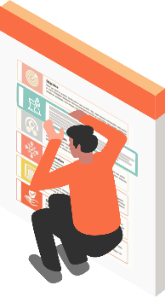
PLAN
PROJECT
PROJECT
WORK
Project Description
Describe what is your project here. For example, Sengineering teams are tasked with creating a scientific proposal and a poster illustrating their proposal for genetically modifying an organism to benefit society. This project should be finished in less than 2 weeks. Engineering teams choose a problem of interest and then come up with an original idea, using genetic modification of a plant, microbe, or animal to address the problem.
Lorem ipsum dolor sit amet, consectetuer adipiscing elit. Maecenas porttitor congue massa. Fusce posuere, magna sed pulvinar ultricies, purus lectus malesuada libero, sit amet commodo magna eros quis urna.

Objective
What you plan to achieve by the end of your project. This might include deliverables and assets, or more intangible objectives like increasing productivity or motivation. Your project objectives should be attainable, time-bound, specific goals you can measure at the end of your project.

Strategy
Overarching set of guidelines to be used by the project in making decisions. and taking action throughout the course of the project. It is in alignment with the corporate, business, marketing, and operational strategies.

Implementation
The stage of a project lifecycle where you put everything you've planned and built into action. You have plans, ideas, and strategies in place, and now you're simply executing them. Describe planned course of actions to be performed.

Collaboration
Project collaboration takes place when a group of people with varying project management skills and experiences come together to tackle a single project. Everyone in the collaborative group is included in the decision-making process and has access to all information. Whether there are clearly defined roles or not depends on the project.

Schedule
A project schedule indicates what needs to be done, which resources must be utilized, and when the project is due. It's a timetable that outlines start and end dates and milestones that must be met for the project to be completed on time.

Check
Project managers should regularly check project elements such as: Status, Budget, Tasks, Schedules, Quality assurance, Dependencies, Potential risks.
Always empower team members to speak up if they see an issue or feel something is not working during project execution.

