 |  |  |  |  | 
 | RETURN TO WORK PLAN
 |  |  |  |  |  |  |  |  | 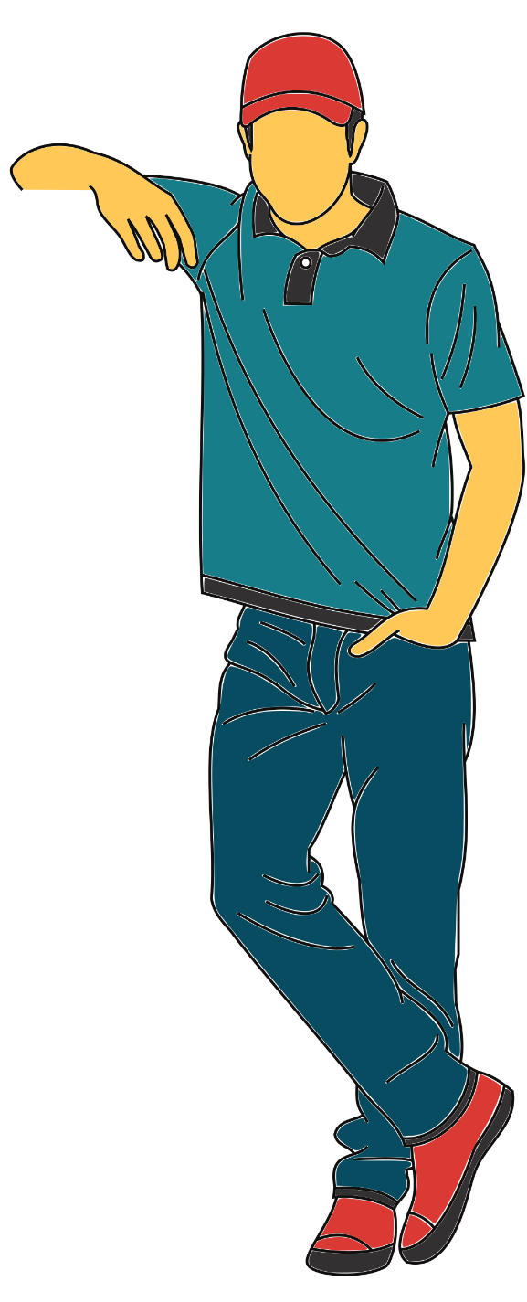
 | PHASE | WEEK | MON | TUE | WED | THU | FRI | No. of Days  in a week | TOTAL  Hours
 | PHASE 1: Preboarding. Online contact with team and new peers. Have lunch with the team. |  |  |  |  |  |  | PHASE 1
 | 1 | 1 | 2 h |  |  | 2 h |  | 2 | 4 h
 | PHASE 2: Having the first day back at the office and evaluating the set-up and supplementary needs. Sharing the work plan for the first two weeks with specific tasks. |  |  |  |  |  |  | PHASE 2
 | 2 | 2 | 3 h | 3 h |  | 4 h |  | 3 | 10 h
 | 2 | 3 | 4 h |  | 4 h |  | 5 h | 3 | 13 h
 | PHASE 3: Become re-accustomed to the workflow. Start taking on lighter duties. Participate in team building social activities. |  |  |  |  |  |  | PHASE 3
 | 3 | 4 | 4 h | 4 h |  | 4 h | 5 h | 4 | 17 h
 | 3 | 5 | 5 h |  | 6 h | 6 h | 6 h | 4 | 23 h
 | PHASE 4: Start taking on heavier responsibilities and review the ongoing process. Is additional support required? |  |  |  |  |  |  | PHASE 4
 | 4 | 6 | 6 h |  | 6 h | 6 h | 6 h | 4 | 24 h
 | 4 | 7 | 7 h | 7 h |  | 6 h | 6 h | 4 | 26 h
 | 4 | 8 | 7 h | 7 h | 6 h | 6 h | 6 h | 5 | 32 h
 | 4 | 9 | 7 h | 7 h | 7 h | 7 h | 7 h | 5 | 35 h
 | PHASE 5: Reboarding interview evaluation and consider being back to one of the phases above. If all fine, going back to normal working conditions. |  |  |  |  |  |  | PHASE 5
 | 5 | 10 | 7 h | 7 h | 8 h | 7 h | 7 h | 5 | 36 h
 | 5 | 11 | 7 h | 8 h | 8 h | 7 h | 7 h | 5 | 37 h
 | 5 | 12 | 8 h | 8 h | 7 h | 8 h | 8 h | 5 | 39 h
 | 5 | 13 | 8 h | 8 h | 8 h | 8 h | 8 h | 5 | 40 h

