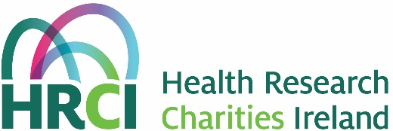

HRCI/HRB Joint Funding Scheme 2020
(formerly the MRCG/HRB Joint Funding Scheme)

PART C1

Collaboration Agreement Form

Section 1: Application details

Title of Application

Principal Investigator’s Name

Section 2: Details of collaboration

Collaborator
Name, Institution/Company and address

What are the objectives of the collaboration? (max 150 words)

What is the collaborator contributing to the delivery of the project and what task(s) are they responsible for? Is the contribution unique or could a similar contribution be made by an alternate group/organisation? (max 150 words)

Please describe how the proposed collaboration either enables the planned research to be undertaken or enables the planned research to be undertaken to the required quality and/or timescale. (max 150 words)

For industrial collaborator(s), do any of the academic applicants have a direct or indirect interest (consultancy, shareholding, options etc)? If so what is the nature of the interest and how are conflicts of interest between the parties being managed? (max 150 words)

Are there any restrictions on tech transfer, knowledge transfer and/or dissemination of the results from this project arising out of this collaboration? If so, what are these restrictions? (max 150 words)

Section 3: Funding
Please provide details of any income and/or expenditure to the project arising out of this collaboration. Please note that any items of expenditure claimed from the project budget must also be added in the budget section of the application form.

Category | Cost (€) | Specify whether 1,2 or 3  - In-kind contribution  - Funding requested from project budget  - Additional funding leveraged from elsewhere
e.g. consumables
e.g. advice
Please extend table as necessary to include additional categories

Provide details and justification with regard to each item listed in the table above (max 200 words)

Section 4: Signatures

Principal Investigator

As the Principal Investigator I confirm, to the best of my knowledge, that the information provided in this Collaboration Agreement is correct.

Name (BLOCK CAPITALS): _________________________________________________

Signature: ____________________________ Date:___________________

Collaborator

As Collaborator I confirm, to the best of my knowledge, that the information provided in this Collaboration Agreement is correct.

Name (BLOCK CAPITALS): _________________________________________________

Signature: ____________________________ Date:___________________

Collaborator

The General Data Protection Regulation (GDPR) came into force on 25 May 2018. As a result the applicant team are asked to declare that they understand that personal data provided as part of this application, including but not limited to CV information, may be shared with person(s) based outside of the European Economic Area (EEA) for the specific purpose of obtaining peer reviews of this application , and for assessment, monitoring and evaluation purposes.

As Collaborator I confirm, to the best of my knowledge, that the information provided is correct, and I understand that personal data provided as part of this application may be shared outside of the EEA for the purpose of international peer review, and may be used for assessment of the application; monitoring of successful awards; and evaluation of HRBs approach to funding and investment in research, in line with HRB Privacy and Retention policies and as detailed in the APA 2019 Call Guidance Notes.

Name (BLOCK CAPITALS): _________________________________________________

Signature: ____________________________ Date:___________________

Collaboration agreement form must be included with the application.

Forms must be completed, signed, and dated.
Electronic signatures are accepted.

