 |  | GUN BILL OF SALE
Date: ______________________
 |  |  |  |  | ("SELLER") and
 |  |  |  | ("BUYER") agree as follows:
For the payment of the sum of $ |  |  | by BUYER and other good and valuable consideration, the
receipt and sufficiency of which is hereby acknowledged, SELLER does hereby sell, transfer, and convey to BUYER and his heirs, executors, administrators, and assigns the following described firearm(s):
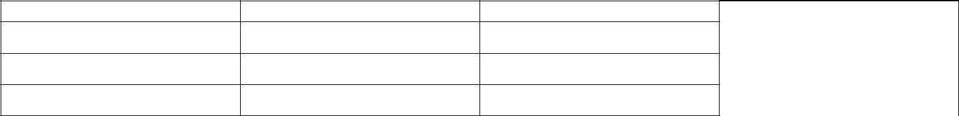

Manufacturer/Importer

Model

Serial Number

Caliber

Concealed Handgun Permit Number of Buyer:

Buyer’s Drivers License Number:

Seller hereby warrants that they are the lawful owner of said property and that they have full legal right, power, and authority to sell said property. Seller further warrants said property to be free of all encumbrances, liens, security agreements, claims, demands, and charges of every kind whatsoever and will warrant and defend the title to said property against any and all persons whomsoever.

Buyer hereby certifies that they are legally able to purchase, possess and own the firearm under applicable State and Federal law and that the information given is true and correct to the best of their knowledge.

The said firearm is being sold "as is" without any express or implied warranty as to condition or working order.

SELLER and BUYER declare under penalty of perjury that to the best of their knowledge all disclosures to each other in connection with the above transaction, and all other information on this Bill Of Sale, is true and correct.

The Parties have executed this Bill Of Sale on this day of , 20 .

Seller Name:

Signature:

Seller Street Address:

City: State: Zip Code:

Phone: _________________________________ Email: _________________________________

Buyer Name:

Signature:

Buyer Street Address:

City: State: Zip Code:

Phone: _________________________________ Email: _________________________________

