HOUSING AUTHORITY OF THE CITY OF PITTSBURGH

REQUEST FOR PROPOSALS
Moving Services Authority Wide RFP# 250-13-12

Due: Monday, April 30, 2012
At 11:00 am.

To: Will McDanel Procurement Director
100 Ross St. 2nd Fl. Suite 200 Pittsburgh, PA 15219

SECTION I INTRODUCTION

The HACP is a municipal corporation, formed under the U.S. Housing Act of 1937, codified at 42 U.S.C. Section 1401 et seq. as amended and the Housing Authority Law of Commonwealth of Pennsylvania codified at 35 P.C. 1542, et. seq. as amended. As such, the HACP is charged with providing “affordable decent, safe and sanitary housing for low-income persons.”

The HACP has approximately 350 employees and services over 18,000 family member residents. The Authority itself maintains approximately 2,992 low-income public housing rental units; and, through its Section 8 program, funds the rental of more than 5,452 occupied Section 8 households that are privately owned.

Major operational departments include Property Management, Maintenance, Occupancy, Section 8, and Modernization & Development. Major administrative departments include Legal, Finance, Management Information Systems, and Human Resources. Our public and community relations departments are Community Affairs, Public Safety and Resident Self-Sufficiency. All departments work together to achieve the goals of the Authority that are set by the Board of Commissioners. Day to day decision-making rests with the Executive Director, who reports to the Board of Commissioners on a regular basis.

The Housing Authority of the City of Pittsburgh seeks proposals from persons or organizations qualified to provide: Moving Services.

The Authority is contemplating the award of a professional service contract or contracts for a period of three (3) years with two (2) one (1) year extension options, in the form of the Sample Contract (Attachment A) through this solicitation process.

Any questions regarding this Request for Proposals should be in writing and directed to: Will McDanel-Procurement Director
Housing Authority of the City of Pittsburgh 100 Ross St. 2nd Fl.
Pittsburgh, PA 15219
412.456.5248 phone
412.456.5007 fax
Will.mcdanel@hacp.org

A complete proposal package may be obtained from:
Business Opportunities Section of the HACP website, www.hacp.org

Following are the Key Dates associated with this Request for Proposals:

Monday, April 30, 2012 at 11:00 a.m. Deadline for Submission of Proposals

Will McDanel – Procurement Director Procurement Department
Housing Authority of the City of Pittsburgh 100 Ross Street 2nd Fl. Suite 200 Pittsburgh, PA 15219
Thursday, April 19, 2012 at 10:00 a.m. Pre-submission Meeting:
Housing Authority of the City of Pittsburgh 100 Ross Street 2nd Fl.
Pittsburgh, PA 15219

Monday, April 23, 2012 at 11:00 a.m. Deadline for the submission of written
questions.

**Deadlines are subject to extension at HACP discretion and will be communicated as an addendum to this solicitation.

SECTION II SCOPE OF SERVICES

The contractor will be responsible for services including but not limited to the moving services as described below:

Contractor must be able to perform moving, packing, unpacking and storage services for residences and commercial.

Contractor will perform residential and commercial moves for the Authority as needed.

Contractor will perform packing and unpacking when needed. Contractor may be asked to provide tape, boxes and other packing material as requested.

Contractor must be able to perform emergency move within 24-48 hours as requested. Contractor must obtain authorization by HACP designee for all moves.
Contractor will provide written Task Order Proposals for all commercial moves and moves involving multiple residential units.

Contractor will provide resident name, address, number of rooms, if packing and unpacking was provided and if a truck was used on all invoices.

Contractor will submit original invoices containing Mgmt # and P.O #. Contract must have a PAPUC number.
Contractor assumes all liability for damage incurred during move.

SECTION III GENERAL REQUIREMENTS

An Offeror may be an individual or a business corporation, partnership, firm, joint venture or other legal entity duly organized and authorized to do business in the City of Pittsburgh, financially sound and able to provide the services being procured by HACP.

If an Offeror has been debarred, suspended or otherwise lawfully precluded from participating in any public procurement activity, such firm shall disclose that information in its offer, which may be sufficient ground for disqualification. If the selected firm fails to disclose such information and HACP discovers it thereafter, then HACP could terminate the contract.

Each Offeror must be in good standing with HACP, and any Federal, State or Municipality that has or has had a contracting relationship with the firm. Therefore, if a Federal, State or Municipal entity has terminated any contract with an Offeror for deficiencies or defaults, that Offeror is not eligible to submit a Response to this Solicitation.

If Offeror is not in good standing with HACP, and/or any Federal, State or Municipality this must be disclosed.

Offeror must have and maintain all necessary insurance to cover malpractice liability and workers’ compensation and submit proof of it with their proposal submission.

SECTION IV
CONTENT OF RESPONSE DOCUMENTS

Offerors submitting Proposals should fully read and comprehend the Instructions to Offerors Non-Construction provided in Attachment B and General Conditions – Non Construction provided in Attachment C. Proposals received without all of the required information may be deemed non-responsive. Offerors must submit one (1) original plus three (3) paper copies of their technical proposal and one (1) electronic copy in .PDF format on a CD. Offerors must also submit in a separate sealed envelope, one (1) original fee proposal and one (1) electronic copy. Proposals must include, in the same order as below and using the forms attached hereto, the following information, exhibits and schedules:

- General Information
  - Letter of Interest (Cover letter)
  - Type of Organization; Corporation, Partnership, Joint Venture or Sole Proprietorship. Names of shareholders, partners, principals and any other persons exercising control over the Firm.
  - Description of the Offeror’s capacity including staff resources
  - Organizational Certifications:
    - Copies of Certificate of Incorporation, Partnership Agreement, Joint Venture or other organizational document.
    - A corporate resolution signed by the Secretary of the Corporation and notarized, certifying the name of the individual(s) authorized to sign the offer, the contract and any amendments thereto.
    - PAPUC# must be included with your proposal
    - A copy of damage claim procedures should be included with proposal. Also please describe how offeror will be minimizing damage claims.

- References
  - The bidder shall list three (3) firms, governmental units, or persons for whom the bidder has previously performed work of the nature requested under this RFP. Name of the contracting entity.
  - Name, title and a telephone number of a contract person for each identified contracting entity to permit reference checks to be performed. The identified party must be one who has first-hand knowledge regarding the operation of the contracted facility or project and who was involved in managing the contract between the Offeror and the contracting entity.
  - In addition to the references, all bidders will provide the last three jobs they performed, contact information from the job and all change orders related to the job and the reason for each.
  - All bidders will provide information on the most recent HACP job to include all change order information and the reason for each. The most recent HACP job can be one of the 3 last jobs performed if that is the case.

- Proposed Staffing and Sub-consultants Responsibilities and Qualifications
Provide the following information relative to the proposed staffing and sub-consultants for this contact:

  - Provide background information regarding each identified Staff member that accurately describes his or her employment history and relevant experience providing services similar to those described in this Request for Proposals.

  - Description of the Scope of Services for at least three (3) projects in which the Staff and/or sub-consultant has provided services similar to those described in this Request for Proposals. Please include the individual’s role in each project and all relevant aspects of each project.

  - Resumes for the owners and key management personnel of the company demonstrating their experiences in managing similar services to those described in this RFP.

- Methodology
Project Approach: Provide a brief narrative of the Offeror's approach to the services described in this Request for Proposals. Availability: Describe the availability of the Staff proposed and the turnaround time for each request to be made by the Authority.

- Certifications and Representations of Offerors
Each Offeror must complete the Certifications and Representations of Offerors provided in
Attachment D.

- Minority and Women Business Participation Plan
HACP MBE and WBE Goals. It is the policy of HACP to ensure that Minority Business Enterprises (MBEs) and Women-owned Businesses (WBEs) are provided maximum opportunity to participate in contracts let by HACP. In accordance with Executive Order 11625, HACP has established a minimum threshold of eighteen percent (18%) of the total dollar amount for MBE utilization in this contract. HACP has established a seven percent (7%) minimum threshold for participation of WBEs, and, HACP strongly encourages and affirmatively promotes the use of MBEs and WBEs in all HACP contracts. For these purposes, an MBE is defined as "any legal entity other than a joint venture, organized to engage in commercial transactions, that is at least fifty-one percent (51%) owned and controlled by one or more minority persons." Also, a minority person is defined as a member of a socially or economically disadvantaged minority group, which includes African- Americans, Hispanic Americans, Native-Americans, and Asian Americans. A WBE is defined as "any legal entity other than a joint venture, organized to engage in commercial transactions, that is at least fifty-one percent (51%) owned and controlled by a female.

Proposals submitted in response to this solicitation MUST include an MBE/WBE participation plan which, at a minimum, demonstrates “Best Efforts” have been taken to achieve compliance with MBE/WBE goals. HACP’s Procurement Policy defines “Best Efforts” in compliance with MBE/WBE goals to mean that the contractor must

certify and document with its bid or proposal that it has contacted in writing at least ten
(10) certified MBE and ten (10) certified WBE subcontractors to participate in the proposed contract with HACP or lesser number if the contractor provides documentation that ten (10) certified MBE and WBE contractors could not be identified. Each contractor shall certify as to same under penalty of perjury and shall submit the back-up documentation with its bid or proposal. Any bid or proposal received from a contractor that does not contain such certification and back-up documentation acceptable to HACP shall be deemed non-responsive by HACP.

If you have any questions regarding the HACP MBE/WBE goals please contract Mr. Kim Detrick, Contract Manager, by e-mail at Kim.Detrick@HACP.org or by contacting him at the Procurement Department, Housing Authority of the City of Pittsburgh, 100 Ross Street, 2nd Floor, Pittsburgh PA 15219, telephone (412) 456-5116 opt.4. Proposals must demonstrate how the Offeror intends to meet or exceed these goals. Also, complete the table provided in Attachment E and include with your proposal.

- Section 3 Participation
Section 3 of the Housing and Urban Development Act of 1968, as amended (12 U.S.C. 1701, et seq.) (“Act”) requires the Housing Authority of the City of Pittsburgh to ensure that employment and other economic and business opportunities generated by financial assistance from the Department of Housing and Urban Development (“HUD”), to the greatest extent feasible, are directed to public housing residents and other low income persons, particularly recipients of government housing assistance, and business concerns that provide economic opportunities to low and very low income persons.

To comply with the Act HACP requires its contractors to provide equal employment opportunity to all employees and applicants for employment without regard to race, color, religion, sex, national origin, disability, veteran’s or marital status, or economic status and to take affirmative action to ensure that both job applicants and existing employees are given fair and equal treatment.

The goal of this policy is to obtain a reasonable level of success in the recruitment, employment, and utilization of HACP residents and other eligible persons and/or businesses by contractors working on contracts partially or wholly funded with HUD monies. HACP shall examine and consider a contractor’s potential for success in providing employment and business opportunities to those covered under Section 3 prior to acting on any proposed contract award. In response to any RFP, RFQ or IFB HACP will require submission of the Section 3 Opportunities Plan and roster of current employees, and certification that the bidder will comply with the requirements of Section 3 either by hiring Section 3 employees to directly perform under the contract or by committing a dollar amount to HACP’s Section 3 program in an amount consistent with the chart below.

Below are the HACP Section 3 Guidelines as listed in the HACP Program Manual: Resident Hiring Requirements / Resident Hiring Scale

TOTAL LABOR DOLLARS USE TOTAL CONTRACT AMOUNT FOR SERVICE  CONTRACTS | RESIDENT LABOR AS A % OF TOTAL LABOR  A. DOLLARS
Labor dollars $25,000 but less than  $100,000 | 10% of the labor dollars
$100,000, but less than $200,000 | 9% of the labor dollars
At least $200,000, but less than  $300,000 | 8% of the labor dollars
At least $300,000, but less than  $400,000 | 7% of the labor dollars
At least $400,000, but less than  $500,000 | 6% of the labor dollars
At least $500,000, but less than $1  million | 5% of the labor dollars
At least $1 million, but less than $2  million | 4% of the labor dollars
At least $2 million, but less than $4  million | 3% of the labor dollars
At least $4 million, but less than $7  million | 2% of the labor dollars
$7 million or more | ½ to 1 % of the labor dollars
**A copy of HACP’s Section 3 Program Manual is available for download at www.HACP.org

A copy of HUD’s Section 3 requirement is provided in Attachment F. If you have any questions regarding the Section 3 Requirements or would like to discuss goals and planning for Section 3 Requirements please contract Roxanne Thomas, Section 3 Liaison, by e-mail at Roxanne.Thomas@hacp.org or by contacting her at Housing Authority of the City of Pittsburgh, Bedford Hope Center 2305 Bedford Avenue, Pittsburgh PA 15219, telephone (412) 456-5000 ext. 1048. Proposals must demonstrate how the Offeror intends to meet or exceed the Authority’s Section 3 requirements. Also, complete Attachment F Section 3 Opportunities Plan and include with your proposal.

Any bid or proposal received from a contractor that does not contain a Section 3 Opportunities Plan or certification and back-up documentation acceptable to HACP shall be deemed non-responsive by HACP.

- Firm Demographics
Provide demographic description of all employees of your firm using the table provided in Attachment G

- TIN/W-9 Form
Complete a W-9 Request for Tax Payer Identification Number and Certification, as provided in Attachment H.

- MBE/WBE Letter of Intent
Complete a Letter of Intent for each MBE/WBE firm contacted, a sample letter is provided in Attachment I.

SECTION V EVALUATION CRITERIA

The Evaluation Committee will evaluate and will score each proposal that is submitted as a complete response. It is noted that the proposed Fee will be evaluated separately. Responses may receive a maximum score of one hundred (100) points subdivided as follows:

Experience of Firm: Maximum 15 points Demonstrated successful experience and capability of the proposed staff and sub-consultants proposed for this project in providing the services described in this Request for Proposals.

Capacity: Maximum 25 points
Demonstrated ability of the Offeror to provide the resources (staffing, equipment, office facilities and other) necessary for the timely and efficient implementation of HACP’s goals and objectives as described in this solicitation.

Proposed Fee: Maximum 25 points
Proposed rates and level of service are reasonable and appropriate in relation to the services requested.

Methodology: Maximum 10 points
The Offeror’s proposed methodology is reasonable and logical and will ensure that HACP requirements will be met and indicates that the Offeror has a clear understanding of the scope of services required.

MBE/WBE Participation Maximum 10 points Demonstrated experience and commitment of the Offeror to assist the HACP in meeting its requirement and goals related to Minority/Women Business Participants.

Section 3 Maximum 15 points
Demonstrated commitment to assist the HACP in meeting its requirements and goals related to Section 3.

Deductions
Points may be deducted for failure to submit all required documents or for submitting irrelevant or redundant material.

SECTION VI PROCUREMENT AND AWARD PROCESS

Pursuant to 24 C.F.R. Section 85.36 (d)(3), goods or services are being procured as described in Section II of this solicitation. The following instructions are intended to aid Offerors in the preparation of their Proposals:

- Pre-Submission Conference
A pre-submission conference will be conducted on Thursday, April 19, 2012 at 10:00 a.m., at 100 Ross Street, 2nd Floor, Pittsburgh, PA 15219. Nothing discussed or expressed at the Pre-Submission Conference will change, alter, amend or otherwise modify the terms of this Solicitation unless a subsequent written amendment (addendum) is issued. Verbal responses by HACP's representatives shall not constitute an amendment or change to this Solicitation.

Material issues raised and addressed at the Pre-Submission Conference shall be answered solely through an addendum to this Solicitation. Likewise, ambiguities and defects of this Solicitation raised at the Pre-Submission Conference shall be corrected by a written amendment only, which, if issued, shall form an integral part hereof.

Although not mandatory, all prospective respondents are strongly encouraged to attend the Pre-Submission Conference. Failure to attend will not excuse the legal contractual duty imposed by this Solicitation and the subsequent contract on each respondent to familiarize itself with the request for proposals.

Each firm shall submit in writing to the Contract Manager to request additional information as follows:

1. Describe any items, information, reports or the like, if any, that the Proposer will require from the HACP in order to comply with the scope of Services.

- Amendments to Solicitation
Any and all amendments to this Solicitation shall be sent by certified mail, return receipt requested, electronic mail, and/or by fax, to all potential Offerors who attend the Pre-Submission Conferences and/or receive the solicitation materials.

Notwithstanding any information that may be contained in the Solicitation and amendments thereto, Offerors are responsible for obtaining all information required thus enabling them to submit Responses.

- Submission of Proposals and/or Amendments to Proposals; Deadlines
Responses may be hand-delivered or sent by certified or registered mail, return receipt requested, to the following address:
Will McDanel Procurement Director
Housing Authority of the City of Pittsburgh 100 Ross St. 2nd Fl. Suite 200
Pittsburgh, PA 15219

Proposals must be received at the above address no later than Monday, April 30, 2012 at 11:00 a.m., regardless of the selected delivery mechanism.

Each Response will be date-time stamped immediately upon its receipt at HACP to document its timeliness. Any Proposal received after the specified deadline shall be automatically rejected and will be returned unopened except as identified in the Instructions to Offerors attached hereto.

Any amendments to a response must be received before the specified response due date and time established for the delivery of the original Proposal except as identified in the Instructions to Offerors attached hereto.

- Evaluation and Award Process
HACP staff will review each Proposal to determine if it was complete and if it was responsive to this Request for Proposals. HACP may allow a Proposer to correct minor deficiencies in its Proposal that do not materially affect the Proposal.

All Proposals determined to be complete and responsive will be provided to an HACP Evaluation Committee. HACP’s Evaluation Committee will review and evaluate the Proposals.

HACP reserves the right to interview Offerors in the competitive range, request additional information from selected Offerors and/or negotiate terms and conditions with selected Offerors.

HACP will perform a responsibility determination of the Offerors, which may include reference and financial background checks.

HACP will award to the highest-ranked Offerors determined to be responsive and responsible and whose offer is in the best interest of HACP.

HACP shall not be responsible for and will not reimburse any Offeror for any cost(s) associated with preparing a proposal.

A Proposal submitted by an Offeror does not constitute a contract, nor does it confer any rights on the Offeror to the award of a contract. A letter or other notice of Award or of the intent to Award shall not constitute a contract. A contract is not created until all required signatures are affixed to the contract.

Prior to contract execution of any professional service contracts which have a potential amount of $25,000.00 or greater, the selected firm may be required to appear before and present a Minority and Woman Owned Business participation plan to the City of Pittsburgh Equal Employment Opportunity Review Commission for approval. Any HACP contract which has a potential amount of $50,000.00 or more is subject to approval by the HACP Board of Directors.

ATTACHMENT A

CONTRACT

(Shaded areas of the contract and Contract Exhibits must be filled out and contract returned with proposal)

PROFESSIONAL SERVICE CONTRACT FOR
Moving Services

This Agreement is made as of between HOUSING
AUTHORITY OF THE CITY OF PITTSBURGH, a body corporate and politic created under the provisions of the Housing Authorities Law, as amended, having its principal office at 200 Ross Street, Pittsburgh, Pennsylvania 15219 ("Authority"), and , having its principal office at ("Contractor").

PREAMBLE

Authority desires the Contractor to provide Moving Services.

Contractor desires to provide to the Authority Moving Services.

AGREEMENT

In consideration of the mutual covenants and promises set forth herein, the parties hereto, intending to be legally bound hereby, agree as follows:

- Engagement. Authority hereby engages Contractor to render the following services set forth on Exhibit A (the "Services").

Contractor hereby accepts such engagement and covenants that Contractor will devote and will cause its employees to devote their best efforts, knowledge and skill to the performance of the Services and such additional services as may be mutually agreed upon by Authority and Contractor.

It is understood that the Contractor’s Services shall be rendered at such times and places as directed by Authority.

Authority may at any time make changes to the Services to be performed. If any such change causes an increase or decrease in the rates or the time required for performance of the Services, Authority shall make an equitable adjustment in the rates and the time required for performance of the Services, and shall modify this Agreement accordingly.

- Contractor Conflicts. Contractor agrees that neither Contractor nor its employees shall, directly or indirectly, engage in any activity, which would detract from Contractor’s ability or its employees' ability to apply their best efforts, knowledge and skill to the performance of the Services. Contractor is charged with the responsibility to promptly disclose to Authority any situations that may create possible conflicts of interest so that appropriate action

can be taken to address such situations. No member, official, or employee of Authority, during his or her tenure or for one year thereafter, shall have any interest in this Agreement or the proceeds thereof.

Contractor may not participate in the award or administration of a contract supported by Federal funds if a conflict of interest, real or apparent, would be involved.

In the event Contractor is or becomes aware of a conflict of interest and fails to disclose the conflict to Authority; the Authority may immediately terminate this Agreement pursuant to paragraph 7(ii)(b) hereof.

- Compensation. In full compensation for the Services to be rendered by Contractor to Authority hereunder, Authority agrees to pay Contractor for the Services in accord with the Fee Schedule set forth on Exhibit B; however, the compensation of costs for services not to exceed fee of $ . No work or expenses for which an additional cost or fee will be charged by Contractor shall be furnished without the prior written consent of Authority.

Contractor shall submit monthly invoices to Authority, which invoices shall include an itemization of the hours expended by Contractor and Contractor's employees and the nature of the Services performed and shall be prepared in a form reasonably satisfactory to Authority.

Contractor shall use its reasonable business efforts to submit invoices within 45 days of rendering Services.

All invoices should be mailed to: Housing Authority of the City of Pittsburgh
100 Ross Street 2nd Fl. Suite 200 Pittsburgh, PA 15219
Attn: Invoicing and Receiving

Authority shall use its reasonable business efforts to process and pay each such invoice within 30 days of its receipt.

- Term. The commencement date for performing the Services shall be the date of this Agreement, listed above, and will continue for a term of three (3) years with two (2) one (1) year extension options at the discretion of the Authority, unless sooner terminated as provided herein.

- Contractor’s Obligations. Contractor shall comply with the following:

  - If requested, Contractor will submit monthly written narrative progress reports to the Authority. Contractor shall retain all records in connection with this Agreement or the Services provided herein for a period of three years after all payments required herein are made and all other pending matters are closed.

  - This Agreement is subject to and incorporates herein the provisions of the
U. S. Department of Housing and Urban Development regulations and the sections of the Code of Federal Regulations that are applicable to said program.

  - The rules and regulations of the Office of Management and Budget (OMB) Circular A-133 apply. If the Contractor is a non-profit organization incorporated or registered to do business in Pennsylvania under the laws of the Commonwealth of Pennsylvania, Contractor shall provide a copy of its annual Audit or Review, whichever is required to the Pennsylvania Bureau of Charitable Organizations.

  - If Contractor is a Subrecipient or pass-through entity, Contractor must comply with applicable regulations pertaining to this Agreement.

- Insurance. Contractor will obtain and maintain (a) workers' compensation insurance in accordance with State Workers' Compensation Law; and (b) liability insurance with a combined single limit of not less than $100,000 per occurrence with insurers reasonably acceptable to the Authority. Authority will be named as an additional insured on each of such liability policies and such coverage shall be on a primary and non contributory basis. Contractor will deliver to Authority certificates evidencing such policies prior to the commencement of the Services, and will deliver evidence of the renewal or replacement of such policies at least 30 days prior to the expiration thereof. Each of such policies will contain a waiver of the insurer's rights of subrogation against Authority.

- Termination.

- The Authority may terminate this Agreement for convenience upon 30 days' prior written notice to the Contractor.

- This Agreement shall terminate automatically without notice upon the occurrence of any of the following events:

  - A material breach of this Agreement by Contractor;

  - Contractor or Contractor's employees engaging in conduct materially injurious to the Authority or to itself/themselves, including but not limited to acts of dishonesty or fraud, commission of a felony or a crime of moral turpitude, or alcohol or substance abuse;

  - Contractor's refusal to substantially perform the Services;

  - Contractor becomes insolvent or makes a general assignment for the benefit of creditors; or
  - Contractor files a petition in bankruptcy or such petition is filed against Contractor.

Authority shall be liable only for payment for Services rendered prior to the effective date of termination. If this Agreement is terminated pursuant to subparagraphs (a) or (c) Authority may take over the Services and prosecute the same to completion by contract or otherwise, and Contractor shall be liable for any additional costs incurred by Authority. Authority may withhold any payments to Contractor, for the purpose of set-off or partial payment, as the case may be, of amounts owed to Authority by Contractor.

- Minority/Women Participation. Contractor shall use its best efforts to ensure that minority-owned businesses and women’s business enterprises shall have the maximum opportunity to participate in the performance of contracts and subcontracts financed, in whole or in part, with federal funds provided under this contract. In this regard, Contractor shall take all necessary steps in accordance with 24 CFR 85.36(e), to ensure that minority-owned businesses and women’s business enterprises have the maximum opportunity to compete for and perform contracts. Contractor shall not discriminate on the basis of race, color, national origin or sex in the award and performance of contracts assisted by the U.S. Department of Housing and Urban Development.

Failure of Contractor to carry out the requirements set forth in 24 CFR 85.36(e) shall constitute a breach of contract and, after notification from the U.S. Department of Housing and Urban Development or Authority, may result in termination of this contract or such other remedy as is deemed appropriate.

For the purposes hereof, a minority-owned business shall mean sole proprietorship, partnership or corporation-owned, operated and controlled by minority group members who have at least 51% ownership. The minority group members must have operational control and interest in capital and earnings commensurate with their respective percentage of ownership. Furthermore, to qualify as a minority-owned business, the business must be certified as an MBE by either the City of Pittsburgh, Allegheny County, Commonwealth of Pennsylvania or some other governmental entity whose certification is acceptable to Authority. Minority group members include, but are not limited to, African-Americans, Hispanic Americans, Native Americans, Asian-Pacific Americans, Asian-Indian Americans and Hasidic Jewish American.

A women’s business enterprise is defined as a sole proprietorship, partnership or corporation owned, operated and controlled by women who have at least 51% ownership. Women must have operational control and interest in capital and earnings commensurate with their respective percentage ownership. Furthermore, to qualify as a women’s business enterprise, the business must be certified as a WBE by either the City of Pittsburgh, Allegheny County, Commonwealth of Pennsylvania or some other governmental entity whose certification is acceptable to Authority.

In the event of a contractor’s failure to comply with the equal employment opportunity and affirmative action provisions, including the affirmative action undertaking outlined in its proposal, or with any of the rules, regulations or orders referenced within this contract, HACP, at its discretion, may exercise any one or more of the following rights and remedies:

- cancel, terminate or suspend the contract in whole or in part

- recover from the Contractor, by set off against the unpaid portion of the contract, as liquidated damages and not as a penalty, an agreed upon sum for each day that the contractor fails to comply with the contract, the sum being fixed and agreed upon by and between contractor and HACP because of the impracticability and extreme difficulty of fixing and ascertaining the actual damages which HACP would sustain in the event of such a breach
- such other rights and remedies (which are cumulative and not exclusive) available under applicable law on in equity.

- Acceptance of the Services. Authority has the right to review and/or require correction of any Services provided by Contractor. Contractor shall make any required corrections to any Service within 10 days at no additional charge. The payment of any invoice by Authority does not indicate acceptance of Services provided. Further, the Authority reserves the right at any time to reject or disapprove any Service provided. If Contractor fails to make the necessary corrections within a reasonable time after notice to do so from the Authority, or if the submission of any corrected Service remains unacceptable, the Authority may immediately terminate this Agreement pursuant to paragraph 7(ii)(a) hereof or reduce the hourly rate to reflect the reduced value of the Services provided.

- Confidential Information. Contractor agrees that Contractor will not knowingly reveal to a third party or use for Contractor's own benefit, either during or after the term of this Agreement, without the prior written consent of Authority, any confidential information pertaining to the business and affairs of Authority, its officers, employees and directors obtained while working with Authority except for information clearly established to be in the public record.

- Representation and Warranties of Contractor. Contractor hereby represents and warrants to Authority that Contractor is not a party to or otherwise subject to or bound by any contract, agreement or understanding which would limit or otherwise adversely affect Contractor's ability to perform the Services or which would be breached by Contractor's execution and delivery of this Agreement or by the performance of the Services.

- Indemnification. Contractor agrees to indemnify and hold Authority harmless from any and all claims, damages, liabilities, costs and expenses (collectively “Claims”) arising out of or in connection with Contractor's or its employees' performance of the Services on behalf of Authority.

- Independent Contractor. Contractor shall perform the Services hereunder as an independent contractor and not as an agent or employee of the Authority. Contractor shall be responsible for paying any and all required Federal, state or local taxes arising from the performance of the Services. Contractor agrees to remove any employee from the performance of the Services at the request of Authority.

- Copyright. No material produced in whole or in part under this Agreement shall be subject to copyright in the United States or in any other country. Authority shall have unrestricted authority to publish, disclose, distribute, and otherwise use, in whole or in part, any reports, data, or other materials and documentation prepared by Contractor under this Agreement.

- Inspections; Work Product. Pursuant to 24 CFR 85.36(i)(10) and (11), access shall be given by Contractor to Authority, the United States Department of Housing and Urban Development, the Comptroller General of the United States, or any of their duly authorized representatives, to any books, documents, papers, and records of Contractor which are directly pertinent to this Agreement for the purpose of making an audit, examination, excerpts, and transcriptions. All required records shall be retained for three years after Authority makes final payment and all other pending matters on which Contractor performed Services are closed.

All work product produced by Contractor, including Contractor's employees, in accordance with this Agreement shall become the sole property of Authority in perpetuity. "Work product" shall include all records and other documents resulting from the Services performed under this Agreement. It is understood that Authority may reproduce any such work product without modifications and distribute such work product without incurring obligations for additional compensation to Contractor.

- Return of Authority Property. Promptly after termination of this Agreement, Contractor shall return and shall cause its employees to return to Authority all property of the Authority then in Contractor's possession, including without limitation papers, documents, records, files, computer disks and confidential information, and shall neither make nor retain copies of the same. Authority's obligation to make final payment to Contractor following termination, including without limitation accrued but unpaid fees under paragraph 3 hereof, shall be contingent upon Contractor's compliance with this paragraph.

- Third Party Solicitation. Contractor warrants that Contractor has not retained any company, firm or person to solicit or secure this Agreement and has not paid or agreed to pay any company, firm or person any fee, commission, percentage, brokerage fee, gifts, or any other consideration, contingent upon or resulting from the award or making of this Agreement.

- Release. Prior to final payment under this Agreement, or prior to settlement upon termination of this Agreement, and as a condition precedent thereto, Contractor shall execute and deliver to Authority a final release ("Release"), in a form acceptable to Authority, of all claims against Authority by Contractor under and by virtue of this Agreement, other than such claims, if any, as may be specifically excepted by Contractor in stated amounts set forth therein.

- Disputes. All disputes arising under or related to this contract, including any claims for damages for the alleged breach thereof which are not disposed of by agreement, shall be resolved under this clause.

- All claims by the Contractor shall be made in writing and submitted to the Contracting Officer for a written decision. A claim by the Authority against the contractor shall be subject to a written decision by the Contracting Officer.

- The Contracting Officer shall, within 30 days after receipt of the request, decide the claim or notify the Contractor of the date by which the decision will be made.

- The Contracting Officer’s decision shall be final unless the Contractor

  - Appeals in writing to a higher level in the Authority in accordance with the Authority’s policy and procedures;

  - Refers the appeal to an independent mediator or arbitrator; or

  - Files suit in a court of competent jurisdiction. Such appeal must be made within 30 days after receipt of Contracting Officer’s decision.

- The Contractor shall proceed diligently with performance of this contract, pending final resolution of any request for relief, claim, appeal, or action under or relating to the contract, and comply with any decision of the Contracting Officer.

- Notices. All notices or other communications to either party by the other shall be deemed given when made in writing and deposited with the United States Postal Service addressed as follows:

If to the Authority: Housing Authority of the City of Pittsburgh
LaVerne Wagner Occupancy Dept. 100 Ross St. 4th Fl.
Pittsburgh, PA 15219
412-456-5000 x 4512
Laverne.Wagner@hacp.org

And a copy of the notice or other communication should be sent to:

Housing Authority of the City of Pittsburgh 100 Ross St. 2nd Fl. Suite 200
Pittsburgh, PA 15219
Attn: Kim Detrick, Contract Manager

If to Contractor: Name:
Address:

Phone/Fax:
Email:

- Compliance with Law. Contractor shall comply with all Federal, State and Local laws, regulations ordinances and codes relating to the operation and activities of Authority and all Services performed pursuant to this Agreement, including, but not limited to completing the following items which shall be attached as exhibits:

  - Non-Debarment Certificate (Exhibit C)

  - Certification re: Lobbying (Exhibit D)

  - Disclosure of lobbying activity (Exhibit E)

  - Conflict of Interest (Exhibit F)

- Transfer by Contractor. Contractor shall not transfer all or any part of its rights or obligations herein to any person or legal entity.

- Miscellaneous. The invalidity or unenforceability of any provision hereof shall in no way affect the validity or enforceability of any other provision. This Agreement embodies the entire Agreement between the parties hereto and supersedes any and all prior or contemporaneous, oral or written understandings, negotiations, or communications on behalf of such parties. This Agreement may be executed in several counterparts, each of which shall be deemed original, but all of which together shall constitute one and the same instrument. The waiver by either party of any breach or violation of any provision of this Agreement shall not operate or be construed as a waiver of any subsequent breach or violation hereof. This Agreement is executed in and shall be governed by and construed in accordance with the laws of the Commonwealth of Pennsylvania. This Agreement may only be amended by written agreement of both parties hereto. This Agreement shall inure to the benefit of the Authority, its successors and assigns.

[REMAINDER OF PAGE INTENTIONALLY LEFT BLANK]

SIGNATURE PAGE TO PROFESSIONAL SERVICE CONTRACT FOR
Moving Services

HOUSING AUTHORITY OF THE CITY OF PITTSBURGH

Date: By:
Contracting Officer

Vendor Name

Date: By:

Title:

EXHIBIT A

SCOPE OF SERVICES

The contractor will be responsible for services including but not limited to the moving services as described below:

Contractor must be able to perform moving, packing, unpacking and storage services for residences and commercial.

Contractor will perform residential and commercial moves for the Authority as needed.

Contractor will perform packing and unpacking when needed. Contractor may be asked to provide tape, boxes and other packing material as requested.

Contractor must be able to perform emergency move within 24-48 hours as requested. Contractor must obtain authorization by HACP designee for all moves.
Contractor will provide written Task Order Proposals for all commercial moves and moves involving multiple residential units.

Contractor will provide resident name, address, number of rooms, if packing and unpacking was provided and if a truck was used on all invoices.

Contractor will submit original invoices containing Mgmt # and P.O #. Contract must have a PAPUC number.
Contractor assumes all liability for damage incurred during move.

EXHIBIT B
FEE SCHEDULE

Contractor will be paid based on the following:

Attachment J, Fee Sheet of RFP 250-13-12 to be incorporated here

EXHIBIT C - CERTIFICATION OF PROPOSER

REGARDING DEBARMENT SUSPENSION AND OTHER RESPONSIBILITY MATTERS

(Proposer) certifies to the best of its knowledge and belief, that it and its principals:

- Are not presently debarred, suspended, proposed for debarment, declared ineligible or voluntarily excluded from covered transactions by any Federal department or agency;

- Have not within a three year period preceding this bid been convicted of or had civil judgment rendered against them for commission of fraud or a criminal offense in connection with obtaining, attempting to obtain or performing a public (Federal, State or Local) transaction or contract under a public transaction: violation of Federal or State antitrust statutes or commission of embezzlement, thief, forgery, bribery, falsification or destruction of records, making false statements or receiving stolen property;

- Are not presently indicted for or otherwise criminally or civilly charged by a governmental entity (Federal, State or Local) with commission of any of the offenses enumerated in paragraph (2) of this certification: and

- Have not within a three year period preceding this bid had one or more public transaction (Federal, State or Local) terminated for cause or default.

If the Proposer is unable to certify to any of the statements in this certification, the Proposer shall attach an explanation to this certification.

(Proposer) CERTIFIES OR AFFIRMS THE TRUTHFULNESS AND ACCURACY OF THE CONTENTS OF THE STATEMENTS SUBMITTED ON OR WITH THIS CERTIFICATION AND UNDERSTANDS THAT THE PROVISIONS OF 31 U.S.C. SECTIONS 3801 ET SEO. ARE APPLICABLE THERETO.

Signature and Title of Authorized Official

EXHIBIT D - CERTIFICATION REGARDING LOBBYING

I, ,
Hereby Certify on (Name and Title of Authorized Official)

Behalf of that (Subcontractor)

- No Federal appropriated funds have been paid or will be paid, by or on behalf of the undersigned, to any person for influencing or attempting to influence an officer or employee of an agency. A Member of Congress, and officer or employee of Congress, or an employee of a Member of Congress in connection with the awarding of any Federal contract, the making of any Federal grant, the making of any Federal loan, the entering into of any cooperative agreement, and the extension, continuation, renewal, amendment, or modification of any Federal contract, grant, loan or cooperative agreement.

- If any funds other than Federal appropriated funds have been paid or will be paid to any person for influencing or attempting to influence an officer or employee of any agency, a Member of Congress, an officer or employee of Congress, or an employee of a Member of Congress in connection with this Federal contract, grant, loan, or cooperative agreement, the undersigned shall complete and submit Standard Form-LLL “ Disclosure Form to Report Lobbying”, in accordance with its instructions.

- The undersigned shall require that the language of this certification be included in the award documents for all subawards at all tiers (including subcontracts, subgrants, and contracts under grants, loans, and cooperative agreements) and that all subrecipients shall certify and disclose accordingly.

This certification is a material representation of fact upon which reliance was placed when this transaction was made or entered into. Submission of this certification is a prerequisite for making or entering into this transaction imposed by Section 1352, Title 31, U.S. Code. Any person who fails to file the required certification shall be subject to a civil penalty of not less than $10,000 and not more than $100,000 for each such failure.

Signature and Title of Authorized Official

EXHIBIT E - DISCLOSURE OF LOBBYING ACTIVITIES

Complete this form to disclose lobbying activities pursuant to 31 U.S.C. 1352

Public Reporting Burden for this collection of information is estimated to average 30 minutes per response, including the time for reviewing instructions, researching existing data sources, gathering and maintaining the date needed and completing and reviewing the collection of information. Please do not return your completed form to the Office of Management and Budget sent it to the address provided by the sponsoring agency.
1. Type of Federal Action: | 2. Status of Federal Action: |  |  | 3. Report Type:
a. contract  b. grant  c. cooperative agreement  d. loan  e. loan guarantee  f. loan insurance | a. bid/offer/application  b. initial award  c. post-award |  |  | a. initial filing  b. material change  For Material Change Only year quarter date of last report
4. Name and Address of Reporting Entity:  Prime Subawardee Tier ,if known:  Congressional District, if known: |  | 5. If reporting entity in No. 4 if Subawardee, enter name and address of Prime.  Congressional District, if known:
6. Federal Department/Agency: |  | 6. Federal Program Name/Description:  CFDA Number, if applicable:
8. Federal Action Number, if known: |  | 9. Award Amount, if known:  $
10a. Name and Address of Lobbying Registrant (If individual, last name, first name, MI): |  | b. Individuals performing services (Include address if different from No. 10a) (last name, first name, MI):
I. Information requested through this form is authorized by Sec
319, Pub L. 101-121, 103 Stat. 750, as amended by Sec. 10: Pub. |  |  | Signature
L. 104-65, Stat 700 (31 U.S.C. 1352). This disclosure of |  |  | Print Name
lobbying activities is a material representation of fact upon |  |  | Title:
which reliance was placed by the above when this transaction |  |  | Telephone No.:
was made entered into. This disclosure is required pursuant to |  |  | Date:
31 U.SA.C. 1352. This information will be reported to the
Congress semiannually and will be available for public
inspection. Any person who fails to file the required disclosure
shall be subject to a civil penalty of not less than $10,000 and
not more than $100,000 for each such failure.
Federal Use Only Authorized for Local Reproduction Standard Form LLL (1/96)
Authorized for Local Reproduction Standard Form LLL (1/96)

INSTRUCTIONS FOR COMPLETION OF SF-LLL DISCLOSURE OF LOBBY ACTIVITIES

This disclosure form shall be completed by the reporting entity, whether subawardee or prime Federal recipient, at the initiation or receipt of a covered Federal action, or a material change to a previous filing, pursuant to title 31 U.S.C. section 1352. The filing of a form is required for each payment or agreement to make payment of any lobby entity for influencing or attempting to influence an officer or employee of any agency, a Member of Congress, an officer or employee of Congress, or an employee of a Member of Congress in connection with a covered Federal action. Use the SF-LLL-A Continuation Sheet for additional information in the space on the form is inadequate. Complete all items that apply for both the initial filing and material change reports. Refer to the implementing guidance published by the Office of Management and Budget for additional information.

  - Identify the type of covered Federal action for which lobby activity is and/or has been secured to influence the outcome of a covered Federal action.

  - Identify the status of the covered Federal action.

  - Identify the appropriate classification of this report. If this is a follow up report caused by a material change to the information previously reported, enter the year and quarter in which the change occurred. Enter the date of the last previously submitted report by this reporting entity for this covered Federal action.

  - Enter the full name, address, city, state and zip code of the reporting entity. Include Congressional District if known. Check the appropriate classification of the reporting entity that designates if it is, or expects to be a prime or a subaward recipient. Identify the tier of the subawardee, e.g., the first subawardee of the prime is in the 1st tier. Subawards include but are not limited to subcontracts, subgrants and contract awards under grants.

  - If the organization filing the report in item 4 checks “Subawardee” then enter the full name, address, city, state and zip code of the prime Federal recipient. Include Congressional District, if known.

  - Enter the name of the Federal agency making the award or loan commitment. Include at least one organizational level below agency name, if known. For example, Department of Transportation, United States Coast Guard.

  - Enter the Federal program name or description for the covered Federal action (item 1). If known, enter the full Catalog of Federal Domestic Assistance (CFOA) number for grants, cooperation agreements, loans, and loan commitments.

  - Enter the most appropriate Federal identifying number available for the Federal action identified in item 1 (e.g., Request for Proposal (RFP) number, Invitation for Bid (IFB) number: grant announcement number: the contract, grant or loan award number, the application/proposal control number assigned by the Federal agency. Include prefixes e.g. RFP-DE-90-00).

  - For a covered Federal action where there has been an award or loan commitment by the Federal agency, enter the Federal amount of the award/loan commitment for the prime entity identified in item 4 or 5.

  - (a) Enter the full name, address, city, state and zip code of the lobbying entity engaged by the reporting entity identified in item 4 to influence the covered Federal action.

(b) Enter the full names of the individual (s) performing services, and include full address if different form 10 (a). Enter Last Name, First Name, and Middle Initial (MI).

  - Enter the amount of compensation paid or reasonably expected to be paid by the reporting entity (item 4) to the lobbying entity (item 10). Indicate whether the payment has been made (actual or will be made 9planned). Check all boxes that apply. If this is a material change report, enter the cumulative amount of payment made or planned to be made.

  - Check the appropriate box (es). Check all boxes that apply. If payment is made through an in-kind contribution, specify the nature and value of the in-kind payment.

  - Check the appropriate box (es). Check all boxes that apply. If other, specify nature.

  - Provide a specific and detailed description of the services that the lobbyist has performed, or will be expected to perform, and the date (s) of any services rendered. Include all preparatory and related activity, not just time spent in actual contact with Federal Official (s) or employee (s) contacted of the officer (s) employee (s) or Member (s) of Congress that were contacted.

  - Check whether or not a SF-LLL-A Continuation Sheet (s) is attached.

  - The certifying individual shall sign and date the form, print his/her name, title, and telephone number.
Public reporting burden for this collection of information is estimated to average 30 minutes per response. Including time for reviewing instructions, searching existing data sources, gathering and maintaining the data needed, and completing and reviewing the collection of information. Send comments regarding the burden estimate or any other respect of this collection of information, including suggestions for reducing this burden, to the Office of Management and Budget. Paperwork Reduction Project (0348-004-5), Washington, D.C. 20503.

EXHIBIT F - CONFLICTS OF INTEREST

("Contractor") certifies that:

- No employee, officer, or agent of the Housing Authority of the City of Pittsburgh ("HACP") participated in the selection, or in the award or administration of the Contractor's Agreement with HACP, which would involve a conflict of interest, real or apparent. A conflict would arise when (i) a HACP employee, officer or agent, (ii) any member of his or her immediate family, (iii) his or her parents (iv) his or her business associates or (v) an organization that employs, or is about to employ, any of the foregoing, receives a payment from the Contractor or any affiliate thereof, or has a financial or other interest in the Contractor or the Contractor's Agreement with HACP.

- Contractor shall not enter into any contract, subcontract or agreement with any officer, agent or employee of HACP during his or her tenure nor for one year thereafter shall any officer, agent or employee of HACP have any interest, direct or indirect, in the Contract Agreement, including the proceeds thereof.

CONTRACTOR

Date: , 2012 By:

Name:

Title:

ATTACHMENT B
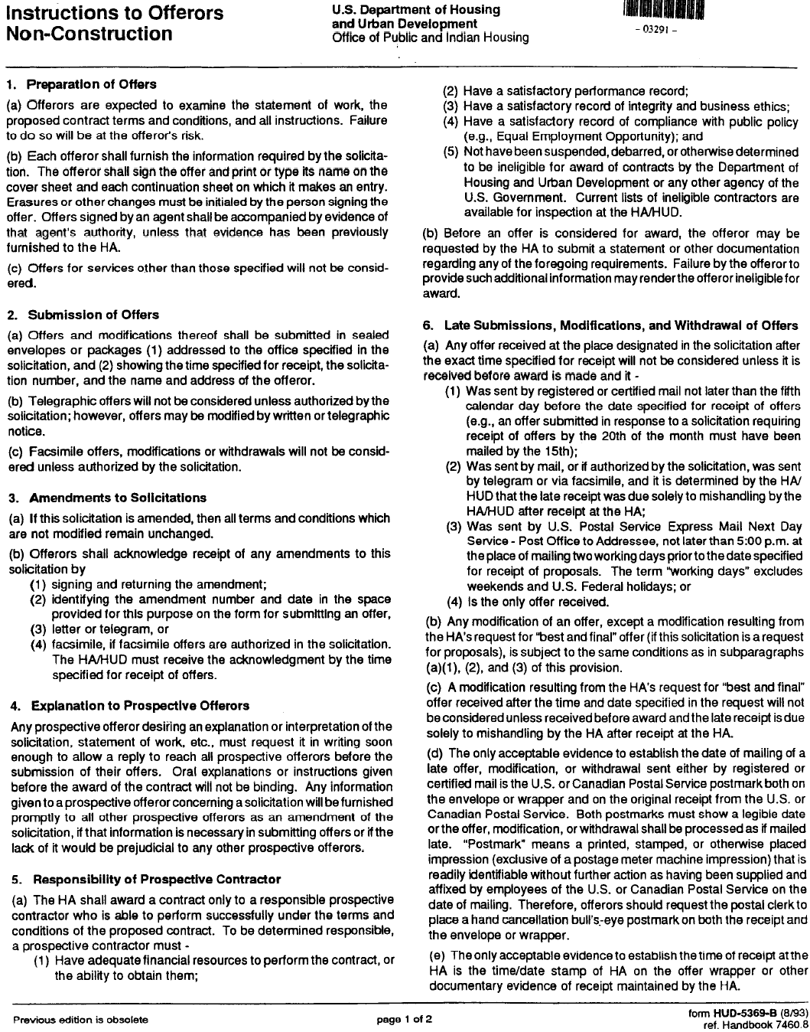

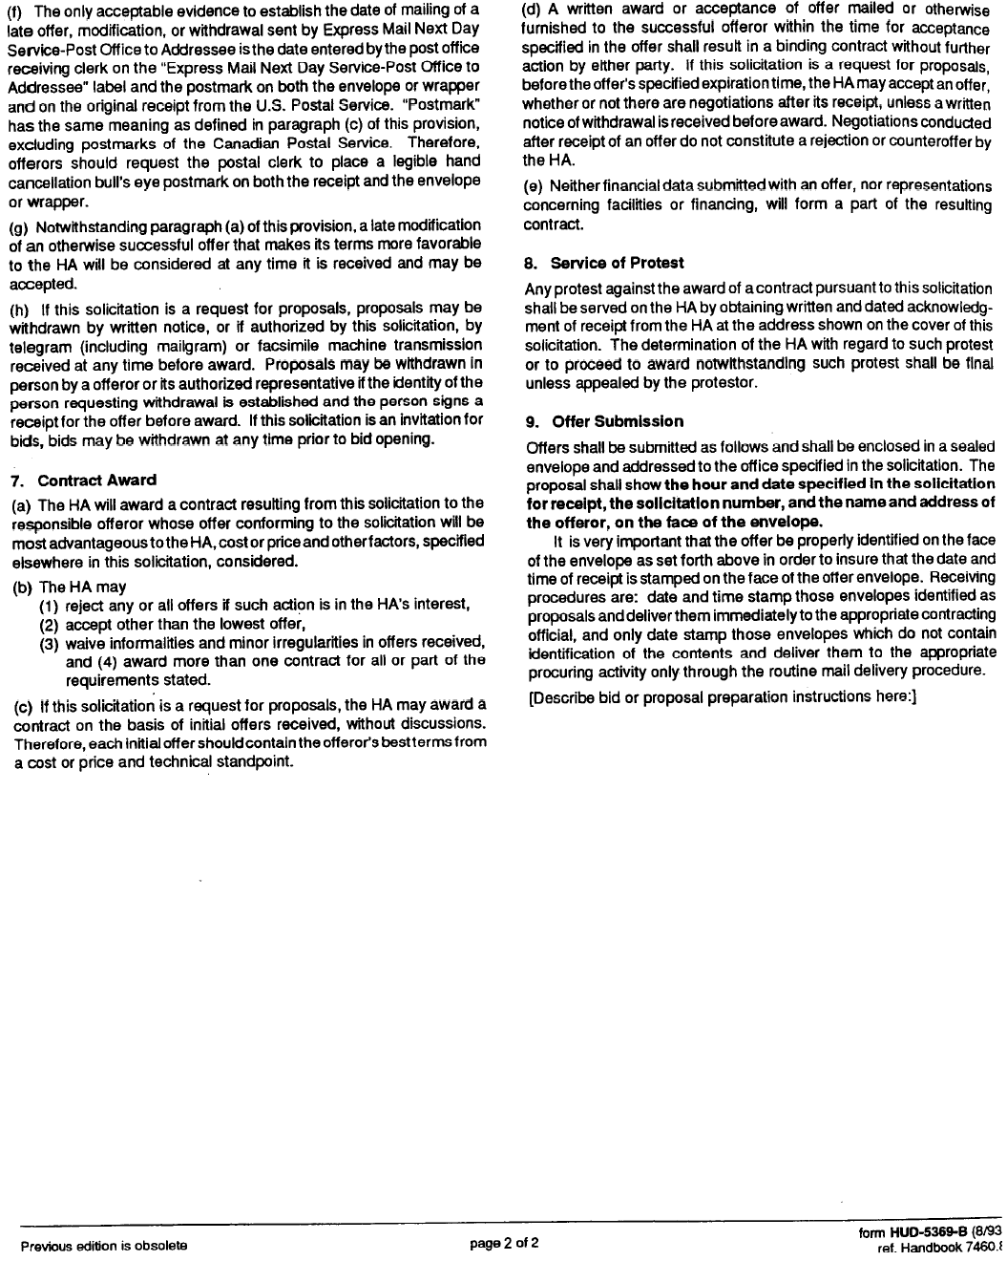

ATTACHMENT C
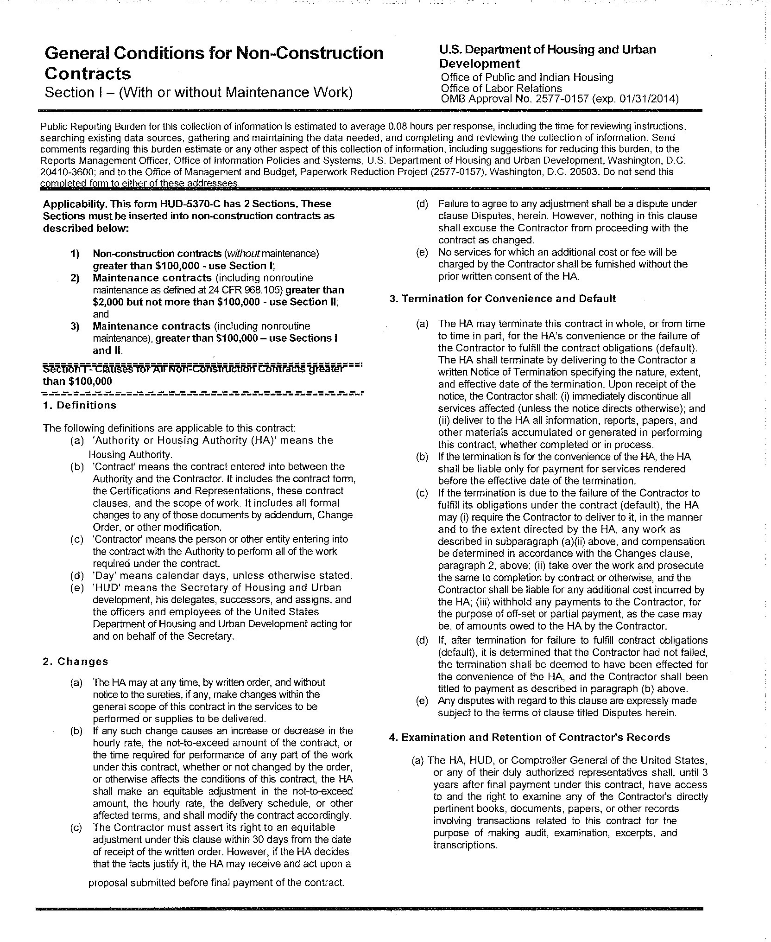

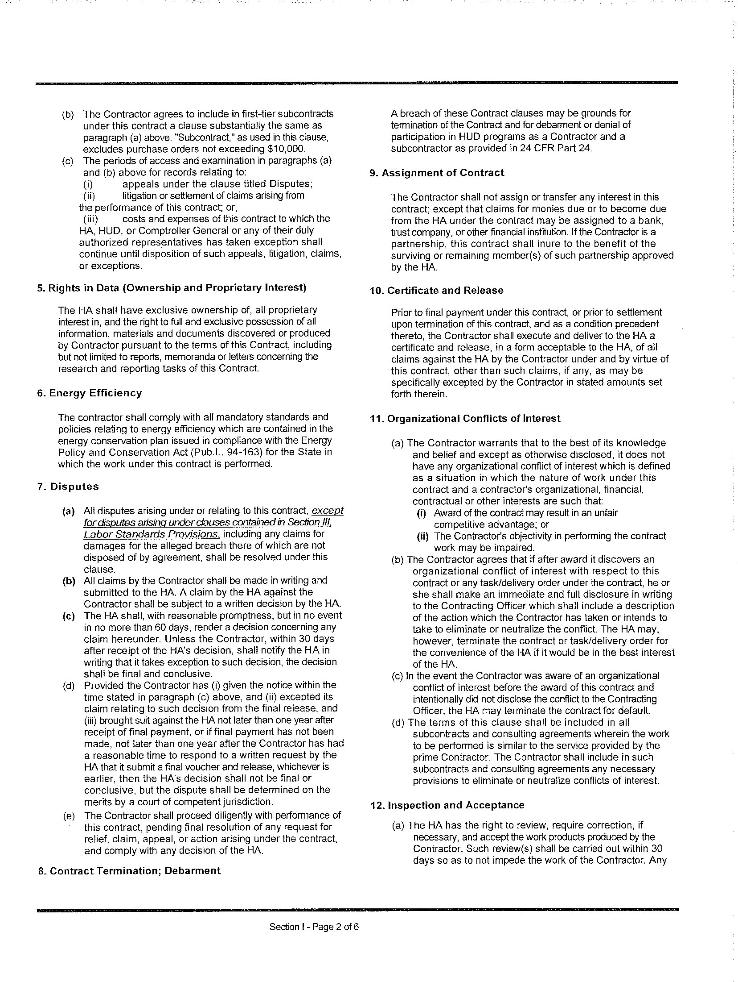

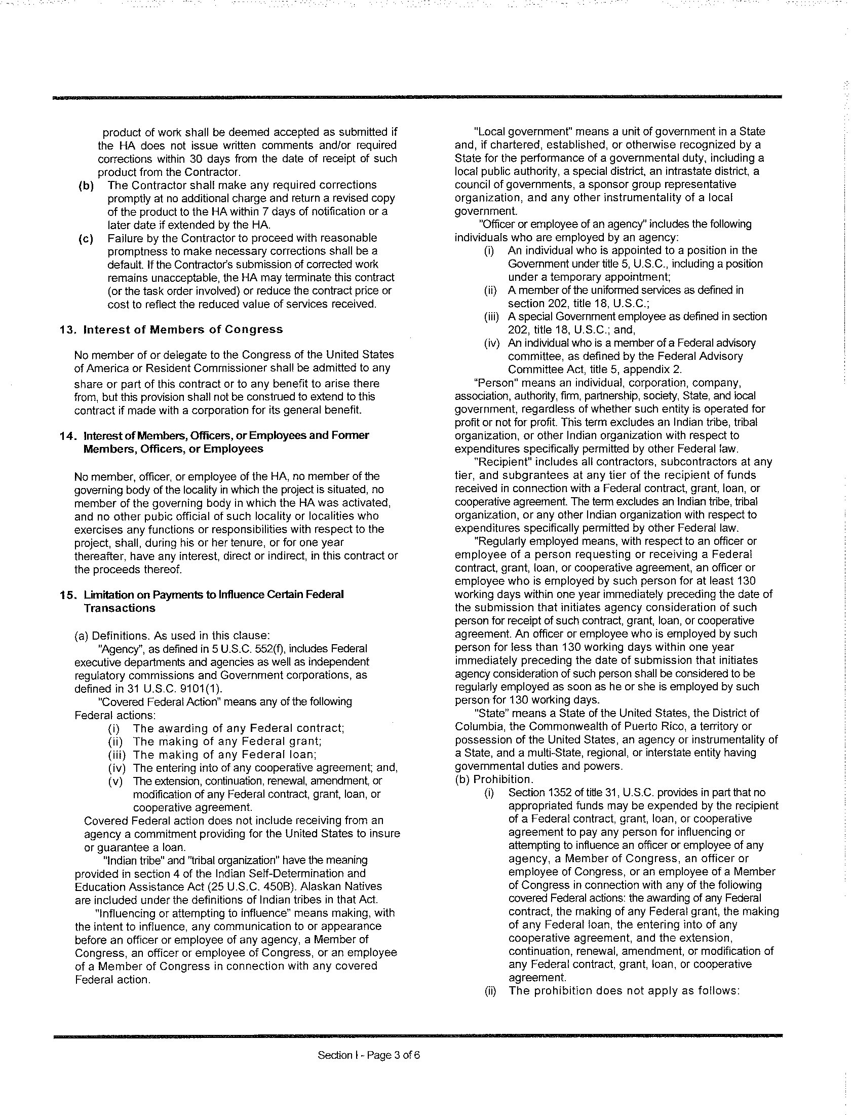

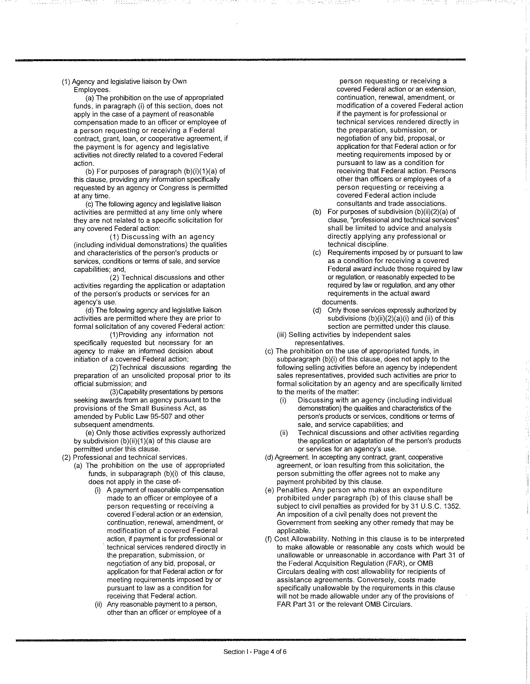

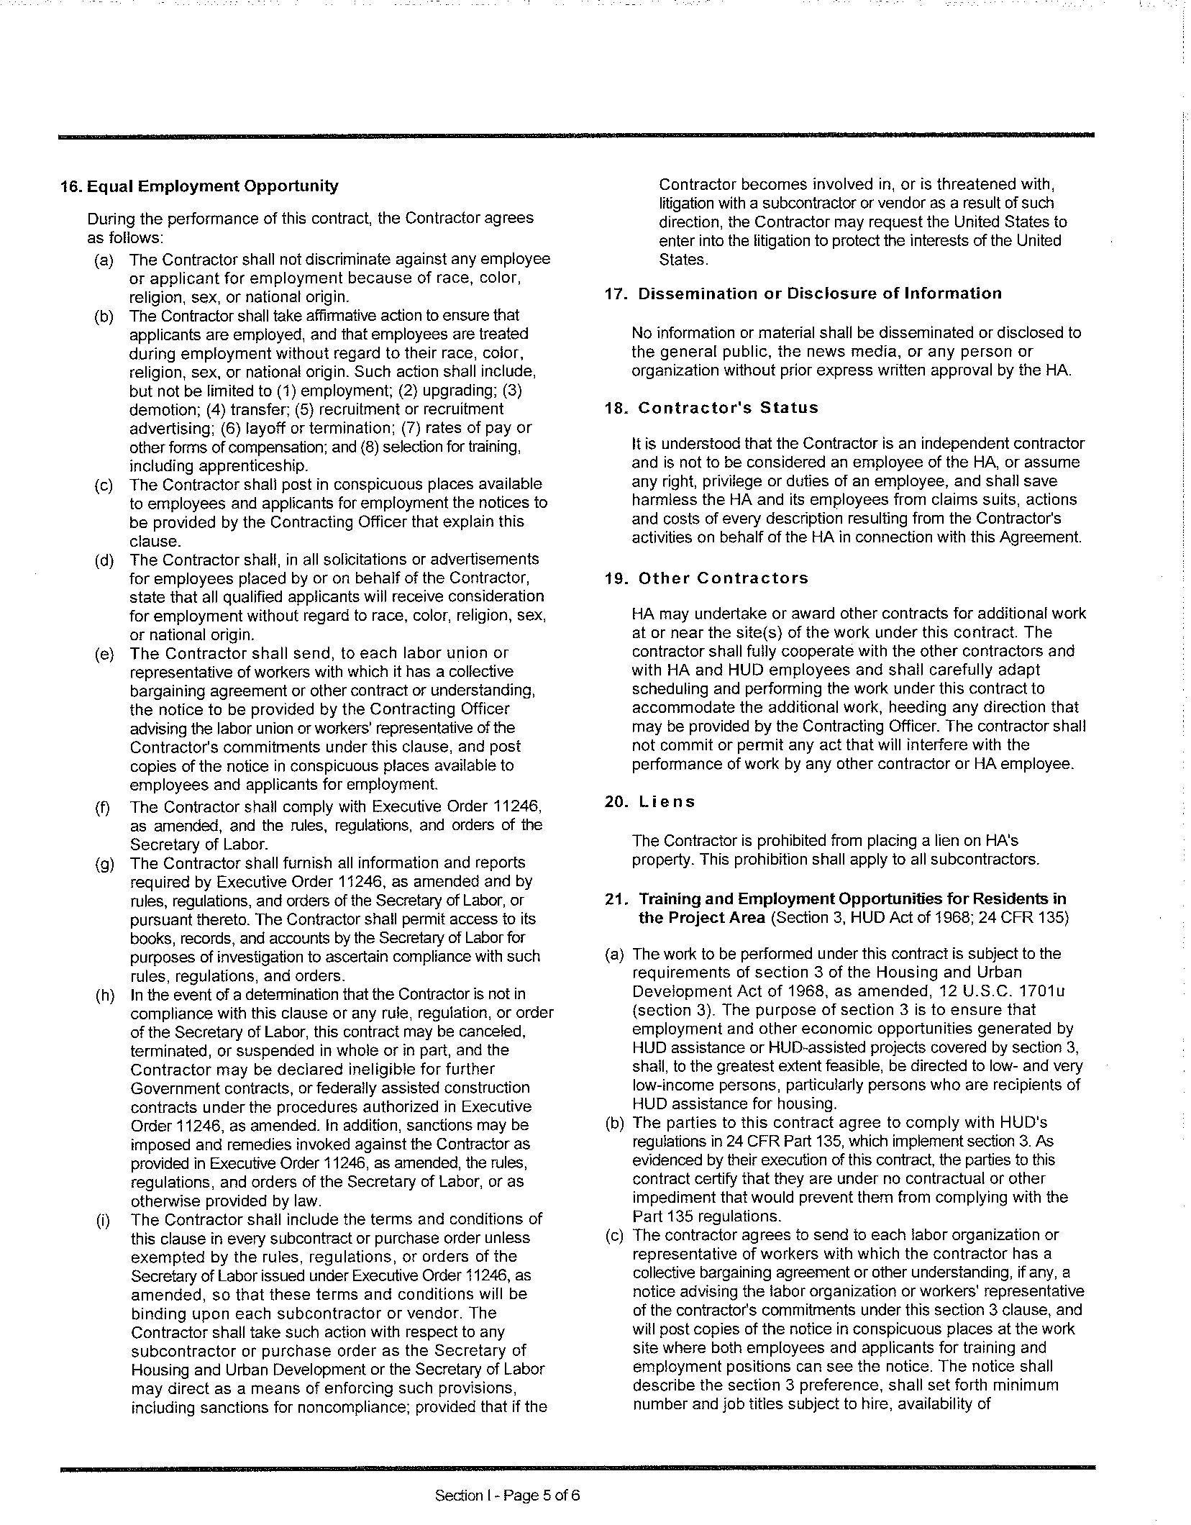

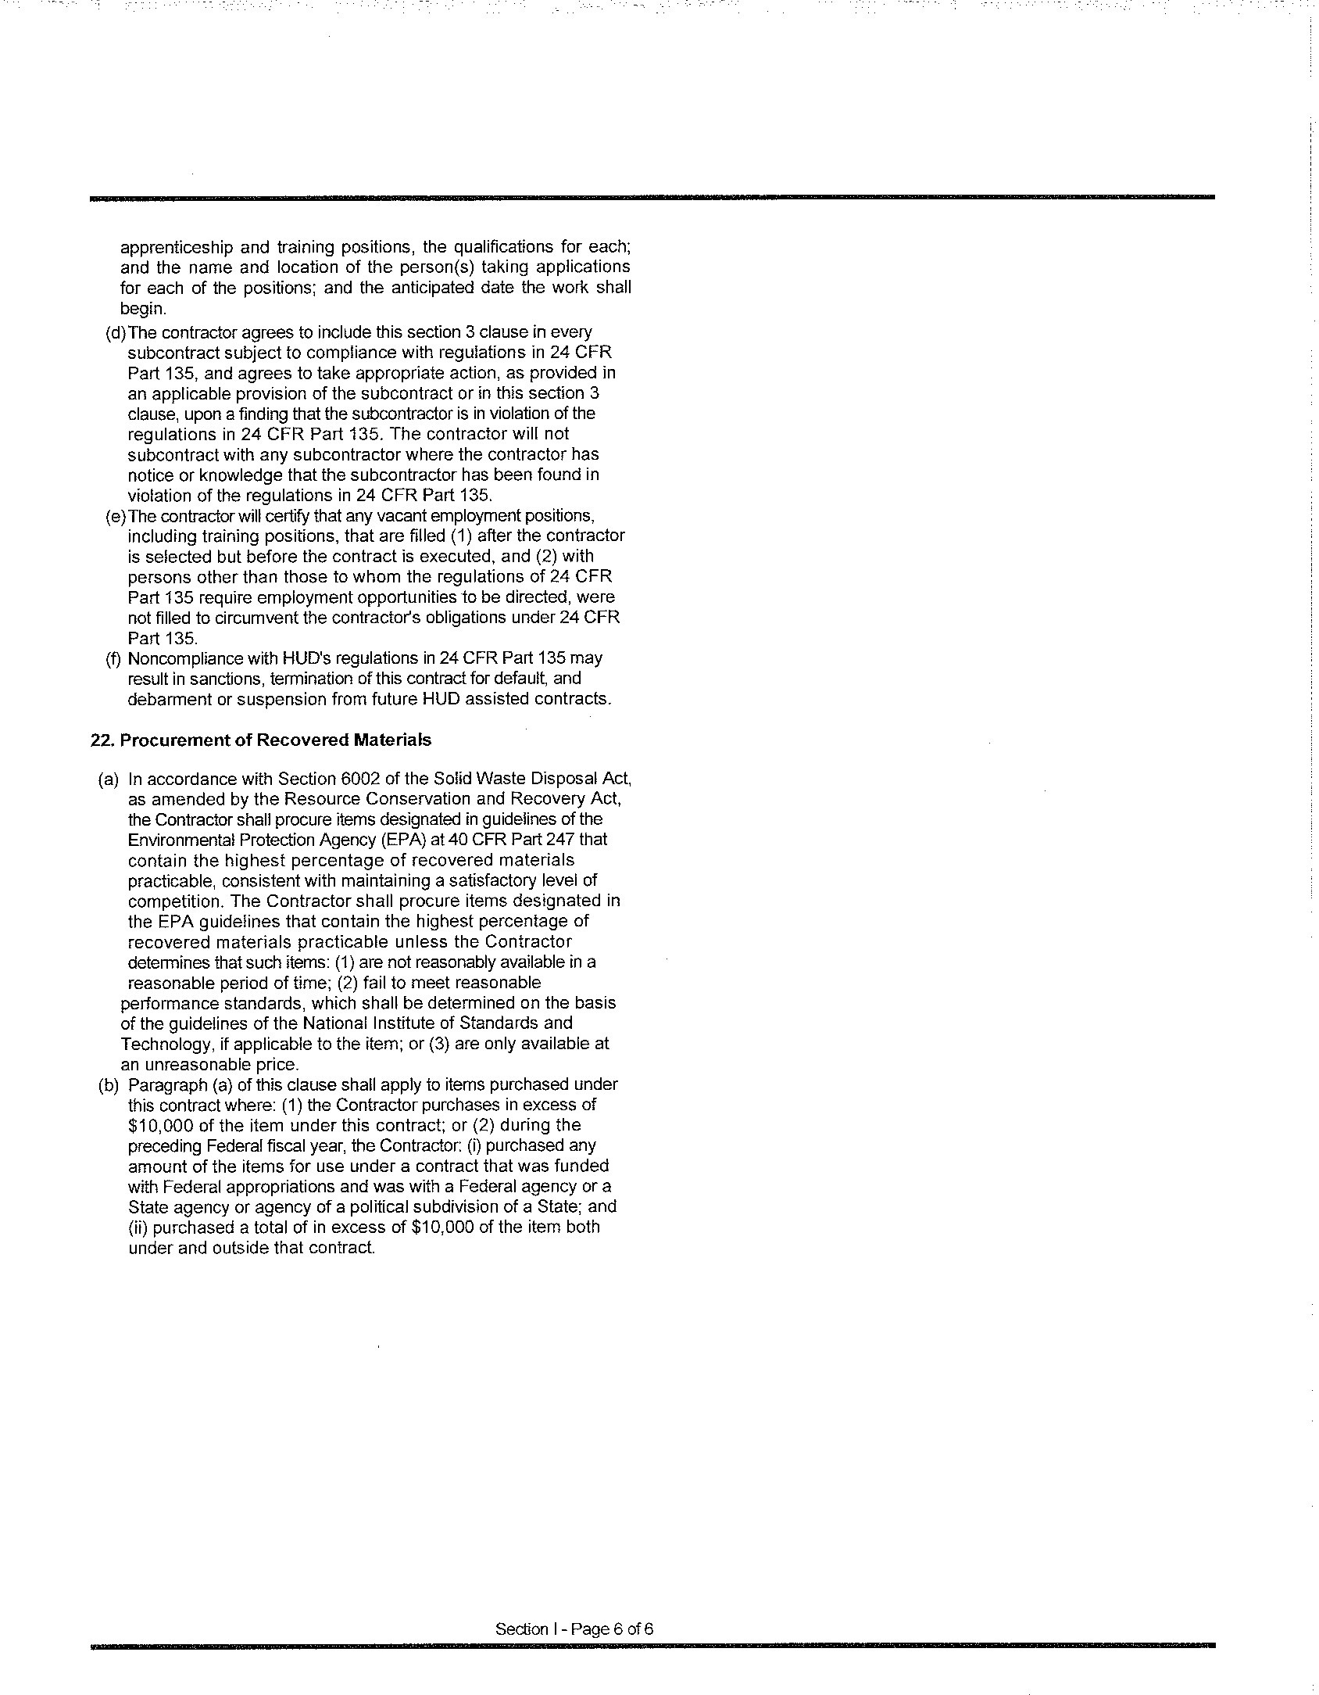

ATTACHMENT C.1 – SUPPLEMENTAL GENERAL CONDITIONS

SUPPLEMENTAL GENERAL CONDITIONS

To the extent that there is a conflict between the terms of the General Conditions and the terms of the Supplemental General Conditions, the terms of the Supplemental General Conditions shall govern to the extent of such conflict.

If HUD 5370 applies:

Section 31(e) of the General Conditions shall be deleted in its entirety and replaced by the following:

31(e). Forum. The Contracting Officer’s decision shall be final unless, within thirty (30) days of receipt of the Contracting Officer’s decision, the Contractor files suit in a court of competent jurisdiction.

If HUD 5370-EZ applies:

Section 3(d) of the General Conditions shall be deleted in its entirety and replaced by the following:

31(d). Forum. The Contracting Officer’s decision shall be final unless, within thirty (30) days of receipt of the Contracting Officer’s decision, the Contractor files suit in a court of competent jurisdiction.

If HUD 5370-C applies:

Section 1 Item 7(d) of the General Conditions shall be deleted in its entirety and replaced by the following:

Section 1 Item 7(d). Forum. The Contracting Officer’s decision shall be final unless, within thirty (30) days of receipt of the Contracting Officer’s decision, the Contractor files suit in a court of competent jurisdiction.

HOUSING AUTHORITY OF THE CITY OF PITTSBURGH

Date:

Signature:
Contracting Officer

==========================================================================

Vendor Name(Insert vendor company name above)

Date: Signature:

Title:

ATTACHMENT D
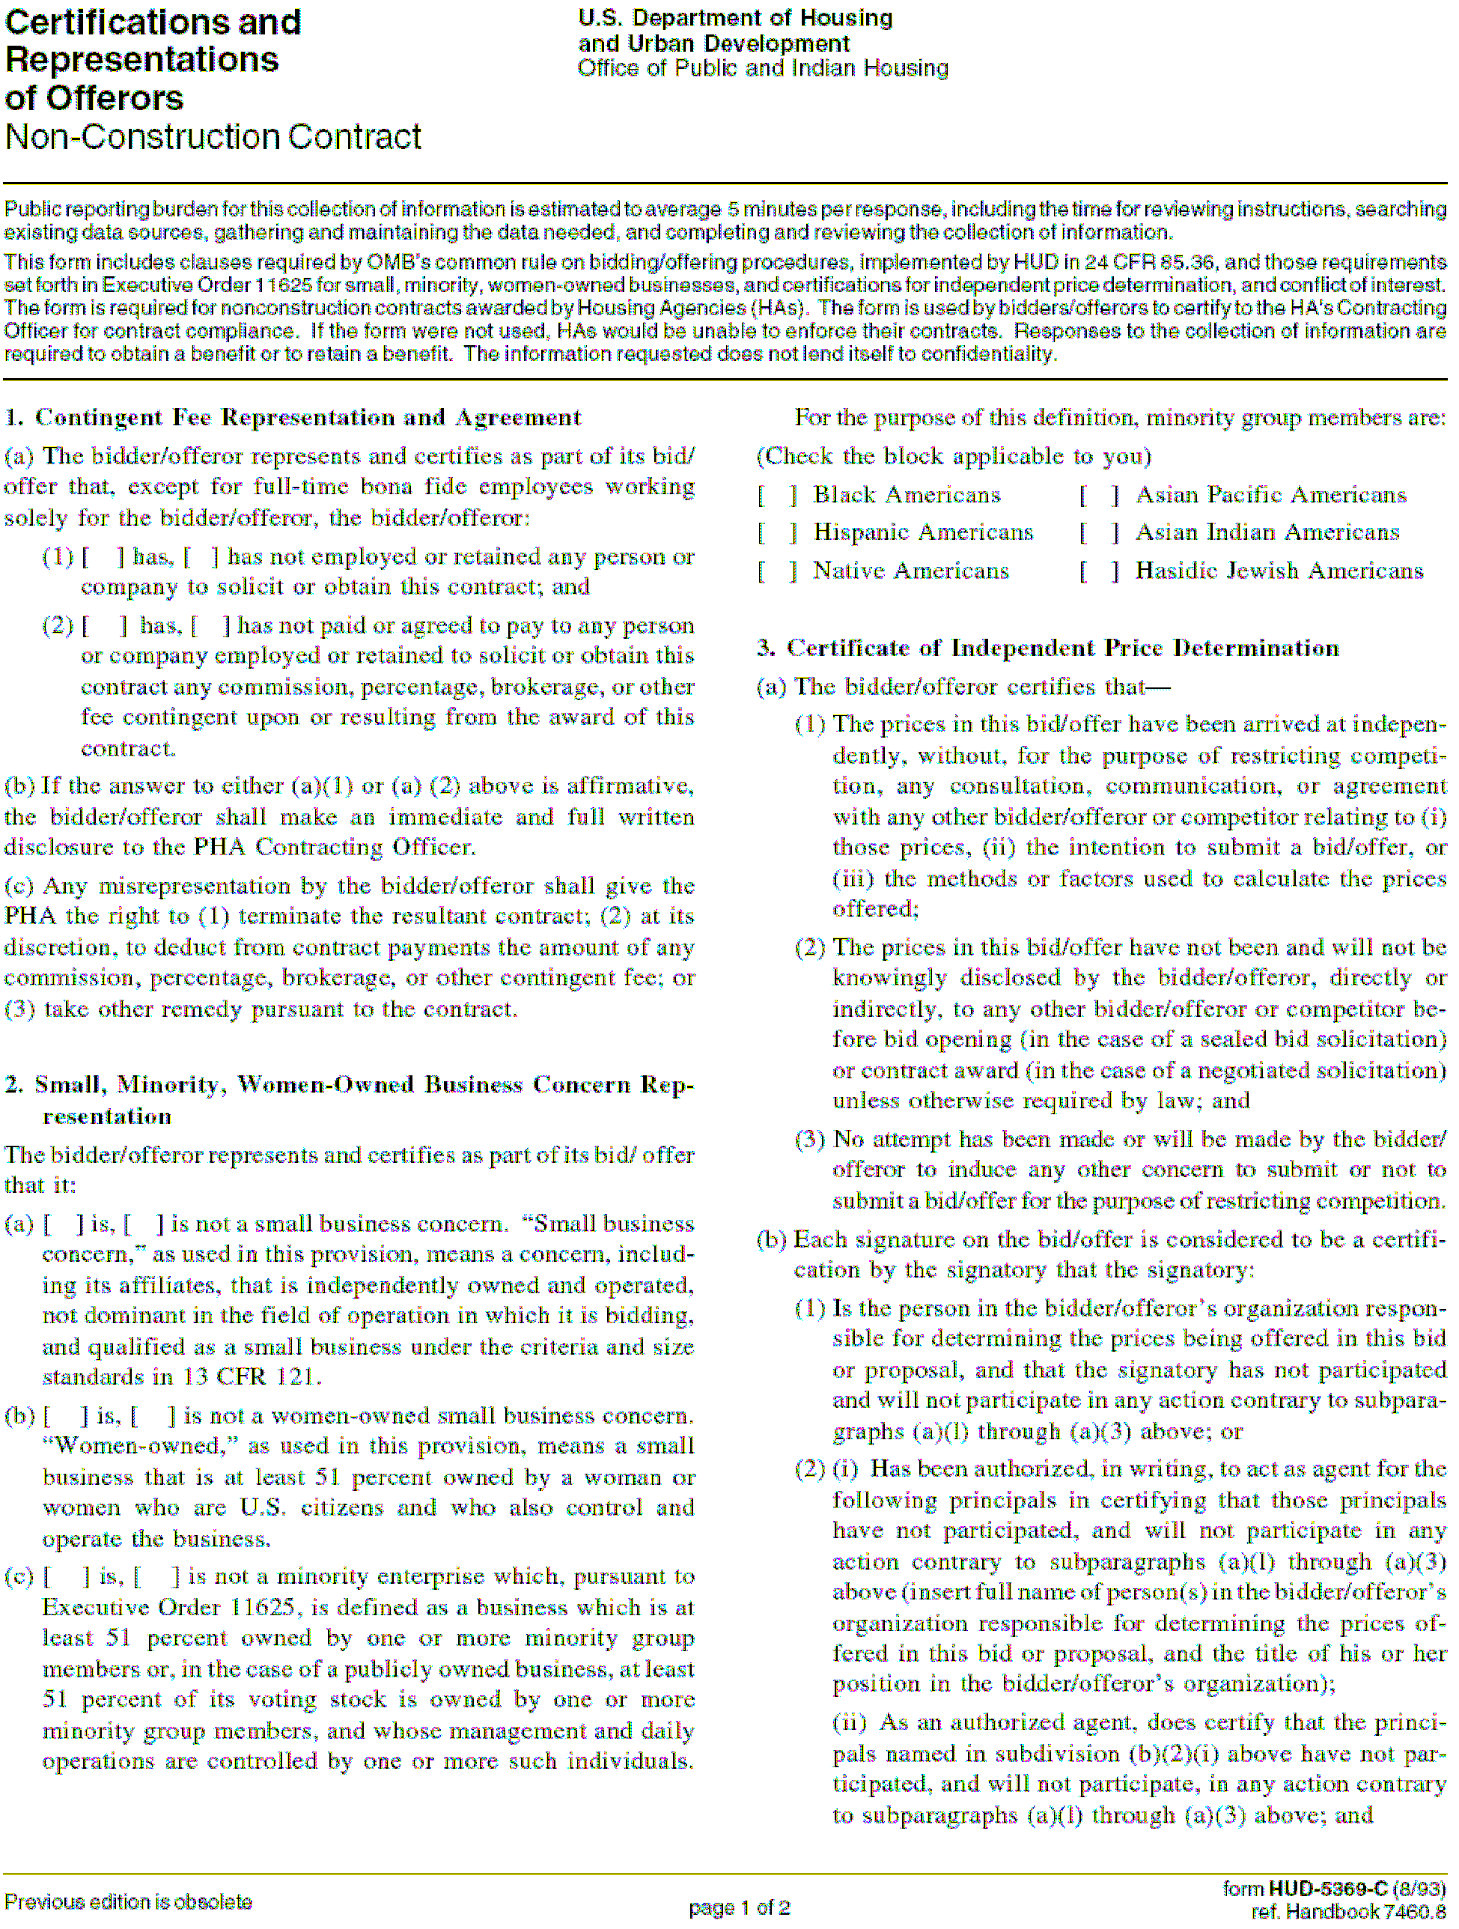

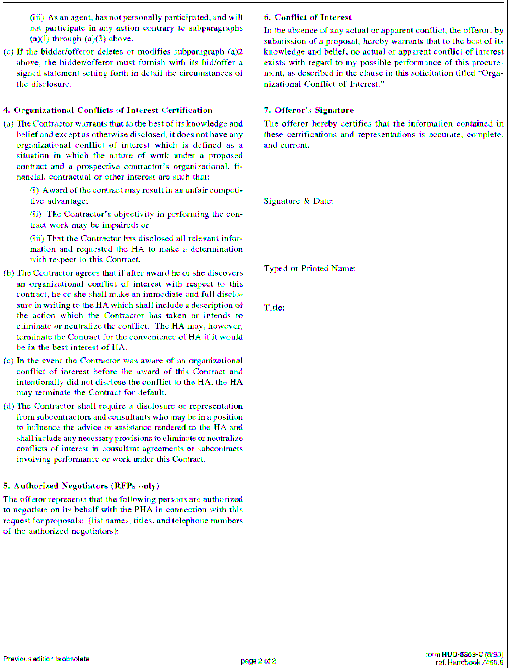

ATTACHMENT E - SPECIAL PARTICIPATION SUMMARY

I. SMALL BUSINESS PARTICIPATION Is the Offeror a Small Business as defined by the size and standards in 13 CFR 121?

Yes No

III. WOMEN-OWNED BUSINESS PARTICIPATION
Is the Offeror classified as a Woman-Owned Business Enterprise as defined in Art. 2, Part C of HUD-5369-C

Yes No

II. MINORITY BUSINESS PARTICIPATION Is the Offeror classified as a Minority Business
Enterprise as defined in Art. 2, Part C of HUD-5369-C? Yes No
If “No”, area any Consultants classified as Women-Owned Business Enterprises?

Yes No

If “No”, area any Consultants classified as Minority Business enterprises?

Yes No
Consulting Firm(s) (WBE) | $ Value Contract | % of Fee

If “Yes”, please fill in the following chart:
If “Yes”, please fill in the following chart:

Consulting Firm(s) (MBE) | $ Value Contract | % of Fee

Offeror: RFP#:

Due Date:

ATTACHMENT F - Section 3 Clause

- The work to be performed under this contract is subject to the requirements of section 3 of the Housing and Urban Development Act of 1968, as amended, 12 U.S.C. 1701u (Section 3). The purpose of Section 3 is to ensure that employment and other economic opportunities generated by HUD assistance or HUD- assisted projects covered by Section 3, shall, to the greatest extent feasible, be directed to low- and very low-income persons, particularly persons who are recipients of HUD assistance for housing.

- The parties to this contract agree to comply with HUD’s regulations in 24 CFR part 135, which implement Section 3. As evidenced by their execution of this contract, the parties to this contract certify that they are under no contractual or other impediment that would prevent them from complying with the part 135 regulations.

- The contractor agrees to send to each labor organization or representative or workers with which the contractor has a collective bargaining agreement or other understanding, if any, a notice advising the labor organization or workers’ representative of the contractor’s commitments under this Section 3 clause, and will post copies of the notice in conspicuous places at the work site where both employees and applicants for training and employment positions can see the notice. The notice shall describe the Section 3 preference, shall set forth minimum number and job titles subject to hire, availability of apprenticeship and training positions, the qualifications for each; and the name and location of the person(s) taking applications for each of the positions; and the anticipated date the work shall begin.

- The contractor agrees to include this Section 3 clause in every subcontract subject to compliance with regulations in 24 CFR part 135, and agrees to take appropriate action, as provided in an applicable provision of the subcontract or in this Section 3 clause, upon a finding that the subcontractor is in violation of the regulations in 24 CFR part 135. The contractor will not subcontract with any subcontractor where the contractor has notice or knowledge that the subcontractor has been found in violation of the regulations in 24 CFR part 135.

- The contractor will certify that any vacant employment positions, including training positions, that are filled (1) after the contractor is selected but before the contract is executed, and (2) with persons other than those to whom the regulations of 24 CFR part 135 require employment opportunities to be directed, were not filled to circumvent the contractor’s obligations under 24 CFR part 135.

- Noncompliance with HUD’s regulations in 24 CFR part 135 may result in sanctions, termination of this contract for default, and debarment or suspension from future HUD assisted contracts.

- With respect to work performed in connection with Section 3 covered Indian housing assistance, section 7(b) of the Indian Self-Determination and Education Assistance Act
(25 U.S.C. 450e) also applies to the work to be performed under this contract. Section 7(b) requires that to the greatest extent feasible (i) preference and opportunities for training and employment shall be given to Indians, and (ii) preference in the award of contracts and subcontracts shall be given to Indian organizations and Indian-owned Economic Enterprises. Parties to this contract that are subject to the provisions of Section 3 to the maximum extent feasible, but not in derogation of compliance with section 7(b).

SECTION 3 OPPORTUNITIES PLAN
Business Opportunities and Employment Training for Housing Authority of the City of Pittsburgh Low Income Public Housing Residents (LIPH) and Area Residents of Low and Very Low Income Status (ARLIS)

PRIME CONTRACTOR’S NAME: SPECIFICATION OR RFP/IFB/RFQ NUMBER: SPECIFICATION OR RFP/IFB/RFQ TITLE:

The Contractor hereby agrees to comply with all the provisions of Section 3 as set forth in 24 CFR
  - et seq. and the HACP Section 3 Policy and Program requirements. The Contractor hereby submits this document to identify employment opportunities for HACP residents (LIPH) and Area Residents of Low and Very Low Income Status (ARLIS) during the term of the contract between the Contractor and the HACP.
The preference of HACP is to ensure that as many HACP residents as possible are employed. In an effort to further that requirement, HACP has created a preference tier structure as outlined in the HACP Section 3 Policy and Program Manual which can be reviewed by visiting the “Vendor Services” section of www.hacp.org. Contractors are required to comply with Section 3 by first considering Tier I – Hiring. If the Contractor cannot meet its Section 3 requirement in Tier I and needs to move to Tier II or Tier III, that Contractor must document this inability to comply with the preference and the need to move to a lower tier. (Such inability must be documented for moves within tiers). The Contractor agrees to meet its Section 3 requirement following the Preferential Tier Structure as indicated by the selection below (check one or more tiers below):

[ ] Tier I – HIRING
The Contractor affirms that the jobs identified shall be for meaningful employment that may or may not be related to the scope of services covered under Contract/Purchase Order # . The Contractor has committed to employ resident(s) in order to comply with its Section 3 requirements. A prime contractor may satisfy the HACP Resident Hiring Requirements through his/her subcontractors. Contact the HACP Resident Employment Program for resident referrals at 412-395-3950, Ext 1048.
When Tier I is selected, the Contractor shall complete the following table as instructed below:
    - Indicate each job title for all phases of this contract
    - The number of positions that will be needed in each category
    - How many of those positions are currently filled
    - The number currently filled by low and very low-income HACP residents
    - The number currently filled by City of Pittsburgh neighborhood area residents
    - How many positions need to be filled
Indicate your requirement for the number of positions you intend to fill with:
    - Low income HACP Residents (LIPH) and/or
    - Low and very low income City of Pittsburgh Neighborhood Area Residents (ARLIS)



Section 3 Labor Utilization Assessment and Plan
SPEC or RFP TITLE: |  |  |  |  | SPEC or RFP NUMBER:
JOB TITLE (1) | NUMBER OF POSITIONS |  |  |  |  |  | HIRING REQUIREMENT
JOB TITLE (1) | # NEEDED (2) | CURRENTLY FILLED |  |  |  | TO BE FILLED (6) | LIPH (7) | ARLIS (8)
JOB TITLE (1) | # NEEDED (2) | TOTAL (3) | LIPH (4) | ARLIS (5) |  | TO BE FILLED (6) | LIPH (7) | ARLIS (8)

LIPH – HACP low income public housing resident
ARLIS - Area Residents of Low/Very Low Income Status – (Area is the Pittsburgh metropolitan area)

In the event the value of Section 3 resident hiring is less than the amount identified in the Resident Hiring Scale, vendors must contribute to the HACP Education Fund an amount not less than the difference between the value of Section 3 hiring and the amount identified in the Resident Hiring Scale, which funds shall be used to provide other economic opportunities.
Therefore, if it is anticipated that any position listed above shall be for less than the full term of the contract period, you must indicate on the lines below, the anticipated term for each position:

[ ] Tier II – CONTRACTING
The contractor has identified HACP resident-owned business(es) or Section 3 business(es) which is/are 51 percent or more owned by Section 3 residents or 30 percent or more of their permanent full-time workforce are Section 3 residents. This will satisfy the contractor’s Section 3 requirement covered under Contract/Purchase Order # .
In a one (1) page letter on your firm’s letterhead:
- Indicate the requirements, expressed in terms of percentage, of planned contracting dollars for the use of Section 3 business concerns as subcontractors.
- A statement of the total dollar amount to be contracted, total dollar amount to be contracted to Section 3 business concerns for building trades, and total dollar amount to be contracted to Section 3 business concerns for other than building trades work (maintenance, repair, modernization, and development).
- A description of the method used to develop the requirements above and the efforts to be undertaken by the contractor to meet those requirements.

[ ] Tier III - OTHER ECONOMIC OPPORTUNITIES
Firms may provide other economic opportunities to train and employ Section 3 residents or make a direct cash contribution to the HACP Education Fund. HACP has established the following minimum threshold requirements for provision of training or contribution to the HACP fund that provides other economic opportunities:
  - Contractor incurs the cost of providing skilled training for residents in an amount commensurate with the sliding scale set forth in the Resident Hiring Scale; or,
  - Contractor makes a contribution to the HACP Education Fund at Clean Slate E3 to provide assistance to residents to obtain training. The level of contribution would be commensurate with the sliding scale set forth in the Resident Hiring Scale.
Contractor shall provide, in a letter on firm letterhead:
- Indication of the skilled training to be provided, the number of persons to be trained, the training provider, the cost of training, and the trainee recruitment plan; or,
- Provide the amount of planned contribution to be made in relation to percentage of the contract labor hours costs. (Contribution checks should be made payable to: Clean Slate E3 Education Fund and mailed to Clean Slate E3, C/O Housing Authority of the City of Pittsburgh, Finance Department, 200 Ross Street, 9th Floor, Pittsburgh, PA 15219.

[ ] Tier IV – No New Hire Opportunity
If awarded this contract, the contractor will be able to fulfill the requirements of the IFB/RFP/RFQ with the existing work force. No new hires will be employed as a result of this award. If this position changes and hiring opportunities become necessary, the HACP Resident Employment Program will be notified.

SECTION 3 OPPORTUNITIES PLAN

By signing below, the Contractor hereby agrees to comply with the selected Section 3 requirements indicated above. To the extent that the completion of this form is contingent upon future information, for example price negotiations, request for specific services, etc., the undersigned hereby affirms and agrees to fully adhere to the spirit and intent of the HACP Section 3 Policy.

Furthermore, the undersigned acknowledges and affirms responsibility for completion and submission of this form as part of the response documentation for this Invitation for Bid or Request for Proposal. Failure to submit this form may jeopardize the responsiveness of your submission.

Company Name:

Name:

Title:

Signature: Date:

Witness Name:

Witness Signature: Date:

ATTACHMENT G - Firm Demographics
 |  | Male |  |  |  |  |  |  |  | Female |  |  |  |  |  |  | Total # of American Minorities
 | All employees | White American | African American | Hispanic American | Asia American | Hasidic Jew American | Other American Minority | Foreign | Total Males | White American | African American | Hispanic American | Asia American | Hasidic Jew American | Other American Minority | Foreign | Total # of American Minorities
Partner
Associate
Professional
Secretarial
Clerical
Other
Total

Explain all other American Minority:

Be certain that the numbers in this table are accurate and add up correctly.

49

ATTACHMENT H

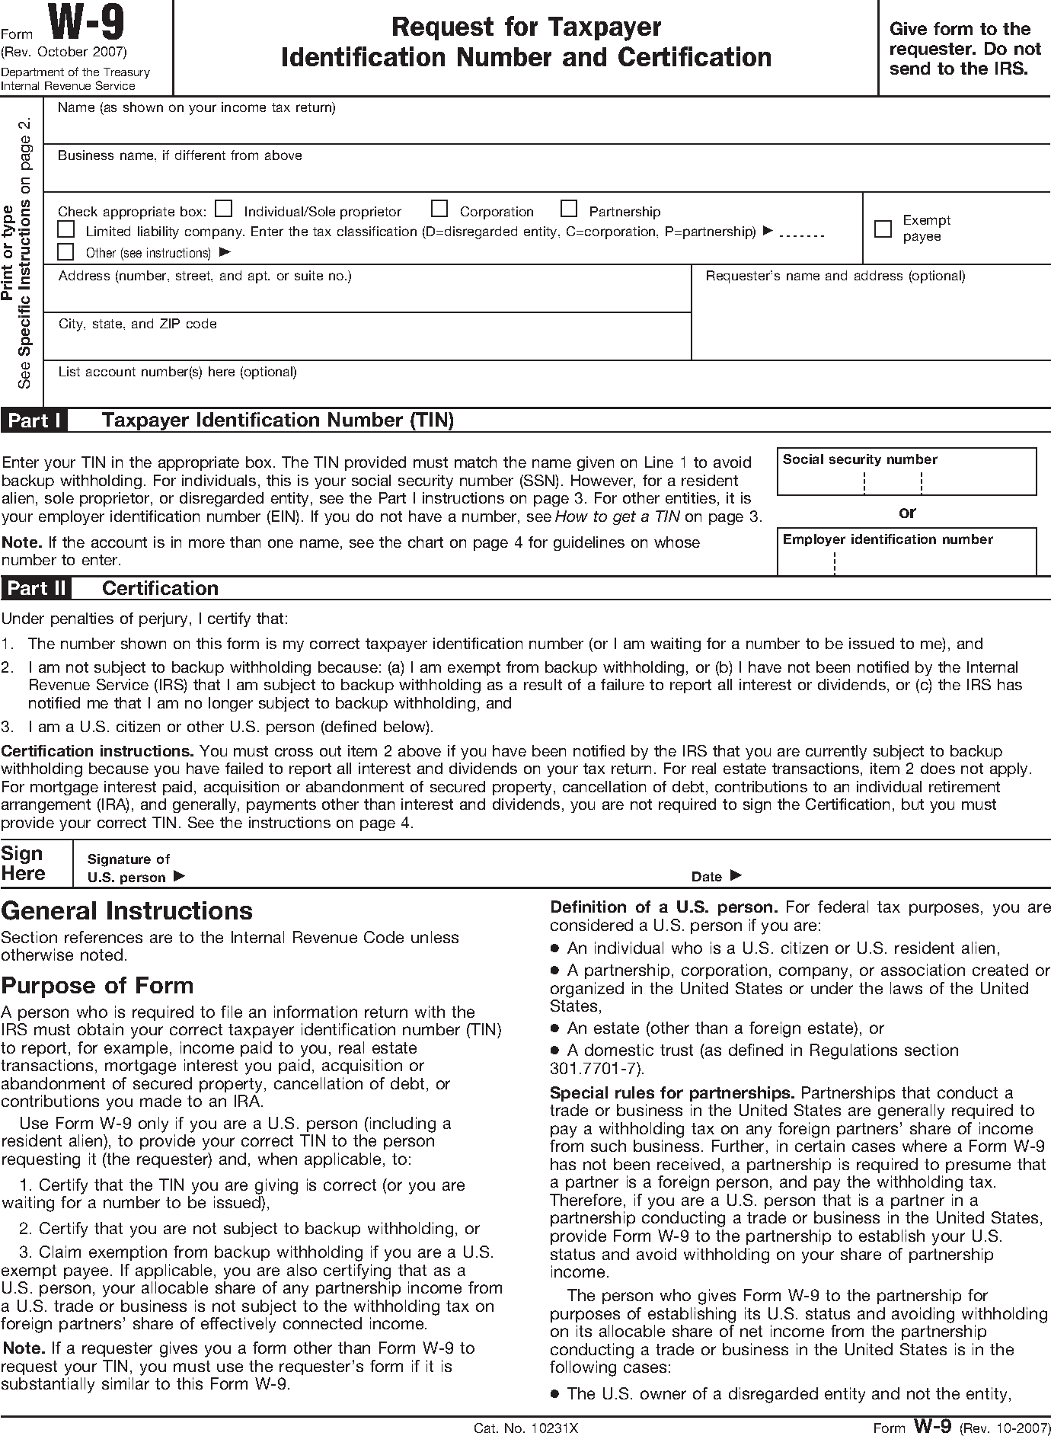

Instructions for completing this form can be found at http://www.irs.gov/pub/irs-pdf/fw9.pdf

Attachment I
Sample M/WBE Commitment Letter

<Date>

<Name Of MBE or WBE Contact Person>
<Name of MBE or WBE firm>
<Address>
<City>, <State> <Zip>

Re: <Name of HACP Project>

Dear <Name of Contact Person at MBE or WBE Firm>

<Name of Prime Bidder> has submitted a bid for the above referenced project to the
Housing Authority City of Pittsburgh (HACP).

If we are the successful bidders and awarded the contract, <Name of Prime
intends to utilize <Name of proposed MBE or WBE firm> as follows:

Scope of Proposed Services:

Bidder>

Estimated Dollar Value:

Please call should you have any further questions. We thank you for your continuing interest.

Sincerely,

<Contact Person from Prime Bidder> <Contact Person from MBE/WBE>

(Signature) (Signature)

(Name) (Name)

ATTACHMENT J

Moving Services RFP#250-13-12

FEE SHEET
PRICE IS TO BE LISTED PER THE FOLLOWING:

No Truck Required: Moving from one apartment to another in the same building
Type Moving/Number of  Rooms | Initial Term | Ext Opt 1 (1 year) | Ext Opt. 2 (1 year)
1 Room within the same  apartment | $ | $ | $
2 Room/efficiency | $ | $ | $
3 rooms – 1 bedroom | $ | $ | $
4 rooms –2 bedrooms | $ | $ | $
5 rooms – 3 bedrooms | $ | $ | $
6 rooms – 4 bedrooms | $ | $ | $
7 rooms – 5 bedrooms | $ | $ | $
Each Additional Room | $ | $ | $
Packing/Unpacking  Services, per man per hour | $ | $ | $

Truck Required: Moving from one apartment to another location
Type Moving/Number of  Rooms | Initial Term | Ext Opt 1 (1 year) | Ext Opt. 2 (1 year)
1 Room within the same  apartment | $ | $ | $
2 Room/efficiency | $ | $ | $
3 rooms – 1 bedroom | $ | $ | $
4 rooms –2 bedrooms | $ | $ | $
5 rooms – 3 bedrooms | $ | $ | $
6 rooms – 4 bedrooms | $ | $ | $
7 rooms – 5 bedrooms | $ | $ | $
Each Additional Room | $ | $ | $
Packing/Unpacking  Services, per man per hour | $ | $ | $

Commercial – Office
Service | Initial Term | Ext Opt 1 (1 year) | Ext Opt. 2 (1 year)
Cost per man per hour  without a truck | $ | $ | $
Cost per man per hour with  a truck | $ | $ | $
Packing/Unpacking  Services, per man per hour | $ | $ | $

Storage: Billed separately as requested and to be billed to HACP at Cost.

Company Name (Printed):

Name (Printed):

Title:

Address:

Phone/Fax:

Email Address:

Signature:

