
COMPANY NAME

PAINTING ESTIMATE

Estimate prepared for:

Mr. John Smith

Client Address

Estimate #: 001236 Client Phone Number

Date: 01.01.2020.

INTERIOR
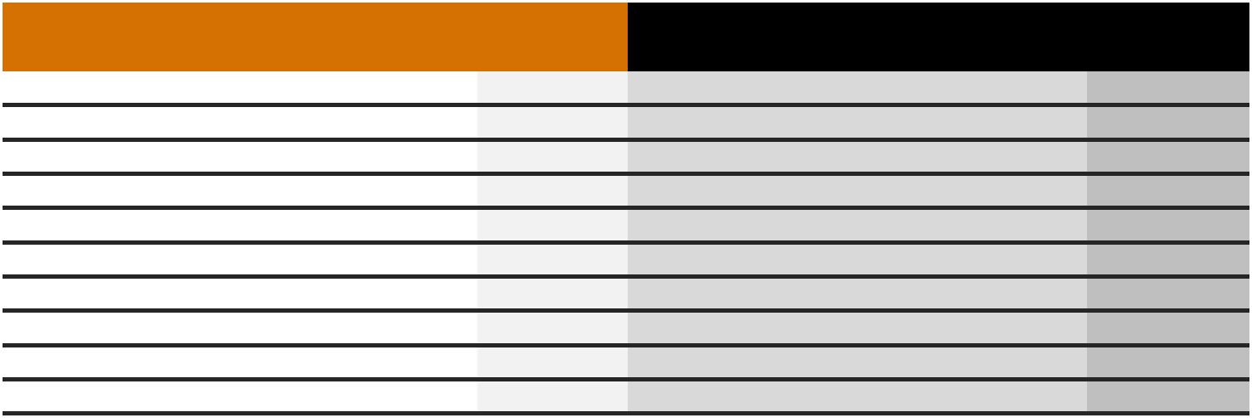

INTERIOR MATERIALS |  | QTY | COST | AMOUNT | INTERIOR LABOR | HOURS | RATE | AMOUNT
DESCRIPTION |  | QTY | COST | AMOUNT | DESCRIPTION | HOURS | RATE | AMOUNT
Material Description 1 |  | 5 | $25.00 | $125.00 | Labour Description 1 | 10 | $25.00 | $250.00
Material Description 2 |  | 4 | $10.00 | $40.00 | Labour Description 2 | 5 | $25.00 | $125.00
 |  |  |  | $0.00 |  |  |  | $0.00
 |  |  |  | $0.00 |  |  |  | $0.00
 |  |  |  | $0.00 |  |  |  | $0.00
 |  |  |  | $0.00 |  |  |  | $0.00
 |  |  |  | $0.00 |  |  |  | $0.00
 |  |  |  | $0.00 |  |  |  | $0.00
 |  |  |  | $0.00 |  |  |  | $0.00
 |  |  |  | $0.00 |  |  |  | $0.00
 | INTERIOR MATERIALS TOTAL |  |  | $165.00 |  | INTERIOR LABOR TOTAL |  | $375.00
 |  |  |  |  |  |  | ESTIMATED | $540.00
 |  |  |  |  |  | INTERIOR TOTAL |  | $540.00

EXTERIOR
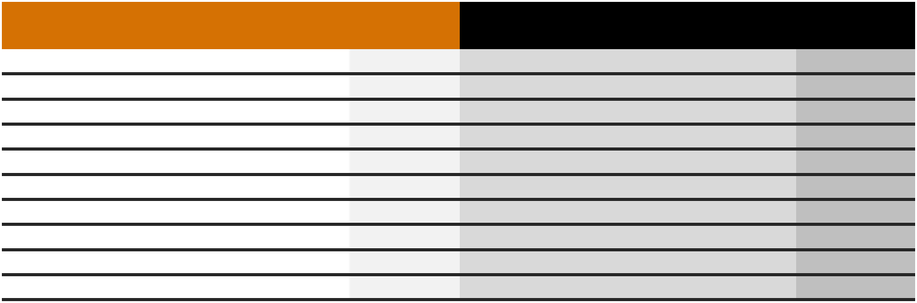

EXTERIOR MATERIALS |  | QTY | COST | AMOUNT | EXTERIOR LABOR |  |  | RATE | AMOUNT
DESCRIPTION |  | QTY | COST | AMOUNT | DESCRIPTION |  |  | RATE | AMOUNT
Material Description 1 |  | 5 | $25.00 | $125.00 | Labour Description 1 | 10 |  | $25.00 | $250.00
Material Description 2 |  | 4 | $10.00 | $40.00 | Labour Description 2 | 45 |  | $10.00 | $450.00
 |  |  |  | $0.00 |  |  |  |  | $0.00
 |  |  |  | $0.00 |  |  |  |  | $0.00
 |  |  |  | $0.00 |  |  |  |  | $0.00
 |  |  |  | $0.00 |  |  |  |  | $0.00
 |  |  |  | $0.00 |  |  |  |  | $0.00
 |  |  |  | $0.00 |  |  |  |  | $0.00
 |  |  |  | $0.00 |  |  |  |  | $0.00
 |  |  |  | $0.00 |  |  |  |  | $0.00
 | EXTERIOR MATERIALS TOTAL |  |  | $165.00 |  | EXTERIOR LABOR TOTAL |  |  | $700.00
THANK YOU FOR YOUR BUSINESS! |  |  |  |  |  |  |  | ESTIMATED | $865.00
 |  |  |  |  |  |  | EXTERIOR TOTAL
Payment Info:
Account #: |  | 1234-5678-900000 |  |  |  |  | SUB TOTAL: |  | $1,405.00
A/C Name: |  | Lorem Ipsum |  |  |  |  | TAX: |  | 10%
Bank Details: |  | Enter Bank Details
Bank Details: |  |  |  |  |  |  | TOTAL: |  | $1,545.50


Authorised Sign

