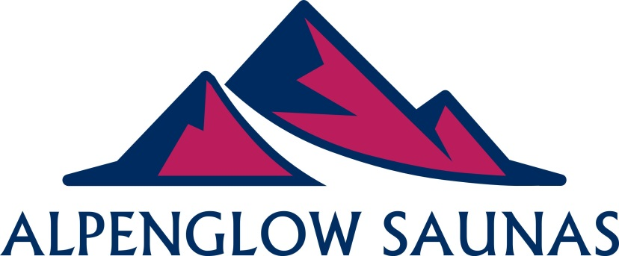
RENTAL WAIVER AND RELEASE OF LIABILITY FORM
1. DISCLAIMER
This Waiver and Release, effective as of ______/________/_______(the “Effective Date”), is made and entered into by and between:

[Rentee Full Name] of this address located at:
[Rentee Full Address]
(Hereinafter the “Rentee”), and:
Nahum Robertson and Alpenglow Saunas
[Rentor Full Name]
With a registered address located at:
2386 Alberni Highway, Coombs, BC V0R 1M0
[Rentor Full Address]
(Hereinafter the “Rentor”).

2. EXPRESS ASSUMPTION OF RISK
The Rentee hereby agrees that he/she is renting, operating or using the equipment provided by the Rentor at his/her own risk. The Rentee agrees that he/she is voluntarily participating in all activities related to the rental, operation, or use of the rental equipment, and assumes all risk of injury, illness, damage or loss that might result, even if the risks arise out of the negligence or fault of the Rentor.
3. WAIVER/RELEASE OF LIABILITY
By the execution of this Release, the Rentee agrees that the Rentor shall not be liable for any damages arising from personal injuries sustained by the Rentee or anyone under the Rentee’s custody, care, and control, as a result of any and all activities related to the rental, operation, or use of equipment provided by the Rentor. The Rentee assumes full responsibility for any such injuries or damages which may occur, and further agrees that the Rentor shall not be liable for any loss or theft of personal property. The Rentee specifically agrees that the Rentor shall not be responsible for such injuries, damages, loss or theft, EVEN IN THE EVENT OF NEGLIGENCE OR FAULT BY the Rentor whether such negligence is present at the signing of this Release or takes place in the future. This Waiver and Release does not apply to gross negligence or intentional torts by the Rentor
4. LIABILITY TO THIRD PARTIES
The Rentee hereby agrees that he/she will indemnify and hold harmless the Rentor for all personal injuries, property damages, or any other damages to any and all third parties, including, but not limited to, operators of other equipment under the Rentee’s custody, care, and control, as a result of any and all activities related to the rental, operation, or use of equipment provided by the Rentor, even if such damages arise out of the negligence or fault of the Rentor.
5. SECURITY DEPOSIT
In addition to the rental fee, the rented may also pay a security deposit (a pre-authorization on the credit card) to cover any late return charges, excessive equipment damages incurred or equipment loss. This deposit shall not be charged if the equipment is not damaged, lost or returned earlier than the agreed date by the Rentee. Rentee will be aware of the security deposit and late return charged when making their rental booking.

6. ACKNOWLEDGMENT OF WAIVER AND RELEASE
The Rentee states that he/she has had sufficient time to review the Waiver and Release and to ask any questions associated with said Release. The Rentee further states that he/she has carefully read the foregoing Waiver and Release, knows the contents thereof, and has signed this Release as his/her own free act. The Rentee warrants that he/she is aware that he/she may rent, operate, or use equipment from another rental facility, but has chosen to rent, operate, or use equipment from Rentor with the knowledge that signing this Release is a requirement for rental, operation, and use of said equipment. Rentee further warrants that he/she is fully aware that he/she is waiving any right he/she may have to bring a legal action to assert a claim against Rentor for Rentor’s negligence.
7. SEVERABILITY
If any provision of this Agreement shall be held to be invalid or unenforceable, such provision shall be stricken and the remainder of the Agreement shall remain in full force and effect to accomplish the intent and purpose of the parties. The parties agree to negotiate the severed provision to bring the same within the applicable legal requirements to the extent possible.
8. DISPUTES
Any dispute, controversy or claim arising out of or in connection with this Agreement, including without limitation, any dispute regarding the enforceability of any provision, that cannot be resolved through good faith negotiations within thirty (30) days or such longer period of time as may be mutually agreed between the Parties, shall be submitted to and finally resolved by a court of competent jurisdiction in
[rentees city]
[rentees province]
In

