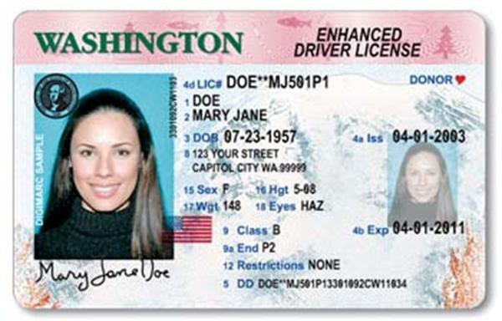
Authorization of Temporary Guardianship:
I, (parent’s name) the Parent of (child’s name) hereby grant temporary guardianship to (guardian’s name) for the period from the day of 20 and expiring
on the day of 20 .
I also approve of my Child participating in the (event name) on
(date). I authorize the Temporary Guardian to act on my behalf in making all
decisions on a daily basis as to the Child's activities.
SIGNATURE
DATE

Please attach copy of PARENT ID with signature:
PARENT INFORMATION
TEMPORARY GUARDIAN
Full Name:

Full Name:

Phone:

Phone:

Email:

Email:

CHILD INFORMATION
Full Name:

Example of ID w/ Signature. Can be included in separate document.

