APPEAL LETTER
Yael & Gavriel Moses 2241 Rose Street
Berkeley, CA 94709
August 10th, 2009

Deborah Matthews, Chair
Zoning Adjustments Board Members 2120 Milvia Street
Berkeley, CA 94704

CC:
Rena Rickles Susan Wengraf

Re: 1340 Arch Street; Appeal AUP; Request Zoning Adjustments Board Public Hearing

Dear Chair Matthews and Board Members:
We, as the closest and most immediately impacted by the proposed “large family day care” directly uphill and east of us, with its outdoor play area directly under our windows, appeal the granting of the Administrative Use Permit. We do this because the Findings are not supported by the evidence, the Conditions do not adequately protect us from the unreasonable detriment which, under the factual circumstances of this application, will cause unreasonable detriment to us as well as our neighbors and our neighborhood.

As you can see from the signatures at the end of this letter, most of our neighbors support our appeal. Many other neighbors will or have sent in letters opposing this project because the Conditions imposed do not protect us from the negative impact of this project.

The Granting of the AUP, without more restrictive conditions, violates the purpose of the R-1 District.

While a "Large Family Day Care Home" can be granted with an AUP, said permit must meet the Use Permit findings set out in 23B.28.050 of the Zoning Code which states the AUP can be granted only if the use "under the circumstances of the case" will not be detrimental to the immediate neighbors, or neighborhood. In this case the project is located in a quiet, hill neighborhood, adjacent to two dangerous intersections, in a landslide and wildlife fire area. Thus the protections against detriment must be more stringent than in a less environmentally and physically sensitive area.

While the R-1 zoning allows construction of “community facilities” when they “will not be detrimental to the immediate neighborhood (23D.16.020.D),” the AUP and the NOD at issue do not impose conditions which will prevent the proposed Large Family Day Care Facility from being a detriment to the immediate neighbors or the immediate neighborhood.

The AUP, as granted, does not impose conditions which adequately address the three major areas by which the Large Day Care Center will be a detriment to the immediate neighbors and/or neighborhood—noise, traffic/fire and evacuation issues/safety/ and parking.

Character of neighborhood: AUP ignores the change this will have on the nature of neighborhood: The AUP states that it “does not fundamentally alter the nature of the underlying uses.” The reality is that a minimum of 14 additional cars driving up and down our street and parking on a dangerous intersection during both morning and evening rush hours and with 14 young children in the front yard directly under our windows, will inevitably impact the character of this neighborhood.

The AUP, because it fails to recognize unique configuration which exists between 1340 Arch Street and 2241 Rose Street, does nothing to protect us from the noise impact of this proposed use.

Because of the juxtaposition and just under seven (7) foot distance of the study and bedroom of our house to the front yard of 1340 Arch Street (the only location where the 14 children can play outdoors since1340 Arch does not have a usable back yard and it is the front garden that functions as one), we will be uniquely impacted by the noise of 14+ children playing right directly under our home/office windows.
Normally rear yards face each other and the noise from outdoor activities is an expected not an intrusive noise. Moreover, 1340 Arch is up the hill from us and thus its garden is above our ground floor windows and level with our second floor windows where we work and write. The distance between 1340 Arch yard and our windows is 6’11”. Elevation differential from our property line to the top of the 1340 front yard is 23 feet. As a result the yard and house at 1340 Arch function acoustically as an amphitheatre amplifying and projecting the sound. Yet the AUP imposes no conditions on the Applicant to reduce the impact of that noise.

Furthermore, the quadrangle encompassing historic Rose Glen Alley to the west, and the historically significant row of houses to the east (among them Julia Morgan and Maybeck designed houses that survived the 1923 fire) has been and continues to be home to a number of scholars and writers who moved into this neighborhood precisely because its peacefulness affords a quiet setting for their writing and research.

The AUP/NOD imposes no conditions requiring the project sponsor to mitigate the traffic impact upon the neighborhood.

The AUP, as Conditioned, does not address accurately the number of cars to be expected:

No formal traffic study was done and the AUP states that “this trip generation is below the City’s 30 trips for formal traffic study.” The minimum of 14 children plus 2 teachers already generates a minimum of
32 trips per day. The AUP is not clear whether the permit allows 14 children on site at any one time or a total enrollment of 14 children. If it's 14 children at all times this means that there will be a larger total of kids, i.e. only 14 present at one time, definitely triggering a traffic study. To protect against this impact, at a minimum the AUP must be modified to state that no more than 14 children may be enrolled (including Applicant's children, if they too will be part of the day care)—otherwise enforcing the 14-child maximum and the impacts therefrom will be a procedural nightmare.

The AUP/NOD do not protect us from the car pollution/noise pollution that will be created.
The AUP does not address the serious and dangerous traffic issues which already exist and will be compounded by the addition of 14+ cars arriving and departing at 'rush' hour:

Intersection dangers: 1) There is an existing problem at the 3 stop intersection of Rose and Spruce, where drivers do not stop and near accidents are a daily occurrence and real accidents are frequent. An increase in traffic at these peak hours, compounded by the fact that the drivers will be driving erratically as they are searching for the rare available parking space instead of focusing on on-coming traffic and pedestrians, will increase the number of real accidents. 2) This dangerous situation is compounded by the fact that the proposed site is at the "T" junction of Rose and Arch, where drivers frequently make U turns in the face of cars zooming down Arch at top speed. An increase in traffic at this already dangerous corner, with all cars searching for parking spaces and where young children will be dropped off and picked up, is inviting danger. This will become even more dangerous when the re-paving of Rose, starting at the end of this month, will be completed creating a smooth new surface enticing drivers to drive even faster. At a minimum a Condition must be added requiring the Day Care center to provide an 'on the street' employee to monitor the safe drop

off and pick up of children, stop attempts to J-walk and double park. It is unreasonable to assume parents will self monitor.

All of this begs the question: why a traffic study including the safety issues of the intersection was not done? For the safety of traversing traffic, of the neighborhood and of the young children, such a study must be done prior to the issuance of AUP so that necessary additional Conditions can be attached to the permit.

The applicant shall be allowed to conduct one on-site event:

Condition #15, in the NOD, is not clearly drafted and leaves too much room for misinterpretation. To avoid any misunderstanding, we would suggest to redraft the first sentence to read as follows:

"The one event per year could include but is not limited to a fundraiser, a student performance, an assembly, a parent volunteer day or a work party. "

Without that revision we believe that this could become a matter of contention if it is not made clear from the start.

The AUP, as Conditioned, does not address the parking impact of this project

Contrary to the statement in the AUP parking spaces on site are not sufficient; existing on street parking cannot take this additional load: In this case, project sponsor already has 2 cars and only 2 parking spaces. Spaces earmarked for 2 proposed staff are not available. In addition, the neighborhood streets are impacted by residents parking and UC students who are renting on the block (6 students just in the house across the street from 1340 Arch). In addition when UC is in session many students park here and walk to campus for their classes. The Day care will impact the ability of neighbors to park on their own block. (See below photograph with typical existing lack of available parking—and this is while UC is on summer break. As can be seen, this situation shows no spaces available for parking along 1340 Arch).

Photo of existing available parking:
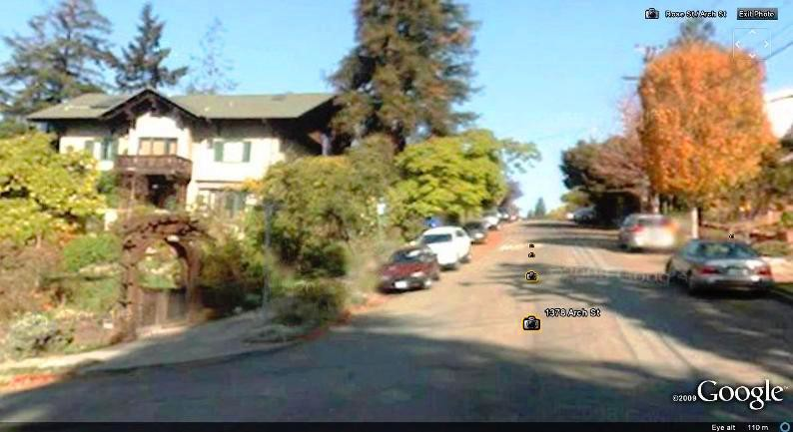

Evacuation and Safety Issues are not addressed

This site is located in the middle of a Wildlife Fire District and Earthquake Safety District. In case of earthquake and/or fire, residents will be driving hastily to evacuate; while emergency vehicles will be speeding toward the site. Meanwhile 14 sets of worried parents will likewise be heading to the day care center to 'rescue' their children. Yet there is no requirement for an emergency earthquake or fire evacuation plan (for the day care to move the children to a pre-determined off-site location). Nor has the local fire marshal, with specific knowledge of the unique dangers of fire and evacuation in this area been called upon to address the safety of this site. Again, at a minimum, the AUP must be modified to require inspection by Berkeley's Fire Marshall and imposition of his safety requirements PRIOR to a decision on an AUP.

The NOD and AUP should not be granted, where, as here, Applicant's intended operation is in conflict—

Contradicting assurances given by the applicants in their amended letter to the neighborhood dated June 18th, that “we are changing the name of our program from The Berkeley Rose School to The Berkeley Rose Daycare,” their literature continues to use the term “school” [see below current website]. In addition, in said letter, they declare that “the term ‘school’ was included in the business name as a marketing differentiation tool.” No permits should be granted until the Applicant states with finality, her intended use and until requisite reviews match.


Our concern, therefore, has to do with the nature of this “Family Childcare Home.” As their webpage
continues to define it, it is a “school,” and, more specifically, in the mold of the religious leader Rudolf Steiner inspired Waldorf Schools. As all such schools do, in the Waldorf “way,” (and this was confirmed in the presentation that was made to the neighborhood last spring) it is supposed to grow year by year one grade at a time, up to 8th grade. This will change the picture, year by year and is of grave concern to us for obvious reasons. We are not looking here in any way at the kind of home daycare enterprise as contemplated by the law passed to make neighborhood family daycare accessible. At $10,500 a child, this is not family daycare but a business: 10,500 x 14= $145,000 + with additional charges for after school care past 1pm.

It is our understanding that the state and the city support the creation of family day cares as a way of making pre-schools and aftercare programs available to all in all neighborhoods. The proposed large family daycare at 1340 Arch, with an advertised tuition of $10,500 for a half day, is not easily affordable, will not address the state and city intent about such facilities, and does not meet neighborhood needs.

Conclusion

We oppose our neighbors running a commercial business of this magnitude on our residential street, with the concomitant traffic, pollution, and noise. But as written, the AUP and the NOD force us and our neighbors to absorb the impact of the Berkeley Rose School in, on and around our homes, and the concomitant loss in property values that go with it. The NOD and AUP fail to require the applicant, who will financially profit greatly from this enterprise, to reduce the impact upon us.

We ask that you the ZAB members vote to conduct a public hearing so that this Large Family Day Care facility will not be detrimental to our neighborhood.

Very truly yours,

Yael and Gavriel Moses

