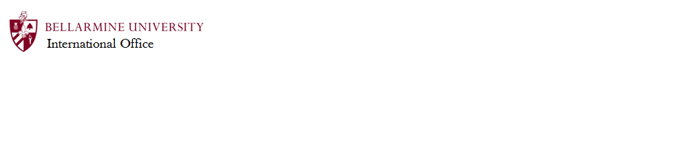
International Student, Social Security Number Request

To receive your Social Security Number, you need to:
- Secure employment
- Wait at least two weeks from the date on your I-94 card to apply
- Obtain the Employment Verification Letter from the Bellarmine International Office (attached below)
- Fill out Section 1 of the Employment Verification Letter
- Have your employer complete Section 2 of the Employment Verification Letter
- Come to the International Office during regular business hours with Section 1 and 2 completed. The International Office will complete the form by signing Section 3.

The Social Security Administration requires the following items be presented to them in order to process your application:
- Passport
- Form I-94 with Travel History
- Form DS-2019
- Completed Employment Verification Letter
- Completed Form SS5, download from www.socialsecurity.gov/forms/ss-5.pdf

Additional Information available at www.socialsecurity.gov/pubs/EN-05-10181.pdf

For on-campus employment, once you receive your Social Security Number in the mail, go to the Human Resources Office in Horrigan Hall, Room 213, so they can update your employment file.

IMPORTANT: Your Social Security Number is valid for your lifetime. Keep it in a safe place and do not carry it around with you. In the United States, this is number is used for credit and identity checks. For that reason, you should be very cautious about giving this number out to anyone without a good reason. Clear instances when you will be required to provide your SSN would be to your new employer and when filing your tax return with the IRS. In other situations, it is not impolite to ask why your social security number is required and what protections will be used to keep it safe. For more information, see http://www.ssa.gov/pubs/EN-05-10064.pdf

J-1 Student Social Security Letter

Section 1, TO BE COMPLETED BY THE STUDENT:

Last Name: First Name:
Date of Birth: SEVIS ID#: N

Section 2, TO BE COMPLETED BY THE STUDENT’S EMPLOYER:

This letter is to certify that the student named above has been offered employment with

(Department/Office/Firm) in the position of

. The student is expected to begin working on

and work hours per week.

Employers Other Than Bellarmine: EIN number________________________
Bellarmine University’s EIN number is 61-0482955.

Sincerely,

X
Immediate Supervisor Signature Supervisor’s Name and Title (print)

Phone:

Section 3, TO BE COMPLETED BY A DESIGNATED SCHOOL OFFICIAL (DSO):

I certify that the above named student is enrolled as a full-time student at Bellarmine University.

X
RO/ARO Signature Date

RO/ARO Name and Title (print)

