TRANSITION AND SEPARATION AGREEMENT
This Transition and Separation Agreement ("Agreement") is between the City of Colorado Springs (the "City') and Timothy R. Mitros ("Employee"), and shall be effective on the day on which it is signed by Employee (the "Effective Date"), provided that Employee does not later revoke this Agreement in accordance with Section 1 1 .c. below.
Purpose of Aqreement. Employee is subject to City Policy No. 64: the At-Will Senior Manager Benefit Program. The parties are entering into this Agreement to establish the terms and conditions of Employee's transition from City employment as well as to amicably and completely resolve any and all matters between them.
- Resignation and Separation Date. On or before 5:00 p.m., December 23, 2016, Employee shall provide Michael Sullivan, Human Resources Director, with a letter announcing his retirement effective January 13, 2017 (the "Separation Date").
- Transition Period.
  - The 'Transition Period" will begin on the Effective Date and will end at the end of the day on January 13, 2017.
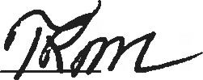
  - During the Transition Period, Employee shall continue to receive Employee's current rate of pay which will be processed through the normal payroll cycle and Employee shall continue to be eligible for any benefit program maintained by the City in accordance with the terms of the applicable policy or agreement governing such program as well as applicable law.
- Pavments and Other Consideration. If Employee signs and does not revoke this Agreement, and executes the Supplemental Release attached hereto as Exhibit A on or after the Separation Date and does not revoke it, the City agrees: (i) to pay Employee an amount equal to 6 months of Employee's current base salary, to be paid within 5 working days following the date the Supplemental Release becomes binding and non-revocable; (ii) to pay the employer's share of the cost of premiums to continue Employee's current medical and dental coverage through July 31, 2017, so long as Employee timely pays Employee's share of the contributions to the City; and (iii) to allow Employee to continue, if currently enrolled, in the vision plan through July 31, 2017, so long as Employee timely pays the cost of the premium. All payments shall be subject to legally-required withholdings. Further, the parties agree that no PERA contributions will be made on these payments as they do not constitute salary for PERA purposes.
- Payment of Accrued Benefits. On the regularly-scheduled pay date following the Separation Date, the City shall pay Employee for any and all accrued benefits Employee is entitled to receive pursuant to City policy.
- Benefit Termination. Effective on the Separation Date, Employee shall cease to be eligible for any and all City benefit programs and policies, with the exception of any policies for which employees separated from the City remain eligible and those benefits outlined in Section 4. Notwithstanding the foregoing, Employee shall be eligible to continue Employee's health insurance benefits in accordance with COBRA at Employee's own expense provided that Employee timely elects COBRA coverage and makes timely payments.
- Confidentiality/ Non-Disparaqement.
  - Confidentiality of Agreement. Employee represents and warrants to the City that, prior to the date Employee signs this Agreement, Employee did not disclose to any person, other than to Employee's spouse, tax advisor, and/or counsel, the terms of this Agreement. After the Effective Date, neither Employee, counsel for Employee, nor any other person under Employee's control shall disclose any term of this Agreement, except that Employee may disclose such information to Employee's spouse, or as required by subpoena or law, or to an attorney or accountant to the extent necessary to obtain professional advice. All parties acknowledge the City is subject to the Colorado Open Records Act ("CORA").
  - Confidentiality of City Information. Pursuant to Employee's job duties with the City, Employee received confidential and sensitive information. Employee shall not disclose any information that Employee received or obtained pursuant to Employee's job duties or during the course of Employee's employment with the City except in response to an order or subpoena of a court or government agency of competent jurisdiction, provided, however, that notice of receipt of such order or subpoena shall be immediately communicated to the City Attorney's Office so that the City shall have an opportunity to intervene and assert what rights it has to nondisclosure prior to Employee's response to such order or subpoena.
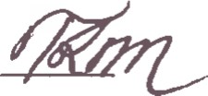
  - Mutual Non-disparaqement. Employee shall not make negative or disparaging comments relating to the City, its elected officials, employees or representatives, its services, or Employee's employment with the City. In addition, Employee will not disclose to any person or entity the circumstances surrounding Employee's departure from the City's employment. The City shall not make negative comments relating to Employee's employment with the City or the circumstances surrounding Employee's departure from the City's employment. All parties acknowledge the City is subject to the CORA. Notwithstanding the foregoing, if either party is subject to a valid subpoena or court order, or is otherwise required by law, to provide truthful testimony in a proceeding, such testimony will not be a violation of Section 7 of this Agreement.
  - Discrimination Claims. Nothing in this Agreement is intended to limit in any way Employee's right or ability to file a charge or claim of discrimination with the Equal Employment Opportunity Commission ("EEOC") or comparable state or local agency. Employee retains the right to communicate with the EEOC and comparable state or local agencies and such communication may be initiated by Employee or in response to the government and is not limited by any confidentiality or non-disparagement obligation under this Agreement. Employee shall not be entitled to recover any monetary relief or other individual remedy in connection with a charge or claim of discrimination filed with the EEOC or comparable state or local agency or any resulting litigation.
Damaqes. Employee recognizes and agrees that this Section 7 was a significant inducement for the City to enter into this Agreement. Any violation of this section shall be considered a material breach of this Agreement, and Employee will be subject to liquidated damages as set forth in this section. Employee recognizes and agrees that the damages to the City for a breach of this Section 7 provision cannot be quantified with sufficient certainty to provide for an adequate remedy at law if Employee breaches or threatens to breach this Agreement. Because of this difficulty, Employee agrees to pay the City $30,000 in liquidated damages if Employee breaches this Agreement. Employee also agrees that injunctive relief is warranted if any court of competent jurisdiction determines that Employee has or is reasonably about to breach this Agreement.
- Assistance Prior to Separation Date. In exchange for the payments and/or other consideration provided under Section 4, Employee shall remain reasonably available to respond to requests for information and assistance directed to Employee by City management during the period prior to the Separation Date.
- Cooperation in Proceedings. Employee agrees that Employee shall fully cooperate with respect to any claim, litigation or judicial, arbitral or investigative proceeding initiated by the City, any private party, or by any regulator, governmental entity, or self-regulatory organization, that relates to or arises from any matter with which Employee was involved during Employee's employment with the City, or that concerns any matter of which Employee has information or knowledge (collectively, a "Proceeding"). Employee's duty of cooperation includes, but is not limited to: (i) meeting with the City's attorneys by telephone or in person at mutually convenient times and places in order to state truthfully Employee's recollection of events; (ii) appearing at the City's request as a witness at interviews, depositions, or trials, without the necessity of a subpoena, in order to state truthfully Employee's knowledge of matters at issue; and (iii) signing at the City's request declarations or affidavits that truthfully state matters of fact of which Employee has personal knowledge obtained during the course of Employee's relationship with the City. In addition, Employee agrees to promptly notify the City Attorney's Office of any requests for information or testimony that Employee receives in connection with any Proceeding relating to the City's business. Notwithstanding any other provision of this Agreement, this Agreement shall not be construed or applied so as to compel any party to take any action, or omit to take any action, requested or directed by any regulatory or law enforcement authority. The City shall exercise reasonable good faith efforts to minimize the extent to which its requests for cooperation pursuant to this Section conflict with Employee's professional and personal commitments.
1 0. Re-emplovment. Employee agrees not to seek re-employment or initiate any effort to be re-employed by the City, Colorado Springs Utilities or any of the City's enterprises at any time in the future. This provision may be waived in writing by the Mayor at the Mayor's sole and absolute discretion.
1 1 . Release of Claims.
- Release. Employee, on behalf of Employee and Employee's heirs, personal representatives and assigns, and any other person or entity that could or might act on behalf of Employee, including, without limitation, Employee's counsel (all of whom are collectively referred to as "Releasers"), hereby fully and forever releases and discharges the City, its past, present and future departments and divisions, and each of their past, present and future elected officials, officers, employees, benefit plans or programs, and any and all other persons or entities that are now or may become liable to any Releaser due to any Releasee ^{l}s act or omission, (all of whom are collectively referred to as "Releasees") of and from any and all actions, causes of action, claims, demands, costs and expenses, including attorneys' fees, of every kind and nature whatsoever, in law or in equity, whether now known or unknown, that Releasers may now have, or claim at any future time to have, based in whole or in part upon any act or omission occurring on or before the date Employee signs this Agreement, without regard to present actual knowledge of such acts or omissions, including specifically, but not by way of limitation, matters which may arise at common law, such as breach of contract, express or implied, promissory estoppel, wrongful discharge, tortious interference with contractual rights, infliction of emotional distress, defamation, or under federal, state or local laws, such as the Fair Labor Standards Act, the Employee Retirement Income Security Act, the National Labor Relations Act, Title Vll of the Civil Rights Act of 1964, the Age Discrimination in Employment Act, the Rehabilitation Act of 1973, the Equal Pay Act, the Americans with Disabilities Act, the Family and Medical Leave Act, and any civil rights law of any state or other governmental body; PROVIDED, HOWEVER, that notwithstanding the foregoing or anything else contained in this Agreement, the release set forth in this Section shall not extend to: (i) any rights arising under this Agreement; (ii) Employee's rights, if any, to indemnification, and/or defense under any City Charter, City Code, policy or procedure in connection with Employee's acts and omissions within the course and scope of Employee's employment with the City; (iii) any vested, unpaid rights Employee may have under any pension, retirement, profit sharing, or similar plan; (iv) Employee's rights, where applicable, to file and/or participate in any administrative proceeding of any federal, state or local government agency, subject to Employee's acknowledgment and agreement that, by signing and not revoking this release of claims, Employee shall not be entitled to recover any monetary relief or other individual remedy in connection with the proceeding or any ensuing litigation; or (v) any rights that are not waivable or releasable by law. Employee hereby warrants that Employee has not assigned or transferred to any person any portion of any claim which is released, waived and discharged above. Employee represents and warrants that Employee has not experienced any illness, injury, or occupational disease that Employee attributes to Employee's employment with the City giving rise to a potential workers' compensation claim under the workers' compensation laws of the state of Colorado that was not reported to the City before the Effective Date. Employee has had the opportunity to consult with counsel with respect to the agreements, representations, and declarations set forth in the previous sentence. Employee understands and agrees that by signing this Agreement Employee is giving up any right to bring any legal claim against the City concerning, directly or indirectly, Employee's employment relationship with the City, including Employee's separation from employment. Employee agrees that this legal release is intended to be interpreted in the broadest possible manner in favor of the City, to include all actual or potential legal claims that Employee may have against the City, except as specifically provided otherwise in this Agreement.
- Acknowledgment of Rights Under the Older Workers Benefit Protection Act. Employee agrees and acknowledges that Employee: (i) understands the language used in this Agreement and the Agreement's legal effect; (ii) understands that by signing this Agreement Employee is giving up the right to sue the City for age discrimination; (iii) will receive compensation and benefits under this Agreement to which Employee would not have been entitled without signing this Agreement; (iv) has been advised by the City to consult with an attorney before signing this Agreement; and (v) was given no less than a 21 -day consideration period. Employee agrees that any changes to this Agreement prior to the signing of this Agreement will not result in an additional 21 -day period to consider the Agreement.
Employee acknowledges that Employee may sign this Agreement at any time prior to the expiration of the 21 -day consideration period and that any decision by Employee to do so has not been induced by the City through fraud, misrepresentation, a threat to withdraw or alter the offer prior to the expiration of the 21 -day period, or by offering different terms if the Agreement is signed prior to the expiration of the 21 -day period.
- Revocation Right. For a period of 7 calendar days after the date Employee signs this Agreement, Employee may, in Employee's sole discretion, rescind this Agreement, by delivering a written notice of rescission to Michael Sullivan, Human Resources Director. If Employee rescinds this Agreement within such 7 calendar day period, this Agreement shall be void, all actions taken pursuant to this Agreement shall be reversed, and neither this Agreement nor the fact of or circumstances surrounding its execution shall be admissible for any purpose whatsoever in any proceeding between the parties, except in connection with a claim or defense involving the validity or effective rescission of this Agreement. If Employee does not rescind this Agreement within the 7 calendar day period, this Agreement shall become final and binding and shall be irrevocable.
12. Miscellaneous.
- Entire Agreement. This Agreement sets forth the complete agreement between the parties and replaces or supersedes any prior agreement of the parties relating to severance or benefits. No other covenants or representations have been made or relied upon by either party, and no other consideration, other than that set forth in this Agreement, is due between the parties.
- No Admissions. The parties understand and agree that this Agreement shall not be construed as an admission of liability on the part of either party, liability being expressly denied.

- Choice of Law. This Agreement is governed by the laws of the State of Colorado.
- Additional Warranty and Acknowledgment. The parties warrant and represent that they have been offered no promise or inducement except as expressly provided in this Agreement, and that this Agreement is not in violation of or in conflict with any other agreement of either party.
- Other Agreements. Each party shall promptly execute, acknowledge and deliver any additional document or agreement that the other party reasonably believes is necessary to carry out the purpose or effect of this Agreement.
- Withholdings. All payments under this Agreement shall be subject to legallyrequired withholdings.
- City Property. Employee has returned to the City, or will return to the City by the Separation Date, all City Property and all documents containing City information. "City Property' includes, but is not limited to, vehicles, keys, access cards, files, furniture, memoranda, reports, software, credit cards, computer disks or drives, instructional and management manuals, books, cellular phones, computer equipment, electronic equipment, and any electronically stored information.
- Invalidated Provision. If any provision of this Agreement should be declared to be unenforceable by any administrative agency or court of law, the remainder of the Agreement shall remain in full force and effect, and shall bind the parties as if the invalidated provision were not part of this Agreement.
 Counterparts and Telecopies. This Agreement may be executed in counterparts, or by copies transmitted by telecopier or electronic mail, all of which shall be given the same force and effect as the original.
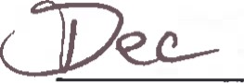
9..-..Ä 2-0) 6
DATE EMPLOYEE WAS PROVIDED AGREEMENT:
By their signatures below, both parties acknowledge that they have read this Agreement and understand its terms.

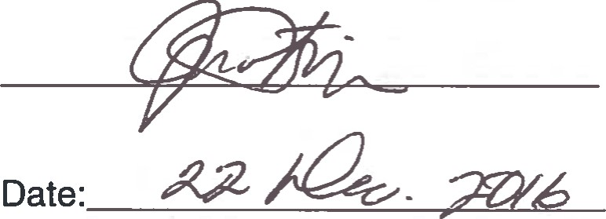
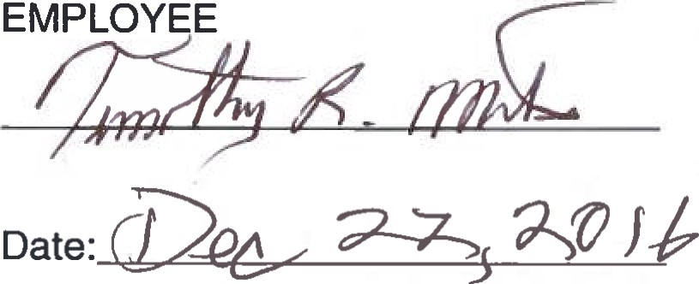 CITY OF COLORADO SPRINGS
Approved as to form:
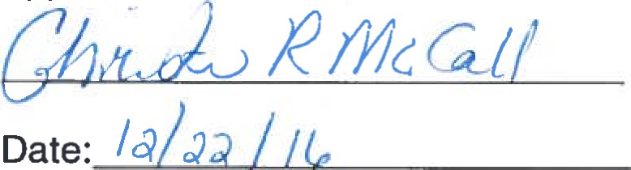
EMPLOYEE HEREBY ACKNOWELDGES THAT EMPLOYEE WAS ADVISED TO CONSULT EMPLOYEE'S OWN ATTORNEY PRIOR TO SIGNING THIS AGREEEMENT AND THAT EMPLOYEE HAD 21 DAYS TO REVIEW THIS AGREEMENT AND IF EMPLOYEE SO CHOOSES TO EXECUTE THIS AGREEMENT PRIOR TO THAT TIME, EMPLOYEE HAS 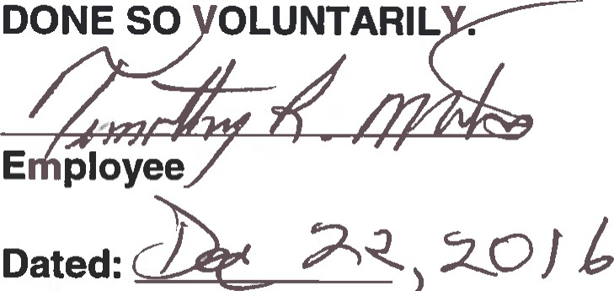DONE SO OLUNTARIL .
7)

