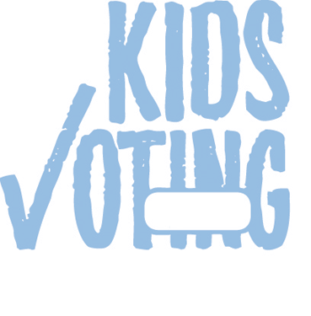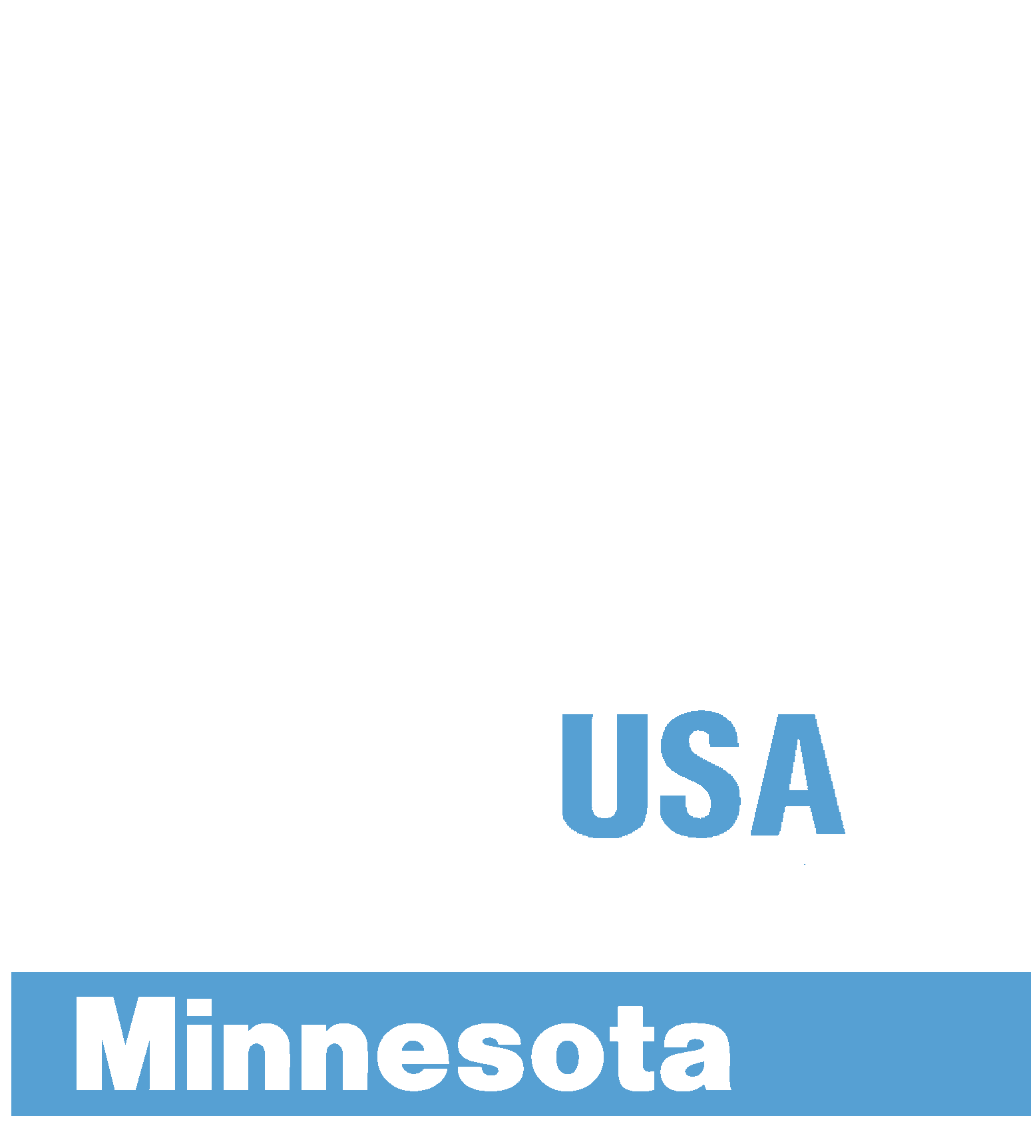
Kids Voting Prior Lake- Savage Schools November 4, 2014 Ballot

SCHOOL BOARD ISD 719 (PRIOR LAKE)
To fill vacancy in term expiring Jan. 2, 2017 (VOTE FOR ONE)
Melissa Bednarek Enger
`
` Write-in, if any

U.S. REPRESENTATIVE DISTRICT 2
(VOTE FOR ONE)

Paula Overby
Independence
`
John Kline
Republican
`
Mike Obermueller
Democratic-Farmer-Labor
`
SCHOOL BOARD ISD 719 (PRIOR LAKE)
(VOTE FOR UP TO FOUR)

Ben Hanson
`
Richard Wolf
`
Todd Sorensen
`
Stacey Ruelle
`
SECRETARY OF STATE (VOTE FOR ONE)
Bob Helland
Independence
`
Dan Severson
Republican
`
Steve Simon Democratic-Farmer- Labor
`

Bob Odden
Libertarian Party
`
` Write-in, if any

ATTORNEY GENERAL (VOTE FOR ONE)
Brandon Borgos
Independence
`
Scott Newman
Republican
`
Lori Swanson Democratic-Farmer- Labor
`
Andy Dawkins
Green Party
`
Mary O’Connor
Libertarian Party
`
Dan R. Vacek
Legal Marijuana Now
`
` Write-in, if any

STATE AUDITOR (VOTE FOR ONE)
Patrick Dean
Independence
`
Randy Gilbert
Republican
`
Rebecca Otto Democratic-Farmer- Labor
`
Keegan Iversen
Libertarian Party
`
Judith Schwartzbacker Grassroots-Legalize Cannabis
`
` Write-in, if any

GOVERNOR AND LIEUTENANT GOVERNOR (VOTE FOR ONE TEAM)
Hannah Nicollet/ Tim Gieseke Independence
`
Jeff Johnson/ Bill Kuisle Republican
`
Mark Dayton/ Tina Smith Democratic-Farmer- Labor
`
Chris Holbrook/ Chris Dock Libertarian Party
`

Chris Wright/ David Daniels Grassroots-Legalize Cannabis
`
` Write-in, if any

UNITED STATES SENATOR (VOTE FOR ONE)
Steve Carlson
Independence
`
Mike McFadden
Republican
`
Al Franken Democratic-Farmer- Labor
`
Heather Johnson
Libertarian Party
`
` Write-in, if any

MARKING INSTRUCTIONS
IMPORTANT: USE A #2 PENCIL OR THE MARKING PENCIL PROVIDED. DO NOT USE INK OF
ANY COLOR. To vote for the candidate of your choice, completely fill in the circle BELOW each candidate’s name like this: ~
School
Grade

0
0
0

0
1
1
1

1
2
2
2

2
3
3
3

3
4
4
4

4
5
5
5

5
6
6
6

6
7
7
7

7
8
8
8

8
9
9
9

9

º

¡

™

