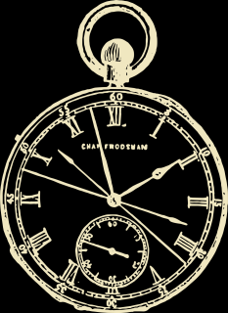
Belle Steele
• SEAT 34 •

