

Manners for the Real World
Learn to Set the Table
Objective: Youth will…
- Set a table for a family meal
- Hold flatware appropriately while eating
Core Curriculum Area:
Family and Consumer Sciences
Suitable Delivery Modes:
- Club
♦
♦
♦
Special Interest Camp
School Enrichment
Curriculum to Use:
This lesson plan is usually considered part of a home environment or etiquette project. Information on how to set a table is not included in the 4-H Home Environment series but is necessary to complete the activity in Unit 3: Where I Live, on pp 11-13. Unit 3 is available as a pub to download at: (http://www.ca.uky.edu/agc/pubs/4jb/4jb03po/4jb03po.pdf )
Grade Levels: 4-12
Life skills:
Nurturing relationships, social skills, planning/organization, critical thinking, decision making
Background Information for Presenter:
Fewer young people today than in past generations are taught how to set a table. With today’s on-the-go lifestyle, some families rarely sit down together at a table for a meal. Recent research has shown that children in families that eat together tend to do better in school.
Having a “set” table is not a necessity but a well set table makes for a pleasant setting for family interaction.
Total Time: 45 minutes
Materials Needed:
□
9 or more sets of dishes for each place setting
9 plastic plates
9 plastic beverage glasses 9 plastic table knives
9 plastic forks
9 plastic spoons
9 paper or cloth napkins Enough knives & forks for every person
Optional: 9 place mats or 12”X17” pieces of craft foam Opt: 1 plastic dinner plate Opt: 1 plastic beverage glass Opt: 1 set of plastic flatware (knife, fork, & spoon)
□
□
□
□
□
□
□
Pre-Test: (5 minutes) Conduct test with participants.
Ask for four volunteers. Without giving hints, ask each one to use the tableware you have placed in front of them to set the table. When they finish, ask the rest of the group to look at each example and stand in front of the one they think is accurate. Designate an area for those who think none of the examples is correct. Do not indicate if any are accurate but say something like, “Let’s find out.” Mentally note which youth select the arrangement that is considered a standard place setting.
□
□
□
□
Introduction: (<5 minutes) Share with participants.
How many of you set the table at your house? Have you ever been to a meal somewhere that the table was set with dishes ready for you to sit down and eat? Even if you haven’t already had that experience, today you will learn how to set a table for your family.
Advance Preparation:
- Prepare items for demonstration
1

Demonstration: (15 minutes) Conduct the activity with participants.
Gather youth close to the demo area or use the visual which can be held up for all to see. Show youth where to position each piece of the place setting as you talk. (A placemat is not required but it is helpful in defining the space for the tableware.)
Use diagram A.
Evaluation Tool:
- End of meeting questionnaire
- Pre/post-test
- Open-ended questions
- Activities & games
- Checklist
- Show of hands
- Interview
- Quotes
Bring out the following demonstration aids:
Plate: The plate is placed in the center of the space. Position the plate about 1 inch from the edge of the table. Using your thumb as a ruler, that’s about the space between the tip of your thumb and the first joint.
Essential Elements: Strive to include as many of the elements as possible in each session.
Flatware: The term used for the knives, forks and spoons is flatware. Some people refer to it as silverware but flatware actually made of silver is rarely used today. Flatware is often made of stainless steel and plastic, too. Show examples.
- Positive relationship with a caring adult
- Inclusive environment
- Safe emotional & physical environment
- Engagement in learning
- Opportunity for mastery
- Opportunity to see oneself as an active participant in the future
- Opportunity for self-determination
- Opportunity to value and practice service for others
Fork: Place the fork to the left of the plate, about 1” from the edge.
Knife: Place the knife next to the plate on the right. Turn the sharper side toward the plate. Using your thumb, place it about an inch from the edge of the table.
Spoon: Place the spoon to the right of the knife, about 1 inch from the edge of the table.
In Emily Post’s Etiquette, the authors suggest that you remember where each piece of flatware is placed by thinking of the word FOrKS. The fork (F) is on the far left, the “O” symbolizes the plate, the knife (K) comes next, then the spoon (S). To remember that the sharp edge of the knife faces toward the plate, the “r” could remind you of “razor.”
To learn more, check out: https://nifa.usda.gov/resource/essenti al-elements-4-h, https://www.ag.ndsu.edu/pubs/yf/yout hdev/yd1482.pdf, https://nifa.usda.gov/sites/default/files
/resource/Experiential_Learning.pdf, http://4-h.org/
Beverage or drinking glass: Place the glass above the tip of the knife.
Napkin: The most logical place for the napkin is to the left of the fork; however, it is acceptable to place it at other locations. Some like to place it in the center of the empty plate. Some people place the napkin under the fork but then guests must move the fork in order to place the napkin in their lap before they begin to eat. At formal dinners, the napkin might even be folded in a unique way and placed at a non-traditional location.
Standards (KOSSA):
Communications
- AA.3. Communicate and follow directions/procedures
- OE.1. Demonstrate skills in knife, tool, and equipment handling
Using the flatware during a meal:
Tables are set according to the order in which they will be used, starting from the outside in. If the food requires a spoon, select the outermost spoon to the right of the plate. If a fork is needed, use the outermost fork to the left of the plate.
Flatware in other locations: First, use the butter knife to place a pat of butter on the bread plate. As you eat, use the butter knife to place butter on a bite-size piece of bread. Return it to the bread plate when not in use. Flatware located above the plate is usually used for dessert. Once a utensil has been used, do not place it back on the cloth. Place used flatware on the plate of dish on which it was used. At the end of the meal, place the flatware diagonally across the center of the plate. (At the 4 to 10 position on a clock.)
21st Century Skills: Life and Career Skills- Initiative and Self-Direction
Be Self-Directed Learners
- Demonstrate initiative to advance skill levels towards a professional level
2

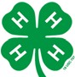
Activity 1: Set the Table
(10 minutes) Conduct activity with youth.
Leave the example in place and let the youth try setting a place using the dishes in the kit. Based on the number of youth in the group and the number of dishes, let them work individually or in pairs to actually set a place.
Activity 2: How to Hold Flatware
(10 minutes) Conduct activity with youth.
Bring the youth back together as a group. Hand each member a knife and fork. Show youth how to hold the flatware.
Explain that while eating, forks and spoons are held like a pencil. The handle is held by the tips of the thumb and index finger and it rests on the middle finger. Young children are often taught to hold the handle in the palm with all fingers wrapped around the handle. As children grow, they are expected to switch from “palm holding” to the “pencil holding” position.
Next show how to hold flatware to cut a piece of meat or vegetable. Show how right-handed people hold the flatware. (Hands are reversed for left-handed people.)
- The fork is placed in the left hand with tines down holding food in place. Grasp handle with hand; place index finger on top of the neck of the fork; other fingers should grip the handle underneath.
- Hold the knife in the right hand in the same position. Using the knife, gently “saw” back and forth until the food is cut. Cut one piece at a time; place each bite into the mouth. Repeat the process.
Reflect: (5 minutes)
To complete the experiential learning model, discuss these or similar questions with participants. [http://florida4h.org/clubs/files/101.10_Using_Experiential_Learning_Model.pdf ]
Share: Remind the youth of the first activity (pre-test).
“How closely did the place settings done by the volunteers match what you have learned today?” “Did anything about the placement of each piece surprise you? “ “When you learned to hold the knife and fork, were you surprised at how to do it?”
Process: “Why would it make a difference where the dishes and flatware are placed?” (Expect answers like: orderly/ organized, attractive, makes people feel comfortable to eat with others or in public) “Does it make a difference in how you hold the flatware when you eat?”
Generalize: Let’s talk about eating together. “Do you enjoy eating with other people?” “Can you think of times when families might get together to have special meals?” (Holidays, birthdays, weddings) “What happens when people eat together?” (Get to know each other better, form relationships, and celebrate)
Apply: “What are other times when table manners are important?”
3

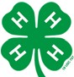
Post-Test: (5 minutes) Conduct test with participants.
The activity where youth are engaged in setting the table serves as the post-test. Move around the room to see that each person’s place setting conforms to the standard. Observe youth as they demonstrate how to hold/use flatware.
Extended Learning: Ways to extend learning beyond this lesson.
For teens, it might be appropriate to add more dishes to the place setting--pieces that they might encounter at a prom, banquet, nice restaurant, or formal dinner. Consider adding: salad fork, soup spoon, cup and saucer, bread plate, and dessert spoon or fork. See diagram B.
Encourage youth to eat a meal in front of a mirror. This shows how their actions appear to others.
Presenter Tips:
Pre-test Relay: If youth are having trouble settling down, skip the pre-test and turn it into a relay race. Form teams of 7 or less. For each team, put one place setting of dishes in a box and place it on a table. Have each team line up in front of the table about 15 feet away. Each member of the team is to run up to the box, take one item out and place it on the table in the appropriate position for a simple place setting.
The 7th or last player may make changes to the layout of the place setting if changes are needed, then run back to the team.
Visual: The visual is handy while working with large groups because it can be held up as an example.
Variety of dishes: You may want to bring dishes to show examples of several place settings—from casual to formal. Be careful to consider the interests of boys in your group.
Tips for making a kit: A kit makes it easy to teach table setting to multiple groups:
•
Paper plates and napkins and plastic flatware and glasses can be used in the kit. These are easy to locate, inexpensive and easy to transport.
For use over and over, plastic dishes might be a good investment. They are light weight and resist breaking. Discount stores and groceries often sell colorful lightweight sets during the summer. These are usually less expensive in August. Since glasses can take up a lot of room in the tub or box, be sure to select the type that can be stacked. Although place mats are optional, you may choose to include them because they define the area for each place setting.
Place an inventory list on the lid of the container so the person returning the kit to the CES office can check to see that all pieces have been gathered and returned to the container.
•
•
4

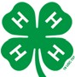
Reporting Your Success:
As a result of this lesson, youth were able to
Initial Outcomes: As a result of this lesson, youth were able to:
•
Demonstrate how to set a simple table setting and hold the flatware appropriately while eating.
Report feeling more confident in social situations where eating is involved.
•
Intermediate Outcomes: Youth:
- Report feeling more confident in social situations.
•
Exhibit grace, confidence and ease in a variety of family and community settings.
Long Term Outcomes: Youth:
- Youth create a positive image that will contribute to leadership opportunities, advancement in education, employment, and strengthening families and communities.
Additional Resources:
Additional information about setting a table can be found in a variety of books and on the internet.
Resource Used:
Post, Peggy, & Post, Emily. (2011). Emily Post’s etiquette: Manners for a new world.
New York: William Morrow.
This lesson plan was written by Martha Welch with input from the Family and Consumer Sciences After-School Kits Design Team. The team is made up of Extension Agents Lynnette Allen, Martha Arterburn, Kim Cox, Natasha Lucas, and
Extension Specialist for 4-H YD Martha Welch.
04-2016.
5

6

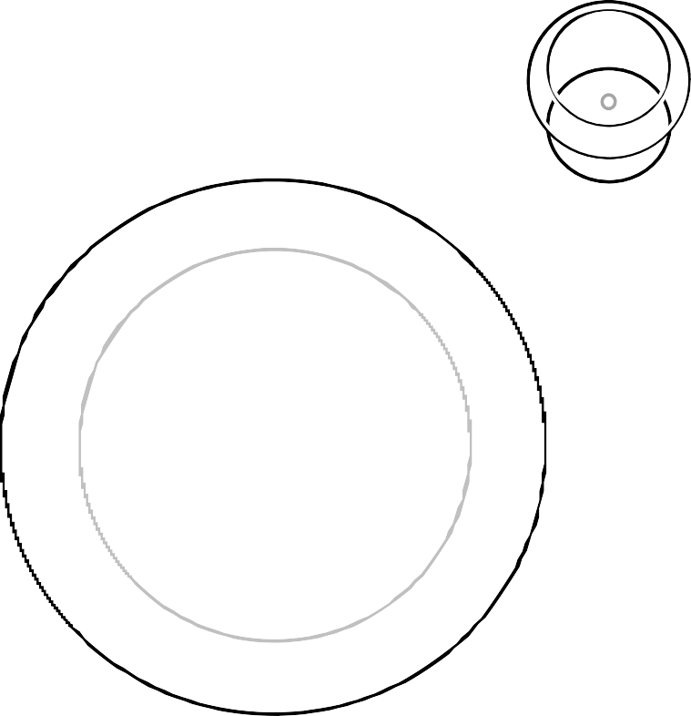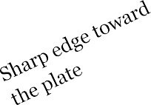
Basic Place Setting
Beverage Glass
Napkin
Plate
Spoon
Fork
Knife
1” from edge of table

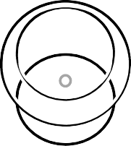
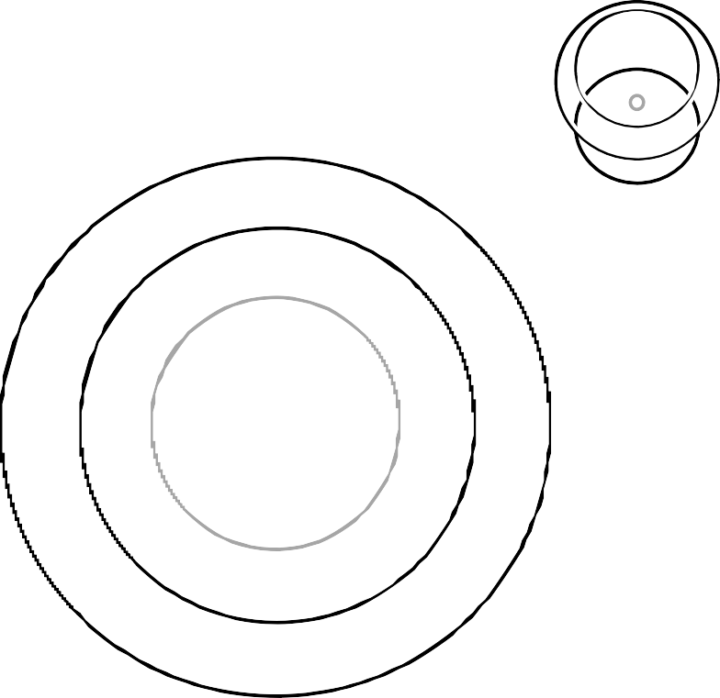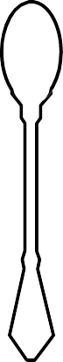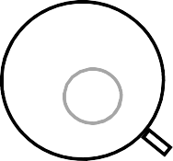
Formal Place Setting
Bread plate
Butter knife
Dessert utensils
Additional beverage
Water
glass
Service plate
Bread knife
Salad plate
Cup and saucer
generally aren’t placed on the table until the dessert course
Napkin
1” from edge of table
Dinner knife
Teaspoon
Salad Dinner
Soup spoon
fork
fork

