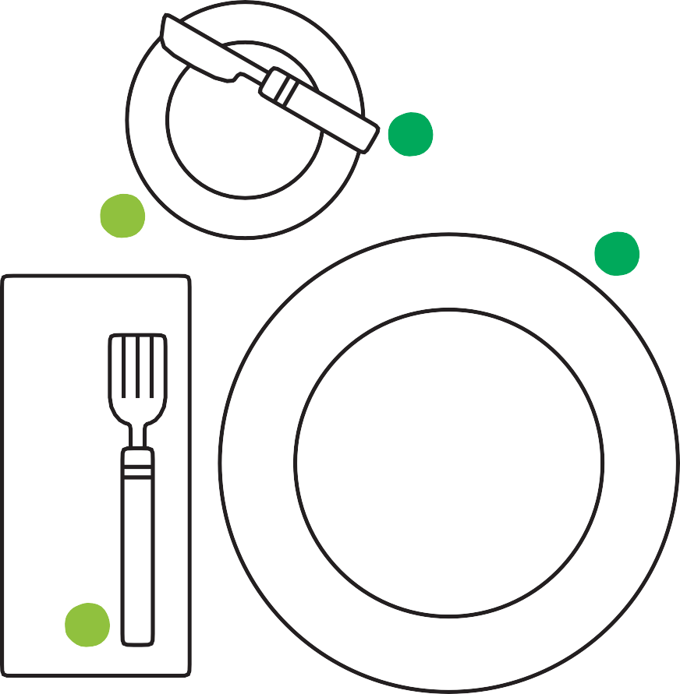

Setting the Table
1
4
7

2
5
8

3
6
9

1
7

8

9
4
5
2
6

3

