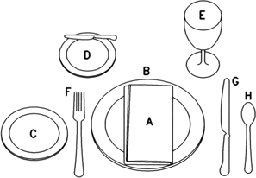
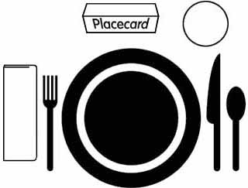




Place Setting Examples
Fork to the left of plate, tines (points) up; Nicely folded napkin next to fork; Knife to the right of plate, sharp edge pointed toward plate; Spoon to the right of knife; Cup or glass above knife & spoon; Centerpiece or Placecard (if used ) above plate.

