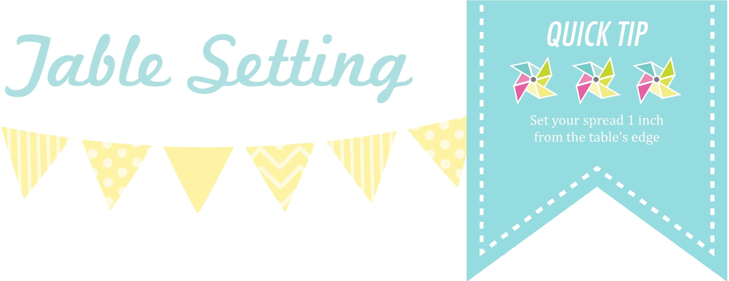

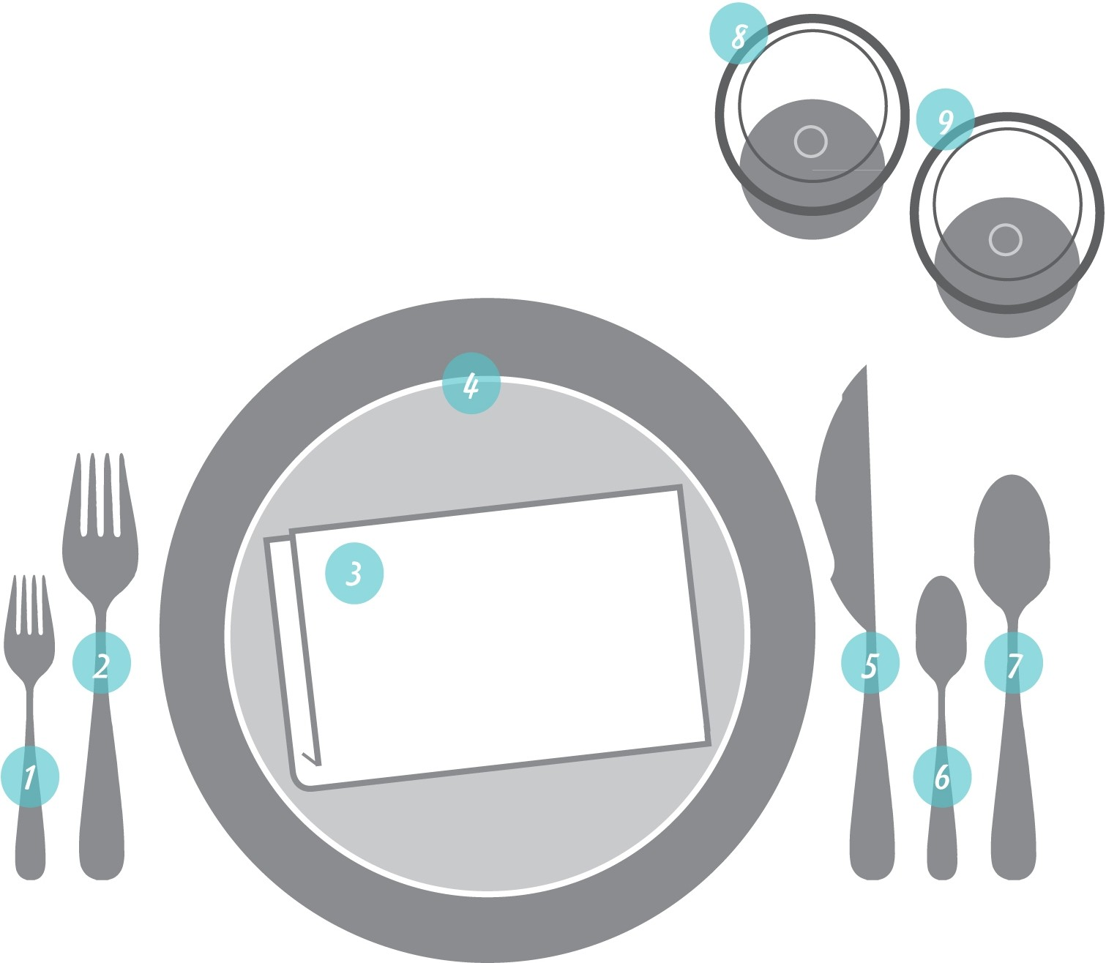



The practice of dictating the precise arrangement of tableware can vary across cultures and history. The two basic structures of formal and informal will fit any event you're planning depending on style appropriately.

INFORMAL PLACE SETTING: When an informal three­ course dinner is served, the typical place setting includes these utensils and dishes if you are
serving. Buffet it is the same without the plate.

WHAT YOU’LL NEED

Salad Fork
- Dinner Fork
- Napkin
- Plate
- Dinner Knife
- Teaspoon
- Soup Spoon
- Water Glass
- Wineglass

FORMAL PLACE SETTING I WHAT YOU’LL NEED
Everything about a formal table I 1. Napkin 9. Dessert Spoon

should be about placement and appear geometrically spaced: the I
- Bread Plate 10. Water Glass
- Place Card 11. Wineglass (red)

centerpiece at the exact center; 4. Salad Fork 12. Wineglass (white) the place settings equally balanced 5. Dinner Fork 13. Dinner Knife
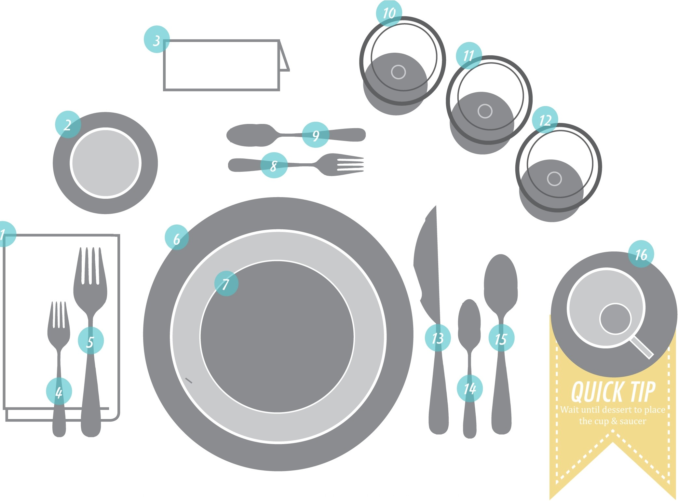

I
and utensils placed equally apart. I 6. Service Plate 14. Teaspoon Creative elements can be added 7. Salad Plate 15. Soup Spoon after this basic structure. I 8. Cake Fork 16. Cup & Saucer

