
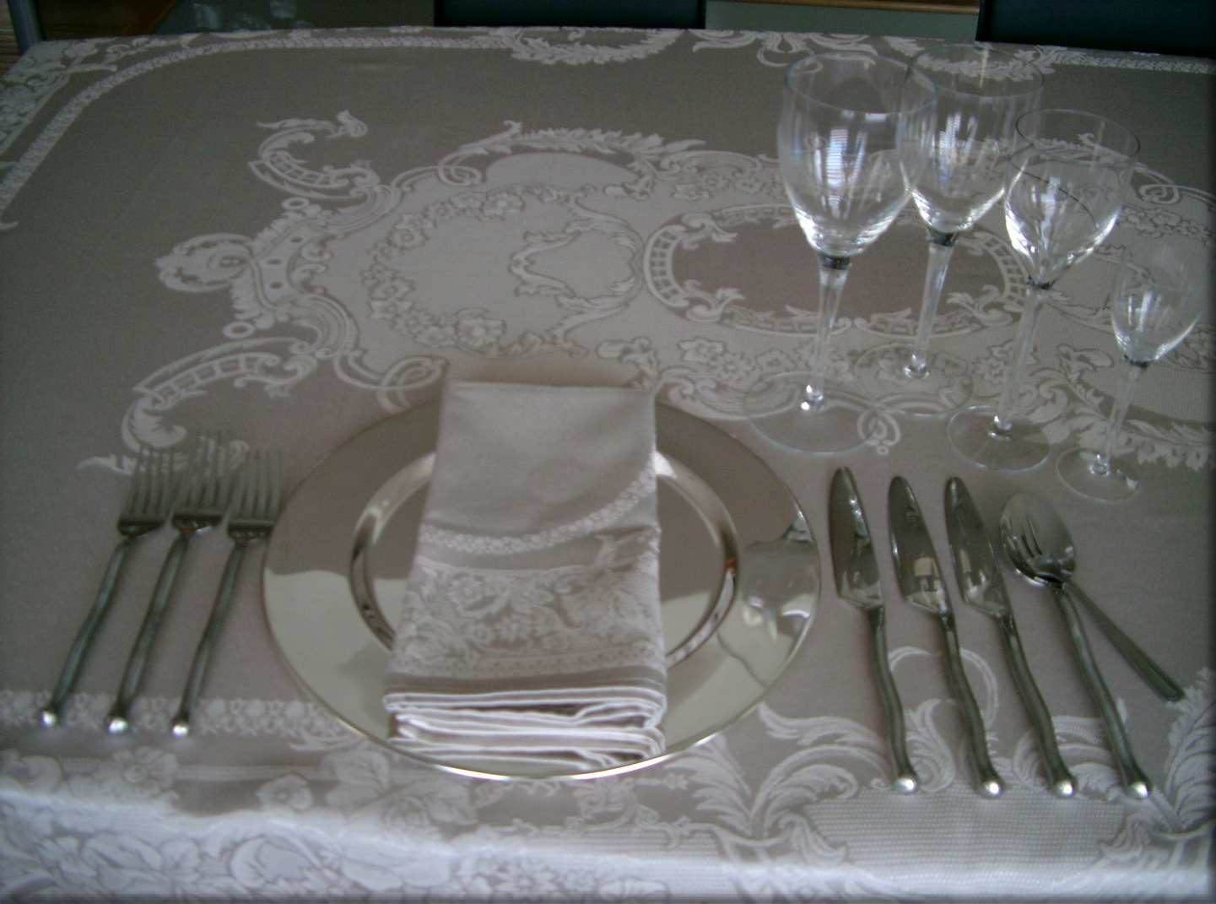
Table Settings
Self-Study & Group Activities
The following activities work well to reinforce learning outcomes with individuals and groups and may be incorporated into your presentations:
© 2015 Personal Impact International

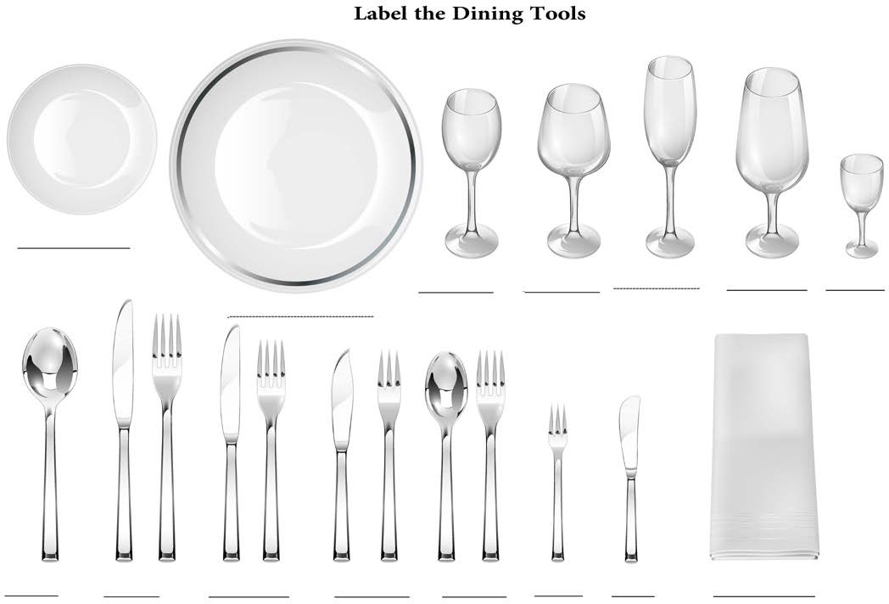
Label the Dining Tools & Place Settings
Exercise 1: Label the Dining Tools & Place Settings
1.
2.
3.
4.
Identify the dining tools
Identify the number of courses in each of the following place settings Check the Key included in this activity.
Review
Notes:
__________________________________________________________________________________________
__________________________________________________________________________________________
__________________________________________________________________________________________
© 2015 Personal Impact International

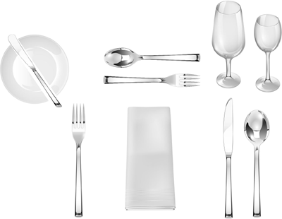
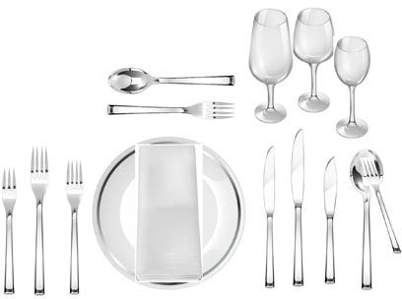
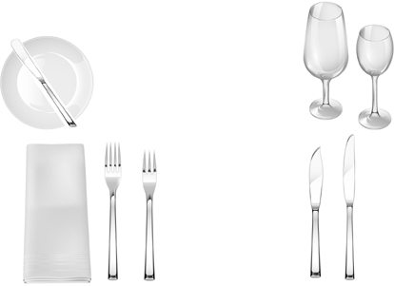
Label the Dining Tools & Place Settings
Exercise 1
Top Row - Left to Right:
_
_
_
Bottom Row – Left to Right:
_
_
_
Exercise 2
Top Row - Left to Right:
_
_
_
Bottom Row – Left to Right:
_
_
_
Exercise 3
Top Row - Left to Right:
_
_
_
Bottom Row – Left to Right:
_
_
_
© 2015 Personal Impact International

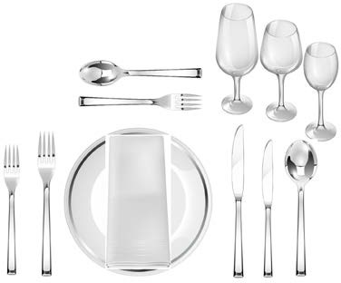
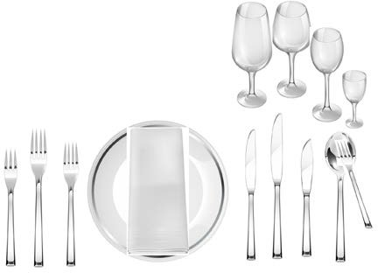
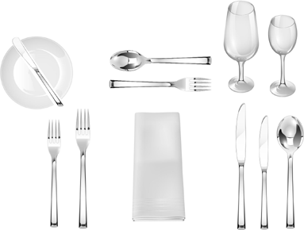
Label the Dining Tools & Place Settings
Exercise 4
Top Row - Left to Right:
_
_
_
Bottom Row – Left to Right:
_
_
_
Exercise 5
Top Row - Left to Right:
_
_
_
Bottom Row – Left to Right:
_
_
_
Exercise 6
Top Row - Left to Right:
_
_
_
Bottom Row – Left to Right:
_
_
_
© 2015 Personal Impact International

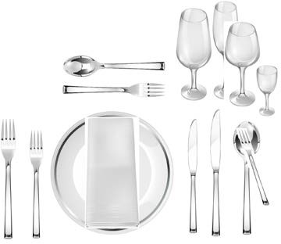
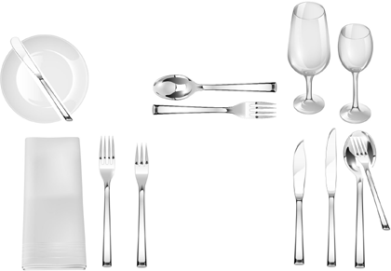
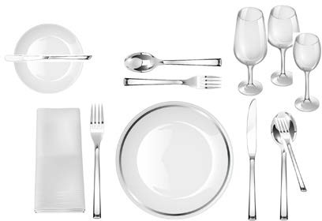
Label the Dining Tools & Place Settings
Exercise 7
Top Row - Left to Right:
_
_
_
Bottom Row – Left to Right:
_
_
_
Exercise 8
Top Row - Left to Right:
_
_
_
Bottom Row – Left to Right:
_
_
_
Exercise 9
Top Row - Left to Right:
_
_
_
Bottom Row – Left to Right:
_
_
_
© 2015 Personal Impact International

Label the
Dining Tools & Place Settings KEY
The following pages may be used to evaluate your answers in the previous exercise:
© 2015 Personal Impact International

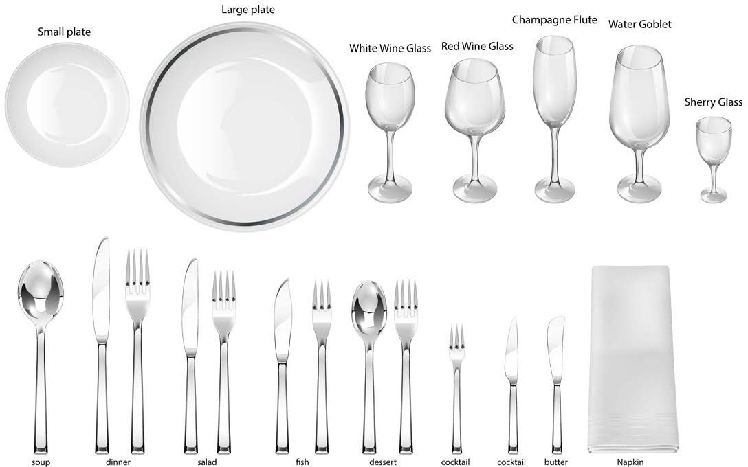
Dining Tools at a Glance
Notes:
__________________________________________________________________________________________
__________________________________________________________________________________________
__________________________________________________________________________________________
__________________________________________________________________________________________
__________________________________________________________________________________________
__________________________________________________________________________________________
© 2015 Personal Impact International

Place Settings at a Glance
Exercise 1
Top Row - Left to Right:
bread plate; butter spreader; dessert spoon; dessert fork; water goblet; white wine;
Bottom Row – Left to Right:
dinner fork; napkin; dinner knife; soup spoon;
Exercise 2
Top Row - Left to Right:
dessert spoon; dessert fork; water goblet; red wine; white wine;
Bottom Row – Left to Right:
fish fork; dinner fork; salad fork; charger; napkin; salad knife; dinner knife; fish knife; soup spoon; cocktail fork;
Exercise 3
Top Row - Left to Right:
bread plate; butter spreader; water goblet; white wine;
Bottom Row – Left to Right:
napkin; salad fork; fish knife; salad knife;
© 2015 Personal Impact International

Place Settings at a Glance
Exercise 4
Top Row - Left to Right:
dessert spoon; dessert fork; water goblet; red wine; white wine;
Bottom Row – Left to Right:
salad fork; dinner fork; charger; napkin; dinner knife; salad knife; soup spoon;
Exercise 5
Top Row - Left to Right:
water goblet; red wine; white wine; sherry;
Bottom Row – Left to Right:
fish fork; dinner fork; salad fork; charger; napkin; salad knife; dinner knife; fish knife; soup spoon; cocktail fork;
Exercise 6
Top Row - Left to Right:
bread plate; butter spreader; dessert spoon; dessert fork; water goblet; white wine;
Bottom Row – Left to Right:
salad fork; dinner fork; napkin; dinner knife; salad knife; soup spoon;
© 2015 Personal Impact International

Place Settings at a Glance
Exercise 7
Top Row - Left to Right:
dessert spoon; dessert fork; water goblet; champagne; red wine; sherry;
Bottom Row – Left to Right:
dinner fork; salad fork; charger; napkin; salad knife; dinner knife; soup spoon; cocktail fork;
Exercise 8
Top Row - Left to Right:
bread plate; butter spreader; dessert spoon; dessert fork; water goblet; white wine;
Bottom Row – Left to Right:
napkin; salad fork; fish fork; fish knife; salad knife; soup spoon; cocktail fork;
Exercise 9
Top Row - Left to Right:
bread plate; butter spreader; dessert spoon; dessert fork; water goblet; red wine; white wine;
Bottom Row – Left to Right:
napkin; dinner fork; charger; dinner knife; soup spoon; cocktail fork;
© 2015 Personal Impact International

Create Your Own Place Setting
Exercise 2: Group Activity – Create Your Place-setting
Option 1 – This option works well in class room settings or for individual practice:
- Cut out utensil drawings
- Laminate utensil drawings (optional)
- Read menu read each sample menu
- Create place setting based on sample menu
- Identify the number of courses in each place setting.
Option 2 – Fun activity for dining practicums (luncheons & dinners)
1.
2.
Show actual menu on PowerPoint
Arrange with catering staff to have all appropriate dining tools stacked on one side of table for each participant.
Ask each participant to set their own place setting, based on menu. Review place setting, before meal is served
Discussed and demonstrate utensils prior to meal being served.
3.
4.
5.
© 2015 Personal Impact International

Create Your Own Place Setting
© 2015 Personal Impact International
MENU II
Freshly Baked Breads & Rolls
~
Soup of the Day
~
Grilled New York Steak, Garlic Pepper Sauce, Roasted Root Vegetables , nugget potatoes
~
Lemon Cheesecake, Blueberry compote
~
Freshly Brewed Regular & Decaffeinated Coffee or Tea
~
Cabernet Sauvignon, JLOR

MENU I
A Selection of Flat Breads and Rolls
~
Carrot and Parsnip Soup with Candied Ginger
~
Roasted Free Range Chicken Breast with Wild Rice and Pancetta Croquette, Smoked Tomato Vin Blanc
~
Milk Chocolate Mousse Tart, Breton Shortbread& Pepper Caramel
~
Freshly Brewed Cafe Milano Coffee and a Collection of Teas
~
Mission Hill 'Five Vineyards' Bin 88 Chardonnay

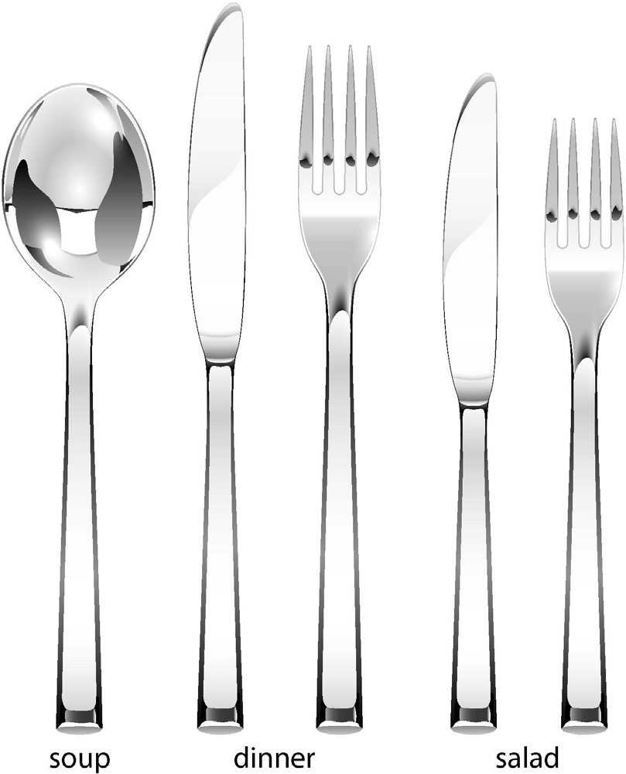
Create Your Own Place Setting
© 2015 Personal Impact International

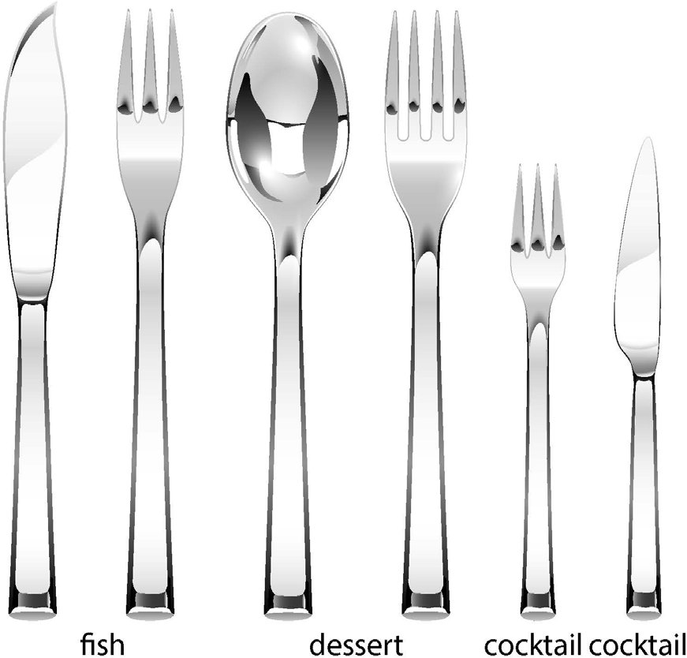
Create Your Own Place Setting
© 2015 Personal Impact International

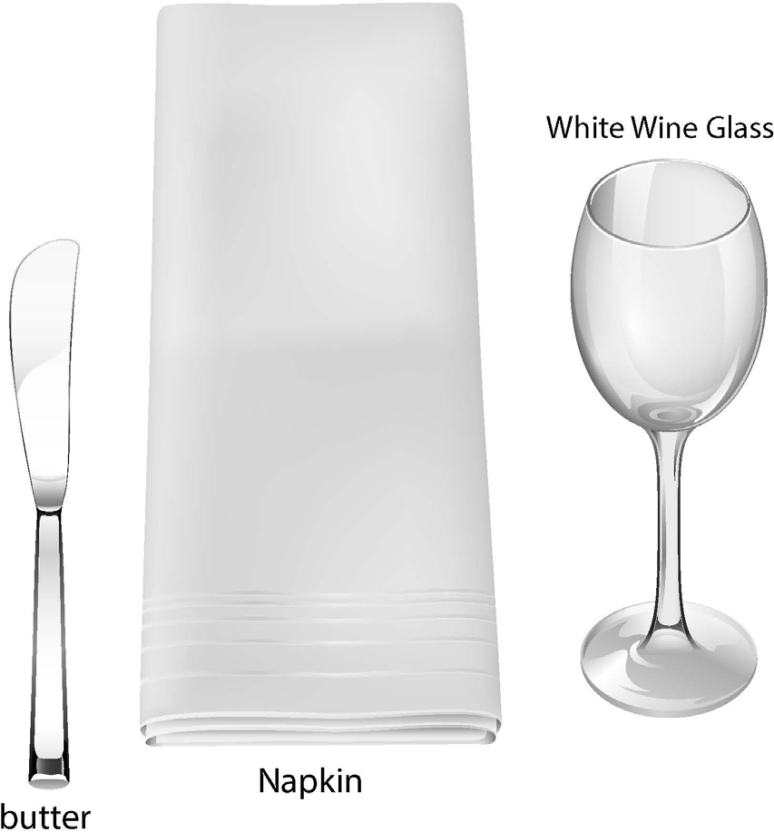
Create Your Own Place Setting
© 2015 Personal Impact International

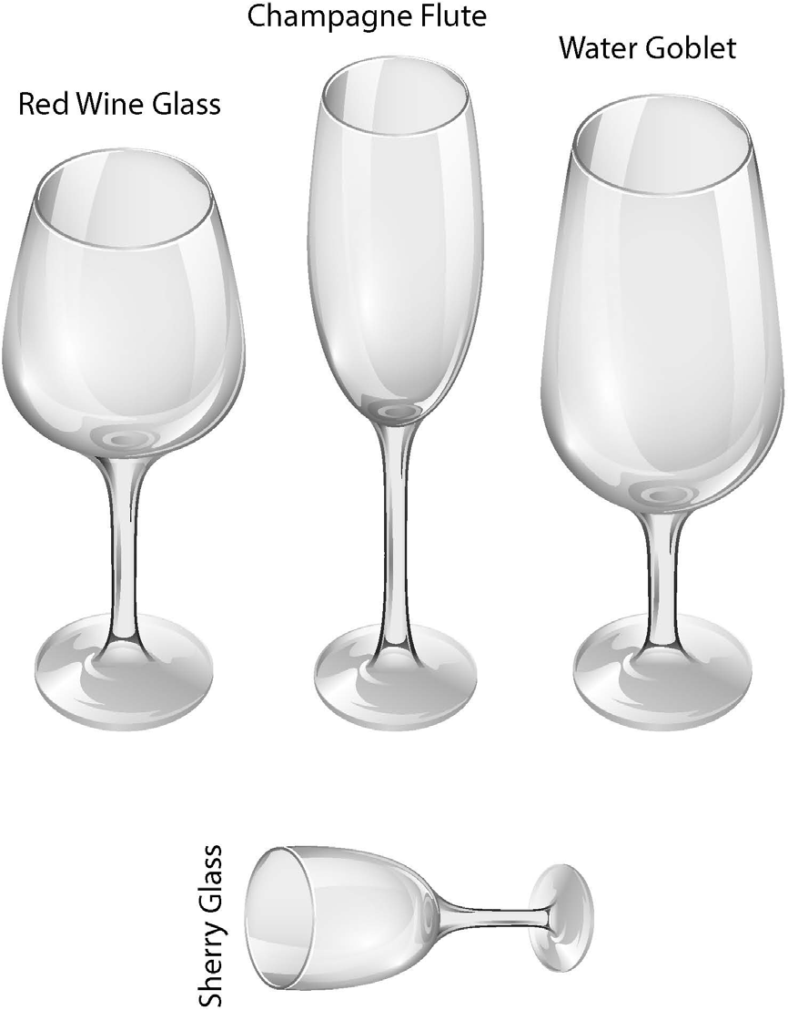
Create Your Own Place Setting
© 2015 Personal Impact International

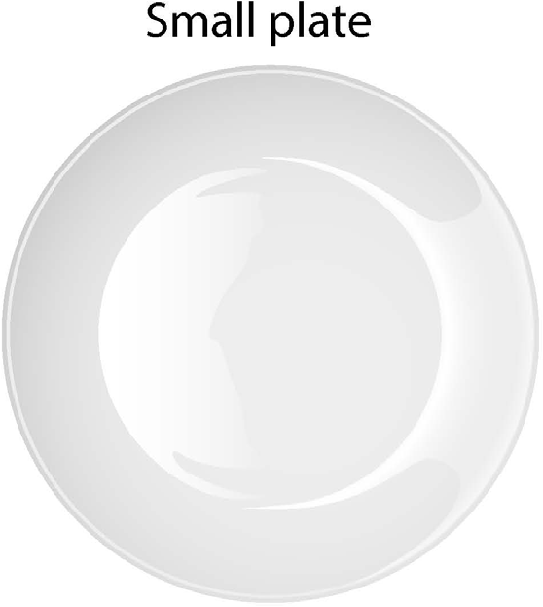
Create Your Own Place
Setting
© 2015 Personal Impact International

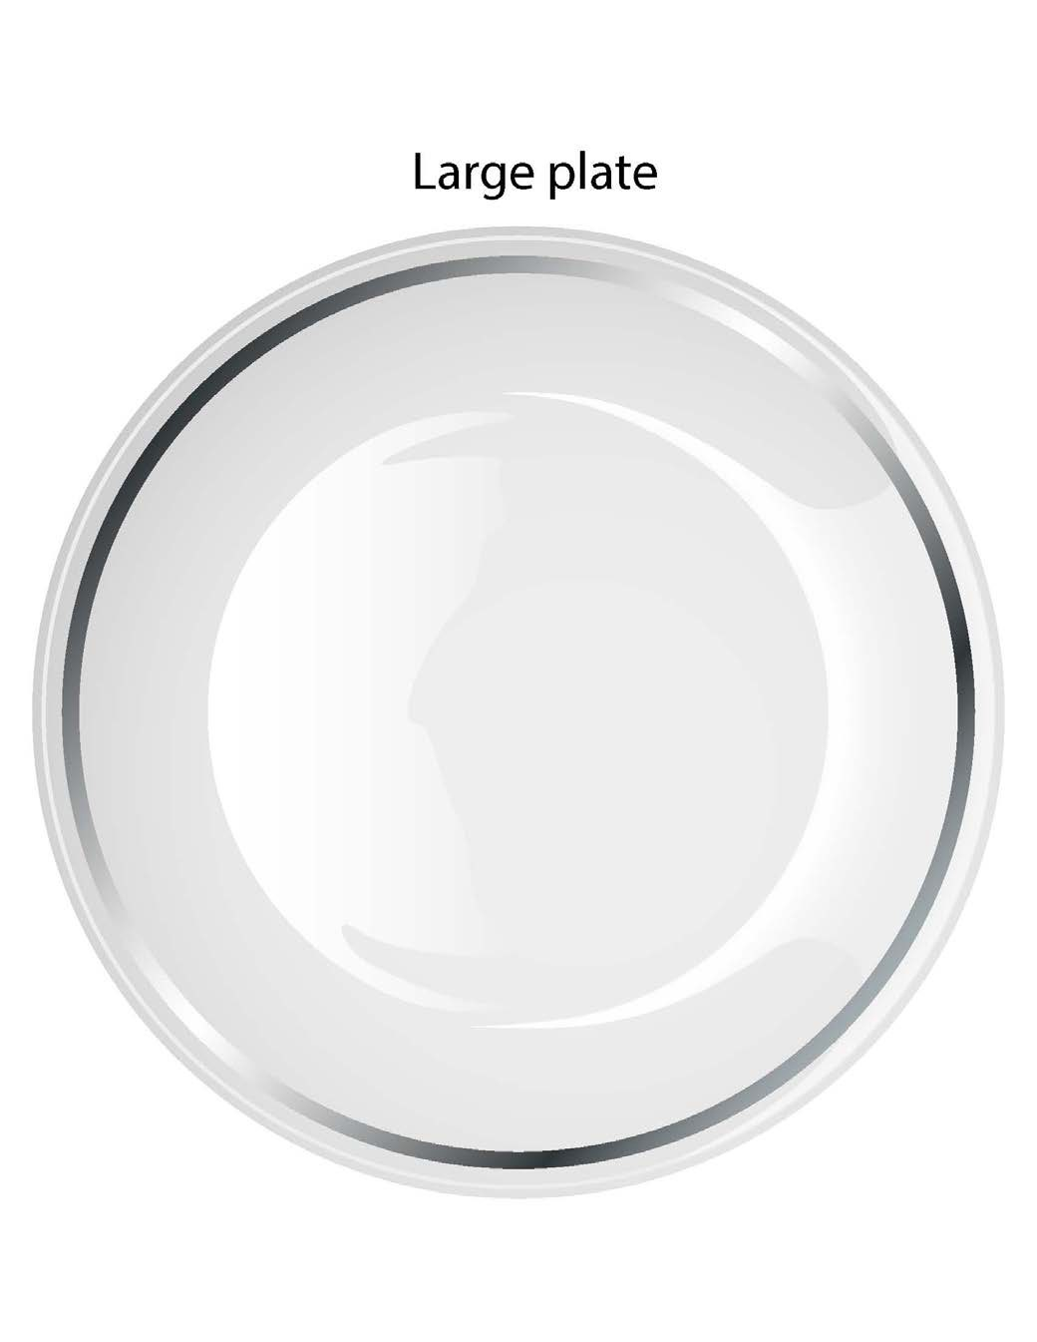
Create Your Own Place Setting
© 2015 Personal Impact International

