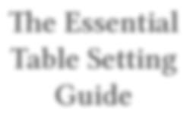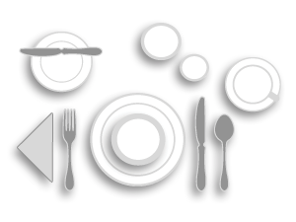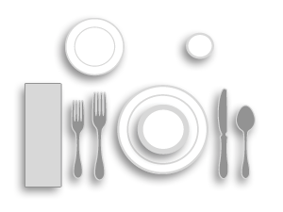
The Essential Table Setting Guide
Proper table setting is an art form. Whether casual or formal, traditional or modern, presentation is everything. When properly set, tableware arrangements enhance the dining experience.
Make a lasting impression using our ﬂatware, dinnerware and drinkware setting tips. This guide gives a quick summary of the proper use of china, ﬂatware and glassware and how much to keep on hand. Happy setting!
Table Settings by Meal
Breakfast
Flatware: Dinner Fork, Dinner Knife, Teaspoon, Butter Knife
Dinnerware: Dinner Plate, Cereal Bowl, B&B Plate, Coﬀee/Tea Cup & Saucer
Quick Tip
The ﬁrst meal of the day typically has a more relaxed, casual feel.
Keep the number of utensils at a minimum.
Drinkware: Water Tumbler or Juice Glass
Accessories: Napkin
Lunch
Flatware: Salad Fork, Dinner Fork, Dinner Knife, Teaspoon
Dinnerware: Dinner Plate, Soup Bowl, B&B Plate
Drinkware: Water Tumbler Accessories: Napkin
Quick Tip
Lunch can be a casual or upscale aﬀair. Pare down your presentation for informal settings.
Dinner
Flatware: Salad Fork, Dinner Fork, Butter Knife, Dinner Knife, Teaspoon
Dinnerware: Dinner Plate, Salad Plate, Soup Bowl, B&B Plate
Drinkware: Water Tumbler, Wine Glass Accessories: Napkin
Quick Tip
How you dress the table depends entirely on how sophisticated your dining room feels. To enhance the look of your tables at dinner, add a tablecloth or placemats, and consider candle lighting and other accents.
Table Setting Guide information courtesy of Oneida and Churchill
1 | www.rwsmithco.com
info@rwsmithco.com

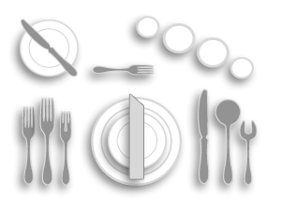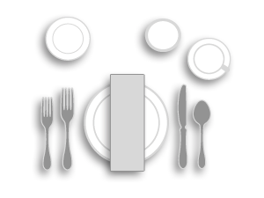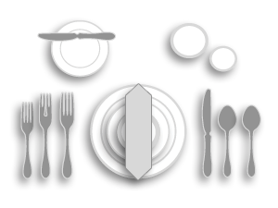
Formal Dinner
Flatware: Salad Fork, Fish Fork, Dinner Fork, Butter Knife, Dinner Knife, Soup/Bouillon Spoon, Teaspoon
Dinnerware: Dinner Plate, Salad Plate, Soup Bowl, B&B Plate
Drinkware: Wine Glass, Water Goblet, Champagne Flute
Accessories: Napkin
Quick Tip
Formal dining room settings require more ﬂatware and glassware pieces than casual settings. When using this display, utensils should be placed in order of the courses oﬀered, allowing guests to work from the outside in, toward the plate.
European Dinner
Flatware: Cocktail Fork, Salad Fork, Fish Fork, European Dinner Fork, Butter Knife, European Dinner Knife, Soup/Bouillon Spoon, Teaspoon, Dessert Spoon
Dinnerware: Dinner Plate, Salad Plate, B&B Plate
Drinkware: Red Wine Glass, White Wine Glass, Sherry Glass
Accessories: Napkin
Quick Tip
This tabletop conﬁgura- tion is intended for the most opulent occasions and typically includes a ﬁsh course.
Banquet / Brunch
Flatware: Salad Fork, Dinner Fork, Dinner Knife
Dinnerware: Dinner Plate, B&B Plate, Coﬀee/Tea Cup & Saucer
Drinkware: Water Goblet Accessories: Napkin
Quick Tip
This type of table display is ideal for events and buﬀet-style service.
Forgo the dinner plate when they are stacked at the initial serving station.
Insights and Best Practices for Setting an Unforgettable Table
Infuse diﬀerent shapes and sizes to bring appeal and excitement to your table presentation
Consider table size and portions when planning your settings
Choose colors, textures and styles that complement the overall look of your dining room
For more tips on table setting, view these resources:
The Emily Post Institute – Table Setting Guides
Etiquette Scholar – Table Setting
Oneida – Table Setting Guide
2 | www.rwsmithco.com
info@rwsmithco.com

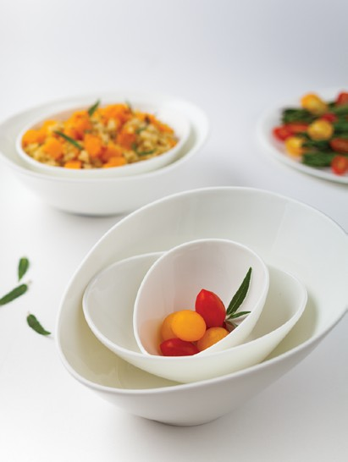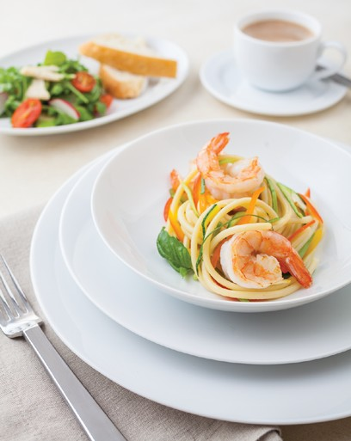
Functionality is more important than accents – make the dining experience your primary focus
Train staﬀ on the proper handling and care of tabletop products to reduce breakage and control costs
Allow at least 24 inches for each place setting
Keep all tableware approximately one inch from the edge of the table
Place all knives with the cutting edge toward the plate
Arrange ﬂatware in order of use, working from the outside toward the plate for each course served
If salad is served after entrée, place salad fork next to plate
Glass placement: from right to left, white wine, red wine, and water/iced beverage. Champagne may be placed behind red and white wine glasses.
A seafood/cocktail fork is always placed to the right of the soup spoon, unless served with a seafood cocktail. It may be placed on the cocktail plate.
Make it neat and straight, with all pieces generally equidistant from each other
Table Setting Beneﬁts

Maximize Your Investment
The number of place settings should match daily usage and the types of specialty pieces should match the menu. Too many items are unnecessary, too few means extra warewashing.
Control Sanitation Costs
The correct place settings for each meal during the day will eliminate warewashing of unnecessary pieces, saving you money.
Create the Proper Ambience/Atmosphere
A customer’s ﬁrst impression is their lasting impression. Make the atmosphere of your establishment unforget- table with a table setting presentation that inspires your guests, and complements the menu and decor.
3 | www.rwsmithco.com
info@rwsmithco.com

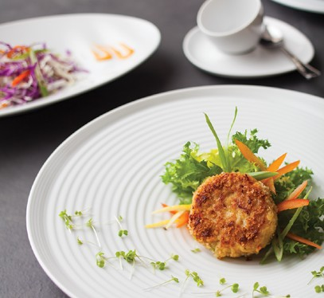
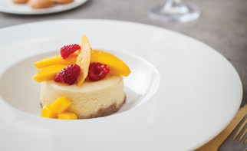
Importance of
Proper Care, Handling & Ordering
Tableware is an invaluable investment for your restaurant. Though durable, commercial china, glass and ﬂatware experience high-volume and rigorous use. Extend the life of your tabletop supplies with our tips for proper handling, cleaning and storage.
In addition to proper handling, maintain correct supply levels to ensure smooth service and lessen warewashing demands for dinnerware, ﬂatware and glassware in your restaurant. Follow the ordering guidelines included here to calculate the quantities needed for your dining room.
USE OUR BUYING GUIDE TO ORGANIZE YOUR NEXT TABLETOP ORDER >>
China
Wash all china at least once before its ﬁrst use.
Do not put detergent directly onto china. An excessive concentration of alkaline detergent can cause permanent damage to decorations, especially those with gold and platinum.
A wash temperature of 60º C (140º F) is recognized as the most eﬀective. Excessively high water temperature will reduce the washing eﬃciency and may damage decorations.
Use racks and baskets made from plastic or ones that are plastic coated so items do not vibrate against each other.
In hard water areas, deposits may form on your china in time if the water is allowed to dry on the china.
These soluble deposits can easily be removed with a diluted acid such as vinegar.
The most severe test of chinaware quality and cost eﬀectiveness is its ability to maintain appearance and resist damage and breakage under the demanding conditions of bussing, scraping, racking, warewashing, and storage.
Washing
Unattractive stains and discolorations can be caused by inattention to cleaning procedures such as allowing china to remain unwashed after use, pre-soaking in water over 160°F, improper detergent concentrations, hard water or iron content, lime content in old equipment, and clogged or eroded spray nozzles. The above can be avoided with these easy to follow tips.
Metal Markings
Metal markings are the appearance of small black marks on the surface of a ceramic product and are caused if two hard substances are rubbed together. These marks are also known as “pencil marks” and can be caused by mineral deposits of metal from certain types of ﬂatware.
Lower grade ﬂatware is softer and is more prone to leaving marks. Markings can also be caused by metal surfaces such as dishwashers and drainers and can usually be successfully removed by rubbing with vinegar, a mild bleach solution, lemon juice and proprietary cleaners.
4 | www.rwsmithco.com
info@rwsmithco.com

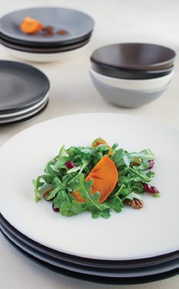
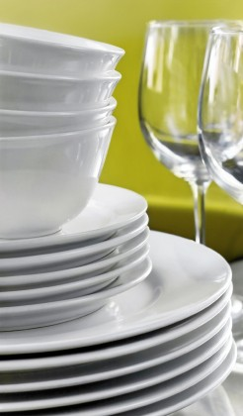
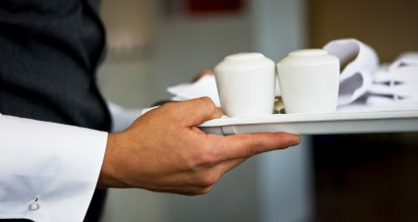
Remember to:
Stack china to the proper level Sort all items in bus tray
Have an adequate supply of china for rush periods
Carry dishes carefully Place cups in racks
Keep receiving area neat and clean
Remove scraps carefully with rubber scraper or water spray
Load like items in each dish rack
Avoid:
Stacking cups
Carrying more dishes than you can safely handle Overloading bus trays
Allowing dirty dishes to pile up
Using abrasive pads or other dishes to remove scraps
Loading loose, mixed items into the dishwasher Stacking dishes more than 16 inches high
China Ordering Guide • Bowls
To determine the needed quantity of each item, multiply the number of seats times the ordering factor for each item.
Care, Handling & Order Guide information courtesy of Churchill, Libbey and Royal Doulton.
5 | www.rwsmithco.com
info@rwsmithco.com
ITEMS SUGGESTED USE FAST FOOD DINING BANQUET CATERING

Bouillon, Handled or Unhandled
Soup, Packaged Sugar, Custard, Egg Cup, Crackers, Condiments, Gelatin
1

1 1/2

1 1/2

1 1/2

4 1/4” – 5”
Fruit Bowl
“Monkey” Dish for Vegetables, Fruits, Puddings, Desserts, Bake & Serve
2

3

6

2 1/2

8 7/8” – 9 1/4”
Rim Deep Soup
A La Carte Soup, Salad, Pasta, Chili, Oyster Stew, Bouillabaisse

1/2

1/2

-

1/2

11” – 12 1/2” Pasta Bowl
Entrée Pastas, Salads
1/2
1/2
-
1/2

China Ordering Guide • Plates
To determine the quantity of each item, multiply the number of seats times the ordering factor shown for each item. Then, order the closest dozen quantity.
China Ordering Guide • Pitchers & Mugs
To determine the quantity of each item, multiply the number of seats times the ordering factor shown for each item. Then, order the closest dozen quantity.
6 | www.rwsmithco.com
info@rwsmithco.com
ITEMS SUGGESTED USE FAST FOOD DINING BANQUET CATERING
Coﬀee/Tea Cup

Coﬀee, Tea, Hot Chocolate, Soup
3

3

2

2

Mug
Hot & Cold Beverages
3
3
2
2
Coﬀee/Tea Saucer

Underliner for Cups, Bouillon, Fruit
3
3
2
2
Coﬀee/Teapot
Hot & Cold Beverages
1/3
1/3
-
1/3
Creamer, 3.50 oz

Cream for Beverages, Syrup, Melted Butter
1/2

1/2

-

1/2

ITEMS SUGGESTED USE FAST FOOD DINING BANQUET CATERING
5 1/2” – 6 1/8”
Plate
Bread & Butter, Desserts, Bouillon Underliner
1 1/2

2

6

2

7 1/2” – 7 1/8”
Plate

Sandwiches, Salads, Desserts, Underliner for Grapefruit, Salad Bowls

1 1/2

2

-

2

8 1/2” – 9 1/8”
Plate

Luncheon, Entrée, Dinner Plate, Pastries,
Underliner for Salad Plate

1 1/2

2

2

2

9 3/4” – 10”
Plate

Dinner, Breakfast, Luncheon, Steaks, Underliner for Salad

1 1/2

3

2

1 1/2

10 1/4” – 10 3/8”
Plate

Entrée, Steaks, Prime Rib, Fish, Mexican Dishes, Service Plate, Poultry

2

2

-

1

7 1/4” – 9 7/8”
Oval Plate/Bowl
Baked Potato, Asparagus, Salad, Cold Seafood
1
1 1/2

-

1

11” – 15”
Large Platter

Steaks, Fish, Soup & Sandwich, Lobster, Prime Rib, Surf N’ Turf, Sandwich Underliner

1

1 1/2

1/2

1

Service Plate 12” – 13”

Tabletop Decoration, Place Plate, Serving Plate, Special Presentations

1 1/2

1 1/2

-

1 1/2

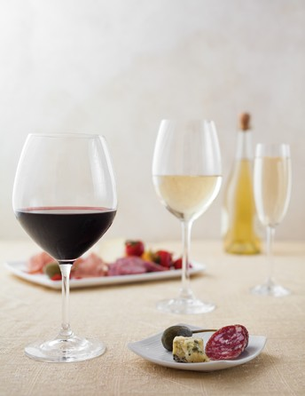
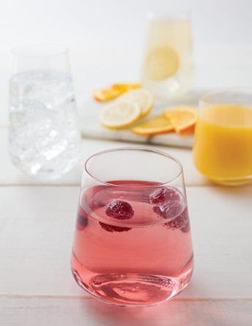
Glassware
Remember to:
Keep adequate supplies of glassware on hand in order to prevent recently washed items from going directly into service
Check dishwasher temperature twice daily Replace worn glass washer brushes
Bus glassware directly into racks, or use divided bus trays with ﬂatware baskets
Pre-heat glasses with hot water when pouring hot drinks
Handle glassware gently; remove abraded, cracked, or chipped glassware from service
Dump ice and let glassware reach room temperature before washing
Remove glasses from bus pans one at a time Clean (scrape) glassware, ﬂatware and then china Store glasses in their properly sized glass racks
Avoid:
Putting cold water or ice into a warm or hot glass Picking up glasses in bouquets
Stacking glasses Scooping ice with glasses
Glass-to-glass contact in overhead racks and anywhere else
Contacting glasses with the beer tap Putting ﬂatware into glasses
Restaurant glassware is varied with numerous uses and styles. For information on diﬀerent glassware types, proper care and optimal storage, view our comprehensive Glassware Guide.
Care, Handling & Ordering Guide information courtesy of Churchill, Libbey and Royal Doulton.
7 | www.rwsmithco.com
info@rwsmithco.com

Glass Ordering Guide • Restaurants
Glass Ordering Guide • Banquets
Glass Ordering Guide • Room Service
Upgrade Your
Room Service Program
Helpful Tips >>
Care, Handling & Ordering Guide information courtesy of Libbey.
8 | www.rwsmithco.com
info@rwsmithco.com
ITEMS
8 oz Tumbler Glassware
Minimum 2 to a room
Ashtray
Minimum 2 to a room
Floral Accessories
Minimum 1 to a room
ITEMS 100 SEATS 200 SEATS 300 SEATS
(in dozens) (in dozens) (in dozens)
5 oz Juice Glass
12
24
36
12 oz Iced Tea Glass
12
24
36
10 oz Water Goblet
24
48
72
5.50 oz Sherbet
12
24
36
6 oz Flute
12
24
36
8.50 oz Wine Glass
12
24
36
Sugar Packet Holder
10
20
30
ITEMS 100 SEATS 200 SEATS 300 SEATS
(in dozens) (in dozens) (in dozens)
5 oz Juice Glass
12
24
36
12 oz Iced Tea Glass
12
24
36
10 oz Water Glass
24
48
72
6 oz Sherbet
12
24
36
6 oz Flute
12
24
36
Sugar Packet Holder
10
20
30

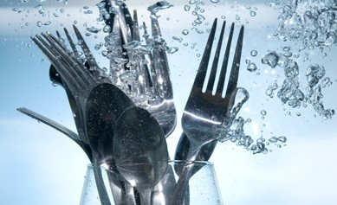
Flatware
Presoaking Tips
Presoaking is recommended, after which utensils should be immediately washed in high temperatures — low temperatures or chlorine baths will attack silver and metal. To prevent corrosion and ﬁlm build-up, ﬂatware must be rinsed thoroughly and dried immediately after rinsing.
Remember To:
Load ﬂatware into presoak containers immediately after use
Change presoak solution frequently
Store ﬂatware in a dry area away from cooking fumes and corrosive materials
Wash ﬂatware in a vertical position in temperatures above 135˚F, and rinse in clean water at 180˚F
Use a nonabrasive, noncorrosive cleaning agent and a water softener or wetting agent
Avoid:
Presoaking ﬂatware for longer than 15 minutes
Loading ﬂatware into aluminum, copper, or copper alloy containers for presoaking; use only plastic or stainless steel
Putting ﬂatware into glasses or cups Leaving ﬂatware soiled overnight
Flatware Ordering Guide
This chart is based on standard restaurant settings. Your speciﬁc need may vary according to individual operation. Multiply your number of seats by the ordering factors listed below for an approximation. Your reserve stock should be at least 25% of that in active service. *Accessory items to be considered separately, depending on type of service and menu.
Care, Handling & Ordering Guide information courtesy of Libbey.
9 | www.rwsmithco.com
info@rwsmithco.com
ITEMS DELUXE SEMI-FORMAL STANDARD
Teaspoon
5
3
3
Dessert Spoon
2
2
2
Tablespoon
1/4
1/4
-
Iced Tea Spoon
1 1/2
1 1/2
1 1/2
Demitasse Spoon
2
-
-
Bouillon Spoon
2
2
2
Utility/Dessert Fork
3
3
3
Dinner Fork
2
-
-
Salad or Fish Fork
*
*
*
Cocktail Fork
1 1/2
1 1/2
1 1/2
Dinner Knife
2
1 1/2
1 1/2
Utility/Dessert Knife
2
1 1/2
*
B&B Knife or Butter Spreader
2
-
-
Steak Knife
*
*
-
Fish Knife
*
*
-

