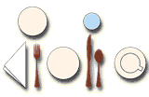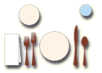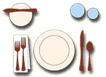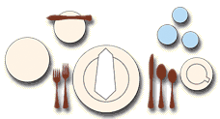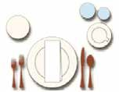
Unit 10 tics, food and entertainment
Table setting at the restaurant
S
etting the tables at restaurants follows some precise rules. These are five of the most common table settings found in restaurants.
Breakfast:
Flatware:
Dinner Fork, Dinner Knife, Teaspoon
Dinnerware: Two Bread & Butter Plates, Cup, Saucer
Glassware:
Water Glass, Juice Glass
Lunch:
Flatware:
Salad Fork, Dinner Fork, Dessert or Dinner Knife, Teaspoon
Bread & Butter Plate, Luncheon Plate Water Glass
Dinnerware: Glassware:
Informal Dinner:
Flatware:
Salad Fork, Dinner Fork, Dinner Knife, Teaspoon, Butter Knife
Dinnerware: Bread & Butter Plate, Salad Plate, Dinner Plate
Glassware: Water Goblet, Wine Glass
Formal Dinner:
Flatware:
Salad Fork, Dinner Fork, Dinner Knife, Oval Bowl Soup/Dessert Spoon or Dinner Spoon, Teaspoon, Butter Knife
Dinnerware: Bread & Butter Plate, Two Salad
Plates, Service Plate, Cup & Saucer
Glassware: Water Goblet, Champagne Flute, Wine Glass
Banquet/Brunch:
Flatware:
Salad Fork, Dinner Fork, Dinner Knife, Teaspoon
Dinnerware: Bread & Butter Plate, Salad Plate, Dinner Plate, Cup & Saucer
Glassware:
Water Glass or Water Goblet, Wine Glass
Tips:
- Allow about 60 cm for each place setting.
- Keep all tableware approximately 3 cm from the edge of the table.
- Place all knives with the cutting edge toward the plate.
- Arrange flatware in order of use, working from the outside toward the plate for each course served. If salad is served after entree, place salad fork next to plate.
- Glass placement: from right to left, white wine, red wine, and water/iced beverage. Champagne may be placed behind red and white.
- A seafood/cocktail fork is always placed to the right of the soup spoon, unless served with a seafood cocktail. It may be placed on the cocktail plate.
1
Map the World - Copyright © EDISCO Editrice - Vietata la vendita e la diffusione

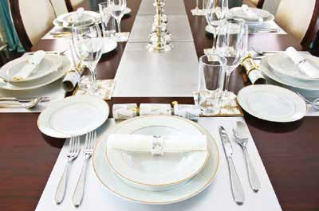
Unit 10 tics, food and entertainment • Table setting at the restaurant
1 Read the instructions a new waiter has written down to remember how to lay the tables and correct his six mistakes.
S
tart with the forks. Put them to the right of the plate. Remember the fork closest to the
plate is for salad. Don’t forget that the dinner plate is already on the table when the guests sit down. The salad plate is placed to the left of the forks. When you place the
knife, this goes on the right side, with the blade facing the guest. The soup spoon is on the far right of the outside knife. The small bread plate is placed above the forks, above and to the left of the service plate. The butter spreader is laid with the other knives. As for the glassware, you can have one water goblet and one or more wine glasses. Put the water goblet as far as possible from the hand, so that they don’t tip it over. At least one wine glass should sit to the
right and possibly above the water glass. Then for the napkin…
2
Reply to an email from one of your customers who wants both a confirmation of his booking and to know how the table setting for the breakfast session he has booked for his colleagues will be.
3
Using the drawings on the previous page, describe the lunch and formal dinner settings.
4
1.
2.
3.
4.
5.
6.
Translate.
Potete spiegare come preparereste i tavoli per il nostro pranzo formale? Qual è la preparazione tradizionale della tavola per una colazione di lavoro? Potete dirmi dove mettere le posate?
Posizionate tutti i coltelli con la lama rivolta verso il piatto.
Il piatto dell’insalata è posizionato alla sinistra delle forchette. Un coltello da bistecca può sostituire il coltello da tavola.
2
Map the World - Copyright © EDISCO Editrice - Vietata la vendita e la diffusione

