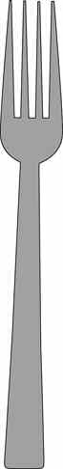
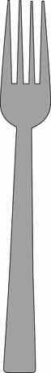
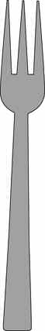
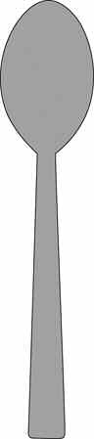
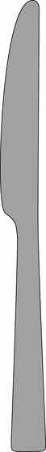
SETTING THE TABLE
Glossary of Table Setting Utensils:
Spoon
Dinner Fork
Salad Fork
Knife
Dessert
Napkin
4-H Special Foods Handbook
14









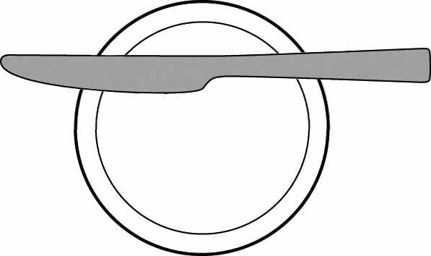
Milk Glass
Juice/Water Glass
Dinner Plate
Salad Plate
Cup and Saucer
Dessert Cup
Dessert Plate
Bread and Butter Plate with Knife
Bowl
4-H Special Foods Handbook
15

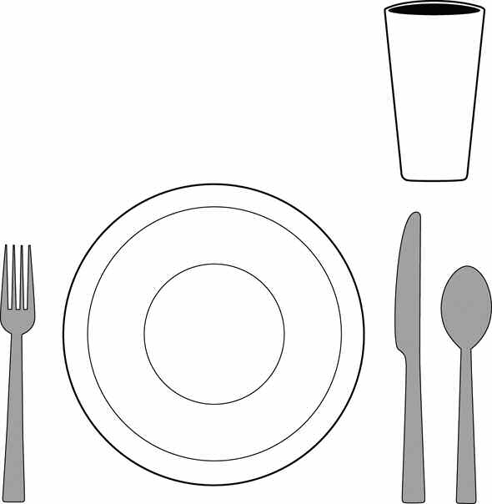
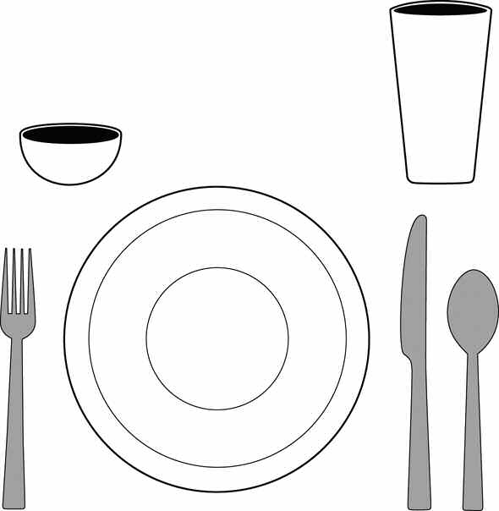
Basic Table Setting:
(may be used at any meal)
Your menu and recipe influence the number and type of dinnerware, flatware, and glasses/cups that you choose for your place setting.
Unfolded Napkin
Folded Napkin
Fold
Open edges
Fold
Grilled Reuben Sandwich Dill Pickles
German Potato Salad Milk
Open edges
Fold
Turkey Tetrazzini Crisp Relishes French Bread Chocolate Pudding Milk
Open edges
4-H Special Foods Handbook
16

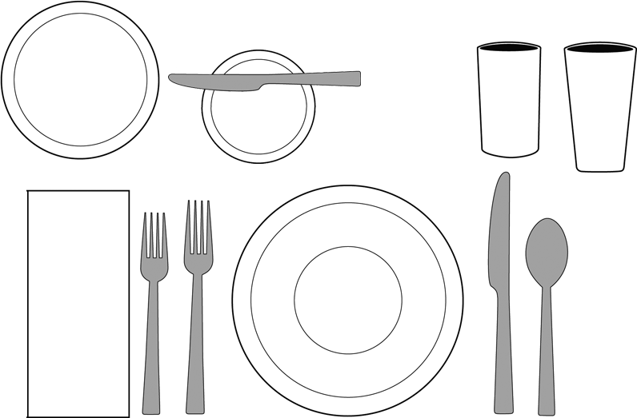
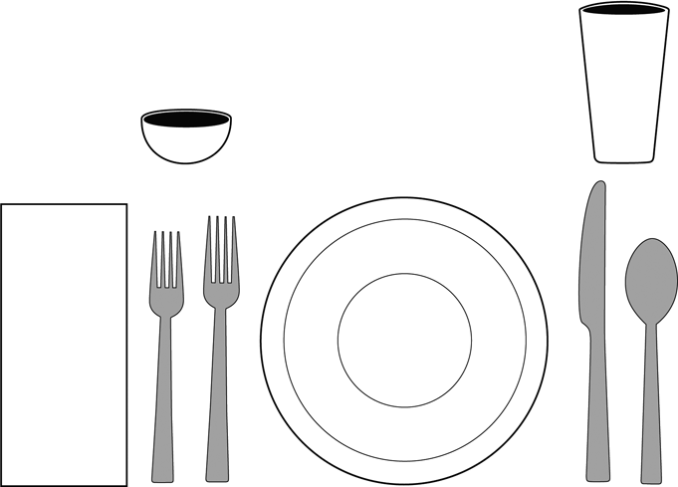
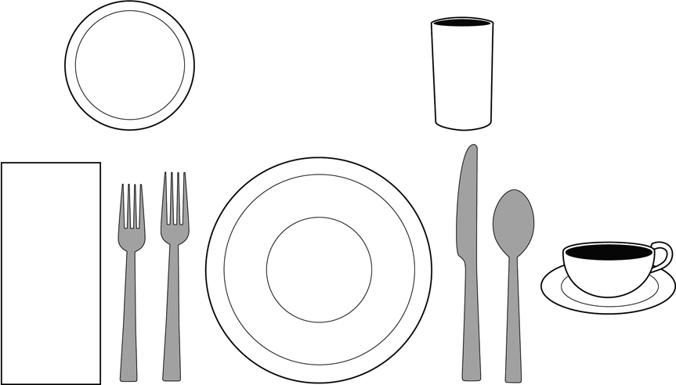
Dinner/Lunch:
Your menu and recipe influence the number and type of dinnerware, flatware, and glasses/cups that you choose for your place setting. In casual family settings, bread plates are often not needed.
Sweet & Sour Pork Chow Mien Noodles Asparagus-Lettuce Salad Fan-Tan Rolls
Milk Iced Tea
Raspberry Pie (the dessert is served following the meal)
Tossed Green Salad
Lasagna Skillet Zucchini Garlic Bread
Fresh Fruit Compote Cookies
Milk
(Salad served before meal)
Beef Roll-Ups Buttered Noodles
Green Peas w/ Mushrooms Perfection Salad
Crusty Rolls Coffee Milk
Blueberry Cheesecake (the dessert is served following the meal)
4-H Special Foods Handbook
17

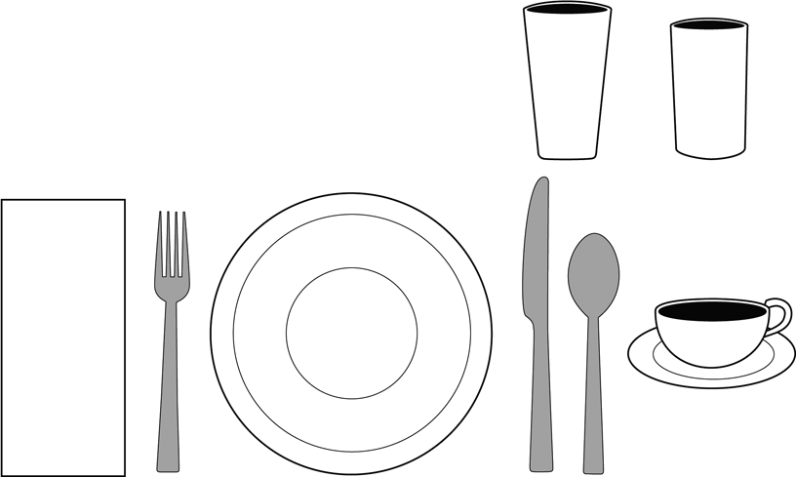
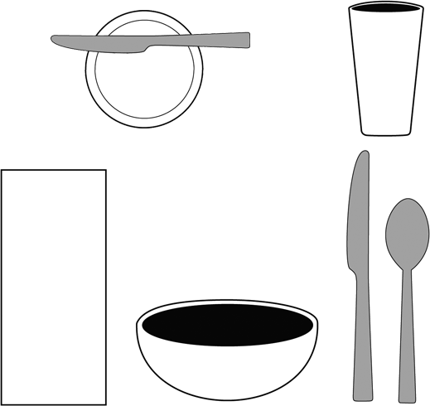
Breakfast:
Your menu and recipe influence the number and type of dinnerware, flatware, and glasses/cups that you choose for your place setting.
Tomato Juice Toasted English Muffins
Sausage Links Milk Coffee
Oatmeal Granola with Fresh Strawberries
*Toast Orange Marmalade Milk
*May use a separate bread plate or the plate under the bowl.
4-H Special Foods Handbook
18

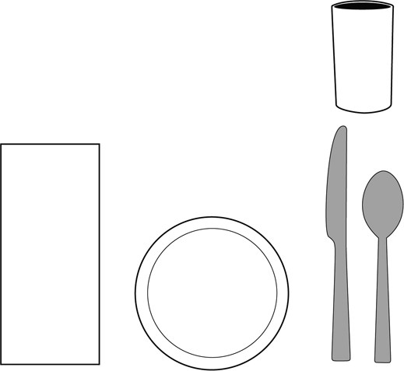
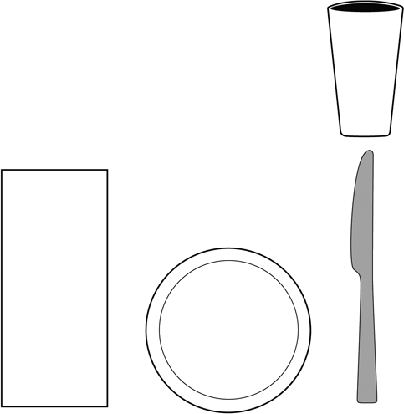
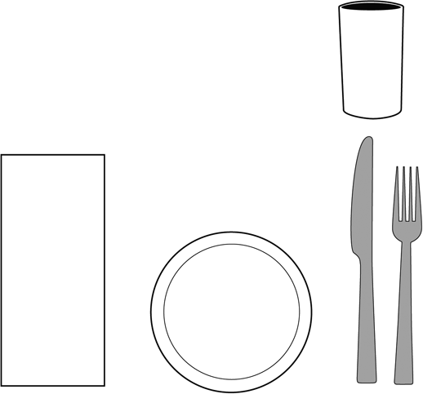
Snack Menu:
Your menu and recipe influence the number and type of dinnerware, flatware, and glasses/cups that you choose for your place setting.
Lemon Bread
Refreshing Orange Sipper
Whole Wheat Muffins
Whipped Strawberry Butter
Milk
Pizza Sandwiches
Strawberry-flavored Milk
4-H Special Foods Handbook
19

