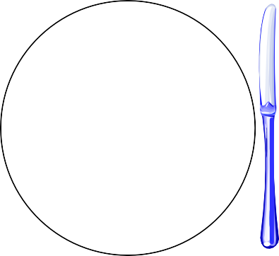
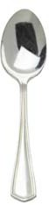
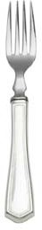
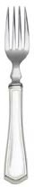
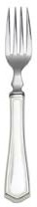
Formal Table Setting
Bread & Butter Plate
Salad
Water Glass
Milk Glass
Dinner Plate
Cup & Saucer
Forks
Salad, Dinner, Dessert
Knife, Spoon

Napkin

