 |  |  |  |  |  | © TemplateLab.com
 | 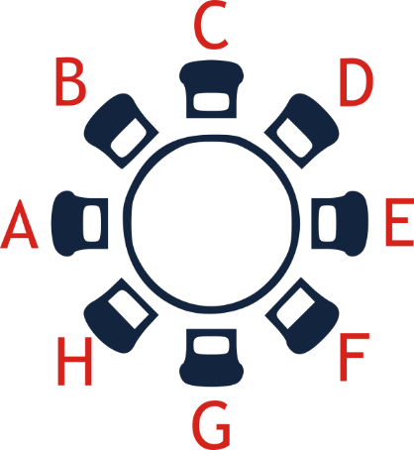  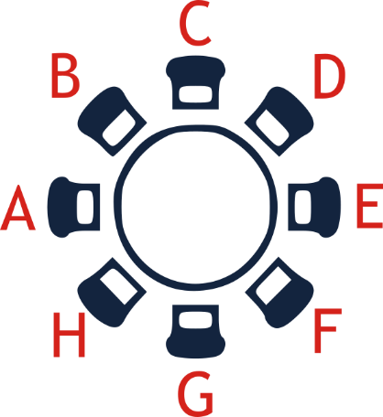  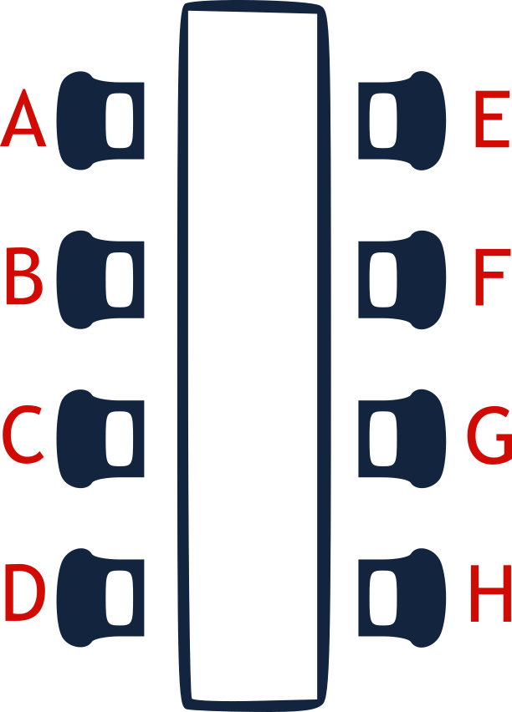  BANQUET Seating Chart  1  2  3  4  5  6  7  8 |  |  |  |  | © TemplateLab.com
 | TABLE #1 |  |  | TABLE #5 |  | © TemplateLab.com
 | A | Mina Davis |  | A | -------------- | © TemplateLab.com
 | B | Daren Ford |  | B | -------------- | © TemplateLab.com
 | C | Michael Red |  | C | -------------- | © TemplateLab.com
 | D | Forest Houston |  | D | -------------- | © TemplateLab.com
 | E | Deborah Tucson |  | E | -------------- | © TemplateLab.com
 | F | Barry Bolden |  | F | -------------- | © TemplateLab.com
 | G | Phoenix Fox |  | G | -------------- | © TemplateLab.com
 | H | Neil Armstrong |  | H | -------------- | © TemplateLab.com
 | TABLE #2 |  |  | TABLE #6 |  | © TemplateLab.com
 | A | -------------- |  | A | -------------- | © TemplateLab.com
 | B | -------------- |  | B | -------------- | © TemplateLab.com
 | C | -------------- |  | C | -------------- | © TemplateLab.com
 | D | -------------- |  | D | -------------- | © TemplateLab.com
 | E | -------------- |  | E | -------------- | © TemplateLab.com
 | F | -------------- |  | F | -------------- | © TemplateLab.com
 | G | -------------- |  | G | -------------- | © TemplateLab.com
 | H | -------------- |  | H | -------------- | © TemplateLab.com
 | TABLE #3 |  |  | TABLE #7 |  | © TemplateLab.com
 | A | -------------- |  | A | -------------- | © TemplateLab.com
 | B | -------------- |  | B | -------------- | © TemplateLab.com
 | C | -------------- |  | C | -------------- | © TemplateLab.com
 | D | -------------- |  | D | -------------- | © TemplateLab.com
 | E | -------------- |  | E | -------------- | © TemplateLab.com
 | F | -------------- |  | F | -------------- | © TemplateLab.com
 | G | -------------- |  | G | -------------- | © TemplateLab.com
 | H | -------------- |  | H | -------------- | © TemplateLab.com
 | TABLE #4 |  |  | TABLE #8 |  | © TemplateLab.com
 | A | -------------- |  | A | -------------- | © TemplateLab.com
 | B | -------------- |  | B | -------------- | © TemplateLab.com
 | C | -------------- |  | C | -------------- | © TemplateLab.com
 | D | -------------- |  | D | -------------- | © TemplateLab.com
 | E | -------------- |  | E | -------------- | © TemplateLab.com
 | F | -------------- |  | F | -------------- | © TemplateLab.com
 | G | -------------- |  | G | -------------- | © TemplateLab.com
 | H | -------------- |  | H | -------------- | © TemplateLab.com

