SEATING CHART
SEATING CHART
BUS
BUS
 |  |  |  |  | 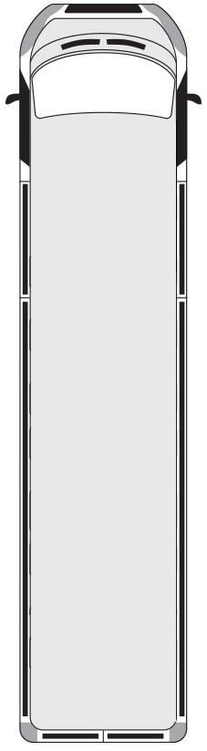
 | Mike Parish | 1 |  |  |  |  |  | 3 | Rita Wilkinson
 | Eliot Corry | 2 |  |  |  |  |  | 4 | Harry Dwayne
 | David Richardson | 5 |  |  |  |  |  | 7 | Omar Porter
 | Kolby Nils | 6 |  |  |  |  |  | 8 | Kelly Simpson
 | Lorem Ipsum | 9 |  |  |  |  |  | 11 | Lorem Ipsum
 | Lorem Ipsum | 10 |  |  |  |  |  | 12 | Lorem Ipsum
 | Lorem Ipsum | 13 |  |  |  |  |  | 15 | Lorem Ipsum
 | Lorem Ipsum | 14 |  |  |  |  |  | 16 | Lorem Ipsum
 | Lorem Ipsum | 17 |  |  |  |  |  | 19 | Lorem Ipsum
 | Lorem Ipsum | 18 |  |  |  |  |  | 20 | Lorem Ipsum
 | Lorem Ipsum | 21 |  |  |  |  |  | 23 | Lorem Ipsum
 | Lorem Ipsum | 22 |  |  |  |  |  | 24 | Lorem Ipsum
 | Lorem Ipsum | 25 |  |  |  |  |  | 27 | Lorem Ipsum
 | Lorem Ipsum | 26 |  |  |  |  |  | 28 | Lorem Ipsum
 | Lorem Ipsum | 29 |  |  |  |  |  | 31 | Lorem Ipsum
 | Lorem Ipsum | 30 |  |  |  |  |  | 32 | Lorem Ipsum
 | Lorem Ipsum | 33 |  |  |  |  |  | 35 | Lorem Ipsum
 | Lorem Ipsum | 34 |  |  |  |  |  | 36 | Lorem Ipsum
 | Lorem Ipsum | 37 |  |  |  |  |  | 39 | Lorem Ipsum
 | Lorem Ipsum | 38 |  |  |  |  |  | 40 | Lorem Ipsum
 | Lorem Ipsum | 41 |  |  |  |  |  | 43 | Lorem Ipsum
 | Lorem Ipsum | 42 |  |  |        |  |  | 44 | Lorem Ipsum
 | Lorem Ipsum | 45 |  |  |  |  |  | 47 | Lorem Ipsum
 | Lorem Ipsum | 46 |  |  |  |  |  | 48 | Lorem Ipsum

