Team
Players
Level
Set 1
Set 2
Set 3
Winner

League |  | Result Date
Home |  | Season
Opponent |  | Location

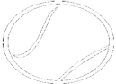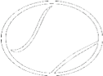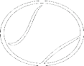
Team | Players | Level | Set 1 | Set 2 | Set 3 | Winner
H
O

Team | Players | Level | Set 1 | Set 2 | Set 3 | Winner
H
O

Team | Players | Level | Set 1 | Set 2 | Set 3 | Winner
H
O

Team | Players | Level | Set 1 | Set 2 | Set 3 | Winner
H
O

Team | Players | Level | Set 1 | Set 2 | Set 3 | Winner
H
O

Team | Players | Level | Set 1 | Set 2 | Set 3 | Winner
H
O

