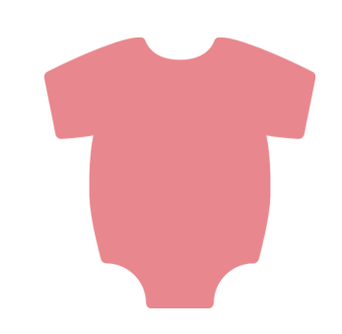

WHAT IS THE BEST TASTING
BABY FOOD FLAVOR?
05
09
12
APRICOT
PEARS
CARROTS
15
23
BANANA
32
APPLE
PEACHES

