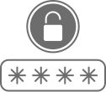
PASSWORD CARD
WEBSITE
USERNAME
PASSWORD
NOTE
WEBSITE
USERNAME
PASSWORD
NOTE
WEBSITE
USERNAME
PASSWORD
NOTE
WEBSITE
USERNAME
PASSWORD
NOTE
WEBSITE
USERNAME
PASSWORD
NOTE
WEBSITE
USERNAME
PASSWORD
NOTE

