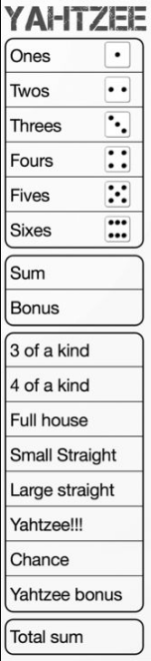 |  | Name | Name | Name | Name

