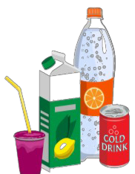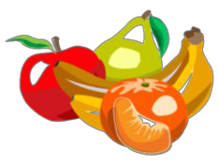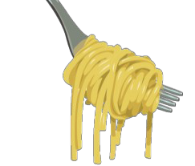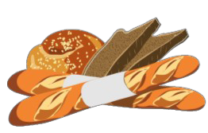
GroceryList
Dairy/Fridge Baking/Dry Goods Sauces/Condiments Frozen
□
□
□
□
□
□
□
□
□
□
□
□
□
□
□
□
□
□
□
□
□
□
□
□
Butter Cheese Shredded
String
Block/Sliced Heavy Cream Cream Cheese Dips
Eggs
Half & Half Milk
Sour Cream Yogurt

Oatmeal Oil Olive Oil
Coconut Oil
Vegetable Oil Shortening Sugar
Brown Sugar
Granulated Sugar Powdered Sugar Vanilla
Yeast

Mayonnaise Mustard Peanut Butter Salsa
Soy Sauce Steak Sauce Tarter Sauce

Fruits
Ice Cream Juice Pizza
Potato Products Vegetables

□
□
□
□
□
□
□
□
□
□
□
□
□
□
□

□
□
□
□
□
□
□
□

Beans/Pasta/Grains Fresh Vegetables

□
Beans

□
□
□
□
□
□
□
□
□
□
□
□
□
□
□
□
□
□
Asparagus Broccoli Carrots Cauliflower Celery Corn Cucumbers Lettuce Onions Peppers Potatoes Spinach Squash Tomatoes Zucchini

□
□
Lasagna
Mac and Cheese Noodle Mixes Ramen
Rice Brown Instant White Wild
Spaghetti

□
Canned Goods □
□
□
□
□
□
□
□
□
□
□
□
□
□
□
□
□
□
Applesauce Canned Beans Canned Fruits Canned Soups Carrots
Corn
Diced Tomatoes Green Beans Tomato Sauce Tuna
Spaghetti Sauce Canned Peas

□
□
□
□
□
□
□
□
□
□
□
□
□
□
Bacon Chicken Ground Beef Deli Meat Fish
Ham
Hot Dogs/Brats Pork
Sausage Turkey

□
□
□
□
□

□
□
□
□
□
□
□
□
□
□
□
□
□
□
□
Black Pepper Cinnamon Cumin Garlic
Onion Powder Oregano Paprika Parsley
Salt

□
□
□
□
□
□
□
□
□
□
□
□
Apples Bananas Berries Grapes
Lemons/Limes Melons Oranges Peaches
Plums

Drinks
□
□
□
□
□
□
□
□
□
□
□
Water Juice Soda Tea

□
Cereal

□
□
□
□
□
□

Pancake Mix Pop Tarts Syrup

Bakery

□
Sauces/Condiments □
□
Bagels Bread Buns
Pita Bread Rolls Tortillas

□
□
□
□
□
□
□
□
□

□
□
□
□
□
□
□
□
Baking Powder Baking Soda Canned Milk Chocolate Chips Baking Cocoa Cornstarch Flour
Food Coloring

□
□
BBQ Sauce Dressing

□
□
□
□
□
□

□
□
□
Honey Hot Sauce Ketchup

Baking/Dry Goods
Breakfast
Fresh Fruits
Spices/Herbs
Meats

